# CHAPTER THREE

**NATURAL TERRAIN REPRESENTATIONS**

## 

## Techniques of terrain features representation

The height of the surface of the earth varies from place to place. Land features like plains, hills, plateaus, valleys, ridges, etc., which make the earth’s surface uneven are known as relief features. Before the middle of 18th century, reliable instruments were not available to reckon the height and extent of relief features and, therefore, the mountains and hills were shown pictorially without making any reference to their actual height and extent.

The relief features have three dimensions namely the length, the breadth and the height but a map on which they are represented has only two dimensions namely the length and the breadth. Therefore, one needs to get a specialized training in the art of representing relief on maps and considerable experience and skill to visualize three dimensions of relief features from a map. Relief features are represented on maps by the following methods.

## Spot heights and bench marks

**Spot height** is the height above mean sea level of a point on the ground. It is indicated on the map but not on the ground and is shown by a dot near which a figure is written. The figure is stands for the height of the point above the mean sea level. For instance, if the height of a place is written as **.**4600 on the map, it means the height of the point where dot is placed, is 4600m if the scale of the map gives distances in kilometers. Spot-height is given on small-scale as well as large-scale maps. Spot-height alone fails to give any general idea of relief, but is helpful in revealing the height of hill summits or points along the roads. On large-scale plans, they are frequently the only indications of relief.

**Bench mark** is a mark chiseled on a stone pillar or other suitable object of permanent nature, a few centimeters of above the level of the ground. The height of the mark (not the ground) above a datum that is mean sea level is also chiseled near it. A bench-mark is used as a reference by surveyors. Their position on a map is indicated by a point near which BM and a figure indicating the height are placed. For instance, if it is written as

* BM1680 and it means that the bench-mark is located on the ground where the point is marked and its height above the mean sea level is 1680 m if the scale of the map gives distances in kilometers.

**Figure 3.1** Contour map showing both bench marks and spot heights

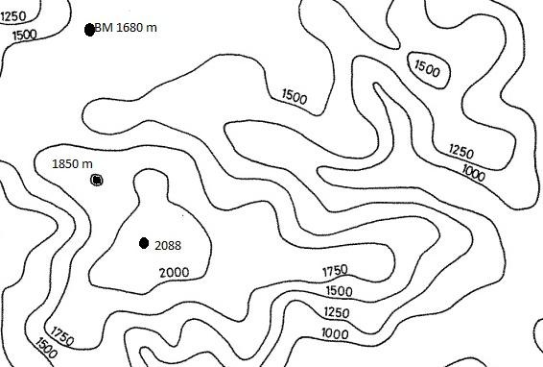

## Contour Lines

Representation of relief by contours is a standard and a commonly used method of showing relief on maps. All the possible information regarding the shape of the ground can be obtained quite accurately from contour map. It is defined as, "... lines on the map depicting the metric locations of points on the earth's surface at the same elevation above sea level." Contour lines are measured up from a base datum, usually sea level and the lines measured down from the datum are called depth contours or isobaths. Few contour lines exist in nature with the exception of shorelines and a few man made features. The height difference between contours is called the contour interval. Small scale regional maps will have a larger contour interval, and will be less accurate, and very large scale maps used for engineering and planning will have a very small contour interval, and be very accurate.

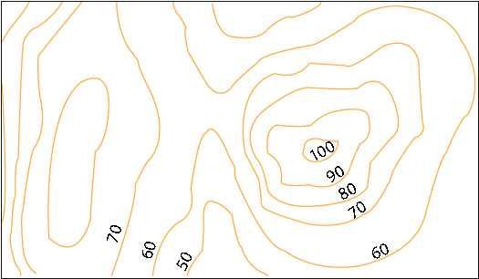

**Figure 3.2** A contour map with a contour interval of 10 meters

## Skeletal Lines

Lines that divide up terrain are called skeletal lines, structure lines, or break lines. These lines divide up watersheds, show drainage networks, ridge lines, breaks in slope, etc. Skeletal lines have been used as an independent method for the depiction of terrain. Skeletal line drawings consisting of mountain crests, ridge lines, and streams are combined with spot elevations, annotation and other text have been used for expedition reports and travel books. Skeletal lines can also be used to improve the visual interpreting of hill and mountain shapes through the addition of stream lines.

Skeletal lines can be combined with other display methods such as contour lines or shading to improve the visual interpretation of hill and mountain shape. The use of skeletal lines in a final map product should be limited to those lines which contribute to the effectiveness of the display of terrain such as in the case of stream lines. Excess use of skeletal lines may detract from the final map because they may clutter the map unnecessarily.

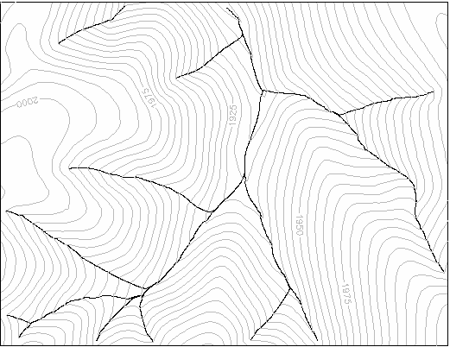

**Figure 3.3** Skeleton lines indicating valley lines derived from the contours (Aumann, Ebner, and Tang, 1991)

## Shading

The gradation from dark to light in a single color according to specific principals for the purpose of creating a three dimensional effect is called shading. In contrast to the metric accuracy of contour lines, hill shading is primarily used for its visual effects. There are three different types of shading. ***Slope shading*** operates on the principal that the steeper the slope - the darker the shade. ***Oblique shading or hill shading*** is based upon the effect of an oblique light source on a terrain surface. ***Combined shading*** combines the effects of slope and hill shading.

* + - * ***Slope Shading:*** as mentioned above operates basically on the principal of the steeper-the darker. Moellering and Kimberling (1990) presented a method for the display of slope-aspect maps which retains the three dimensional quality while including the display of slope-aspect.
      * ***Hill shading*:** The lighting effects produced by nature, in the photograph of a physical terrain model, are shading manually produced on a map and shading produced by digital methods. All of these examples are very appealing visually. Hill shading provides us with a view that is familiar but not one which we experience in our daily lives (at least most of us). Hill-shading gives an intelligible pattern of relief to the eye at a glance. It represents the relief of the ground on the map on a map vividly and effectively. One of the method’s limitations is that it does not give the absolute heights above mean sea level. It also fails to indicate whether the ground is sloping upward or downward and whether the unshaded area is low-level or high-level area. Therefore, hill-shading used in combination with contours gives more satisfactory results. Hill-shading on the topographical maps drawn on the scale of 1:50,000, shows effectively the direction of the ridges, escarpments and valleys and helps in understanding the relief easily.

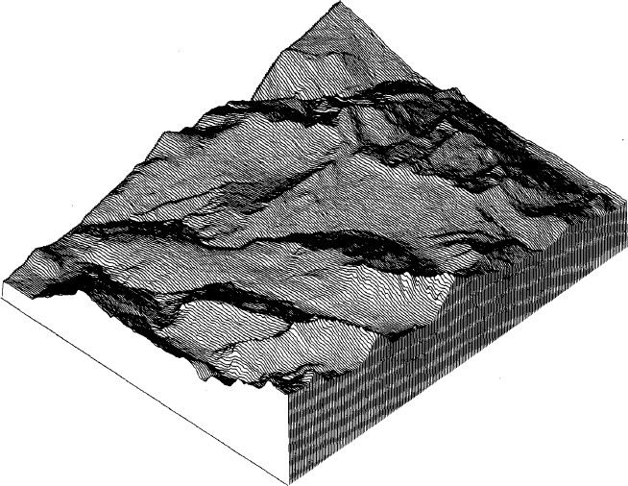

**Figure 3.4** A block diagram representation of terrain surface to show hill shading.

## Physical Models

The building of physical terrain models is rarely undertaken due to the high costs involved but it is the most direct way of showing the three dimensional land surfaces. Physical models are also clumsy and difficult to store. Physical models usually require an exaggeration in vertical scale relative to horizontal scale.

## Physiographic Diagrams

Pictorial methods of representation of terrain, physiographic diagrams are classified as a type of schematic map. These maps combine a planimetric base with an oblique viewing angle of terrain features. The base of a mountain symbol will be correct planimetrically but its peak may be offset by the oblique viewing angle. The purpose of these maps is the depiction of the relationship between the landforms and their geology and geomorphology.

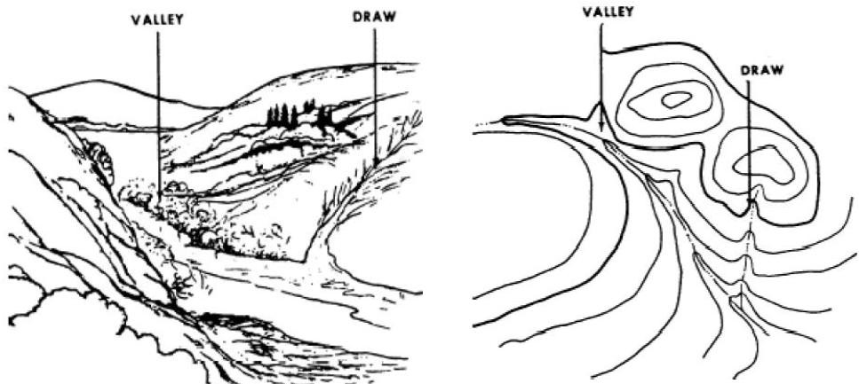

**Figure 3.5** Physiographic diagrams (left) and plannimetric view (right) representing terrain features

## Layer tinting or Altitude-tinting

This method has been devised to depict the relief on small scale maps by coloring with different tints of a color or various colors in the spaces between some prominent contours. A color legend is given so that the height of the land above the mean see-level represented by different tints is readily ascertained. This method is used to show relief on atlas and wall maps not on topographical maps. Blue is used for representing the sea and other water bodies. The deeper the water, the darker is the shade of the tint employed. Various shades in the following order as the height of the land increases: green, light green, yellow green. For height varying from 500 to 5000 meters, the following shades of brown are used in the order, which the height increases: light brown, brown, dark brown, reddish and crimson red. It may, however, be noted that the above mentioned scheme of altitude-tinting is not rigidly followed. Various shades of green may be used for heights much lower than 500 meters and those brown for heights should be used which brings out relief effectively.

Although layer tinting conveys a vivid picture (picture with intense/strong coloring) of the general character of relief, it is not without drawbacks:

* + - * A strip between two contours shaded with a particular tint appears to be of uniform height at all the points although height increases to wards the contour showing higher elevation.
      * An impression of sudden increase in height is created at a contour where shade changes. Thus, a map showing relief by layer tints gives a ‘stepped’ appearance.

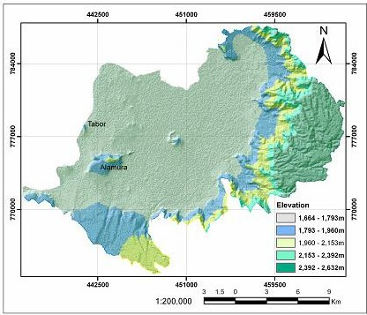

**Figure 3.6** Layer tinting of five colors showing topographic structure and elevation of Lake Awassa watershed from DEM (Arega, 2009).

## Contour line types and characteristics

The three types of contour lines (Figure 3.1) used on a standard topographic map are as follows:

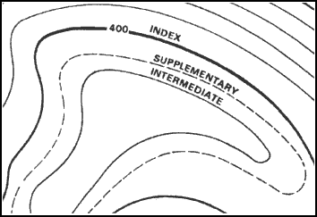

**Figure 3.7** Contour line types

* ***Index*:** Starting at zero elevation or mean sea level, every fifth contour line is a heavier line. These are known as index contour lines. Normally, each index contour line is numbered at some point. This number is the elevation of that line
* ***Intermediate*:** The contour lines falling between the index contour lines are called intermediate contour lines. These lines are finer and do not have their elevations given. There are normally four intermediate contour lines between index contour lines.
* ***Supplementary*:** These contour lines resemble dashes. They show changes in elevation of at least one-half the contour interval. These lines are normally found where there is very little change in elevation, such as on fairly level terrain.

The choice of suitable contour interval in a map depends upon four principal considerations. These are: [nature of the terrain](http://nptel.iitm.ac.in/courses/Webcourse-contents/IIT-ROORKEE/SURVEYING/modules/module5/html/86.htm) , [scale of the map,](http://nptel.iitm.ac.in/courses/Webcourse-contents/IIT-ROORKEE/SURVEYING/modules/module5/html/87.htm) [accuracy,](http://nptel.iitm.ac.in/courses/Webcourse-contents/IIT-ROORKEE/SURVEYING/modules/module5/html/88.htm) [time and cost](http://nptel.iitm.ac.in/courses/Webcourse-contents/IIT-ROORKEE/SURVEYING/modules/module5/html/89.htm) available.

* **Nature of Terrain:** The contour interval depends upon the nature of the terrain (Table 3.1). For flat ground, a small contour interval is chosen whereas for undulating and broken ground, greater contour interval is adopted.

**Table 3.1** Contour Interval (CI) for different types of Survey

|  |  |  |  |
| --- | --- | --- | --- |
| **No** | **Purpose of survey** | **Scale** | **CI (m)** |
| 1 | Building site | 1/1000 or less | 0.2 to 0.5 |
| 2 | Town planning, reservoir etc. | 1/50,00 to 1/100,00 | 0.5 to 2 |
| 3 | Location Survey, earthwork, etc. | 1/100,00 to 1/200,00 | 1 to 3 |

* **Scale of the Map:** The contour interval is normally varies inversely to the scale of the map i.e., if the scale of map is large, the contour interval is considered to be small and vice versa (Table 3.2).

**Table 3.2** CI for different scales and types of Ground

|  |  |  |  |
| --- | --- | --- | --- |
| **No** | **Map Scale** | **Type of Terrain** | **CI(m)** |
| 1 | Large (1:1000 or less) | Flat | 0.2 to 0.5 |
| Rolling | 0.5 to 1 |
| Hilly | 1 to 2 |
| 2 | Intermediate (1:1000 to 1: 10,000) | Flat | 0.5 to 1.5 |
| Rolling | 1.5 to 2 |
| Hilly | 2 to 3 |
| 3 | Small (1: 10,000 or more) | Flat | 1 to 3 |
| Rolling | 3 to 5 |
| Hilly | 5 to 10 |

* + **Accuracy:** Accuracy need of surveying work also decide the contour interval. Surveying for detailed design work or for earthwork calculations demands high accuracy and thus a small contour interval is used. But in case of location surveys where the desired accuracy is less, higher contour interval should be used.
  + **Time and Cost:** If the contour interval is small, greater time and funds will be required in the field survey, in reduction and in plotting the map. If the time and funds available are limited, the contour interval may be kept large.

The principal characteristics of contour lines which help in plotting or reading a contour map are as follows:

* + - The variation of vertical distance between any two contour lines is assumed to be uniform.
    - 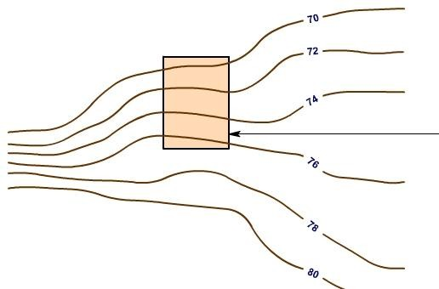The horizontal distance between any two contour lines indicates the amount of slope and varies inversely on the amount of slope. Thus, contours are spaced equally for uniform slope (Figure 3.8); closely for steep slope contours (Figure 3.9) and widely for moderate slope (Figure 3.10).

**Uniform slope**

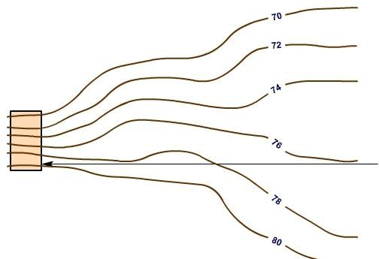**Figure 3.8** Contours of terrain having different types of slope (uniform slope)

**Steep slope terrain**

**Figure 3.9** Contours of terrain having different types of slope (steep slope)

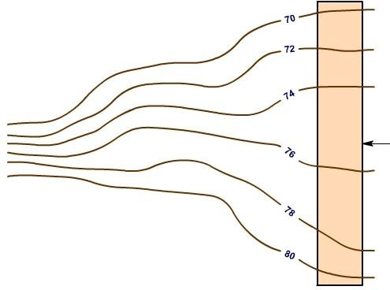**Gentle slope terrain**

**Figure 3.10**Contours of terrain having different types of slope (gentle slope)

* + - * The steepest slope of terrain at any point on a contour is represented along the normal of the contour at that point (Figure 3.3). They are perpendicular to ridge and valley lines where they cross such lines.
      * Contours do not pass through permanent structures such as buildings ([Figure 3.11](http://nptel.iitm.ac.in/courses/Webcourse-contents/IIT-ROORKEE/SURVEYING/modules/module5/html/91.htm#%23))

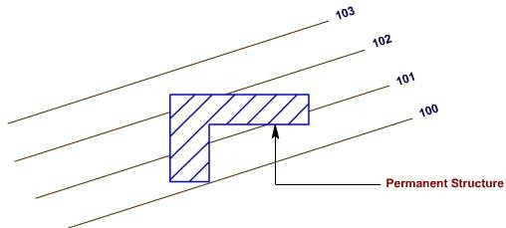

**Permanent Structures**

**Figure 3.11** Contours across permanent structures

* Contours of different elevations cannot cross each other (caves and overhanging cliffs are the exceptions).
* Contours of different elevations cannot unite to form one contour (vertical cliff is an exception).
* Contour lines must close on themselves, either on or off a map. They cannot dead-end and do not have sharp turnings.
* A contour line must close itself but need not be necessarily within the limits of the map.
* A closed contour line on a map represents either depression or hill. A set of ring contours with higher values inside, depicts a hill whereas the lower value inside, depicts a depression (without an outlet).
* Contours deflect uphill at valley lines and downhill at ridge lines. Contour lines in U-shape cross a ridge and in V-shape cross a valley at right angles. The concavity in contour lines is towards higher ground in the case of ridge and towards lower ground in the case of valley as shown in figure 3.12.

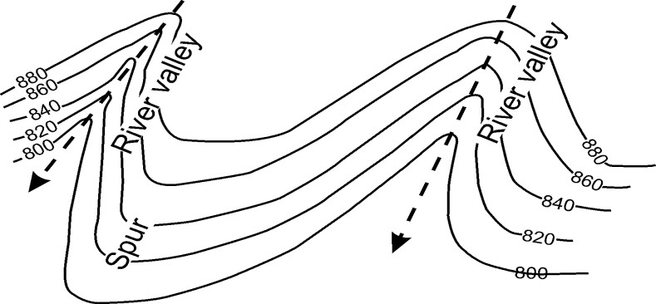

**Figure 3.12** Contour line deflect uphill at valley line and down hill at ridge line

## Interpretation of land surface forms

Terrain features do not normally stand alone. To better understand these when they are depicted on a map, you need to interpret them. Terrain features (Figure 3.13) are interpreted by using contour lines, the SOSES approach, ridgelining, or streamlining.

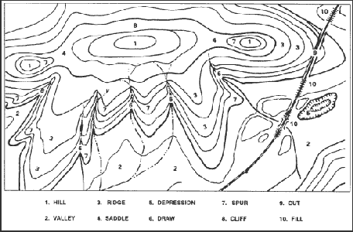

**Figure 3.13** Terrain features.

**Contour Lines**. Emphasizing the main contour lines is a technique used to interpret the terrain of an area. By studying these contour lines, you will be able to obtain a better understanding of the layout of the terrain and to decide on the best route.

**SOSES.** It is a recommended technique for identifying specific terrain features and then locating them on the map is to make use of five of their characteristics known by the mnemonic SOSES. Terrain features can be examined, described, and compared with each other and with corresponding map contour patterns in terms of their shapes, orientations, sizes, elevations, and slopes.

* ***Shape***. The general form or outline of the feature at its base.
* ***Orientation***. The general trend or direction of a feature from your viewpoint. A feature can be in line, across, or at an angle to your viewpoint.
* ***Size***. The length or width of a feature horizontally across its base. For example, one terrain feature might be larger or smaller than another terrain feature.
* ***Elevation***. The height of a terrain feature. This can be described either in absolute or relative terms as compared to the other features in the area. One landform may be higher, lower, deeper, or shallower than another.
* ***Slope***. The type (uniform, convex, or concave) and the steepness or angle (steep or gentle) of the sides of a terrain feature.

Through practice, one can learn to identify several individual terrain features in the field and see how they vary in appearance. However, it is important to note that further terrain analysis using SOSES can be learned by using the Map Interpretation and Terrain Association Course. It consists of three separate courses of instruction: basic, intermediate, and advanced. Using photographic slides of terrain and other features, basic instruction teaches how to identify basic terrain feature types on the ground and on the map. Intermediate instruction teaches elementary map interpretation and terrain association using real world scenes and map sections of the same terrain. Advanced instruction teaches advanced techniques for map interpretation and terrain association. The primary emphasis is on the concepts of map design guidelines and terrain association skills. Map design guidelines refer to the rules and practices used by cartographers in the compilation and symbolization of military topographic maps. Knowledge of the selection, classification, and symbolization of mapped features greatly enhances the user's ability to interpret map information.

**Ridgelining.** This technique helps you to visualize the overall lay of the ground within the area of interest on the map. Follow these steps:

* Identify on the map the crests of the ridgelines in your area of operation by identifying the close-out contours that lie along the hilltop.
* Trace over the crests so each ridgeline stands out clearly as one identifiable line.
* Go back over each of the major ridgelines and trace over the prominent ridges and spurs that come out of the ridgelines.

The usual colors used for this tracing are red or brown; however, you may use any color at hand. When you have completed the ridgelining process, you will find that the high ground on the map will stand out and that you will be able to see the relationship between the various ridgelines.

**Streamlining.** This procedure is similar to that of ridgelining in that it involves:

* Identify all the mapped streams in the area of operations.
* Trace over them to make them stand out more prominently.
* Then identify other low ground, such as smaller valleys or draws that feed into the major streams, and trace over them.
* This brings out the drainage pattern and low ground in the area of operation on the map. The color used for this is usually blue; but again, if blue is not available, use any color at hand so long as the distinction between the ridgelines and the streamlines is clear.

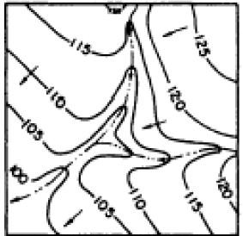

**Figure 3.14** Contour lines showing stream junction

## 

## Recognizing terrain features using profiles and cross-sections

* + 1. **Profiles**

The study of contour lines to determine high and low points of elevation is usually adequate for military operations and other development projects: highways, building construction, landscaping, etc. However, there may be a few times when we need a quick and precise reference to determine exact elevations of specific points. When exactness is demanded, a profile is required. A profile, within the scope and purpose of this lecture material, is an exaggerated side view of a portion of the earth's surface along a line between two or more points.

A profile can be constructed from any contoured map. Its construction requires the following steps:

* + - 1. Draw a line on the map from where the profile is to begin to where it is to end (Figure 3.15).

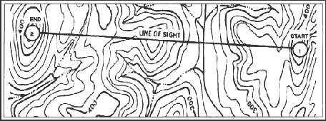

**Figure 3.15** Connecting points.

* + - 1. Find the value of the highest and lowest contour lines that cross or touch the profile line. Add one contour value above the highest and one below the lowest to take care of hills and valleys.
      2. Select a piece of lined notebook paper with as many lines as was determined in (ii) above. If lined paper is not available, draw equally spaced horizontal lines on a blank sheet of paper.
      3. Number the top line with the highest value and the bottom line with the lowest value as determined in (ii) above.
      4. Number the rest of the lines in sequence, starting with the second line from the top. The lines will be numbered in accordance with the contour interval (Figure 3.7).

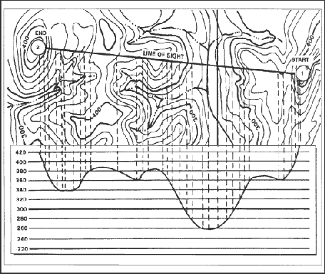

**Figure 3.16** Dropping perpendiculars

* + - 1. Place the paper on the map with the lines next to and parallel to the profile line (Figure 3.16).
      2. From every point on the profile line where a contour line, stream, intermittent stream, or other body of water crosses or touches, drop a perpendicular line to the line having the same value. Place a tick mark where the perpendicular line crosses the number line (Figure 3.16). Where trees are present, add the height of the trees to the contour line and place a tick mark there. Assume the height of the trees to be 50 feet or 15 meters where dark green tint is shown on the map. Vegetation height may be adjusted up or down when operations in the area have provided known tree heights.
      3. After all perpendicular lines have been drawn and tick marks placed where the lines cross, connect all tick marks with a smooth, natural curve to form a horizontal view or profile of the terrain along the profile line (3.7). Note that the profile drawn may be exaggerated. The spacing between the lines drawn on the sheet of paper determines the amount of exaggeration and may be varied to suit any purpose.
      4. Draw a straight line from the start point to the end point on the profile. If the straight line intersects the curved profile, line of sight to the end point is not available (Figure 3.17).

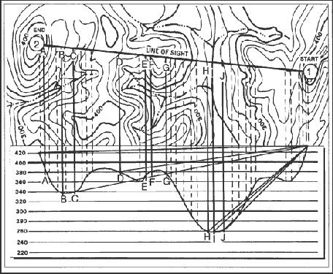

**Figure 3.17** Drawing lines to additional points.

* + - 1. Determine the line of sight to other points along the profile line by drawing a line from the start point to additional points. In Figure 3.17, line of sight is available to:

|  |  |  |
| --- | --- | --- |
| **A—Yes** | **D—Yes** | **G—Yes** |
| **B—No** | **E—No** | **H—No** |
| **C—No** | **F—No** | **I—No** |

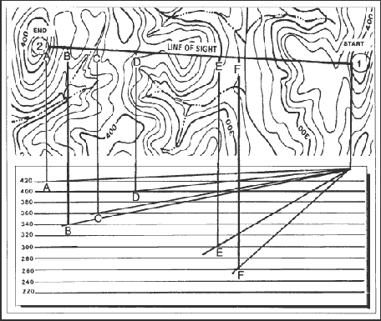

**Figure 3.18** Drawing a hasty profile**.**

When time is short, or when a complete profile is not needed, one may be constructed showing only the hilltops, ridges, and if desired, the valleys. This is called a hasty profile. It is constructed in the same manner as a full profile (Figure 3.18). A profile can be used for many purposes. The primary purpose is to determine if line of sight is available.

## Cross-sections

It is also called a transverse profile (not longitudinal), which is drawn across terrain features like valley, a mountain range, river channels, road cross-sections, etc. These are drawn at right angles to the direction run of the above features. They provide the data for estimating quantities of earth work and assessing the geometrical orientation of the stream channels. To set out right angles to the main line of section, the cross-staff, the optical square, the 3-4-5 method, etc, is used is used and the distances are measured left and right from the center of the peg. Cross-section may be taken at fixed distance interval (chainage). The length of the cross-section depends upon the nature of the work. For instance, stream channel analysis requires the readings taken from one end of the channel to the other end.

Cross-sections are plotted almost in the same manner as the longitudinal sections (profiles), except that both the vertical and horizontal scales are kept equal, i.e., VE=1. The point along the longitudinal sections is plotted at the center of the horizontal axis. The points to the left of the center point are plotted to the left and those to the right are plotted to the right as shown in figure 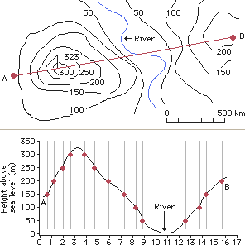3.19.

**Figure 3.19** Cross-section view of line AB drawn on a topographic map

The map on top is a topographical map. The map’s curving lines, or contours, are labeled with numbers indicating how high above sea level the contours are. The second map is a cross-section of the map on top. The x-axis (the horizontal axis) of the cross-section corresponds to the line from A to B on the topographical map. The y-axis (the vertical axis) of the cross-section is used with the x-axis to plot the height of each contour where it crosses the A-B line. This creates a series of dots; by connecting the dots, a cross- section of the landscape is created.

## Determining line of site from maps and aerial photos

The line of site (LOS) is an unobstructed view from point A to point B. Requests for LOS products are becoming more frequent just as the effective ranges of our weapons, radar, and communications equipment are increasing.

Some of the methods for determining LOS are:

* Ground truth (occupy positions), which is the most reliable, least likely, and least convenient method.
* Elevation layer tints, which do not consider refraction or the curvature of the earth.
* Survey inter-visibility formula, which adds constants for curvature of the earth and refraction but does not consider vegetation height.
* Profile (topographic map) method is the old, faithful method, almost universally known, but which does not consider refraction or curvature of the earth.
* Aerial photography (the floating line method), which is better used for short distances.
* Using digital terrain elevation data (DTED) and it is useful for a wide variety of product.

As a terrain analyst, you must often determine if one location can be seen from another location or if terrain is blocking the view. Inter-visibility is the ability to see from one object or station to another and is important to determine LOS. The best way to determine inter-visibility is to physically occupy each station. Since you cannot always be in the physical area, however, you must use topographic maps and aerial photographs. You must be able to plot coordinates on stereo-paired photos and construct a profile of a topographic-map area.

## Topographic Map Method

First make sure you have your photo interpretation kit. It contains a photo plot, your remote-sensed imagery (RSI), straightedge, pin vise and pin, point designation grid (PDG) template, and a mission directive that contains location instructions. It involves the following steps:

**Step 1** Look at your mission directive to obtain information about the location you will profile. The directive will also tell you which points to plot on the map.

**Step 2.** Draw a line across the area to be profiled connecting the two points you have just plotted. This is the profile line. Figure 3.20 shows an example.

**Step 3.** Increase the value of the highest contour line. This will become the upper-line measurement on the numbered profile lines. Start by looking at the map and identifying the highest contour line that either crosses or touches the profile line you have just drawn. Next, look at the bottom of your map and identify the contour interval; for example, it may say “contour interval 20 meters.” Increase the highest contour line by the contour interval.

## For example:

* + - * Highest contour line = 200 meters
      * Contour interval = 20 meters
      * 200 + 20 = 220 meters

**Step 4.** Decrease the value of the lowest contour line that touches or crosses the profile line. This will become the lowest line measurement on the numbered profile lines. Again, use the contour interval from the map. Decrease the lowest contour line by the contour interval.

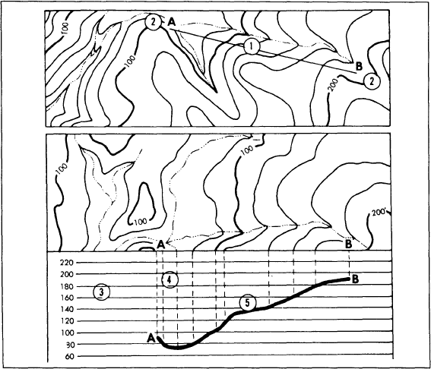

**Figure 3.20** Drawing LOS from contour maps

## For example:

* + - * Lowest contour line = 80 meters
      * Contour interval = 20 meters
      * 80 - 20 = 60 meters

**Step 5.** Prepare a profile. A profile is a side view of terrain along a line between two points. On a blank sheet of paper, draw a straight line the same length as the profile line paper. Each line represents a contour value line that crosses or touches the parallel line. The highest elevation is at the top, the lowest is at the bottom.

Draw two additional lines at the top and bottom so that one line is above the highest elevation and the other is below the lowest elevation. Number all lines to the right or left in sequence, with the highest value at the top. The dotted lines at 220 and 60 are the two added lines.

Next, place your lined sheet of paper against the profile line on the map. Extend dotted, vertical (perpendicular) lines from every point on the profile line to the corresponding value line. Place a tick mark where each perpendicular line crosses the profile line. This will ensure the contour value for each profile below a map. Look at the perpendicular extensions from the contour lines to the corresponding value line.

**Step 6.** Interpolate hill and valley lines. Interpolation is a method of determining the highest elevation of a hill and the lowest point of a valley. Since they are either higher or lower than the known elevations, determine them separately.

On the profile, insert the interpolated lines between the other contour-value lines. To estimate the height of a hill using the interpolation method, add half the contour interval to the known elevation.

## For example:

* + - * Known elevation = 200 meters
      * Contour interval = 20 meters
      * 1/2 Contour interval = 10 meters
      * 200 + 10 = 210 meters
      * Interpolated value = 210 meters

To estimate the bottom of a valley using the interpolation method, subtract half the contour interval from the known elevation.

## For example

Known elevation = 80 meters Contour interval = 20 meters 1/2 Contour interval = 10 meters 80 - 10 = 70 meters

Interpolated value = 70 meters

**Step 7.** Draw interpolated perpendicular lines extending to the corresponding value lines.

Notice how close they are to the highest and lowest elevation lines.

**Step 8. Draw** a dark line connecting the perpendicular lines. Smooth, natural lines represent hills and valleys. V- or U-shaped lines represent streams. Figure 24 illustrates a completed profile.

## Aerial Photography Method

**Step 1.** Orient the aerial photos for stereo viewing. Ensure that shadows of features such as bridges, riverbanks, and low buildings appear to fall toward you, the viewer.

**Step 2.** Locate the PDG coordinates on each photo. PDG coordinates provide a means of locating (plotting) points that represent features, targets, and positions on an aerial photograph. Look in your mission directive to identify the PDG coordinates of two points for each photograph. Place a grid over each photo, beginning with the left one, and locate the grid square containing the point you will plot.

Using the standard “read right and up,” plot each point according to its PDG coordinates. Use the standard map scale of 1:50,000, so you can use a map protractor for plotting. Plot the points in order of the first point on the left photo, first point on the right photo, second point on the left photo, and second point on the right photo. Finally, enter the coordinates in the marginal information area on each photo.

**Step 3.** Pinprick the points on the photos, in the same order as in step 2.

**Step 4.** Draw a connecting line between the points you have pin pricked and connect points 1 and 3 on the left photograph. Next, connect points 2 and 4 on the right photo. At this time, take a moment to cheek your work to make sure it is accurate. The points you have plotted must correspond to the location in the mission directive.

**Step 5.** Place the stereoscope over the aerial photographs, with the left lens placed over the left photo and the right lens over the right photo. Look through the stereoscope and adjust the photographs slightly so you will get the best possible stereo images. Features will appear to be three-dimensional if you have obtained stereovision as shown in figure 3.21.

**Step 6.** Determine inter-visibility. After positioning the stereoscope over the photos, look through your stereoscope. The two lines will fuse into one line. If it appears to float above the ground, you have determined inter-visibility. If the line appears to cut through the ground, you have not. By determining inter-visibility between two points, you have also determined LOS between them.

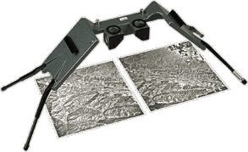

**Figure 3.21** Mirror stereoscope to view the three-dimensional features on the overlapping pair of aerial photographs.