# CHAPTER FOUR

# MORPHOMETRIC ANALYSIS OF TERRAIN

## 

## Relief and slope analysis: Definitions

* + - * **Slope:** is a rate of change of elevation. It is important to determine the steepness of topography, overland and subsurface gradient flow, resistance to uphill transport, geomorphology, and soil water content of the natural terrain features. Gradient or slope can also be defined as an inclination of the earth’s surface with respect to the horizontal. Units can be ft/mile (feet per mile) or m/km (meter per kilometer) depending upon the distance measurement unit we commonly use. The ease at which equipment or personnel can move is affected by the slope of the ground or terrain feature. This slope can be determined from the map by studying the contour lines, i.e., the closer the contour lines, the steeper the slope; and the farther apart the contour lines, the gentler the slope.
      * **Relief:** is the representation (as depicted by the mapmaker) of the shapes of hills, valleys, streams, or terrain features on the earth's surface. Relief is also the term for variance in the vertical configuration of the earth’s surface. You have seen how relief can be shown in a plotted profile or cross section. These, however, are views on a vertical plane, but a topographic map is a view on a horizontal plane. On a map of this type, relief may be indicated by different methods as discussed above in chapter 3. However, the contour-line method is the one most commonly used on topographic maps.

## Theories of slope evolution and development

All topographic studies basically are the study of how slopes change through time. Geomorphology is the attempt to systematize the facts and relationships of earth’s internal and external processes and how they produce an infinite variety of landscapes. The theories of landform development have devised several comprehensive theories of terrain evolution. These are as follows.

### W.M. Davis: The geographical cycle

It is the first conceptual model of landscape evolution to gain widespread acceptance within the discipline. The ‘**geographical cycle**’, expounded by William Morris Davis, was the first modern theory of landscape evolution. It assumed that uplift takes place quickly. The raw topography is then gradually worn down by geomorphic processes, without further complications from tectonic movements. Furthermore, slopes within landscapes decline through time, i.e., maximum slope angles slowly lessen (though few field studies have substantiated this claim). So, topography is reduced, little by little, to an extensive flat region close to base level (a **peneplain**) with occasional hills called monadnocks after Mount Monadnock in New Hampshire, USA, which are local erosional remnants, standing noticeably above the general level.

The reduction process creates a time sequence of landforms that progress through the stages of youth, maturity, and old age. However, these terms, borrowed from biology, are misleading and much censured. The ‘geographical cycle’ was designed to account for the development of humid temperate landforms produced by prolonged wearing down of uplifted rocks offering uniform resistance to erosion. However, it was extended to other landforms, including arid landscapes, glacial landscapes, periglacial landscapes, to landforms produced by shore processes, and to karst landscapes.

It was remarkably influential and persistent but no longer dominates research thinking like it did, but still used as a teaching tool and residual influence reflected in the way geomorphologists adhere to cyclical models. William Morris Davis’s ‘geographical cycle, in which landscapes are seen to evolve through stages of youth, maturity, and old age, must be regarded as a classic work, even if it is now known to be **unsound.** Its appeal seems to have lain in its theoretical sense and in its simplicity. It had an all-pervasive influence on geomorphological thought and spawned the once highly influential field of denudation chronology. The work of denudation chronologists, who worked mainly with morphological evidence, has subsequently been criticized for seeing flat surfaces everywhere.

Thus Davis aspired to a deductive, theoretical, genetic model of landscape evolution. The concepts of structure, process and time were his theoretical framework:

* + **Structure** was regional and considered as an initial condition (beyond the scope of his model). It refers to the type and arrangement of underlying rocks and surface materials.
  + **Process** was the sum of weathering and transport rather than specific processes or mechanisms, although since his cycle was based on the assumption of a normal climate,

*i.e.* humid temperate, fluvial processes predominate. It involves the internal and external forces that shape the landforms.

* + **Stage:** time was the central theme, but time in the sense of landscape development relative to the completion of the entire geographical cycle, *i.e.*, extent of landscape development. It refers to the length of time during which the process have been at work. He recognizes three stages: youth, maturity and old age.

Davis devised a circular sequence of terrain evolution in which a relatively flat surface was uplifted from a lower to a higher elevation where it was incised by fluvial erosion into a landscape of slopes and valleys, and thoroughly denuded until it became a flat surface at low elevation. He also recognizes rejuvenation, in which the cycle can be interrupted at any time by regional uplift.

The Davis’s idealized ‘geographical cycle’ in which a landscape evolves through ‘life-stages’ to produce a peneplain involves:

* + - **Youth:** a few ‘consequent’ streams, V-shaped valley cross-sections, limited floodplain formation, large areas of poorly drained terrain between streams with lakes and marshes, waterfalls and rapids common where streams cross more resistant beds, stream divides broad and ill-defined, some meanders on the original surface.

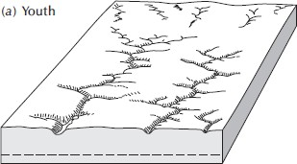

**Figure 4.1** youthful stage

***Source:*** fundamentals of geomorphology (2003, Richard John Huggett) adapted from holmes (1965, 473)

* + - **Maturity:** well-integrated drainage system, some streams exploiting lines of weak rocks, master streams have attained grade (p. 191), waterfalls, rapids, lakes, and marshes largely eliminated, floodplains common on valley floors and bearing meandering rivers, valley no wider than the width of meander belts, relief (difference in elevation between highest and lowest points) is at a maximum, hillslopes and valley sides dominate the landscape.

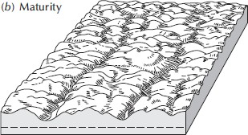

**Figure 4.2.** Maturity stage

***Source:*** fundamentals of geomorphology (2003, Huggett) adapted from Holmes (1965, 473)

* + - **Old age:** trunk streams more important again, very broad and gently sloping valleys, floodplains extensive and carrying rivers with broadly meandering courses, valleys much wider than the width of meander belts, areas between streams reduce in height and stream divides not so sharp as in the maturity stage, lakes, swamps, and marshes lie on the floodplains, mass-wasting dominates fluvial processes, stream adjustments to rocks types now vague, extensive areas lie at or near the base level of erosion.

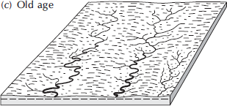

**Figure 4.3.** Old stage

***Source:*** fundamentals of geomorphology (2003, Huggett) adapted from Holmes (1965, 473)

### Theory of crustal change and slope development

A variation on Davis’s scheme was offered by **Walther Penck**. The theory developed because of imperfections in Davis’s geomorphic cycle:

* + - No intact peneplain surfaces currently exist, only remnants
    - Doubts that little erosion takes place during initial stage of uplift
    - Doubts about sequential development, saying it is misleading
    - No proof has been found that one stage commonly precedes another in regular fashion.

According to the Davisian model, uplift and planation take place alternately. But, in many landscapes, uplift and denudation occur at the same time. The continuous and gradual interaction of tectonic processes and denudation leads to a different model of landscape evolution, in which the evolution of individual slopes is thought to determine the evolution of the entire landscape. Three main slope forms evolve with different combinations of uplift and denudation rates:

* + - **Convex slope** profiles, resulting from waxing (increasing) development, form when the uplift rate exceeds the denudation rate.
    - **straight slopes**, resulting from stationary (or steady-state) development, form when uplift and denudation rates match one another; and
    - **Concave slopes**, resulting from declining (waning) development, form when the uplift rate is less than the denudation rate. Later work has shown that valley-side shape depends not on the simple interplay of erosion rates and uplift rates, but on slope materials and the nature of slope-eroding processes.

According to Penck’s arguments, slopes may either recede at the original gradient or else flatten, according to circumstances. Many textbooks claim that Penck advocated ‘parallel retreat of slopes’, but this is a false belief. Penck argued that a steep rock face would move upslope, maintaining its original gradient, but would soon be eliminated by a growing basal slope. However, the complexities of this theory are stressing that the uplift stimulates erosion immediately and hence the slope form is significantly influenced by the rate of uplift or other crustal deformation; and emphasizing on a parallel retreat which the slope angle remains approximately the same overtime, instead of processing a continually diminishing angle of a slope.

### Equilibrium theory

It is the idea that slope forms are adjusted to geomorphic processes so that there is a balance of energy; the energy provided is just adequate for the work to be done. It explains the variations in crustal movement and the resistance of underlying rock from place to place as significant as differences in process of determining terrain. The theory has serious shortcomings in areas that are tectonically stable or have limited stream flow.

## Stages of slope development or landmass dissection

Landforms and landscapes change over time as a result of various dynamic factors. These factors include tectonic movement, weather, erosion, and gravity. At any given moment, a landscape may include one or more of the features shown. A landmass, like a stream, may be said to pass through several stages of development from initial form, through youth and maturity, to old age.

* The **initial stage of dissection** of any area may be considered that stage in which drainage is just beginning to develop or has recently developed. Much of the initial block surface remains undissected and undrained.
* The **youthful stage** is characterized by active stream development and dissection, though most of the original surface remains.
* The **mature stage** may be described as consisting of slopes, resulting from the almost complete dissection of the original landmass. Little or no original upland surface remains.
* In the **old-age stage**, a large number of the inter-fluvial spurs and divides have been removed by erosion and much of the lower topography is adjusted to a new base level. The original upland surface is reflected only by a relatively few remaining hills or outliers which rise above the new well developed lower surface.

## Forms and classes of slope

Slope can be expressed as the slope ratio or gradient, the angle of slope, or the percent of slope. The slope ratio is a fraction in which the vertical distance is the numerator and the horizontal distance is the denominator. The angle of slope in degrees is the angular difference the inclined surface makes with the horizontal plane. The tangent of the slope angle is determinedly dividing the vertical distance by the horizontal distance between the highest and lowest elevations of the inclined surface. The actual angle is found by using trigonometric tables. The percent of slope is the number of meters of elevation per 100 meters of horizontal distance. Slope information that is available to the analyst in degrees or in ratio values may be converted to percent of slope. Instruments used for determining a slope of a given terrain feature in the field are hand held Clinometers and Abney level, optical theodolites, levels, etc

The rate of rise or fall of a terrain feature is known as its slope. This slope can be determined from the map by studying the contour lines (the closer the contour lines, the steeper the slope; the farther apart the contour lines, the gentler the slope). Four types of slopes that concern the military are as follows:

1. **Gentle.** Contour lines showing a uniform, gentle slope will be evenly spaced and wide apart (Figure 4.4). Considering relief only, a uniform, gentle slope allows the defender to use grazing fire. The attacking force has to climb a slight incline.

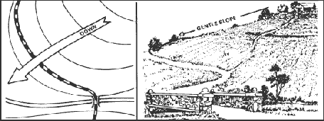

**Figure 4.4** Uniform, gentle slope

1. **Steep.** Contour lines showing a uniform, steep slope on a map will be evenly spaced, but close together. Remember, the closer the contour lines, the steeper the slope (Figure 4.5). Considering relief only, a uniform, steep slope allows the defender to use grazing fire, and the attacking force has to negotiate a steep incline.

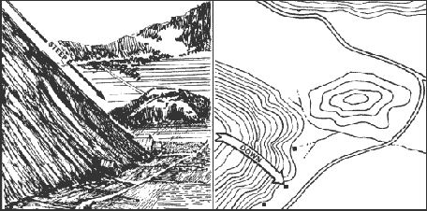

**Figure 4.5** Uniform, steep slope

1. **Concave.** Contour lines showing a concave slope on a map will be closely spaced at the top of the terrain feature and widely spaced at the bottom (Figure 4.6). Considering relief only, the defender at the top of the slope can observe the entire slope and the terrain at the bottom, but he cannot use grazing fire. The attacker would have no cover from the defender's observation of fire, and his climb would become more difficult as he got farther up the slope. concave slope segments are depositional (e.g. talus) or transporational (e.g. pediments) slope segments that form near the base of slopes and in the absence of removal of waste (e.g. river down cutting) with increasing runoff down slope, velocity and sediment transport can be maintained over increasingly lower slopes.

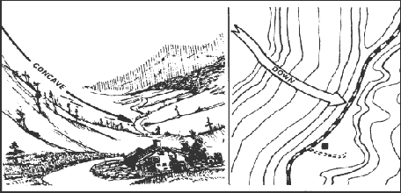

**Figure 4.6** Concave slope

1. **Convex.** Contour lines showing a convex slope on a map will be widely spaced at the top and closely spaced at the bottom (Figure 4.7). Considering relief only, the defender at the top of the convex slope can obtain a small distance of grazing fire, but he cannot observe most of the slope or the terrain at the bottom. The attacker will have concealment on most of the slope and an easier climb as he nears the top. Convex slope segments form on the upper parts of slopes in response to soil creep and rain splash erosion, when slopes are below the threshold for rapid mass wasting.

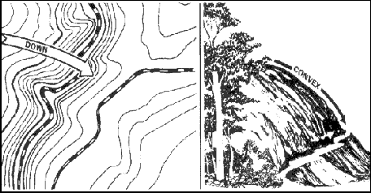

**Figure 4.7** Convex slope

1. **Composite slope:** It composed of the characteristics of both concave and convex slopes. As a result, it termed as ***convexo-concave slope***. Usually, these forms of slope are convex at the bottom, straight in the middle and concave at the top referring point deposition and erosion. Most hill slopes consist of a series of segments, for example, convexo-concave with soil and vegetation: a convex upper segment, straight mid slope and basal concavity.
2. **Cliff (free face):** is the simplest but commonest type of slope. It usually developed along coastal areas by waves’ undercutting, on some deeply cut river banks, in glaciated mountain areas, etc. Cliffs are so steep that 400 or more values are usual and are the products of weathering for mostly debris fall immediately to the base, i.e., there is less or no accumulation of detritus.

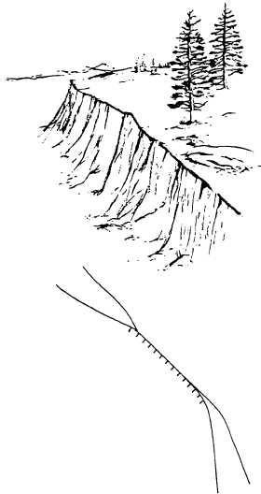

**Figure 4.8** Cliff

## Determining slope and relief

Slope may be expressed in several ways, but all depend upon the comparison of vertical distance (VD) to horizontal distance (HD). Before we can determine the percentage of a slope, we must know the VD of the slope. The VD is determined by subtracting the lowest point of the slope from the highest points of contour lines while the HD between the two points on the map is through ruler.

* + - * It is expressed in percentage form
      * The slope angle can also be expressed in degrees. To do this, determine the VD (rise) and HD (run) of the slope. Multiply the by 57.3 (constant value) and then divide the VD by the HD. This method determines the approximate degree of slope and is reasonably accurate for slope angles less than 20º.
      * The slope angle can also be expressed as a gradient. The relationship of horizontal and vertical distance is expressed as a fraction with a numerator of one.
      * Gradient or slope can also be defined as an inclination of the Earth’s Surface with respect to the horizontal. Units can be ft/mile (feet per mile) or m/km (meter per kilometer) depending upon the distance measurement unity we commonly use.



## Determining average slope of natural terrain features

It the average angle at which the surface slopes away from the horizontal. It is simply an indication of angles the surface depart from the horizontal on the average. The commonly used methods of computing average slopes are as follows:

### F. Walder and K. Peuk Method (1890)



* This method of determining average slopes of natural terrain features is very tedious job because job to measure all the contour lengths, but measuring total areas may be easier.

### Went worth’s method



* Wentworth’s method is simpler in computation only for measurements shown on terrain maps are in British units.

### Strahler’s Method

Statistics describing ground surface slope have geomorphic, hydrologic, engineering, and military applications because slope steepness influences rates of runoff, soil creep, and soil flowage and the ease of cross-country movement of men and vehicles. Slope maps can be drawn to show the areal distribution of degree of slope and magnitude of the down slope component of gravitational acceleration.



**Note:** It also possible to use metric system. The problem here is determining the average contour width because it requires due consideration of all the contour width of course changing. We usually use planimeter and measure the area between two successive contours. Where:

* Area= Width × Length
* Width = Area/Length

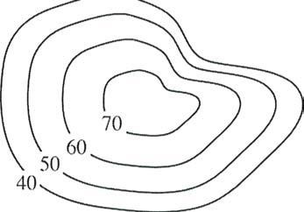

**Figure 4.9** Five concentric contour lines showing elevation 70m, 60m, 50m, and 40m values from center to periphery.

**Example:** Calculate the average slope of in the above figure. Steps are:

* measure the area between all five successive contours
* Measure the length of all 4 contours(ℓi )
* And hence, determine the width (W)



### Average slope of a tract of land

The average slope, in percent, for a given area is the product of the selected contour interval (CI) and the sum of the length of each selected contour interval divided by the area in square feet.



Where:

**CI=** Contour interval in feet.

**L**= the sum of the length of the contour lines, at the selected contour interval

**A**=the total area, in acres, of the parcel.

### Main Channel Slope

It is an estimate of the typical rate of elevation change along the main channel that drains the basin. This measurement is often related to peak flow magnitude and flood volume. Estimate the main channel slope by measuring the length of the main channel from the mouth of the stream or the study site to the mapped source of the main stream.

The steps are:

* At each stream channel, mark off 10% and 85% of the main channel length on the map;
* Estimate the elevation in meters at the 10% and 85% distance points, using contour lines on the topographic map; and
* Compute the main channel slope as follows:



### Watershed Slope

Flood magnitudes reflect the momentum of the runoff. Slope is an important factor in the momentum. Both watershed and channel slope may be of interest. Watershed slope reflects the rate of change of elevation with respect to distance along the principal flow path. Typically, the principal flow path is delineated, and the watershed slope (S) is computed as the difference in elevation (DE) between the end points of the principal flow path divided by the hydrologic length of the flow path (L).



The elevation difference DE may not necessarily be the maximum elevation difference within the watershed since the point of highest elevation may occur along a side boundary of the watershed rather than at the end of the principal flow path.

### Average channel slope

Two values are needed in order to calculate the Average channel slope: the catchment outlet elevation and the elevation of the farthest point along the drainage network.

It is calculates as:



Where:

Δ*h* = Height difference between catchment outlet and the farthest point along the main channel.

*L=* Main channel length or any other two points of interest.

For instance, as shown below contour lines that are close together indicate steep slopes which are usually found in the highest part of the catchment. As the land flattens out, the contour lines are further apart. Slopes can vary within a catchment. Note that the lowest slopes occur along the drainage lines and ridge lines. The steepest slopes occur midway between these points.

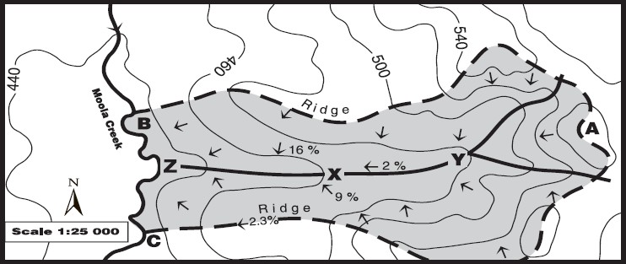

**Figure 4.10** A topographic map with a catchment area highlighted

In figure 4.10, the height difference between X and Y is 20 m (480 m–460) and the horizontal distance is 1000 m. The average slope between X and Y would be calculated as follows: Average slope (%) = [20/1000] X 100 = 2%

### Average slope steepness

The catchment has to be reclassified in several sub area elevation ranges. For instance the average slope for every elevation range can based on the hydrologic characteristics of the main stream of the watershed with respect to fluvial processes: erosion, transportation and deposition. It is calculated as:



Where:

*S m* = average slope steepness

*DA* = total drainage area

*S i =* average slope for every (reclassified) elevation range.

*DA i* = drainage area of every (reclassified) elevation range.

## Determining relief of the natural terrain features

* **Basin Relief:** It is the difference in elevation between the highest and lowest points in the basin. It controls the stream gradient and therefore, influences flood patterns and the amount of sediment that can be transported. Hadley and Schumm (1961) showed that sediment load increases exponentially with basin relief.
* **Basin relief ratio:** Basin relief ratio index is the basin relief divided by the basin length. It is useful when computing basin of different sizes because it standardizes the change in elevation over distance.
* **Ruggedness number:** It refers the level of smoothness and roughness of a give terrain system, like watershed. Relative relief as the elevation difference between the highest and the lowest possible area. Rn ranges between zero and one, **(0< Rn < 1)**. Rn=0 refers there is no ruggedness situation while Rn nearer to 1 shows more ruggedness in the terrain.



Where, K (5250) is a constant value given in the formula.

## Drainage basin analysis

**Evolution of different drainage patterns**

Stream channels and the systems they comprise obviously change through time, but there are differing opinions on how stream systems change, the pattern of change, the rate of change, etc. Because stream erosion is slow by human standards, the changes are mostly theoretical. Changes in stream patterns can be postulated from field study/examination of relict stream structures (paleo-stream structures) and flume analyses based on stream table studies (stream tables that are small scale simulations of rivers). From relict stream studies and flume simulations, some very broad generalizations regarding changes in basin morphometry through time can perhaps be made. Parker used materials to simulate uniform consolidated surficial materials. The stream table simulation, Parker used initially developed a dense dendrite pattern such would be expected in a temperate area with uniform surface material of low slope. Streams and therefore their patterns grow by head ward extension until divides are reached. In Parker's simulation, streams did, in fact, grow by head ward extension.

During simulated extension phases, drainage density increased, especially around the outside margins of the basin. During the extension phases drainage density decreased in the lower (downstream or "center) portion of the basin as a consequence of loss of channels. Essentially the high density dendritic pattern in the center of the basin "evolved" into a low density dendritic pattern with time; so the discharge pattern would be expected to change, i.e., discharge patterns would probably become more "flashy" with evolution of the drainage basin. That change in discharge patterns with evolution of ]stream patterns might be generally extrapolated as trellis patterns age, perhaps the extension of streams to divides results in even less density of streams in the "center" portions of trellis systems and a shift to even "flashier" discharge. It may be stretching the study, but it is arguable that the centers of most drainage basins tend toward flashier discharge as they age.

### Stage of Stream development

The following stages may be identified: initial stage, youthful stage, maturity, old age and rejuvenation.

* ***Initial stage****:* The initial stage of a stream is usually characterized by a lack oforder and organization. Falls, rapids, and variable stream gradients are typical. Initial drainage may develop on uplifted coastal plains and peneplains, in glaciated plains, on young lava surfaces and volcanoes, and on pediment surfaces.
* ***Youthful stage:*** During the youthful stage, the major observable activity of a stream is that of downcutting. The stream occupies the entire valley floor. Frequently, the valley profile is V-shaped and stream course is relatively straight. Waterfalls and rapids persist well in this stage.

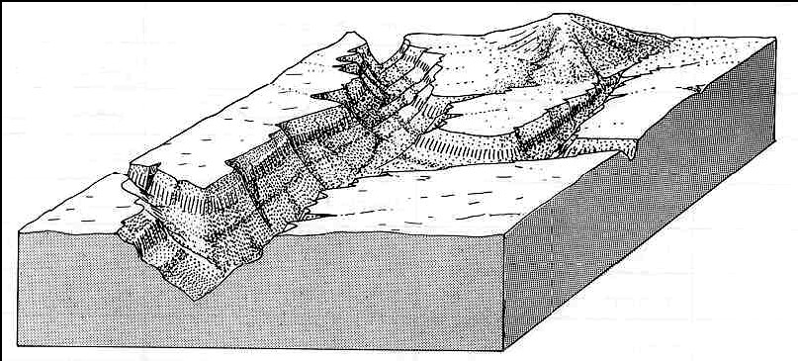

**Figure 4.11** Block diagram illustrating youthful stages in the fluvial cycle of erosion

* ***Mature stage:*** Down-cutting is diminished and lateral erosion becomes dominant. Valley floor is wider than stream channel. In **full maturity**, a stream flows in a well established meandering course, sweeping back and forth across a flood plain sufficiently wide to accommodate the entire meander belt. **Early maturity** is characterized by the partial development of a flood plain. In **late maturity**, the flood plain is noticeably wider than the meander belt of the stream.

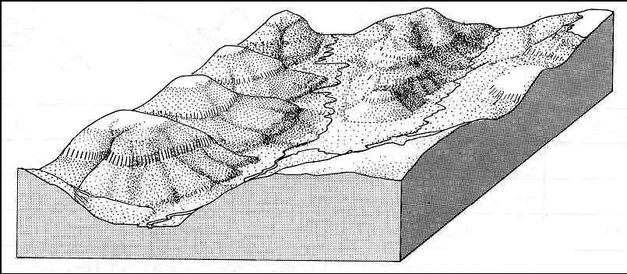

**Figure 4.12** Block diagram illustrating matured stages in the fluvial cycle of erosion

* ***Old age:*** In old age the flood plain is so extensive that the entire meander belt has enough room to follow a gross meander like course. Lateral erosion and point bar deposition dominates. Oxbow lakes are common. The width of the flood plain is many times that of the meander belt and natural levees are present along much of the stream channel.

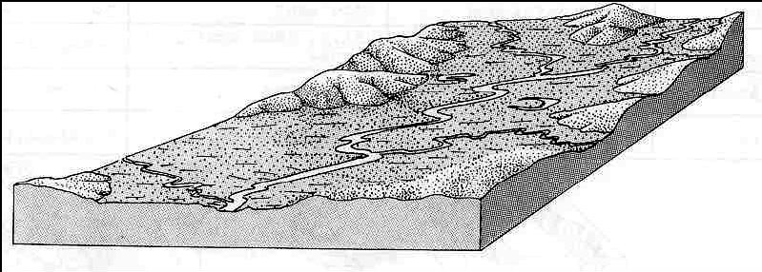

**Figure 4.13** Block diagram illustrating old stages in the fluvial cycle of erosion

* + - * ***Stream rejuvenation:*** At any time in a stream's development from one stage to the next, changes may occur which produce a return to the dominantly downcutting youthful stage. Thus, a fully mature stream may rapidly become incised a second time. Rejuvenation may be produced one or more of the following: uplift, tilting, lowering of base level, and increase in a volume of stream by capture and through change in climate. Entrenched meanders, broad and flat peneplain (partly dissected, relatively steep gradients are very common.

## Genetic Classifications

Streams are generally classified in the following manner consequent, subsequent, resequent, obsequent, insequent, superposed or superimposed and antecedent. Geneticclassification is based on this adjustment and has no relation to original consequent stream direction.

* + - * A ***consequent stream*** is one which develops on some initial topographic feature.
      * A **subsequent stream** is one which has developed a course adjusted along some line or zone of least resistance.
      * A **resequent stream** is one which flows down the dip of the formation. The streams flowing down the steep obsequent faces of the several asymmetric ridges are also classified as obsequent streams.
      * An **obsequent stream** is one which flows in a direction opposite to the dip of the formation. The streams flowing down the back or dip slopes of the ridges are classified as obsequent streams.
      * An **insequent stream** is one which follows a course which is apparently not controlled by any factor of original slope, structure or rock type.
      * A **superposed (or superimposed) stream** is one which has formed on one surface and structure and has since cut down through an unconformity, to flow across lower rock units which have a structure discordant with that above the unconformity. The materials lying above the unconformity may either be bedrock or unconsolidated material.
      * **Antecedent stream** A stream that continued to down-cutting and maintains its original course as an area along its course was uplifted by faulting or folding.

## Drainage basins’ characteristics

### Dendritic drainage patterns

This pattern resembles the complex branching of a tree and is principally a collection of in sequent streams (Figure 4.14). Homogeneity (uniformity)-no structural control-is characteristic. There is no line of structural weakness, and no steeply dipping, non resistant stratigraphic interval along which a stream can cut more rapidly than elsewhere. Dendritic drainage pattern is to be expected in the following areas: unconsolidated sands, silts, clays, gravels; in areas underlain by fine grained, gently sloping shales, tuffs; uniformly resistant crystalline rocks; highly metamorphosed rocks; horizontal or nearly horizontal rocks.

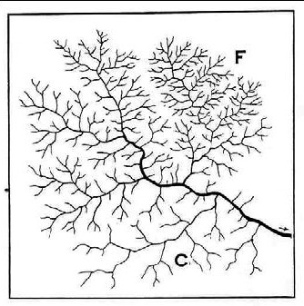The main factor influencing the development of dendritic drainage pattern is the type and the attitude of the rock on which drainage develops. In fine grained and impermeable rocks or layers, the pattern becomes closely spaced and more divided (ramified), whereas, in coarse grained and permeable rocks, it becomes wide spaced and less ramified. Modifications of dendritic drainage pattern: pincer-like drainage pattern, sub- parallel dendritic pattern, dendritic-pectinate pattern (featherlike), dendritic-pinnate.

**Figure 4.14** Dendritic drainage pattern called tree-like or arborescent, i.e., most common basic pattern. F is fine texture; C is coarse texture; and no structural control. It occurs on fine textured impervious material.

### Parallel drainage pattern

Extensive unidirectional slopes, such as those along a broad coastal plain or an elongate linear homoclinal ridge underlain by gently dipping strata or other tabular rock, are often drained by relatively uniformly spaced parallel or subparallel streams. When such streams constitute the principal drainage of an area, they may be referred to as forming a parallel drainage pattern (Figure 4.15) or subparallel drainage pattern (Figure 4.16). In general, this type of drainage pattern develops on fine textured material with steep slopes. Parallel drainage pattern is derived from dendritic and becomes dendritic, when the slope flattens out.

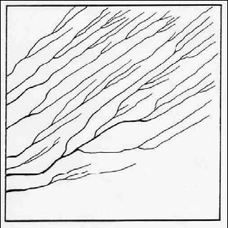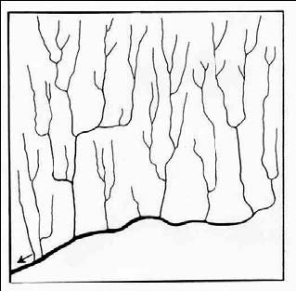

**Figure 4.15** Parallel pattern **Figure 4.16** Subparallel patterns

### Trellis drainage pattern

This pattern in contrast to dendritic drainage pattern is controlled structurally, and is produced in areas in which structural complexities or differences in rock resistance have directed stream development and location along a single major trend (subsequent stream), with smaller tributaries largely at right angles to the main units (Figure 4.17). Parallel folds of beds of different resistance, dipping sedimentary rocks generally exhibit trellis pattern.

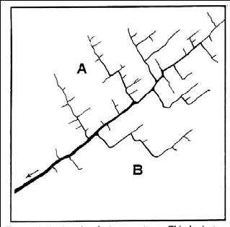

**Figure 4.17** Trellis pattern

### Rectangular and angular drainage patterns

Rectangular drainage patterns (Figure 5.18) usually develop along intersecting fault or joint systems. The adjusted streams or stream segments which define the pattern are all subsequent streams. This pattern occurs in areas underlain by large bodies of homogeneous crystalline rock, and regional plateaus underlain by horizontal or gently dipping resistant sedimentary rocks. Adjustment along one set of joints or faults is more pronounced. Combinations of dendritic and rectangular drainage patterns may occur in an area where the rock mass contains widely spaced fractures. Joint and fault systems rarely intersect at exactly at 90. The term rectangular is therefore usually extended to include large acute intersections. Angular drainage pattern occurs when the joints or faults cross each other at an angle (Figures 4.19).

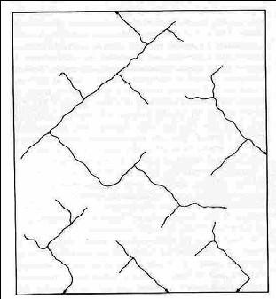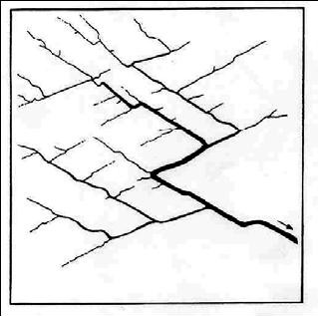

**Figure 4.18** Rectangular pattern **Figure 4.19** Angular pattern

### Radial drainage patterns

Most circular or oval topographically high areas are drained by streams which radiate outward from the central part, and flow down the flanks in all directions (Figure 4.20). Such radially drained topographic features may be underlain by horizontal strata, by dipping strata, by anticlinal or synclinal folds, by crystalline or sedimentary rocks, or by unconsolidated residual or deposited materials. Radial drainage alone cannot be assumed to indicate any particular structure. However, many structural domes rise as topographic domes; Radial consequent drainage develops around their flanks. Volcanoes also display radial drainage.

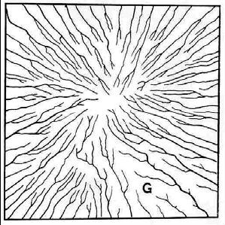**Figure 4.20** Radial drainage patterns

### Annular drainage patterns

Maturely dissected domes and basins are frequently expressed topographically by a series of concentric circular or arcuate ridges and lowlands. The lowlands, which are developed on nonresistant beds, are usually occupied by subsequent streams. These streams, if sufficiently well defined and restricted to the nonresistant belts, form what is called an annular drainage pattern (Figures 4.21).

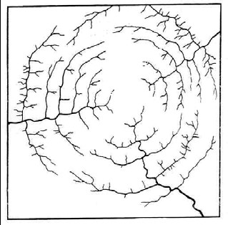

**Figure 4.21** Annular drainage patterns

### Special drainage patterns

Besides the basic drainage types and their modifications, special patterns are known. They are indicative as to the material in which they develop. The following are the most common or significant types:

* The **deranged pattern** is a common type of combined surface and subsurface drainage of glacial drift regions (Figure 4.22).
* The **dichotomic**, is a pattern found on alluvial fans or on deltas. It is controlled by depositional material. This pattern occurs in coarse granular material as shown in (Figure 4.22).
* Alluvials, flood-plains with meandering streams, show a pattern of meander scars and oxbow lakes left by abandoned channels called **anastomotic** (Figure 4.22).
* A stream pattern controlled by its own deposited load is called **braided** (Figure 4.22). It is most common in broad streams which emerge abruptly from high mountains to plains.

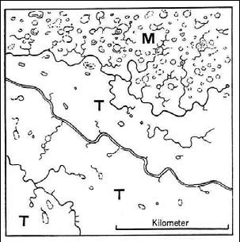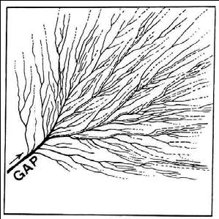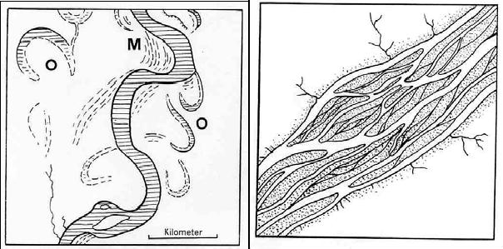

**Figure 4.22** Special drainage patterns, such as deranged, dichotomic, anastomotic and braided patterns, respectively.

## Basin network analysis

Overall Basin Parameters include: basin shape, basin relief, basin area, and basin height. Drainage basins can be outlined on aerial photographs and topographic maps. Roughly the divide between drainage basins lies midway between the head-ward tributaries of two different stream systems. Area can be calculated using girded plastic overlays or by shading the area of one drainage basin within a map of known regional dimensions (area) and digitizing for computer analysis. Basin Relief is the difference in elevation between the highest head-ward tributaries and the mouth of the main drainage stream. Basin height is simply the relief of the basin above a chosen level. In general, the larger the basin the more likely it is to have basin runoff lag. In general, the higher the relief, the shorter the time for precipitation/basin runoff lag; so overall basin parameters do give some indication of stream behavior and predictability of that behavior.

Once the stream channels within a certain watershed have been identified, the quantification of some intrinsic characteristics related to the morphometry of these elements can be used to identify certain general properties. Three basin properties which apply to all basins are: linear properties (one dimensional), areal properties (two dimensional), and relief properties (three dimensional).

## Linear Properties

The linear parts of a river basin are the channels themselves. Water falling within the boundaries of a river basin eventually enters the stream channel and the stream transports the material which the slope processes bring to the bottom of the valley. The size of rivers and basins varies greatly, thus they are classified and ordered.

### The Horton’s Law of Stream order

The ordering system was developed by A.N. Strahler. All the streams which flow from a source and have no tributaries are classified as first order streams. The confluence of two first order streams produces a second order stream, and the confluence of two second order streams produces a third order stream, etc.

The relationships between the number of streams and order are known as **Horton’s Law of Stream Numbers**. It states that: ‘there is a geometric ratio between the number of streams of one order and the next’ this ratio is known as the **Bifurcation Ratio**. The bifurcation ratio of large basins is generally the average of the bifurcation rations of the stream orders within it. Most natural stream systems have a ratio of between 3 and 5. There is also an informal relationship between stream length and order. Higher order basins generally have longer rivers.

First, an important quantifiable characteristic of stream networks is related to the hierarchical arrangement of stream channels. Different methods can be used to classify streams according to their position in the network, but the most commonly used is the method proposed by the famous hydrologist [Robert Horton.](http://www.utexas.edu/depts/grg/hudson/grg360g/EGIS/labs_04/Lab6/New_figures/horton.gif) According to this system, a stream segment with no tributaries is designated as a first-order stream. When two first- order segments join, they form a second-order stream; two second-order segments join to form a third-order segment, and so forth. When a lower order segment joins a higher order segment, there is no change in river order (Figrue 4.23).

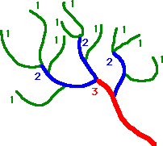

**Figure 4.23** The Horton’s law of the stream order

After the stream segments have been ordered following a given scheme, some interesting relationships have been observed. For example, the bifurcation ratio (also know as the *law of stream numbers*) defined as the ratio between the number of streams of a given order to the number in the next order, has been found to vary around the value from 3 to 5 in basins where geology is reasonably homogeneous. The law of stream lengths (Figure suggests that the length of streams in successive stream orders increases following a geometric relationship. Similarly, the number of streams within each order decreases with order in a linear fashion.

### Stream Branching Morphometry = Stream Bifurcation Patterns

**Stream Branching:** Branching patterns of streams vary depending upon bedrock control. Where uniform materials underlie the drainage basin, the streams usually branch randomly. Where folds or faults control weakness and stream development, the development of branches can be restricted to zones of faults or fracture or weak sedimentary strata. In general tributaries greatly outnumber transporting or major trunks in areas with trellis drainage; so branching ratios can rapidly pinpoint which areas of a basin have significant subsurface control.

**Bifurcation Ratios:** Branching pattern analysis is most commonly examined by counting the number of tributaries of the same rank or same level of contribution.

**Assignments of Numbers:** Stream segments are assigned numbers based upon their position within the river tributary system. Assignments of segment numerical values have been developed in several different ways, the most commonly used are:

### Strahler Method:

* + - segment with no tributaries is designed as a first-order stream
    - two first order streams join to form a second-order stream
    - only where two segments of equal magnitude join is an increase in order required
    - Bifurcation ratios are calculated: number of first order segments divided by the number of second order segments (and so on)

### Shreve Method: probably most commonly used

* segment with no tributaries is designed as a first-order stream;
* additional stream links represent the sum of the link numbers of all tributaries that feed it;
* Bifurcation ratios are calculated: number of first order segments divided by the number of second order segments; and so on.

Significances or implications of Bifurcation ratios are as follows:

* High bifurcation ratios are common in areas with structural control of drainage ways (folded - valley-&-ridge regions; faults). High bifurcation rations also are common in areas of "mature dendritic" drainage patterns. High bifurcation ratios tend to signify streams that have a higher than average flood potential because numerous tributary segments drain into relatively few trunk transporting stream segments) High bifurcation ratios include ratio values reaching upward of 20:1 and more.
* Low bifurcation ratios are more common in areas with uniform surficial materials where geology is reasonably homogenous, ratios usually range from 3.0 to 5.0. Low bifurcation ratios commonly signify areas with high drainage density and therefore fewer collecting segments per transporting segment (sometime check out Strahler or one of the others and look a bifurcation values and their implications)

Stream Length

Stream length involves measurement of the length of the different rank/order streams in a drainage system. Average stream lengths can be compared mathematically to total drainage area, basin relief, etc. Several techniques for measuring stream length involve computer digitization of separate stream segments of the same order. In general, areas with trellis large scale drainage patterns have high ratio values of length vs. other parameters (such as length vs. drainage basin area or length vs. bifurcation ratio). High values of other parameter ratios usually correspond to flash discharge behavior of stream systems.

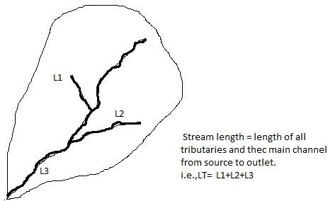

**Figure 4.24** Total stream length of a stream networks in a basin as a sum of lengths of tributaries and the main stream channel.

## Areal Properties

Through introducing a second dimension, the areal properties of a basin can be measured. It is possible to delimit the area of the basin which contributes water to each stream segment. The watershed can be traced from where the stream has its confluence with the higher order stream along hillcrests to pass upslope of the source and return to the junction. This line separates slopes which feed water towards the streams from those which drain in to other streams. If the area of the 1st order basin is found in this way, it is possible to calculate the mean area of the basins. If the watersheds of the second basins are traced in the same way, it will be seen that there are areas which drain directly in to the second order stream. These are called inter basin areas, and they mean that the area of the second order basin is not the sum of the areas of the first order basins.

### Watershed Length

The length (L) of a watershed is the second watershed characteristic of interest. While the length increases as the drainage increases, the length of a watershed is important in hydrologic computations. Watershed length is usually defined as the distance measured along the main channel from the watershed outlet to the basin divide. Since the channel does not extend to the basin divide, it is necessary to extend a line from the end of the channel to the basin divide following a path where the greatest volume of water would travel. The straight-line distance from the outlet point on the watershed divide is not usually used to compute L because the travel distance of floodwaters is conceptually the length of interest. Thus, the length is measured along the principal flow path. Since it will be used for hydrologic calculations, this length is more appropriately labeled as the hydrologic length.

While the drainage area and length are both measures of watershed size, they may reflect different aspects of size. The drainage area is used to indicate the potential for rainfall to provide a volume of water. The length is usually used in computing a time parameter, which is a measure of the travel time of water through a watershed.

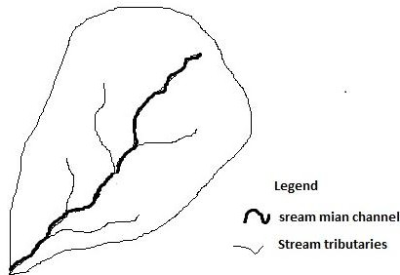

**Figure 4.25** A drainage basin showing the main channel and its tributaries

### Density

The average length of channel per unit area of the drainage basin is called the drainage density.

## Drainage density = SL / SA

Where SL is the total length of streams in the basin, and SA is the total area of the whole basin.

This indicates how frequently streams occur on the land surface. Factors affecting drainage density include geology and density of vegetation. The vegetation density influenced drainage density by binding the surface layer, thus preventing overland flow from concentrating along definite lines and from eroding small rills which might become small channels. The vegetation slows down the rate of overland flow, and stores some of the water for short periods of time and hence the residence times increased.

The effect of lithology on drainage density is marked. Permeable rocks with a high infiltration rate reduce overland flow, and consequently drainage density is low. Groundwater flow is important. Impermeable rocks with little vegetation, with heavy downpours will produce high drainage densities.

### Shape

Shape is important. Long basins have flatter hydrographs and take longer to achieve a throughflow of water from a rain storm. The most efficient basin would be one in which the watershed is circular and all the water disappears down a hole in the middle. Two measures have been devised to assess shape.

Basin shape is not usually used directly in hydrologic design methods; however, parameters that reflect basin shape are used occasionally and have a conceptual basis. Watersheds have an infinite variety of shapes, and the shape supposedly reflects the way that runoff will “bunch up” at the outlet. A circular watershed would result in runoff from various parts of the watershed reaching the outlet at the same time. An elliptical watershed having the outlet at one end of the major axis and having the same area as the circular watershed would cause the runoff to be spread out over time, thus producing a smaller flood peak than that of the circular watershed.

* + - * ***Basin circularity*** compares the area of the basin to the area of a circle of the same circumference.

## Basin circularity = 4p SA / P2

Where SA is the total area of the basin, number 4 is constant value, and P is the length of the basin perimeter of watershed. The closer the number is to 1, the more like a circle the watershed is.

* + - * **Basin elongation** compares the longest dimension of the basin to the diameter of a circle of the same area as the basin.

## Basin elongation = Dlp/ 4SA

Where Dl is the longest dimension of the basin, p is perimeter of the basin , number 4 is constant value and SA is the total area of the basin. This indicated how nearly circular the area of the basin is. The nearer to 1, the greater is the correspondence to a circle.

* + - * ***Basin compactness.*** A number of watershed parameters have been developed to reflect basin shape. The following are a few typical parameters:
      * ***Length to the center of area (Lca*):** the distance in miles measured along the main channel from the basin outlet to the point on the main channel opposite the center of area.

### Shape Factor (Ll)

**Ll = (LLca) 0.3**  Where L is the length of the watershed in miles

### Circularity ratio (Fc):

**Fc = P/ (4pA) 0.5**

Where P and A are the perimeter (ft), number 4 is constant value and area (ft2) of the watershed, respectively.

### Circularity ration (Rc):

**Rc = A/Ao**

Where A0 is the area of a circle having a perimeter equal to the perimeter of the basin.

### Elongation Ration (Re):



Where Lm is the maximum length (ft) of the basin parallel to the principal drainage lines.

Generally, the shape factor (Ll) is the best descriptor of peak discharge. It is negatively correlated with peak discharge (i.e. as the Ll decreases, peak discharge increases).

### Drainage Area

The drainage area (A) is the probably the single most important watershed characteristic for hydrologic design. It reflects the volume of water that can be generated from rainfall. It is common in hydrologic design to assume a constant depth of rainfall occurring uniformly over the watershed. Under this assumption, the volume of water available for runoff would be the product of rainfall depth and the drainage area. Thus the drainage area is required as input to models ranging from simple linear prediction equations to complex computer models. The volume of water that can be generated from rainfall is equal to the product of ppt (mm) and surface are of a basin (A). However, there are different ways by which we can determine the total surface area that can be drained by a particular stream system (main stream with its tributaries). The total drainage area by measuring the map area enclosed by the drainage divide can be estimated in several ways.

* Digitize the drainage basin in to GIS file and obtain the drainage area using the computer software. Note that some drainage basins may already be digitized by state or federal agencies and this information may be accessible to the public. For instance, drainage basin shape files for major basins of Ethiopia are found in ***Ethio GIS*** data base and made accessible for users.
* In this age of computers, geographic data can now be stored electronically. Digital Elevation Models (DEM’s) store topographic data in the form of grid cells. Typically, these grid cells have a resolution of 30 meters and elevation intervals of 1 foot or 1 meter. Using a DEM within a Geographical Information System (GIS), we can perform digital terrain analysis (DTA) such as calculating slopes, flow lengths, and delineate watershed boundaries and stream networks. However, there are certain drawbacks to DTA because some algorithms are not very smart, especially in delineating watershed boundaries.
* Outline the drainage basin with a polar plannimeter (a devise that calculates the area of any plane feature) by moving the tracer point along the drainage divide and recording the enclosed area in varnier units. Convert the varnier units to a convenient area measurement (e.g. Kilometers square, Hectares, Meter square, etc) based on the scale of the map and the conversion factor provided with the plannimeter.
* Use a 100 dot-per-inch transparent overlay placed over the drainage basin. Count the total number of dots falling within the basin divide and one-half of the number of dots falling on the divide line. If the basin is larger than the overlay, divide the basin into smaller sections and measure each smaller area. Note that the precision of this measurement can be improved by increasing grid density on the overlay.
* Use of transparent square grid.

### The delineation process

There are two basic steps to follow in watershed delineation.

***STEP 1:*** Use a topographic map(s) to locate the river, lake, stream, wetland, or other water bodies of interest.

**STEP 2:** Trace the watercourse from its source to its mouth, including the tributaries This step determines the general beginning and ending boundaries.

**STEP 3:** Examine the **brown lines** on the topographic map that are near the watercourse. These are referred to as contour lines. Contour lines connect all points of equal elevation above or below a known reference elevation**.** The dark brown contour lines (thick lines) will have a number associated with them, indicating the elevation. The light brown contour lines (thin lines) are usually mapped at 10 (or 20) meter intervals, and the dark brown (thick) lines are usually mapped at 50 (or 100) meter intervals. Be sure to check the map’s legend for information on these intervals. To determine the final elevation of your location, simply add or subtract the appropriate contour interval for every light brown (thin) line, or the appropriate interval for every dark brown (thick) line.

**STEP 4:** Contour lines spaced far apart indicate that the landscape is more level and gently sloping (i.e., they are flat areas). Contour lines spaced very close together indicate dramatic changes (rise or fall) in elevation over a short distance.

**STEP 5:** Check the slope of the landscape by locating two adjacent contour lines and determine their respective elevations. The slope is calculated as the change in elevation, along a straight line, divided by the distance between the endpoints of that line. • A depressed area (valley, ravine, and swale) is represented by a series of contour lines “pointing” towards the highest elevation. A higher area (ridge, hill) is represented by a series of contour lines “pointing” towards the lowest elevation.

**STEP 6:** Determine the direction of drainage in the area of the water body by drawing arrows perpendicular to a series of contour lines that decrease in elevation. Storm water runoff seeks the path of least resistance as it travels down slope. The “path” is the shortest distance between contours, hence a perpendicular route.

Mark the break points surrounding the water body. The “break points” are the highest elevations where half of the runoff would drain towards one body of water, and the other half would drain towards another body of water

**STEP 9:** Once you’ve outlined the watershed boundaries on your map, imagine a drop of rain falling on the surface of the map. Imagine the water flowing down the slopes as it crosses contour lines at right angles.

Follow its path to the nearest stream that flows to the water body you are studying. Imagine this water drop starting at different points on the watershed boundaries to verify that the boundaries are correct.

**STEP 10:** Distribute copies of your watershed map to your group.

**STEP 11:** Watersheds sometimes have what are termed sub-watersheds within them. Rivers, large streams, lake, and wetland watershed often have more than one sub- watershed (usually smaller tributary watersheds) within them.

Generally, the larger the water body you are examining, the more sub-watersheds you will find. Your watershed map can be further divided into smaller sections or sub- watersheds if it helps organize your study better.

**STEP 12:** Once the watershed and sub-watershed (optional) boundaries have been delineated on the map, your team can verify them in the field, if necessary.

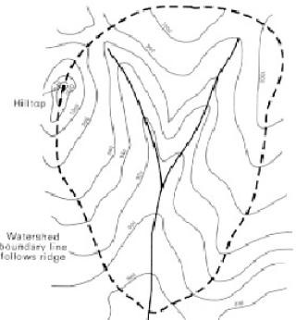

**Figure 4.26** An idealized watershed boundary traced from contour maps

## Relief Properties

All the above features have been considered to lie on a plane surface. The third dimension introduces the concept of relief.

### Average stream gradient

By measuring the vertical fall from the head of each stream segment to the point where it joins the higher order stream and dividing the total by the number of streams of that order, it is possible to obtain the average vertical fall. If this is plotted against the average stream length of that order, then the average gradient is obtained. The average gradients of streams of each order when linked together produce an average long profile of the basin. Generally, these long profiles illustrate that the lower order tributaries are steeper than those of the higher orders. This relationship is well established in geomorphology.

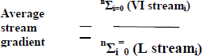

Where: **nΣi=0 (VI)**= is sum of elevation difference for each order of streams

**nΣi=0 (L)** is sum of stream lengths for each order of steams

### Watershed Slope

Flood magnitudes reflect the momentum of the runoff. Slope is an important factor in the momentum. Both watershed and channel slope may be of interest. Watershed slope reflects the rate of change of elevation with respect to distance along the principal flow path. Typically, the principal flow path is delineated, and the watershed slope (S) is computed as the difference in elevation (DE) between the end points of the principal flow path divided by the hydrologic length of the flow path (L): **S = DE/L**

The elevation difference DE may not necessarily be the maximum elevation difference within the watershed since the point of highest elevation may occur along a side boundary of the watershed rather than at the end of the principal flow path.

### Basin Relief

It is the difference in elevation between the highest head ward tributaries and the mouth of the main drainage stream. Basin height is simply the relief of the basin above a chosen level. In general, the larger the basin the more likely it is to have basin runoff lag. In general, the higher the relief, the shorter the time for precipitation/basin runoff lag; so overall basin parameters do give some indication of stream behavior and predictability of that behavior.

In other words, basin relief is the difference in elevation between the highest and lowest points in the basin. It controls the stream gradient and therefore influences flood patterns and amount of sediment that can be transported. Hadley and Schumann (1961) showed that sediment load increases exponentially with basin relief keeping other triggering factors affecting the amount of sediment loads. In addition, basin relief also influences the time lag between time of maximum precipitation and maximum discharge. Various researches have shown that the basin time-lag considerably diminishes with increasing basin relief keeping other surface soil and land use or land cover condition, and other hydrological and hydro-geological parameters.

### Basin Relief ratio

Basin relief ratio index is the basin relief divided by the basin length. It is useful when comparing basins of different sizes because it standardizes the change in elevation over distance.

### Main Channel slope

### It is an estimate of the typical rate of elevation change along the main channel that drains the basin. This measurement is often related to peak flow magnitude and flood volume. It is also the main factor determining the velocity of flow is channel slope. We derive the slope from a plot of bed longitudinal profile Estimate the main channel slope by measuring the length of the main channel from the mouth of the stream or the study site to the mapped source of the stream. At each stream channel bifurcation, follow the fork with either the higher stream order number as explained below or the longer pathway to a stream source. Mark off 10% and 85% of the main channel length on the map. Estimate the elevation in meters at 10% and 85% distance points, using contour lines on the topographic map. Compute the main channel slope as follows:

**Slope= (elevation at 85% length - elevation at 10% length)/ 0.75(main channel length)**

### Basin relief texture (Channel roughness): Manning’s ‘n’

Slope and cross-section are not the only two factors determining discharge. The roughness of the channel is also important, because it determines the frictional effect of the channel in slowing the flow. The rougher the channel, the greater will be the frictional effect. The roughness effect can be described by a number, known as ***Manning’s ‘n’*,** after the person who worked out how to quantify the effect. There is no simple way to determine this number. Mannings ‘n’ values are obtained by empirical methods. For a particular channel section, measurements of discharge cross sectional area and slope can be used to calculate an ‘n’ value. As with most channel parameters an average value is obtained from many sites with similar configurations.

It is also useful to obtain an estimate for that section in which flow velocity of the existing flow was measured and also for the entire reach up to the top of the banks. Manning’s ‘n’ may change with increasing flow.

***Manning’s ‘n’ and changing depth:*** Channel roughness in relation to flow generally decreases with increasing depth of flow. You can visualize low flows having to negotiate their way through and around the material of the bed, which protrudes into the majority of the depth of flow. Here Manning’s ‘n’ assumes a high value. In contrast visualize a flood flow where the majority of the water column is well above the material of the bed. Here Manning’s ‘n’ assumes a relatively low value.

***Generalizations with Respect to Morphometric Analyses:*** A number of authors have published findings on generalities with respect to morphometric analyses and stream systems and their underlying geology, such as:

* areas with trellis patterns tend to have very high bifurcation ratios and flashy discharge patterns;
* areas with dense dendritic, rectangular, radial, and parallel patterns tend to have low bifurcation ratios and non-flashy discharge patterns and are usually developed in unconsolidated or softer surficial materials;
* areas with low density dendritic patterns tend to have high bifurcation ratios and flashy discharge patterns -- usually in less erodable, consolidated bedrock; and
* areas with large basins in humid settings with sandstones, shales, and/or mixed sedimentary strata tend to have low stream densities and therefore tend to be flashy small carbonate basins in subarid settings have very low stream densities (probably is telling us much drainage is through karst) but normally not an intensely flashy discharge pattern because much of the drainage is by groundwater flow which results in lower surface runoff and lower discharger.

***Drainage texture***

It refers to the frequency or density of streams and tributaries in an area. A fine drainage texture indicates a high frequency; a coarse drainage texture refers to a low frequency. Drainage texture is closely related to the permeability of the underlying material. Materials with high permeability exhibit a coarse drainage texture, because most of the water drains down into the ground and the water flowing on the surface is limited, e.g. coarse-grained sandstones, sand and gravel, limestone. Fine-grained materials such as clay and shales have a low permeability and hence only a very limited amount of water seeps down and exhibit fine drainage texture as shown in figure 4.27.

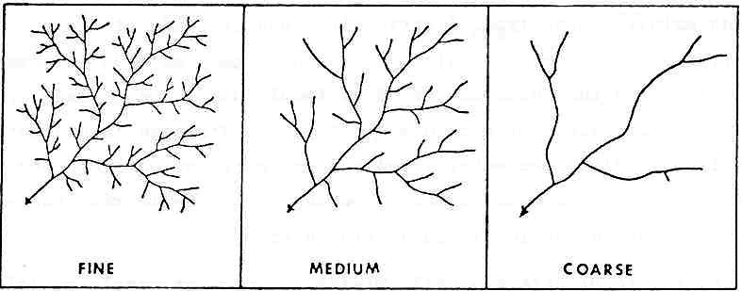

**Figure 4.27** Sketches of drainage density variations

## Stream channel analysis

## Stages in stream channel development

Because stream channels are the features that are measured in some fashion in order to conduct morphometric analyses, the nature or "steps" in the development of channels is important and in "explaining" what erosion features are considered "channels" and are measured. The main steps in developments of channels are:

* **Sheet overland flow:** it begins once soils and surface materials have become saturated with water
* **Tiny rivulets of water**- these are funneled together from sheets by irregularities on the land surface rivulets of water without any surface scour
* **Rills:** rills are small (roughly 1-2 inch wide and deep "cuts" into the surface created by several joined rivulets first "observable" cut/scour/erosional feature on the land surface
* **Gullys:** several inches up to several feet deep and wide cuts into the land surface created by the convergence of a number of rills may become permanent features but are often destroyed by tillage or obscured by vegetation growth.
* **Channels:** channels are permanent runoff features of the land surface in which streams flow continuously or after rainfall events. Channels whether perennial (permanent) or intermittent are the surface erosion features that are readily visible on most maps and aerial photographs; so it is the patterns of perennial or intermittent streams that are used for stream morphometric analysis as shown in figure 4.28.

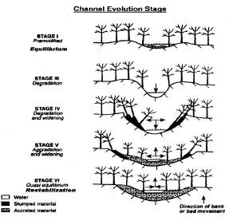

**Figure 4.28** Channel evolution stages following incision (from Sue Perkins, 2oo7)

## Geometric properties of stream channels

Drainage basins and channels are a dynamic part of any landscape, and have significant influences on ecosystems and hydrologic systems. The configuration of natural drainages and channels is the result of many years of variable precipitation and runoff, modified or influenced by other factors (changes in bedrock, geologic structure, faults, etc.).

For purposes of this book, “drainage channels” are generally defined as landscape features that are anticipated or observed to be created by overland flow of ephemeral, intermittent or perennial waters that have become concentrated into more or less discernible flow paths. Drainage channel or channel reaches may be in upland or lowland areas, may be vegetated or not, and may exhibit different degrees of stability.

On the other hand, channels are defined by the transport of water and sediment confined between identifiable banks. In spite of this basic similarity, there are many types of natural stream channels, reflecting spatial differences in channel processes, historical disturbance, lithologic and structural controls, and geologic history. Channel morphology reflects and integrates processes operating in a watershed because material eroded from hill-slopes ultimately is delivered to and routed through the channel network.

Consequently, channel condition provides a logical metric for diagnosing watershed conditions. Channel assessment would be impractical; however, were all channels unique in their potential response to disturbance or changes in watershed processes. Thus, a fundamental tenet of applying watershed analysis to stream channel assessment is that patterns in channel morphology and processes may be used to simplify the wide variety of natural channels into a manageable analysis framework.

Channel morphology and condition reflect the input of sediment, water, and wood to the channel, relative to the ability of the channel to either transport or store these inputs. Systematic and local differences in transport capacity and the nature and magnitude of inputs through a channel network result in a distribution of different channel types throughout a channel network, reflecting spatial differences in channel slope, flow depth, sediment supply, and the availability of large woody debris. Because of these differences, certain channels are more or less sensitive to similar changes in these input factors. Identification of differences in channel processes and sensitivity is a major goal of the channel assessment component of a watershed analysis.

### Stream channel longitudinal analysis

Gradient and valley confinement both progressively decline in the downstream direction. The headwater tributaries have narrow, steep valleys and cobble-dominated bed load sediment. These reaches transport sediment from upstream, and in some cases were a source of coarse sediment when entrenchment occurred. Surface sediment size downstream of the bend is predominantly very coarse to coarse gravel with small cobbles, but some large cobbles are transported all the way to the mouth of stream.

Longer sediment deposition zones occur in the broad meadows below the bend. The sediment source for these zones is primarily itself, since tributary channels along the meadow deliver little or no coarse sediment. There is less large woody debris influence because the meadows are sparsely forested. Channel gradient is flat enough that meander bends, pools, and bars form even where large wood is absent.

**Longitudinal Zones:** The overall longitudinal profile of most streams can be roughly divided into three zones. **Zone 1**, or **headwaters**, often has the steepest gradient. Sediment erodes from slopes of the watershed and moves downstream. **Zone 2**, the **transfer zone**, receives some of the eroded material. It is usually characterized by wide floodplains and meandering channel patterns. The gradient flattens in Zone 3, the primary **depositional zone** as shown in figure (4.29). Watershed form affects the form of the

stream corridor as seen in longitudinal profile. It is tied to many factors including climatic regime, underlying geology, fluvial geomorphology, soils, and vegetation.

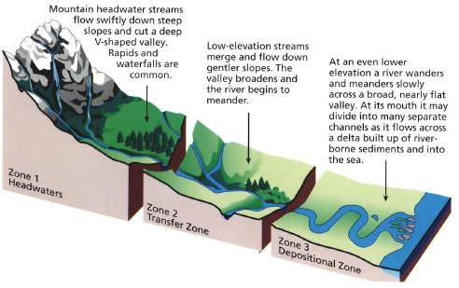

**Figure 4.29** A model showing stream channel longitudinal analysis

### Stream channel cross section analysis

Cross-sectional geometry of streams is defined by coordinates of lateral distance and ground elevation which locate individual ground points. The cross section is taken normal to the flow direction along a single straight line where possible but, in wide floodplains or bends, it may be necessary to use a section along intersecting straight lines; i.e., a .dog-leg section. It is especially important to plot the cross section to reveal any inconsistencies or errors.

Cross sections should be located to be representative of the sub reaches between them. Stream locations with major breaks in bed profile, abrupt changes in roughness or shape, control sections such as free over-falls, bends and contractions, or other abrupt changes in channel slope or conveyance will require cross sections taken at shorter intervals to better model the change in conveyance.

Cross sections should be subdivided with vertical boundaries where there are abrupt lateral changes in geometry and/or roughness as in the case of over bank flows. The subsection divisions must be chosen carefully so that the distribution of flow or conveyance is nearly uniform in each subsection

Streams are a changing part of an ecosystem. In order to look at stream channel change over time, a number of cross sections of the stream will be analyzed. A stream channel cross section is a series of data pairs (distance and elevation) along a straight line that is roughly perpendicular to stream flow.

Terms commonly applied in cross-sectional analysis of stream channels are:

* **Thalweg:** Longitudinal outline/trace/survey of a deepest part of riverbed from source to mouth (upstream/downstream). It is line of steepest descent along the stream.
* **Bank-full Depth:** refers to channel width at bank-full discharge. This stage is delineated by the elevation point of incipient flooding, indicated by deposits of sand or silt at the active scour mark, break in stream bank slope, perennial vegetation limit, rock discoloration, and root hair exposure Bank-full Width (Wbkf): The average depth measured at bank-full discharge.
* **Wetted Perimeter:** refers to the area in which water touches the channel walls. It has the following characterized by channel shape and size controls the wetted perimeter; most efficient streams have small wetted perimeters; and roughness of the channel controls the frictional resistance to water movement, where, a smooth channel decreases frictional force while a rough channel increases frictional force.

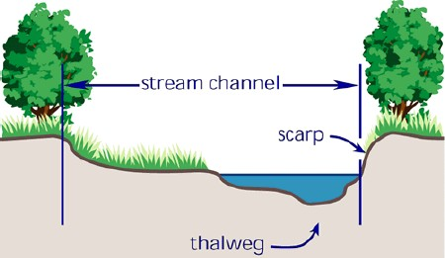

1. Thalweg

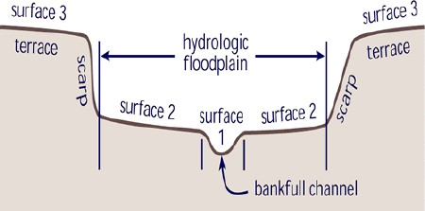

1. Channel cross-section view

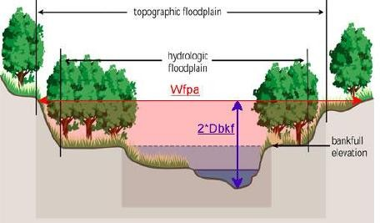

1. Bankful depth

**Figure 4.30** Cross-sectional views of stream channels (a to c).