Course outline : Turbo-Machinery (MEng3201)
Department of Mechanical Engineering/Institute of Technology
Debre Markos University
Course Title | Turbo-Machinery
Course Code | MEng3201
Degree Program | BSc in Mechanical Engineering
Module Name | Energy Conversion Machines
Course Instructor | HARISH H V
ECTS Credits | 5
Contact Hours (per week) | 5
Lecture/Contact | (32 lecture +48 tutorial)
Year/Semester | 5th
Prerequisite | Fluid Mechanics, Thermodynamics II
Status of the course | Compulsory
Course outline | 1. Introduction  1.1. Introduction  1.2. Classification of Turbomachinery  1.3. Application  1.4. Thermodynamics  1.4.1. Basic thermodynamics  1.4.2. Adiabatic flow through nozzles  1.4.3. Adiabatic flow through diffusers  1.5. Compressible flow  1.6. Basic relations  2. Centrifugal pumps and fans  2.1. Introduction  2.2. Impeller flow  2.3. Efficiency  2.4. Performance characteristics  2.5. Design of pumps  2.6. Fans  3. Centrifugal compressors  3.1. Introduction  3.2. Impeller design  3.3. Diffuser design  3.4. Performance
4. Axial-flow pumps and fans
4.1. Introduction
4.2. Stage pressure rise
4.3. Losses
4.4. Pump design
4.5. Fan design

5 Pump selection guidelines,
Cavitation and water hammer problems in pump system

6 Axial-flow compressor
6.1. Introduction
6.2. Basic theory
6.3. Cascade tests
6.4. Performance

7 Gas turbines
7.1. Introduction
7.2. Basic theory
7.3. Design
7.4. Radial-flow turbines

8 Steam turbines
8.1. Introduction
8.2. Impulse turbines
8.3. Reaction turbines

9. Hydraulic turbines
9.1. Introduction
9.2. Pelton wheel
9.3. Francis turbine
9.4. Kaplan turbine
9.5. Cavitation

Teaching & Learning Methods | Lectures (32hrs)  • Tutorials on lectures (48hrs)  • Home study including Project, Field Visit, Personal study and assignments (55 hrs)
Evaluation systems | Assignments: 10%  Quiz exam: 10%  Mid exam: 30% (continuous assessment)  Final Exam: 50%
Course Policy | Minimum attendance required to be permitted to examination:80%  100% attendance during laboratory sessions
References | 1. Earl Logan, ―Turbomachinery, basic theory and application‖, Marcel dekker, New york and basel  2. F. M. White, "Fluid Mechanics", 3rd, 4th or 5th Ed., McGraw-Hill 1994  3. Cohen & Rogers, ―Gas turbine theory and practice‖  4. W. J. Keartin, ―Steam Turbine theory and practice‖  5. Karassik, Pump Handbook, McGraw-Hill, 1985  6. S. L. Dixon, Fluid Mechanics Thermodynamics of Turbo-machinery, Pergamon Press, 1994.  7. R. K. Turton, Principles of Turbomachinery, Chapman and Hall, 1995.  8. R. I. Lewis, Turbomachinery Performance Analysis, Arnold, 1996.  9. Fluid mechanics and Thermodynamics of Turbo Machinery – S.L.Dixon, Butterworth Heinemann, Feb 23, 2005  10. Rama S.R. Gorla and Aijaz A. Khan, Turbomachinery: Design and Theory (Mechanical Engineering (Marcell Dekker)), Aug 12, 2003.  11. Logan, Handbook of Turbo machinery, 2nd 2003

Instructor Name
Mr. HARISH H V
Signature: ____________
Date: ____________

CHAPTER 1
INTRODUCTION AND CLASSIFICATION OF TURBOMACHINES
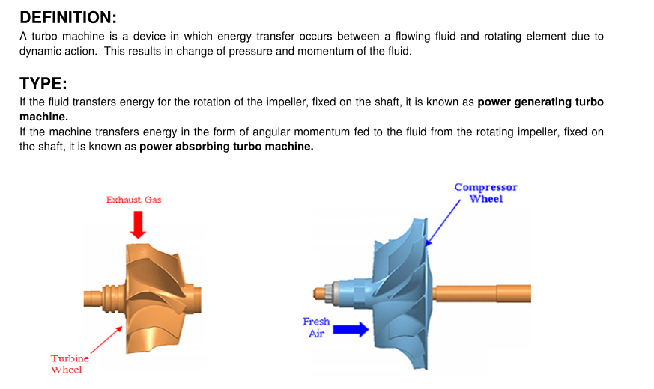

TURBOMACHINE
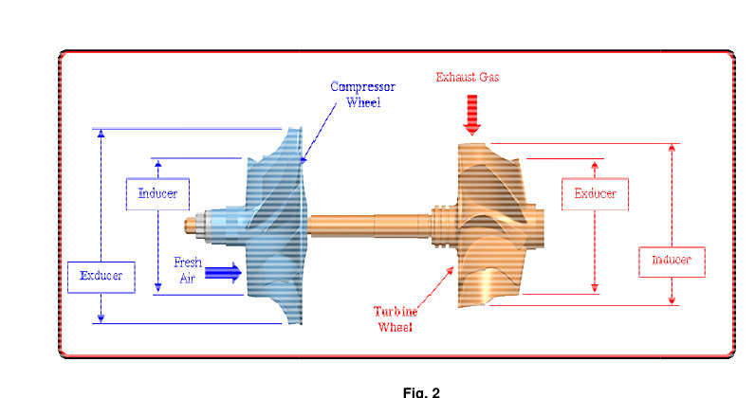

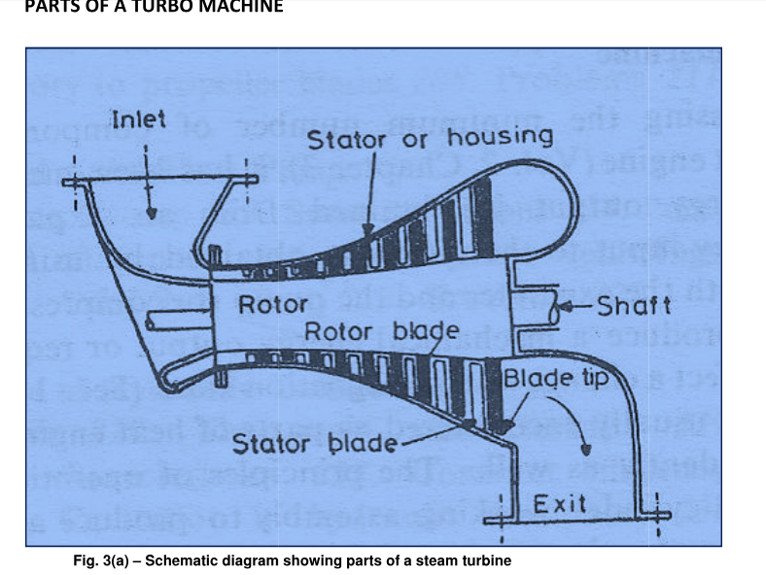
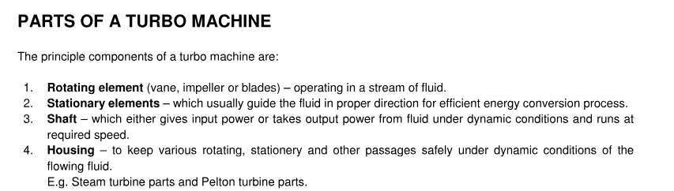

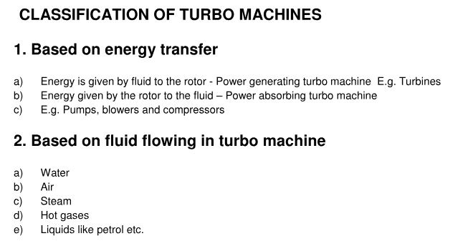
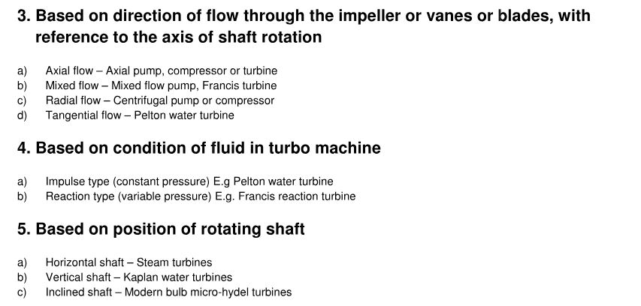

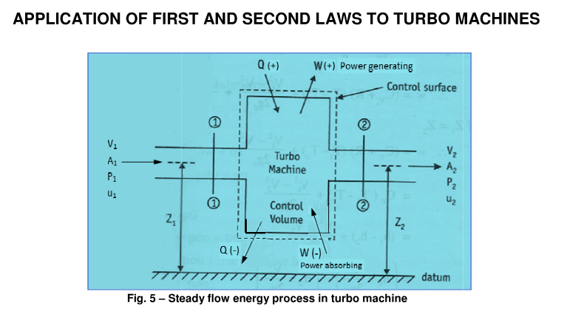
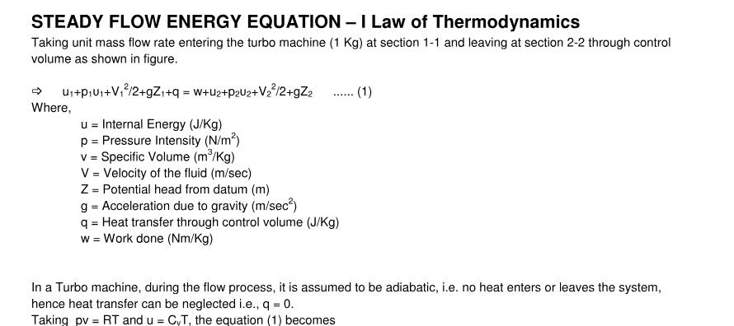
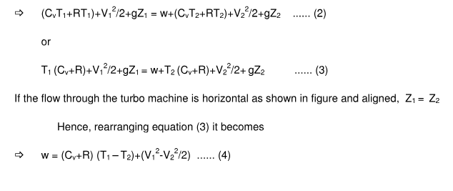
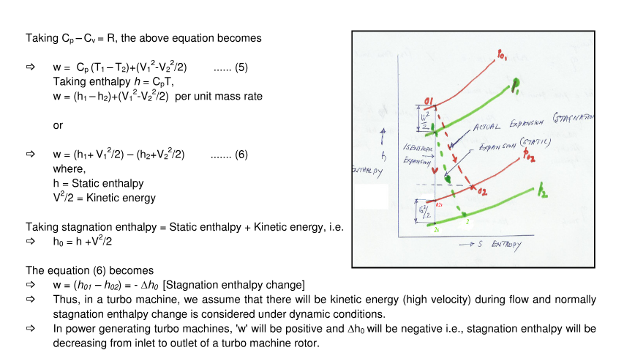
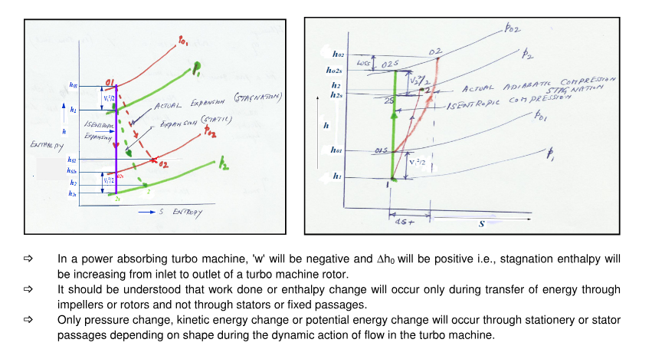

ADIABATIC FLOW THROUGH NOZZLE
Let m₁ is the mass entering the steady flow device at velocity V₁ and pressure p₁ and m₂ is the mass leaving the steady flow device at outlet with a velocity of V₂ and pressure p₂.
According to steady flow energy equation
h₁+V₁²/2 +z₁g +q = h₂ +V₂²/2 +z₂g +w--------equ (2.1)
where suffix 1 indicates inlet and 2 indicates outlet. Since nozzle is an adiabatic device and it is an energy transformation device.
Q=0,w=0,neglecting potential energy
Equation (2.1) becomes
h₁+V₁²/2 = h₂ +V₂²/2
Since inlet entry condition of nozzle is stagnated; that is flow is adiabatically brought to zero V₁=0
h₁ = h₂ +V₂²/2
V₂ = $\sqrt{2\left(h1-h2\right)}$
For gases V₂ = $\sqrt{2\left(T1-T2\right)}$

COMPRESSIBLE FLOW AND BASIC RELATION
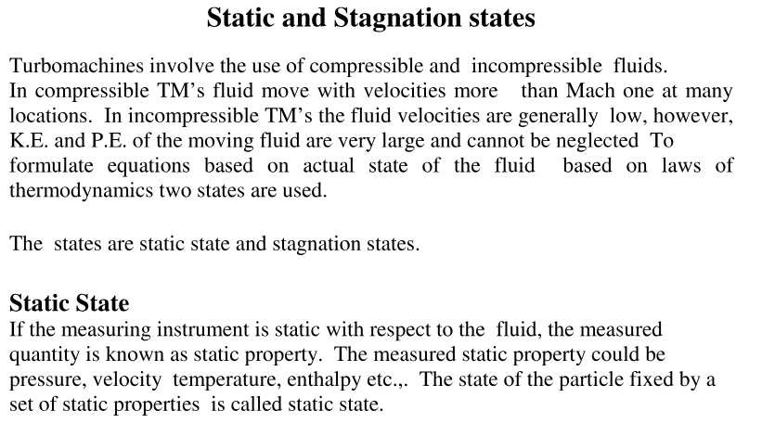
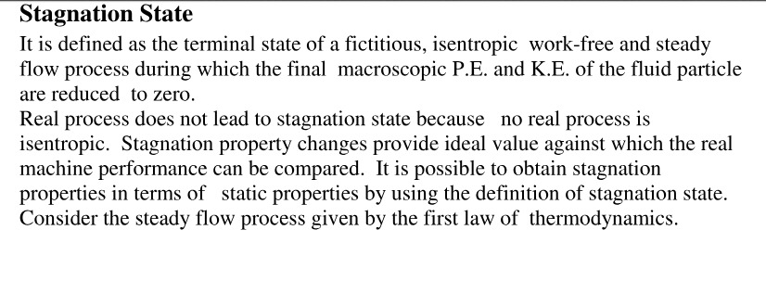
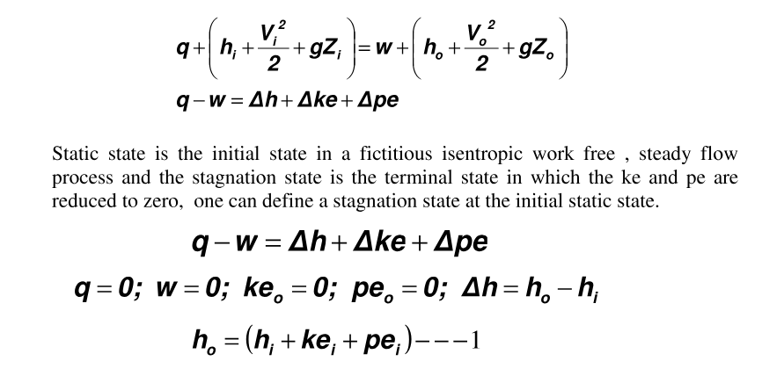
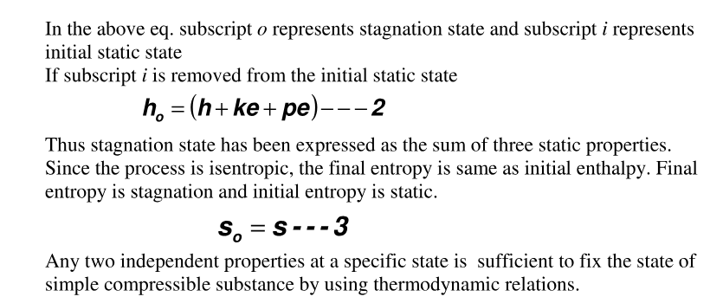

CHAPTER 2
CENTRIFUGAL PUMPS AND FANS

Classification and parts of centrifugal pump:

Rotodynamic Pumps

A roto dynamic pump is a device where mechanical energy is transferred from the rotor to the fluid by the principle of fluid motion through it. The energy of the fluid can be sensed from the pressure and velocity of the fluid at the delivery end of the pump. Therefore,it is essentially a turbine in reverse. Like turbines, pumps are classified according to the main direction of fluid path through them like (i) radial flow or centrifugal, (ii) axial flow and (iii)mixed flow types.

Centrifugal Pumps

The pumps employing centrifugal effects for increasing fluid pressure have been in use for
more than a century. The centrifugal pump, by its principle, is converse of the Francis
turbine. The flow is radically outward, and the hence the fluid gains in centrifugal head while
flowing through it. Because of certain inherent advantages, such as compactness, smooth and
uniform flow, low initial cost and high efficiency even at low heads, centrifugal pumps are
used in almost all pumping systems. However, before considering the operation of a pump in
detail, a general pumping system is discussed as follows.

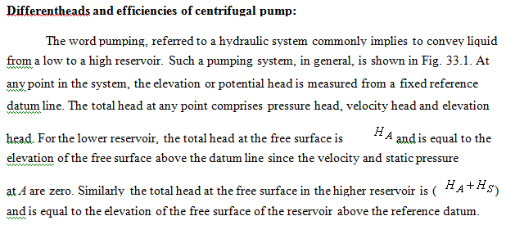
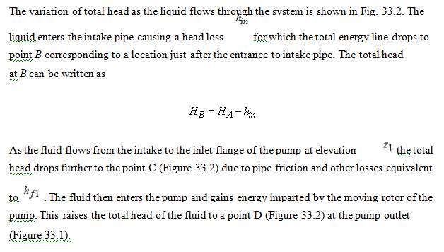
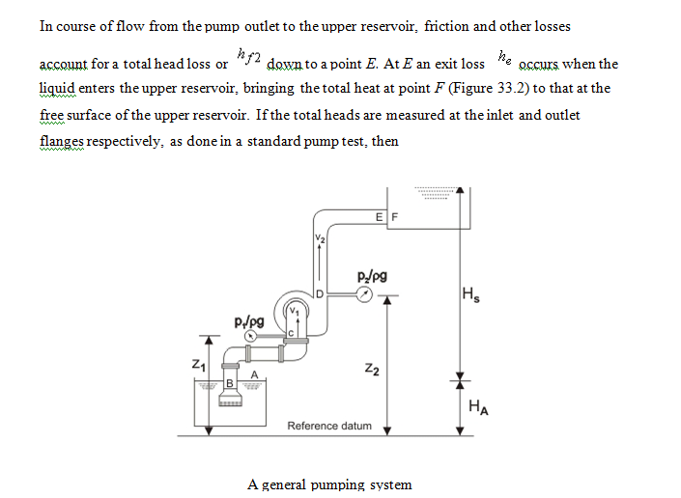
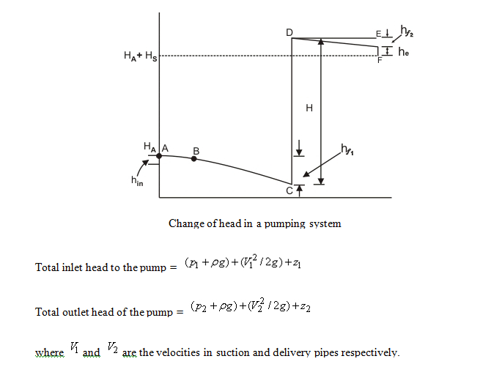
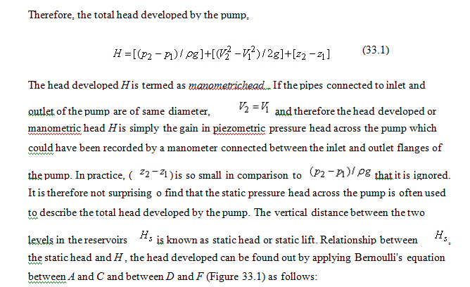
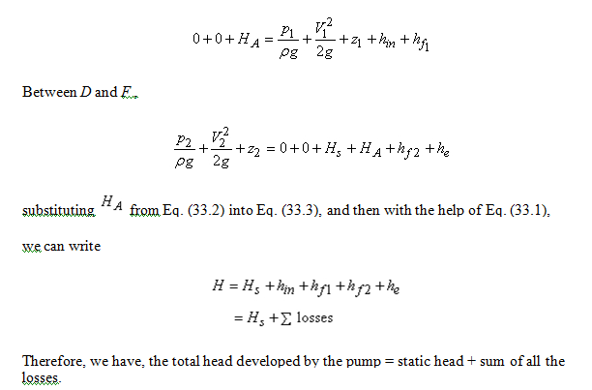

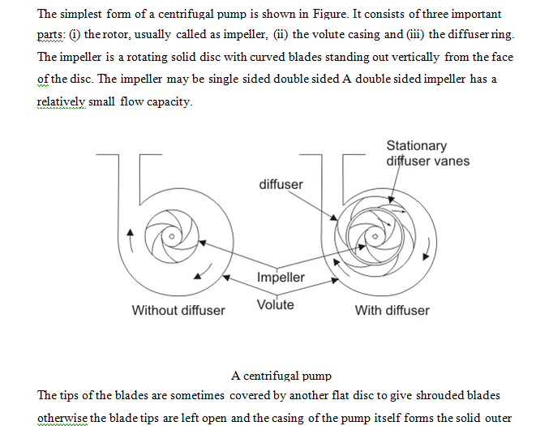
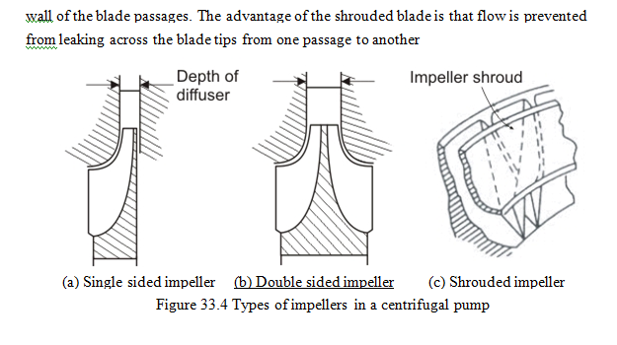

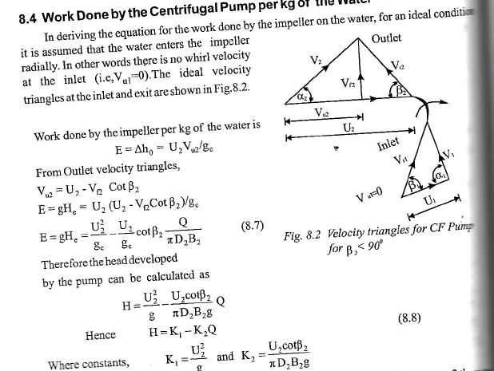

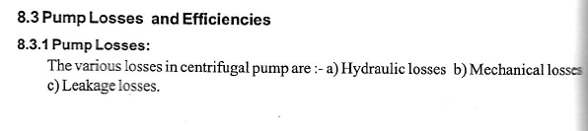
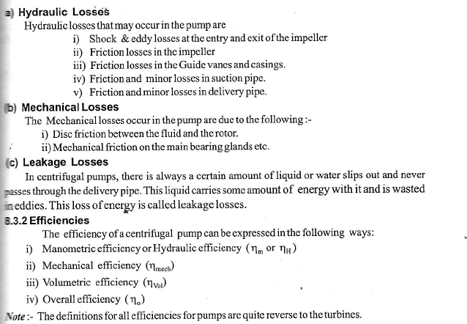

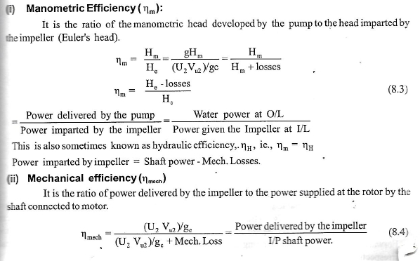

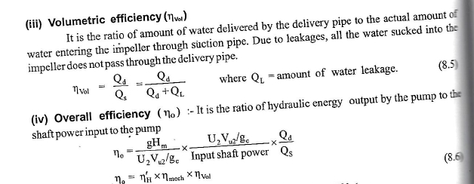

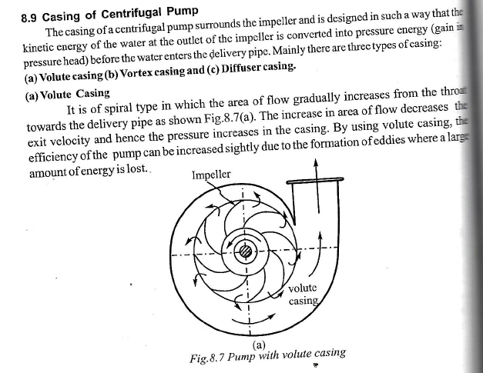
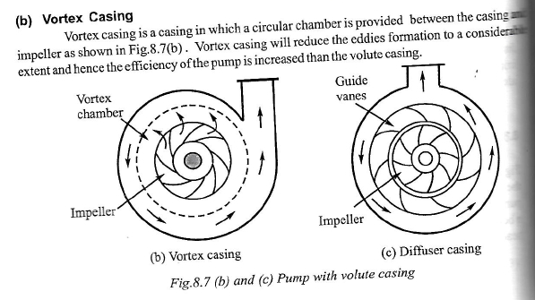
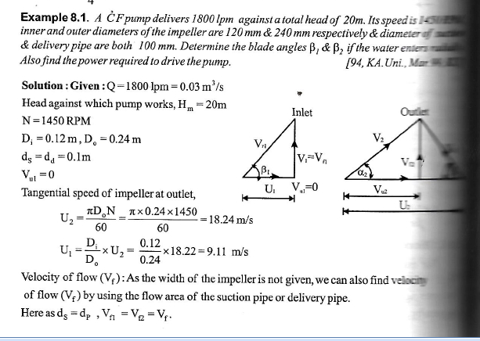
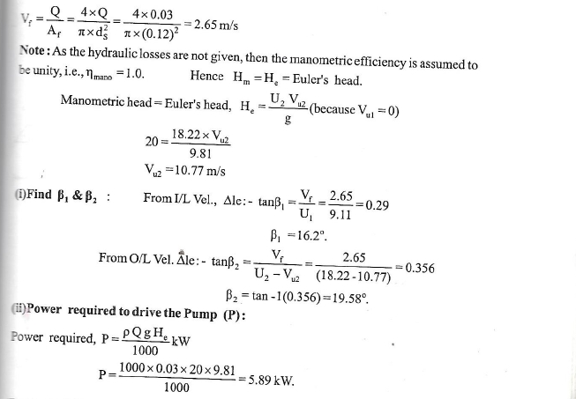
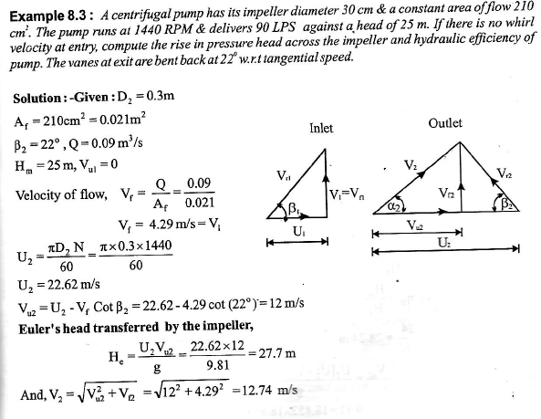
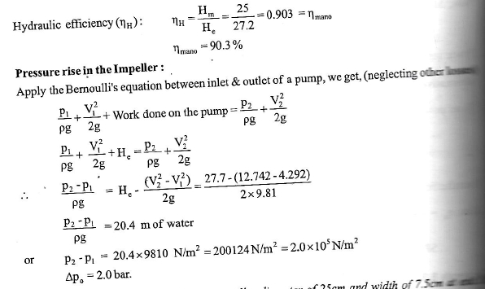

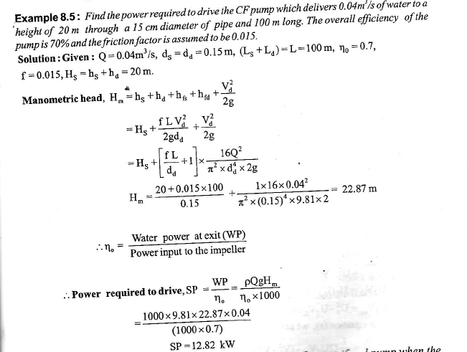

CHAPTER3
CENTRIFUGAL COMPRESSOR

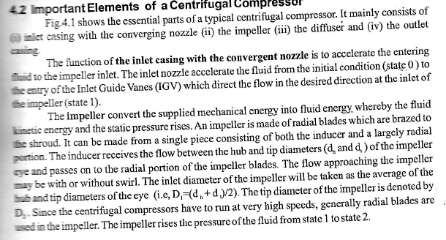

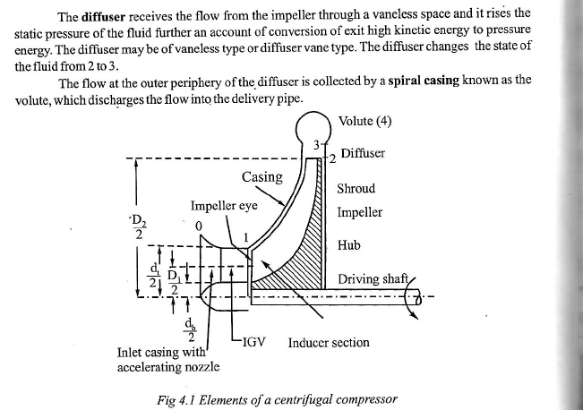

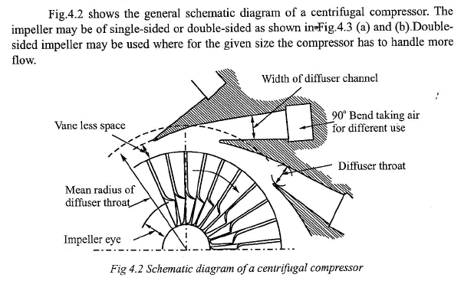

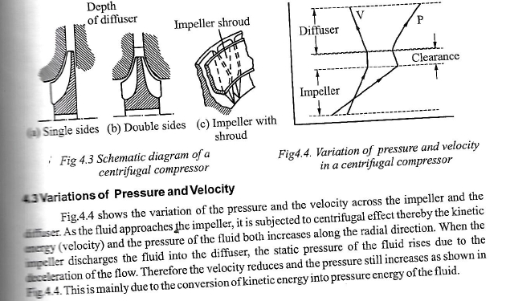

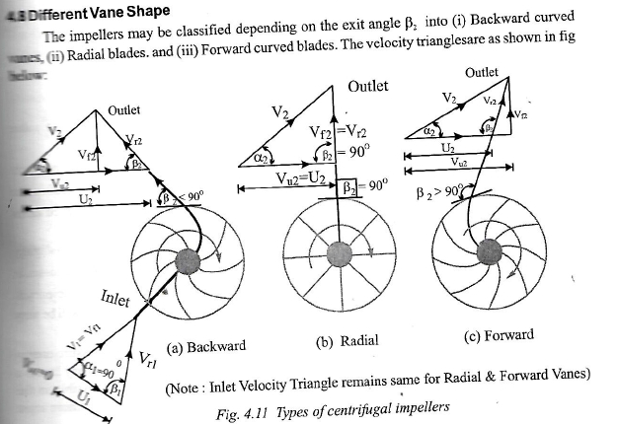

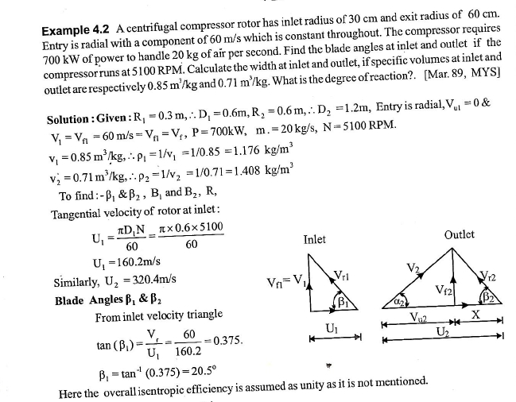

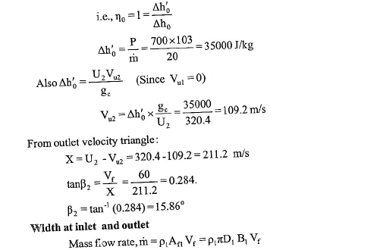
CHAPTER4
AXIAL FLOW PUMP

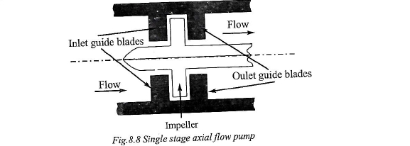
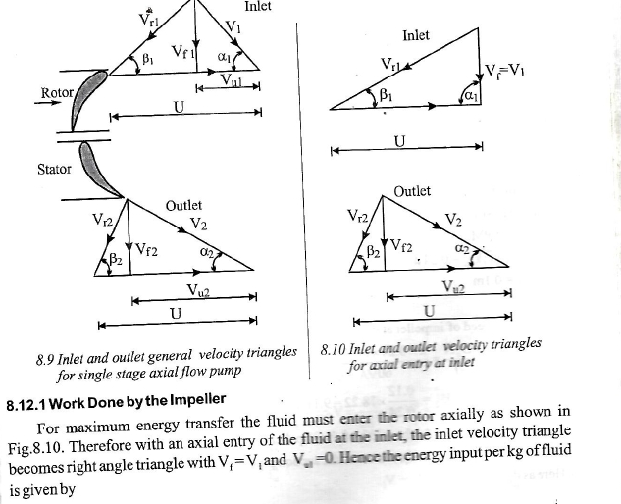

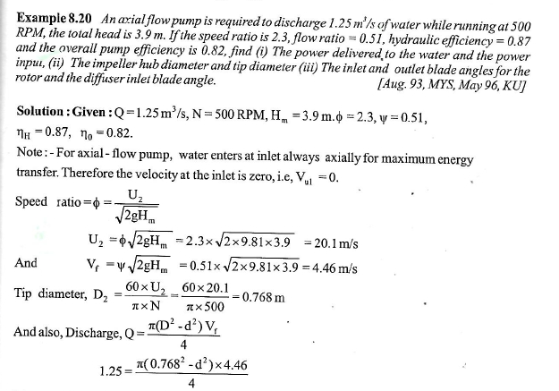
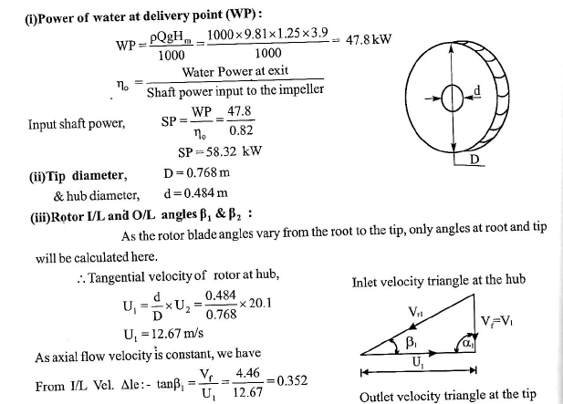

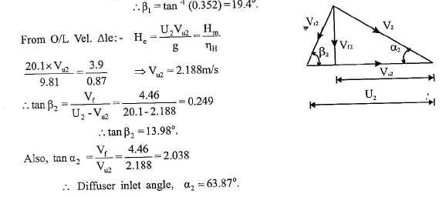

CHAPTER 5
Pump selection guidelines, cavitation, priming

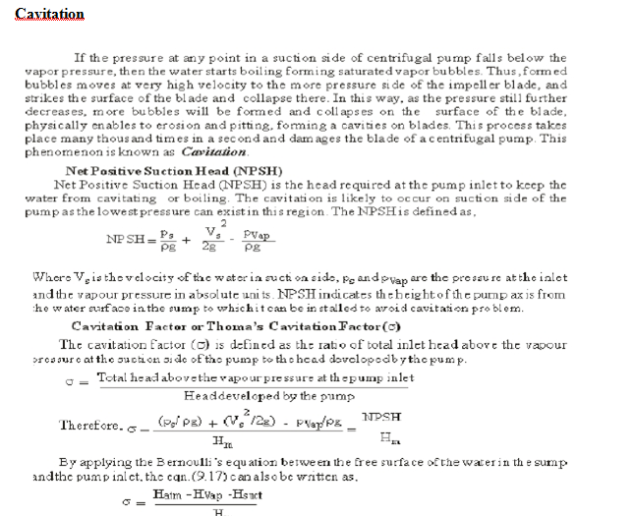
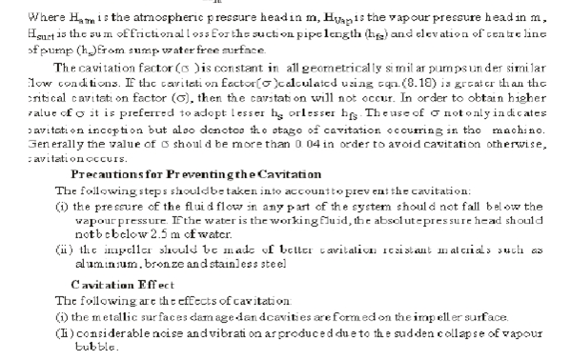
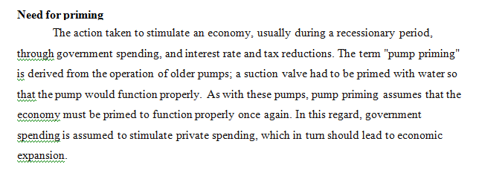

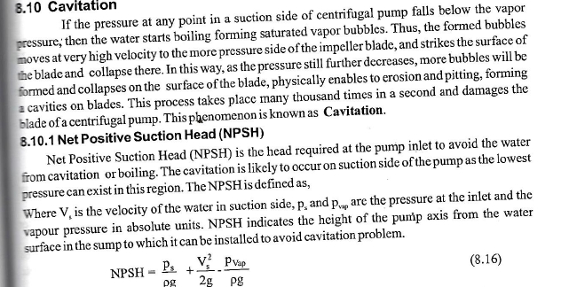
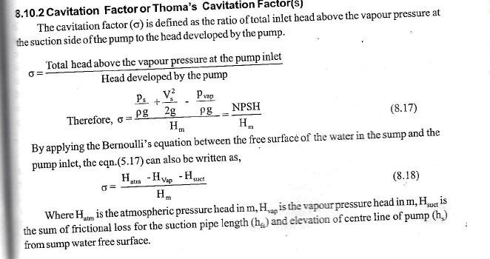
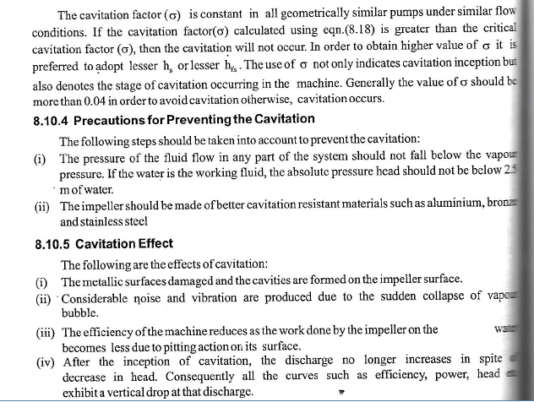

CHAPTER6
AXIAL FLOW COMPRESSOR
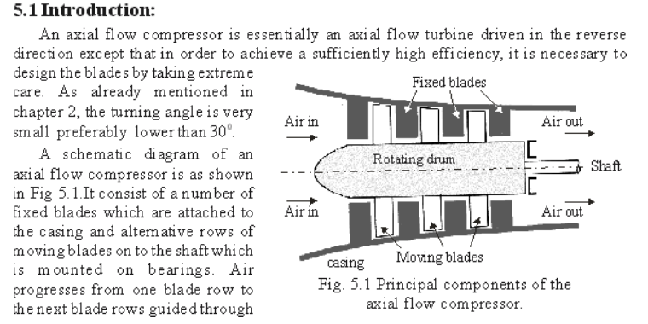
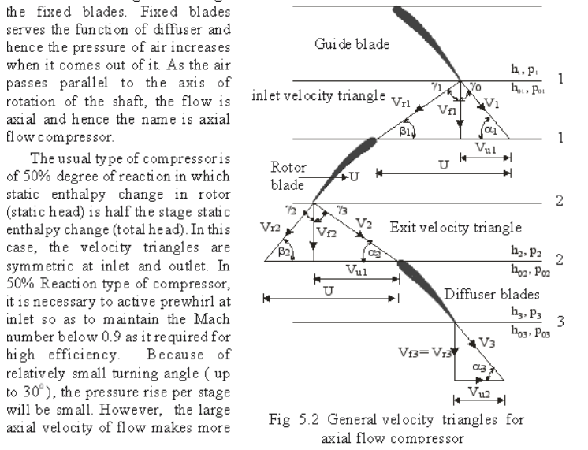
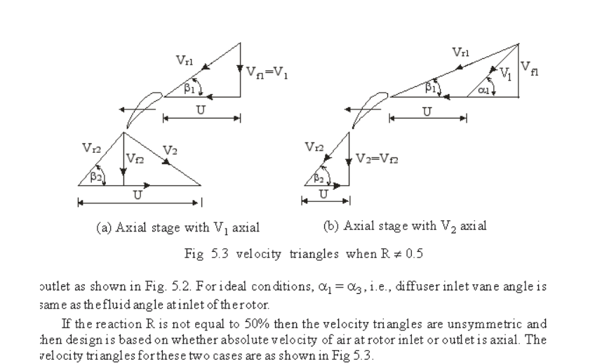
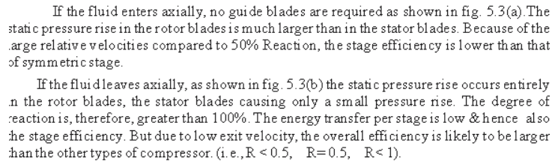
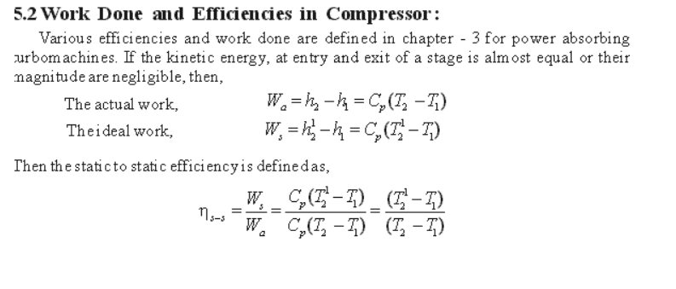
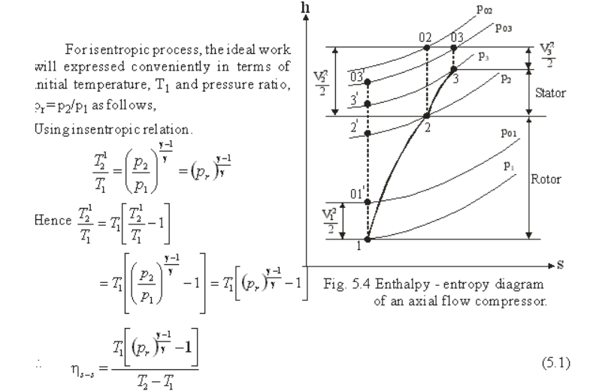
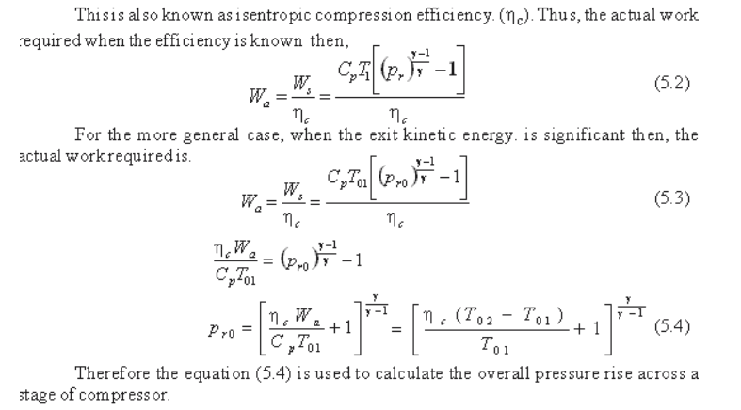

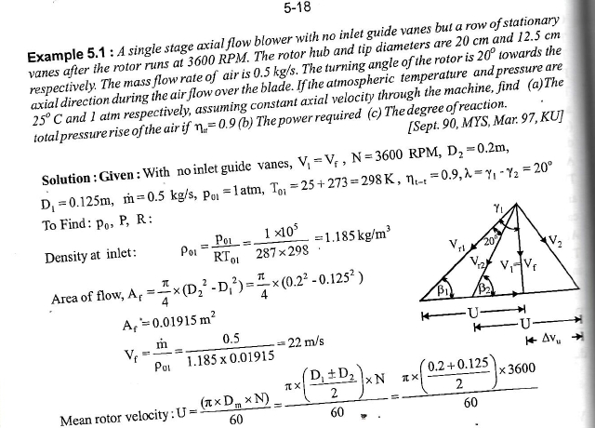

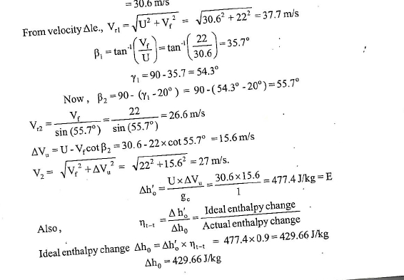
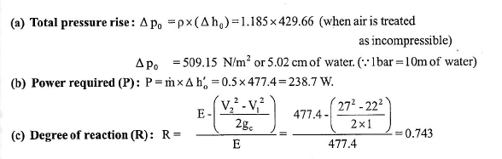

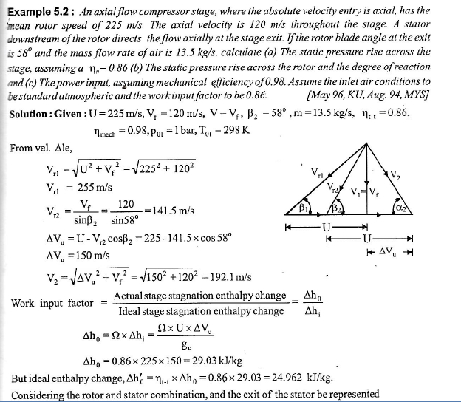
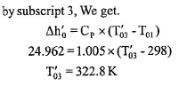
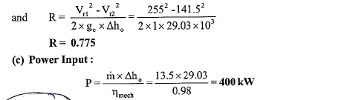

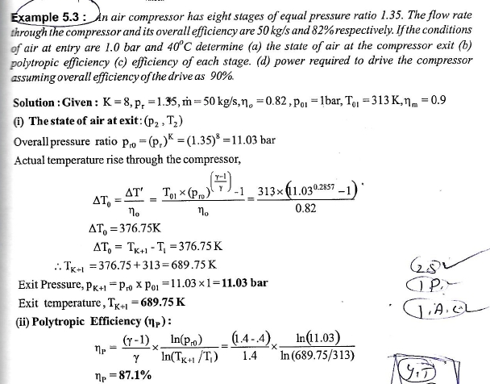
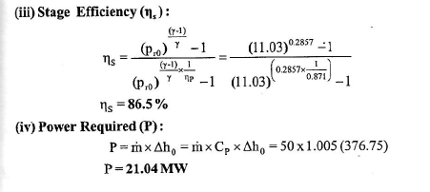

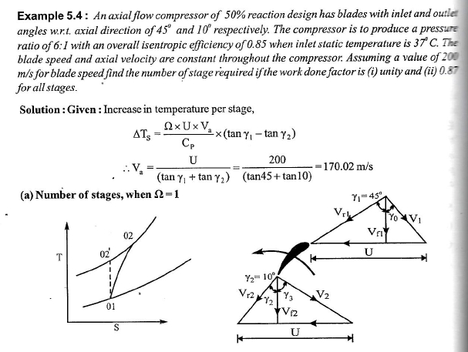

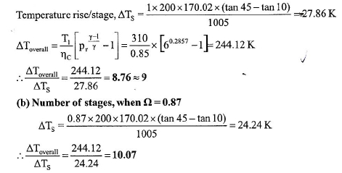

CHAPTER7
GAS TURBINE

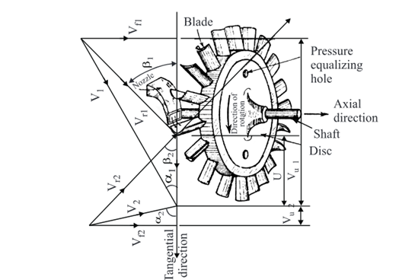
VELOCITY TRIANGLE OF GAS TURBINE

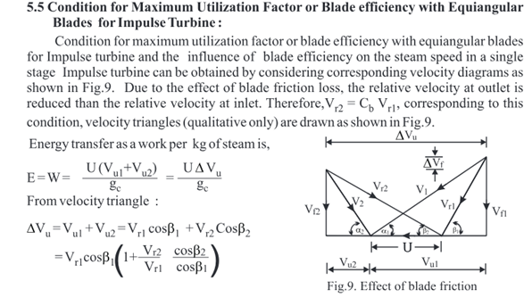
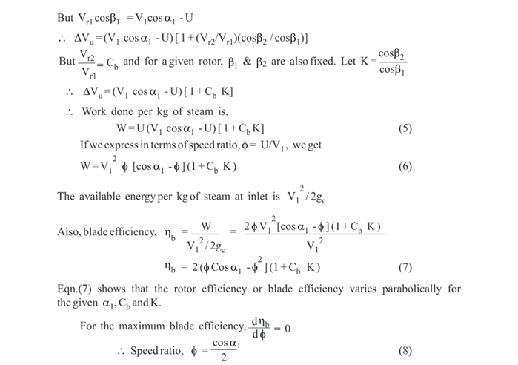

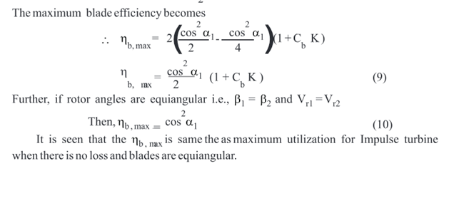

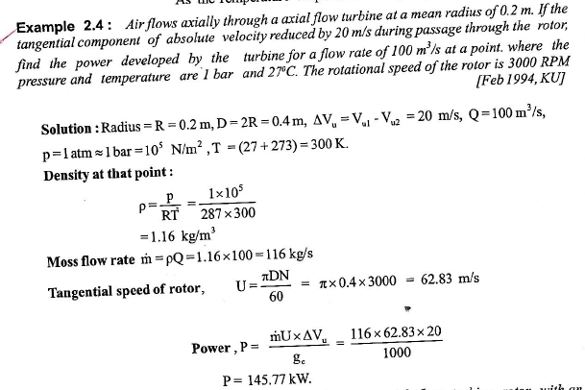

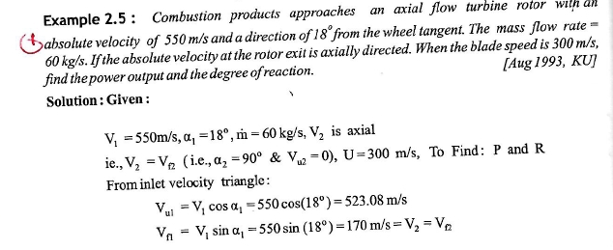

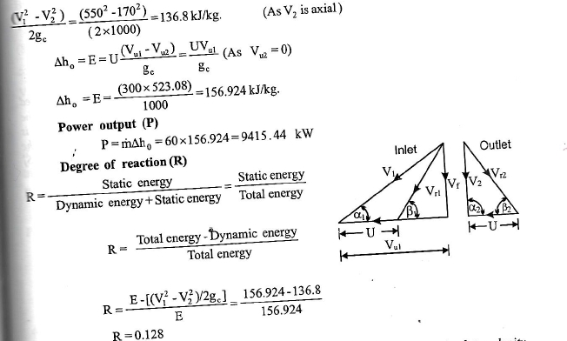

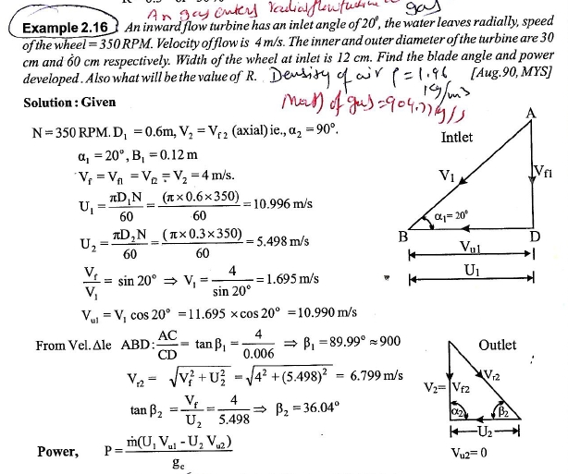
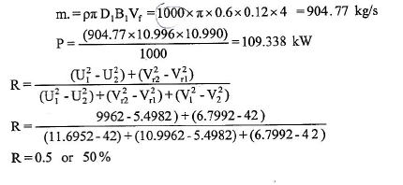

CHAPTER8
STEAM TURBINE
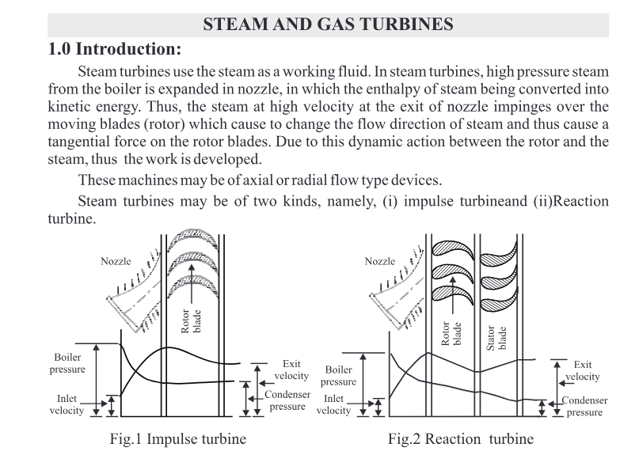
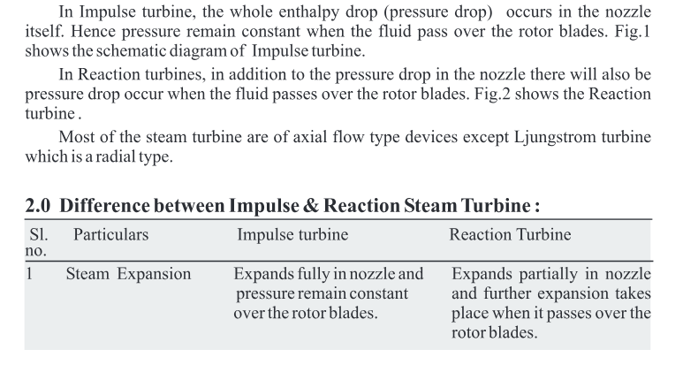

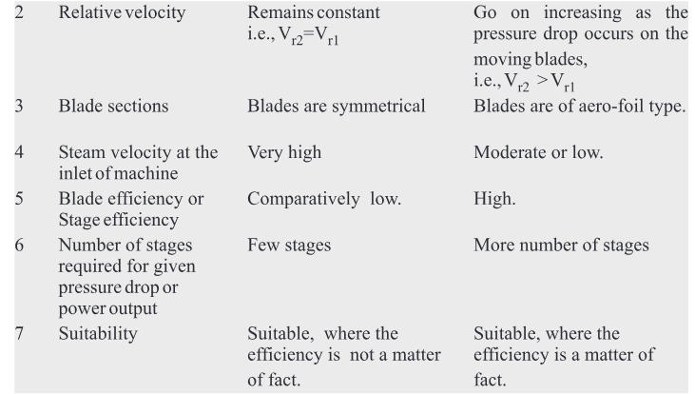
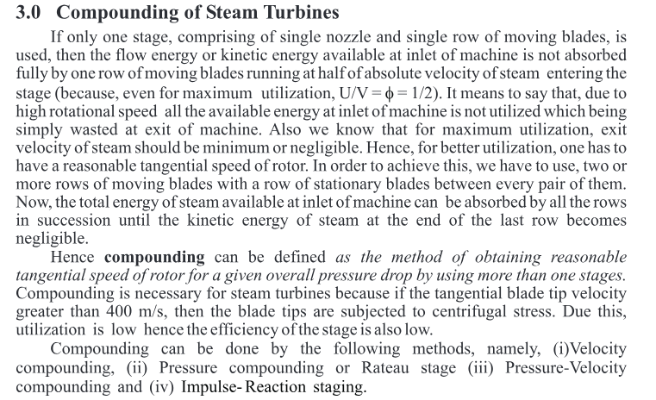
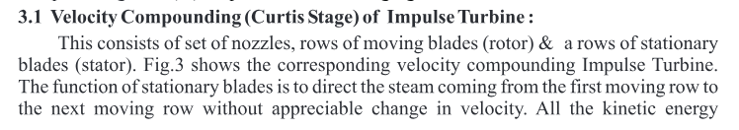
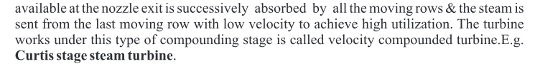

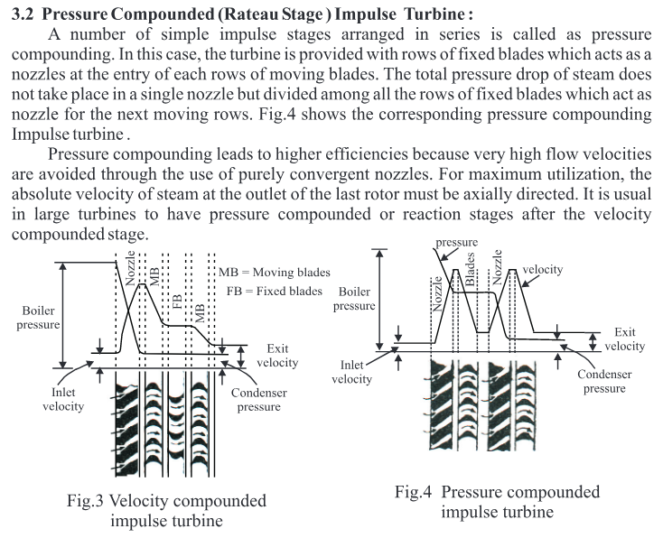
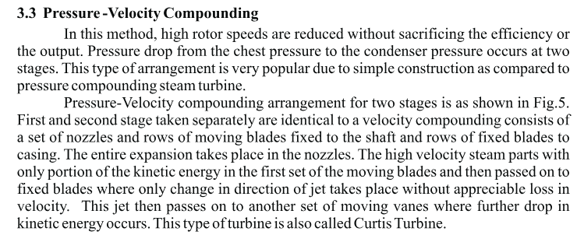
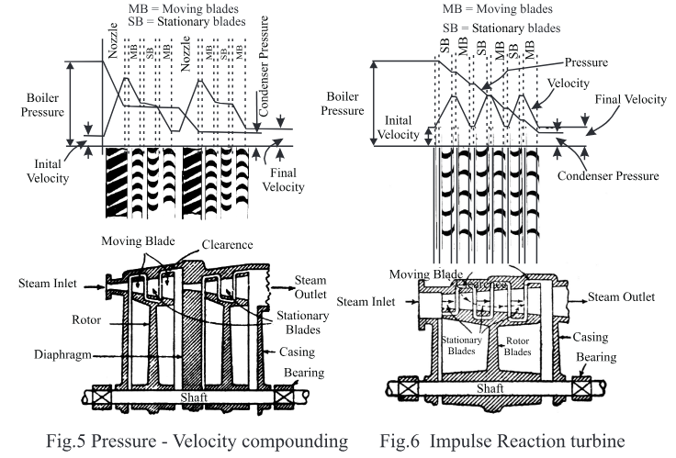
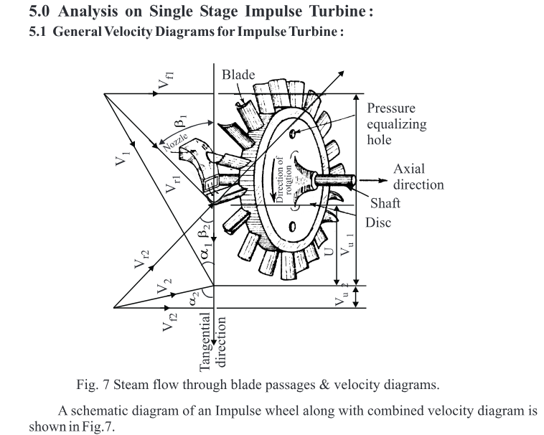
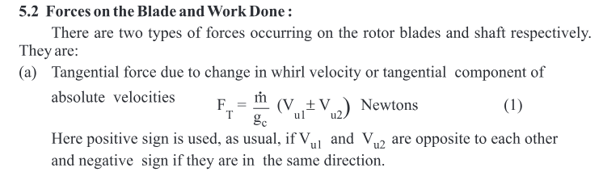
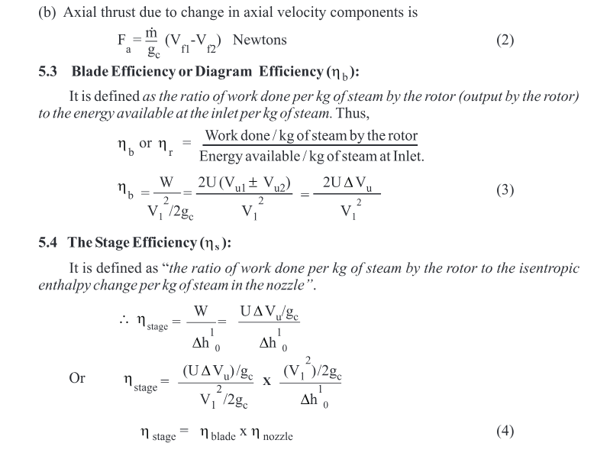
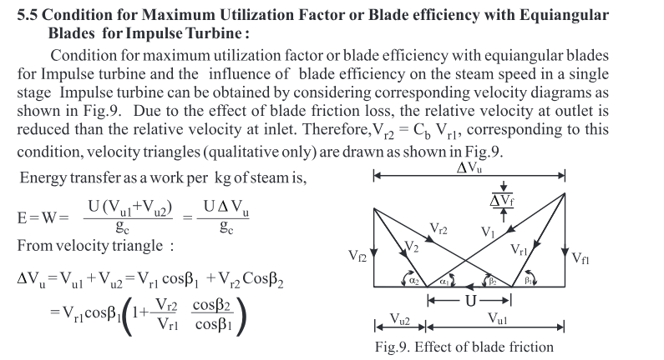
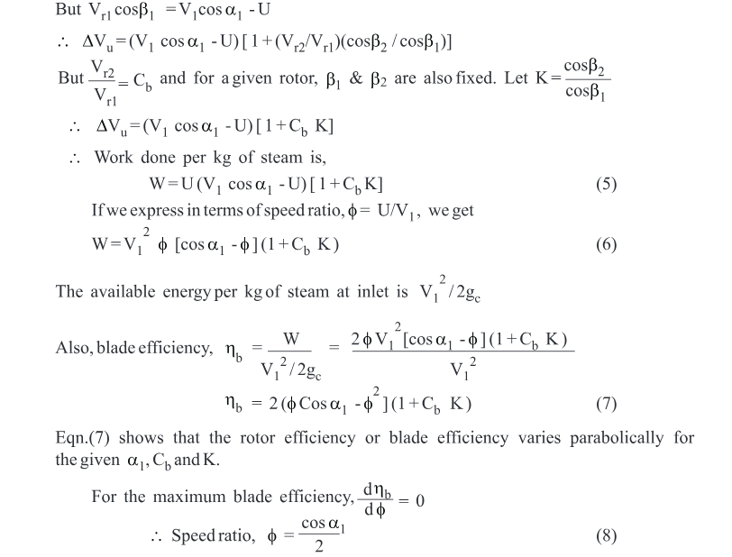
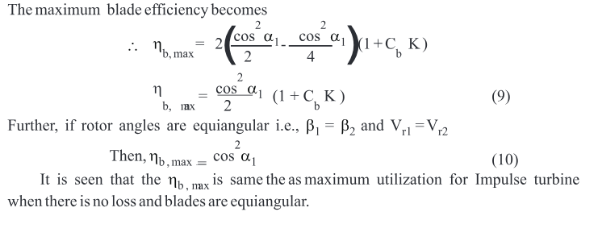
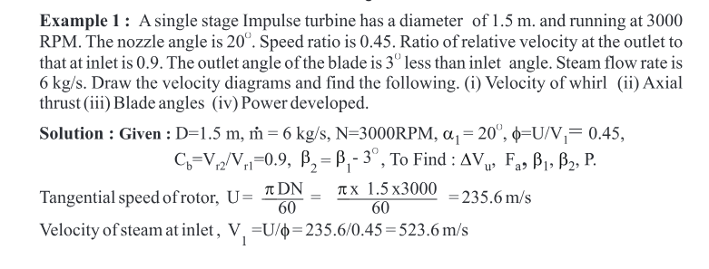
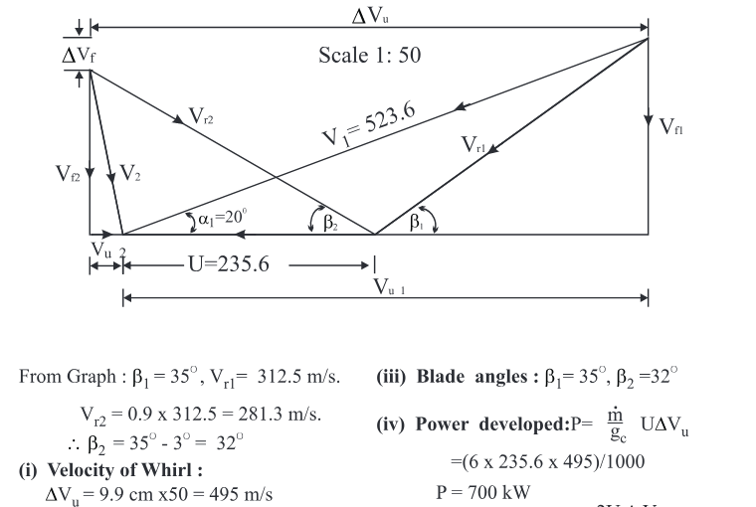
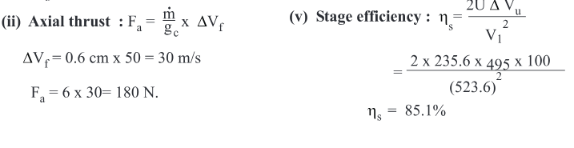

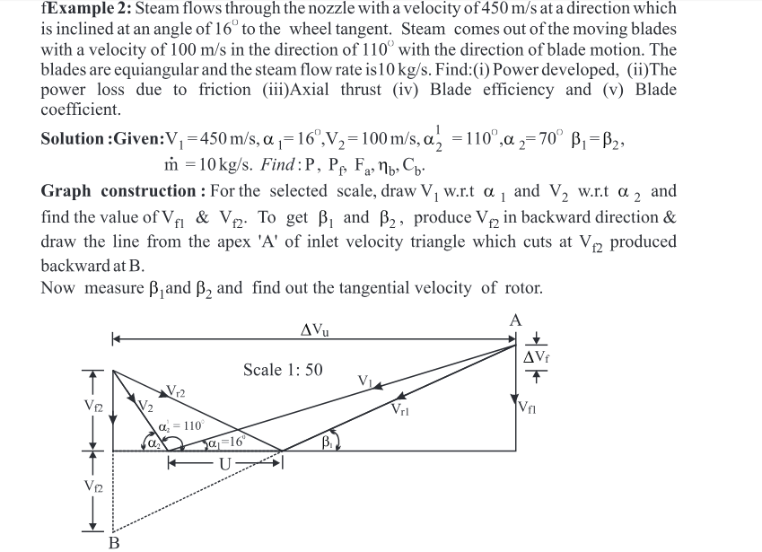
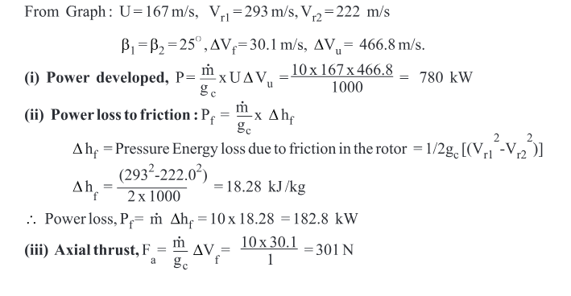
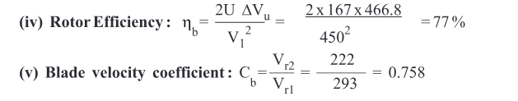
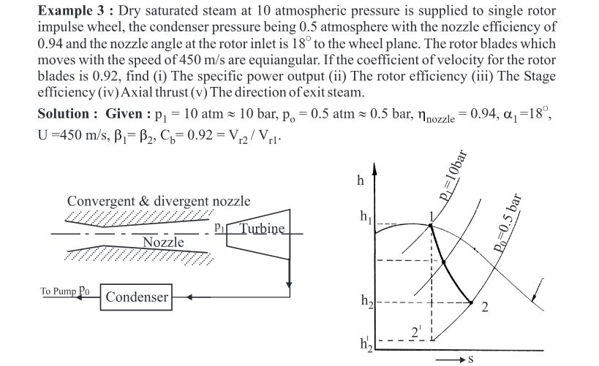
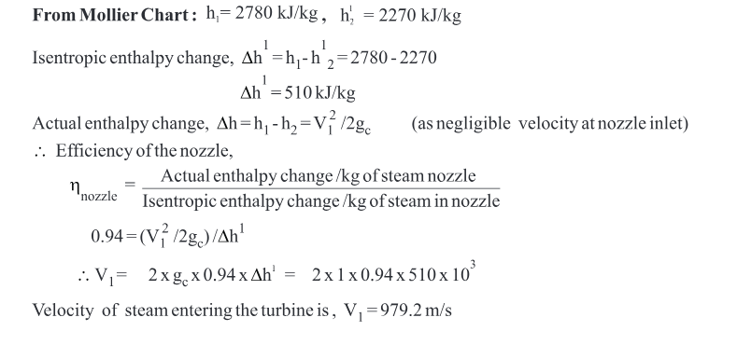
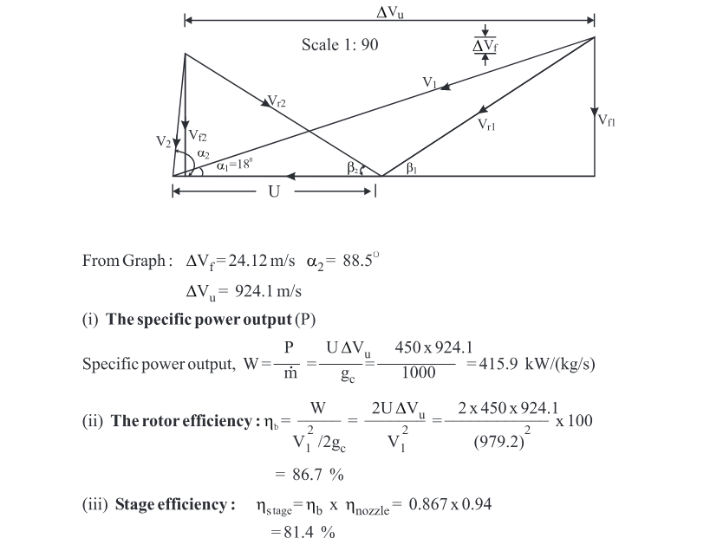
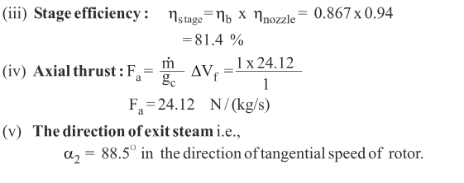
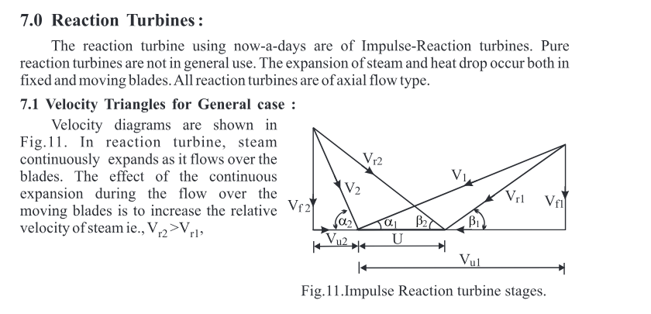
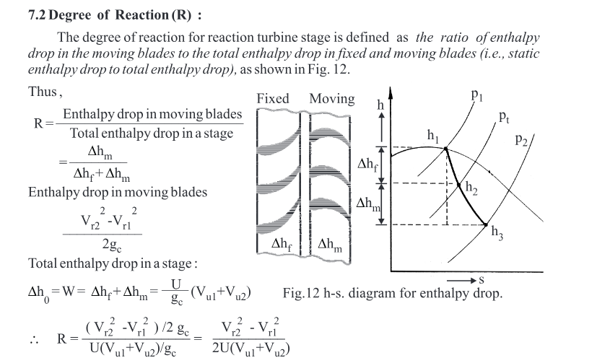
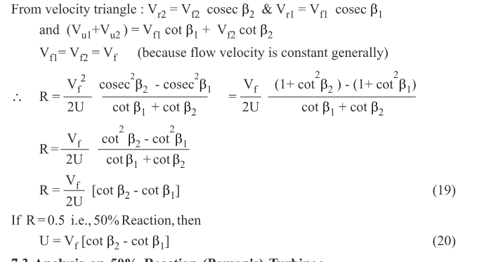
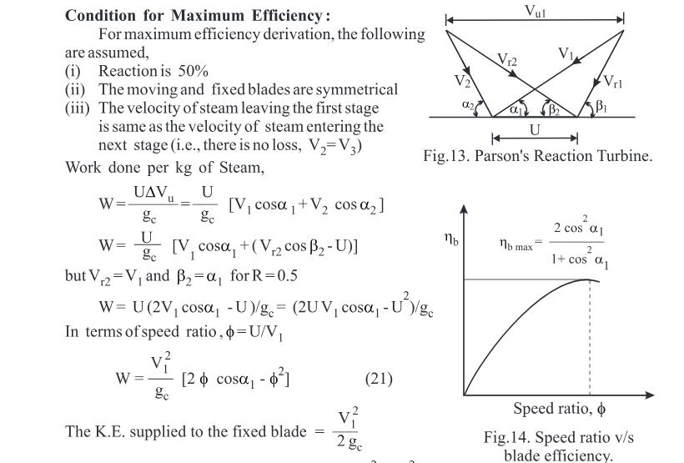
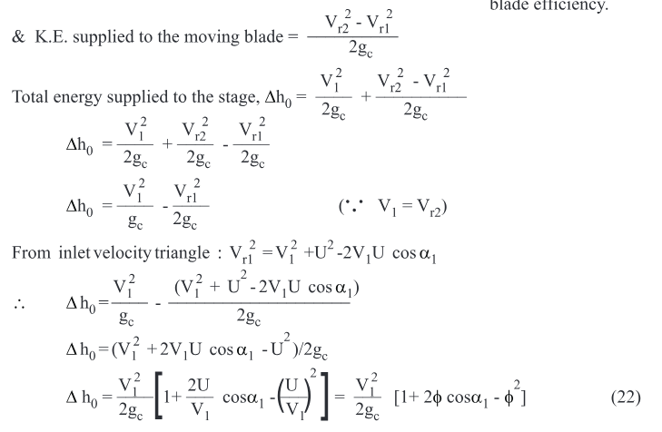
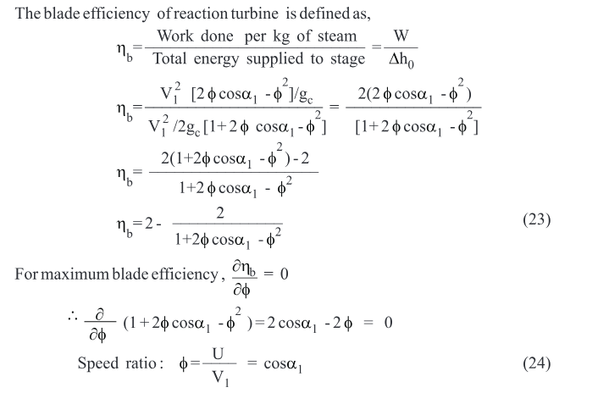
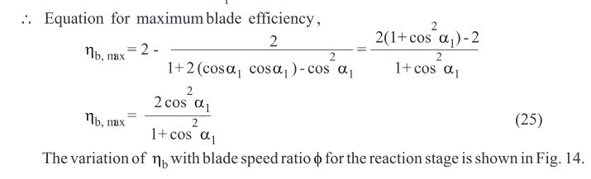
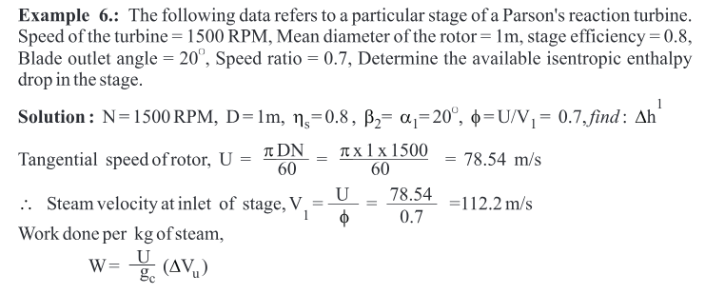
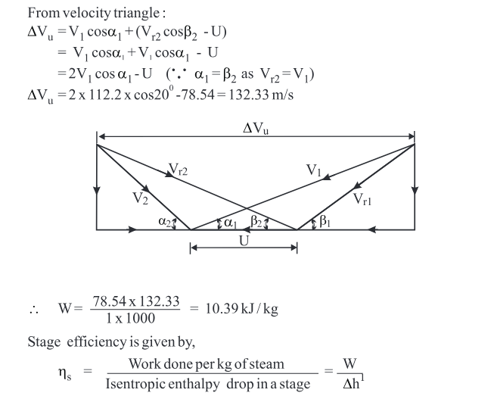
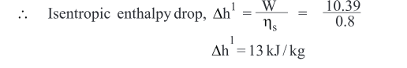
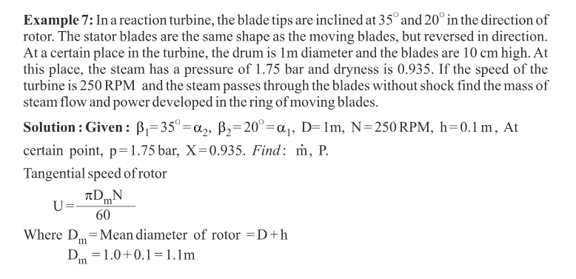
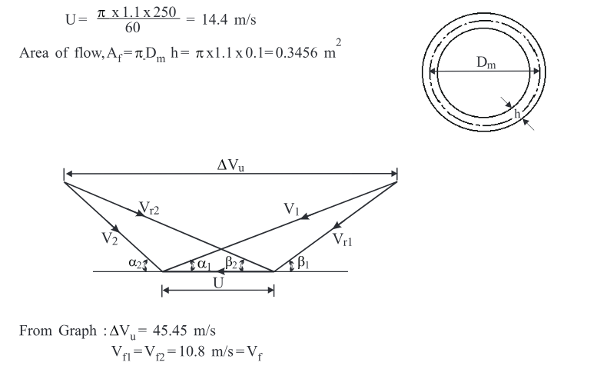
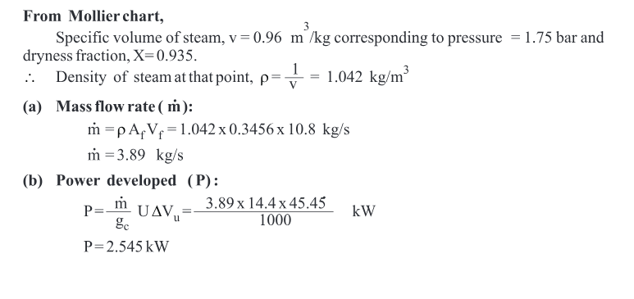

CHAPTER9
HYDRAULIC TURBINE
