**CHAPTER – 2 – STRESS CALCULATION**

**2.1 Completely Reversed or Cyclic Stresses**

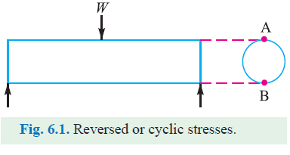

Consider a rotating beam of circular cross-sectionand carrying a load *W*, as shown in Fig. 6.1. This loadinduces stresses in the beam which are cyclic in nature. *A*little consideration will show that the upper fibers of the beam (*i.e*. at point *A*) are under compressive stress and the lower fibers (*i.e*. at point *B*) are under tensile stress. After half a revolution, the point *B* occupies the position ofpoint *A* and the point *A* occupies the position of point *B*.Thus the point *B* is now under compressive stress andthe point *A* under tensile stress. The speed of variationof these stresses depends upon the speed of the beam.From above we see that for each revolution of thebeam, the stresses are reversed from compressive to tensile.The stresses which vary from one value of compressive tothe same value of tensile or ***vice versa*,** are known as ***completely reversed*** or ***cyclic stresses.***

**Notes:**

**1.** The stresses which vary from a minimum value to a maximum value of the same nature, (*i.e*. tensile orcompressive) are called ***fluctuating stresses.***

**2.** The stresses which vary from zero to a certain maximum value are called ***repeated stresses.***

**3.** The stresses which vary from a minimum value to a maximum value of the opposite nature

are called ***alternating stresses.***

**2.2 Fatigue and Endurance Limit**

It has been found experimentally that when a material is subjected to repeated stresses, it fails at stresses below the yield point stresses. Such type of failure of a material is known as **fatigue.** Thefailure is caused by means of a progressive crack formation which are usually fine and of microscopicsize. The failure may occur even without any prior indication. The fatigue of material is effected bythe size of the component, relative magnitude of static and fluctuating loads and the number of loadreversals. In order to study the effect of fatigue of a material, a rotating mirror beam method is used. Inthis method, a standard mirror polished specimen, as shown in Fig. 6.2 (*a*), is rotated in a fatigue testing machine while the specimen is loadedin bending. As the specimen rotates, thebending stress at the upper fibers varies from maximum compressive to maximum tensilewhile the bending stress at the lower fibers varies from maximum tensile to maximumcompressive. In other words, the specimen issubjected to a completely reversed stress cycle.This is represented by a time-stress diagramas shown in Fig. 6.2 (*b*). A record is kept ofthe number of cycles required to producefailure at a given stress, and the results areplotted in stress-cycle curve as shown in Fig.6.2 (*c*). A little consideration will show that ifthe stress is kept below a certain value as shownby dotted line in Fig. 6.2 (*c*), the material will not fail whatever may be the number of cycles. Thisstress, as represented by dotted line, is known as ***endurance*** or ***fatigue limit*** (⬄*e*). It is defined asmaximum value of the completely reversed bending stress which a polished standard specimen canwithstand without failure, for infinite number of cycles (usually 107 cycles).

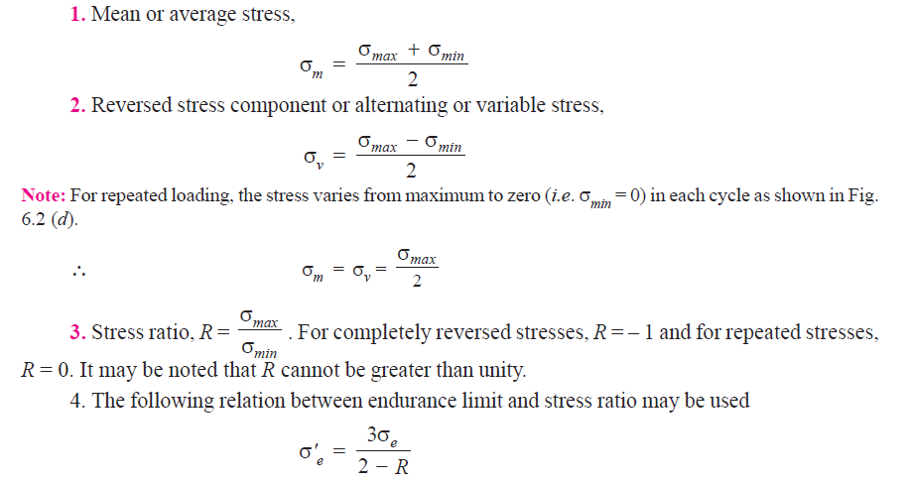

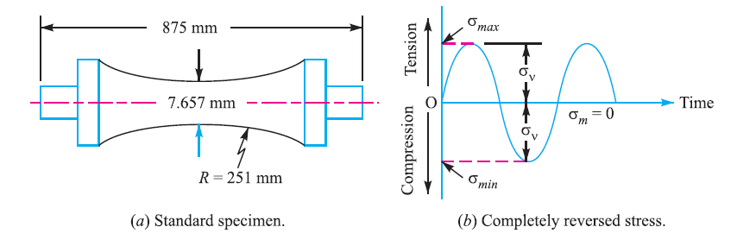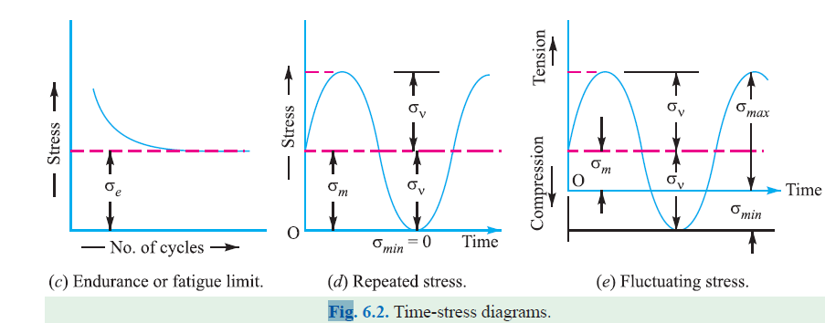

**2.3 Factor of Safety for Fatigue Loading**

When a component is subjected to fatigue loading, the endurance limit is the criterion for failure. Therefore, the factor of safety should be based on endurance limit. Mathematically,

**Factor of safety (*F.S*.) =Endurance limit stress/Design or working stress**

**2.4 Stress Concentration**

Whenever a machine component changes the shape of its cross-section, the simple stress

distribution no longer holds good and the neighbor hood of the discontinuity is different. This

irregularity in the stress distribution caused by abrupt changes of form is called ***stress concentration.*** It occurs for all kinds of stresses in the presence of fillets, notches, holes, keyways, splines, surfaceroughness or scratches etc.

**2.5 Theoretical or Form Stress Concentration Factor**

The theoretical or form stress concentration factor is defined as the ratio of the maximum stress in a member (at a notch or a fillet) to the nominal stress at the same section based upon net area. Mathematically, theoretical or form stress concentration factor,

***Kt***=**Maximum stress/Nominal stress.**

**2.6 Methods of Reducing Stress Concentration**

We have already discussed in Art 6.10 that whenever there is a change in cross-section, such as shoulders, holes, notches or keyways and where there is an interference fit between a hub or bearing race and a shaft, then stress concentration results. The presence of stress concentration cannot be totally eliminated but it may be reduced to some extent. A device orconcept that is useful in assisting a design engineer to visualize the presence of stress concentrationand how it may be mitigated is that of stress flow lines, as shown in Fig. 6.8. The mitigation of stressconcentration means that the stress flow lines shall maintain their spacing as far as possible.

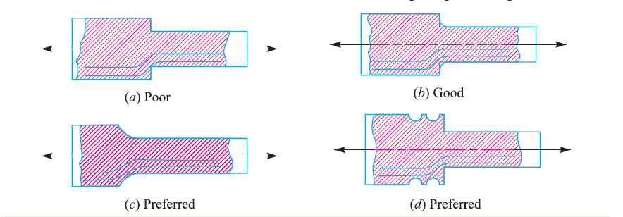

In Fig. 6.8 (*a*) we see that stress lines tend to bunch up and cut very close to the sharp re-entrant corner. In order to improve the situation, fillets may be provided, as shown in Fig. 6.8 (*b*) and (*c*) to give more equally spaced flow lines.Figs. 6.9 to 6.11 show the several ways of reducing the stress concentration in shafts and othercylindrical members with shoulders, holes and threads respectively. It may be noted that it is notpracticable to use large radius fillets as in case of ball and roller bearing mountings. In such cases, notches may be cut as shown in Fig. 6.8 (*d*) and Fig. 6.9 (*b*) and (*c*).

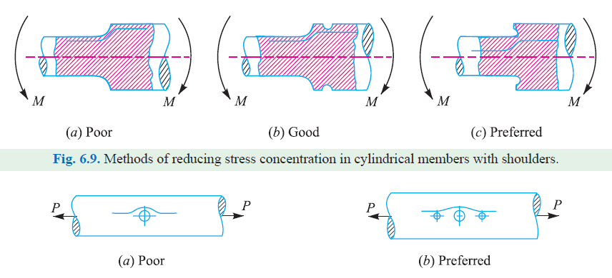

**2.7 Combined Steady and Variable Stress**

The failure points from fatiguetests made with different steels andcombinations of mean and variablestresses are plotted in Fig. 6.15 asfunctions of variable stress (σ*v*) and mean stress (σ*m*). The most significantobservation is that, in general, thefailure point is little related to the meanstress when it is compressive but is verymuch a function of the mean stress whenit is tensile. In practice, this means that fatigue failures are rare when the meanstress is compressive (or negative).Therefore, the greater emphasis must begiven to the combination of a variablestress and a steady (or mean) tensilestress.

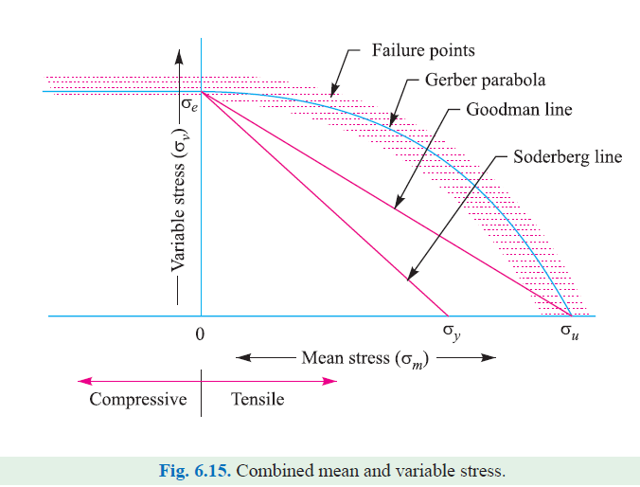

There are several ways in which problems involving this combination of stresses may be solved,but the following are important from the subject point of view :

**1.** Gerber Method, **2.** Goodman Method, and **3.** Soderberg Method.

**2.8 Gerber Method for Combination of Stresses**

The relationship between variables tress (σ*v*) and mean stress (σ*m*) for axial and bending loading for ductile materials are shown in Fig. 6.15. The point σ*e* represents the fatigue strength corresponding to the caseof complete reversal (σ*m*= 0) and the point σ*u* represents the static ultimate strength corresponding to σ*v*= 0.A parabolic curve drawn between the endurance limit (σ*e*) and ultimate tensile strength (σ*u*) was proposed by Gerber in1874. Generally, the test data for ductilematerial fall closer to Gerber parabola asshown in Fig. 6.15, but because of scatter in the test points a straight line relationship (*i.e*. Goodman line and Soderberg line) is usuallypreferred in designing machine parts.

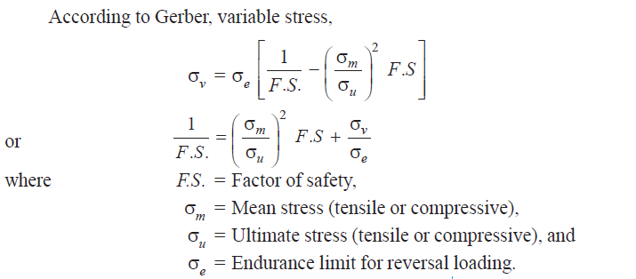

**2.9 Goodman Method for Combination of Stresses**

A straight line connecting the endurance limit (σ*e*) and the ultimate strength (σ*u*), as shown by line *AB* in Fig. 6.16, follows thesuggestion of Goodman. A Goodman line is used when the design is based on ultimatestrength and may be used for ductile or brittlematerials.In Fig. 6.16, line *AB* connecting σ*e* and σ*u* is called ***Goodman's failure stress line.*** If a suitable factor of safety (*F.S.*) is applied to endurance limit and ultimate strength, a safe stress line *CD* may be drawn parallel to the line *AB*. Let us consider a design point *P* on the line *CD.*Now from similar triangles *COD* and *PQD,*

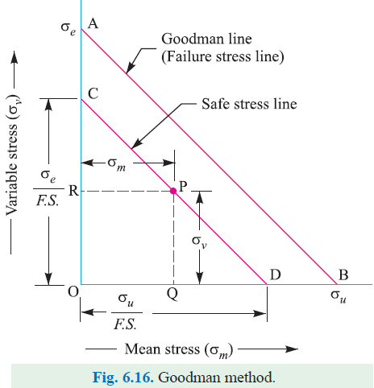

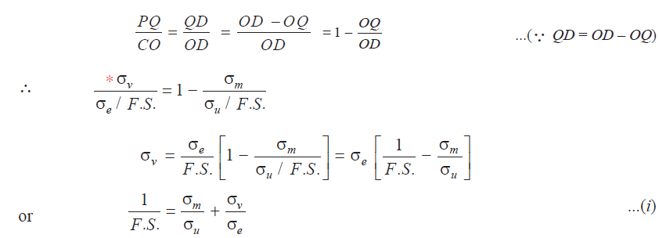

Since many machine and structural parts that are subjected to fatigue loads contain regions of

high stress concentration, therefore equation (*i*) must be altered to include this effect. In such cases,

the fatigue stress concentration factor (*Kf*) is used to multiply the variable stress (σv). The equation **(*i*)**

may now be written as

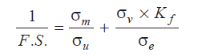

Considering the load factor, surface finish factor and size factor, the above equationmay be

written as

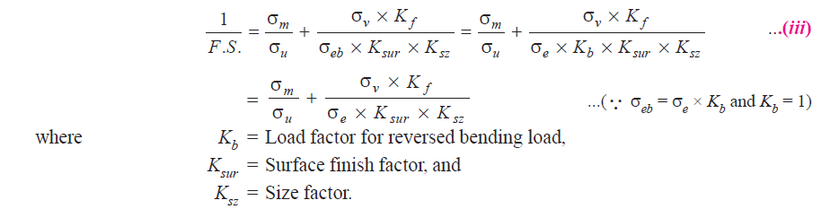

**2.10 Soderberg Method for Combination of Stresses**

A straight line connecting the endurance limit (σ*e*) and the yield strength (σ*y*), as shown by theline *AB* in Fig. 6.17, follows the suggestion of Soderberg line. This line is used when the design isbased on yield strength. Proceeding in the same way as discussedin Art 6.20, the line *AB* connecting σ*e*and σ*y*, as shown in Fig. 6.17, is called ***Soderberg's failure stress line****.* If a suitable factor of safety (*F.S.*) is applied to the endurance limit and yieldstrength, a safe stress line *CD* may be drawnparallel to the line *AB.* Let us consider a designpoint *P* on the line *CD*. Now from similartriangles *COD* and *PQD*

