**Chapter 4 Analog Pulse Modulation Systems**

**Contents**

1. Introduction to analog pulse modulation

2. Sampling Theorem

3. Nyquist Rate

4. Aliasing Effect

5. Types of Pulse Modulation scheme

(i)Pulse Amplitude Modulation (PAM), (ii) Pulse Duration Modulation (PDM) , (iii)Pulse Position Modulation (PPM)

6. Applications of PAM, PDM, PPM

7. Problems

8. Short Questions with Answers

9. Self evaluation quiz-I

1**. Introduction to analog pulse modulation**

So far in all the previous analog modulation schemes like AM,DSB-SC ,FM the carrier signal is sinusoidal . The key parameters of the carrier such as amplitude and frequency is varied according to the instantaneous value of the modulating signal and transmitted successfully through free space which is the transmission medium.

But in analog pulse modulation the carrier signal is not longer sinusoidal .Instead we use pulses. We vary the parameter of the pulses such as amplitude, width and position according to the instantaneous value of the modulating signal. When we use a pulse as a carrier to modulate the modulating signal, such modulation method is called analog pulse modulation. To understand the pulse modulation we should study the sampling theorem.

PULSE MODULATION

Analog Pulse Modulation Digital Pulse Modulation

1 .Pulse amplitude (PAM) 1.Pulse Code (PCM)

2. Pulse Duration or Pulse Width (PWM) 2.Delta modulation

3. Pulse Position (PPM)

The different types of analog pulse modulation schemes are shown in the diagram below.

PAM, PDM or PWM and PPM signals

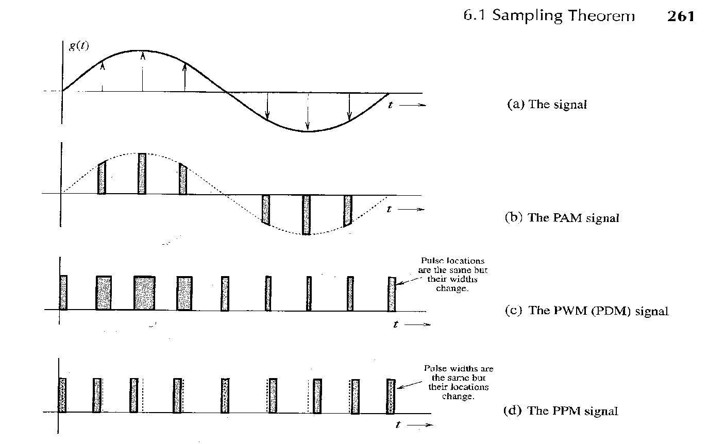

Pulse widths are same but their locations change

Pulse locations are same but their widths change

**2. Sampling Theorem**

The sampling theorem states that

“**A continuous time signal may be completely represented in its sample values and recovered back if the sampling frequency is fs ≥ 2 fm. Here fs is the sampling frequency and fm is the maximum frequency present in the signal**”

*How to understand Sampling theorem*

X(t)

X[2]

X[0]

Figure 2

Figure 1

Figure 2 shows a continuous time signal x(t) is converted to discrete signal x[n].

Figure 1 shows a signal x(t) which is continuous time signal

X(t) ------------- > x[n]

1. What is the time interval so that the information is not lost

Ts= ?

**3. Nyquist rate**

When the sampling rate becomes exactly equal to 2 fm samples per second ,then it is called Nyquist rate. Nyquist rate is also called the minimum sampling rate .It is given by

fs= 2*fm

similarly ,maximum sampling interval is called Nyquist interval. It is given by

Nyquist Interval Ts=1/2* fm seconds

**4. Aliasing Effect**

If continuous time signal is under sampled ; i.e. sampled less than the Nyquist rate then such phenomenon is called as aliasing effect.

**5. (a)PAM,(b)PDM or PWM,(c)PPM**

a) PAM

Pulse Amplitude Modulation is defined as that type of modulation in which the amplitudes of regularly spaced rectangular pulses vary according to the instantaneous value of the modulating signal.

PAM output

Message signal m(t)

Pulse p(t) having pulse duration ‘tp’

The bandwidth required for transmission of a PAM signal is given by

$$BW of PAM≥\frac{1}{2tp}$$

b) PDM or PWM

In this type, the amplitude is maintained constant but the duration or length or width of each pulse is varied in accordance with instantaneous value of the message signal.

c) PPM

In this type, the sampled waveform has fixed amplitude and width whereas the position of each pulse is varied as per instantaneous value of the message signal.

**6. APPLICATIONS OF PAM, PWM, PPM**

PAM APPLICATION

* Pulse-amplitude modulation is widely used in baseband transmission of digital data, with non-baseband applications having been largely replaced by pulse-code modulation, and, more recently, by pulse-position modulation.
* In particular, all telephone modems faster than 300 bit/s use quadrature amplitude modulation (QAM). (QAM uses a two-dimensional constellation).

Use in Ethernet

* Some versions of the Ethernet communication standard are an example of PAM usage. In particular, the Fast Ethernet 100BASE-T2 medium (now defunct), running at 100 Mbit/s, uses five-level PAM modulation (PAM-5) running at 25 megapulses/sec over two wire pairs. A special technique is used to reduce inter-symbol interference between the unshielded pairs. Current common 100 Mbit networking technology is 100BASE-TX which delivers 100 Mbit in each direction over a single twisted pair – one for each direction. Later, the gigabit Ethernet 1000BASE-T medium raised the bar to use four pairs of wire running each at 125 megapulses/sec to achieve 1000 Mbit/s data rates, still utilizing PAM-5 for each pair.

Use in photobiology

* The concept is also used for the study of photosynthesis using a PAM fluorometer. This specialized instrument involves a spectrofluorometric measurement of the kinetics of fluorescence rise and decay in the light-harvesting antenna of thylakoid membranes, thus querying various aspects of the state of the photosystems under different environmental conditions.

Use in electronic drivers for LED lighting

* Pulse-amplitude modulation has also been developed for the control of light-emitting diodes (LEDs), especially for lighting applications. LED drivers based on the PAM technique offer improved energy efficiency over systems based upon other common driver modulation techniques such as Pulse Width Modulation as the forward current passing through an LED is relative to the intensity of the light output and the LED efficiency increases as the forward current is reduced.

PWM APPLICATION

* Pulse-width modulation (PWM), or pulse-duration modulation (PDM), is a commonly used technique for controlling power to inertial electrical devices, made practical by modern electronic power switches. The average value of voltage (and current) fed to the load is controlled by turning the switch between supply and load on and off at a fast pace. The longer the switch is on compared to the off periods, the higher the power supplied to the load is.
* The PWM switching frequency has to be much faster than what would affect the load, which is to say the device that uses the power. Typically switching have to be done several times a minute in an electric stove, 120 Hz in a lamp dimmer, from few kilohertz (kHz) to tens of kHz for a motor drive and well into the tens or hundreds of kHz in audio amplifiers and computer power supplies.
* The term duty cycle describes the proportion of 'on' time to the regular interval or 'period' of time; a low duty cycle corresponds to low power, because the power is off for most of the time. Duty cycle is expressed in percent, 100% being fully on.
* The main advantage of PWM is that power loss in the switching devices is very low. When a switch is off there is practically no current, and when it is on, there is almost no voltage drop across the switch. Power loss, being the product of voltage and current, is thus in both cases close to zero. PWM also works well with digital controls, which, because of their on/off nature, can easily set the needed duty cycle.
* PWM has also been used in certain communication systems where its duty cycle has been used to convey information over a communications channel.

PPM AND ITS APPLICATIONS

* Pulse-position modulation (PPM) is a form of signal modulation in which M message bits are encoded by transmitting a single pulse in one of 2M possible time-shifts. This is repeated every T seconds, such that the transmitted bit rate is M/T bits per second. It is primarily useful for optical communications systems, where there tends to be little or no multipath interference.
* Narrowband RF (radio frequency) channels with low power and long wavelengths (i.e., low frequency) are affected primarily by flat fading, and PPM is better suited than M-FSK to be used in these scenarios. One common application with these channel characteristics, first used in the early 1960s, is the radio control of model aircraft, boats and cars. PPM is employed in these systems, with the position of each pulse representing the angular position of an analogue control on the transmitter, or possible states of a binary switch. The number of pulses per frame gives the number of controllable channels available. The advantage of using PPM for this type of application is that the electronics required to decode the signal are extremely simple, which leads to small, light-weight receiver/decoder units. (Model aircraft require parts that are as lightweight as possible).

**7. Problems**

1. An analog signal is expressed by the equation given below. Calculate the Nyquist rate for this signal.

2. Find the Nyquist rate and the Nyquist interval for the signal

3. For a pulse amplitude modulated (PAM) transmission of voice signal having maximum frequency equal to fm=3KHz, calculate the transmission bandwidth. It is given that the sampling frequency fs=8KHz and pulse duration tp=0.1T

**8. Short Questions with Answers**

1. What is sampling?

The process of converting an analog signal into a discrete signal is known as sampling

2. What do you mean by sampling period (Ts) and sampling rate (fs)?

During sampling ,time taken by the next sample to occur is known as sampling period and denoted as Ts.Sampling rate is the reciprocal of sampling period and denoted as fs=1/Ts.

3. Are there any demerits in PAM?

(1)The bandwidth requirement for transmission of a PAM is very large

(2)Since the amplitude of the PAM Pulses varies in accordance with the modulating signal therefore the interference of noise is maximum in a PAM signal. This noise cannot be removed easily.

4. Discuss the advantages and disadvantages of **PWM**

**Advantages of PWM**

1. Unlike PAM, noise is less since in PWM, amplitude is held constant

2. PWM communication does not require synchronization between transmitter and receiver

**Disadvantages of PWM**

1. In PWM pulses are varying in width and therefore their power contents are variable. This requires that the transmitter must be able to handle the power contents of the pulse having maximum pulse width.

2. Large bandwidth is required for the PWM communication as compared to PAM

5. Discuss the advantages and disadvantages **of PPM**

**Advantages of PPM**

1. Like PWM, in PPM, amplitude is held constant and thus less noise interference

2. Because of constant pulse widths and amplitudes, transmission power for each pulse is same

**Disadvantages of PPM**

1 Requires synchronization between transmitter and receiver

2. Larger bandwidth is required for the PPM communication as compared to PAM

**9. Self evaluation quiz -I**

1. The maximum permissible distance between 2 samples of 2 KHz signal is

(a) 1000 microseconds (b)500 microseconds (c)250 microseconds

2. Pick the odd man out

(a)PWM (b)PPM (c)PDM

3. The PWM needs

(a) more bandwidth than PAM (b) more samples (c) less power than PPM

4. In present day standard digital voice communication ,the voice signal is sampled at a rate around

(a)2000 samples /sec (b)200 samples/sec (c)8000 samples/sec

5. Aliasing occurs , when the Nyquist rate is

(a) 2fm (b) 3 fm (c) 1.2fm

6. Noise is reduced by increasing the sampling rate

(a) True (b) False

Answers to Self Evaluation Quiz

1. (c) 2.(b) 3.(a) 4.(c) 5.(c) 6.(b)