

**DEBER MARKOS UNIVERSITY**

**COLLEGE OF BUSSINES AND ECONOMICS**

**ECONOMICS DEPARTMENT**

**Public Finance**

**Course code: Econ 3122**.

**Credit hours: 3**

**Distance Learning Material**

**Prepared: Yeshiwas Ewinetu (MSC)**

**Tsegaw Kebede (MSC)**

**Edited By: Ermias Abineh (MSC)**

**May, 2019G.C**

**Debre Markos**

# MODULE INTRODUCTION

This model is prepared for 3rd year economics distance students that will be given in 2nd semester. The Course name Public finance and course code is Econ 3122. It takes 3 credit hours and 5 contact hours. The course competency will allow students in engage in analysis of fiscal policy issues. This module consists of nine chapters and the first nature and scope of public finance. Chapter two deals withwelfare economics and public finance. The third chapter deals withpublic revenue. The fourth chapter deals withpublic expenditure. The fifth chapter deals with public budget. The six chapter public debt**.** Thisseven chapterdeficit Financing.The eight chapter fiscal policy and last chapter deals with federal-state financial relations in Ethiopia.

# COURSE DESCRIPTION

Public finance deals with the financial aspects of the government and the possible role of the state in a market economy through the use of lecture, directed reading and term paper (seminar) preparation and presentation.

# COURSE OBJECTIVES

The general objective of the course is to acquaint students with various concepts, theories and realities of public finance such as the rationale for state in the economy, the sources and types of revenue for the public, taxing system and types of taxes, characteristics of an efficient taxing system, criteria for evaluating public expenditure, theories of public expenditure and its impact on the economy, significance , objective and types of public budget, deficit financing and its various means, and some relevant public finance issues in the Ethiopian context.

Contents

MODULE INTRODUCTION 2

COURSE DESCRIPTION 2

COURSE OBJECTIVES 2

CHAPTER ONE 5

MEANING AND SCOPE OF PUBLIC FINANCE INTRODUCTION 5

1.2 Scope of Public Finance 7

1.3 Public Finance and Private Finance 11

1.4 Significance of Public Finance 13

1.5 Economic Rationale of a Modern State 14

Chapter Review Questions 16

CHAPTER TWO 18

WELFARE ECONOMICS AND PUBLIC FINANCE 18

2.2 Application of Welfare Economics 19

2.3 Fundamental Theorem of Welfare 20

2.4 The Efficiency of Competitive Markets 20

2.5 Market Failure, Externalities and Public Goods 27

Chapter review Questions 33

3.1 Source of Public Income 34

3.2. Basic concepts Tax ratio, buoyancy and elasticity of tax 35

3.3 Adam Smith’s Canon of Taxation 38

Dear distance learners!! Can you state the canons of taxation please? 38

3.4 Features (characteristics) of Sound Taxation 39

3.5 Objectives of taxation 40

3.6 Approaches to Taxation 41

3.7 Rate Schedules of Taxation (Tax rate structure) 45

3.8 Direct and Indirect Taxes 50

3.9 Superiority of Indirect Taxes over Direct Taxes 52

3.10 Impact, Shifting and Incidence of Tax 53

3.10.1Theories of Tax Shifting 59

3.10.2 Forward and Backward Shifting 59

3.10.3 Factors Influencing Shifting and Incidence 59

Chapter review Questions 61

CHAPTER FOUR: PUBLIC EXPENDITURE 63

4.1 Meaning and Nature of Public Expenditure 63

4.2. Causes of Growth in Public expenditure 66

4.3. Public expenditure: Canons, Theories and Accountability of Public 68

Expenditure 68

4.3.1. Canon of public expenditure 68

4.3.2. Theories of public expenditure 69

4.3.3. Control and Accountability of Public Expenditure 72

4.4. Effects of Public Expenditure of Production and Distribution 76

4.6. Content of Development Expenditure 78

5.1. Meaning of Public Budget 80

5.2. Importance of Public Budget 82

5.3. Principles of Budgeting 83

5.4. Objectives of Budgeting 83

5.5. Types of Budgeting 84

5.6. Procedures of Budgetin 86

5.7. Theories of Government Budgeting 86

5.8. Performance and Program budgeting system (PPBS) 94

5.9. Zero-Base Budgeting 94

5.10. Budget as an Instrument of Economic Policy 99

Nature and Kinds of Public Debt 103

6.2 Effects of Public Debt 104

6.3 Burden of Public Debt 105

6.4 Redemption of Public Debt 110

6.5 Public Debt in a Developing Economy 111

CHAPTER SEVEN 114

DEFICIT FINANCING 114

7.1 Meaning of Deficit Financing 114

7.1 Different Methods of Deficit Financing 115

7.3 Effects of Deficit Financing 118

7.4 Limits to Deficit Financing 120

CHAPTER: EIGHT 123

Fiscal Policy 123

8.1 Meaning Fiscal Policy 123

**Fiscal Instruments** 124

**1)** **Public Expenditure** 124

8.2 Objectives of Fiscal Policy 127

8.3 Compensatory Fiscal Policy 131

8.4 DISCRETIONARY FISCAL POLICY 136

9.1 Provisions under the Constitution of Ethiopia 143

9.2 Federal Power of Taxation in Ethiopia 144

9.3 State Power of Taxation in Ethiopia 145

RERENCE 147

# 

**CHAPTER ONE**

# MEANING AND SCOPE OF PUBLIC FINANCE INTRODUCTION

**Introduction**

Dear distance learner!! This is the first chapter for the course public finance. Thus it will acquaint you with basic concepts in the subject matter. In this chapter issues like nature of public finance, comparison between public finance and private finance, and role of public finance will be discussed. We have to know that the participation of the government in the economic activities is essential to accomplish the goals of any welfare state. Classical economists advocated minimum functions for the government. Subsequently, the economists Keynes demonstrated that it was possible through fiscal activities of the state to increase employment and to maintain it at high level. This realization led to emphasis on the active participation of the state in the economic activity. The governments of advanced countries are committed to stability and full employment. In case of under developed countries the government aims at accelerated economic development. Government sector can play a decisive role in shaping and charting the path of any economy. Depending on the level of development of each country the roles of government sector differ. However, in all cases the aim is to attain full employment and economic development through the development of agriculture, industry and service sector.

**Objectives of this chapter**

After the end of this chapter students are able to;

* Define the meaning of public finance
* Know the scope of public finance
* Differentiate public finance from private finance
* Understand the significance of public finance
* Identify the role of the government in modern state

**1.1 Definition of public Finance**

Dear distance learners!! Do you know the names of public finance and the meaning of public finance?

………………………………………………………………………………………………………………………………………………………………………………………………………………………………………………………………………………………………………………………………..…………..

Well done!! The name of the subject is given by different economists differently such as; fiscal economics, public sector economy, public economics, fiscal science and public finance etc.

Schultz and Harris define public finance as adjective, it describe public which refers to not only government but also utility enterprise and charitable organizations. According to Dalton, “public finance is one of those subjects which lie on the borderline between economics and politics.

*Public finance,* according to the traditional definition of the subject, is that branch of Economics which deals with, the income and expenditure of a government. In the words of Adam Smith:

"The investment into the nature and principles of state expenditure and state revenue is called *public finance*".

AC.Pigious define public finance is the study of public revenue and expense. The earlier economists were perfectly justified in giving this definition of the science of public finance because the functions of the public authorities in those days were simply to raise revenue by imposing taxes for covering the cost of administration and defense.

Public finance is the study of how the government collects and spends revenue and real resources. It’s the field of economics concerned with how the government raises money, how that money is spent, and the effects of these activities on the economy and on the society. Public finance studies how the governments at all levels national, state and local provide the public with desired services and how they secure the financial resources to pay for these services.

## 1.2 Scope of Public Finance

Dear distance learners can you list some of the subject matter of public finance please?

………………………………………………………………………………………………………………………………………………………………………………………………………………………………

That was great!! Before we directly go to the subject matter of public finance let us define the scope of public finance. It is the coverage of public finance. Since activities of government are wide, then scope of public finance is also too. The scope of the science of public finance now-a-days has widened too much. It is due to the fact that modern states have to perform multifarious functions to promote the welfare of its citizens. In addition to maintaining law and order within the country and provision of security from external aggression, it has to perform many economic and commercial functions. Due to the increased activities of the state, there has taken place a vast increase in the expenditure of the public authorities. The sources of revenue have also increased. Taxes are levied not for raising the revenue alone but are used as an important instrument of economic policy. Public finance now includes the study of financial administration and control as well. We, therefore, agree with Professor Bastable when he defines public finance as that: “Branch of economics which deals with income and expenditure of public authorities or the state and their mutual relation as also with the financial administration and control the term public authorities includes ail bodies which help in carrying on the administration of the state)".

The study of public finance is split up into the following parts (scopes);

1. **Public Revenue**: it deals with the sources of the public revenue, the principles and the effects of public revenue on the economy. Public revenue is the means for public expenditure. Public revenue have two main sources

**1. Tax Revenue**: Taxes are compulsory payments to government without expectation of direct return or benefit to tax payers. Tax is one of the most important sources of revenue.

We have two major types of tax revenue source based on impact or incidence

**A.** **Direct tax** : those tax whose burden or impact and incidence fall on the same person such as employee income tax ,business income tax ,rental income tax, agricultural income tax and other income tax interest income ,royalty tax, capital gain tax , property tax ,gift tax and inherent tax.

**B**. **Indirect tax**: are those tax whose impact (immediate burden) and incidence (ultimate burden) fall on different person such as value added tax (VAT), excise tax , turnover tax (TOT), sur tax, customs duty and stump duty etc. The objectives of taxation are to minimize income and wealth inequalities, stabilize the economy, discourage the consumption of harmful products, provide incentives for capital formation in the private sector, reduce regional imbalance ,enhance standard of livings ,utilize the scarce resources for the production of more essential goods ,minimize unemployment and encourage export .

1. **Non tax revenue**: This is revenue collected from public undertakings, income from issuing of currency, income from the sale of public assets, gift and donation, foreign debt etc. Major constituents of non-tax revenue in Ethiopia are charges, fees, fines, pension contribution, and investment revenue.
2. **Public Expenditure**: This consists of the study of the principles and the effects of public expenditure. Government may have three type of expenditure
3. For maintain ace of the government
4. For the society
5. To help other countries

Public expenditure has two broad headings

**Developmental**: It includes social and community services, economic services, and grants in aid.

**Non developmental**: It consists of interest payments, administrative services, and defense expenses.

1. **Public Debt**: this part studies the causes and the methods of public borrowing as well as public debt management. They are two types of public debt.
2. **Internal debt**: Increasing need of government for funds cannot be fully met by taxation alone in under developed and developing countries due to limited scope of taxation. Government therefore has to resort to alternate internal sources.
3. **External debt**: In under developed and developing countries, internal sources are limited. Under developed and developing countries, therefore go for external debt. Public debt has the objective raising normal current expenditure, exigencies like war, finance productive government enterprise, finance public social welfare and economic development. External debt is an immediate source of funds for development. However, such debt has drawbacks political subordination, other obligation and Excess supply of goods and services in debtor country.
4. **Budget (fiscal policy)**: this part is dealing with budget allocation process which is a key to the government’s roles of allocation, redistribution of resources, and economic stabilization. Fiscal policy refers to that segment of national economic policy, which is primarily concerned with the receipts, and expenditures of these receipts and expenditures. It follows that fiscal policy relate to those activities of the state that are concerned with raising financial resources and spending them. Resources are obtained through taxation and borrowing both within the country and from abroad. Spending is done mainly on defense development and administration. Financial accounts of the income and expenditure position are shown in budgetary statement. Budget can act as an important tool of economic policy. The state by its policy of taxation-regulated expenditure can influence the economic activities and development. The annual budget for the Federal Government of Ethiopia is prepared by the Ministry of Finance and Economic Development (MoFED) and the budgets for the regional governments by the respective regional finance bureaus.
5. **Revenue budget**: This forecasts the total revenue collections of the government from tax and non-tax sources. In Ethiopia, it is classified into three parts:
6. **Ordinary Revenue** : tax and non- tax source ordinal revenue
7. **External Assistance**: External assistance received from friendly countries is called bilateral assistance; whereas assistance (grant) received from multilateral or international institutions is known as multilateral assistance.
8. **Capital Revenue:** It comprises the money received by the government from the sale of government assets, collection of loans, counterpart fund and external loans
9. **Expenditure Budget**: Expenditure budget is a forecast of the total expenditure by the government, in a year. In Ethiopia, it is classified into two parts:
10. **Recurrent Expenditure**: Recurrent expenditure represents expenses made by the government which are recurrent in nature. The recurrent expenditure is classified in Ethiopia under four functional categories:
11. **Administrative and General Services**: it expense spend for activities as performed by political organs of the state such as council of representatives, ministries, defense etc..
12. **Economic Services**: budget expenditure for agricultural, industrial and service sector activates.
13. **Social Services**: Health, education, and culture..
14. **Other Expenditures**: Other Expenditures include pension payments, repayment of public debts, provision of unforeseen expenses and similar items
15. **Capital Expenditure**: Capital expenditure represents expenses made by the government for the implementation and expansion of development projects, research and development programme, government expenditure on construction, infrastructure, industry, machinery, building and equipment. However, in most developing countries, recurrent expenditure is mostly financed from domestic revenue sources i.e, from tax and non-tax revenues, whereas capital expenditure is usually financed by external borrowing and grants.
16. **Financial admiration** (fiscal policy and administration): This category includes the preparation of financial budget, the control and administrations of the budget relevant problems auditing etc. The term budget includes ‘Annual Financial Statements’ which incorporates all the annual statements of receipts and expenditures of the government.
17. **Economic stabilization:** it is only one aspects of the broader field which includes income policy, development policy, price policy and employment policy.

### 1.3 Public Finance and Private Finance

Before directly embark on the public and private finance let us define the two basic terms as follow; The public sector includes public institutions at the local, regional, national and inter- or supranational level. The private sector includes small- and medium sized, as well as large and trans- or multinational companies. Something distinct from the private finance, the question, which we are faced, is what are the differences between private and public finance? That leads to the separate treatment of public finance.

**Similarities**

1. **Rationality:** both kinds of finance are based on rationality i.e maximum satisfaction. If sometimes the individual is tempted by circumstances to act in an irrational and wrong way the government is also subject to such circumstances in regard to expenditures. Of course there may be unwise use by the government to its income.
2. **Borrow Funds as a common feature:** just as an individual cannot have enough income to cover his expenses and fills it by borrowing from others, the government also unable to meet all its targets due to budget constraint and borrow funds from others.
3. **Satisfaction of human wants**: Individual is concerned with the personal wants, while the Government is concerned with the social wants. Thus, both the private and public finance have the same objective, viz, the satisfaction of human wants.
4. **Economic Choice a Common Problem:** Both the individual and Government face the problem of economic choice. That is their sources of revenue are limited, comparing with their expenditure. Hence they have to satisfy the unlimited ends with limited means.
5. **Both are engaged in economic activities**: Including production, exchange, saving, capital accumulation investment etc.
6. **Balancing of Income and Expenditure**: Both individual and Government have incomes and expenditures and trying to balance each other.

**Differences**

In spite of the above similarities there are however, there are glaring differences between them. The differences between the two kinds of finances are more remarkable than similarities in them and are discussed as follows;

**1) Final goal (objective)**

* Private interest (the greatest good for one number) that is the want and satisfaction of household and firm.
* Public collective or social interest (the greatest good for the greatest number) or deal with collective want and satisfaction.

**2)** **Cost adjustment of income and expenditure**

* Private start from revenue calculation; then expenditure.
* Public start from expenditure and then revenue.

**3)** **Nature of resources**

* Individuals have limited resources at their disposable while;
* Public has power to borrow from external, revenue can collect from tax, and from entire wealth of the community through force.

**4)** **Motive of expenditure**

* Private is the expenditure return is curtained?
* Public profit and surplus is not a matter rather for max welfare in which financial return is uncertain.

**5)** **Expenditure and welfare**

* Private marginal utility of money spent on all goods more or less the same.
* Public spend income in such a way that welfare of community should be maximized.

**6) Impact on the society/economy**.

* Private has little impact on the economy
* Public can change the entire nature of the economy, unemployment, inflation, deflation and etc.

**7) Secrete and Publicity**: Private finance is secreting except for taxation while public finance is widely discussed and disclosed.

**8)** **Postponement of Expenditure**: In private finance, the individual can postpone or even avoid certain expenditure, as he likes. But in the case of public finance, the Government cannot avoid certain commitments kike social welfare measures and thus cannot postpone the certain expenses like relief measures, defense, etc.

**9)** **Influence on expenditure**: The expenditure pattern of private finance is influenced by various factors such as Customs, habits culture religion, business conditions etc. But the pattern of expenditure of public finance is influenced and controlled by the economic policy of the Government.

**10) Audit**: In the case of private finance, auditing of the financial transactions of the individuals is not always necessary. But the accounts of the public authorities are subject to audit and inspection.

**11) Coercion**: Under private finance the individuals and business units cannot use force to get their income. But, in public finance the governments can use force in the form of imposing taxes to get income i.e. taxes are compulsory in nature.

**12) Nature of Budget:** In private finance individuals prefer surplus budget as virtue and a deficit budget is undesirable to them but for the government budget surplus is undesirable by the government since it will result negative opinion for the government.

## 1.4 Significance of Public Finance

Justification for public finance in modern state is the need for public sector economy.

* Failure of unregulated market economy: The pattern of consumption, production, distribution and resource allocation will be inconsistent with the social need due to
* Existence of public goods and externality
* Uncertainty.
* Incomplete information.
* Increase and return to scale in natural monopoly.
* Produce or supply more goods as per capital income of the society increase, at least, public goods e.g road and straight line.
* The larger complementarities between government and private sector in sphere of infrastructure and merit goods. The importance of public finance could be view from the following angle.

1. **Taxation**: Taxation is a system of raising the government revenue through tax. When we say tax it is a compulsory contribution payable by an economic unit to a government without direct and equivalent return from the government for the contribution made. The governments often levy taxes to discourage the consumption of harmful commodities. Such as the consumption of cigarette, alcohol and other commodities that fall within that general category needs to be discouraged by introducing excise tax.
2. **Protection of Infant Industries**: If the infant and newly started firm or industries in developing nations are allowed to struggle with foreign firms especially from those technologically advanced countries, they may not survive due to many reason and factors. These industries need protection and government often levies duties in order to protect them.
3. **Provision Public Goods**: Governments provide public good, the government-financed items and services such as roads, military forces, lighthouses, and streetlights. Private Citizens even the wealthy ones would not voluntarily pay for these services, and therefore businesses have no incentive to produce them.
4. **Side Effects of a Market Economy**: Public finance also enables governments to correct or offset undesirable side effects of a market economy. These side effects are called spillovers or externalities. Example: households and industries may generate pollution and release it into the environment without considering the adverse effect pollution has on others. Pollution is a spillover because it affects people who are not responsible for it. To correct a spillover.

## 1.5 Economic Rationale of a Modern State

Dear distance learners!! Can you list rationalities of a modern state please?

………………………………………………………………………………………………………………………………………………………………………………………………………………………………………………………………………………………………………………………………………………………………

**Well done!!**

In modern state basically every government has at least three functions, defense of the country, maintenance of law and order and socio-economic development. The government in a modern state provides the following services.

* Security both in internal and external.
* To control and regularize the economy.
* Justice or the settlement of disputes.
* The social and cultural welfare of the people through education, social welfare schemes.
* To make proper utilization of natural resource.
* The regulation of moral standards.
* The administration of the financial system, expenditure, revenues and fiscal control
* Proper and efficient administration.

1. Why government provides is providing specific goods and services?
2. Which goods and services provided by the government are the two critical questions for the first question the reason is that due to market failure for this we have two options

* Under production due to positive externality
* Over production due to negative externality
* No production due to the presence of public goods

1. **Allocative role:** one assumption of market economy is well defined and enforceable property right, However some time there may be ambiguity in defining and enforcing property right which reduce tradability and marketability which reduce price and results underground or black market economy due to absence of well defied property right and hence government will play allocate role for common propriety resource, externality and market imperfections created market failure through ;

* Government legislation or legal measure.
* Fiscal instrument
* Legal reform
* Creating market for pollutant
* Moral code and social sanctions
* Developing liability schemes
* To bring allocative efficiency when there is negative externality
* Well defined property right
* Per unit tax
* Private bargaining
* To bring allocative efficiency when there positive externality
* Property right
* Per unit subsidy
* Private barging

1. **Distributive role**: it is the role of the government to provide distribution of income. Initially there is inequality in income due to difference in individual capacity, inherited and accumulated wealth, educational status etc. There source may be market imperfection hence to minimize the above problem the government may

* Progressive employee tax on rich and cash benefit for the poor.
* Progressive tax on goods and services consumed by the rich and subsidize the goods and services consumed by the poor.
* Provision at subsidy price

1. **Regulatory role**: regulation is important for society and for the government because it reduce cost of information for society, and for the government it help to protect public interest (selfishness and irrationality), to replace invisible hand of the government by divisible fist and to maximize welfare of the group .The instruments of regulation may be regulation of money demand and money supply ,price ,controlling commercial broad casting ,standardizing product ,control over biased advertising . The regulator satisfies the interest of the government and the public interest regulates the regulators. The efficiency of regulation depends on profit of the firm, implantation capacity and efficiency of the instrument, the presence of illegal evasion and fraud.
2. **Stabilizing role**: stabilization is necessary when there is inflation or deflation ,inequality between aggregate demand and supply, inequality between money demand and money supply , inequality between saving and investment , inequality between expenditure and output. The instruments of stabilization may be fiscal policy instrument (tax and government expenditure) and monetary policy (income and interest rate).
3. **Merit goods**: even if the market is pareto efficient i.e the competitive market will leads to undesirable distribution income and merit goods. The good that the government compels individuals to consume like elementary education and seat belt. Individual may not act in their own best interest. It is often argued that an individual perception of his own welfare may be unreliable criteria for making welfare judgment. The view that the government should intervene because it knows what is in the best interest of individuals better than they do them themselves is referred as **paternalism.**

# Chapter Review Questions

1. What is the meaning of public finance?
2. What is the difference between private finance and public finance?
3. What is the role public finance in the economy?
4. What are the rationalities of public finance in modern state?

# CHAPTER TWO

# WELFARE ECONOMICS AND PUBLIC FINANCE

**Introduction**

Dear distance learner, this is the second chapter which deals with welfare economics. You see, the objective of the government is the welfare of the people. The material progress and the prosperity of a nation are desirable chiefly so far as they lead to the moral and material welfare of all good citizens. In this chapter, issues like pure exchange economy, an economy with production, the fundamental theorem of welfare economics, the role of fairness, causes of market failure and the like will be discussed.

**Objectives**

After the end of this chapter, students will be able to;

* Understand the meaning of welfare economics
* Know pareto optimality of the economy and its criteria
* Identify the causes of market failure and its corrective tools of fiscal policy

**2.1 Approach of Welfare Economics**

There are two mainstream approaches to welfare economics: the early neoclassical approach and the new welfare economics approach.

1. **The early neoclassical approach** was developed by [Edgeworth](http://en.wikipedia.org/wiki/Francis_Ysidro_Edgeworth), Sedgwick, Marshall, and Pigou. It assumes the following:

* Utility is cardinal, that is, scale-measurable by observation or judgment.
* Preferences are exogenously given and stable.
* Additional consumption provides smaller and smaller increases in utility (diminishing marginal utility).
* All individuals have interpersonally comparable utility functions (an assumption that Edgeworth avoided in his *Mathematical 'Psychics*). With these assumptions, it is possible to construct a social welfare function simply by summing all the individual utility functions.

1. **The New Welfare Economics approach** is based on the work of Pareto, Hicks, and Kaldor. It explicitly recognizes the differences between the efficiency aspect of the discipline and the distribution aspect and treats them differently. Questions of efficiency are assessed with criteria such as Pareto efficiency and Kaldor-Hicks compensation tests. While questions of income distribution are covered in social welfare function specification. Further, efficiency dispenses with cardinal measures of utility, replacing it with ordinal utility, which merely ranks commodity bundles (with an indifference-curve map, for example). It is a branch of economics that uses microeconomic techniques to evaluate economic well-being, especially relative to competitive general equilibrium within an economy as to economic efficiency and the resulting income distribution associated with it. It can be seen as intermediate or advanced microeconomic theory. It analyzes *social* welfare, however measured, in terms of economic activities of the individuals that compose the theoretical society considered. Its results are applicable to macroeconomic issues. So welfare economics is somewhat of a bridge between the two branches of economics. Accordingly, individuals, with associated economic activities, are the basic units for aggregating to social welfare, whether of a group, a community, or a society, and there is no "social welfare" apart from the "welfare" associated with its individual units.

## 2.2 Application of Welfare Economics

1. **Cost-benefit analysis** is a specific application of welfare economics techniques, but excludes the income distribution aspects.
2. **Political science** also looks into the issue of social welfare (political science), but in a less quantitative manner.
3. **Human development theory** explores these issues also, and considers them fundamental to the development process itself.
4. **Welfare Economics and Public Finance**

Welfare economics is a branch of economics that focus on normative issues .The fundamental normative issues are

1. What should be produced?
2. How it should be produced?
3. For whom, and who should make these decision?

Under command (socialist) economic system in Eastern like , Soviet union Cuba and North Korea, answered by central planning . Today in most worlds the economic system is characterized by mixed economic system including western like USA and Ethiopia, with some decision made by the government but most left up to the myriad of the firm and the households. But there are many mixes. How are we to evaluate the alternatives? Most economists embrace a criterion called pareto efficiency. Named after the great Italian economist, sociologist, philosopher and statistician Vilfredo Pareto (1848-1923). Pareto optimality is the allocation of resource that no one can be made better off without making some one being made worse off. It implies efficiency. let us see with the following cases assume that the Local government in Bichena is contemplating building a bride in Suha River. Yelmate peoples wish to use the bridge are willing to pay more than enough in tolls to cover the costs of construction and maintenance. The construction of the bridge like to what? pareto improvement. Pareto improvement is a change that makes some individuals better off without making any one worse off. It is an allocation in which we can make one individual better off without affecting the other. It is a change that makes one person better off without making anyone else worse off. If a Pareto improvement is possible, the current allocation is not Pareto efficient.

## 2.3 Fundamental Theorem of Welfare

**Dear distance learners!!** Did you know the fundamental theorems of welfare economics please? if you know you can put your answer in the space provided below please .

………………………………………………………………………………………………………………………………………………………………………………………………………………………………**well done!!** Every competitive economy is (satisfy other conditions), is pareto efficient. Every pareto efficient allocation can be obtained through a competitive market process with an initial redistribution of wealth. It implies every pareto efficient allocation is attained by means of a decentralized market mechanism. In such case decision about type of production, method of production and distribution were answered by myriad of the firm and the household that make up of the economy.

## 2.4 The Efficiency of Competitive Markets

Efficiency is the condition that exists when society gets the most that it can from scarce resources**.** Ideal Perfectly competitive market is contracted by drawing the following assumptions many firm and households, each has small market share and it has no effect on price, all firms and households have perfect information about the availability of the goods and the price which are being charged, no air or water pollution . Let us see why competition leads to economic efficiency with the traditional demand and supply curve.

**Individual Demand curve** gives the amount of the good the individual is willing and able to demand at each price. In deciding how much to demand equal marginal benefit to marginal cost, which is the price they have to pay.

**Individual supply curve** gives the amount of the good the individual is willing and able to supply at each price. In deciding how much to supply firm equates marginal benefit, which is the price equal to the marginal cost. Then the efficiency for the single market is as follows;

Price

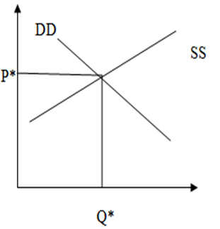

Quantity of the firm

At the market equilibrium, where supply equal to demand that is MB=MC=P which is the requirement for economic efficiency (MC=MB). Additional benefit they receive from consuming with the marginal cost purchasing an extra unit.

At any output such as Q*, the last firms must yield consumers p* exact utility. The supply curve for the competitive industry (SS) is the marginal cost of the firms. If every market in the economy is a perfect competitive free market, the resulting equilibrium through the economy will be pareto efficient. Away from p* and Q*, here is a divergence of between the marginal cost and the marginal benefit derived by the consumers so a move to that position make society better off but the distortion exist whenever society’s marginal cost of producing a good does not equal society marginal benefit from consuming that good due to market failure, externality, imperfect competition.

**A negative externality**

Suppose DD represents the demand curve for a product which may be interpreted as marginal social benefit. MPC is the marginal private cost incurred by the firm in producing the good (assume constant for simplicity). The market clear where MPC=DD at p and Q. If the firm causes pollution, it imposes costs on the society presented by marginal social cost. So the social optimal is where DD(MSB)=MSC at Q*.

Graphically

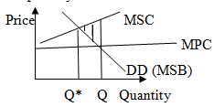

The overall welfare loss to the society from the market failure is given by the excess of MSC over MPC between Q* and Q.

**A positive externality**

As a consequence of a consumption (positive) externality MSB>MPB, and the free market equilibrium provide the quantity Q. As compared with the social optimal at Q’, where MSB=MSC. The under lined area shows the welfare loss .

Graphically

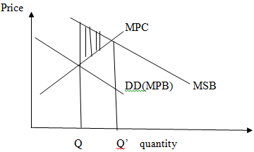

Welfare economics is developed by the utilitarian. Welfare is a branch of economics which deals the evaluation of alternative economic situation from the society wellbeing.

**Factors affecting welfare**

* The size of the national dividend;
* The distribution of national dividend; and
* The variability of national dividend

**Analyzing Economic efficiency**

An allocation of resources is said to be efficient if it is not possible to make one or more persons better off without making at least one other person worse off (applying the Pareto criterion).

To develop deeper analysis efficiency goes beyond demand and supply just presented below.

**Dear Distance learners!!** Can you list the three aspects of efficiency please ?

1……………………….

2………………………..

3………………………..

That was great!!

Dear distance learners!! Efficiency in allocation requires that three efficiency conditions (the three aspects of efficiency) are fulfilled:

1. **Efficiency in (exchange) consumption**: Whatever good is produced has to go to the individual who value them most. It concern the distribution of goods .
2. **Efficiency in production:** Given the society resource, the production of one goods cannot be increased without decreasing the production another or producing at least cost.
3. **Product-mix efficiency**: The good produced corresponding to those desire by the individuals.

**Pareto optimal**: Pareto optimality is a measure of efficiency. Pareto optimality impossible to make any one better off without making someone else worse off by any of the following three means;

* Reallocation of goods among consumers.
* Reallocation of inputs among producers.
* Change in the composition of output. An allocation where the only way to make one person better off is to make another person worse off.

vilfredo pareto proposed that welfare increases if some people gain and nobody loses. Welfare declines if some people lose and nobody gains. If some gain and some lose, the welfare change is ambiguous, no verdict. This partial ordering was later called the Pareto criterion.

1. **Efficacy in exchange /optimal allocation of commodity/ or Pareto optimality in exchange**: it is not impossible to increase the satisfaction of any person without reducing the satisfaction of someone else i.e we cannot improve welfare of an individual without affecting the other. It can be achieved only when all the consumers have the same rate of marginal substitution between the same pair of goods. Given a particular set of available goods, exchange efficiency provides those goods are distributed so no one can be made better off without someone else being worse off. Thus exchange efficiency requires, there is no scope for trade, that would make bot party better off. It means exchange efficiency requires all individual have the same marginal rate of substitution (no room for a deal). To see how competitive economy full fill this conditions. Let us recall two basic concepts

**Budget constraint:** the amount of income consumer can spend on various goods. Its slope is the price ratio of the two goods. To spend more on one good, consumer should spend less on other good.

**Indifference curve:** the combination of goods among whichan individual is different or the same amount of total utility. The optimum of the consumer is attained at the point where the highest possible indiffence curve is tangent to the feasible and attainable budget line.

**Assumption**

* Simple exchange economy: an economy with a fixed production (an economy without production).
* Two individual A and B in the society. A and B each possess a given amount of a given amount of both goods as their initial endowment.
* Two commodities X and Y, these commodities are available in a fixed amount.
* The only economic question to be answered is distribution (exchange).

The exchange is voluntary both individual gain from exchange. Then pareto optimality can be shows by edge worth box as follows.

To construct the Edge worth box,

Let us see the orgin of Household A be **OA**, and the indifference curve for firm A would be X1,X2,X3 and X4. The origin Household B be OB, and the indifference curve for firm B would be Y1, Y2,Y3and Y4.Every point on the on the contract curve is pareto optimal and hence, the contract curve is pareto optimal point (MNPQ) i.e the contract curve is an optimal locus in the sense that if the trading part are located at some point not on the curve, one or both can benefit, and neither suffer a loss, by exchanging goods so as to move to a point on the curve. It is the curves that join the locus of all tangency point of the indifference curve of the two individual is called the contract curve of exchange. Along this curve the MRSxy is the same for individuals A and B.

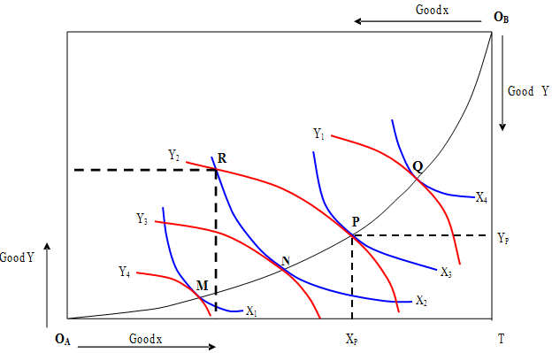

Pareto optimality in consumption

From the above graph pareto optimality or efficacy in exchange can be expressed as: MRSAxy=MRSBXY= $\frac{-Δy}{Δx}$

Suppose that R in the above box is the initial distribution of commodity X and Y by individual A and B the individual A has Xp unit of X and Yp unit of Y. Given the indifference curve for OA for A and OB for B. consumer A wellbeing is enhanced by moving to the origin of consumer B and vice versa. The initial endowment put consumer A at indifference curve X2  and consumer B indifference curve at Y2 at point R the MRSxy for consumer A is greater than MRSxy for consumer B hence A will scarify more Y to get a unit of X and B will scarify more unit of X to get a unit of Y .such situation leads to exchange . From the point R A will trade some Y to B receiving X for exchange .The exact barging reached by the two consumers cannot be determined. If A is skill full negotiator A may induce B to move along Y2 from point R to point P while A move from indifferent curve X2 to X3. Thus, individual A receives all the gain from exchange while B gain or loss nothing and if consumer B is skill full negotiator, the reverse will happened. At point P X3 and Y2 and B move from R to P both can gain from exchange ,thus starting from point R, both individual can gain through exchange by getting to point on the line N and P. The curve that joins the locus of all tangency point on the indifference curve of the two individual is called the contract curve. Along the contract curve MRSxy is the same for both consumers and the economy is in general equilibrium of exchange.

1. **General equilibrium in production or Efficiency production (optimal allocation of factor or resource**): it is impossible to increase the output of one commodity, without by re-allocating factors with our decreasing the production of other. It can be achieved only when all the consumers have the same rate of marginal substitution technical substitution between the same pair of goods. Let us assume

* Two individual producers A and B.
* Two input L and K.
* The only economic question to be answered is production.

To analyze production efficiency we look the concept;

**Production possibility curve (PPC) or production possibility frontier (PPF)**:If the economy is productive inefficiency, it can produce more of one good without reducing the production of other goods. Along the production possibility frontier, the economy cannot produce more of one good, without giving up some of other goods given a fixed set of resource.

**Iso -cost line**: Giving the different combinations of inputs that cost the firm the same amount. The slope of Iso cost line is the price ration of the two factors.

It requires factors are so allocated in such a way that; MRTXsLK=MRTYsLK

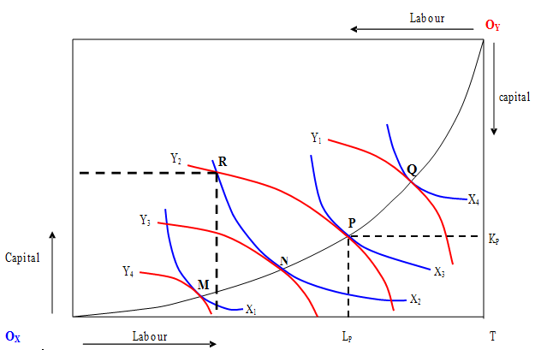

Transferring some units of a good from a person who derives a lower utility to a higher utility. The pareto optimal allocation of commodities can by illustrated by edge worth box. Isoquant of firm A convex to the origin OA and isoquant of firm B is convex to OB. The initial endowment put firm A at isoquant L2 and firm B isoquant at K2 at point R the MRTSLK for firm A is greater than MRSTLK for firm B hence A will scarify more K to get a unit of L and B will scarify more unit of L to get a unit of K .such situation leads to production. From the point R A will trade some K to B receiving L for production .The exact barging reached by the two firms cannot be determined. If A is skill full negotiator A may induce B to move along K2 from point R to point P while A move from isoquant L2 to L3. Thus, firm A receives all the gain from production while B gain or loss nothing and if firm B is skill full negotiator, the reverse will happened. At point P L3 and K2 and B move from R to P both can gain from production ,thus starting from point R, both firms can gain through production by getting to point on the line N and P.

The curve that joins the locus of all tangency point on the isoquant of the two firms is called the contract curve. Along the contract curve MRSTLK is the same for both firms and the economy is in general equilibrium of production. The contract curve shows efficient allocation of commodities (pareto optimal allocation). Along the contract curve marginal rate of substitution is equal along the contract curve.

**A production possibility curve (PPC)** shows us all possible combinations of production quantities of multiple products. The production quantities represent maximum possible output and are based on full and efficient use of currently available resources and of the current production technology.

1. **Perfect Competition and General Economic Efficiency**

General equilibrium in two inputs, two output case

**Assumption**

* Two individual producers A and B.
* Two input L and K.
* The only economic question to be answered is production.
* Two individual A and B in the society. A and B each possess a given amount of a given amount of both goods as their initial endowment
* Two commodities X and Y, these commodities are available in a fixed amount.
* Assume perfect information among sellers and buyers of a product
* Given state of information about technology.

Under general equilibrium analysis the three marginal condition of pareto optimality in welfare maximization are;

1. Pareto optimality in exchange
2. Pareto optimality in production
3. Pareto optimality in product- mix or composite of output.

At equilibrium MRSAxy= MRSBXY=MRTSXLK=MRTSYLK= = $\frac{-Δy}{Δx}$ = $\frac{-ΔK}{ΔL}$ Pareto optimality in welfare maximization.

## 2.5 Market Failure, Externalities and Public Goods

Dear distance learners!! What is the meanings of market failure?

………………………………………………………………………………………………………………………………………………………………………………………………………………………………

**Well done!!**

The notion of market failure basically emanates from transaction cost .This are the cost of transportation ,decision cost ,information cost ,bargain cost and legal contract enforcement cost in the presence of market failure is the rational for many government a activates . There are six important conditions under which market is not pareto efficiency. These are referred as market failure, and they provide rational for government activity. They can be taken as causes of market failure.

1. **Failure of competition (imperfect competition )** : When there is relatively few firm (beer and cement, cigarette industry in Ethiopia) ,two firm having large market share (Selam and Gion floor industry in Debre Markos town ) ,single seller supply the market, many firm producing slightly differentiated product like hotel service in Ethiopia . For such cases the completion is limited economies of scale or declining the average cost as a firm produce more which allow a large firm competitive over small firms. Additionally, imperfect information, high transportation, government activates like paten right, copy right, trade mark and government franchise etc., special knowledge of production technique by the firm, natural resource endowment leads to imperfect completion , which leads to economic inefficiency. Under imperfect completion, firm sets the extra revenue they obtain from selling one unit more marginal revenue equals marginal cost (MR=MC). With adown ward sloping demand curve, the marginal revenue has two components. When a firm sells an extra unit, it receives the price of the unit, but to sell an extra unit it must lower the price it charge on that and on the previous unit –the demand curve is down ward sloping. The revenue gained from selling the extra unit is its price minus the revenue forgone because of the expansion in sales lowers the price on all units. In the graph below, p= price level, PM=price of monopoly, PC price of perfectly competitive, DDM =demand curve for monopoly, DDC=demand curve for perfectly competitive, QM=quantity of monopoly, and QC=quantity of perfectly competitive

Graphically

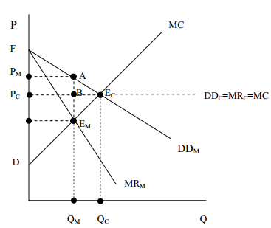

Figure 1.Dead weight loss (social cost) i.e triangle area AEMECA to the society under monopoly market structure. In the above graph the competitive equilibrium occurs at QC, while the imperfect competitive equilibrium occur at QM , a much lower level of output .This reduction in output is the inefficacy associated with imperfect completion . Of course, if there is natural monopoly with a declining average cost and with marginal cost below average cost, completion is not viable, if a firm charge price equal to marginal cost, it would operate at loss since marginal cost is lower than average costs. Even then however, a private monopoly typically charge more than a government run monopoly, the private monopoly seeks to maximize profit but the government monopoly which did not seek any subsidy and would only seek break even.

1. **Externality**: Externality is a side effect of an action which affects the well-being of 3rd party.
2. **Negative externality**: If it has adverse effect on the 3rd party it negative externality (External diseconomy). It is an instance where one individual action imposes a cost on other.

**Private sector equilibrium**: MB=MC => P=MC

**Social equilibrium**: MSB=MC+MEC

MEC+MC=P

MSC=P, P<MC.

MC>P since MEC is added to MPC and hence pareto optimality failed. It leads to deviation of private cost deviate from social. Let us see the detail as follows ;

1. **A.C pious**

Assume:

* Competitive market.
* An industry produce output and emitting pollution
* Per unit pollution is constant.
* The cost of pollution is born by others.

Given the above assumptions the best allocative solution for negative externality is per unit tax.

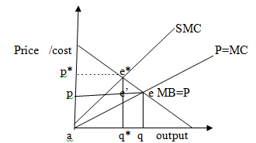

**Private actual equilibrium**: PMC=PMB

P=q at point e.

**Social equilibrium**: SMC=MB

P*=q*at e* here price is higher and output is lower. There is a cost from the society. So there is over production .However the firm is actually production of at q which is over production a distance from q to q*. It is greater than the society demand. So as to internal the cost of pollution the society choice higher price and lower output.

Social welfare =consumer surplus +producer surplus

At e=ape+Ped-aec

Welfare (W)=aed

To reduce a dead weight loss, imposing e*-e’ amount of per unit tax which rise price of goods and reduce output of the firm from q to q*.

Consumer surplus is the difference between consumers is willing to buy and actual buying price.

Then the firm produce at e*.

1. **Coasetheorm**:

Assumption

* Initially provide well defined property right
* minimize zero transaction cost
* small group of individuals

The best solution is private bargaining, in case where assignment of property right is well defined the government should disseminate environmental information i.e the government should teach the society.

1. Baumol and oates , they criticize coase theorem due to their limitation . They supported pigious solution (per unit tax) they have three alternatives.
2. Per unit tax is marginal social damage, if we can measure social damage.
3. Per unit tax is marginal abutment cost (cost required to measure marginal social cost . if we are unable to measure social damage cost .
4. Regulating and standards.

To summarize the allocative role of the government for negative externalities

* Property right
* Per unit tax
* Private bargaining

The summarized policy prescription for negative externality

* Fiscal policy like imposing per unit tax
* Private barging
* Well Defining property right and enforcing contract
* Creating market for pollutant
* Moral code and social sanctions and Developing liability schemes

1. **Positive externality**: If it has a positive effect on the 3rd party it negative externality (External economy). It is an instance where one individual’s actions confer a benefit on other.
2. **Private sector economy**: MB=MC,

P=MC

**Social equilibrium**: MSB=MC

MEB+P=MC

MEB+P>MC leads to inefficiency. There for since MEB is added to price and hence paretooptimality failed. Let us the detail as follows;

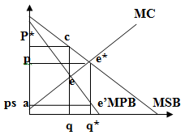

**Private equilibrium**

MPB=MC at p and q at e

**Social equilibrium**

MSB=MC =P*and q*=e*

Actual production takes place at p and q, there is a deficit of social welfare. The summarized police prescription for positive externality;

* Government legislation or legal measure.
* Fiscal instrument like per unit subsidy
* Legal reform
* Private barging

1. **Public goods**: This are some goods which are either will not be supplied by the market or, if supplied, will be supplied in sufficient quantity e.g national defense, lighthouse. It is one type of common property resource

**Characteristics of common property resource;**

* Collectively owned i.e non- excludable
* Equal right
* Difficulty to assign property right
* They are indivisible (unequal distribution may exist) give the above characteristic what type of economic behavior will emerge? it is answered by David home (pre classical economic thought). He classified these goods in two

1. **Free goods:** They are goods without opportunity cost**.**

There is conflict between short run and long run utility maximization ,unregulated self-interest behavior of individual ,indivisibility and large number of consumers , there for he answers individual will utilize common property up to the point of MU=P unfortunately price of common property resource is zero so MU is zero and hence ,over utilization of (depletion of resource will be created due to irrationality ,selfish behavior and unregulated self-interest behavior of individual .This known as tragedy of the common and hence ,the government play an allocative role in common property resource can regulate individual behavior by creating awareness programme , distributing across individual and time .

1. **Pure public goods:** It is viewed as the extreme case of externality. pure public goods have two critical properties
2. **Non- excludable**: person as consumption is not affected by person Bs or others consuming the same product that is to mean generally difficult or impossible to exclude individual from enjoyment of public goods. Non rival in consumption benefits of these goods accrue collectively to the society.
3. **Zero marginal cost of production** i.e zero marginal cost for additional individual enjoying the goods. e.g straight light. Therefore it would be inefficient to apply exclusion even if this could readily be done. Because the derived benefit by individual A from the consumption of the service does not hurt B and the additional cost is zero. The market, which works on the principle of price, will be inefficient for such goods and hence the government can play allocative role for public goods provision through private voluntary arrangement and providing through public budget.
4. **Mixed goods:** It is a half way between private and public goods. There is a problem of externality for private (excludable and rival) goods.

* If positive externality is realized Social marginal benefit is greater than private marginal benefit which leads to under production.
* If negative externality is realized social marginal cost is greater than private marginal cost which leads to over production.

Then the government play allocative role by providing per unit subsidy and self-supply by the government when there is problem inefficacy resulted from of positive externality and for inefficiency created due to negative externality by realizing property right ,reducing transaction coast .

1. **Incomplete market:** It is a market failure created, whenever private market fails to provide goods and services even though the cost of producing it is less than what individual are willing to pay. Some economists believe that the private markets have done a particular poor job for insurance (like health, life, crop insurance, flood insurance, fire insurance), and loan, and that this provides a rational for government activity in these areas.
2. **Information failure (imperfect information)**: The private market often provides an inadequate supply of information, just as it supplies an inadequate amount of other public goods. Resource devoted to research and development can be thought of us a particular important category of expenditure on information E**.**g. many of problem in health sector
3. **Unemployment , and other macroeconomic disturbances**

Most economists take that high unemployment is a prima facie evidence that something is not working well in the market. To some economists high unemployment is most dramatic and most convincing evidence for market failure. The above six causes of market failure are interrelated.

# Chapter review Questions

1. What do you mean by economic efficiency?
2. What conditions have to be satisfied, if the market is to be efficient?
3. What are the principal reasons why market fails to produce efficient out come?
4. What role does government play in making its possible for market to work at all?
5. Why might government intervene the market allocation of resources, even when it is pareto efficiency?
6. Given a perfectly competitive firms p =10 birr and TC =2Q2 -8 Q, it try to shift to monopoly market having a demand function p=4-2Q and total cost TC=2Q2 -4Q.
7. Find the dead weight loss to the society due to its shift?
8. What amount of tax is imposed to adjust market failure created due to natural monopoly power?

**CHAPTER THREE**

**PUBLIC REVENUE**

**Introduction**

Dear distance learners!! Every government needs revenue to fulfill at least three functions defense of the country, maintenance of law and order and socio economic development with their respective importance. Government revenue one lion side of the same coin with government undertaking. It is impossible to discharge the allocative, productive, distributive and stabilizing and provision of merit goods role of the government. Public revenue is an income receiptcollected by the government from the public from different sources. Cognizing this facts, in this chapter we will discuss the source of government revenue specially tax sources , principles of taxation ,tax system and approaches of taxation ,tax incidence and impact of taxation in a given economy .

**Objective of this chapter**

After the end of this chapter students should be able to;

* Define the meaning and type of public revenue
* Estimate tax ratio, tax buoyancy and ,tax elasticity
* Understand Adam Smith’s Canon of Taxation
* Identify the characteristics of good tax system
* Know the different approaches of taxation
* Identify system of tax structures
* Differentiate direct and indirect tax
* Understand Impact, Shifting and Incidence of Tax and its determinates

## 3.1 Source of Public Income

We have three source of public income;

**1) Compulsion source:** Taxes of various types (Direct tax and indirect tax); fines for offences committed (penalty); compulsory loans, and tributes and indemnities arising out of war or from other reasons.

**2) Voluntary payment**: Income from public property such as lease of lands owned by the government; receipts from government enterprises which do not have monopoly power or which do not exercise their monopoly power; fees for services rendered by the government, such as registration of births and deaths, etc , and receipts from voluntary public loans.

1. **Partly Compulsory and Partly Voluntary:** According to Dr. Dalton, these sources are partly of the nature of taxes and, therefore, contain an element of compulsion and partly of the nature of price and, therefore, they are voluntary in character. These sources are; income from public enterprises using monopoly power to raise their prices above the competitive level; betterment (improvement) levy and other special assessment and income from the use of the printing press or through the issue of new paper money to cover the deficit in public expenditure; and voluntary gifts. From the all source of public revenue tax is the major source of government finance. Tax is a compulsory contribution (levy) payable by economic units to a government without expectation of direct and equivalent return (quid pro quo) from the government for the contribution made. From this definition we can understand that; Tax is not voluntary but mandatory contribution(tax payers can’ t refuse to pay) ; It is a contribution by economic unit which is called Assesses or a Tax payer . It may be individual, a body or association; it is contributed to Federal or State government; it is contributed without direct and equivalent returns for the contribution made (absence of quid pro quo) and the system of raising revenue by the government through tax is called taxation.

## 3.2. Basic concepts Tax ratio, buoyancy and elasticity of tax

**Tax base (TB):** It is a legal description of an object which tax is payable or the value of everything which is subject to taxation and anything that can be taxed has a tax base. It can be; income of an individual or organization like; Employee income, and business income, Amount of property or wealth, and the amount of inherits; process of production; value added at each stage of production and the amount of expenditure.

**Tax rate(r):** The rate that is to be applied on a tax base to determine the amount of tax liability.It has the following basic characteristics;

* It should be clearly defined and estimated so as to know tax liability of individual.

**Example:** Income tax Ethiopia (35%), Sweden (61.85% ) , Chad (60% ),Ivory cost (60% ), Japan (55.90%). Greek (50%) ,Quatar (0%), Saud Arbia (0%), United Arab emirate (0%) etc in year 2018.

* It should have clear time dimension (corporate tax, yearly, payroll tax monthly).
* Tax rate may grow (favorable economic growth) and shrink over time (drought and depression) .

**1) Tax ratio:** It is the ratio of tax revenue to gross national product (GNP). It shows tax payable capacity of a nation, economic strength of a nation, living standard level of the people, the extent of gross structure in tax potential related sectors of the economy. The determinates of tax ration are thus per capitals income, living standard of the people, industrial and agricultural development, composite of tax structure and efficiency of tax collection machinery. So that, tax revenue is determined by tax base, tax rate and tax coverage.

Tax revenue/GDP ratios vary widely around the globe. Performance in Sub-Saharan Africa (SSA) and Latin America has improved slightly, overall tax collection has increased from 16-17 percent in 1990 to 19 percent in 2005 (Addison & Levin 2011). In Sub Saharan Africa there has been an increase in the average tax shares in GDP since the late 1990s, but this was very largely due to a marked increase in revenue from natural resources .Tax revenue instability has been documented as particularly important in Sub-Saharan Africa and the countries did not succeed well in eliminating this instability over the period 1980-2005 (Ehrhart & Ebeke, 2010). The OECD data shows, tax/GDP ratios in sub-Saharan countries where tax administration reforms are being implemented now exceed 16.8% of GDP, which was the average for fragile and lower income countries.

**2) Tax buoyancy (TB):** It is the percentage change in tax revenue with growth of tax base .

$$TB=\frac{\%Tax Revenue }{\%Tax base }$$

Typically the base is taken to be GDP, although other bases are possible (e.g. consumption as the base for sales taxes, imports as the base for tariffs, etc.). The revenue could refer to total tax revenue, or to revenue from any given tax. Tax buoyancy is a measure of efficiency of tax collection and responsiveness of gross revenue mobilization in response to growth in GNP or GNI. The increases are measured in real terms - i.e. after adjusting for inflation. If the increases were measured in nominal values then the estimate of TB would be biased towards (Jonathan Haughton,1998) .

**3) Tax elasticity (ET)**

It is the proportionate change in tax revenue per proportionate change in tax coverage or revision of its rate. $ET=\frac{\%Tax Revenue }{\%Tax rate }$

Tax elasticity is best measure of tax responsiveness .This looks just like tax buoyancy, but there is a crucial difference, which is that revenue is calculated as it would have been if there had not been any change in the tax laws, including the tax rates or bases. Thus the tax elasticity is a hypothetical construct. It tries to reconstruct what would have happened, if there had been no changes in the tax rules - i.e. what tax revenue would have been if last year’s laws continued to apply this year. Elastic taxes are generally considered to be desirable, because they reduce the need to tinker (re-new) with the tax system every year. Tax elasticity's are unit free, and so may be compared across countries without any further modification.

**Most widely used Techniques for Estimating Tax Buoyancy**

The traditional way to estimate the elasticity of a particular tax, k, is with the following model

 (source: Tax Buoyancy vs Elasticity in a developing economy, Jane H. Leuthold Tchetche N'Guessan ,1986) .Where T is tax revenue, GDP is gross domestic product, and e is a stochastic disturbance term. Ordinary least squares are used to estimate the coefficients a0 and a1. Since the equation is in double-log form, a1 provides an estimate of the tax buoyancy because it measures the percentage response in the left-hand variable for a one percent change in the right-hand variable.

**Most widely used Techniques for Estimating Tax elasticity**



a1 provides an estimate of the elasticity of the kth tax and ATRk is the adjusted tax revenue .(ATRk) will be computed as; . For j = l, 2,...,n-l where T is actual tax receipts and D is estimated discretionary tax receipts. The subscript denotes the year of the data. Basically, the technique computes what the tax receipts would be in the absence of a discretionary change. An important underlying assumption of this technique, which may or may not be satisfied in a particular case, is that the discretionary changes are no more or less progressive than the tax structure they modify.

Technique for estimating tax elasticity is the dummy variable technique developed by Singer. This technique involves introducing a dummy variable into model (1) for each exogenous policy change. The revised model takes the form:

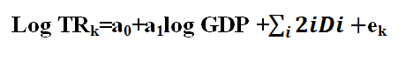

Source: (Priest and the Singer techniques ,1972) . Where the dummy variable, D, takes on the value before the discretionary change and 1 after the change. The summation accounts for the possibility of multiple changes during the period. In this model, the coefficient a estimates the elasticity. The most commonly used techniques to estimate Tax buoyancy are regress the log of tax revenue on the log of the base (e.g. GDP). The coefficient on the log of the base is a measure of the tax buoyancy. This is an elegant approach, although the results are somewhat sensitive to unusual years (outliers) and to the time interval used in the regression. TB is Regress Ln(revenue) on Ln(GDP). Tax buoyancy is a crude measure which does not distinguish between discretionary and automatic growth of revenue. Elasticity is a preferred measure of tax responsiveness since it controls for automatic revenue changes.

**4) Tax stability: -** A simple measure of the stability of tax revenue is the coefficient of variation (CV), which is defined as the standard deviation of tax revenue (as a fraction of GDP usually) divided by its mean; Tax coefficient of variation (TCV) = $\frac{standrad devation }{mean }$

The TCV may be calculated for tax revenue as a whole, or for individual sources of revenue. The measure is most useful when compared across countries.

## 3.3 Adam Smith’s Canon of Taxation

## Dear distance learners!! Can you state the canons of taxation please?

……………………………………………………………………………………………………………………………………………………………………………………………………………………………………………………………………………………………………………………………………………………………..

Well done!! Know before we list out the canons of taxation let us define the meaning of canons of taxation .

Canons are a Latin term which means a principle of taxation which governs the tax collection.

1. **Canon of Equality(justice) :** Tax should be collected based on ability
2. **Canon of Certainty:** To protect the tax­ payers from unnecessary harassment by the ‘tax officials. It should be certain, not arbitrary.
3. **Canon of Convenience:** The mode and timing of tax payment should be, so far as possible, convenient to the tax-payer.
4. **Canon of Economy:** Cost of collection should be the minimum possible**.**
5. **Canon of Productivity:** Tax system should be able to yield enough revenue for government finance.
6. **Canon of Buoyancy:** The tax revenue should have an inherent tendency to increase along with an increase in national income, even if the rates and coverage of taxes are not revised.
7. **Canon of Flexibility:** The authorities without undue delay, to revise the tax structure, both with respect to its coverage and rates, to suit the changing requirements of the economy and of the treasury.
8. **Canon of Simplicity:** The tax system should not be too complicated.
9. **Canon of Diversity**:It would not be a happy situation if the state depends upon too few a source of public revenue.
10. **Canon of Neutrality:** Tax assessor should be free from nepotism and discrimination based on race, region or localities.

## 3.4 Features (characteristics) of Sound Taxation

Know let see some of the basic attributes adopted by a good tax system;

* Equity in the Distribution of Tax Burden
* Productivity
* Recognize the basic rights of Taxpayers
* The Tax System and the Economy
* It is a compulsory contribution,
* It is levied by the government ,
* It is not conditional,
* It is a legal collection tax is for the common benefit ,
* Involve the elements of scarify ,
* Tax impose personal obligation ,
* Tax is based on taxable person ,income ,item and activity ,
* Certain tax have specific objectives ,
* Tax does not discriminate

## 3.5 Objectives of taxation

**Dear distance learners**!! What are the objectives of taxation?

……………………………………………………………………………………………………………………………………………………………………………………………………………………………………………….

That was great!!

As we know tax is a basis of financing government undertaking. Know it is time to see the main objectives of taxation in every nation.

* Raising public revenue to finance its activity.
* Minimize income and wealth inequality.
* Stabilize the economy.
* To discourage the consumption of harmful products.
* To promote private investment.
* Enhance capital accumulation.
* Reduce regional imbalance.
* Raise standard of livings.
* Encourage export (tax free zone, tax treaty.
* Create employment opportunity.
* Utilize scarce resources for production of more essential goods
* Reduce for debt burden.

3.6 Approaches to Taxation

**Dear distance learners!!** We have three approach of taxation. They are three approaches of taxation such as the benefit received approach, the ability to pay and the cost of service.

**1) The Benefit Principle of Taxation**

The benefit principle of taxation, therefore, relationship between tax payer and the government is seen as one of exchange in which tax is considered as a price to be paid for the benefit received. The burden of tax divided among the people in proportion to the benefit received. The rules of public household should be more or less like the rules that govern exchange of goods in the private market.

**Example**: A tax on petrol, for example, may be paid by motor vehicle owners against the benefit of motor way road facilities they receive from government. The act of to contract high way the finance comes from automobile product. This type of budgeting is known as **ear marking.** It means that for the same product the finance comes from the accompanied product. To generalize, the appropriate tax system or general tax formula in benefit approaches of taxation depends upon the relationship between ; The income elasticity of demand for public goods and services and; The price elasticity of demand for public goods and services .If the income elasticity of demand is high the appropriate tax rise with income rapidly but the required rate structure may be ;

* If Ey>Ep => progressive tax structure.
* If Ey=EP => proportional tax structure.
* Ey<EP=> regressive tax structure

**Example** : Let us assume the public good is tradable and having demand function Qd =300-2Po +3Yo . Where Yo is initial income and Po is initial price level. If the initial income of the consumer that are going to spend in public good is Birr 100 and the initial price of the public good is Birr 10per units of good bought .Then ;

1. What type of tax structure you are going to adopt as revenue expert?
2. What is the problem of the above approaches of tax structure?

**Solution** :

DQ/Dp=-2 and Qo=500 unit , Po=Birr 10 per unit and Yo is Birr 100

dQ/dY= 3

/Ed/= dQ/Dp xpo/Qo= 0.04

Ey= dQ/Dp xYo/Qo= 0.60

Therefore, Ey>Ed , the appropriate tax structure will be progressive tax structure . Its main limitation is that Ey and Ep for public good is not marketable(cannot be calculated)

**Limitation of ability to approaches of taxation**

* It is unrealistic: difficult in estimation of benefit from the society.
* It violet equity principle.
* It introduces rigidity.
* It is semi-commercial relationship.
* It does not allow the allocation of resource for alternative use

**2) The costs of service approach**

It states that the bases of taxation should be the cost incurred by the government to provide service for the individual tax payers. Each individual tax payer has to pay the tax equal to the cost of service to him.

**Limitation**

* It is difficult to measure the cost of service incurred by the government to each individual tax payer .
* If the cost taken as abases of taxation, it violate equity principle .
* It violates the basic characteristics of tax is that it is compulsory contribution and has no equal and equivalent return.
* It is not faire in welfare state in the area of free medication and free education.

**3) Ability Principle approaches of Taxation**:

The ability approach is based on the broad assumption that those who possess income or wealth, consumption (expenditure spent) should contribute to the support of the government according to their relative abilities. This accepts tax as a compulsory contribution payment to the government without any direct benefit. It the most realistic and generally acceptable theory. Let see some of the justifications for ability to approaches as follows;

1. Ability principle is justified through the principle of diminishing marginal utility of income.
2. It is justified through equality of sacrifice, proportional sacrifice and marginal sacrifice.
3. It also justified on the basis of faculty. Faculty is the capacity of an individual to produce and consume and this is represented by the income and the accumulated wealth of the individual.
4. The ability to pay insures equity.

We have two types of equity;

* 1. **Horizontal equity:** People with the same or equal income or capacity pay the same tax. Its rule is merely applies the basic principle of equity under the law . If income is used as the index of ability to pay, income taxation is the appropriate instruments and people with the same income will pay the same amount of tax.
  2. **Vertical equity:** People with different income will pay different tax or people with greater ability to pay more. Its rule is in line with equal treatment but precede on the promise that different amount of tax to be paid by people with different ability to pay. People with the same income will pay the same amount of tax under horizontal equity. However , to determine the different amount of the amount tax payable by people with different income level under horizontal equity differential will be made as follows (solving problem of vertical equity ). Equal scarify rules (John Stuart mill ) Tax payers are said to be treated equally , if their tax payment involves an equal scarifies or loss of welfare which relates to loss of income as measured by the marginal utility of income schedule . So the differentiate of the amount determined by the shape of marginal utility of income schedule and the rule that equality of scarify is defined by i.e equal absolute , equal proportional and equal marginal scarify .

1. **Equal absolute scarify:** Utility scarified due to tax should be equal for both individuals. Supported by Marshall and Sidgwick . If marginal utility curve is horizontal, the appropriate tax will be head tax (lump sum tax). If MU curve is decline ,the appropriate tax formula is in determinant it depend on the elasticity of marginal utility with respect to income and the decision rule be as follows ;

* EMU=1, Proportional .
* EMU>1, Progressive
* EMU <1,Regerssive

1. **Equal proportional scarify:** The ratio of utility scarified due to tax, the pre tax utility should be equal for both individual. It leave the relative position of total utility of tax-payers unchanged (cohen). Tax formula for equal scarify ability to pay principle and the appropriate tax formula will be decided as follows ;

* If MU is Horizontal => Proportional.
* If MU is increasing but straight line =>Regressive tax structure.
* If MU is decline but straight line => Progressive tax structure.
* If MU decline but at decreasing rate => Indeterminate

1. **Equal marginal scarify:** After tax marginal utility and income are equals; If MU curve is horizontal ,any tax system is appropriate . It good from the ground of welfare supported by Edge Worth and Pigou . If MU curve is declining, the appropriate tax system is progressive.

**Index of ability to pay**

Implementation of horizontal and vertical equity rule requires a quantitative measure of ability to pay. Ideally this measure reflects the entire welfare which a person can derive from all option available to him like; consumption, holding of wealth, and the enjoyment of leisure unfortunately, such measure is not practicable especially the value of leisure cannot be measured.

**1) Property as the basis:**It is the best index of ability to pay.

**Weakness**

* Property is not the main source of income, though itis an important one.
* Property may or may not yield an income in any particular year.
* The tax on property will fall upon the capital value of the property if, in any year, there is no income or there is actually a deficit.

**2) Income as the basis** (net income) is best than gross income. Thus, the main index of ability, it seems to be agreed generally, is income while supplementary indices can both be property and expenditure. In recent years, in many countries of the world, direct ability of taxation is based on all the three indices.

**3) Expenditure as the basis:** Expenditure measures the true utility or satisfaction derived from income. So the best index to measure the ability to pay is income than wealth and consumption for personal income tax . Despite these facts, we have the following basis of tax to construct the index of ability to pay let us see limitation as follows; Income is not utilized for investment is a very important aspect of spending, both significant and urgent. There is no sense in taking consumption expenditure as an index of ability to pay and ignoring saving and investment expenditure. The choice of tax base cannot be made in theoretical vacuum. It depends on the structure of the economy in which the taxation occurs and the tax handles which this structure provides. Example in agricultural society, property tax may be better than income and consumption since what the income obtained is consumed on the farm.

## 3.7 Rate Schedules of Taxation (Tax rate structure)

Based on the degree of progression or distribution of tax burden on tax payers there are 4 commonly used tax structure;

1. **Proportional or Flat taxation structure:** Taxes every tax payer at flat rate (singe) uniform rate.

**Table:** numerical example for proportionate tax structure

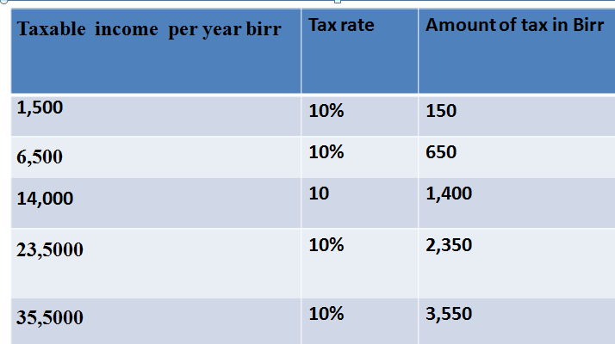

**Figure:** numerical example for proportionate tax structure

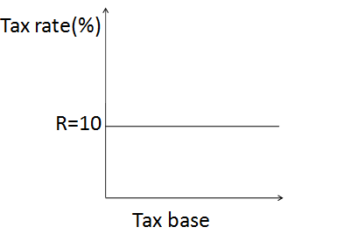

**Merit**

* It satisfies the principle of certainty and simplicity.
* It is neutral for wealth and income distribution i.e the economic status of tax payers remain the same.
* It does not affect the willingness to work more and save more.

**Demerits**

* The burden of tax falls more heavily on the poor section of the society.
* It increase income inequality gap between poor and rich individuals.
* It is less elastic and inadequacy of fund for need of the modern government.

1. **Progressive Tax structure**: It refers to that system of taxation under which the rate of taxation increases with increase in income. Tax liability to tax base increases with increase in tax base. i.e Higher income group (rich) ,more tax , Middle income group ,lower amount of tax, The lower income group (poorer) are exempted .

**Example** : Ethiopia and most developing countries adopt this type of tax structure .

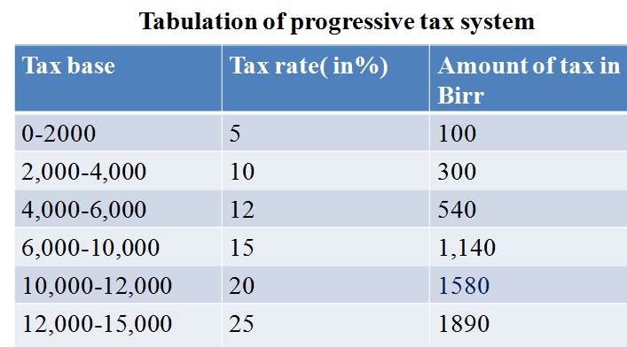

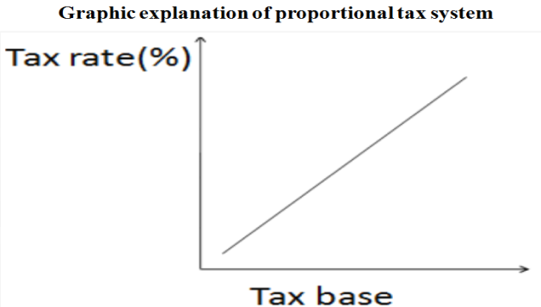

**Merit**

* Reduction income and wealth inequality.
* It both economic and elastic.
* It is help full in curbing inflation trend.

**Demerits**

* The saving potential will lost or reduced substantially.
* The rich groups invariably try to evade tax by presetting fails return of income and wealth.
* The tax rate determination is arbitrary (no guide line principle or rule of tax rate determination).

1. **Regressive tax system:** The higher income group or richer are at a lower rate and the low income group ( poor ) may pay high amount of tax . The effect of tax rate decline as the value of tax base increases .

**Example;** Denmark, Sweden and Norway have quite regressive direct taxes, as do the Netherlands and Switzerland.

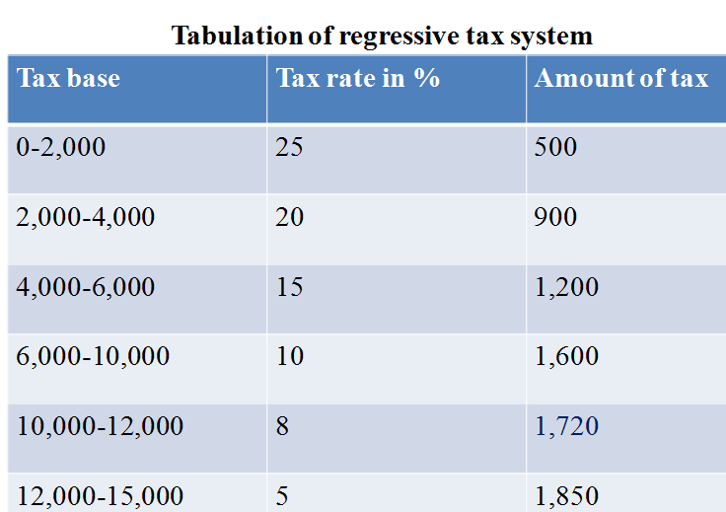

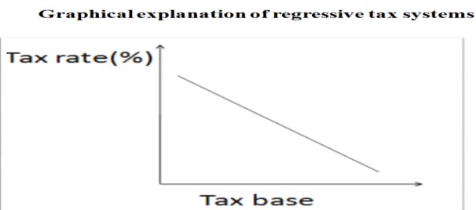

**Merit**

* Incentive to work and earn income.
* Tax mobilize by reducing consumption (MPC for poor is high.

**Demerits**

* Un faire (injustice) .
* Widen the gap between poverty and prosperity

1. **Digressive or Mild tax structure:** It is similar with progressive tax structure, but in dis-regressive the rate of progression is not the same proportion as the income. With it marginal tax rate declines, with each incremental tax base .i.e. the tax rate increase but at deceasing rate.

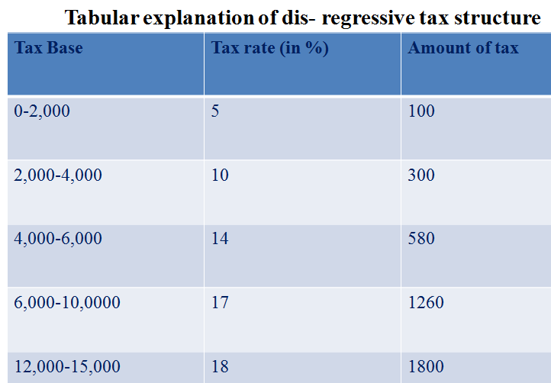

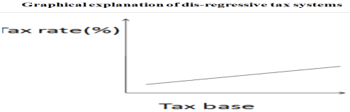

**Merit**

* Encourage incentive to work, save and invest.

**Demerit**

* Widened Income inequality**.**

Tax system is system in which tax liability is computed. There are two types of tax system in the world.

1. **The global tax system**

It is a system in which the tax liability is computed in aggregate (sum ) of all incomes and losses derived by the tax payer from different sources in the world. Tax is computed in the final balance of all business activates owned by tax payers.

1. **Scheduler tax system**

It is a system in which tax liability is computed on separate schedule. In this system income is classified for income tax purpose according to its nature and source. The classification into which the income fall are known as schedule. The Ethiopia tax system follows the schedule system of taxation where by different type of income are segregated into different schedules for computing tax liability. In Ethiopia we have five tax schedule (source : 286/2002 later modified 240/2008 income tax law, and income tax regulation 78/2002 , Tax administration pro. 241/2008 ).

1. **Schedule A**: It is used to collect employment income tax .
2. **Schedule B :** It is used to collect rental income tax .
3. **Schedule C**: It is used to collect Business income tax.
4. **Schedule D**: It used to collect other income tax.
5. **Schedule E**: Consists of list of non–taxable income.

**Category of tax payers**

The Ethiopia income tax law categorizes tax payers in to three.

1. **Category A:** Any business having annual turnover of birr 1,000,000 or above. Required to hold book of account. Declare their income monthly to the tax authority and required to pay tax July 1-October, 30. Need to collect value added tax (0, 15 and 150 %) of their sale.
2. **Category B**: Any business having annual turnover of Birr 500,000-1,000,000. Required to hold book of account and declare their income monthly to the tax authority quarterly basis and required to pay tax July 1-Augest 30 or Powagema 5/6. Need to collect Turn over tax (2 or 10 %) of their sale.
3. **Category C** : Any business having annual turnover of less than Birr 500,000 as estimated by tax authority .Not mandatory to have book of account but required to declare their income on yearly basis and required to pay tax July 1-30 . Need to collect turn over tax .Tax assessment is made in standard assessment method. (per 5 year, new assessment were made ) (Income tax proc.240/2008) .

## Direct and Indirect Taxes

**Dear distance learners**!! What is the basis of classifying tax?

………………………………………………………………………………………………………………………………………………………………………………………………………………………………

**That was great!!**

On the bases of impact (immediate burden) and incidence (ultimate burden) of tax ,taxes are classified in to ;

1. **Direct:**  Those tax whose impact and incidence fall on the same person. They are entirely paid by the individual on whom the taxes are imposed. They are levied based on income or wealth(property ) of a person .Example for the type of direct tax

* Employee income
* Rental income tax
* Business income tax
* other income taxes including
* Interest income tax, income from game of chance
* Divided income tax , casual rent of property
* Royalty income ,income from capital gain

**Advantage**

* Reduce inequality in income and wealth.
* They are certain
* They are economic
* They are elastic
* They are equitable
* They create civic consciousness

**Dis -advatage**

* Easily evaded it is a method of saving tax liability tax liability through fraud means or by directly violating tax laws such as under invoice ,overstate tax deductable expense techniques .
* Tax avoidance is a method of saving tax liability by taking advantage of loopholes in in the tax law such as splitting business or transaction techniques.
* They are unpopular
* They are inconvenient
* Taxes are arbitrary etc.

1. **Indirect tax:** Those tax whose impact and incidence fall on different person. The impact fall on the person who is legally label to pay tax to the government in the first instance .The incidence of the tax fall on the person who finally bear the burden of tax .They are tax based on consumption or expenditure of a person .Example for the of indirect tax

* Value added tax (VAT) (285/2002).
* Excise tax (307/2002).
* Turn over tax (TOT) (308/2002).
* Sur tax
* Custom duty
* Stamp duty (some time fall on the category of others )

**Advantage**

It is convince and more popular, cannot be evaded, can be elastic. ,lead to social welfare, have wide coverage, help production and investment and it can be progressive

**Dis –Advantage**

Uncertain, regressive in effect, promote inflation, high administrative cost, discourage savings and did not create civic consciousness.

## Superiority of Indirect Taxes over Direct Taxes

1. Indirect taxes which are confined to goods with zero elasticity of demand (absolutely inelastic demand) or low elasticity are regarded the best.
2. Indirect taxes are useful where external diseconomies exist on the production side or on the consumption side.
3. Indirect taxes have been found to be superior to direct taxes, since their effects on incentives to work and save may not be so harmful (unless, of course, they fall on capital goods).
4. They are also suitable for purposes of income correction.
5. It is difficult, if not also improper, to levy direct taxes on low income groups, the only way the poor can be asked to pay for government expenditure is through commodity taxes.

## 3.10 Impact, Shifting and Incidence of Tax

The impact of taxis the immediate or initial burden of tax on the person who pay it in the first instance; the person who pays the tax to the government in the first instance and hence, the person who is responsible by law to pay the tax amount to the government in the first instance.

Shift of tax is the process by which the money or economicburden of a tax is transferred from one person (seller) to another person (buyers).For Incidence of tax ultimate burden burden of tax. It is economic incidence or the initial and finical responsibility or burden**.**

Tax incidence is the study of the effects of tax policies on prices and the economic welfare of individuals. Tax incidence is not an accounting exercise but an analytical characterization of changes in economic equilibrium when taxes are changed. Tax can be shifted directly prices, which affect quantities because of behavioral responses, which affect indirectly the price of other goods. If prices are constant economic incidence would be the same as legislative incidence.

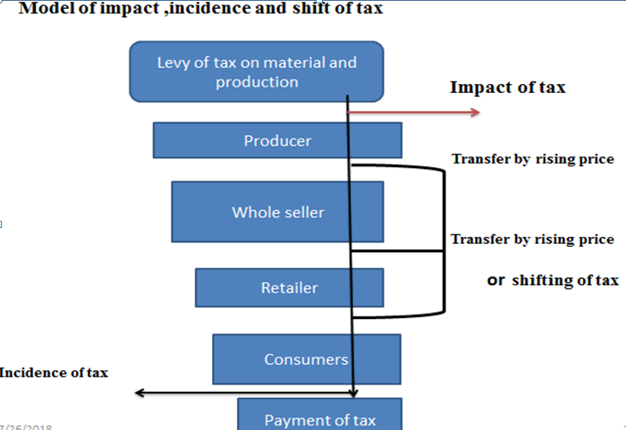

**Partial equilibrium view of product tax**

1. **Per unit tax:** It is a type of tax per unit of products. It reduces market supply in the market.
2. **Ad valorem tax:** The product tax may be imposed as a percentage of prices. It is a general product or sale taxes are necessary of ad valorem form, with a uniform rate applied to a wide range of products. If it is imposed as sale tax, it reduces demand for in the market.

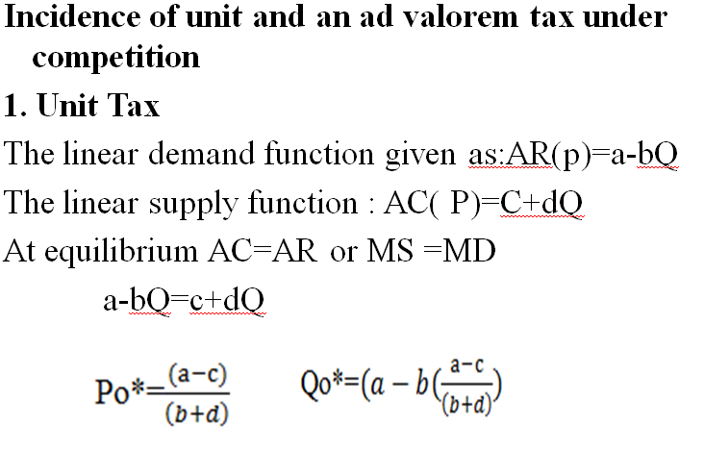

Let the government impose U amounts of per unit tax then U will reduce demand for goods in the market Demand function after tax: Pn=a-bQ-U; The supply function p=c+dQ Then , the equilibrium level of price and quantity after the imposition of unit tax will be ;

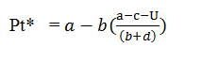

The change in gross price(∆P)= (Pt*- P*) . Where Qt* and pt* equilibrium level of quantity and price after tax .

Under the condition of fixed cost d=0 ,then the change in price reduced to : ∆P=U.

**2. Advalorem Tax**

It is Appling to gross price or market price , given the amount of tax rate **t** imposed ,then the demand will be reduced and having but supply in un affected then

* Supply function p=c+dQ
* The demand function : P=(1-t)(a-bQ)but T=tgPg

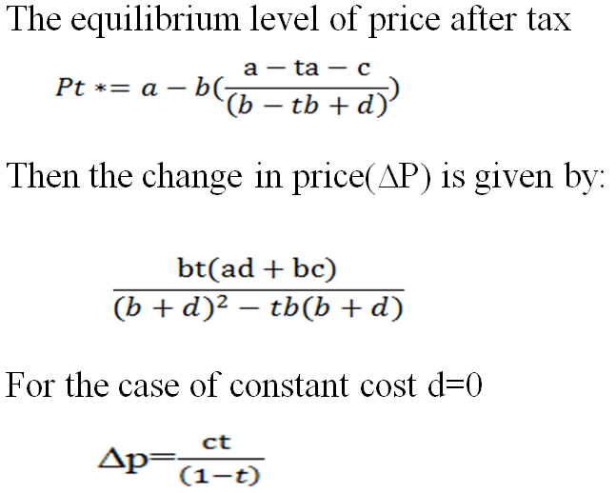

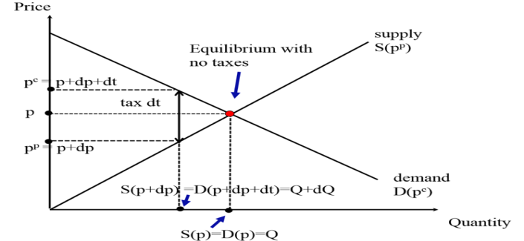

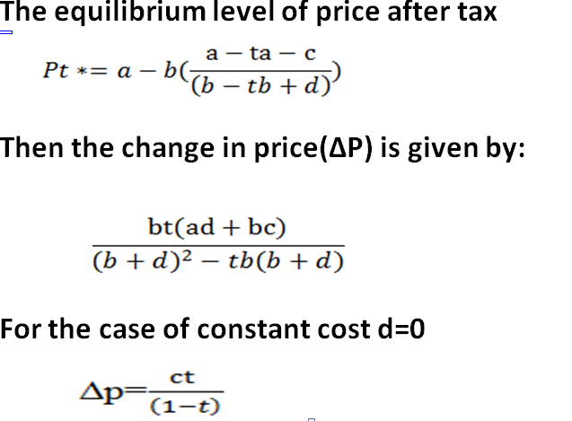

We know that for the case of unit tax, the change in price is a function of the slope of the demand and supply function only. While for ad valorem tax the intercept of the two functions also enter as determinates of price change. Given the value of U and t, the resulting change in gross price from either tax will be greater, the larger b (slope of demand function) and the smaller is d (slope of supply function ).

**Price and output effect of unit and ad valorem Taxes under monopoly**

In case of linear supply and demand function, it may be shown that the increase in price and condition of monopoly is one-half of that of the competitive case.

For monopoly firm AR=a-bQ

TR =ARXQ=aQ-bQ2

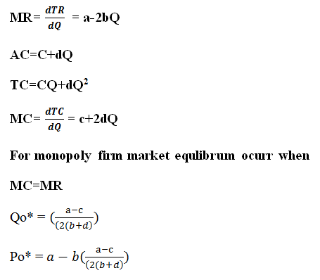

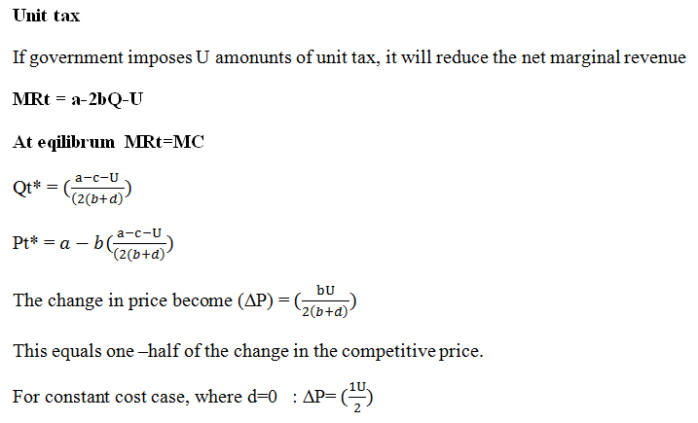

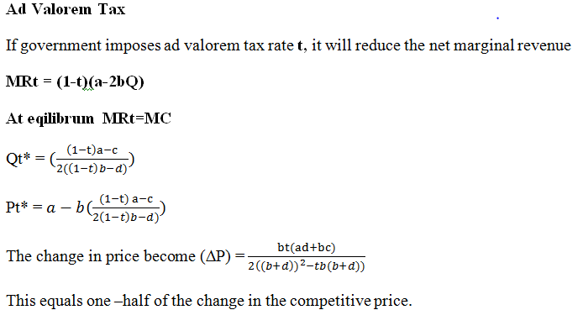

To summarize: Per unit tax = consumer price - producer price. Seller price =consumer price + per unit tax rate. So to find the seller price given the tax rate, the supply functions and demand function (ps is inverse supply function). i.e D(ps + t) = S(ps)

**Example:** Given inverse Demand: Pd(q) = 50 + q and Supply: S(p) = 10 + 7p. Suppose govt. imposes tax t = 0.90 per gallon sold.

1. Find the equilibrium level of price and quantity?

P*=10 and Q*=10.70

B) What is the after tax equilibrium?

Ans .Pt*=10.70 and Qt*=78.60

C) How much tax revenue (TR) does the government collect?

Ans .TR=70. 74

D) What amount of tax is covered by seller and buyer?

**Ans.** The amount of tax covered by seller is 0.70 per gasoline. The amount of tax takes by seller (producer)= 0.20 per gasoline .

**Dead weight burden of tax:** Deadweight burden (also called excess burden) of taxation is defined as the welfare loss (measured in Birr's ) created by a tax over and above the tax revenue generated by the tax. Welfare is measured by the sum of the consumer surplus and producer surplus. The welfare loss of taxation is measured as change in consumer plus producer surplus minus tax collected. The inefficiency of any tax is determined by the extent to which consumers and producers change their behavior to avoid the tax; deadweight loss is caused by individuals and firms making inefficient consumption and production choices in order to avoid taxation. If there is no change in quantities consumed, the tax has no efficiency costs .Deadweight burden (DWB) (or deadweight loss) of small tax dt .

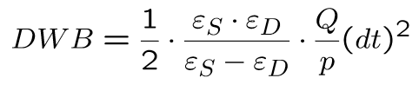

* When DWB increases with the absolute size of elasticity's es>0 and ed> 0.
* DWB increases with the square of the tax rate t. small taxes have relatively small efficiency costs, large taxes have relatively large efficiency costs.
* Pre-existing distortions (such as an existing tax) makes the cost of taxation higher: move from the triangle to trapezoid.

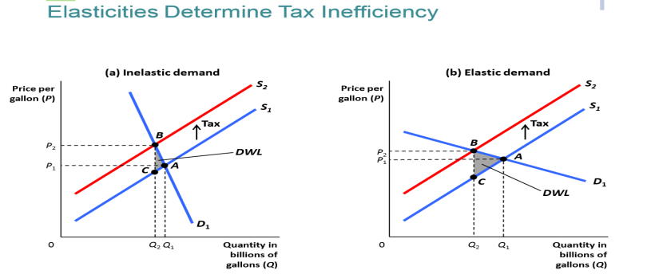

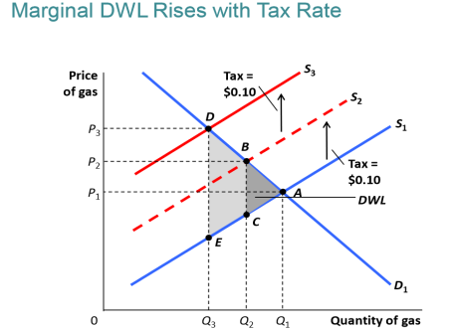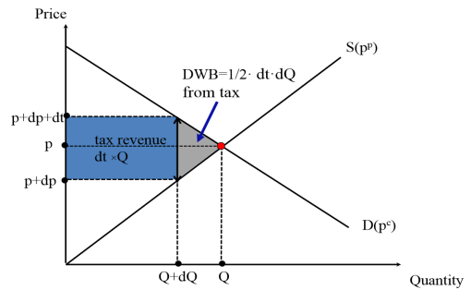

**Maximization of Revenue under unit tax Mathematical**

For a competitive industry using linear schedules. Let the demand schedule be defined by: p=a-bQ .The supply schedule by: Ps=c+dQ .

After the imposition of unit tax (u), the gross supply becomes : Psg=c+dQ +U

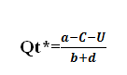

Tax Revenue (TR) then equals to TR=UxQt*



**Example:** Suppose the demand for bread has elasticity equal to -0.5 at the current equilibrium, while the demand for Berger has elasticity of -5 at current equilibrium. Bread is mostly consumed by poor people and Berger is mostly consumed by rich people.

1. Suppose that Berger is taxed at 1% rate. What is the optimal tax rate on Bread ?
2. Do you think such a tax schedule would be feasible to implement? Explain what vertical equity means in this context.

**Solution** :

A) Efficiency require ed for bread X tax rate on bread = ed for Berger X required tax rate (r )

The optimal tax rate on bread (r) = 0.01 X -5 = -0.5 r => r=10%

### 3.10.1Theories of Tax Shifting

**Dear distance learners!!** Can you state theories of tax shift please?

……………………………………………………………………………………………………………………………………………………………………………………………………………………………....

**Well done!!** Let us see theories of tax shift as follows.

1. **Concentration theory (**Physiocrats theory): All taxes will come to be absorbed by or their incidence concentrated on these two surpluses, i.e., rent and profit. i.e for land tax

**2. Diffusion theory:** Every time a thing is bought or sold, the tax levied on it gets partly shifted.

**3. Modern theory of shifting**: The price of commodity must cover the tax, i.e., the price will be increased by the amount of the tax. If, however, the price cannot be raised by the full amount of the tax, then the tax will be partially shifted to the buyer.

### 3.10.2 Forward and Backward Shifting

**1) For ward shift:** passing the money burden of tax on to the buyer of the product by raising its price, and the incidence has moved to the buyer.

**2) Back ward shift:** When the seller of the product taxed fails to raise the price and is unable to shift the tax forward, either he himself will absorb it or he will try to shift it backward to the factors of production like labor or capital.

### 3.10.3 Factors Influencing Shifting and Incidence

**1) Internal factors**

**2) External factors**

**1)Public Policy and Tax Laws:** Tax laws, on the other hand, may legally prohibit forward or backward shifting of tax through controls, restriction on prices, minimum wage legislation, and prohibition of wags cut, etc . If the government wants lower price, tax shift is impossible).Customary price (if possible to set high price set by seller, shift is possible) .Geographical coverage (wide market, possible to shift ).Availability of substitute (easy to shift ,if no substitute good) Market structure (In monopoly market possible to shift tax). Size of the tax area (if a is taxed market, possible to shift).General business conditions (during prosperity possible to shift tax).

1. **Magnitude of Tax**: Large amount of tax, tax shift takes place since absorption of tax is more likely to reduce the profit of the seller**.**
2. **Coverage of Tax:** If wide coverage of commodity or more general in nature =tax shift is easier. If non general of commodity (single brand) tax shift is difficult.

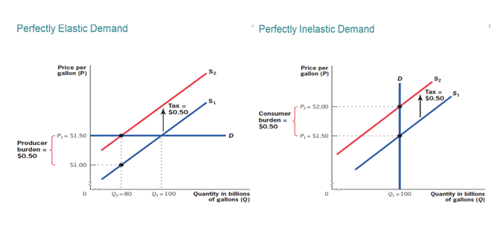

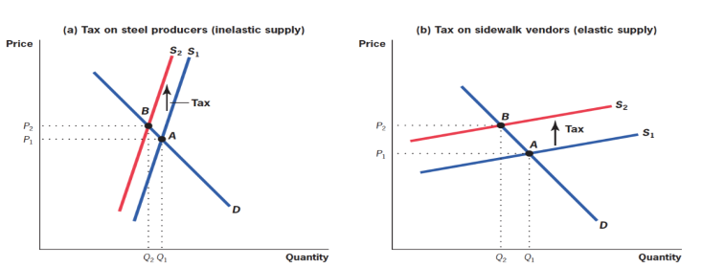

To summarize tax incidence Statutory incidence not equal to economic incidence; Equilibrium is independent of who nominally pays the tax; More inelastic factor bears more of the tax and these are robust conclusions that hold with more complicated model.

# Chapter review Questions

* 1. Define the meaning of public revenue?
  2. Define tax ratio, tax buoyancy and, tax elasticity?
  3. List and state clearly Adam smith’s canon of taxation?
  4. Explain the characteristics of good tax system?
  5. What are the different approaches of taxation?
  6. State the types of tax?
  7. Differentiate the impact of tax , and shifting and incidence of tax
  8. Given the public goods have the following demand function: Qx=300-0.50Px+0.05Y ,

1. Design the appropriate tax formula (tax structure) when price of good X is birr 10 and Income of the household in birr 50 to spend on public good assuming the public good is tradable? (Benefit principle).
2. Is this above formula practically appropriate?
   1. Given the demand and supply function in Deber Markos city administration given as; Qd=80-5P and Qs=-20+5P in Teff market. Let the government impose 3birr on each unit purchased on the bases of the above information.
3. Who is legally required to?
4. Calculate net price (Pn)?
5. Calculate gross price (gp)?
6. Calculate tax revenue collected by Debre Markos city admiration from the above Teff market?
7. Decide buyer and seller incidence using the elasticity approach?

# CHAPTER FOUR: PUBLIC EXPENDITURE

**Introduction**

***Dear learner,*** this is a chapter which deals with the expenditure of the government. In the 17th and 18th centuries public expenditure was considered as wastage of money. Thinkers said government should stay with their traditional functions of spending on defense and maintaining law and order.

Throughout the 19th century, most governments followed laissez faire economic policies and their functions were only restricted to defending aggression and maintaining law and order. The size of public expenditure was very small. But now the expenditure of governments all over the world has significantly increased. In the early 20th century, John Maynard Keynes advocated the role of public expenditure in determination of level of income and its distribution. In developing countries, like Ethiopia, public

Expenditure policy not only accelerates economic growth and promotes employment opportunities but also pays a useful role in reducing poverty and inequalities in income distribution.

**Objectives**

After studding this chapter students will be able to:

➢ Define public expenditure

➢ Realize why public expenditure increase from time to time

➢ State the different theories of public expenditure and make a comparison among the different theories by considering their strong and weak sides

➢ Explain the effect of public expenditure both on production and employment

➢ Recognize what government expenditure could incorporate so as to achieve its objectives of economic development?

## 4.1 Meaning and Nature of Public Expenditure

Dear students, could you define public expenditure? use the space provided for your response.

___________________________________________________________________________________________________________________________________________________________________________________________________________________________,Have you tried it? Good!!!

**Public expenditure** is the flow of financial means within the public budget system. Thus, the funds are allocated within the state’s fiscal functions. They stick to the principle of being nonrefundable and non-equivalent. Public expenditure is covered by public income, possibly including debt tools.

As the role of the state increases, then in addition to funding state institutions, there is a higher need of also funding **public projects** or even completing **public expenditure programmes**.

This is not related only to public fund operations, but they are also connected with a certain specific target. Thanks to their functioning, it is possible to put the following items into effect:

a) Specific goods and services, or investment units;

b) Corrections of unfair distribution of wealth towards an affected group;

c) Stimulating economic entities to behave in a certain way (e.g. developing a certain branch of the economy, etc.).

An expenditure program is more complex than a project. A program contains goals, procedures, timetables, and may also contain partial projects. Programs usually have a longer-term character compared to projects.

**Types of Public Expenditure**

Public expenditure may be classified into developmental and non-developmental expenditures.

Former includes the expenditure incurred on social and community services, economic services, etc. Non-developmental expenditure includes expenditures made for administrative service, defense service, debt servicing, subsidies, etc.

Public expenditure is classified into revenue expenditure and capital expenditure. Revenue expenditure includes civil expenditure (e.g., general services, social and community services and economic services), defense expenditure, etc. On the other hand, capital expenditure comprises expenditures incurred on social and community development, economic development, defense, general services, etc.

Public expenditure may also be classified as plan expenditure and non-plan expenditure. Non-plan expenditure falls under two broad heads, viz., revenue expenditure and capital expenditure. The former comprises interest payments, defense expenditures, subsidies, pensions, other general services (like health, education), economic services (like agriculture, energy, industry, transport and communication, science, technology and environment, etc.). Expenditures on agriculture, rural development, irrigation and flood control, energy, industry and mineral resources, etc., are included in plan expenditure.

**Importance of Public Expenditure**

An old-fashioned dictum says that **“The very best of all plans of finance is to spend little, and the best of all taxes is that which is least in amount.”** No one today believes this philosophy.

In the 1930s, J. M. Keynes emphasized the importance of public expenditure.

The modern state is described as the **‘welfare state’**. As a result, the activities of the modern government have widened enormously. Modern governments are undertaking various social and economic activities, particularly in less developed countries (LDCs).

**i. Economic Development:**

Without government support and backing, a poor country cannot make huge investments to bring about a favorable change in the economic base of a country. That is why massive investments are made by the government in the development of basic and key industries, agriculture, consumable goods, etc.

Public expenditure has the expansionary effect on the growth of national income, employment opportunities, etc. Economic development also requires development of economic infrastructures. A developing country like India must undertake various projects, like road bridge-dam construction, power plants, transport and communications, etc.

These social overhead capital or economic infrastructures are of crucial importance for accelerating the pace of economic development. It is to be remembered here that private investors are incapable of making such massive investments on the various infrastructural projects. It is imperative that the government undertakes such projects. Greater the public expenditure, higher is the level of economic development.

**ii. Fiscal Policy Instrument:**

Public expenditure is considered as an important tool of fiscal policy. Public expenditure creates and increases the scope of employment opportunities during depression. Thus, public expenditure can prevent periodic cyclical fluctuations. During depression, it is recommended that there should be more and more governmental expenditures on the ground that it creates jobs and incomes.

On the contrary, a cut-back in government’s expenditure is necessary when the economy faces the problem of inflation. That is why it is said that by manipulating public expenditure, cyclical fluctuations can be lessened greatly. In other words, variation of public expenditure is a part of the anti- cyclical fiscal policy.

It is to be kept in mind that it is not just the amount of public expenditure that is incurred which is of importance to the economy. What is equally, if not more, important is the purpose of such expenditure or the quality of expenditure. The quality of expenditure determines the adequacy and effectiveness of such expenditure. Excessive expenditures may cause inflation.

Moreover, if the government has to impose taxes at high rates there will be loss of incentives. So, it is necessary to avoid unnecessary expenditure as far as practicable, otherwise benefits of better economic development may not be reaped. As a fiscal policy instrument, it may be counterproductive.

**iii. Redistribution of Income:**

Public expenditure is used as a powerful fiscal instrument to bring about an equitable distribution of income and wealth. There are good much public expenditure that benefit poor income groups.

By providing subsidies, free education and health care facilities to the poor people, government can improve the economic position of these people.

**iv. Balanced Regional Growth:**

Public expenditure can correct regional disparities. By diverting resources in backward regions, government can bring about all-round development there so as to compete with the advanced regions of the country. This is what is required to maintain integration and unity among people of all the regions. Unbalanced regional growth encourages disintegrating forces to rise. Public expenditure is an antidote for these reactionary elements.

Thus, public expenditure has both economic and social objectives. It is necessary to ensure that the government’s expenditure is made solely in the public interest and does not serve any individual’s interest or that of any political party or a group of persons.

## 4.2. Causes of Growth in Public expenditure

**Dear distance learners**, could you list some of the causes of public expenditure? you can use the space provided for your response.___________________________________________________________________________________________________________________________________________________________________________________________.Have you tried it? Good!!

For the last many years public expenditures have been growing for so many reasons. Some of the reasons for the growth of public expenditure are thought be as follows:

**(a) Size of the Country and Population:**

We see an expansion of geographical area of almost all countries. Even in no-man’s land one finds the activities of the modern government. Assuming a fixed size of a country, developing world has seen an enormous increase in population growth. Consequently, the expansion in administrative activities of the government (like defense, police, and judiciary) has resulted in a growth of public expenditures in these areas.

**(b) Defense Expenditure:**

The tremendous growth of public expenditure can be attributed to threats of war. No great war has been conducted in the second half of the twentieth century. But the threats of war have not vanished; rather it looms large. Thus, mere sovereignty, demands a larger allocation of financial sources for defense preparedness.

**(c) Welfare State:**

The 19th century state was a **‘police state’** while, in 20th and 21st centuries modern state is a **‘welfare state’**. Even in a capitalist framework, socialistic principles are not altogether discarded. Since socialistic principles are respected here, modern governments have come out openly for socio-economic uplift of the masses.

Various socio-economic programmes are undertaken to promote people’s welfare. Modern governments spend huge money for the purpose of economic development. It plays an active role in the production of goods and services. Such investment is financed by the government.

Besides development activities, welfare activities have grown tremendously. It spends money for providing various social security benefits. Social sectors like health, education, etc., receive a special treatment under the government patronage. It builds up not only social infrastructure but also economic infrastructure in the form of transport, electricity, etc. Provision of all these require huge finance. Since a hefty sum is required for financing these activities, modern governments are the only providers of money. However, various welfare activities of the government are largely shaped and influenced by the political leaders.

**(d) Economic Development:**

Modern government has a great role to play in shaping an economy. Private capitalists are utterly incapable of financing economic development of a country. This incapacity of the private sector has prompted modern governments to invest in various sectors so that economic development occurs.

Economic development is largely conditioned by the availability of economic infrastructure.

Only by building up economic infrastructure, road, transport, electricity, etc., the structure of an economy can be made to improve. Obviously, for financing these activities, government spends money.

**(e) Price Rise:** Increase in government expenditure is often ascribed to inflationary price rise.

## 4.3. Public expenditure: Canons, Theories and Accountability of Public

## Expenditure

### 4.3.1. Canon of public expenditure

The main ***principles or canons of*** public expenditure are as follows:

**(i) The Principle of Maximum Social Advantage:** The government expenditure should be incurred in such a way that it should give benefit to the community as a whole. The aim of the public expenditure is the provision of maximum social advantage. If one section of the society or one particular group receives benefit of the public expenditure at the expense of the society as a whole, then that expenditure cannot be justified in any way, because it does not result in the greatest good to the public in general. So we can say that the public, expenditure should secure the maximum social advantage.

**(ii) The Principle of Economy:** The principle of economy requires that government should spend money in such a manner that all wasteful expenditure is avoided. Economy does not mean miserliness or niggardliness. By economy we mean that public expenditure should be increased without any extravagance and duplication. If the hard-earned money of the people, collected through taxes, is thoughtlessly spent, the public expenditure will not confirm to the cannon of economy.

**(iii) The Principle of Sanction:** According to the principle, all public expenditure should be incurred by getting prior sanction from the competent authority. The sanction is necessary because it helps in avoiding waste, extravagance, and overlapping of public money. Moreover, prior approval of the public expenditure makes it easy for the audit department to scrutinize the different items of expenditure and see whether the money has not been overspent or misappropriated.

**(iv) The Principle of balanced Budgets:** Every government must try to keep its budgets well balanced. There should be neither ever recurring surpluses nor deficits in the budgets. Ever recurring surpluses are not desired because it shows that people are unnecessarily heavily taxed.

If expenditure exceeds revenue every year, then that too is not a healthy sign because this is considered to be the sign of financial weakness of the country. The government, therefore, must try to live within its own means.

**(v) The Principle of Elasticity:** The principle of elasticity requires that public expenditure should not in any way be rigidly fixed for all times. It should be rather fairly elastic. The public authorities should be in a position to vary the expenditure as the situation demands. During the period of depression, it should be possible for the government to increase the expenditure so that economy is lifted from low level of employment. During boom period, the state should be in a position to curtail the expenditure without causing any distress to the people.

**(vi) No unhealthy effect on Production and Distribution:** The public expenditure should be arranged in such a way that it should not have adverse effect on production or distribution of wealth in the country. Public expenditure should aim at stimulating production and reducing inequalities of wealth distribution. If due to unwise public spending, wealth gets concentrated in a few hands, then its purpose is not served. The money really goes waste then.

### 4.3.2. Theories of public expenditure

'Let us now discuss some of the important theories which seek to explain the factors that determine increasing public expenditure.

**Marginal Utility Approach**

This is one of the important theories developed in the 1920s which suggested an economic approach to determine the composition of expenditure and budgeting. According to this theory, the government spends its limited income on alternative services in such a way that the marginal benefit is the same on all items. Just as an individual, in order to satisfy hisher wants, spends in a manner to achieve a certain balance among different types of expenditure which would ensure some marginal return of satisfaction from all of these. According to Pigou, "Expenditure should be so distributed between battleships and poor relief in such wise that the last shilling devoted to each of them yields the same real return." The same principle has been restated by Dalton thus

"Public expenditure should be carried just so far that the marginal social advantages of expenditure in all directions are equal and just balance the marginal social disadvantages of all methods of raising additional public income".

Though the principle of maximum social advantage is quite attractive in theory, there are practical problems in making it operational. Firstly, it is not easy to quantitatively measure the benefits flowing from diverse. Items of public expenditure for instance, expenditure incurred on defense and social security. Secondly, this theory cannot be subjected to a test. Evaluation of activities of the government is difficult due to the vast array of services and goals of the government and absence of an acceptable measure. Thirdly, it is not only the level of present satisfactions of the 'Community' that a government will be concerned with. The future interests of the community are also important.

Fourthly, what the community can afford also depends on how the money is raised and how it is spent. Expenditure on unnecessary wars or departments of the government may result in social disadvantages. Expenditure on sustaining loss-making public enterprises with social service content may, on the other hand, be easily justified. This principle is thus, at best, applicable to the use or distribution of a fixed sum rather than as a standard for determining the total size of public expenditure.

**Public Goods Approach**

Public goods are those for which no private mechanism exists for providing the demand which are consumed in equal amounts by all. People who have not paid for them cannot be excluded from their enjoyment, e.g. public parks or security. Public goods usually correspond to all goods and services provided by government and include a wide variety of goods and services. The demand for such public goods becomes an important element in the determination of public expenditure.

**Public Choice**

The recognition of the importance of the political processes in revealing public preferences has, in due course, contributed to the growth of "public choice" theories. Anthony Downs offered useful analysis of these political processes. Downs' theory, which was based primarily on the US systems, provided a general framework for explanation of public expenditure. In democratic societies, it is held; governments determine revenues and expenditure to maximize their chances for winning the election. The budgeted expenditure is determined not with reference to overall spending and taxation but through a series of separate policy decisions based on estimates of gains and losses of votes. According to Downs, government will provide what voters want and not necessarily what is beneficial. Thus the central reality for governments is the citizen's vote and not his welfare. In order to fulfill voters' demands, promises made at election time, their aspirations for projects or services, the expenditure has to expand making for larger government, larger bureaucracies, bigger budgets and more problems in trying to find resources for financing the budgeted expenditure.

**Positive Approaches**

The positive approaches are concerned with the actual growth of public expenditure over a period of time and deal with the formulation and verification of hypothesis. These include:

**Wagner's Law**

The earliest theory advanced is that of Adolph Wagner in 1876 which came to be known as "Wagner's law". He propounded the "Law of increasing expansion of public and particularly state activities" which is referred to as the "law of increasing expansion of fiscal requirements".

The law suggests that the share of the public sector in the economy will rise as economic growth proceeds, owing to the intensification of existing activities and extension of new activities.

According to Wagner, social progress has led to increasing state activity with resultant increase in public expenditure. He predicted an increase in the ratio of government expenditure to national income as per capita income rises. It is the result of growing administrative and protective actions of government in response to more complex legal and economic relations, increased urbanization, and rising cultural and welfare expenditures. Another reason is the decentralization of administration and the increase in the expenditure of local bodies.

According to Musgrave, however, it is not fruitful to seek an explanation for the total expenditure. Tests carried out by various researchers have shown that the increase in expenditures is far more complex than is evident from the tests carried out on empirical data.

Therefore, according to Musgrave, it may be far more rewarding to adopt a desegregated approach (an approach which divides the study of expenditures of government) through a study of expenditures of government on capital formation, consumption and transfer payments.

**Displacement Effect Hypothesis of Peacock and Wiseman**

Peacock and Wiseman based on a study entitled "The Growth of Public Expenditure in the UK, 1961", provided an explanation to fluctuations in public expenditure over time. The hypothesis put forward is that public expenditure grows due to growth in revenue. During settled times, people call be expected to develop notions of acceptable rates of taxation. This can be known as the tolerable level of taxation and this level cannot be high. With real economic growth, the more or less stable level of taxation will produce increasing amounts of revenues as well as expenditure. This, however, does not explain the relative increasing growth in public expenditure.

### 4.3.3. Control and Accountability of Public Expenditure

Dear distance learners, what do you think about the meaning and role of public expenditure management (PEM)? You can use the space provided for your response._____________________________________________________________________________________________________________________. Have you tried it? Good!!

*The budget should be a financial mirror of society's economic and social choices*. In order to perform the roles assigned to it by its people, the state needs, among other things, to: (i) collect resources from the economy, in sufficient and appropriate manner; and (ii) allocate and use those resources responsively, efficiently and effectively.1 Public expenditure management pertains only to (ii), and is thus only one instrument, albeit a key instrument, of government policy.

Hence, although this book focuses on PEM, readers are advised to always keep in mind the integral relationship between revenue and expenditure—i.e. between the money collected directly or indirectly from the people (and, in most developing countries, from aid donors), and the use of that money in a manner that reflects most closely the people’s preferences.2 Also, close cooperation between tax and budget officials is a must for many areas, e.g., budget forecasting, macroeconomic framework formulation, trade-offs between outright expenditures and tax concessions.

The question of the mechanisms by which the people’s preferences are ascertained, political accountability is obtained, and government action is monitored, is central to politics and very important, but outside the scope of this analysis (as well as beyond the mandate of international development institutions).3 Nevertheless, the analysis and discussion throughout this volume is largely predicated on the existence of *some* government legitimacy, *some* measure of legal and political accountability, and *some* separation of powers among the executive, legislative, and judicial branches of government. As a logical extreme, it would in theory be conceivable to “improve” PEM in a kleptocracy designed exclusively for the benefit of the power elite (as for example in Mobutu’s Zaire), but it would certainly not assist the country’s economic development.

That said, *public expenditure management is instrumental in nature*. There is a necessary distinction between the expenditure *policy* question of “what” is to be done, and the expenditure *management* question of “how” it is to be done. It is true that attempts to set hard boundaries between policy and implementation eventually lead to unrealistic policies, ad hoc implementation and, over time, both bad policy and bad implementation. However, the distinction between the soundness of PEM procedures and processes and the goals that they are meant to achieve remains very important. Among other things, the mechanisms, techniques, skills, and data required for good PEM are different from those needed to formulate good policy.

Accordingly, the analysis and discussion herein is generally applicable regardless of the economic orientation, strategic priorities, or policy choices of the government in question.

**The policy context and the objectives of Public expenditure management**

*A) The policy context*

The key goals of overall economic policy are conventionally defined as growth, equity, and stability. It has long been understood that these three goals are complementary over the long term. Economic growth provides the resources needed for poverty reduction, but cannot be sustainable if it is not accompanied by sufficient stability and equitable policies. Unstable economic and financial circumstances are inimical to growth, and typically hurt the poor most.

But stability in a context of persistent economic stagnation and poverty is hardly a desirable outcome. In the short-term, however, these goals may be mutually conflicting, and a sound resolution is required (and hence a robust institutional mechanism) that takes all three into consideration in a coherent policy package.

*B) The three key objectives of Public expenditure control or management*

As noted, public expenditure management is instrumental in nature. As a central instrument of policy, it must pursue all three overall economic policy goals. Financial stability calls, among other things, for fiscal discipline; economic growth and equity are pursued partly through allocation of public money to the various sectors; and, most obviously, all three goals require efficient and effective use of resources in practice. Hence, the three goals of overall policy translate into three key objectives of good public expenditure management: *fiscal discipline* *(expenditure control); allocation of resources consistent with policy priorities (“strategic”* *allocation); and good operational management.*7 In turn, good operational management calls for both efficiency (minimizing cost per unit of output) and effectiveness (achieving the outcome for which the output is intended).8 But in addition, as stressed earlier, attention to proper norms and due process is essential as well. This book shall return again and again to these three key objectives, but a few general considerations are advanced below.

There are linkages between the three key objectives of PEM, their corresponding major function, and the government level at which they are mostly operative. Fiscal discipline requires control at the aggregate level; strategic resource allocation requires good programming, which entails appropriate cabinet-level and inter ministerial arrangements; and operational management is largely an intra ministerial affair. It should be stressed, however, that fiscal discipline and operational management are amenable to “technical” improvement than is the strategic allocation of resources. As Petrei, 1998 puts it:

*“Resource distribution among programs is perhaps the least technical part of the budget* *process. With the exception of investment projects, spending decisions are rarely based on* *technical principles or on detailed work to determine the population’s preference. The allocation* *of funds results from a series of forces that converge at different points of the decision-making* *process, with an arbitrator who ruled according to an imperfect perception of present and future* *political realities. The ministries, the headquarters of the principal agencies, and many other* *decision-making positions are occupied by politicians who, theoretically, have developed a* *certain intuition about what people want. In any event, the effort made at this stage of the budget* *process to collect and analyze information is less than at any other stage.”*

*C) Complicating the issue*

Reality is more complex in other ways as well. Although fiscal discipline, strategic resource allocation, and operational efficiency are in general the three key objectives of PEM, in most countries the budgeting system is expected to achieve a variety of aims. A. Premchand lists eleven dimensions of public expenditure management. Most of these dimensions can be readily reconciled within the triad of PEM objectives, and some are in effect different formulations of the same objective. However, the reality is that all these dimensions— duplicative or not—has come to be associated with public budgeting at various times. Because it is manifestly impossible for any budget system to conform to all these dimensions at the same time, a strategic decision is needed regarding which one or two or three of these dimensions to focus at a given time in the specific country concerned. Thus, although we will continue to refer throughout this book to the triad of PEM objectives, the inevitable simplification should be kept in mind.

*D) A word about sequencing*

If you can’t count the money, you can’t allocate it, and if you can’t allocate it you can’t manage it. Fiscal discipline, in many ways, comes first; resource allocation and operational efficiency come next. This is literally true in those few developing countries that have extremely weak revenue forecasts and cash management systems. In those countries, improving expenditure control is first and foremost, and any effort at addressing the other two objectives of PEM would be futile and possibly counterproductive. However, it is essential to: (i) design and implement improvements in expenditure control in ways that do not jeopardize the improvements in sectoral allocation and resource management which must eventually follow; and (ii) have a clear ex-ante sense of how far to push improvements in expenditure and cash control before it becomes timely and necessary to address strategic allocation and management issues.

In countries where expenditure control and cash management are already minimally acceptable, none of the three PEM objectives of expenditure control, resource allocation, and good operational management should be pursued in isolation from the others (just as the overall policy goals of growth, stability, and equity are interrelated). Improvements in one or another area can and should go forward as and when circumstances permit (see the “tortohare” approach to reform outlined in chapter 17). But a coherent vision of the entire reform process is needed to prevent “progress” in any one objective from getting so far out of line as to compromise progress in the other two, and thus the public expenditure management reform process in its entirety. Hence, a multiyear perspective is essential for good PEM.

***The components of good governance***

There is a general consensus that good governance rests on “four pillars”: accountability, transparency, predictability, and participation. Accountability means the capacity to call public officials to task for their actions; transparency entails the low-cost access to relevant information; predictability results primarily from law and regulations that are clear, known in advance, and uniformly and effectively enforced; and participation is needed to supply reliable information and to provide a reality check for government action.

Accountability is a must everywhere, but does not become operational until one defines accountability “of whom”, “for what”, and “to whom”. Transparency can be problematic when it infringes on necessary confidentiality or privacy. Full predictability of inefficiency or corruption is not a great advantage. And it is evidently impossible to provide for participation by everybody in everything, and unwise to use participation as an excuse to avoid taking tough but necessary decisions.

*Accountability* is needed both for the use of public money and for the results of spending it.

Because, through overuse, the term “accountability” has acquired mantra-like qualities (and has no exact translation in many languages), it is helpful to unbundle it at the outset. Effective accountability has two components: (i) answerability and (ii) consequences. First, answerability (the original meaning of the word “responsibility”) is the requirement for central budget officials and sector ministry personnel to respond periodically to questions concerning where the money went and what was achieved with it. The dialogue itself matters, much more than any bean counting or mechanistic recitation of outputs. Second, there is a need for predictable and meaningful consequences (not necessarily punitive; not necessarily monetary; not necessarily individual). This should be self-evident. However, the need for consequences of some sort is so often disregarded in practice that one must make the elementary point that without consequences, “accountability” is only an empty and time consuming formality.

## 4.4. Effects of Public Expenditure of Production and Distribution

Public expenditure diverts economic resources into channels determined by the government in accordance with national objectives and public policy. As consequence, the scale and direction of public expenditure may affect the

* pattern and levels of consumption of the community
* volume of production
* allocation of resources
* distribution of incomes
* Levels of prices and employment.

These effects are discussed below:

**Consumption**

Public expenditure enhances the quality of life of people by providing recreational, cultural, educational and public health facilities, such as public parks, playgrounds, libraries, educational institutions, hospitals and dispensaries and scientific, cultural and commercial exhibitions.

Consumption, after all, is the end objective of economic activity of individuals. By promoting the level of economic activity and a more equitable distribution of income, the state can bring about a greater sense of social and economic security in the lives of individuals. The government enables them to live a fuller and richer life.

**Allocation of Resources**

Public expenditure allocates resources in accordance with national priorities. The priorities may be defense, agricultural production and self-sufficiency in food, industrial development, generation of employment opportunities, an equitable distribution of income, balanced regional development, population control, a better ecological balance etc. Public expenditure in these areas is bound to raise the community's productive power. According to Dalton "increased public expenditure in many of these directions is desirable in order to bring about that distribution of the community's resources between different uses, which will give the best results, balancing without bias the present and future". Changes in national priorities, from time to time, will be reflected in the pattern of public expenditure. Again, resource allocation has to take into account the balance between present needs and future requirements. Apart from imparting a sense of fairness as between generations, projects with long gestation periods can be undertaken only by the state. Hence allocation has to keep in view the fact that market economy cannot always take care of social needs. These can be taken care of only by the state.

**Production**

The roles of private and the public sectors are complementary. The public sector provides the infrastructure, transport and communications, power, education and public health programmes.

In the absence of goods and services provided by the government sector, private sector can hardly make any meaningful contribution towards production and development: According to

Dalton, other things being equal, taxation should not adversely affect production and public expenditure should increase it as much as possible. Public expenditure can affect (i) the ability to work, save and invest, (ii) the desire to work, save and invest, and (iii) allocation of resources as between different uses. Public expenditure can influence these factors either favorably or unfavorably.

The economies of developing countries cannot make significant progress unless they concentrate on development of investment goods sector. This may not result in production in the immediate future, as in education and health programmes, infrastructural projects and projects with long gestation periods. This would, however, certainly build up growth potential in the economy, and help take the economy to a self-generating level.

**Distribution**

In Dalton's words, "other things being equal, that system of public expenditure is best, which has the strongest tendency to reduce the inequality of incomes?" A system of grants and subsidies is equitable in the measure in which it is progressive. This leads to maximum social benefit. An approximation to this principle would be provided by a system of grants which would bring all incomes below a certain level to that level (say, above the poverty line), without adding anything to incomes above that level. A public distribution system which makes available essential commodities at subsidized prices to the poor, will also achieve the same result. Free provision of services to all members of the society e.g., free health service or free education, "narrows the area of inequality". Social security measures and social insurance schemes, which are helped partly or wholly from public funds, e.g. old age pensions, sickness and maternity benefits, unemployment relief, industrial injury compensation, widow’s pension etc., improve distribution by reducing inequality of incomes.

**Economic *S*tabilization**

Business activity in an economy is usually characterized by fluctuations of a cyclical nature. A boom in the economy may burst and lead to a depression. While during boom, prices rise beyond the reach of common person, spelling misery. During depression, employment and production levels fall drastically causing colossal damage. During depression, when employment, production and national income start declining, government can undertake compensatory spending. This may imply heavy public works programmes so that employment and incomes may pick up leading to economic recovery. During boom, public expenditure should be strictly curtailed, leading to surplus budgets. During depression, public expenditure policy would lead to heavy outlays on public works; expenditure would thus be in excess of revenues, leading to deficit budgets. Thus public expenditure, if properly planned and conscientiously undertaken, will have the favorable effect of raising employment, production and national income, after pulling the economy out of depression and thus bringing about greater economic stability.

**Economic Growth**

The goals of planning are effectively realized only through government expenditure. The government allocates funds for the growth of various sectors like agriculture, industry, transport, communications, education, energy, health, exports, imports, with a view to achieve impressive growth. Government expenditure has been very helpful in maintaining balanced economic growth. Government takes keen interest to allocate more resources for development of backward regions. Such efforts to reduce regional inequality and promotes balanced economic growth.

**4.5. Public Expenditure and Control of Inflation**

Government expenditure must reduced in non productive and long gestation period productive projects to reduce inflation pressure .i.e reduce public expenditure on civil service, defense, interest payment. Most **serious** type of inflation is due to enormous government expenditure on war, and preparation for war in peace time. The government can postpone the construction of social capital such as post offices, schools, etc. Which will increase the size of income of people but will not contribute to the increase of goods? The government can give subsidies to those industries which are producing inflation-sensitive goods so as to accelerate their production or to enable producers to sell them at lower price.

## 4.6. Content of Development Expenditure

Development expenditure of the government should aim at stimulating and supplementing private initiative and enterprise.

1. **Stimulating private initiative**:through loans, subsidies, tax concessions and exemptions and providing market and other information and research facilities.
2. **Provision of social and economic overheads***:*indirect stimulation.

1) First head education and public health.

2) Second head power, transportations and communication.

**3**. **Public enterprise**:private sector unable to undertake either due to low profit margin, require huge capital investment like, basic industries, development ofirrigation resour­ces, electric power, etc.

**Review Questions**

1. Define public expenditure and give reasons for increase in public expenditure in recent years.
2. List and explain the main principle of public expenditure.
3. Discuss the principle of maximum social advantage as applied in the field of public finance. What are its limitations?
4. Discuss How public expenditure increase production and reducing inequality of incomes?
5. State and explain what the contents of development expenditure?
6. Discuss how public expenditure could be used in curbing inflation

# 

**CHAPTER FIVE: PUBLIC BUDGET**

**INTRODUCTION7**

Dear learner Government budgets have economic, political and technical basis. Unlike a pure economic budget, they are not entirely designed to allocate scarce resources for the best economic use. They also have a political basis where in different interests push and pull in an attempt to obtain benefits and avoid burdens. The technical element is the forecast of the likely levels of revenues and expenses. In general, a government budget is an annual financial statement presenting the revenues and spending for a financial year that is often passed by the legislature, approved by the executive and presented by the ministry of finance. The budget is also known as the annual financial statement of the country. It estimates the anticipated government revenues and government expenditures for the ensuing (current) financial year.

**OBJECTIVES**

After studding this chapter you will be able to:

* Define what government (public) budget mean
* Understand the different theories of government (public) budgeting
* State the various classification of budget
* Explain the role the government budget can play as instrument of economic policy.

## 5.1. Meaning of Public Budget

Throughout the world, the processes for determining how to raise, allocate and spend public resources constitute one of the foundations of government. The way public resources are used is a major determinant of the achievement of public policy objectives. The annual budget is a key policy document, setting out a government’s intentions for raising revenues and using resources during the year. “A **government budget** is an annual financial statement showing item wise estimates of expected revenue and anticipated expenditure during a fiscal year.” Just as your household **budget** is all about what **you** earn and spend, similarly the **government budget** is a statement of its income and expenditure.

**What is a budget? Have you answered it? It is**

• A record of the past

• A plan, a statement about the future

• A mechanism for allocating resources

• An instrument for pursuing efficiency

• A means for securing economic growth

• An engine of income distribution

• A precedent

• The result of political bargaining

• The most operational expression of national policies in the public sector

Budgets are fundamental for meeting three important policy objectives:

**Aggregate fiscal discipline**: Decisions about total revenues, expenditures and financing arrangements shape the size and form of government intervention in the economy. In order to avoid accommodating all spending demands, aggregate expenditure ceilings should be set before any decisions on individual components of the budget, and should be sustainable over the medium-term.

**Allocation of resources consistent with strategic policy priorities**: Expenditures should be based on the strategic priorities set by the government, and on considerations of effectiveness and equity. This requires a coherent linkage between policy, planning and budgeting both at the intra and at the inter sect oral level.

**Efficiency and effectiveness in implementing activiti**es: government agencies should utilize budgetary resources in order to maximize their tangible outputs and outcomes.

Predictable disbursements, building adequate capacity and correcting perverse institutional incentives can assist in this respect.

Aaron Wildavsky’s definition of budgets as ‘attempts to allocate financial resources through political processes to serve differing human purposes’ points to the two main characteristics of budgeting processes in poor countries: scarcity and uncertainty. On one hand, the budget process forces public policy choices to be made, and trade-offs to be identified. However, in an environment characterized by lack of transparency and accountability, scarcity also means that budgets may be limited to wishful lists of political promises, which then remain unfulfilled as hard budget constraints start to bite during the course of the financial year, or are financed through means that put fiscal stability at risk.

At the same time, the complexity of the environment in which budgets are formulated and implemented often results in a high degree of uncertainty about actual budget outcomes. Financial shocks, political turmoil and natural emergencies can have a deep impact on normal budget practices, resulting in shifting priorities and ad-hoc measures which undermine the predictability and significance of the budget as a policy statement and guide for government action.

**What is public budgeting?**

*Government budgeting* is the critical exercise of allocating revenues and borrowed funds to attain the economic and social goals of the country. It also entails the management of government expenditures in such a way that will create the most economic impact from the production and delivery of goods and services while supporting a healthy fiscal position.

Budgeting, like any other activity, is subject to the interpretation of each practicing organization. Budgeting is the process of preparation, implementation and operation of budgets decisions into specific projected financial plans for relatively short periods of time. In other words, budgeting is the process of “translating financial resources into human purposes” (Wildavsky, 1986).

Budgeting is also viewed as a process of identifying, gathering, summarizing and communicating financial information of an organization’s future activities. Blumentritt (2006) further explained that budgeting processes include a review and study of the prior period’s financial results, projections for sales, operating expenses (fixed, variable, and semi-variable) and financing expenses, examination of proposals for capital expenditures, and means of rolling up and rationalizing figures from different functional departments to ensure they meet company-wide profit expectations.

## 5.2. Importance of Public Budget

Public budget enables countries to:

* To use their resources efficiently by setting the physical targets for different actions considering different factors, It may be formulating the programmes on the basis of past experience
* To avoid arbitrary use of resources
* Avoid corruption. Because at the end of the budget year ,the government and its various departments know that they are responsible to the legislature for their action and budgetary performances
* To achieve regional balance by reallocating funds

## 5.3. Principles of Budgeting

* Ca***non of Comprehensiveness***: according to this principle a yearly financial plan of a nation should include complete revenue and expenditure lists. It ought to be accompanied by an account of the performance of fiscal policies and programmers of the government during the previous year.
* ***Canon of Exclusiveness***: this canon suggests that public budget should exclude matters out of finance.
* ***Canon of Unity*** -according to this principle revenue should be recorded in a revenue account and expenditure ought to be recorded in the expenditure account.
* ***Canon of Specification*** -this principle suggests that every item of revenue should be specific, this means the type, and amount and time of collection ought to be determined.
* ***Canon of Periodicity*** -this rule implies that government should prepare a yearly plan of revenue and expenditure.

## 5.4. Objectives of Budgeting

Budget as a crucial and imperative instrument of economic policy would involve the following objectives.

* Building of economic overheads: In less developed countries, there is scarcity of economic overheads. Thus budgetary provisions help to build infrastructures, which in turn make important influence on industrial and agricultural development.
* Balanced development: developing countries suffer from regional imbalance in economic development. Therefore, government budget can correct these geographical back ward regions
* Poverty reduction: poverty removal programme is a part and parcel of the budget in less developed countries. All expenditure measures are designed so that they directly or indirectly influence reduction of poverty in the country.
* Full employment and price stability: A significant function of the budget is to secure the objective of full employment and price stability
* Check on misuse of public goods: No doubt budget is a financial plan relating to public revenues and expenditures. Thus it is a check whether the collected revenues are used for the proposed objectives in an efficient way or not
* Development of human capital: Skilled human labor is most important for any countries development more than anything. Thus budget provisions can go a long way to serve the purpose.

## 5.5. Types of Budgeting

The end product of a budgeting process is a master budget. The master budget summarizes the objectives of all subunits of an organization. It quantifies the expectation regarding the future income, the financial position, cash flows and supporting plans. Master budgets can be divided into two primary components; operating budget and financial budget which are further described below.

***Dear distance learner!*** Do you know the different types of budget? What are they? Write your on the space provided and try to relate it the following analysis.

_____________________________________________________________________________________________________________________________________________________.

***Multiple and unified budgets***

In some countries of the world, for instance U.S.A, there was traditional way of preparing budgets in parts and presents each part separately in order to evaluate specialize function of the government This types of budgets are said to be ***Multiple budgets***.

However, in now a day a type of budget that has got favor is a ***united budget***. In this case a budget is prepared in a united way; important sub portions are classified and presented separately under it.

***Revenue (current) and capital Budgets***

In various countries of the world, the budget is categorized in to

* Revenue
* Capital account.

***Revenue budget***- includes those items that have recurring nature. This means it incorporates tax as well as non-tax revenue and the expenditures financed with revenue receipts. Current expenditures, which are financed out of these revenue receipts, are all sorts of administrative as well as defiance expenditures and debt services. They are also known as non-developmental expenditures.

***Capital budget****-* includes these items that have a nature of acquiring and disposing capital assets.

This means it consists capital account receipts such as market loans, borrowing from National

Bank of a nation, through the selling of Treasury Bills, and others in order to finance capital expenditures that are intended for the creation of capital assets in the economy. They contribute to increase the productive capacity of the nation and hence, are said to be developmental expenditures. Expenditure of on construction of dam, building, and irrigation agricultural and industrial activities are examples capital budget.

**Functional Budget**- It is classified based on the purpose of the expenditure. This classification covers only the expenditure. The UN Bureau of Economic Affairs, in its " Manual for Economic and Functional classification of Government Transaction 1959" groups expenditure under five headings namely general services, community services, social services, economic service and un allocable (quoted in Bahtia, 2002).

However, the National Council of Applied Economic Research in its Economic functional

Classification of Central and State Government Budget 1957-58 did not include the group of community service. It distributed these services in to social or economic services accordingly. (Bhatia, 2002, p. 263). Therefore, the functional classification of spending has been divided in to four groups as shown below.

**General services**: *this group incorporates expenditures on civil and defense activities such as general administration, tax collection, police defense, mint and currency, external affairs, provision for against natural disasters etc.*

***Social Services***: this group involves expenditures on services like education, health, family planning, housing, library (public), broadcasting, employment program, and nutrition program for children, relief expenditure for disabled persons and etc.

***Economic Services***: this category involves all spending which facilitate economic activity directly or indirectly. They are divided into agriculture, industry, transport and communication, and other economic activities.

***Unallocable:*** this group involves those items that cannot be categorized under the above groups.

These are interest payment, pension, food subsidies, special loan, aid to foreign nations etc

5.6. Procedures of Budgetin**g**

***Dear distance learner***! Do you know the procedure of preparing a budget? Go to the nearby planning office and ask about it. Write what you get from there and try to relate with following analysis.

________________________________________________________________________________________________________________________________________________________________________________________________________________________________________.

One of the most important factors which affect economic growth is inefficient utilization of limited economic resources, Therefore, any country has to control its expenditure in such away to buttress its growth. There are different stages of controlling public expenditure. These are:

***Budget preparation***- it is the first stage of controlling annual financial Plan. The Ministry of

Finance prepares the National budget. The main target of budget preparation is to

* ·Make the plan to send and raise revenue systematically.
* ·Show economic, social and other government policies.
* ·Provide consistence means for auditing and careful implementation of financial plans.
* ·get approval and power from the legislature to raise the said revenues and spend them etc.

***Approval of Budget***- it is the second stage that implies the presentation of budget to the parliament and getting approval. The Minister of Finance presents the budget. The initial speech that it makes is emphasized on overall economic and related conditions of the nation and the main budgetary. Finally, the budget is approved by the parliament and assumes the power of law.

***Execution of Budget***- is the third stage of control over of public expenditure. The implementation of the budget will be started after it is approved but with great commitment to avoid wastage.

***Auditing of Budget***- is the fourth stage of control over of government spending. In this stage the auditor audits government account and prepare the audit report. This enables government to see the area where wastage exists and to correct it.

## 5.7. Theories of Government Budgeting

While federal, state, and local government budgets are driven by policy priorities and make “policy statements,” public budgeting theories have tended to focus on the rationale for incremental budget changes. As a consequence, budget theory development, particularly incrementalism, has focused on explaining budget decisions rather than focusing on how budget policy and budget content is determined. An inherent assumption of incremental budget theory is that marginal budget decisions are the “necessary tools for policy change negotiation” as marginal changes are more politically feasible. Therefore, incrementalism has greater value for explaining marginal budget or policy tradeoffs than as a theory that explains what is in public budgets or what goods and services should be provided by the public v. the private sector.

Also, by emphasizing small budget changes, incrementalism has been criticized for its inability to explain large, no incremental, budget adjustments. Authors such as Caiden raised concerns regarding “time-bombs” , and others have found evidence of large budget changes that pose problems for incremental budget theory. Still others determined that while incremental budget changes may predominate, breaks in incremental funding must be accounted for and analyzed

So while a descriptive budget theory such as incrementalism provides insights into marginal budget and policy adjustments, it is lacking in its ability to explain why nonincremental budget reallocations might occur. Moreover, incrementalism lacks the ability to explain why programs or policies are being executed through the public expenditure budget. Assuming that the budget is an articulation of policy and policy change, a theory that explains why programs may or may not be in the budget under different circumstances is a valuable addition to budget theory. A corollary to that conceptual question is: In a federalist system which level of government should budget for various expenditures, or how should the costs of the public programs be shared across government levels? This issue is becoming an increasingly important public policy concern.

Public expenditure theory can be considered as a policy-based theory of public budgeting. In contrast to incrementalism, public expenditure theory considers which goods and services or programs should or may be provided by government and included in a public budget. Also, public expenditure theory provides insights regarding which budget, federal, state or local, various programs should be in rather than explaining how final budget allocations are resolved.

In addition, public expenditure theory-based policies may produce nonincremental budgetary changes as well. Such policy driven budget adjustments may contribute to the nonincremental changes.

It is generally agreed among economists that there are basic responsibilities and functions of government in a free market economy. These functions are:

* The allocation function
* The distribution function
* The stabilization function

**Allocation Function**

The marketplace, through the interaction of supply and demand, determines the “optimal” provision and allocation of most goods—those produced in a perfectly competitive market. In addition, the marketplace automatically answers the three basic economic questions that must be answered in every economic system: (1) what is produced; (2) how are goods produced; and (3) how are the goods produced distributed? However, if the assumptions of the competitive model are not satisfied “Pareto optimality,” or maximum social welfare, may not be obtained through the marketplace and a case may exist for the public sector to “allocate” resources through the political process.

Four situations that can occur may cause the marketplace to fail to optimally provide for a good or service:

1. The existence of public or collective consumption goods or services,
2. The existence of externalities,
3. The existence of natural monopolies or imperfect competition, and
4. The existence of consumer ignorance.

Each of these situations and their relevance to determining what will be in a public budget is briefly discussed in sections which follow.

**The Case of Public Goods**

Public goods are defined by two basic characteristics: non excludability and non rivalry of consumption. Non excludability exists when a good is equally available to all consumers; e.g., a fireworks display. One person’s consumption of a fireworks display does not preclude someone else consuming the fireworks.

It is impossible, or at least extremely expensive, to exclude anyone from the consumption of a public good, since these goods cannot be packaged and distributed separately to individuals. Hence, the characteristic of non excludability. Non rivalry of consumption means that individuals are not rivals over the consumption of the same good. Non rivalry exists when the marginal cost of each additional consumer is zero. For example, take the case of a lighthouse— the marginal example cost of one additional boat using the light from a lighthouse is zero. Boats are not rivals for the consumption of the light of the lighthouse.

Goods that have these two characteristics are defined to be pure public goods. (It is possible to have a situation where the characteristic of non excludability is present but non rivalry is not, or vice versa—such a good is an impure or quasi- public good.) It is recognized that in many cases, public goods, or quasi public goods can, and will, be provided by the private marketplace.

However, generally, public goods will *not* be provided through the marketplace, since no one can be excluded from the consumption of a public good. Individuals can consume a public good without having to pay for the good.

When we have public goods, individual preferences for public goods can only be revealed through a political process or by a voting system whereby each individual realizes that they must live with the choices that are collectively made, and collective preferences will be revealed through the budget process. In other words, when public support is sufficient, public goods will be provided through the budget process to deal with the special characteristics of public goods.

Moreover, when the political process determines that new goods and/or services should be provided, new programs will be established and non incremental budget changes may occur. In like manner, when the policy decision process fosters major increases for programs such as education or national defense, budget adjustments may be anticipated.

**The Case of Externalities**

When externalities exist, goods will be provided through the market process (unlike the case with public goods), but these goods will either be under- or overprovided by the market.

Therefore, governmental intervention is required to guarantee that the output of these goods is “optimal.” It should be noted again that this intervention need not require actual government provision.

Externalities are activities the production and/or consumption of which gives rise to benefits or costs to persons other than those individuals producing and/ or consuming the goods. Goods that give rise to externalities are separable and divisible and can be exchanged via the market process, yet the market still is not optimal.

Other more meaningful examples of consumption externalities exist such as the case of education. When one person consumes education, it enhances their utility (it increases their productivity and, hence, lifetime earning potential). But at the same time, consumption of education by one individual increases the utility of the rest of society since they will earn more income, pay more taxes, be better citizens, and so on. In fact, it is because the rest of society also benefits from one individual’s consumption of education that, collectively, we are willing to subsidize a person’s consumption of education and absorb part of the cost.

The case of a negative consumption externality is the converse of this. In this case, an individual consumer considers only his or her costs and benefits, but additional costs may be imposed on society. Since an individual does not consider the total costs to society, only his or her own costs as an individual, the private marketplace results in an overconsumption of the good. Thus, government intervention, for example, in the form of taxes, is required to increase the cost to the individual and, thus, cause his or her consumption to decrease. (It is noted that with small groups, bargaining may take place. For example, depending upon the establishment of property rights, one person may pay another person for the opportunity to party.) We also note that the external diseconomy may not be completely eliminated; rather, it is reduced in an efficiency level, or the level where marginal social benefits are equal to marginal social costs.

As indicated, the existence of externalities, such as positive externalities associated with education, may establish the case for public provision of goods and services by the public sector through the budget process. In other cases, such as when negative externalities are produced, the case may be made for the creation of public regulatory agencies which, in turn, are funded through the budget process. In such case, the budget allocation issues involve decisions regarding the size and capacity of the regulatory activity compared to other budget choices. The creation of new agencies and/or programs can generate non incremental budgetary changes as well.

**The Case of Natural Monopolies and Imperfect Competition**

The marketplace may also fail to allocate economic activities efficiently because the conditions of perfect competition are not met: a producer may have a sufficient share of the market such that he is able to affect the price of the product by changing his output level (i.e., he is not a price-taker.) As a result, his profit-maximizing price will not be equal to marginal cost, as is the case with perfect competition.

This situation can actually occur for several reasons: (1) the efficient size of the firm may be so large relative to the size of the market that it forms a natural monopoly; (2) the market (for a variety of reasons) may be characterized by oligopoly (e.g., the automotive industry), in which just a few firms dominate the market; or, (3) there may be a large number of firms, but each has sufficient market power that it faces a sloping, rather than a horizontal demand curve.

Economics of scale occur in production when, as the inputs into the production process increase, the output of that production process increases by proportionally greater amounts. For example, if the inputs into the production process are doubled, output will increase by more than twofold, and as a result, the average cost of production will continually decline with expansions in out99 put. In such a situation, only one or maybe just a few firms can survive in the market, given the limited demand that exists for the product. That’s why we say that such markets will be natural monopolies—one firm will generally be able to continually expand output at lower average costs and, by so doing, drive his competitor out of the market.

With the case of imperfect competition, firms set prices above marginal costs, resulting in suboptimal resource allocation. However, government intervention may not result in improved resource allocation. In fact, if government intervention results in setting prices equal to marginal costs, a decrease in welfare may result. For example, the Organization of Petroleum Exporting

Countries may set a policy resulting in increased oil prices. At the same time, if it is believed that electricity provided in a noncompetitive market is “overpriced” and the government attempts to set electricity prices equal to marginal costs (MC), an excessive use of electricity may result, visa`- vis oil products. Thus, the theory of “second best” applies to industries and sectors of the economy that are interdependent. This often places policy makers in an unfortunate position of often being forced to accept some point of inefficiency.

Relative to the budget, this form of market failure also suggests reasons for funding of public sector action. Goods and services from an industry with natural monopoly characteristics could be provided by the public sector. Alternatively, like the case of externalities, industries with monopoly tendencies can be subjected to public regulation with funding provided by the budget process.

**The Existence of Consumer Ignorance**

The final case that results in the failure of the marketplace occurs when consumers are ignorant, or do not have complete and perfect information. In such a case, consumers are not aware of all of the benefits and costs associated with the consumption of a particular good. Therefore, the consumer is not in a position to make a “rational” decision with regard to how much or how little of the good to consume. Consider the case of education. Education gives rise to externalities or benefits to individuals other than the direct consumer of the education. In addition, it is often likely that the individual consumer of education is not aware of all the benefits that accrue to him because of his consuming education. That is, many of the benefits of education are of a consumption nature—they accrue at the time of consumption. But many of the benefits of education are of an investment nature in that they do not accrue except at some period in the future. A student attending school may consider only the present cost and benefits in deciding whether or not to consider additional education. Since so many of the costs are incurred today (out of pocket expenses, forgoing income, unpleasantness of study, boring teachers) and so many of the benefits accrue in the future, it may appear that costs exceed benefits and, therefore, a rational economic decision is to not consume more education. In this case, since the consumer is ignorant of the future benefits of education, the government requires the individual to attend school through age sixteen, or the government subsidizes one’s education to reduce the cost part of the cost-benefit calculation.

As another example, take the case of drug consumption. Many of us are unaware of the full range of costs of consuming certain drugs. Thus, the federal government has established the Food and Drug Administration to regulate drug production and distribution. In fact, certain drugs are illegal and cannot be distributed at all. Again, we might note that while there exists a need for government intervention, this intervention does not imply actual government provision. Intervention again could involve the creation of a policy or program activated by the budget process.

Thus, to sum up, the interaction of supply and demand determines the optimal provision and allocation of a good produced in a perfectly competitive market. However, the perfectly competitive market fails to properly provide and allocate goods when there exists goods with public good characteristics or which give rise to externalities, when we have industries characterized by increasing returns to scale, or imperfect competition and consumer ignorance.

Thus, an economic rationale for government provision exists, and the public sector budget becomes the policy tool for government involvement in the marketplace.

**Distributive Function**

As noted above, given the absence of externalities, public goods, and consumer ignorance, perfectly competitive markets ensure that society reaches this mystical point known as Pareto optimality, or the point whereby the welfare on no one individual can be increased without causing a reduction in the utility of at least one other individual. But it is unlikely that existing factor endowments (the distribution of land, labor, and capital), society’s tastes and preferences, and technologies, will be such that the resulting distribution of income is acceptable to society. It is generally agreed then that government redistributes resources through both revenue and expenditure measures to ensure that society achieves an ethically acceptable income distribution.

What is it that determines the existing patterns of income distribution; i.e., why are some people better off than others in terms of income? The answer to this question can be partially found in the economist’s marginal productivity theories that tell us that an individual’s wages are equal to his marginal product. If some people have less income than others, the policy prescription is quite simple—increase the productivity of those with lower incomes (by means of education, better health care, job training, and more). In addition, due to market imperfections, public employment programs, wage subsidy programs, and effective enforcement of antidiscrimination laws have been implemented to enhance the effectiveness of programs designed to improve worker productivity.

At the same time, it is also recognized that productivity levels of individuals are a function of many variables in addition to education and investment in human capital. For example, some individuals are born into families with wealth or perhaps a family business that guarantees the individual a high income level. Some individuals are born with extremely high IQ levels; some people are born seven feet tall and with the ability to play basketball; and some people are born with attractive appearances and pretty voices. In all of these cases, individuals were lucky enough to be born with some special characteristic that will allow them to earn a high income.

Thus, the point is that the present distribution of income is in part determined by one’s productivity, but it is also determined in part by one’s luck.

While poverty in Ethiopia is both an absolute and a relative concept, we all readily admit that poverty does exist in this country. The question now becomes what can the government do about the existing pattern of income distribution? Government can, through the budget process, affect the income distribution, both absolute and relative, in various ways: through its tax structure, through specific expenditure programs, and through its macroeconomic policies to promote growth and full employment. Policies initiated to affect income distribution patterns may influence the traditional, incremental adjustments to program budgets, much like the adjustments resulting from policy changes relative to public goods, externalities and natural monopolies.

**Stabilization Function**

The allocative and distributive functions of government are concerned primarily with the basic microeconomic questions of what is produced, how it is produced, and to whom goods are distributed. The stabilization function, however, is concerned with the macroeconomic problems of unemployment, inflation, and economic growth.

During the Great Depression of 1929–1939, it became obvious that the labor market would not always automatically adjust to a level of full employment, and we began to look to government to help stabilize our economy through a combination of the use of monetary and fiscal policies.

The fiscal policy impacts of stabilization policy initiatives have, periodically, resulted in large or non incremental budget adjustments. Such adjustments realized as large increases in jobs programs, highway construction, and other jobs creating infrastructure pro- grams and projects may produce punctuations in historical budgetary patterns.

## 5.8. Performance and Program budgeting system (PPBS)

The budget would frame a programme structure to attain a particular objective and specify spending to attain it. Program budgeting aimed at **direct funding** more towards the achievement of **actual policy objectives** or outputs.We may think of all those expenditures allocated to the set of programmes under a particular objective as belonging to a total spending agency which is responsible for attainment of the objective .Under program budgeting, **government activities** are divided into the **hierarchical structure of program**, subprogram, activity and component (if necessary).Appropriations can then be made to **particular program according** to the priorities of the government of the day.

Burk head defines **performance budget** as one which presents the purposes and objectives for which funds are requested, the costs for programmes proposed for achieving these objectives and **quantitative data** measuring the accomplishments and **work performance** under each programme.Its main purpose is to measure the benefits and to relate them to costs incurred. The **targets to be achieved** during the budget period are **set as objectives**. Thus, a determination of attaining a specific amount of benefit from a particular outlay inevitably takes into consideration some sort of cost-benefit analysis on the basis of either past performance or comparative study of the relevant market situation,

## 5.9. Zero-Base Budgeting

Zero-base budgeting (ZBB) is a budgeting process that asks managers to build a budget from the ground up, starting from zero. However, ZBB has been the subject of a fair amount of controversy over the years, owing primarily to questions about the value derived from ZBB analysis versus the cost required to put ZBB into practice.

**A Brief History of ZBB**

Zero-base budgeting, also known simply as ZBB, has had a long and sometimes controversial history in the public sector. Zero-base budgeting first rose to prominence in government in the

1970s when U.S. President Jimmy Carter promised to balance the federal budget in his first term and reform the federal budgeting system using zero-base budgeting, a system he had used while governor of Georgia. ZBB, as Carter and budget theorists envisioned it, requires expenditure proposals to compete for funding on an equal basis – starting from zero. In theory, the organization’s entire budget needs to be justified and approved, rather than just the incremental change from the prior year.

Interest in ZBB had been in decline for many years. The large amount of paperwork and data ZBB generates, along with doubts about the method’s ability to fully meet its theoretical promises, were at least partially responsible. Also, the improving economic conditions from the low points of the late ‘70s and early ‘80s, in the U.S., and the early ‘90s, in Canada, probably reduced the perceived need for what was largely regarded as a “cutback budgeting” method.

However, pure ZBB may have largely disappeared, but it wasn’t forgotten; vestiges have lived on. In fact, ZBB seems to be experiencing a kind of resurgence.

**The Theory of Zero-Base Budgeting**

ZBB promises to move the organization away from incremental budgeting, where last year’s budget is the starting point. Instead, the starting point becomes zero, with the implication that past patterns of spending are no longer taken as a given.

To deliver on this promise, the organization is first divided up into “decision units” – the lowest level at which budget decisions are made. Decision units could be formed along functional or organizational lines – for example, a division of a department is a common decision unit, but programs could be used as well. Managers in each decision unit then prepare a detailed description and evaluation of all activities it performs, including alternatives to current service delivery methods and the spending plans necessary to achieve the decision unit’s goals. This information is used to create a number of “decision-packages,” which show marginal spending level differences that represent varying levels of effort and cost. There should be at least three decision-packages for each decision-unit, though there could be as many as ten or even more.

The three elementary categories of decision-packages are presented below. More than one decision package could be presented for each category.

• **Base package**: This type of package meets only the most fundamental service needs of the decision unit’s clientele and represents the minimum level of funding needed for the unit’s services to remain viable. There could be multiple base packages, each addressing a different way to provide the base service. This represents an important departure from incremental budgeting in that an incremental budget never considers what the absolute minimum level of funding a program can survive on is. Rather, the current level of spending is usually considered a sort of de facto minimum.

• **Current service package**: This type describes what it takes to continue the level of service currently provided to the unit’s clientele. The difference between the base package and the current service level may be expressed by multiple decision packages, with each package representing one aspect of what it takes to get from base funding to the current service level.

There could also be different decision packages describing different means for achieving the same service level.

**• Enhanced package**: This category addresses resource required to expand service beyond current levels. There could be any number of enhanced packages. In addition to the detailed information on inputs (dollars, personnel, etc.) needed to provide the service, decision packages include performance measures that express the impact of the package on service levels. For instance, a series of decision-packages from a street repair division might use measures to describe the variation in lane miles that can be maintained and the smoothness of the car ride that will be experienced (as might be expressed through a pavement quality index).

Because of the detailed information required and because decision-packages are created for the lowest levels of budgetary decision making, ZBB requires greater involvement of mid-level and perhaps even line managers – an important difference between ZBB and many other budget processes. Because each division is creating between three and ten decision packages, along with the required supporting information for each, the documentation can be substantial.

After the decision-packages are completed, they are gathered up and ranked from top to bottom within the organizational unit in which the decision unit resides. For example, in a local government, the head of a department might gather the decision-packages from the divisions of the department and then rank them all together. Decision-packages could be gathered and ranked on an organization-wide basis, but this is uncommon due to the amount of paperwork involved and because it is usually easier for a department director to rank decision-package options within his or her own department than for a chief executive or budget office to rank packages across departments.

After the packages are ranked, the ranking is then used by central budget authorities (e.g., budget office, chief executive, governing body) as the basis for making allocations. For instance, each department would submit its suggested ranking to the chief executive, who would use those rankings to formulate a recommended budget for review by the governing body.

The foremost theoretical advantage of ZBB is that it offers a rational and comprehensive means to cut the budget. ZBB can be used to make different cuts to different services based on the perceived value to the organization (rational) and all spending is put under scrutiny (comprehensive). This compares to a traditional line-item process where only incremental spending is considered and where there is no ready means to compare the value of one service versus another, and, thus, to determine different reductions in spending for different services on a rational basis. Hence, ZBB promises to move budgeting away from the use of across-the-board cuts – a budget reduction method that does not differentiate the value of one service versus another.

The other major advantage is that it gives top management better insights into the detailed workings of departments. In theory, ZBB clearly differentiates service level options, the impact of different service levels on what the community will receive from government (through performance measures), and a detailed plan for the inputs necessary to provide those service level options.

ZBB, of course, is also theorized to have its drawbacks. The most widely known is the work associated with generating the decision-packages and then reviewing them. Conceivably, an organization could develop hundreds of decision-packages, requiring substantial time commitments from every level of management to develop, review, and rank them.

Another important drawback is the reluctance of managers to suggest decision-packages below current spending. The advantage of an incremental budget process, for risk adverse departmental managers, is that only a marginal portion of their budget is on the line in any given year. Under ZBB, the whole budget is on the line and managers are, in fact, expected to actively provide far reaching options for how their budget can be cut back, including revealing the absolute minimum level of funding they can accept. This dynamic might lead managers to attempt to “game” the system, such as providing a very small number of decision-packages that contain a broad array of services, so that budget decision makers are not able to identify, much less de-fund, discrete service levels. Managers of decision-units might also deliberately give low rankings to services with high public appeal knowing that budget decision makers will refuse to cut such services thereby sparing services the department had ranked higher, but which are actually less valued by the community.

The final theoretical drawback is that ZBB is not associated with an explicit planning process that is separate from the budget process. This has two primary implications. First is that ZBB does not provide a structured method for taking account of the community’s or elected officials’ views and long-term priorities. Rather, ZBB is driven largely by managers’ perceptions and preferences. Elected officials may provide input on the final ranking of decision-packages, but even this is simply reacting to staff recommendations and, in any event, is too late to make a far reaching impact on how the budget is structured. The second implication is that because participants in the ZBB process will necessarily be preoccupied with putting together the numbers for various decision-packages, they will not be able to focus on considering significant changes to how service is provided. Rather, participants will tend to focus on the current service model and dividing that into decision-packages, instead of proposing packages for entirely new alternatives to meet the same underlying demand from the public.

**Challenges and Risks**

ZBB presents an opportunity for organizations to cut costs and improve quantitative and qualitative aspects of operations, but completing a full ZBB cycle can be both challenging and risky for most organizations. Prioritizing program needs can be threatening to some managers,29 and can prove problematic for departments with intangible outputs. Most significantly, the process itself is costly, complex, and time consuming.30 Especially compared to traditional budgeting, ZBB requires extra time and specialized training, both of which represent added costs to an organization that may already be pressed for resources.

Using ZBB may pose a risk to a company’s brand. While ZBB in and of itself will not necessarily harm a company’s brand, implementing ZBB can pose risks to customer experience and a company’s ability to price at a premium. For organizations that depend on high levels of service to maintain brand and premium pricing, pivoting to a more cost-restrictive approach could cause an unintended culture shift by changing attitudes towards cost. The new cost mindset could undermine or prohibit the very enablers of the organization’s former brand prestige and pricing power. Cutting costs deemed non-core to a company’s operations that are in fact core to its customers’ experience could harm the brand and backfire.

For the public sector in particular, it can be difficult to scrutinize all of an organization’s programs within the time constraints of a budget cycle. Government agencies that use ZBB tend to pull staff/resources off of their day-to-day activities, or give them double duty to support ZBB activities. This can make an already complex process even more challenging, especially when coupled with learning how to conduct ZBB on the fly. Also, agencies often already have established processes for conducting regular program effectiveness reviews on a periodic basis (e.g. quarterly, annually, or tied to certain milestones in a program). In these instances, ZBB can be disruptive, potentially to a prohibitive degree.

In response to these challenges and constraints, both private corporations and federal agencies can and do mitigate the risks of a full ZBB cycle by adopting aspects of ZBB on a select function basis. In the public sector, having a team comprised of consultants, advisors, and government personnel can accelerate the ZBB process by breaking down barriers, translating program-related information, and gathering data. The ZBB process can also be optimized by leveraging the established processes for the regular program reviews a government agency already conducts.

For example, agencies can add a ZBB component to annual or periodic program reviews instead of performing a separate review.

Another way private corporations and federal agencies can utilize ZBB is choosing to use only components of ZBB (such as requesting priority packages for executive evaluation) or applying ZBB irregularly or only in select departments. Adopting specific aspects of ZBB that are advantageous to an individual organization can position companies and agencies to benefit immediately from restrictive budgeting practices without suffering from the potential consequences of applying a budgeting model that is partially unsuited to their needs. Cherry picking components, however, can result in a watered-down version of ZBB that has more in common with traditional budgeting than with a full cycle of zero-based budgeting. At this point, the conversation is no longer about ZBB, but about general budgeting best practices.

## 5.10. Budget as an Instrument of Economic Policy

Government budget is an important instrument of economic policy in both developed and developing countries. In the DCs, the economy operates at full employment level and, hence, there does not exist unemployed resources. But the economy is subjected to trade cycle and, therefore, occasionally faces the problems of depression or unemployment and inflation. In the underdeveloped countries, the economy operates at less than full employment level and, hence, the main problem is how to attain economic growth/ development and growth/development process is faced with a number of problems related with ;

* + - * + allocational,
        + distributional
        + stabilisational

However, well designed government budget can solve these problems in the following ways.

**(1) *Revenue Raising Device.***The government requires enough revenue to discharge its fiscal responsibility. Given the available resources, budget secures generation of revenue through a financial plan. The receipts side of the budget clearly mentions the sources and the extent of funds for the purpose of financing state activities.

**(2) *Building of Economic Overheads.***The main reason ofunderdevelopment, of the poor countries is absence ofproper economic infrastructure. Without proper transport and communication system, large scale generation of electric power, establishment ofbasic and key industries and proper training facilities forworkers and entrepreneurs, industrial development is not possible. Similarly, agricultural production and productivity cannot improve in the absence ofproper irrigation facilities, flood control measures, technological improvement with research and development activities, etc. These facilities must be provided by the government. The cost ofsupplying these services is heavy and cannot be raised directly from the beneficiaries and the budget has a tremendous influence on the whole economy.

**(3) *Diversion of Resources to More Useful Production.***Free market mechanism leads to production of those goodswhich give maximum profit to private enterprises. Hence private investment is generally concentrated on the production of luxury commodities. It is, therefore, necessary to divert resources to the production of moreuseful goodsand services, particularly of the kind of mass consumption ones. This can be done by government interference through the budget. Imposition of heavy tax on harmful and less essential goods and tax exemption or tax concessions granted to more essential goods and services can divert resources to the production of right kind of goods and services. Grant of facilities through budgetary expenditure can also dothe same job**.[allocation of resources!!]**

**(4) *Proper Allocation of Resources:***Most efficient allocation of resources is given bythe equality between marginal cost and price which is possible only under perfect market conditions. Underdeveloped countries seriously suffer from the existence of monopoly, monopolistic competition and oligopoly. The government can correct this misallocation either in the form of production subsidy /supply of G/S and this can narrow the gap [P-MC].

**(5) *Balanced Development:***Underdeveloped countries suffer from regional imbalance in economic development. Left to the private sector which is motivated by profit maximization, the industries will be located in the urban and already-developed areas.

The government can correct this geographical imbalance by setting up public sector industries in backward areas, via;

Subsidy

Tax

Facilities

**(6) *Income and Employment:*** Income of the people in LDCs can be increased only through increased productivity and production. Budgetary provisions can go a long way to achieve this. When agricultural technology is improved through budgetary programmes, the income of the people engaged in agriculture rises. Improvement in small scale industries in the rural areas and setting up of public sector industries in the backward regions will increase employment opportunities in these industries. The budgetary provisions of employment-related tax concessions can influence creation of employment opportunity in the private sector also.

**(7) *Saving and Investment:*** In underdeveloped countries, the level of saving & investment is very low. Without increased saving and investment, economic growth cannot be achieved. Due to low level of income, marginal propensity to consume is very high and, hence, the mass people cannot save. Public saving is, therefore, necessary. The saving and investment of private individuals are also influenced by the savings-investment-related tax concessions and other budgetary subsidy programmes. Capacity and willingness to work, save and invest of the people is increased through various human capital formation measures and creation of employment opportunities.These is all done through budgetary expenditures.

**8) *Poverty Removal:*** Poverty removal programme is a part & parcel of the budget in UDCs countries.

All expenditure measures are designed in such a way that they directly or indirectly influence reduction of poverty in the economy. Direct budgetary programmes for poverty removal are those of increasing employment opportunities & creation of community assets like;

* + - * employment insurance,
      * social security,
      * consumption subsidy,
      * public distribution system & price support programmes, low-income housing,
      * area development, input supply,
      * agricultural wage restructuring,
      * etc.

**(9) *Full Employment and Price Stability****: An* important function of the budget is to secure the objective of full employment and price level stability. In the underdeveloped economies where resources are not fully employed public expenditure programmes and tax incentive measures are put into operation to secure full employment. All these measures should clearly put in the government budget.

**(10) *A Check to Misuse of Public Funds.***Since budget is a financial plan relating to public revenues and PEs for the budgeted period, it imposes definite restraints on the tax gatherer and public funds spender. The legislature and the people know from the study of budget how the revenues will be raised and how will they be spent. Revenue mobilization and public expenditure activities will be put to scrutiny of the legislature and also of the members of public. Incase of inefficiency or misuse in the task of budgetary performance, the executive agencies will be accountable. This will definitely put a check on the improper use and mishandling of public funds.

**CHAPTER SIX: PUBLIC DEBT**

**INTRODUCTION**

***Dear learner***, In this chapter you will have good understanding on Nature and kinds of public debt, Effects of public debt, Burden of public debt, Redemption of public debt and Public debt in a developing economy. Public debt indicates the amount of outstanding debt instruments that are issued by the government any time during the past but yet not repaid. Incurring public debt is a regular phenomenon in managing fiscal and monetary policy of an economy leading to governments borrowing money from local and international institutions to cover the public deficit. Mostly the lenders to the government are the financial intermediaries of the country, and in developing countries, public debt holders are banks and pension funds who hold the surpluses of the economy. According to Alisena and Tabelleni (1989) public debt has many purposes even though it seems to indicate a negative reflection of the economy. The most purpose of public debt is redistributing the income over time across generations while serving as a mechanism to minimize deadweight losses on taxation created through providing public goods and services for the well being of the public.

**OBJECTIVES**

After studying this chapter, you should be able to

* Explain the objectives of public debt
* Explain the nature of public debt and the burden of public debt
* Discuss the effects of public debt on consumption, distribution, production and on economic activities.
* Discuss the different methods of redemption of public debt and estimating debt burden of a country.
* Explain the differences of taxation and public debt
* Explain the role of public debt in economic development

## Nature and Kinds of Public Debt

In the general public debate on the complexities of government debt, hardly any distinction is made between the different forms of debt. The catch-all term “government debt” masks its various forms and the significant differences in the effects and hazards of the various types.

Government debt is the financial debt accumulated by the government sector through borrowing and the issuance of bonds, treasury bills, treasury bonds and similar instruments.

Governments borrow funds in this fashion if current spending is not completely covered by revenue. If regular expenditure exceeds non-credit revenues, this gap has to be financed through borrowing. Funding raised in this manner, unless earmarked for debt rescheduling or rolling over loans from previous fiscal years, constitutes annual net new debt. The net new debt and the loans for debt rescheduling and follow-up financing together form gross new borrowing which is much larger and requires parliamentary approval. The ratio of net new debt to gross domestic product is referred to as the deficit ratio. This is, however, different from the debt level, which is equal to the sum (positive and negative) of previous net new debt. Divided by GDP, it becomes the government debt-to-GDP ratio. As government borrowing does not mature all at once18 and the debt level by far surpasses the net new debt, there are constant transactions of (gross) debt relief and (gross) new debt. Whereas under fiscal law the gross principle generally applies, meaning that all gross transactions are recognized, as opposed to the balance of spending and revenues, this is not always the case for debt.

In general, Public debt refers to borrowing by a government from within the country or from abroad, from private individuals or association of individuals or from banking.

## 6.2 Effects of Public Debt

Effects of Public Debt on Production, Consumption, Distribution and Level of Income and Employment are assessed below.

1. **Effects on Production:** Public debts are raised to finance productive enterprises of various kinds, e.g., steel works, cement, multipurpose projects, construction of ships, railway lines and highways, heavy electrical and engineering works, mining, oil refining, etc.
2. **Effects on Consumption:** When people subscribe to government loans, they generally have to curtail consumption. Since investment of funds raised by borrowing raises the level of employment and as a result raises the level of consumption.
3. **Effects on Distribution:** Public loans transfer money from rich to government. The fiscal operations of the government are to benefit the poor primarily. The incomes of the poor increase directly through increased employment or it benefit them in directly through the enlargement of social services.
4. **Effects on the Level of Income and Employment:** In modern times, public borrowing is resorted to in order to raise funds for financing agriculture, industry, mining, transportation, communication, etc. It increases employment opportunities, the level of income and standard of living.

## 6.3 Burden of Public Debt

**The Traditional View of the Burden of a National Debt**

***Dear distance leaners***!! Is a national debt a burden on a country? If it is, what is the nature of the burden? Who bears this burden? Use the space provided for your response._____________________________________________________________________________________________________________________________________________.Have you tried it? Good!!

Questions such as these have perplexed economists at least since the days of Adam Smith. Great Britain in his day had accumulated a large national debt fighting the Seven Years War (the French and Indian War) and was about to add a further considerable sum suppressing the rebellion in its American colonies.

Interestingly, mainstream macroeconomics views the burden of a national debt, not in terms of the debt per se, but in terms of government budget deficits that are the cause of the debt and its growth. Thus, the burden that a national debt imposes on a country is due to the government’s budget deficits.

To see clearly the nature of this burden and who bears it, assume that the country’s resources are fully employed and that capital (or saving) cannot flow internationally between countries. Also assume that this country now engages in a war with a neighbor and that the increased expenditures associated with the war lead to a budget deficit that is financed by issuing bonds.

The increase in government expenditures increases aggregate demand. In a fully employed economy, in addition to raising prices, the increase in demand will lead to a rise in interest rates.

The increase in interest rates is the means by which the government obtains the additional resources to fight the war for the increase will discourage interest-sensitive spending by the private sector. This is primarily business spending for capital goods such as plant, equipment, and structures and spending by households for homes, automobiles, appliances and the like.

Thus, the budget deficit “crowds out” private capital and the burden of the growing national debt represented by the bonds issued to finance the war, is the decrease in the private capital stock of the country. The level of output is determined by the capital stock, labor force, and productivity levels. Since the private capital stock inherited by future generations will be smaller, it implies that the level of output enjoyed by them will be lower.7 The lower level of output is thus the ultimate burden of the debt and it is a burden that is largely shifted forwarded to future generations.

If the debt is taken for productive purposes, for e.g. for irrigation, transportation, railway, roads, information technology, human skill development, etc., it will not mean any burden. In fact, they will confer a benefit. But if the debt is unproductive it will impose both money burden and real burden on the economy.

**Burden of internal debt:** Internal debt involves a series of transfers of wealth within the country, i.e., from lender to government and then later on at the time of redemption from government to lender. Money is thus transferred from one section of the community to other sections. In this case the money burden on the economy is zero.

But there may be real burden on the community. In order to repay the interest and the principal amount of the debt, the government has to levy taxes. What the taxpayers pay the lenders receive. The lenders are generally rich people and tax burden is fall on poor especially in the case of indirect taxes. The net result may be that the wealth is transferred from poor to rich. This is the loss of economic welfare.

**Measurement of Internal Debt Burden**

Internal public debt indicates a financial burden on the government. The size of internal debt burden can be measured or estimated through the following methods.

* Some empirical researches (e.g., Arcand et al., 2012; Ceсchetti and Kharroubi, 2012) show that the credit(private credit )-to-GDP ratio exceeding a threshold of 90-100% of GDP **negatively impacts the economic growth.**

**Exampl**e

In the second quarter the US has $21.195 trillion as June ,29 ,2018 ,and it has also a nominal GDP of $ 20.412 trillion . Then

1. Calculate Debt to GDP ratio. Ans. 104%
2. Is the debt cost the countries economic growth? Yes, the US debt cost the economy around 44.2% in economic growth.

**2) Debt service ratio (DSR**)

A research conducted by Drehmann and Juselius, 2012, shows that another efficient leading indicator is a ratio of current **debt service payments** to r**evenue**s or expenditure.

The DSR is calculated as a ratio between accumulated debt service payments, including both partial debt redemption and interest payments, and the current revenues.

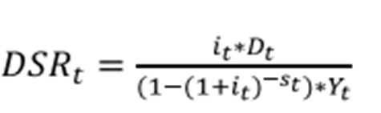

**Solvency** can be defined as the country’s ability to discharge its external obligations on a continuing basis. It is relatively easy, but not very helpful, to define a country's theoretical ability to pay.

**Liquidity:** when a shortage of liquid assets affects the ability of an economy to discharge its immediate external obligation almost always emerge in circumstances that give rise to insolvency or unwillingness to pay.

## 6.4 Redemption of Public Debt

Debt redemption is a means of repaying a loan. Different means are used by the government to redeem its debt.

**Methods of Debt Redemption**

1. **Utilization of surplus revenue:** This is an old method and badly out of tune with the modern conditions. Budget surplus is not a common phenomenon. Even when there is a surplus, it cannot be used for making any substantial reduction in the public debt.
2. **Purchase of government bonds:** The government may buy her own stocks in the market, thus wiping off its obligation to that extent. This may be done by the application of surplus revenues or by borrowing at low rates, if the conditions are favorable.
3. **Terminable annuities:** When it is intended completely to wipe off a permanent debt, it may be arranged to pay the creditors a certain fixed amount for a number of years. These annual payments are called ‘annuities’. It will appear that, during the time these annuities are being paid, there will be much greater strain on the government finances than when only interest has to be paid.
4. **Conversion of high-interest-rate loans to low-interest-rate loans:** A government may have borrowed when the rate of interest was high. Now, if the rate of interest falls, it can convert a high-rated loan into a low-rated one.
5. **Sinking fund:** This is the most important method. A fund is created for the repayment of every loan by setting aside a certain amount every year out of the current revenue. The sum to be set aside is so calculated that over a certain period, the total sum accumulated, together with the interest thereon, is enough to pay off the loan.

## 6.5 Public Debt in a Developing Economy

The debt position of developing countries is far more precarious than the picture reflected in the problems of those few developing countries that have attracted widespread attention as the largest debtors.

**Role of Public Debt in a Developing Economy**

1. Taxation should cover at least current expenditure on normal government services and borrowing should resort to finance government expenditure which results in creation of capital assets.
2. Public borrowing for financing productive investment generates additional productive capacity in the economy
3. It is used as an instrument to mobilize resources which would otherwise hoarded in real estate or jewellery
4. It provides the people opportunities to hold their wealth in the form of safe and stable income-yielding assets, i.e., government bonds
5. The management of public debt is used as a method to influence the structure of interest rates.
6. Public has become a powerful tool of developmental monetary policy
7. There are two ways in which the governments of under-developed countries raise resources through public loans:
8. Market borrowing, i.e., sales to the public of government bonds (long-term) and treasury bills (short-term) in the capital market
9. Non-market borrowing, i.e., issue to the public of debt which is not negotiable and is not exchange in the capital market, for e.g., National Saving Certificates
10. There are two forms of loans, i.e., voluntary and forced loans. Forced loans or compulsory borrowing is a compromise between taxation and borrowing. Like a tax it is a compulsory contribution to the government but like a loan, it is to be repaid with interest.

**Difficulties of Public Debt in LDCs**

1. In LDCs there are no or very small organized capital and money markets. The resources are too inadequate to fulfill the capital needs of the economy.
2. Resources are hoarded in non-productive sections of the economy, for e.g., real estate jewellery.
3. The savings in rural areas cannot be mobilized effectively because rural incomes do not move through monetary channels
4. The response to government securities is also poor because of rising prices

**REVIEW QUESTIONS**

1. Explain public debt? What is the difference between taxation and public borrowing?
2. What are the differences between public debt and private debt?
3. What is the importance of public debt in developing economy like Ethiopia?
4. What are the methods of estimating debt burden? Discuss
5. Does deficit financing always lead to inflation?
6. Discus the different methods of redemption of public debt.
7. Explain the effects of public debt on the economy of a country
8. Discuss the nature of the burden of public debt.
9. Explain the different classification of public debt.
10. What are the objectives of public debt?

# CHAPTER SEVEN

# DEFICIT FINANCING

**Introduction**

Deficit financing is a tool that is important to take over the economy from depreciation. To finance this deficit, government uses different method of financing like borrow from commercial bank and central bank. The objectives of this tool are to promote economic growth, fight unemployment and finance war e.t.c. In this part, we will discuss about means of financing, goal of deficit financing, its impact and limitation of deficit financing. Deficit financing has faced problems like promotion of import, control price and income moreover, control credit.

**Course Objectives**

At the end of this chapter, students should able to

* Define deficit financing
* Identify means of financing
* Clarify objectives of deficit financing
* Examine the effect and limitation of deficit financing

## 7.1 Meaning of Deficit Financing

**Dear leaner!** Can you define deficit financing? ………………………………………………………………………………………………………………………………………………………………………………………………………….

**It is great**! Deficit financing has become an important tool of financing government expenditure. In simple terms it means the way the gap between excess of government expenditure over its receipts is financed. However the concept of deficit financing is interpreted in different ways in the western countries. In the western countries whenever the public expenditure is greater than its revenue receipts, it is financed through public borrowing or creation of new money. Whenever there is deficit in the current account, its financing becomes deficit financing. Even public borrowing is a way of deficit financing.

In the modern sense public borrowings to finance excess of public expen­diture over revenue is included in the capital account of the budget. After including these borrowings in the capital account, there may still be a deficit in the budget. The method adopted by the government to finance this overall budget deficit in the current and capital account together is known as deficit financing. Thus budget deficit and deficit financing are two different concepts. Budget deficit is a narrower concept, referring to excess of public expenditure over current revenues. Most countries adopt a wider concept of deficit financing whereby any method adopted to bridge the budget deficit even after borrowings, becomes deficit financing. Further in the narrower con­cept, the budget deficit is managed through market borrowing out of public saving. So it is non-inflationary. But in the broader sense of deficit financing, it refers to borrowing from the banking system. Hence it is inflationary in character.

## 7.1 Different Methods of Deficit Financing

Governments can adopt three methods of deficit financing and the impact is different in each case. Firstly governments can borrow from non-bank investors or commercial banks. This is considered non-inflation­ary as it tends to replace private expenditure. For example when government borrows from commercial banks, their liquidity is reduced so that it reduces loans to the private sector. Thus the government borrowing from commercial banks replaces private expenditure and hence it is non-inflationary. If the non bank investors get loans from the commercial banks against their fixed deposits and use it to lend to government it would be inflationary.

In the second case when the government draws from its cash balances with the central (National) bank it is not inflationary. But in the third method when the government borrows from the central bank against its securities, the central bank creates new money by resorting to the printing press. This would again result in a secondary reaction of expansion of bank credit. This type of deficit financing by loans from central bank tends to be highly inflationary.

**7.2 Objectives of deficit financing**

**Dear learner**! Can you mention the major objectives of deficit financing? ......................................................................................................................................................................................................................................................................................................................

**That is great!** Deficit financing has been ascribed an important role in fiscal policy on account of increases in public expenditure on various accounts. The different objectives of deficit financing make it clear.

1. **To finance wars**. Deficit financing has been found to be the simplest and quickest method to finance huge War expenditures. War time emergency makes it difficult for government to raise urgent resources through its usual methods of taxation and public borrowing. The funds obtained through deficit financing are used by the government to purchase goods and services to fight war. This raises the aggregate demand. Resources are mobilized by the government not for productive purpose but for war efforts which is unproductive. Thus the rise in aggregate demand and non-availability of sufficient goods result in an inflationary price rise. The experience of Germany during the two world wars is a classic example of the harmful effects of Wartime inflation. During First World War, the German paper Mark depreciated so much in value that one gold Mark could not be purchased by even one billion papers Mark. Similarly during Second World War, the ratio of gold to paper currency became as low as 0.01 per cent on account of deficit financing. However, wartime emergency requires a quick mode of financing. Hence deficit financing cannot be avoided. Precautions should be taken to control private demand.
2. **To fight unemployment during depression**. Keynes advocated deficit financing as an important tool of solving the problem of involuntary unemployment during depression. This unemployment during depression occurs due to lack of effective demand since private spending is low. There­fore the only way to combat unemployment would be for the government to invest in public works programmed to create employment. Further during depression welfare payments to be made by the government would also increase. Government cannot get finance for this expenditure out of taxation or public borrowing as taxable capacity and ability to contribute to government loans is very low during depression. Hence the government has to borrow from the banking system. Thus deficit financing becomes the best mode of financing anti-deflationary expenditure.Keynes suggested that the investment undertaken by the government will result in a multiple increase in incomes via the multiplier effect. However the operation of the multiplier may not be that successful in underdeveloped countries as there is unutilized or idle capacity in both agricultural and industrial sectors. Supply of working capital is also very low. On the other hand marginal propensity to consume is very high. Thus Keynes' multiplier may actually raise the aggregate demand instead of raising the aggregate supply. Hence deficit financing to combat unemployment in underdeveloped countries requires great caution in handling so that inflationary pressures are not generated.
3. **To promote economic development**. Deficit financing can go a long way in promoting economic development in underdeveloped countries. There are two issues to be discussed here. First refers to the way in which deficit financing can be used to finance development projects. Second whether deficit financing for development results in inflationary potential. The major obstacle to development in these countries is low rate of capital formation which is not enough for sufficient investment to provide jobs for the large number of unemployed. With increasing population the level of unemployment also increases necessitating greater capital formation. Low incomes of people reduce the taxable capacity as well as ability to save. For the same reason, government cannot raise resources through public borrow­ing too. Hence deficit financing becomes the only way of mobilizing required resources, in developing countries.

Deficit financing can help to stimulate the rate of investment indirectly. Deficit financing for development first of all increases incomes and thus savings too. It results indirectly in forced saving too because when the government purchases goods and services for its projects, people do not get them. So the reduced private spending results in larger saving.

If the government uses deficit financing to undertake productive projects then output would increase and it may not be inflationary. But there are certain rigidities in the developing countries which do not result in comple­mentary factors for investment. Firstly there is a lack of entrepreneurship and technical know-how. Secondly there is no adequate infrastructure such as organizations, market communications etc. These market imperfections fail to increase effective supply along with increasing demand and these causes rising prices.

Further elasticity of supply is not the same in different sectors of the economy. For example elasticity of supply tends to be low in agriculture than in industry. In the initial stages of development if the government expenditure is directed towards these sectors whose elasticity of supply is low, it is certain to increase incomes and demand in these sectors but lack of supply response would raise prices. In all these cases, if deficit financing used for development schemes results in inflationary price rise, the government should carefully raise taxation to siphon off the excess purchasing power in the hands of the people.

Another way in which deficit financing can promote development is when it increases the incomes of the entrepreneurs whose propensity to save is high. In fact this may result in greater inequality of income. But in the initial stages, higher propensity to save of the entrepreurial class is a wel­come feature in the interest of general economic development. This fits into the theory of imbalanced growth given by A.O. Hirshman.

In general it is accepted now that so long as care is taken to avoid inflationary potential, deficit financing is a very useful instrument of devel­opment in developing countries. Deficit financing should preferably be used for quick yielding projects in the initial stages so that the increase in produc­tion will control inflationary pressure. If development projects have long gestation period, deficit financing for such projects would bring in inflation­ary price rise. Hence in developing countries deficit financing should be carefully used in the initial stages to lay a good foundation for necessary infrastructure for development.

1. **To mobilize surplus, idle and unutilized resources**. Keynes had advocated deficit financing for the mobilization of surplus labour and other resources during depression. This argument may be applicable to underdeveloped countries only with limitations. If deficit financing is used to employ such labour in the agricultural sector in these countries, it may create inflationary price rise.

On the other hand deficit financing is recommended for its ability to create new resources in these countries. When deficit financing raises prices in these countries, it reduces consumption and savings become forced. Thus deficit financing is recommended in developing countries for the mobilization of forced savings or for the creation of new resources, which again can be used for next stage of development. That is why W. A. Lewis said that "Inflation for the purpose of capital formation is in due course self-destructive".

1. **To finance the Plans.** In developing countries like Ethiopia which have adopted planned economic development huge resources are required for implementation of government investment. The government takes greater interest to create infrastructure, industrial development in vital sector be­sides transport and communication. Deficit financing is a. useful tool to finance the Plans.
2. **To serve as an alternative tool.** Underdeveloped countries suffer from low taxable capacity and low savings. Hence government's ability to raise resources gets constrained. Therefore there is no harm in resorting to deficit financing as an alternative source of mobilizing resources besides taxation and public borrowing.

## 7.3 Effects of Deficit Financing

**Dear learner!** Discuss the two major impact of deficit financing? …………………………………………………………………………………………………………………………………………………………………………………………………………………………………………………………………………………………………………………………..

**That is great!** Deficit financing can make or mar progress if it is not carefully planned. It has diverse effects depending upon how it is handled. The major effects pertain to inflation and distribution of income.

1. **Deficit financing and inflation.** There are two views regarding the impact of deficit, financing on prices. The first view is that deficit financing is pro inflationary. This view holds that the first impact of deficit financing is on the creation of new money. Deficit financing is recommended for the creation of capital goods whose gestation period is long. There is increase in money incomes in this sector. But consumer goods producing sector does not respond quickly to bring more production. This results in rise in prices of consumer goods which may prove to be spiraling. The price rise will be greater if market imperfections exist as bottlenecks to increased production.

Further, a part of the increased incomes, in the absence of sufficient goods to spend, may be channelized into commercial banks who may use it for further credit creation. In fact in developing countries the inflationary pressures are due to monetary expansion after deficit financing. Inflation then tends to be demand-pull type while deficit financing in developed countries causes cost-push type of inflation on account of long-term gestation projects.

The poor developing countries are not well equipped in terms of mone­tary and fiscal policy to control inflation. Hence there is a possibility that unabated inflation on account of deficit financing may hinder economic development of these countries.

The second view holds that deficit financing is not necessarily inflationary because public sector has emerged as a dominant sector in these economies. If this additional finance is utilized for productive purposes, it need not be inflationary. Deficit financing is required to provide finance for increasing output at stable prices. If deficit financing is not resorted to there may be a decline in prices which will have an adverse effect on output and employment.

W. A. Lewis points out that there are three stages in the impact of deficit financing. In the first stage, only capital goods industries are created through deficit financing and as they have long gestation, prices rise steeply. In the second stage, the rise" in prices makes people reduce consumption which results in forced savings which increases investment. In the third stage, the capital formation of the first stage begins to bring consumer goods to the market which helps to lower prices. Therefore deficit financing is 'danger­ous and painful' only in the first stage. In Lewis' view inflationary potential of deficit financing is therefore self-destructive. Others however point out that if the consumer goods are not increased in the second and third stages due to some constraints, inflation becomes rampant.

1. **Effect on distribution of income.** Deficit financing has certain un­desirable effects on the distribution of income. Deficit financing provides incentives to entrepreneurs through larger profits on account of rising prices. But the same rising prices reduce real incomes of the wage earning class. This leads to a distribution of income in favour of the profit earning classes. Hence inequality of incomes widens. This is very much against the social objectives of equitable distribution of income and wealth. Thus an analysis of the objectives and effects of deficit financing proves that it is a double-edged sword. Its effects can be good so far as it promotes capital formation and does not allow for a steep increase in prices. Its effects can be harmful if the inflationary potential goes uncontrolled, bringing about adverse effects on distribution of incomes and wealth, thus increasing in­equality. The exact impact of deficit financing depends upon the mode of deficit, governments' attitudes and policies, reaction of the private sector and growth of the public sector.

Deficit financing can be a very useful and effective fiscal tool for devel­opment in under developed countries if it is used only for capital formation to channelize resources into productive areas. The mild price rise on account of deficit financing in the early stages acts as an incentive to entrepreneurs to increase productive activity. Such a functional rise in prices is harmless.

## 7.4 Limits to Deficit Financing

Dear learner! Can you mention the major limitation of deficit financing? ...................................................................................................................................................................................................................................................................................................................

**That is great!** It is now recognized that deficit financing is a bad master but can be a good servant *i.e.,* it should be handled carefully without using it excessively. This raises the question as to what is the safe limit for deficit financing. Several factors are to be considered in determining the safe limit.

1. **Growth rate of the economy and money supply.** The money supply should expand to facilitate the growth rate of the economy. Suppose the total money supply in the economy is 4,000 million Birr and the growth rate of the economy is 5 per cent, it requires an additional money supply Birr. 200 billions per annum to sustain the growth rate. Hence deficit financing can be used to create Birr 200 billion per annum. But since it is used for productive assets creation, deficit financing can be even more than 5 per cent of the money supply. Thus even 7 or 8 per cent expansion in money supply on account of deficit financing need not be inflationary in developing countries.
2. **The efforts made by the government to mobilize its resources.** Deficit financing should be used only as a last resort after all alternative source of finances are exhausted. The public will not mind the effects of deficit financing when they know that the government has undertaken all efforts to mobilize other resources and only when they are exhausted, deficit financing is adopted.
3. **Control of incomes and prices.** Deficit financing to finance govern­ment projects enters the income stream in the form of wages and salaries. It is this increasing incomes and wages which exert an inflationary pressure. Hence a proper control over income and prices acts as a control over the inflationary potential of deficit financing.
4. **The growth of monetized sector.** It is the existence of a large non-­ -monetized sector which aggravates the inflationary potential of deficit financing. The extent to which the non-monetized sector is brought into the ambit of monetized sector, acts as a safe limit to deficit financing.
5. **Increase in the production of public sector**. Deficit financing is incurred to finance public sector projects. If their production increases, this increase in production will cushion the inflationary potential of deficit fi­nancing. It is for the same reason deficit financing should not be incurred for unproductive purposes.
6. **Promotion of imports**. Deficit financing is bound to increase incomes in the initial stages which causes and increase in demand for goods and services. Since production does not increase immediately in the early stages, the inflationary pressures can be kept within safe limits by permitting import of goods. This of course depends upon the foreign exchange reserves to the country.
7. **Restriction on credit:** A large portion of new money created through deficit financing may reach the banking sector in which case it gives them an opportunity to create credit further. Restriction on credit can limit infla­tionary pressures.
8. **Direct and indirect control**. Government should adopt various measures to control prices directly and indirectly. Direct control refers to the control of prices beyond the stipulated levels. It is a type of administered prices. Indirect controls result in government's improving the public distri­bution system to supply goods to the people at reasonable prices.
9. **Public spirit of cooperation and toleration.** Some economists point out that "The role of public understanding and public cooperation is a factor in tending to diminish the price effect of deficit financing". Unless the government enjoys the public cooperation, it will have to face open, popular and political opposition to further use of deficit financing when the prices rise excessively. The spirit of tolerance on the part of public acts a limit on government's use of deficit financing.

In the final analysis the state of the economy, the purpose for which deficit financing is incurred, the control over money expansion, prices and incomes, the magnitude of the deficit financing, are all factors /which, limit the government's powers to resort to deficit financing excessively.

**Review question**

1. Define deficit financing**?**
2. List and explain the objectives of deficit financing?
3. What are the different means of deficit financing made by the government?
4. Discuss the impact of deficit financing on the economy?
5. Describe the major limitation of deficit financing?
6. How domestic debts solve deficit financing?

# CHAPTER: EIGHT

# Fiscal Policy

**INTRODUCTION**

Government can manipulate revenue and expenditure of the economy with the help of fiscal policy. This policy promotes the economy through achieving full employment, equitable distribution of income and wealth, proper allocation of resource and price stability. In this chapter, we will discuss about how fiscal policy works, components of fiscal policy, objectives of fiscal policy and types of fiscal policy. The two types of fiscal policy are discriminatory and compensatory. Tax and expenditure are the major components.

**COURSE OBJECTIVE**

**At the end of this chapter, students should able to:**

* Examine component of fiscal policy
* Identify the major objectives of fiscal policy
* Explain the two type of fiscal policy

## 8.1 Meaning Fiscal Policy

**Dear learner!** Define fiscal policy and its components? ………………………………………………………………………………………………………………………………………………………………………………………….. ………………..

**That is great!** Fiscal policy is defined by Arthur Smithies as "a policy under which the government uses its expenditure and revenue programme to produce desir­able effect and avoid undesirable effects on the national income, production and employment". This definition acknowledges that the government expen­diture and taxation are the two fiscal tools which can have desirable as well as undesirable effects on macro variables like income, production and em­ployment. Otto Eckstein defines fiscal policy as "changes in taxes and expenditure which aim at short run goals of full employment, price level and stability". This definition adds two more goals of fiscal policy viz., price level and stability. Urusula Hicks broadens the scope of fiscal policy. She defines it as a policy "concerned with the manner in which all the different items of Public Finance ... may collectively be geared to forward the aims of economic policy". Thus besides public expenditure and taxation, public debt can be included as the third element of fiscal policy. Gerhard Colm therefore defines fiscal policy "as the conduct of the government expenditure, reve­nues and debt management in such a way as to take fully into account the effect of these operations on the allocation of resources and the flow of funds, and thereby their influence on the levels of income, prices, employ­ment and production".

Fiscal policy differs from monetary policy in its mode of operation, Gardner Ackley points out "unlike monetary policy these measures involve direct government entrance into the market for goods and services (in case of expenditure) and a direct impact on private demand (in the case of taxes)". Thus the impact of fiscal policy on aggregate demand is direct while the monetary policy can affect the aggregate demand only indirectly through the banking sector.

**Fiscal Instruments**

Government expenditure, taxation and public borrowing are three fiscal tools which act as levers to bring changes in income, employment and prices.

1. **Public Expenditure**

Government expenditure incurred in any way results in an increase in wages and salaries of its employees in the form of interest payment on debts or results in welfare payments like pensions or social security benefits. They tend to increase the disposable incomes of the people which cause an increase in the aggregate demand for goods and services. Thus an increase in government expenditure increases aggregate demand while a decline in public expenditure decreases aggregate demand. Therefore during inflation public expenditure should be reduced to control the demand-pull inflation. During depression public expenditure gains much importance. Keynes had established that the Great Depression of 1930s was caused by deficiency of aggregate demand. Private investment will be sluggish during depression. Expenditure on public works programmes must be increased to raise aggregate demand.

Government expenditure on public works programme or welfare benefits either way result in an increase in incomes. This increase in incomes causes an increase in consumption. Increase in consumption again results in the secondary increase in income. This income-consumption effect goes on and the initial increase in public expenditure brings about a multiple increase in income. This can be illustrated with the help of government expenditure multiplier.

 *(1)*

where, 

 whereis autonomous

 whereis autonomous

 *(2)*





 *(3)*

Now if there is a change in government expenditure by , then new equilibrium income will be  *(4)*

 *(5)*

Subtracting (3) from (5) we obtain the change in income,

 *(6)*

 (government expenditure multiplier) *(7)*

The value of  is equal to the ordinary investment multiplier of Keynes. Therefore it can be presumed that the government expenditure also results in changes in income via ordinary multiplier.

This concept of government expenditure multiplier helps to show its usefulness as a fiscal instrument. If the marginal propensity to consume 'b' is 0.75, the value of government expenditure multiplier would be 4. Thus if there is inflation and there is need to reduce aggregate demand by Birr 400 billion, the government must plan to reduce its public expenditure by Birr 100 billion. A reduction of Birr 100 billion of public expenditure will operate through a multiplier value of 4 to reduce incomes ultimately by Birr 400 billion. Similarly, during deflation, if there is need to increase' aggregate demand by Birr 400 billion, public expenditure should be increased by Birr 100 billion

1. **Taxation Policy**

The effect of taxation is different from that of public expenditure. An increase in taxation reduces disposable incomes. This reduces their Con­sumption and savings. An increase in taxation reduces aggregate demand while a decline in taxation increases it. During inflation therefore taxation should be raised to reduce the disposable incomes of the people. This will help to control inflationary pressures. During depression taxation should be reduced to leave more disposable incomes to encourage people to spend.

The operation of taxation as a fiscal instrument can also be made clear through the tax multiplier concept. Taxes tend to reduce the disposable incomes of the people. Hence,

 

 

where 

 







If taxes are changed by , then





Subtracting equation (9) from equation (10), we get



 (tax multiplier)

If the marginal propensity to consume is 0.75, the value of tax multiplier would be 3. The negative sign shows that an increase in taxation will lower incomes. It is interesting to note that the value of tax multiplier is less than the value of government expenditure multiplier. This has important policy implications. If the aggregate demand of Birr 400 billion has to be increased during depression, government must plan for an expenditure of Birr 100 billion with an expenditure multiplier of 4. But instead of expenditure it decides to make use of tax policy then, it should reduce taxation by Birr 133.33 billion as the tax multiplier is 3. Thus the extent of fiscal operations through taxation has to be much larger than that under public expenditure.

This analysis can be further extended to find out what happens if the government uses both tax and expenditure changes. The question is what would be the effect on the economy if the government finances all its expen­ditures with the help of taxation only. The classical economists had called the effect of such a balanced budget to be neutral. But the evolution of the concepts of tax and expenditure multipliers helps to understand that the impact of bal­anced budget cannot be neutral because

Tax multiplier

Expenditure multiplier 

Hence when taxes equal expenditure the multiplier effect would be



It means that the balanced budget multiplier is equal to unity. In other words, even when all expenditure is financed through taxation in a balanced budget, it would cause an increase in income to the full extent of additional expenditure. This explodes the classical belief of neutral effects of a bal­anced budget. On the other hand even a balanced budget has expansionary effect. Therefore when there is inflation there should be a surplus budget while during depression a deficit budget. At the level of full employment, even a balanced budget can be expansionary to cause inflationary pressures.

1. **Government Borrowing**

The third fiscal tool is government borrowing. Public debt policy influ­ences aggregate demand through the volume of liquid assets. When government floats a loan there is a transfer of liquid funds from the private sector to the government which reduces the purchasing power of the private sector. At the time of interest payments and repayment of debt, there is transfer of funds from the government to the private sector which increases the purchasing power in the hands of the private sector.

## 8.2 Objectives of Fiscal Policy

Dear learner! What are the major objectives having fiscal policy?

............................................................................................................................................................................................................................................................................................................

That is great! : Fiscal policy is now considered an important instrument to achieve the macroeconomic goals. The classical economists had believed in automatic full employment and so they advocated laissez faire. There was no need for government interference in the economic system. Taxation was to be mini­mum to meet the requirements of the government expenditure on law and order and defense only. They advocated a balanced budget. Thus minimum taxation to meet only essential public expenditure and balanced budget were the principles of sound public finance in classical theory.

In sharp contrast to such a passive role for fiscal policy, modern econo­mists like Keynes assigned an active and positive role to fiscal policy. Fiscal policy should be used to regulate and control the economy with the help of fiscal tools like taxation, public expenditure and public borrowing. This was called the principle of Functional finance.

The concept of Functional finance has been developed by A.P. Lerner. Functional finance evaluates fiscal policy by its effects on the way it functions in an economy. According to the principles of Functional finance, fiscal policy must first remove the factors that cause inflation and deflation so that economic stability can be maintained. Secondly, the purpose of borrowing is not to raise money only but to make people hold more bonds, and less money. Hence public borrowing should be used to control purchasing power in the economy. Thirdly taxation is also to be used not only to raise revenue for the government but also to control purchasing power in the hands of the people. Fourthly, any excess of government expenditure over its revenue should be met with by public borrowing. But if borrowing is not possible, it should be covered through deficit financing or printing of new money, more so in depression.

Thus Functional finance assigns an important role to fiscal policy *viz.,* to control cyclical fluctuations in the economy by avoiding inflation and defla­tion and also to achieve and maintain full employment and price stability. It means budget need not be balanced. Thus the principle of functional finance replaced the principles of sound finance.

Musgrave however feels that there can be no simple set of principles to demarcate fiscal policy. There are actually a number of unrelated issues. Mus­grave hence points out that fiscal instrument should be used (1) to secure adjustments in/the allocation of resources (2) to secure adjustments in the distribution of income and wealth and (3) to secure economic stabilization.

This theoretical development has considered the conditions of developed countries while setting forth general objectives of fiscal policy. The objectives of fiscal policy in developed countries are bound to be different from developing countries. In the developed countries the major objectives are full employment, economic stability and a high and stable rate of growth. In devel­oping countries besides these three, the major objective is to stimulate capital formation and encourage investment, to achieve economic development. Hence the major objectives of fiscal policy may be identified as follows.

1. **Full employment.**

Full employment is a common objective of fiscal policy in both developed and developing countries. Fiscal policy should aim at reducing the extent of unemployment and under-employment. Public ex­penditure on social overheads, and public sector enterprises all help to create employment opportunities. Tax holidays and subsidies to start industries in rural areas help to generate employment.

Public expenditure for implementing public works programmes like road construction and other construction activities was recommended by Keynes to reduce unemployment during depression. He advocated government spending to compensate for the deficiency in private spending so that such expenditure would result in employment. Public expenditure used for Integrated Rural Development Programme is highly commendable for their effects on generation *of* employment.

1. **Price stability.**

Price stability is an important objective for all coun­tries in general. Fiscal policy should aim at avoiding both recessions and inflation. Generally, mild rise in prices is considered as an incentive for capital formation and investment but high rate *of* inflation would remove the gains *of* development. There will be an imbalance between aggregate de­mand and aggregate supply. Increasing public expenditure is bound to increase the purchasing power in the hands *of* the public but structural rigidities will not permit a quick increase in production. Hence inflationary pressures are bound to occur in the course *of* economic development. But it may not be possible to curtail public expenditure as it is very much required in a developing country in the absence *of* private investment. Hence fiscal incentives in the form *of* tax concessions to industries, tax holidays to newly started industries subsidies to encourage production *of* essential goods will help to increase production; India has tried all these measures to encourage production in essential fields. Subsidies for fertilizers and other agricultural inputs to help farmers are another example to increase agricultural produc­tion to stabilize prices.

In general lowering *of* public expenditure is not advisable in developing countries to fight inflation. So also an increase in taxation may not be possible as taxable capacity is low. Further, these economies may be in need *of* tax concessions to encourage production. Hence in times *of* inflation, fiscal policy should be supplemented by monetary policy to control inflation.

1. **To accelerate the rate of economic growth.**

A high rate *of* growth along with price stability is the third important objective *of* fiscal policy especially in a developing economy. All the three fiscal instruments of taxation, public expenditure and public borrowing should be used with a view to encourage production, consumption and distribution *of* goods. They should be aimed at increasing national income as well as per capita income.

Fiscal instrument should be directed to increase the productive capacity *of* the economy. Tax instrument should encourage investment and discourage consumption in order to increase production. For instance it may be necessary to reduce the high rate *of* tax on richer sections *of* the people to encourage capital formation. Supply side economists advocated tax incentives to encourage production.

1. **Optimum allocation of resource.**

Resources are scarce in a developing economy. Hence optimum allocation *of* such scarce resources becomes a primary objective *of* fiscal policy. Public expenditure can be undertaken in desired areas where private resources will not flow. Similarly tax exemptions and concessions can help to attract resources towards needy sectors. So also high taxation will drive away resources from such fields. For example high capital gains tax on speculative -dealings in land share etc., may be necessary to curtail inflationary pressure. Kaldor recommended gift tax in order to reduce inequalities *of* income being encouraged through transfer *of* property. Fiscal policy may have to be used to achieve direct curtailment of consumption and socially unproductive investment.

1. **Equitable distribution of wealth and income.**

Extreme inequalities of income and wealth are harmful to economic development. Such inequalities exist in a large extent in developing countries. Redistributive public expenditure and redistributive tax policy can help to reduce such inequality in income and wealth.

Redistributive public expenditure policy requires that government should spend in a way which would benefit low income groups. Public expenditure on free education, welfare schemes all help to improve the standard of living as well as the productive capacity ofthe poorer people.

A redistributive tax policy should require highly progressive taxation. Richer sections can be highly taxed and tax exemptions can be given for the poorer sections. Similarly heavy indirect taxes can be levied on luxury goods since they are consumed by the rich. However high rate of taxation in order to bring equitable distribution should not reduce the incentives to save and invest. Hence tax concessions can be given to even richer sections provided they are invested in proper channels.

1. **External stability.**

Fiscal policy can be used to achieve external economic stability. Fluctuations in international trade can cause instability in national income due to the operation of foreign trade multiplier. There should be a built-in flexibility in the budget so that the revenue and expendi­ture of the government will play a compensatory role to stabilize such external fluctuations. Tariff policy can help here. During inflation heavy import duty on import of consumer goods and luxury goods can be levied. During depression government should spend for public works programme. Fiscal policy to minimize international fluctuations requires deficit budgets in depression and surplus budgets in inflation.

1. **To promote capital formation and investment.**

Fiscal tools can be effectively utilized to promote savings and capital formation. Tax rebates, subsidies and tax concessions should be given for encouraging investment in the private sector. In early stages of development, government expenditure must be incurred to create social overhead capital like transport and commu­nication, power generation etc., such measures would increase the social marginal productivity of investment and help the growth- of private invest­ment also.

1. **To remove regional imbalance.**

In a developing economy, regional imbalance in development can hinder progress. Fiscal policy can be geared to develop such regions where development is lacking. Tax concessions may be given to industries started in backward areas. Public expenditure may be used to start industrial estates with all facilities to encourage entrepreneurs to start industries in such areas.

These objectives of fiscal policy make it very clear that fiscal instruments have an active role to play not only to achieve economic stability and full employment but also to promote economic development. Fiscal policy assumes a new significance in the face of the problem of capital formation in underdeveloped countries. The U.N. Report *on* 'Taxes and Fiscal policy' points out, "fiscal policy is assigned the central task of wresting from the pitifully low output of underdeveloped countries suffi­cient savings to finance economic development programmes and to set stage for more vigorous public investment activity".

## Compensatory Fiscal Policy

Dear learner! Define compensatory policy and how it works? ………………………………………………………………………………………………………………………………………………………………………………………………………………………………

**That is great!** Compensatory fiscal policy refers to the way the government plans a budget surplus or deficit to compensate spending by the public in the econ­omy.

Expansionary fiscal policy refers to **increases in government expenditures and/or decreases in taxes to achieve macroeconomic goals.**  Expansionary fiscal policy refers to deliberate changes on the budget such as changes in tax rates or public expenditure or both. It is of three types.

* + cut tax rate,
  + Increase public expenditure,
  + combination of the two and
  + Increase welfare payments and public works. The success of expansionary fiscal policy to control deflation.

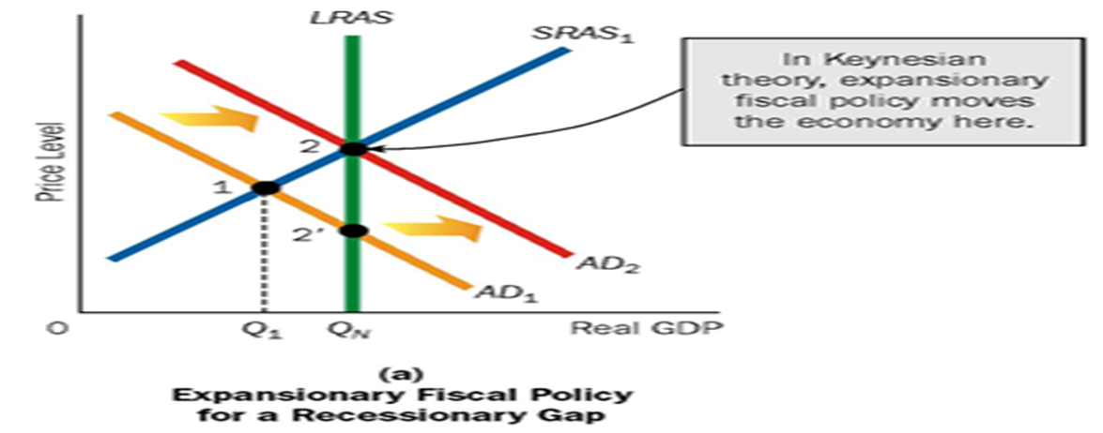

**Figure 8.1 expansionary fiscal under Keynes perspective**

It became prominent after the success of Keynes' prescriptions to fight the great depression of 1930s. The underlying principles of compensatory finance are:

1. If there is unemployment as during depression, the fiscal policy should be geared to increase the level of aggregate demand.
2. During times of inflation, the level of aggregate demand should be reduced to make it equal to the value of available output.
3. If there is full employment, fiscal policy should maintain the level of aggregate demand so that there is neither inflation nor unemployment.
4. **Anti-deflationary fiscal policy**

During depression the economy suffers from unemployment, falling income and shrinking economic activity. Eco­nomic activity is low because aggregate demand is low and people are not spending. People do not spend because of low incomes and unemployment. This vicious circle has to be broken through fiscal policy. The right type of fiscal policy is one which raises aggregate demand. This can be done in two ways. Fiscal policy should be directed to make people spend more. Secondly if private spending does not increase, government should increase its expenditure to compensate for the deficient private spending.

In the first case all fiscal instruments can be used to stimulate private expenditure. For example private consumption can increase if they have more disposable incomes. For this tax rates should be reduced or some taxes which affect consumption adversely can be abolished. Sales tax should be abolished and excise duties on goods must be reduced. Public expenditure should be incurred on schemes which would raise the incomes of the poor. Public borrowing should not be resorted to as people cannot contribute to it. Rather depression is the time to make redemption of public debt if possible so that funds flow to the people to enable them to spend or invest.

Similarly private investment expenditure can be stimulated. Private in­vestment is low during depression because marginal efficiency of capital is low. Therefore business and corporate taxes should be reduced. Firms which increase their investment to provide more employment during depression should be given tax concessions. Public debt redemption during depression will increase funds in the hands of richer sections who are the investing class of people.

Though all these fiscal measures can help to increase private expenditure on consumption and investment, it may not really bring in the desired result. When business prospects are gloomy, private investments may not come forth at all. Similarly private consumption expenditure may take a long time to react. Therefore the best and the only way to bring a turning point is for the government to increase its expenditure. In fact this remedy suggested by Keynes succeeded so well in U.S.A. in bringing recovery during the Great Depression in 1936, which has been responsible for the development of the theory of compensatory fiscal policy.

The government can increase its expenditure in two ways. Firstly it can spend for social security benefits in the form of unemployment allowance, free meals etc. But Keynes pointed out that it may solve poverty but not unemployment. It also hurts human dignity to live on doles. What people require during depression are jobs. When they work they get incomes to spend. Therefore the second set of measures refers to increase in public expenditure on public works programmes.

Keynes’ 'General Theory of Employment Interest and Money' projected public works programme as anti depression device. Public works programme covers constructive activities like road and railway development, construc­tion of buildings, irrigation projects etc. Such activities serve the twin purpose of giving jobs and incomes as well as creation of long-term assets for the economy. If nothing is possible it was even suggested that govern­ment can spend money to make people dig holes today to be filled up by another batch next day. The keyword is provision of jobs during depression' to enable people to have earning capacity. This initial increase in public expenditure would result in a multiple increase in incomes through multi­plier effect.

Keynes suggested that the government should keep a plan for such public works programmes ready so that it can be implemented as soon as the signs of depression appear. Infact the timing of public works pro­gramme to be started at the right time is very crucial in anti-deflationary fiscal policy because the right action and the right quantum of expenditure can help to nip the problem in the bud. If the schemes are started after the problem is aggravated, it may require a much larger public expenditure. Such an injection of fresh purchasing power in the form of an increase in public expenditure is known as pump priming. This increase in investment may set in motion a process of recovery from the conditions of depression. It is like a little water poured into a pump to prime it; it may supply an endless flow of water. Similarly if the government spends some money, the flow of economic life would continue smoothly forever.

There is however some limitations in implementing public works pro­gramme. It is often difficult to forecast the signs of depression. Hence the public works programmes may not be started at the appropriate time, thus raising the burden of public expenditure. The government may not have funds to spend, as tax revenue is bound to be low during depression. For this Keynes suggested that such schemes can be implemented through deficit financing. Further public works programmes are implemented by the central government in a federal set up. The whole programme may get delayed as it takes time for the central government to assess the problems of different areas. This recognition lag will cause a decision lag which may delay the success of the schemes. Most important of all, the government should slowly withdraw such expenditure as the economy recovers.

In spite of all these problems it cannot be denied that government interfer­ence through public expenditure is the best way to initiate a recovery during depression. This philosophy was responsible for the implementation of the New Deal Programme by the President Roosevelt in U.S.A. in 1936 and within three years, the economy was well on the road to recovery.

1. **Anti-inflationary fiscal policy.**

During inflation prices rise due to excess of purchasing power over available output. Therefore fiscal policy should be geared to reduce aggregate demand. This can be achieved through a surplus budget *viz.,*public revenue is more than public expenditure.

The suitable anti-inflationary tax policy is one where tax rates are in­creased and new taxes are introduced so that there is a reduction in the disposable income of the people. Income tax helps to reduce the disposable incomes of the people and reduce their purchasing power. Income tax rates can be easily raised during inflation. Expenditure tax can be introduced. However tax incentives can be given to entrepreneurs as it would increase production. Tariff policy may be suitably changed to allow for greater in­flow of imported goods to meet the domestic demand.

Just as tax policy is useful to reduce private spending, public expenditure should also be curtailed during inflation. Some schemes which are not re­quired can be given up. Such schemes which can be undertaken at a later date without any adverse effect can be postponed. Government should re­duce payments made to social security. A reduction of public expenditure in productive channels may have harmful effects in the long run. Hence the curtailment of public expenditure during inflation should occur in unproduc­tive channels.

Public borrowing should be increased so that funds flow from the private sector to the government, thus reducing aggregate demand. Hence compensatory finance recommends surplus budget during inflation.

**Fiscal Stabilizers and Flexibilities**

The success of fiscal policy especially compensatory fiscal policy de­pends upon the existence of flexibility in the economic system.

Built-in-flexibility is very important in a fiscal system for the success of fiscal tools. Built-in-flexibility refers to the automatic adjustment in the public expenditure and taxes with reference to inflation and deflation without giving rise to any deliberate action on the part of the government. For example if progressive system of tax rates is adopted, tax revenues would automatically go up as national income increases. Modern fiscal system has several such built-in stabilizers. When national income declines income tax and corporation tax automatically bring less revenue. Pub1ic expenditure on unemployment insurance, welfare schemes, automatically increase during depression. Thus falling revenue and increasing expenditure cause a deficit budget. Fiscal instruments which contain such ability to respond to increase and decrease in national income are called Automatic Stabilizers.

As automatic built in stabilizers, direct taxes, corporate profit tax, capital gains tax etc. are better than indirect taxes like excise duty and sales tax, because they are taxes on goods and hence consumption rises less than proportionately in relation to income.

Public expenditure if it responds quickly to changes in income can act as a good stabilizer. Modem governments are quick to provide welfare benefits as and when problems arise. Thus unemployment allowances during reces­sion, support prices for agricultural products, all involve automaticity during recession resulting in much needed transfer of purchasing power into the hands of the people. Similarly during inflation as situation improves such welfare payments taper down.

Built-in-stabilizers provide a cushion to the cyclical changes in income. Any government action involves delay and hence automatic stabilizers start functioning at the appropriate time without delay. However the effectiveness of built-in-stabilizers depends on the elasticity of public expenditure. It is bound to succeed only at a high level of taxation and expenditure; otherwise the impact would not be felt.

## DISCRETIONARY FISCAL POLICY

Contractionary fiscal policy attempts to decrease government expenditures and/or increases in taxes to achieve macroeconomic goals.Discretionary fiscal policy refers to deliberate changes on the budget such as changes in tax rates or public expenditure or both. It is of three types;

* + Increase tax rate.
  + Decrease public expenditure.
  + Combination of the two.
  + Reduce welfare payments and public works .The success of discretionary fiscal policy to control inflation.

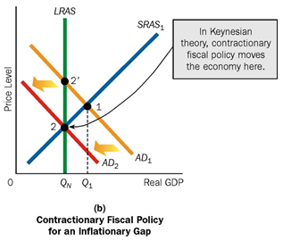

**Figure 8.2 contractionary fiscal policy under Keynes perspectives**

Crowed out effect

It is a situation when incased in government expenditure leads to a reduction in private investment spending such that it dampens the initial increase in of total increase in national income. If G increases =>increases in AE=> increase in Y in the good market=>Increase the demand for money in money market increase => high interest rate => reduce private investment =>lower income in the good market.

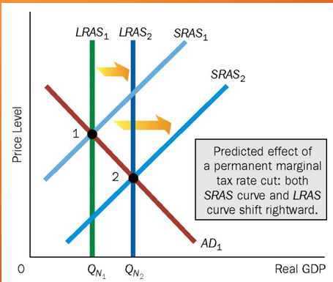

Figure 8.3 the Predicted Effect of a Permanent Marginal Tax Rate Cut on Aggregate Supply

The Laffer curve: Tax Rates and Tax Returns

There are two tax rates at which zero tax revenues will be collected – 0 and 100%. An increase in tax rates could cause tax revenues to increase, A decrease in tax rates could cause tax revenues to increase. Tax revenues = (Tax base) x (the average Tax rate

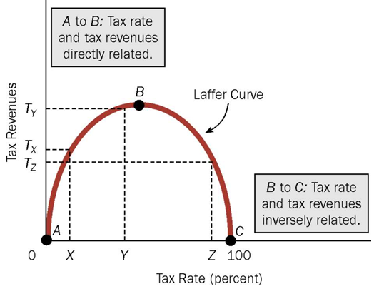

**Figure 8.4 graph of laffer curve on tax rate and return**

**Implication of Laffer curve:** We assume that as the tax rate is reduced, the tax base expands. The rationale is that individuals work more, invest more, and enter into more exchanges, and shelter less income from taxes and lower tax rates.

Tax revenues increase if a tax reduction is made in the downward-sloping portion of the curve (between points B and C); tax revenues decrease following a tax rate reduction in the upward sloping portion of the curve (between points A and B).

**Usefulness of Fiscal Policy**

The usefulness of fiscal policy to achieve the macro objectives of full employment and stability has come into prominence ever since it was used to counter unemployment during the great depression of 1930s.

The usefulness of fiscal policy to assure full employment arises from the fact that the fiscal instruments like public expenditure help to increase the level of aggregate demand to the required level. The figure below illustrates this.

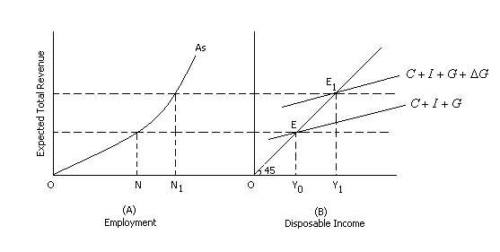

***Fig. 8. 5 Effect of Government Expenditure on Employment***

Diagram (A) shows the level of employment to be ON when the original aggregate demand is indicated by the curve C + I + G. If *N1* is the full employment level, there is unemployment to the extent on NN1. If government increases its expenditure on public works programme, it results in multiple increases in income. The shift in the aggregate demand to C + I + G +  results in an income of *OY1* and the new equilibrium at Et results in an employment of ON1thus public expenditure can be a very effective tool to raise the level of employment during depression.

Fiscal policy can be effective at times when even monetary policy fails to operate. During depression monetary policy may fail to be effective. Even if the rate of interest is lowered by the central bank, entrepreneurs may not come forward to invest as the marginal efficiency of capital is low. This is illustrated in the figure below.

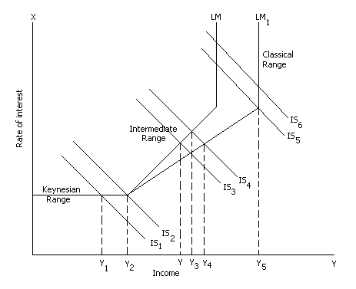

***Fig.8.6 Fiscal Policy Operation***

Keynesian range shows a situation during depression when the demand for money is so infinitely elastic (horizontal portion of LM curve) that monetary policy fails. In such a situation an increase in government expenditure as shown by a shift from IS1 to IS2 helps to increase income from Y1 to Y2 and thus cause an increase in aggregate demand.

The effectiveness of fiscal policy is moderate in the intermediate range of the LM curve i.e., for the same extent of shift in IS curve from IS3 to IS4 income increases from Y3 to Y4 only. In the classical range, LM1 curve is perfectly inelastic and fiscal policy fails to operate. A shift from IS5 to IS6 cannot bring any increase in income beyond Y5.

Of course the extent of effectiveness of fiscal policy in the intermediate range depends upon the elasticity of LM curve. Thus with less elastic LM2 curve, the shift from IS3 to IS4 helps to bring only a small increase from Y* to Y3.

As an instrument of government's policy, fiscal policy can be effectively used as complementary to monetary policy. The monetary policy influences the level of aggregate income and spending in the economy by influencing the money supply and the cost of borrowing funds from banks *i.e.,* the rate of interest. Fiscal policy on the other hand affects aggregate demand through its effects upon the size, composition and timing of government spending and revenues. Thus during depression, public works programme through deficit spending should be accompanied by a cheap money policy of low interest rates. Similarly during inflation, surplus budget should be accompa­nied by dear money policy. Thus both fiscal policy and monetary policy can be coordinated well to achieve economic stability quickly.

**8.5 Limitations of Fiscal Policy**

**Dear learner**! Discuss the major limitation of fiscal policy**?**

**…………………………………………………………………………………………………………………………………………………………………………………………………………….**

**That is great!** Fiscal policy alone cannot achieve the macro policy objectives. There are certain limitations:

1. Fiscal policy acts through changes in aggregate demand. Therefore it cannot bring about structural changes in the economy if the situation requires it.
2. The impact of fisca1 measures is selective.
3. The success of fiscal instruments depends upon accurate forecasting and timing as in the case of pump priming.
4. It is difficult to measure the extent of fiscal action required. The quantum of public expenditure to be raised or lowered, taxation to be increased or decreased, the extent of public borrowing or repay­ment of public debt are all to be carefully manipulated.
5. Fiscal instruments are supposed to bring about the required changes in aggregate demand through multiplier effect. But multiplier does not operate properly in developing countries on account of several bottle­necks. If only the value of tax multiplier and expenditure multiplier could be gauged correctly, they could have real impact on the econ­omy.

6. Fiscal policy suffers from different lags in the implementation of macro policy. First there is the recognition lag. The government should be able to identify the symptoms of an oncoming inflation or deflation so that needed steps can be taken. Failure to recognize the symptoms results in not only delay in solving the problem but also increases the extent of budgetary operations. Secondly there is the decision lag. Democratic procedures and parliamentary sanctions may delay government action. Political considerations may interfere in taking useful measures. Thirdly there is the action lag. For example, government may decide to spend more, but it can be done only if there are suitable plans drawn and kept ready. This lag can be avoided if the fiscal advisers to the government have well planned anti-inflationary and anti-deflationary schemes. Fourthly even if all these are overcome, there is the outside lag for the policy to take effect. If chain reaction of a change in tax or public expenditure or public debt policy may take some months to be felt as they operate through income-consumption relationships.

There are certain specific limitations of fiscal policy in developing countries. Large extent of tax evasion, low elasticity of taxes, low taxable capacity may hinder the operation of tax policy. Similarly existence of barter economy, large extent of under employment, lack of support from the public may not he helpful for public expen­diture as a fiscal instrument. Unorganized money and capital markets, lack of confidence in investing in government bonds may affect the success of fiscal policy in developing countries.

In spite of these limitations, fiscal policy and monetary policy are the twin instruments in the armory of the economic system to achieve full employment and growth with stability. All that fiscal policy requires is proper timing and action.

**Review question**

1. Discuss how fiscal policy works in the given economy?
2. Discuss the major role of fiscal policy?
3. How tax and government expenditure used to finance economy?
4. Explain compensatory and discriminatory fiscal policy?
5. Discuss about tax categories?
6. Discuss the major limitation that faces fiscal policy?

# 

**CHAPTER: NINE**

**Federal-State Financial Relations in Ethiopia**

**Introduction**

One of the component of fiscal policy is tax and used as revenue to finance different public service and recurrent activities. Ethiopia constitution provides power over taxation between federal and state power. In this part, we will discuss about the function of federal and state on taxation incase of Ethiopia. Federal government collect, custom duties, income tax, lotteries and game chances and state government also collect transport charge, income tax from employee and enterprise. But this practice varies across nation in the planet.

**Course objectives**

**At the end of this chapter, students should able to:**

* **Identify the role of federal power on taxation in Ethiopia**
* **Examine the role of state power on taxation in Ethiopia**

Ethiopia is a Federal Government; the federal- state financial relations are based on the principles of federal finance. In a federation, there is constitutional division of powers, functions, and resources between the federal and the state governments. Thus, federal-state financial relations are defined under the constitution of the Federal Democratic Republic of Ethiopia Proclamation No. 1/1995.

## 9.1 Provisions under the Constitution of Ethiopia

Under the constitution there is a threefold distribution of legislative powers between the Federal and States, viz., Federal power of taxation, State power of taxation and Concurrent power of taxation (Articles 96, 97 & 98).

The House of the Federation and the House of Peoples’ Representatives shall, in a joint session, determine by a two-thirds majority vote on the exercise of powers of taxation which have not been specifically provided for in the Constitution.

1. **Distribution of functions**

There are detailed lists in the Ethiopian Constitution of Federal Powers, the State Powers and Concurrent Powers where Federal legislation prevails in case of conflicts. Thus, there are functions, which are exclusively assigned to Federal Government, others exclusively to the State Governments, some of which, where the Federal and State Governments exercise Constitutional Jurisdiction. And anything could still be left out after mentioning Federal and State power of taxation, as a residuary item, it belongs to the Federal Government.

The Functions of the Federal Government include defense, defense industries, foreign affairs, citizenship, marine shipping and navigation, airways, post and telegraphs, National Bank, currency and foreign exchange, foreign loans, foreign and interstate trade, important industries and institution of national importance, etc.(see Article 51).

The functions of the State Governments include, public order, police, administration of justice, public health, education, agriculture, forests, fisheries and other industries etc, (see Article 52).

1. **Distribution of Revenue**

The Federal Government and the States shall share revenue taking the federal arrangement into account.

## Federal Power of Taxation in Ethiopia

**Dear learner! Discuss the federal power over taxation in Ethiopia?**

**…………………………………………………………………………………………………………………………………………………………………………………………………………….**

**That is great!** The role federal powers over taxation are listed below**:**

1. The Federal Government shall levy and collect custom duties, taxes and other charges on imports and exports
2. It shall levy and collect income tax on employees of the Federal Government and international organizations
3. It shall levy and collect income, profit, sales and excise taxes on enterprise owned by the Federal Government.
4. It shall tax the income and winnings of national lotteries and other games of chance
5. It shall levy and collect taxes on the income of air, rail and sea transport services.
6. It shall levy and collect taxes on income of houses and properties owned by the Federal Government; it shall fix rents
7. It shall determine and collect fees and charges relating to licenses issued and services rendered by organs of the Federal Government
8. It shall levy and collect taxes on monopolies
9. It shall levy and collect Federal stamp duties.

## 9.3 State Power of Taxation in Ethiopia

1. States shall levy and collect income taxes on employees of the state and of private enterprises.
2. States shall determine and collect fees for land usufractuary rights
3. States shall levy and collect taxes on the incomes of private farmers and farmers incorporated in cooperative associations.
4. States shall levy and collect profit and sales taxes on individual traders carrying out a business within their territory
5. States shall levy and collect taxes on income from transport services rendered on waters within their territory.
6. They shall levy and collect taxes on income derived from private houses and other properties within the State. They shall collect rent on houses and other properties they own.
7. States shall levy and collect profit, sales, excise and personal income taxes on income of enterprises owned by the States
8. Consistent with the provisions sub-Article 3 of Article 98, States shall levy and collect taxes on income derived from mining operations, and royalties and land rentals on such operations.
9. They shall determine and collect fees and charges relating to licenses issued and services rendered by State organs.
10. They shall fix and collect royalty for use of forest resources.

**9.4 Concurrent Power of Taxation in Ethiopia**

1. The Federal Government and the States shall jointly levy and collect profit, sales, excise and personal income taxes on enterprises they jointly establish.
2. They shall jointly levy and collect taxes on the profits of companies and on dividends due to shareholders.
3. They shall jointly levy and collect taxes on incomes derived from large-scale mining and all petroleum and gas operations, and royalties on such operations.

**Undesignated Powers of Taxation in Ethiopia**

The House of the Federation and the House of Peoples’ Representatives shall, in a joint session, determine by a two-third majority vote on the exercise of powers of taxation which have not been specifically provided for in the Constitution.

**Directive on Taxation**

1. In exercising their taxing powers, States and the Federal Government shall ensure that any tax is related to the source of revenue taxed and that it is determined the following proper considerations.
2. They shall ensure that the tax does not adversely affect their relationship and that the rate and amount of taxes shall be commensurate with services the taxes help deliver.
3. Neither States nor the Federal Government shall levy and collect taxes on each other’s property unless it is a profit making enterprise.

**Review question**

1. Discuss the function of federal government on taxation in Ethiopia?
2. Discuss the role of state power on taxation in Ethiopia?
3. Discuss the benefit provided by the constitution?
4. Discuss tax law in Ethiopia

# RERENCE

Richard Musgave, Tylor, Hicks, etc defined public finance in different ways. However,

J.M. Keynes has revolutionized and changed the meaning of public finance.

Atkinson, Anthony B. and Joseph E.Stiglitz.1980.Lecture on public economics McGraw-Hill books Co-

Bailey, Stephen J. 1995. Public sector Economics: Theory, policy and practice Macmillan Press Ltd.’London.

Baker,Samuel& Catherine Elliot (eds.) 1990. Readings in public sector Economics . D.C.Health and Co: Lexington.

Boadway.Robin W. 1979.Public sector Economics. Wintrop Publisher: Cambridge.

Brown .C.V. and P.M. Jackson, 1990.Pulic sector Economics, 4th edition. Blackwell: Oxford.

Browning ,E.K. and J.M. Browning ,1987 Public finance and the price system 3red

Edition . Macmillan publishing Co.: New York.

Cullis John ,& Philip Jones 1998. Public finance and public choice .2nd edition.Oxford University Press;Oxford.

Easterly ,William , et al (eds.),1994. Public sector Deficits and macroeconomic performance, Oxford University Press : Oxford. Jha Raghbendra ,1998 Modern Public economics Rout ledge : London

Musgrave ,R.A and Peggy Musgrave ,1982. Public Finance in theory and practice, 3rd edition McGraw-Hill: London.

Stiglitz,J.E. 2000.Economics of the public sector ,3rd edition .W.W. Norton & co.: New York .

**DEBRE MARKOS UNIVERSITY**

**COLLEGE OF BUSINESS AND ECONOMICS**

**DEPERATMENT OF ECONOMICS**

Assignment for Public finance for Economics Distance Education students

**Weight:** 30% **Submission Date** …………………….

**Try to do the assignment by your own and if you have any questions which are not clear attach at the end of the assignment paper please.**

**Part I: True or False Questions (1 point each)**

**Read the following sentences carefully and write TRUE if the statement is correct or FALSE if the statement is not correct on your answer paper**

1) Internal debt has no direct money burden unlike external debt trap.

2) Most of the debt is redeemable in nature in practical world.

3) Productive loan does not cause any net burden in the community.

4) Compulsory debt is the same as tax but the former is repaid.

5) The maximum social advantage theory of public expenditure is derived from the principle of equi-marginal returns as applied to an individual.

6) The practice of balanced budget will encourage expansion of government activities as against the Keynesian notion of large budgets.

7) Zero based budgets are prepared to know how much expenditures will be there for just to survive.

8) Canon of productivity requires public authorities should clearly know the purpose and extent of public expenditure.

9) Bond issued for construction of renaissance dam in Ethiopia is a type of long term public debt.

10) Budget preparation is the first procedure of budgeting.

**PART II: MULTIPLE CHOICE QUESTIONS (1POINT EACH)**

Choose the best answer and write the capital letter of your best choice in the space provided in each the answer sheet number.

* 1. Revenue should be recorded in a revenue account and expenditure ought to be recorded in the expenditure account. This is the canon of ……..
     1. Exclusiveness
     2. Unity
     3. Specification
     4. Comprehensiveness
  2. …………. The plan which intends to figure out expected operations revenue and expenses of an organization for a future time period.

1. Public debt
2. Taxation
3. Fiscal policy
4. Budgeting

**Given the graph below try to answer question; 3-7.**

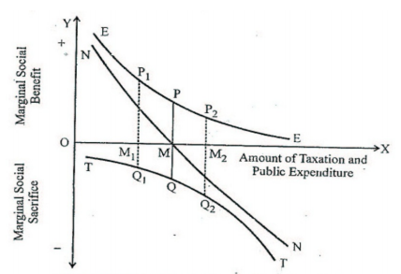

* 1. . The optimum size of the budget is determined at ;

${OM}_{2}$

1. OM
${OM}_{1}$

2. Cannot be known
   1. From the above graph the line **NN** measures;
3. The marginal social sacrifices
4. The marginal social benefits
5. The net marginal benefit
6. Total benefit
   1. Any point to the right of M, results;
7. Net marginal benefit negative
8. Net befit is zero
9. The government should raise the size of budget and move from ${ M}_{1}$ to M.
10. The government should raise the size of budget and move from $M_{2}$ to M.
    1. Any point to the Left of M, results;
11. Net marginal benefit negative
12. Marginal social sacrifices is greater than the marginal social benefit
13. The government should raise the size of budget and move from $M_{2}$ to M
14. The government should raise the size of budget and move from $M_{1}$ to M.
    1. The above graphically analysis of public expenditure theory is done by whom?
15. Adam smith
16. Colin Clark
17. Richard Musgrave
18. David Richardo
    1. All of the following expenditure increase employment opportunity except?
19. Heavy expenditure in the public sector
20. Expenditure on public utility.
21. Expenditure for the promotion of smuggling activity
22. Public expenditure at the time of depression
    1. In country X the government officials use the budget for self-consumption like pretty recreation car and build their private hotel around the lake shore .which principle of expenditure is violated in country X.
23. Canon of surplus
24. Canon sanction
25. Canon of certainty
26. Canon of economy
    1. Which of the following is correct about the effect of public debt in the economy?
27. In the current time the public debt of Ethiopia is above the World Bank Tipping point
28. In the current time the public debt United States of America below the world bank Tipping point
29. Debt to GDP ratio for developed country is more than the emerging markets
30. Debt to GDP ratio of developed country is less than the emerging markets
    1. All are a type of capital expenditure incurred by the public sector except ;
31. expenditure on research and development activity ,
32. expenditure on infrastructure,
33. expenditure on public work,
34. expenditure on salary for civil servants
    1. What is the primary objective of budget in least developing country?
35. Multidimensional poverty reduction
36. Economic growth
37. Full employment
38. Price stability
    1. ………………..is borrowing by a government from within the country or from abroad.
39. Public aid
40. Public debt
41. Public donation
42. Public gift
    1. In the current year, what methods of debt reduction are adopted by Greek to reduce debt burden?
43. Printing of currency
44. Rise tax rate on employee income
45. Purchasing of bonds and debentures
46. Encourage domestics public borrowings
    1. Which of the following is correct about the effect of public debt on the economy?
47. It always increases consumption.
48. It always increases production.
49. It might have neutralized effect on the distribution of income.
50. Usually decrease income inequality.
    1. …………are probably the most systematic and, therefore, the best method of redeeming public debt.
51. Buying up Loans
52. Sinking funds
53. Conversion of Loans
54. Repudiation of debts
    1. ……..is a policy under which the government uses its expenditure and revenue programme to produce desir­able effect and avoid undesirable effects on the national income, production and employment.
55. Monetary policy
56. Fiscal policy
57. Income policy
58. All
    1. . All are the tools of fiscal policy except;
59. Taxation
60. Public borrowing
61. Government borrowing
62. Issuance of currency
    1. Which of the following is considered as the federal government power of taxation only?
63. Levy and collect income taxes on employees of the state and of private enterprises.
64. Tax the income obtained from winnings of national lotteries and other games of chance.
65. Levy and collect taxes on income derived from private houses and other properties within the State.
66. Levy and collect taxes on the incomes of private farmers and farmers incorporated in cooperative associations.
    1. Which of the following is wrong about the measure of public debt burden?
67. Debt to GDP ratio is a solvency measure.
68. The ratio of present value of export to fiscal revenue is a measure of sustainability.
69. The ratio of debt service to export ratio is the measure sustainability.
70. The ratio of short term debt to total debt ratio is the measure of solvency.

**Good Luck!!!!!!!!!!**