Debre Markos University

Department of economics

Econometrics –II Assignment 2 for ext. (15%)

1. Given the estimated AR (1) model in time series analysis as:

${Unemployment}_{1991}$ = 28.5 + 0.5Unemployment *t-*1 +et and if the estimated average value of unemployment in 1990 was 20.4, what is the mean value of unemployment in 1991?

1. Given the following simultaneous equation models find the reduced form of 

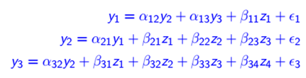

1. How can we choose the model between fixed or random effects in panel analysis?
2. Consider the model “A” with time invariant individual (entity) specific parameter and model “B” with time variant (random) individual specific parameter. What types of panel models are A &B?
3. How can be the crosectional effect and time effect estimated under panel model?