FINACIAL ACCOUNTING-II WORK SHEET MARCH, 2020

1. What are the major characteristics of plant property and equipment’s?
2. What is goodwill? What is a bargain purchase?
3. Why Goodwill impairment loss reversals are not permitted?
4. Brothers Inc. purchased land at a price of Br 27,000. Closing costs were Br 1,400. An old building was removed at a cost of Br 10,200. What amount should be recorded as the cost of the land?
5. Abyssinia Corporation purchased a truck by issuing Br 80,000, 4-year, zero-interest-bearing note to Dallol PLC. The market rate of interest for obligations of this nature is 10%.pass all the necessary journal entry.
6. Amble Inc. exchanged a truck with a book value of Br 12,000 and a fair value of Br 20,000 for a truck with additional Br 5,000 cash payment. The exchange has commercial substance. At what amount should Amble record the truck received?
7. In accounting for plant assets, which of the following outlays made subsequent to acquisition should be fully expensed in the period the expenditure is made?
8. Expenditure made to increase the efficiency or effectiveness of an existing asset.
9. Expenditure made to extend the useful life of an existing asset beyond the time frame originally anticipated.
10. Expenditure made to maintain an existing asset so that it can function in the manner intended.
11. Expenditure made to add new asset services.
12. None of the above
13. Goodwill represents(more than one Possible answer)
14. The excess of the sum of the fair value of the (1) consideration given/shares already owned over theSum of the fair values assigned to identifiable assets acquired less liabilities assumed.

*B.* the excess of the sum of the fair value of the (1) consideration given/shares already owned overSum of the fair values assigned to tangible assets acquired less liabilities assumed.

*C.* the excess of the sum of the fair value of the (1) consideration given/shares already owned overSum of the fair values assigned to intangible assets acquired less liabilities assumed.

*D.* the excess of the sum of the fair value of the (1) consideration given/shares already owned overBook value of an acquired company.

*E.* the lower of the sum of the fair value of the (1) consideration given/shares already owned over the fair value of net assets of acquired company.

F. the excess of the sum of the fair value of the (1) consideration given/shares already owned over the fair value of net assets of acquired company.

1. Che Company traded a used truck for a new truck. The used truck cost Br30, 000 and has accumulated depreciation of Br27, 000. The new truck is worth Br37, 000. Che also made a cash payment of Br36, 000. How much loss should be recognized for this transaction (The exchange lacks commercial substance?)
2. Tana Company purchases a building for Br11, 300,000 on January 2, 2014. An engineer’s report shows that of the total purchase price, Br11, 000,000 should be allocated to the building (with a 40-year life), Br150, 000 to 15-year property, and Br150, 000 to 5-year property. No residual (salvage) value should be considered. What is the depreciation expense for 2014 using component depreciation?
3. Ottawa Corporation owns machinery that cost Br 24,000 when purchased on July 1, 2011. Depreciation has been recorded at a rate of Br 3,000 per year, resulting in a balance in accumulated depreciation of Br 10,500 at December 31, 2014. The machinery is sold on September 1, 2015, for Br 12,500. Pass all the necessary journal entry to record the sale of machinery?
4. Moha PLC purchased land, building, and equipment from Langano Corporation for a cash payment of Br350, 000. The estimated fair values of the assets are land Br 80,000, building Br 220,000, and equipment Br 100,000. Record the assets purchased on Moha PLC books?
5. Hason Company is constructing a building. Construction began on February 1 and was completed on December 31. Expenditures were Br1,800,000 on March 1, Br1,200,000 on June 1, and Br3,000,000 on December 31. Hason Company borrowed Br1,000,000 on March 1 on a 5-year, 12% note to help finance construction of the building. In addition, the company had outstanding all year a 10%, 5-year, Br 2,000,000 note payable and an 11%, 4-year, $3,500,000 note payable.
6. . Determine the capitalized asset? Capitalization period? Compute the weighted-average interest rate used for interest capitalization purposes
7. Compute total interest for Hanson Company for the year.
8. Compute capitalized interest for Hason Company. D. Present all necessary journal entry.
9. Cedric Company recently traded in an older model computer for a new model. The old model’s book value was Br180, 000 (original cost of Br400, 000 less Br220, 000 in accumulated depreciation) and its fair value was Br200, 000. Cedric paid Br60, 000 to complete the exchange which has commercial substance. How much gain should be recognized for this transaction?
10. Mandela Company constructed a warehouse for Br 280,000 on January 2, 2014. Mandela estimates that the warehouse has a useful life of 20 years and no residual value. Construction records indicate that Br 40,000 of the cost of the warehouse relates to its heating, ventilation, and air conditioning (HVAC) system, which has an estimated useful life of only 10 years. What is the first year of depreciation expense using straight-line component depreciation under IFRS?
11. Debebe PLC purchased special purpose machinery for its production through issuing a 100, 000, zero-interest bearing note and payable five years from now to the seller. How much should be debited to machinery account if the market prevailing rate is 10%?
12. Negede PLC has purchased building with land at cost (lump sum price) of Br 500,000 from Hayat Real-estate. The building has a market value of Br 400,000 and a book value of Br 200,000 on the other hand the market and book value of the land is Br 100, 000 and Br 300, 000 respectively. How much should be reported as cost of building and land on the balance sheet of Negede PLC, respectively?
13. On July 1, 2014, Big Corporation purchased Young Company by paying Br250, 000 cash and issuing a Br100,000 note payable to Young. At July 1, 2014, the balance sheet of Young Company was as follows.

Cash Br 50,000 Accounts payable Br200, 000

Accounts receivable 90,000 Stockholders’ equity 235,000

Inventory 100,000 Total Liability and equity 435, 000

Land 40,000

Buildings (net) 75,000

Equipment (net) 70,000

Trademarks 10,000

Total Assets Br 435,000

The recorded amounts all approximate current values except for land (fair value of Br60, 000), inventory (fair value of Br125, 000), and trademarks (fair value of Br15, 000).

**Required:**

1. Compute the value of net asset acquired and goodwill to be recognized on July 1, 2014 if any.
2. Prepare journal entries for purchase of assets.
3. On Dec 31, 2014 the fair market value of purchased Young net assets is Br 300,000. Determine the goodwill impairment loss and make an entry.
4. Cruz Company has purchased two tracts of land. One tract will be the site of its new manufacturing plant, while the other is being purchased with the hope that it will be sold in the next year at a profit. How should these two tracts of land be reported in the statement of financial position?
5. Indicate where the following items would be shown on a statement of financial position.

**(a)** A lien that was attached to the land when purchased.

**(b)** Landscaping costs.

**(c)** Attorney’s fees and recording fees related to purchasing land.

**(d)** Variable overhead related to construction of machinery.

**(e)** A parking lot servicing employees in the building.

**(f)** Cost of temporary building for workers during construction of building.

**(g)** Interest expense on bonds payable incurred during construction of a building.

**(h)** Assessments for sidewalks that are maintained by the city.

**(I)** the cost of demolishing an old building that was on the land when purchased.

21. One financial accounting issue encountered when a company constructs its own plant is whether the interest cost on funds borrowed to finance construction should be capitalized and then amortized over the life of the assets constructed. What is the justification for capitalizing such interest?

22. Ito Company receives a local government grant to help defray the cost of its plant facilitates. The grant is provided to encourage Ito to move its operations to a certain area. Explain how the grant might be reported.

23. Stan Ott is evaluating two recent transactions involving exchanges of equipment. In one case, the exchange has commercial substance. In the second situation, the exchange lacks commercial substance. Explain to Stan the differences in accounting for these two situations.

24. Identify the factors that are relevant in determining the annual depreciation charge, and explain whether these factors are determined objectively or whether they are based on judgment.

25. Cruz Company has FOUR building. One will be its new manufacturing plant, the second is being purchased with the hope that it will be sold in the next year at a profit. The third is used for rental. The fourth building is acquired for resale. How should these four building be reported in the statement of financial position? (Hint: PPE, Inventory, Non-current asset held for sale, investment property)

26. What are the major factors considered in determining what depreciation method to use?

27. Explain how gains or losses on impaired assets should be reported in income.

28. Intangibles have either a limited useful life or an indefinite useful life. How should these two different types of intangibles be amortized?

29. Why does IFRS make a distinction between internally created intangibles and purchased intangibles?

30. What is the nature of research and development costs? Can development costs be capitalized? Explain.

31. Recently, a group of university students decided to incorporate for the purposes of selling a process to recycle the waste product from manufacturing cheese. Some of the initial costs involved were legal fees and office expenses incurred in starting the business, governmental incorporation fees, and stamp taxes. One student wishes to charge these costs against revenue in the current period. Another wishes to defer these costs and amortize them in the future. Which student is correct?

32. PPE recognized at measurement date A. cost model B. Revaluation model why?

33. PPE recognized at subsequent date A. cost model B. Revaluation model why?

34. Assume 1 January 2011 you buy a machine

* + historical cost = $1 million
  + useful life = 10 years
  + depreciation method = straight-line
  + nil residual value
* 31 December 2012 revalue machine to $1.2 million (fair value)
* 31 December 2014 the recoverable amount (fair value less costs to sell) = $300,000
* 31 December 2016 revalue machine to $800,000 (fair value)
* The entity transfers the realised portion of the revaluation surplus reserve to retained earnings in the period of its realisation (through for example, depreciation, impairment or derecognition)

Record all the necessary journal entries using both cost and revaluation model?

1. Presented below are the components related to an office block that Veenman Company is considering purchasing for €10,000,000.

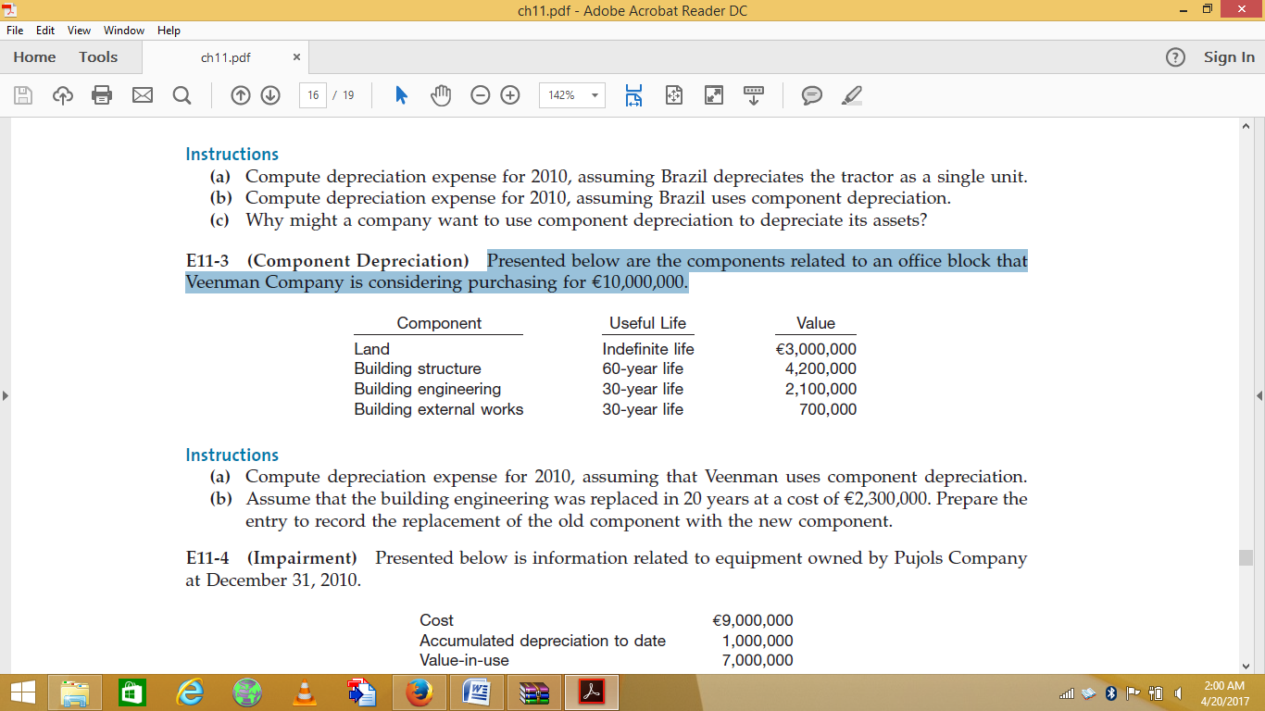

**Instructions:**

1. Compute depreciation expense for 2010, assuming that Veenman uses component depreciation.
2. Assume that the building engineering was replaced in 20 years at a cost of €2,300,000. Prepare the entry to record the replacement of the old component with the new component.
3. At the beginning of 2010, Callaway Company acquireda mine for $850,000. Of this amount, $100,000 was ascribed to the land value and the remaining portionto the minerals in the mine. Surveys conducted by geologists have indicated that approximately 12,000,000units of the ore appear to be in the mine. Callaway incurred $170,000 of development costs associatedwith this mine prior to any extraction of minerals. It also determined that the fair value of its obligationto prepare the land for an alternative use when all of the mineral has been removed was $40,000. During2010, 2,500,000 units of ore were extracted and 2,200,000 of these units were sold.

**Instructions:**

Compute the following.

1. The total amount of depletion for 2010.
2. The amount that is charged as an expense for 2010 for the cost of the minerals sold during 2010.
3. At the end of 2010, Silva Group tests a machine for impairment. The machine is carried at depreciated historical cost, and its carrying amount is $150,000. It has an estimated remaining useful life of 10 years. The machine’s recoverable amount is determined on the basis of a value-in-use calculation, using a pretax discount rate of 15 percent. Management-approved budgets reflect estimated costs necessary to maintain the level of economic benefit expected to arise from the machine in its current condition. The following information related to future cash flows is available at the end of 2010.

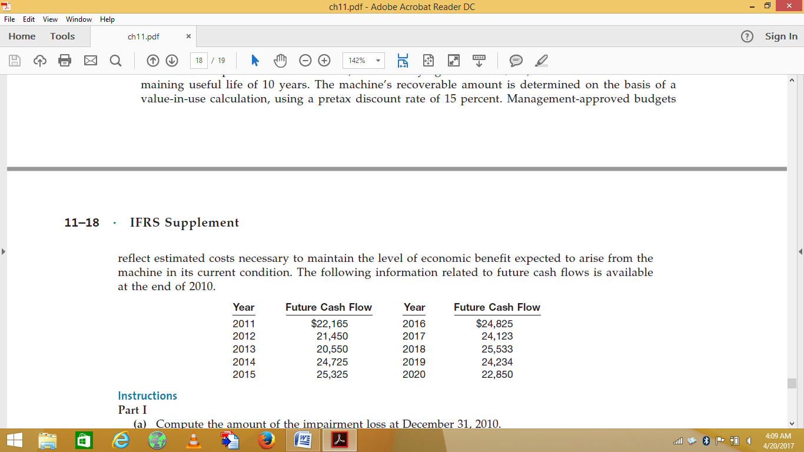

**Instructions:**

**Part I**

1. Compute the amount of the impairment loss at December 31, 2010.
2. Prepare the journal entry to record the impairment loss, if any, at December 31, 2010.

**Part II**

In the years 2011–2013, no event occurs that requires the machine’s recoverable amount to be re-estimated. At the end of 2014, costs of $25,000 are incurred to enhance the machine’s performance. Revised estimated cash flows in management’s most recent budget are as follows.

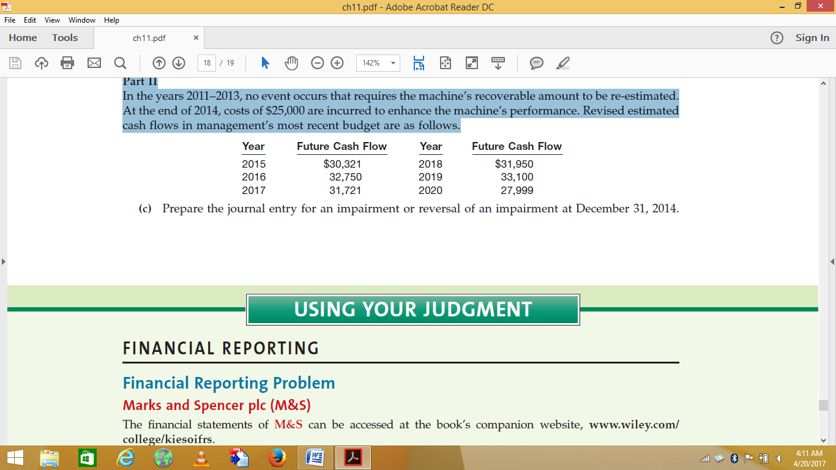

(C) Prepare the journal entry for an impairment or reversal of an impairment at December 31, 2014.

1. Saladin Company purchased Machine #201 on May 1, 2010. The following information relating to Machine #201 was gathered at the end of May:

|  |  |
| --- | --- |
| Price | $85,000 |
| Credit terms | 2/10, n/30 |
| Freight in costs | $800 |
| Preparation and installation costs | $3,800 |
| Labor costs during regular production | $10,500 |

It was expected that the machine could be used for 10 years, after which the residual value would be $0. Saladin intends to use the machine only 8 years, however, after which it expects to be able to sell it for $1,500. The invoice for Machine #201 was paid May 5, 2010. Saladin uses the calendar year as the basis for the preparation of financial statements.

**Instructions:**

1. Compute the depreciation expense for the years indicated using the straight-line method for 2010. (Round to the nearest dollar.)
2. Compute the depreciation expense for the years indicated using the sum-of-years' digits method for 2011. (Round to the nearest dollar.)
3. Compute the depreciation expense for the years indicated using the double-declining balance method for 2010. (Round to the nearest dollar.)
4. Suppose Kelemua, the president of Saladin, tells you that because the company is a new organization, she expects it will be several years before production and sales reach optimum levels. She asks you to recommend a depreciation method that will allocate less of the company’s depreciation expense to the early years and more to later years of the assets’ lives. What method would you recommend?
5. On July 31, 2010, Menkorer Company paid $3,000,000 to acquire all of the ordinary shares of Cobble Incorporated, which became a division (cash-generating unit) of Menkorer. Cobble reported the following statement of financial position at the time of the acquisition.

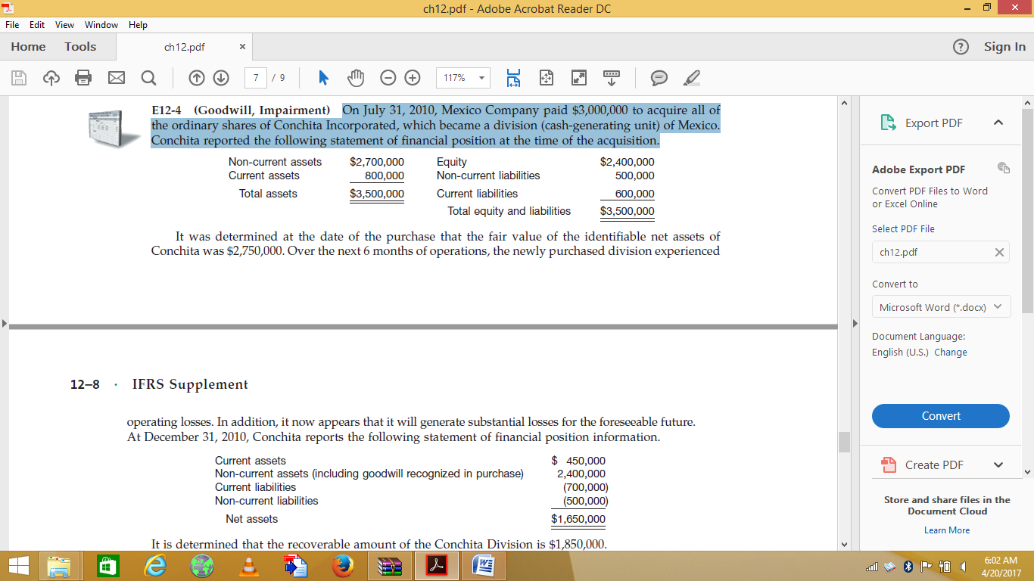

It was determined at the date of the purchase that the fair value of the identifiable net assets of Cobble was $2,750,000. Over the next 6 months of operations, the newly purchased division experienced operating losses. In addition, it now appears that it will generate substantial losses for the foreseeable future. At December 31, 2010, Cobble reports the following statement of financial position information.

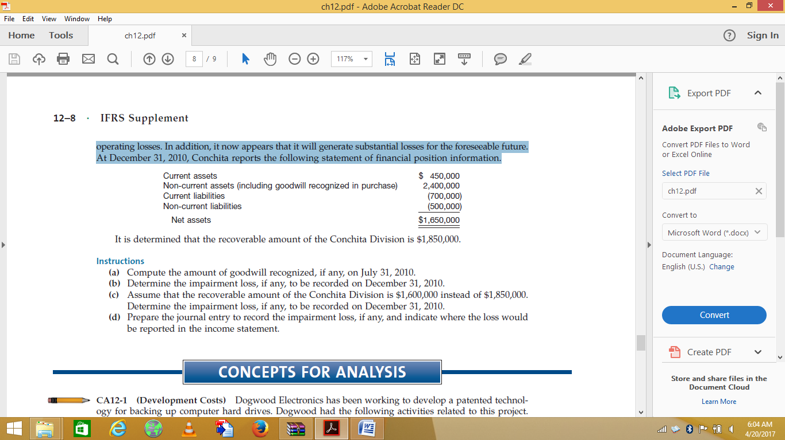

It is determined that the recoverable amount of the Cobble Division is $1,850,000.

**Instructions:**

* 1. Compute the amount of goodwill recognized, if any, on July 31, 2010.
  2. Determine the impairment loss, if any, to be recorded on December 31, 2010.
  3. Assume that the recoverable amount of the Cobble Division is $1,600,000 instead of $1,850,000. Determine the impairment loss, if any, to be recorded on December 31, 2010.
  4. Prepare the journal entry to record the impairment loss, if any, and indicate where the loss would be reported in the income statement.