**CHAPTER-THREE**

**HYPOTHESIS TESTING**

**Objectives:**

After completing this chapter, you should be able to;

-Define hypothesis testing and related concepts.

-Understand hypothesis test of the proportion and the mean.

-Compute hypothesis tests of the population proportion and population mean.

**3.1 Introduction**

In the preceding chapter, estimation, we used information obtained in a simple random sample to construct a confidence interval estimate of the unknown value of a population parameter. In this chapter we shall start with an assumed value of a parameter then we shall use sample evidence to decide whether the assumed value is unreasonable and should be rejected, or whether it should be accepted.

**Basic Concepts**

**Hypothesis & hypothesis testing defined**

**Hypothesis** is the assumptions we make about the value of population parameter. So ***hypothesis testing*** is a procedure based on sample evidence and probability distribution used to determine whether the hypothesis is a reasonable statement and should not be rejected, or is unreasonable and should be rejected.

**3.2 Null and Alternative hypothesis**

In testing the value of unknown population parameter, there will be two hypotheses one is called the null hypothesis and the other is called the alternative hypothesis. The ***null hypothesis*** (to be tested) is designated as Ho (H sub zero), and the ***alternative hypothesis*** (true if Ho is False) is designated by Ha. The hypotheses are written in a form like.



Here the null hypothesis is that the population mean is greater than or equal to 20 kgs, and the alternative hypothesis is that the population mean is less than 20 kgs.

**3.3 Type I and Type II errors**

In hypothesis testing we reach at a conclusion based on sample evidence. We cannot be sure of our conclusion and an error is made if a true Ho is rejected or a false Ho is accepted.

 Ho

|  |  |  |
| --- | --- | --- |
|  | Rejected | Accepted |
| True | Type I error | Correct decision |
| False | Correct decision | Type II error |

Ho

Accepting a false Ho is called a Type II error and rejecting a true Ho is called Type I error. A Legal analogy will help you fix type I and type II error in mind. Suppose that a defendant is really innocent, but the jury's finding is guilty i.e. the jury has rejected a true null hypothesis and committed a type I error. On the other hand, if the defendant actually is guilty and the jury's finding is innocent, the jury has accepted a false null hypothesis and committed a Type II error.

We often refer to those two possible errors as alpha error '' " and the beta error ""

 error - the probability of making type I error

 error - the probability of making type II error

**Steps in Hypothesis Testing**

1. State the hypotheses
2. State the decision rule
3. Compute the value of the test statistic
4. Reject Ho or accept Ho

Let's see one example of proportion to illustrate each step.

* 1. **Tests of a Population Proportion**

**3.4.1 One tail-test of a population proportion**

**Example**: Suppose the sponsor of the "Ethiopian Idols show" television program states the program should be canceled if there is convincing evidence that the program’s share of the viewing audience is less than 25 percent. The sponsor also states that

1. the worst error would be to cancel the program if its audience share is 25 percent or more and
2. the chance of making the worst error is to be only 5 percent

A sample of 1250 TV viewers will be interviewed, and the sample proportion  of viewers who watch Ethiopian Idol show will be used to decide whether or not the program is canceled. Now suppose there are 260 Ethiopian Idols Show viewers in the sample. The sample proportion of viewers is 0.208 ().

Should the sponsored cancel the program?

The sample proportion of viewers is

=

**Step 1: Identify Ho and Ha**

The easiest way to do this is to take the sponsor's strict inequality statement "less than 25 percent'' as Ha. That makes Ha: P<25, so we have Ho P25



**Step 2: Determine the Decision rule**

***Decision rule*** is a statement of the condition under which the null hypothesis is rejected and the conditions under which it is not rejected.

The sponsor would not reject Ho if the sample proportion of viewers is 0.25 or more because such value of support Ho: P0.25. But a value less than 0.25 raises doubt about the truth of Ho: and if is much smaller than 0.25, the sponsor should reject Ho.

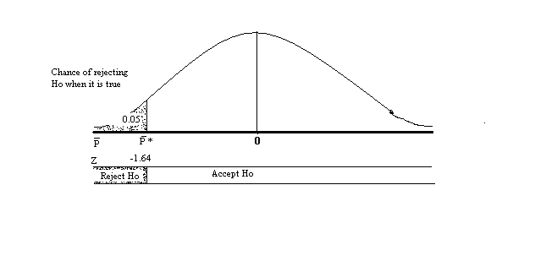**Figure 3.1**

To establish the decision rule we must determine the value of * in figure 3.1 or the value of Z associated with *. We will use the Z value in the decision rule. For the tail area =0.05 the value of Z associated with * is -Z 0.05 = -1.64. The decision rule is

Reject Ho if sample Z < -1.64

The rule is equivalent to rejecting Ho if the sample is less than * as shown in the above figure.

**Step 3: Compute the value of he test statistic**

***Test statistic*** is a value determined from sample information, used to reject or not to reject the null hypothesis.

In case of our example we compute the value of the sample Z that is associated with the sample  value.

=

Sample Z = 

and δ= where: p + q = 1

So P= 0.25 and q= 1-0.25 = 0.75

δ=

Sample Z= 

**Step 4 Accept or reject Ho**

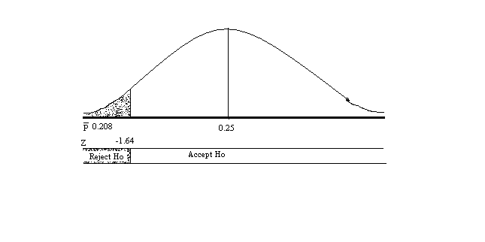

**Figure 3.2**

Finally, noting that the sample Z value, -3.44 is less than the -1.64 in the decision rule, we reject Ho. That means we accept Ha: P< 0.25 and conclude that the sponsor should cancel the program. Fig 3.2 shows that Ho was rejected because the sample Z lies in the reject Ho region.

**The level of significance**

The symbol  denotes the chance of committing a type I error.  is called the ***significance level*** of a test. When the value of a test statistic leads to rejection of Ho we say that the value is statistically significant.

In the above example the sample Z - 3.44, leads us to reject Ho: P25; so we say that the sample Z is statistically significant. The sample Z; -3.44 shows us that the sample proportion 0.208 is "Substantially'' less than 0.25. Or we may say, 0.208 is significantly less than 0.25, enough less to convince us that the null hypothesis Ho: P25 should be rejected.

When an analyst say that a test result was significant at the 5 percent level but not significant at the 1 percent level: that means the null hypothesis that was tested would be rejected if = 0.05 but would be accepted if =0.01.

**3.4.2 Two-tail test of a population proportion**

When Ho contains only the = sign, Ha will contain the  sign. The test then is called a two-tail test because the rejection consists of two tails of the sampling distribution.

**Example:** During a 1997's and audit, Discrepancies were found in CBE's invoice ledger. Consequently, the controller had all invoices for the year checked to determine if they were correctly recorded in the ledger. The proportion of incorrectly recorded invoices was found to be 0.04. The controller instituted a new procedure for processing invoices. Subsequently, a random sample of 500 invoices was checked to determine whether the proportion incorrectly recorded had changed from 0.04.

1. Perform a hypothesis test at the 5 percent if 11 of the sample invoices were recorded incorrectly
2. What is implied by the test result?

# Solution

1

a) Ho: P= 0.04

Ha: P 0.04

 The population proportion of incorrectly recorded invoices has changed from 0.04 if it is either less than or greater than 0.04

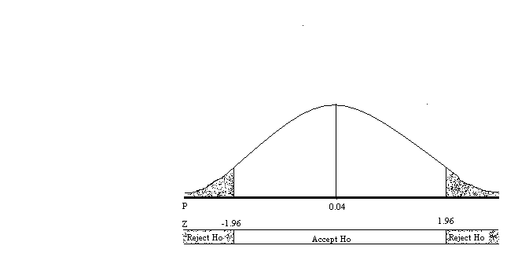

**Figure 3.3**

Ho will be rejected if the sample proportion leads to sample Z which is in either of the two tails of Figure 3.3.

 = 0.05 since there are two rejection regions, half of =0.05 is assigned to each tail. The Z value of a tail area of ½(0.05) = 0.025

= Z 0.025 = 1.96

The decision rule will be to reject Ho if the sample Z is less than -1.96 (the left in fig 5.3) or if it is greater than 1.96 (the right). A simple way to express the rule is to state that Ho will be rejected if the absolute value of the sample Z, designated by /Z/, is greater than 1.96.

2.

Reject Ho if /sample Z/ > 1.96 …. This is a two-tail decision rule

To compute the value of the Z test statistic, we need the standard error of the population

=

We have P= 0.04 (from Ho), q will be 1-0.04 = 0.96 and n= 500



The sample proportion of incorrectly recorded invoices (11 out of 500) is

=

3.

The sample test statistic then is

Sample Z= 



The absolute value of the sample Z, /-2.05/ = 2.05 it exceeds 1.96: so the decision is

Reject Ho: Proportion of incorrect invoices is not 0.04.

4

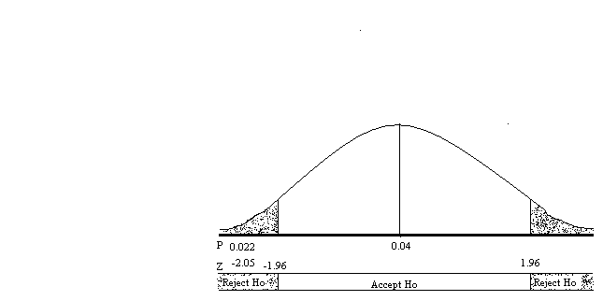

**Figure 3.4**

b) Ho: P= 0.04 was rejected. The sample proportion = 0.022 implies that the new procedures instituted by the controller should be continued because it reduced the proportion of incorrectly recorded invoices.

**N:B** We performed a two tail test in the example because the controller was interested in whether or not the proportion has changed. The word change or the word different indicates that a two-tail test is to be performed.

**3.5 Tests of a Population Mean**

Let be a hypothesized value of a population mean

The three possible forms of hypotheses about population mean are

a) Ho: μ ≤ μn

Ha: μ > μn

b) Ho: μ ≥ μn

Ha: μ < μn

c) Ho: μ = μn

Ha: μ≠ μn

"a'' and "b" lead to one tail test i.e. ''a'' is a right tail test and ''b'' a left tail test. Test ''c'' is a two-tail test.

In each case, the test will be made by obtaining a simple random sample of size n and computing the sample mean . Then  will be used in computing a test statistic. Depending upon the value of the test statistic, Ho will be accepted or rejected.

As you know from chapter 3 (sampling and sampling distribution) that for a ***normal population*** having a mean of μn and a known standard deviation the distribution of sample mean is normal: the sampling distribution has a mean of μn and a standard error of



Then the statistic



So: The sample Z value is the test statistic for testing a hypothesis about a mean of a normal population whose standard deviation is known.

If the standard deviation of the population is unknown, then we estimate by the sample standard deviation Sx; and we estimate the standard error of the mean by  where



if the population is normal, the statistic



has the student t distribution with n-1 degree of freedom

So: The sample t value is a test statistic for testing a hypothesis about the mean of a normal population whose standard deviation is unknown.

In chapter 3 (sampling & sampling distribution) there was one rule of thump which states that the sampling distribution of can be assumed to be normal even for non-normal population if the sample size is greater than 30 (n > 30). Following that rule of thump, we will use the test statistic;



to test a hypothesis about the mean of any population (normal or not)

In the above formula the standard error of the mean is

*  if the population standard deviation is known, but is
*  if the population standard deviation is unknown.

To summarize, in testing a population mean we will

1. Use the sample Z test statistic when
   1. The population is normal and is known, or
   2. The sample size is greater than 30 (n>30)
2. Use the sample t test statistic when the population is normal,  is not known, and n

**3.5.1 One-Tail Test of Population Mean**

**Example:** The president of a store selling dairy products asserts that the mean content of the store's 32 fluid ounce milk containers is at least 32 ounces. Perform a hypothesis test at the 1 percent level of significance if the mean content of a random sample of 60 containers is 31.98 ounces and the sample standard deviation is 0.10 ounce.

**Solution**

The assertion that the mean is at least 32 ounces is the null hypothesis

1. 

* The test will be left-tailed because Ha states that 
* n>30 (i.e. n=60)

So the test statistic is sample Z

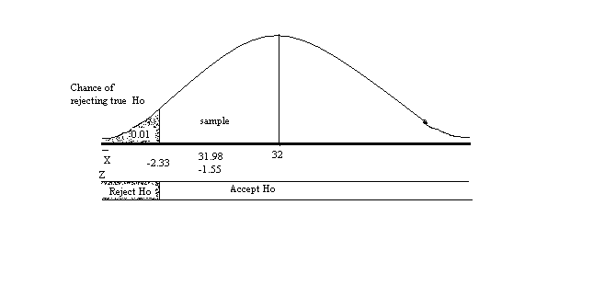

**Figure 3.5**

2. The decision rule is

Reject Ho if sample Z is less than -2.33

3. The test statistic is

Sample Z=

We have, the sample mean is = 31.98, we need a value for standard error of the mean . The example provides us the sample standard deviation Sx = 0.1. Therefore we can estimate  by the sample standard error of the mean



Now we can compute the sample Z



= 

The sample Z, -1.55 is not less than -2.33 so we

4. Accept Ho

Thus we accept the president’s assertion that the mean content of the containers is at least 32 ounces. Figure 5.5 above shows that Ho was accepted because the sample Z value lies in the acceptance region of the test.

**3.5.2 Two-tail test of Population Mean**

**Example:** A machine should produce 'parts' that have a mean diameter of 25 mm. Part diameters are normally distributed. The mean diameter of a sample of 10 parts is to be used to check whether or not the machine is running properly.

1. Perform a hypothesis test at the 5 percent level if the mean of the sample is 25.02 mm and sample standard deviation is 0.024 mm
2. What is implied by the test result?

**Solution**

1. The machine is running properly if the mean diameter of parts is  If  is either less or greater than 25 mm (μ≠25) the machine is not running properly. Hence, we have a two-tail test.

1. 

* + Part diameters are normally distributed
  + Their standard deviation is unknown
  + 

The test statistic is then the sample t value

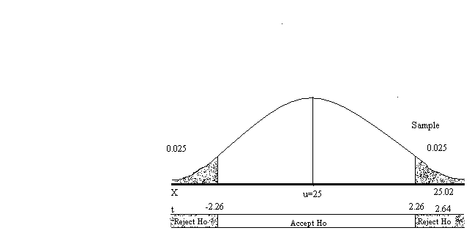

**Figure 3.6**

Significance level is 0.05; we place half of this chance (0.025) in each tail.

To determine the t value for a one tail area of 0.025 we need to know the number of degrees of freedom ν. In testing a hypothesis about a population mean, the number of degrees is one less than the sample size

That is ν = n - 1

in our example ν = 10 - 1 = 9

The t-value for a one-tail area of 0.025 and 9 degree of freedom is

t 0.025, 9 = 2.26 (table value).

Ho will be rejected if the sample t value is less than - 2.26 or greater than 2.26

2. Reject Ho if /sample t/ > 2.26

Next we need the sample t value

sample 

Sx= 0.024 mm. The sample standard error of the mean  is computed by the formula



With n=10 and Sx = 0.024



The sample mean is = 25.02

Sample t = 

3. Sample t=2.64

Because (sample t) = /2.64/ = 2.64 is greater than the 2.26 in the decision rule

4. We reject Ho

Figure 5.6 shows that Ho: was rejected because the sample Z lies in the rejection region of the test.

b) The result of the test and the fact that the sample mean, 25.02 mm, is greater than the proper mean, 25 mm, imply that the population mean is greater than 25 mm. Therefore, the machine setting should be adjusted to a smaller diameter.