UNIT TWO

Choice –involving risk and uncertainty

The traditional theory of demand examined so far implicitly assumed a risk free world. It assumed that consumers face complete certainty as to the results of the choices they make. Clearly, this is not the case in most instances. In contrary to our earlier assumptions of price, income and other variables to be known with certainty, many of the choices that people make involve considerable degree of uncertainty.

Although risk and uncertainty are usually used interchangeably, some people distinguish between the two.

1. **Uncertainty**: refers to a situation when there are more than one possible outcomes to a decision-maker and where the probability of each specific outcome is not known. This may be due to insufficient past information or instability in the structure of the variables.
2. **Risk:** refers to a situation where there are more than one possible outcomes to a decision-maker and the probability of each specific outcome is known or can be estimated.
3. **Certainty**: refers to a situation where there is only one possible outcome to a decision and this outcome is known precisely. For example, investing on treasury bills leads to only one outcome (i.e. the amount of the yield), and this is known with certainty.

Expected Value and Variation of Risky Choices

We usually need two measures to describe and compare risky choices. These measures are: expected value and variation.

1. Expected value: is the weighted average of all possible payoffs/outcomes that can result from a decision under the various states of nature, with the probability of those payoffs used as weights. It measures the value that we would expect on average. If we multiply each possible outcome or payoff by its probability of occurrence and add up these products, we get the expected value. If, for instance, there are two possible outcomes having payoffs X1 and X2 and if the probability of each outcome is given by P1 and P2, then the expected value is:

E(X) = P1X1 + P2X2

Example: If the probability that an oil exploration project will be successful is ¼ and the probability that it will be unsuccessful is ¾, and if success yields a payoff of 40 Birr per share while failure yields a payoff of 20 Birr per share, the expected value is:

E(X) = P(success)(yield from success) + P(failure)(yield from failure) = ¼ (40 Birr/share) + ¾ (20 Birr/share)

= (10 + 15) Birr/share

= 25 Birr/share

2. Variability: is the extent to which the possible outcomes of an uncertain event may differ. We measure variability by recognizing that large differences between the actual and expected value imply greater risk.

Standard deviation is the often used measure of variability. Standard deviation measures the dispersion of the possible outcomes from the expected value. The smaller the value of the standard deviation (σ), the tighter or less dispersed the distribution is and thus the lower would be the risk attached to it, and vice versa.

Standard deviation (σ) = 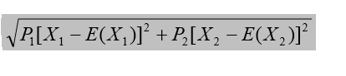

If two alternatives to choose from have the same expected value, the one with the lower/smaller standard deviation is less risky and is hence the preferred one. If, however, one alternative offers a higher expected value but is much riskier than the other one and vice versa, the preference depends on the individual – whether he/she is a risk averse, a risk neutral, or a risk loving person.

**Different Preferences towards Risk**

1. A Risk Averse Person: is a person preferring a certain income to a risky income with the same expected value. For a risk averse person, losses are more important (in terms of the change in utility) than gains. Losses hurt him/her more seriously than gains benefit him/her. Thus, the marginal utility of income (MUI) diminishes as income rises.

To illustrate, assume that a person can either have a certain income of 20 Birr, or an alternative decision yielding an income of 30 Birr with probability of 0.5 and an income of 10 Birr with probability 0.5. The expected income from this second alternative (A2) is:

E(A2) = 0.5(30) + 0.5(10)

= (15 + 5) Birr

= 20 Birr.

This is the same as the income earned without risk (from the first alternative – A1).

A risk averse person facing this situation prefers to consume the risk free 20 Birr to trying the alternative in which he/she could have consumed 30 Birr if successful or 10 Birr if unsuccess ful.

The figure below makes this point more clear. 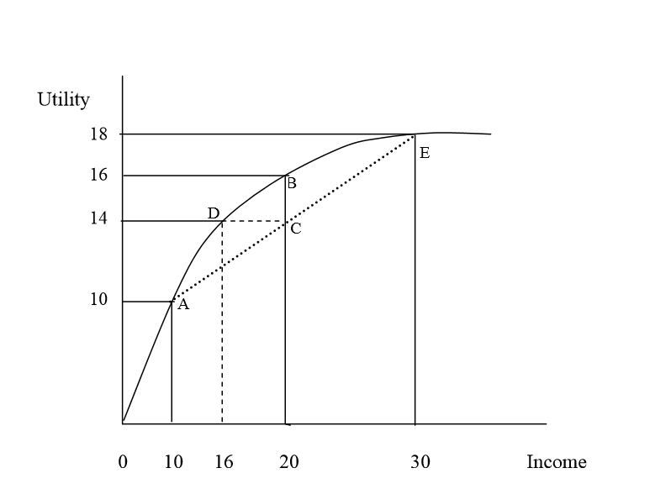

Figure; 2.1 Utility Functions for a Risk Averse Individual

From the figure, we see that utility at point B is greater than utility at point C. The utility of this risk averse person from the risk free income of 20 Birr is 16 (point B) and the expected utility from the risky alternative is:

E(U) = 0.5U(10 Birr) + 0.5U(30 Birr)

= 0.5(10) + 0.5(18)

= 14 (point C).

Note that the expected utility, E(U), is the sum of the utilities associated with all possible outcomes weighted by the probability that each outcome will occur.

The risk averse person achieves the expected utility of 14 at a lower, but a risk free, income of 16 Birr. That is, a risk free income of 16 Birr gives the same level of satisfaction as a risky alternative with an expected income of 20 Birr. Thus, he/she is willing to pay or forgo 4 Birr (20 Birr – 16 Birr = 4 Birr) to avoid taking risk. The maximum amount of money (4 Birr in our case) that a risk averse person will pay to avoid taking a risk is called a risk premium.

1. A Risk Neutral Person: is a person who is indifferent between a certain income and an uncertain income with the same expected value. For this person, the marginal utility of income is constant.

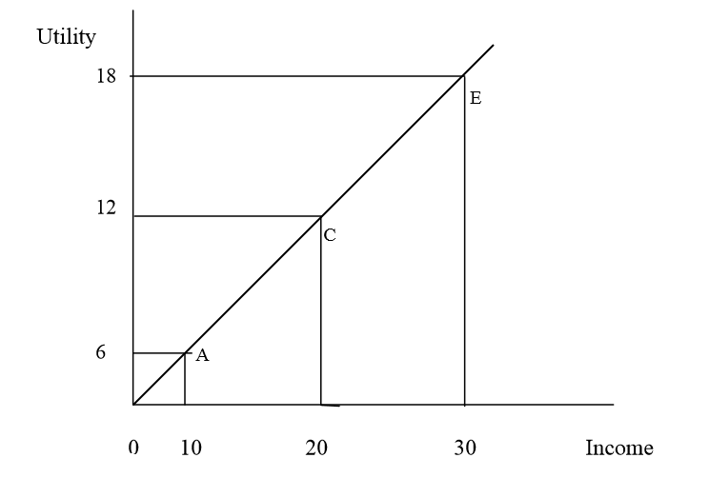

Figure; 2.2 Utility Function for a Risk Neutral Individual

The utility of this risk neutral person from the risk free income of 20 Birr is 12 (point C) and the expected utility from the risky alternative is: E(U) = 0.5U(10 Birr) + 0.5U(30 Birr)

= 0.5(6) + 0.5(18)

= 12 (the same point C).

As 12 = 12, the risk neutral person is indifferent between the risky and the risk free alternatives.

1. A Risk Loving Person: is a person who prefers a risky income to a certain income given that the risky alternative has the same expected value as the certain income. This person may prefer an uncertain income to a certain one even if the expected value of the uncertain income is less than that of the certain income. The expected utility of the uncertain income is greater than the utility of a certain income for a risk loving person and thus their utility of income curve is upward bending.

The utility of this risk loving person from the risk free income of 20 Birr is 8 (point B) and the expected utility from the risky alternative is:

E(U) = 0.5U(10 Birr) + 0.5U(30 Birr)

= 0.5(3) + 0.5(18)

= 10.5 (point C).

As 10.5 > 8, the risk loving person prefers the risky alternative to the risk free alternative.

Risk loving people prefer alternatives with high expected value and high standard deviation (risk) to a lower paying but less risky alternative (unlike the risk averse people). However, risk loving people are few at least with respect to major purchases or large amounts of income or wealth.

**Risk Aversion and Indifference Curves**

We also describe the extent of a person’s risk aversion in terms of indifference curves that relate the expected income to the variability of income, the latter being measured by the standard deviation.

An indifference curve shows the combinations of the expected value and the standard deviation of income that give the individual the same level/amount of utility. Indifference curves are upward sloping. This is because risk is undesirable (a ‘bad’) so that the greater the amount of risk, the greater the amount of income needed to make the individual equally well-off. An increase in the standard deviation (a higher variability of income) must be compensated by a higher expected value of income so as to a leave a person on the same level of utility.

As opposed to the case of a highly risk avert person, a slightly risk avert person requires only a small increase in expected income, E(I) for a large increase in the standard deviation of income (σ).

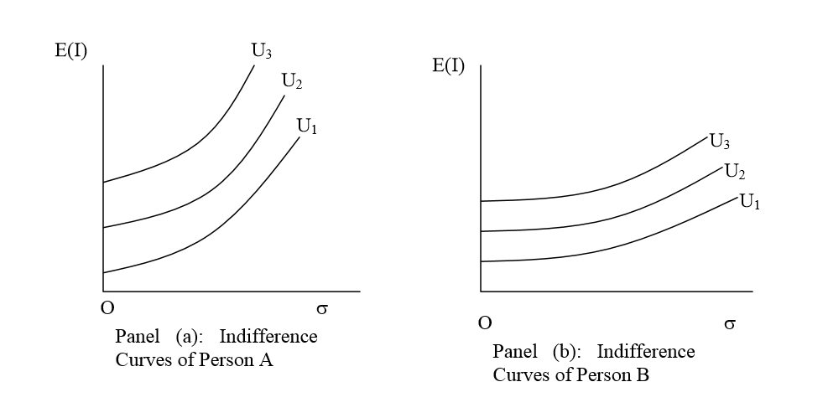Figure; 2.3 Person A is more Risk Averse than Person

**Reducing Risk**

In the face of a broad variety of risky situations, people are generally risk averse. Consumers and managers commonly reduce risk using various ways. The major ones are: diversification, insurance and obtaining more information.

1. **Diversification**: refers to reducing risk by allocating resources to a variety of activities whose outcomes are not closely related –“Don’t put all your eggs in one basket.”

2. **Insurance**: If the cost of insurance is equal to the expected loss, risk averse people will buy enough insurance to recover fully from any losses they might suffer. For a risk averse consumer, the guarantee of the same income regardless of the actual outcome generates more utility than would be the case if that person had a high income when there was no loss and a low income when a loss occurred.

3. **The value of information**: People often make decisions based on limited information. If more information were available, one could make better predictions and reduce risk. Even though forecasting is inevitably imperfect, it may be worth investing in a marketing study that provides a reasonable forecast for the future.