Debre Markos University
College of Agriculture & Natural Resources

Lecture Note for the course of Advances Dairy Production (ANNF 572)

February, 2020
Debre Markos, Ethiopia

Course Title: Advances Dairy Production (ANNF 572)
Table of Contents
1. Introduction 5
1.1. Milk Production International Situation 5
1.1. Milk Production National Situation 9
1.2. Role of cattle, camel, goat and sheep in milk production 9
1.2.1. Features of the dairy industry 10
1.2.2. Advantage of keeping dairy cattle 11
1.3. Milk production systems in Ethiopia 11
1. Lowland pastoralist dairy production 12
2. Rural high land small-holder dairy production 12
3. Urban and peri-urban milk production 12
4. Intensive (Large scale) dairy farming 12
1.3.1. Major constraints of dairy industry in Ethiopia 13
2. Management of Dairy Animals 15
2.1 Breeds and Breeding Practices 15
2.2. Dairy cattle Housing and management 18
2.3. Animal health management 23
3. Managing of Different Classes of Animals 32
3.1. Caring for pregnant cow 32
3.2. Caring for dairy calves 33
3.3. Caring for lactating cow 35
3.4. Caring for dairy heifers 35
3.5. Caring for Breeding Bulls 36
4. Lactation Physiology and Modern Milking Management 36
5. Dairy building, design and construction 45
5.1. Site selection 45
5.1.1. Essential Site selection Factors 45
5.2. Type of building 46
5.2.1. Types of dairy houses and space requirement 47
5.3. Arrangement and installation of equipment 49
6. Milk as food 49
6.1. Factor affecting the composition of milk 51
7. Milk constituents or composition 54
8. Milk chemistry 60
8.1. Basic Physico-chemical properties of milk 60
9. Microbiology of Milk 62
9.1 General Aspects 62
9.1.1 Microorganisms 62
9.2. Pasteurization 68
9.3. Sterilization 68
9.4.1 Sources of contamination 68
9.4.2. Control of micro-organisms in butter 69
10. Clean milk production 69
10.1. Sources of contamination 70
10.1.1. The interior of the udder 70
10.1.2. The cow as a source of pathogens 70
10.1.3. Milking utensils 70
10.1.4. Miscellaneous sources of bacteria in milk 71
10.2. Cooling milk 71
11. Milk processing and hygiene 72
11.1 Milk separation 73
Gravity separation 73
Centrifugal separation 74
Standardization of milk and cream 78
11. 2. Butter making with fresh milk or cream 80
11.3 Butter making with sour whole milk 84
11.3.1 Butter making 84
11.4. Ghee, butter oil and dry butterfat 86
11.5. Cheese-making 87
11.5.2. Cheese making with sour skim milk 89
11.6. Milk fermentation 90
11.7.1 Fermented milks 91

1. Introduction
Dairy production is an important component of livestock farming in Ethiopia. The huge and diverse livestock population, varied and favourable agro-ecology for dairying, increasing demand for dairy products in urban and peri-urban areas, long-standing culture of dairy products consumption, and favourable policy are indicators of the importance and potential of dairying in the country. However, productivity of dairy animals in general is limited. This results in shortage of supply of dairy products and requires the country to spend hard currency to import dairy products from abroad.

1.1. Milk Production International Situation

Top 10 Countries by Milk Production
1. India
India’s economy is largely based on agriculture and animal husbandry in which milk production plays important role. It is also the largest buffalo milk producer in the world.
Cattle breeds found in the country: 37 cattle breed found in the country but out of these Sahiwal, Gir, Red Sindhi, Tharparkar and Rathi known for milking attributes. Milk Produced: 146.31 Million tonnes of Milk
Milk Producing Regions: Gujarat, Rajasthan, Punjab, Maharashtra, Uttar Pradesh and Andhra Pradesh
Reason for the success of dairy Industry: Due to integrated co-operative system of milk collection, transportation, processing and distribution.
2. United States America
Milk is an important American economic good, not only because Americans drink a lot of milk and consume its by-products, but it is also a significant export. Milk became a bigger percentage of American farming during the Industrial Revolution and the various technological and educational improvements that accompanied that time. USA is the second largest cow milk producer in the world.
Cattle breeds found in the country: Holstein, Brown Swiss, Guernsey, Ayrshire, Jersey, Red and White, and Milking Shorthorn.
Milk Produced: 93.5 million tonnes
Milk Producing Regions: California, Wisconsin, Idaho, Pennsylvania, Texas and Minnesota
Reason for the success of dairy Industry: Technological advancements, large grazing field and centralization of American milk farming.
3. China
The dairy industry in China is one the fastest developing sectors within the food and beverage industry. Dairy is now being seen as an essential element of a healthy diet for more and more Chinese consumers.
Milk Produced: 45 Million tonnes
4. Pakistan
Livestock sector of Pakistan is only the economic engine for poverty alleviation.
Cattle breeds found in the country: Sahiwal, Cholistani, Red Sindhi, Achai, Bhagnari, Dajal, Dhanni, Gibrali, Kankraj, Lohani, Rojhan, and Thari.
Milk Produced: 42 million tonnes
Milk Producing Regions: Punjab and Sindh Province
5. Brazil
The Brazil’s economy is based on the agriculture. Hence, eventually it became the world's largest exporter of coffee, soybeans, beef, sugarcane, and ethanol. Its dairy production systems are varied; they range from situations were two cows are pastured and milked by hand to large state-of-art free-stall and dry lot operations.
Cattle Breed in the country: Jersey and Holstein-Friesian
Milk Produced: 35.7 million tonnes
Reason for the success of dairy Industry: Large landmass, coupled with large climatic and cultural variations. And also tropical and temperate pastures are used for year-round rotational grazing in most parts of Brazil.
6. Germany
Germany dairy industry is much organised and there is an Association of the German Dairy Industry represents the interests of and provides services for its members at the regional, national, European and international level.
Cattle breeds found in the country: Angeln Cattle, Gelbvieh, German Angus, German Black Pied Dairy, German Red Pied, Glan Cattle, Harzer Rotvieh, Hinterwald Cattle, Murnau-Werdenfels Cattle, and Vorderwald Cattle
Milk Produced: 29.34 million tonnes
Reason for the success of dairy Industry: Approximately 100 high-performing privately owned, cooperative and multinational companies.
7. Russia
Russia is the largest country in the world, covering more than one eighth of Earth's inhabited land area but unfortunately only small part of land is fit for human survival due to harsh climate with very low level of fertilisation and therefore slowly emptying the nutrient resources of the soil. The Country is moving towards dairy farming by incorporating new techniques and through genetically modified cattle breed. Milk is one of the main products of animal husbandry in the Russian Federation. It accounts for about 40 percent of the gross product of animal husbandry.
Cattle Breed in the country: Holstein-Friesian cattle
Milk Produced: 29 million tonnes
Milk Producing Regions: Moscow and St. Petersburg
8. France
Farming Industry is one of the important industry in France, it has achieved self-sufficient in food supplies- from cereals crops, to beef, pork and poultry to fruit and vegetables. Brittany is the number one region for livestock production in France. In 2008, the region produced 57% of the national tonnage of pork, 42% of the eggs, one third of poultry meat, one quarter of the veal meat and 21% of the milk volume.
Milk Produced: 23.2 million tonnes
9. New Zealand
Milk is big business in New Zealand and it is New Zealand’s top export earner. There are 4.8 million dairy cows in New Zealand. That is more than the number of people living in New Zealand.
Milk Produced: 21.53 million tonnes
10. Turkey
Dairy products have an important role in the Turkish diet. Consumption level of liquid milk is very low; the most common form of milk consumption is yoghurt, followed by white cheese (feta type) and ayran, a liquid salted milk drink.
Milk Produced: 19 million tonnes
Reason for the success of dairy Industry: Dairy-processing industry received a considerable investment, and the number of modern milk processing plants has increased. Low milk productivity domestic breeds are replaced by high productivity culture breeds.

List of Top 10 Countries by Milk Production (2017)
Countries By Milk Production (Decreasing Order) |  | Milk Production (Million Tonnes)
1 | India | 146.31 Million tonnes
2 | United States America | 93.5 million tonnes
3 | China | 45 Million tonnes
4 | Pakistan | 42 million tonnes
5 | Brazil | 35.7 million tonnes
6 | Germany | 29.34 million tonnes
7 | Russia | 29 million tonnes
8 | France | 23.2 million tonnes
9 | New Zealand | 21.53 million tonnes
10 | Turkey | 19 million tonnes

The Global Dairy Sector: Facts
Sustainable production, processing and consumption of milk and dairy products benefit people and the planet, and can help to achieve the Sustainable Development Goals.
- Milk is one of most produced and valuable agricultural commodities worldwide. In 2013, with a total production of 770 billion litres valued at USD 328 billion, milk ranked third by production tonnage and was the top agricultural commodity in value terms the world over. Milk contributes 27% to the global value added of livestock and 10% to that of agriculture.
- Milk is a local commodity. It is produced and consumed in basically all world’s countries and, in most of them, it ranks among the top five agricultural commodities in both quantity and value term. Whole fresh cow milk represents 82.7% of global milk production, followed by milk from buffaloes (13.3%), goats (2.3%), sheep (1.3%) and camels (0.4%).
- Milk is a global commodity. Milk and dairy products account for about 14% of global agricultural trade. In particular, whole milk powder (WMP) and skimmed milk powder (SMP) are the most traded agricultural commodities globally as percentage of production traded, while fresh dairy products, with less than 1% of production traded, are the least traded agricultural commodity.

- The dairy sector is growing fast: World milk production is projected to increase by 177 million tonnes by 2025, at an average growth rate of 1.8% per annum in the next 10 years. Over the same period, per capita consumption of dairy products is projected to increase by 0.8% and 1.7% per year in developing countries, and between 0.5% and 1.1% in developed economies. Because of the total size of the dairy industry, these growth rates can produce big development payoffs for people’s livelihoods, for the environment and for public health.
- The dairy sector is heterogeneous. World milk production largely derives from cattle, buffaloes, goats, sheep and camels. Milk animals are raised in a multitude of production systems, which can be stylized in four. Specialized landless systems, whose main objective is the production of milk. Market-oriented and subsistence-oriented integrated dairy-crop systems that target the joint production of several outputs, including milk, meat and crops. Pastoral systems that rely on mobility to produce milk and, to a lesser extent, other livestock products and services.

- Dairy animals are a popular asset in rural areas. Over one out of four of the 570 million farm holdings worldwide, that is over 150 million farmers, keep at least one milk animal, including cows, buffaloes, goats and sheep. In particular, there are about 133 million holdings keeping dairy cattle; 28.5 million keeping buffaloes; 41 and 19 million keeping goats and sheep respectively. Farmers often keep mixed herds with more than one species of dairy animal. Cows are by far the most common dairy animal, with farmers in developing countries usually keeping them in herds of 2 or 3 heads. In industrialized economies, however, herds are often larger: the average dairy farms in the UK and the US manage 90 and 300 dairy cows respectively. However, farms with more than 100 cows represent less than 0.3% of all dairy farms globally.

- Dairy animals support livelihoods. Dairy animals are a regular source of food and cash for farmers, who either consume or sell milk and dairy products every day, which is not the case with crops or meat. Dairy animals are a store of wealth and enhance resilience: farmers can sell them in time of need to generate cash; use animals as collateral for loans; and transport them even for long distances, thereby maintaining an important asset base when forced to leave their homestead. Dairy animals generate dung, which is valuable as fertilizer, fuel and construction material, and can be also marketed. They also contribute to crop productivity through animal traction and provide social status and social capital, thereby facilitating networking, which is at the core of effective market and supply chain relations and alliances.

- Dairy products are key to nutrition and health. Milk and dairy products are nutrient- dense foods supplying energy and significant amounts of protein and micronutrients including calcium, magnesium, selenium, riboflavin, vitamins B5 and B12, which are essential to reduce hunger and malnutrition particularly amongst the most vulnerable (e.g. pregnant women and children). Most countries with dietary guidelines recommend dairy as a component in a balanced diet. At global level, milk contributes on average 134 kcal of energy/capita per day, 8.3 g of protein/capita per day and 7.6 g of fat/capita, or 5%, 10% and 9% to the global supply of energy, protein and fat respectively. It is the fifth largest provider of energy and the third large provider of protein and fat for human being. Dairy products are a source of affordable nutrition to meet recommended level. For example in the US, at about $0.23 per 100 kcal, milk and milk products cost less per kcal than meat, poultry and fish ($0.41 per kcal), fruit and vegetables; similar to eggs, sugars, sweets and other beverages; and scarcely more expensive than grains, dry beans, legumes and nuts.viii In Germany, the price of 100 kcal of milk and milk products is about €0.19: only fats, that include butter and margarine (€0.08 per kcal); noodles, rice and bread (€0.11); and sweets and nibbles (€0.13) are less expensive.

- Milk production supports women empowerment. Livestock are possibly the most popular asset among rural women in developing countries as animals are more easily acquired – e.g. through inheritance or markets – than land and other physical and financial assets. Dairy cows are directly owned by women in 25% of cattle keeping households, which implies that over 37 million of dairy farms are female-headed. Women, however, regardless of their owning milk animals, play a major role in dairy production systems: they often feed the animals; milk them; clean the animals and their stall; compost manure and are often responsible for breeding, health and the sale of milk. Dairy often serves as the first stepping-stone for rural women to start consolidating a better place for themselves in the society, especially in rural areas. As about 22% of world’s women of working age are employed in agriculture and about one fourth of agricultural holdings keep milk animals, both male and female headed, about 80 million women are to some extent engaged in dairy farming.

- The dairy industry creates jobs. Dairy producers are often organized in cooperatives or liaise with other value chain actors to process and sale milk and dairy products to consumers. At global level, skimmed milk (75%), cheese (12%) and butter (3%) represent over 90% of all processed milk. Processing activities, from pasteurization to yogurt manufacturing, not only add value to raw milk but also create jobs. Employment is a major pathway out of poverty and job creation is a global challenge: 470 million jobs are needed globally for new entrants to the labour market between 2016 and 2030. Evidence from Bangladesh, Kenya and Ghana suggests that for every 100 litres of milk traded between 1.2 and 5.7 full time jobs are created. In Great Britain, there are about 13,000 dairy farms that create a total of 28,000 full-time jobs only at farm level. The 6,200 Australian dairy farms generate about 39,000 fill-time jobs. The over 736 Chinese dairy enterprises employ over 270,000 people. Overall, about 240 million people are likely to be directly or indirectly employed in the dairy sector. With an estimated 150 million dairy farms worldwide, it is likely that the dairy sector supports the livelihoods of up to one billion people worldwide.

- The dairy industry has a role in public health. While intake of dairy products is part of a healthy diet, zoonotic and food-borne diseases originating from dairy animals can be harmful for people. There are about forty-five zoonotic bovine pathogens, with the majority (69%) present the world over. For 44% of these pathogens, human to human transmission also occurs. At the same time, the consumption of dairy products, and in particular the intake of raw milk and other unpasteurized products, can result in food- borne illnesses. Excessive intake of antibiotics by milk animals can also contribute to anti-microbial resistance in human beings.

- The dairy industry relies on natural resources such as land, water, nutrients and energy. Feeding dairy cows, sheep, goats and buffaloes requires around 1 billion ha of land, or 7% of total land on earth. The majority of this area is grasslands (pastures and rangelands) but the dairy herd also uses about 150 million ha of arable land. The global dairy herd consumes about 2.5 billion tons of dry matter feed annually, about 40% of the global livestock feed intake. 77% of this is grass and straws, meaning that the global dairy herd is converting materials that are not edible to humans into high quality protein and essential micro-nutrients. Producing these feed materials requires significant amounts of nutrients and water and can be associated with land degradation, water pollution, losses of biodiversity or deforestation.
- The dairy herd contributes to greenhouse gas emissions, especially through rumination. Dairy animals produce around 3.1 giga tonnes of CO2 equivalent per year or 40% of global livestock emissions, with dairy cattle accounting for 75% of it. Enteric methane represents 51% to 67% of the herd’s emissions, depending on the species and production system. Compared with carbon dioxide which is long-lived climate pollutant (up to 200 years atmospheric residence time) methane is short-lived but traps 84 times more heat than carbon dioxide over the first two decades after it is released into the air. Therefore, the potential of reducing negative impacts on climate through increased productivity of ruminants is important. Options aiming to reduce emissions per kg of milk exist and mainly target feed use efficiency, manure management and herd performances through improved animal health and husbandry.

1.1. Milk Production National Situation

Ethiopia
Production/supply: The total volume of milk produced in Ethiopia increased over the last 15 years from less than 1 billion litres to 3.06 billion litres in 2015/16. The overall country milk production expected to surpass existing milk demand as per GTP II period (2015–2020) projection with about 2501 million litres that is 47% above (Livestock master plan, 2015). In milk shades like Addis and its surrounding there are small scale dairy semi-commercial farms that supply significant volume of milk to Addis Ababa and other nearby towns.

At global level demand for milk and milk products in developing countries is growing with rising incomes, population growth, urbanization and changes in diets. In addition to the increase in the local production, imports of dairy products had an increasing trend in the past. Over the last five years the country is spending more than 15 million USD on average for imported dairy products the main share of the spending is for milk powder. As per LMP projection milk consumption of the country will reach 5,466 million litres in 2019/20. Ethiopia exported an amount less than 300,000 USD per annum during the last five years. Majority of the export destined to Somalia and traditional spiced butter export for Ethiopian community and other consumers to USA and other countries.

1.2. Role of cattle, camel, goat and sheep in milk production
In Ethiopia dairy production depends mainly on indigenous livestock genetic resources; more specifically on cattle, goats, camels and sheep. Cattle has the largest contribution (81.2%) of the total national annual milk output, followed by goats (7.9%), camels (6.3%) and sheep (4.6%) (CSA 2009). Despite its potential for dairy development, productivity of indigenous livestock genetic resources in general is low, and the direct contribution it makes to the national economy is limited. For example, in 2009 average cow milk production was estimated at only 1.54 litres/cow per day (CSA 2009), and the per capita milk consumption was only about 16 kg/year, which is much lower than African and world per capita averages of 27 kg/year and 100 kg/year, respectively (FAOSTAT 2009). A recent report by CSA (2010/11) indicated that the total production of cow milk is about 4.06 billion litres, and this translates to an average daily milk production/cow of 1.86 litres/day. The MoA (2012) also reported some improvement in per capita consumption of milk and estimated it at 19.2 kg.

Further, the annual rate of increase in milk yield (estimated to be 1.2%) lags behind the increment in human population (estimated to be about 2.7% per annum) (CSA 2008) and this resulted in large supply–demand variance for fresh milk (MoARD 2004). Azage (2003) estimated that if the current level of milk production would be maintained, then about 6 million tonnes of additional milk (4% increment in total milk production) is required per
annum to feed the increasing human population and narrow the gap in milk supply and demand. Thus, the country has been spending foreign currency to import dairy products from abroad to meet domestic demand. Therefore, dairy production in Ethiopia is anticipated to increase rapidly in response to the fast growing demand for livestock products resulting from increasing human population, especially in urban areas, and rising consumer income, provided that appropriate interventions are made along the dairy value chain.
On the other hand, Ethiopia has a huge potential for dairy development in Africa. The large and diverse livestock genetic resources, existence of diverse agro-ecologies suitable for dairy production, increasing domestic demand for milk and milk products, better market opportunity, and proximity to international markets indicate the potential and opportunities for dairy development in the country. However, dairy development has been hampered by
multi-faceted, production system-specific constraints related to genotype, feed resources and feeding systems, access to services and inputs, low adoption of improved technologies, marketing and absence of clear policy support to the sector.

1.2.1. Features of the dairy industry
Milk is a cash crop for small holders, converting low value forages and crop residues and using family labor, into a valued market commodity. The dairy industry occupies a unique position among other sectors of agriculture as milk is produced every day, giving a regular income to farmers. Furthermore, milk production is highly labor intensive, providing a lot of employment. Four special features of dairy industry which are interrelated are:
- Property of milk:-Because fresh milk is bulky and highly perishable produced on a daily basis and hence it requires high transportation cost which limits how far it can be profitably sold from its point of production. Milk also subject to adulteration and the quality of raw material is dependent on farm management. Therefore strict and comprehensive quality regulations are required than other agricultural sectors.
- Socioeconomic position of dairy farmers:-The vast majority of producers are small scale, with a weak and vulnerable position in the market place. Consequently in many countries, for its initial establishment, the dairy industry has required considerable market protection, for example as an integral part of the countries rural development policy.
- Strong position is held by cooperatives in milk processing and marketing:-cooperatives play an important part in the dairy industry in developing countries where they are mainly responsible for processing and marketing dairy products. Cooperatives also closely involve producers in many aspects of their industry such as reproductive and diseases management. The small family farm with such vulnerable and difficult product as milk to market needs assured outlet and guarantee of a known price.
- Milk is very valuable but at the same times an extremely expensive raw material:-Milk is invaluable as a source of high quality nutrients particularly for children. Its high cost necessitates its use for making products which have high quality. Milk is also known as white gold. Consequently the processing industry is far more important in dairying than in other sectors of agriculture, and such operations must satisfy high technical and quality standards.

1.2.2. Advantage of keeping dairy cattle
1. Dairy production is biologically efficient system that converts large quantities of the most abundant feed in the tropics (forages) into the most nutritious of all human foods (milk). Any attempt to compare the efficiency with which the various classes of livestock and poultry convert feed into food reveals immediately the complexity of the problem. Such a comparison involves not only the age and weight of the animals selected but also the choice of various rations including the relative proportions of concentrates and roughages. Dairy cows have a high degree of efficiency in converting feed protein in to milk protein, and under certain conditions non-protein nitrogen can be used to replace some of the protein in the feed. In contrast to beef, lamb, pork and veal carcasses, milk is 100% edible. The comparative efficiency of nitrogen conversion is 27% in the dairy cow (milk), 22% in the broiler (meat) and the hen (eggs), 16% in swine, and only 6% in beef cattle when the cost of feeding the dam is included.
2. Regular income: Dairy production can present vital source of regular income. While most crops generate irregular cash income with good dairy production can continue year round with good management. Income from dairy cows can meet essential household expenditures such as school fees, medical bills, and purchase of food stuffs, farm inputs and household goods.
3. Sustainable system: Low soil fertility is the primary constraint to agriculture in most developing countries and for some small scale dairy farmers manure can be as important as milk. Manure from dairy cows provide a critical source of organic matter nutrients boosting crop yields on farmers where chemical fertilizers are often unavailable and un affordable.
4.The trend of rapidly growing populations and increased proportion of people living in urban areas and higher incomes have fueled increased demand for milk and other animal derived foods throughout the developing world.

1.3. Milk production systems in Ethiopia
The main source of milk production in Ethiopia is from the cow but small quantities of milk are also obtained from goat and camel in some region particularly in pastoralist areas. Four major systems of milk production systems can be distinguished in Ethiopia, these are:
1. Lowland pastoralist dairy production
2. Rural high land small-holder dairy production
3. Urban and pri-urban (small and medium dairy farms in backyards in and around towns and cities).
4. Intensive (Large scale) dairy farming

Lowland pastoralist dairy production
This is a milk production system in which well-adapted indigenous cattle are herded in arid and semi-arid areas by traditional cattle owners who depends on milk to meet part of their subsistence food requirements. It is estimated that about 30% of the livestock population in Ethiopia are found in pastoral areas. The pastoral livestock production system which support an estimated 10% of the national human population and covers 50-60 percent of the total land areas of the country and have altitudes below 1500 m.a.s.l.

The productivity of the cattle depends largely on season due to rain fall pattern that influences availability of feed. In this system herds are large and milk production is low and seasonal. Milk produced in this system is a valuable component in the family diet. Milk surplus is rarely sold, except by households living close to main roads and urban centers where there is demand for fresh and fermented milk and butter. In this system frequency and amount of dairy products traded depend on herd size and distance to the market and women from households with large herds trading more often.

Rural high land small-holder dairy production
The mixed crop-livestock farming system is the dominant livestock production system in the Ethiopian highlands. In this system, crops and livestock play interdependent roles, with livestock providing draught power and manure for the crop agriculture while crop residues provide feed sources for the livestock. Cattle are the most important livestock species in this system because they are used for ploughing and compacting of farm lands, threshing crops, and providing manure. Cattle production in the mixed farming system is limited by several factors: declining availability of grazing lands due to increasing human population and encroachment for crop cultivation; poor production and reproductive performance; and lack of or inadequate access to technologies.

In most high lands, there is a decline in share of pasture land for grazing. But, with the corresponding increase in the cultivated area, there is a growing need to continuously produce more animal draught power for ploughing. Farmers incorporate small scale dairy production with crop farming with the objective of producing power (oxen) for tilling the land. The majority of milking cows are indigenous animals which have low production performance; with average age at firs calving of 53 months and calving interval of 25 months. Cows had three to four calves before leaving the herd at 11-13 years of age, the average cow lactation yield is 524 litres for 239 days of which 238 litres is offtake for human use while 286 litres is suckled by the calf. But also a very small number of crossbred animals are milked to provide the family with milk, butter and cottage cheese. Surpluses are sold, usually by women, who use the regular cash income to buy household necessities or to save for festival occasions. Work is another "product" in addition to milk. In most crop livestock production systems, animals provide draught power for land cultivation and other agricultural operations.

Urban and peri-urban milk production
This system is found in and around major cities and towns which have a high demand for milk and agricultural land is shrinking due to expanding urbanization or non-existence and labor cost is on the increase. The main feeds sources are agro-industrial by products (Oil Seed Cakes, Bran, etc) and purchased roughage. They may or may not have access to cultivable or pasture land and some of them are usually seen grazing the few animals they have by road side. Their main source of animal feed is home produced hay for some, and pastured hay for other with or without additional supplemental feed. Farmers use all or part of their land for home grown feeds. The animals they keep range from 50% cross breeds to high grade Friesians. Generally, the primary of the production system is to sale milk as a means of additional cash income.

Intensive (Large scale) dairy farming
This is a more specialized dairy farming practiced by state sector and very few individuals on commercial basis. Most of the intensive dairy farms are concentrated in and around Addis Ababa and are basically based on exotic pure bred stock. The urban, peri-urban and intensive dairy farmers are produce 2% of the total milk production of the country.

1.3.1. Major constraints of dairy industry in Ethiopia
Livestock provide a livelihood for 65% of the Ethiopian population (Solomon, 2003). This sector is the source of animal protein, power for crop cultivation, means of transportation, export commodities, manure for farmland and household energy, security in times of crop failure, and means of wealth accumulation in the country. However, the productivity of this sector is constrained by several factors, including poor genetics that result in low production and low reproductive performance, poor quality and varying seasonal availability of feed, high disease incidence and parasite challenges, low accessibility of services and inputs, and lack of a well-organized marketing system, which is dominated by informal marketing (Feed The Future, 2016)

The livestock sub-sector in general and the dairy sub-sector in particular do not make a contribution to the national income considering with it size. The reasons for this are numerous and include both non-technical and technical constraints.
1). Non-technical constraints
The non-technical constraints of dairy developments generally include a variety of Socio- economic and institutional considerations, which in most cases are common constraints to other Agricultural sector in the country.
i) Human population
The high rate of population increase (2.9-3% per annual) is reckoned to affect livestock development. The demand for livestock products directly related with the annual population growth which the livestock production is lag behind with the rate of population growth (1.1%). Moreover, high population growth has forced people to cultivate more and more land. The necessity to extend the cropping areas to support the increasing population in the highlands, the carrying capacity of the land is stretched beyond its limits, which resulted in low production performance of the livestock.
ii) Livestock population
One of the serious constraints to the livestock development in Ethiopia rest on the importance attached to the economic functions of the livestock found in various agro-ecological zones, overall, livestock in Ethiopia are used as input function, asset and security function.
Farming methods in Ethiopia have remained unchanged for centuries, cultivation is carried out using oxen drown traditional ploughs in the highland this demand high dependency on animal power (as an input function). High population growth has forced people to plough more land, which in turn demand more ploughing capacity Therefore, to fulfil this demand more ploughing capacity requires for the presence of a higher cattle herd, which created pressure on grazing land and ultimately poor economies of peasant farm.

The other economic benefit of livestock, as a source of additional income consideration as assets and security are also important, and due to low productive indigenous stock these functions requires to maintain large herd and demand additional area of grazing land.
In the low lands the pastoral nomads maximum benefit from livestock through milk and meat (The output function): Furthermore, in order to overcome low productivity of their livestock and recurring draught large number of stock is maintained as security function as well.
2). Technical constraints
The Ethiopian cattle population is almost entirely composed of indigenous animals. Recent estimates show that 98.66%, 1.19%, and 0.14% of cattle are indigenous, hybrid, and exotic breeds, respectively (CSA, 2015a). The cattle management system is predominated by extensive production systems, where indigenous breeds are kept under low-input/low-output husbandry practices. The average daily milk production and lactation length for a local cow are 1.35 liters and six months, respectively. The mean age at first calving and the calving interval are around 50 and 22 months, respectively (Duguma et al., 2012). Unavailability and high prices of better-performing, genetically improved heifers is the key bottleneck. Improved bulls are unavailable and artificial insemination (AI) service is insufficient and inefficient, despite high demand for it.
The major technical constraints are
i. Animal Health Disease
ii. Feed and Nutrition shortage
iii. Genotype
i) Animal health
Animal health and improved management is also one of the major constraints of dairy development in Ethiopia which cause poor performance across the productive system. Many of the problems result from the interaction among the technical and non-technical constraints themselves e.g. poorly fed animals develop low disease resistance, fertility problem, partly because the animal health care system relies heavily on veterinary measures, poor grazing management systems continue to cause high mortality and morbidity (e.g internal parasites), many of the disease constraints which affect supply are also a consequence of the non-technical constraints e.g. insufficient money to purchase drugs or vaccines. Knowledge concerning dairy herd management such as barn types, feeding methods, waste management, and calf feeding and care, in relation to, tropical conditions is lacking. Western technologies in these areas have been proven to be mostly impractical for developing countries, due to differences in socio-economic and climatic factors.
ii) Feed and nutrition
The available feed resources in the mixed crop-livestock production areas are natural pastures, crop residues, and to a lesser extent, improved forage, concentrates, and nonconventional feeds. Natural pasture is the primary feed source for livestock, and is abundant during rainy season. In some areas, it is harvested during wet season and conserved for dry season. Crop residues are the second most abundant feed sources in the country and include straw teff (Eragrostis teff), barley, wheat, stover of sorghum and maize, and legume residues such as fava bean and field pea. Animals are fed on crop stubble during harvesting seasons. In some places, improved forage is cultivated and fed to dairy cows to increase milk production, but this practice is not widespread. Nonconventional feeds, such as weeds and brewers grains, a by-product of local tella (beer) production, are also fed to livestock.

Free grazing is the most common feeding system in mixed crop-livestock farming areas, while stall-feeding is dominant in urban dairying. Animals graze on pasture land, along roads and rivers and around homesteads in mixed farming areas. Livestock developments in Ethiopia are mainly limited by technical and institutional factors. The technical constraints include poor genetic makeup of the animals, insufficient and low quality feed sources, unavailability and prohibitive prices of improved breeds, and widespread disease. Limiting institutional factors include poor linkages between technology sources such as research centers and end users, and limited extension and financial services.

Furthermore, there is a large gap between feed supply and demand, which becomes worse during drought years. The major proportion of available feed resources is roughage with low nutritional value and poor management; improved feed accounts only 0.3% of the total feed available in the country (CSA, 2015a) and the price of feed concentrates is high. Feed availability is seasonal and knowledge of conserving extra feed during the wet season for the dry season is lacking. In addition, feed production is affected by unavailability of land. Additionally, increased cropping and urbanization result in encroaching on grazing lands, which is more pronounced in the highland mixed farming areas than in the lowland areas. A study conducted in north western Ethiopia indicates that grazing land declined by 30.52% from 1986 to 2013 (Amsalu & Addisu, 2014). Credit services for livestock development are not satisfactory because the amount provided is small, the procedures to get the credit are complex, and producers lack awareness of the importance of credit. Women have less access and are considered less creditworthy than their male counterparts for various reasons. Moreover, the livestock mortality rate is very high; the death estimates for 2014/2015 fiscal year were 3.23 million cattle (CSA, 2015a). These estimates do not include the non sedentary (nomadic) areas of the country.

In highland zones, high population growth and density are causing the shortage of grazing land on which livestock production by smallholders depends. In the lowland areas, the shortage of feed and water during the dry season forces animals and livestock keepers to trek long distances in search of feed. The quality of feed also deteriorates during the dry season in both the mixed farming and pastoral system. Water is scarce resource in many parts of the rural Ethiopia. Limitations on water intake depress animal performance quicker and more drastically than any other nutrient deficiency. Water deprivation affects feed intake metabolism and productivity.

iii) Genetics
The genetic of Ethiopia's livestock have involved largely as a result of natural selection influenced by environmental factors. This has made the stock better conditioned to with stand feed and water shortages, disease challenges and harsh climates. But the capacity for the high level of production has remained low.

3. Institutional constraints
Examples of the institutional support required to facilitate dairy industry growth include credit institutions, farmer training facilities, milk collection centers, processing and marketing facilities, dairy farmer Cooperatives or groups and research and extension services. A milk collection and cooling center is required, to collect milk from SHD farms, and then transport it to a milk processing plant for processing, packaging and marketing products.
Farmer organizations such as dairy cooperatives are important for SHD development. The milk collection and cooling center, feed mill, AI service, milk processing and marketing all have to be well organized in order to promote SHD. These business enterprises can be operated by a dairy cooperative or a farmer association. In developing countries dairy cooperatives are not usually strong in business operations. It is important to assess of existing farmer organizations and determine methods to strengthen them.

2. Management of Dairy Animals

2.1 Breeds and Breeding Practices
Selection methods of dairy animals
Selection is the tool in the hand of the breeder to improve the performance of the animal. Selection is defined as a process in which certain individuals in a population are preferred over others for producing next generation. Selection does not create new genes, but it only increase frequency of desirable genes. Selection may be natural or artificial. Natural selection goes by time with nature. Man, aimed at improving genetic potential of farm animals, controls artificial selection.
1. Individual selection
Selection on the basis of individual phenotypic performance is called individual selection. It is the most commonly used basis for improvement in livestock. Characters like body type, growth rate are evaluated directly from the individual animal performance. The limitations of individual selection are:
1) Some important traits like milk production, maternal abilities in cows are expressed only in females.
2) The performance records for milk and other maternal qualities are available only after sexual maturity is reached.
3) When the heritability of a trait is high, individual merit is a poor indicator of breeding value.
2. Pedigree selection
Selection on the basis of performance of the ancestors is called as pedigree selection. Pedigree selection is very useful when the traits selected are highly heritable. If a performance record of individual is available, the addition of pedigree information usually adds little to accuracy of estimates of breeding value of individual. Pedigree selection is especially useful for early selection of individuals as in case of selection of young bulls for progeny testing. Limitation of pedigree selection is that the environment under which ancestor records were made several years ago are quite different from the existing environmental conditions when an individual is evaluated for selection.
3. Family selection
Family represents a group of animals having common genetic relationship. Generally full sibs and half sibs are the most common collateral relatives, whose records are often used to estimate the breeding value. When individual’s performance is also included in calculating the sibs average performance, it is called family selection. Family selection is very useful in case of traits with low heritability.
4. Progeny testing
Selection of the individuals on the basis of average performance of their progeny is called progeny testing. It is the estimation of an individual by evaluating its off springs. It is very useful tool in evaluating breeding worth of dairy cattle. It offers best means of achieving genetic improvement in traits of moderate to low heritability. The rate of progress achieved by this method is double to that possible by phenotypic selection. Progeny testing is generally used for selecting males as a large number of progeny can be obtained for each male, while the number of progeny produced by a female is limited. A major limitation of progeny testing is prolonged generation interval as individuals are to be selected only after their test progeny performance is evaluated. It is also very expensive since a large number of animals are to be performance recorded. For practical genetic consideration, the number of unselected daughters studied to evaluate a bull should be between 30 and 50.

Systems of breeding
The aim of breeding is to produce outstanding and improved types of animals which can give better services to man. Selection and system of breeding constitute the only tools available to the breeder for improvement of the animals.
General Objective of Breeding
- To produce the future progeny of good genotype to make further profit.
- To bring together the desirable gene combination after selection.
- To enhance the effect of heterozygosis.
- To overcome hereditary defects.
- To form a base for synthesis of new strain/line/breed.
Systemic breeding (mating): It is mating of female animal with male, which are either closely related or distantly related. Common types of systemic breeding include the following:
- Inbreeding: mating of closely related individuals such as families. This system results in more homozygous traits.
- Cross breeding: mating of distantly related breeds. They can be two pure breeds. In this system of breeding more heterozygous is expressed.
NB: Mating system alone doesn’t change the expected gene frequency. But, if it is used together with selection, it gives successful result.

Broadly, breeding systems are divided as:
- In breeding: it is mating of related animals and
- Out breeding: it is mating of unrelated animals.
In breeding further divided in to two:
- Close breeding: it is mating of closely related animals. Eg. Son X Dam; Sire X Daughter; Brother X Sister
- Line breeding: it is mating of less or distantly related animals. Eg. Half brother X half sister; Cousin mating; Grand son X Dam; Grand sire X grand daughter.
Out breeding also divided in to:
- Out – crossing: mating of unrelated purebred animals within the breed, usually ancestor and off-springs are not related up to 4 to 5 generations.
Example: Red Sindhi cow X Red Sindhi sire (both unrelated)
- Grading up: practice of breeding pure breed sire of a given breed to non-descript females and their off-springs generation after generation.
Example:
Generation level | Offspring
Generation level | % blood level replaced | % non descript
1st generation | 50.0 | 50.0
2nd generation | 75.0 | 25.0
3rd generation | 87.5 | 12.5
4th generation | 93.75 | 6.25
5th generation | 96.87 | 3.13
6th generation | 98.44 | 1.56
7th generation | 99.22 | 0.78
- Hybridization: mating of animals of two species
Examples:
- Jack (Male Ass) X Mare (Female Horse) = Mule
- Stallion(Male Horse) X Jannet (Female Ass) = Hinny
- American Bison X European cow = catalo( male sterile and female fertile)
- Female zebra X Stallion = Zebroid
- Merino ram X Bikaneri ewe = Hissardale
- Cross breeding: mating of unrelated animals of two or three breeds. This method is used for production of new breed. It is the mating of different breeds of animals
Economic characters in dairy cattle
The various economic characters in Dairy Cattle management are
- Lactation yield
- Lactation period
- Persistency of yield
- Age at first calving
- Service period
- Dry period
- Calving interval
- Reproductive efficiency
- Efficiency of feed utilization
- Disease resistance.
1. Lactation yield
The lactation yield in a lactation period is known as lactation yield. ‘The lactation yield in Indian breeds is very low compared to exotic breeds. This is dependent on no. of calving, frequency of milking, persistency of yield .Normally in dairy cattle 30 - 40% increase in milk production from first lactation to maturity is observed. After 3 or 4 lactation the production starts declining. For comparison of milk yield of different breeds and animals the milk yield should be converted into fat corrected milk (FCM). 4% FCM = 0.4 total milk + 15 total fat. After parturition the milk yield per day will be increased and reaches peak within 2-4 weeks after calving. This yield is known as peak yield. The maintenance of peak yield for more time is importance for better milk production. The lactation period in Indian breeds is low and so the production is also less and conversion.
2. Lactation period
The length of milk producing period after calving is known as lactation period. The optimum lactation period is 305 days. The milk production will Breeding of dairy animals and farm records wil be less, if this period is shortened. Indian breeds will have less lactation period, but in some breeds this period is more with very little milk production.
3. Persistency of Milk Yield
During lactation period the animal reaches maximum milk yield per day within 2-4 weeks which is called peak yield. For high level of lactation yield, this peak yield should be maintained for longer period as far as possible, The maintenance of peak yield for long period is known as persistency, slow decrease in dairy milk yield after reaching peak yield in necessary. High persistency is necessary to maintain high level of milk production.
4. Age at first calving
The age o the animal at first calving is very important for high life time production. The desirable age at first calving in Indian breeds is 3 years, 2 years in cross breed cattle and 3 1/2 years in Buffaloes. Prolonged age at first calving will have high production in the first lactation) but the life time production will be decreased due to less no of calving. If the age at first calving is below optimum, the calves born are weak, difficulty in calving and less milk production in first lactation.
5. Service period
It is the period between -date of calving and date of successful conception. The optimum service period helps the animal to recover from the stress of calving and also to get back the reproductive organs back to normal for cattle the optimum service period is 60-90 days. If the service period is too prolonged the calving interval prolonged, less no. of calving will be obtained in her life time and ultimately less life time production.’ If the service period is too short, the animal will become weak and persistency of milk production is poor due to immediate pregnancy.
6. Dry Period
It is the period from the date of drying (stop of milk production) to next calving. When the animal in pregnancy, before next calving. The animal should be given rest period to compensate for growth of foctus. A minimum of 2 – 2 ½ months dry period should be allowed) If the dry period is not given or too low dry period, the animals suffer from stress and in next lactation, the milk production drops substantially and also it gives weak calves. On the other hand if the dry period given is too high, it may not have that much effect on increasing milk yield in the next lactation, but it decrease the production in the present lactation.
7. Calving interval
This is the -period between two successive calving. It is more, profitable to have one calf yearly in cattle and at least one calf for every 15 months in buffaloes. If the calving interval is more, the total no. of carvings in her life time will be decreased and also total life production of milk decrease.
8. Reproductive Efficiency
The reproductive efficiency means the more number of calves during life time, so that total life time production is increased, The reproduction or breeding efficiency is determined by the combined effect of hereditary and environment. Several measures of breeding efficiency like number of services per conception, calving interval, and days from first breeding to conception are useful. Reproductive efficiency has generally a low heritability value indicating that most of the variations in this trait is due to non genetic factors. In adverse environmental conditions, the poor milk producing animals may not be much affected compared to high effect in high milk yield.
9. Efficiency of Feed Utilization and Conversion into Milk
The animal should take the feed more and utilize efficiently to convert into the milk.
10. Disease Resistance
Indian breeds are more resistant to majority of disease compared to exotic cattle. Cross breeding helps to get this character.
(Source: http://bieap.gov.in/DairyAnimalManagementTheory.pdf )

2.2. Dairy cattle Housing and management

Cattle will produce milk and reproduce more efficiently if they are protected from extreme heat particularly from direct sunshine. Barns must protect cows from wind, moisture and extreme temperatures. Thus providing shade becomes an important factor. If cattle are kept in a confined area, it should be free from mud and manure in order to reduce hoof infection to a minimum. Concrete floors or pavements are ideal where the area per cow is limited.

Essential Site selection Factors
Potential sites should be eliminated if they cannot provide these four essential factors:
1. Water: A year-round supply of potable water is essential for watering animals and sanitation. Water is also needed for fire protection and cooling cows and milk. Between 40 to 50 gallons of fresh water per cow are needed daily for lactating cow consumption and milking center cleaning. Peak water consumption usually occurs shortly after milking
2. Drainage: Proper surface and subsurface drainage are required to divert storm water away from animal housing units and to help prevent frost heaving of foundations. Select an elevated building site with a slope of 2 to 6 percent to provide adequate drainage while minimizing erosion.
3. Required area availability for future expansion:
The site should provide an area that is several times larger than the size of the animal housing unit. Assume the operation will double in size and plan accordingly. Make room for feed areas, machine storage, vehicular traffic, and water and electricity upgrades. The site should allow for adequate manure storage. The site should also provide space for the collection and control of contaminated water from the animal housing units. Allow for adequate separation between buildings to prevent the spread of fire and to enhance natural ventilation.
4. Off-farm factors: The site must meet local building codes and pollution requirements. It should also provide adequate setback distances from neighboring residences to avoid nuisance problems such as noise and odor. A site that is isolated from the residence and sensitive environmental habitats is ideal.
Market access:-easy and cheap availability of raw material, and market for selling different products should be available in the nearby areas.
Other Considerations
You should consider several other site factors when evaluating potential sites. These factors are not as essential as water, drainage, required area, and off-farm factors. However, a potential site should be eliminated if it cannot provide a majority of these other factors:
1. Access: The site should provide for the construction of all-weather roads for milk trucks, service personnel, veterinarians, feed delivery, manure handling equipment, and emergency vehicles. Plan a minimum road width of 12 feet and for adequate turn-around areas. The minimum turning radius is 50 feet for a hay wagon and at least 55 feet for large milk or feed trucks.
2. Electric power: Electricity is needed for heating, lighting, pumps, and motors. The site should be located near electric lines and have access to three-phase power if it is available. A minimum 200-amp, 230-volt entrance is recommended and thorough grounding is necessary to reduce stray current problems.
3. Manure storage and usage: The seasonal high-water table must be at least one foot below the bottom elevation of the manure storage pit and the pit cannot be built within a 100-year flood plain. The site should also have sufficient land so that manure application does not exceed crop nutrient needs. Consult a certified nutrient management planner to determine if potential sites meet this criterion. The land should not be located further than one mile from the manure storage facilities to minimize hauling costs. Land for manure application should have minimal slope to minimize manure runoff and should not lie adjacent to neighboring residences or public facilities.
4. Soil type: The type of soil can have a significant impact on the cost of constructing a manure storage structure. In most cases, a lagoon must be lined with a clay-type soil, concrete, or a heavy plastic liner. If clay must be transported a long distance, the cost of constructing a clay-lined lagoon can be 25 percent more than if suitable clay is available on the farmstead. A plastic or concrete liner may be comparable in cost to a clay liner if clay must be hauled a long distance. If the proposed building site has sandy soil and extremely shallow fractured bedrock, then an aboveground storage structure may be required. Aboveground storage costs about twice as much as lined lagoons.
5. Wind and snow control: The site should have windbreaks to help deflect winter winds and control snow. Take advantage of trees, existing buildings, and hills for winter wind protection; however, windbreaks should not interfere with summertime ventilation. Consider prevailing wind directions for reducing odor complaints and for controlling snow drifting, insects, noise, and dust.
6. Security: The site should provide security against theft, vandalism, and fire. Visitor access should be limited to control disease and to reduce interference with farm work. When dairy facilities are located on the same site as the manager’s residence, the access lane should run near the home. Facilities located away from the manager’s residence pose the most problems. Install gates at remote accesses with signs warning about unauthorized entry. Also, make access roads visible from a public road or neighboring residence.
7. Safety: The site should be located away from the residence to reduce the risk of exposing children to injury or death from equipment and animals.

Types of Housing & Housing Equipment
There are generally two main types of dairy housing:
1. Tie Barns: - animals are tied by neck chains in rows on a platform. Closed tie up barns are easier to clean and are more hygienic, but have problem in rainy season, there is a problem of humidity/dampness and ventilation. Such types of sheds are more expensive than loose houses.
2. Loose housing:-This type of housing has yards and this is recommended for most of Ethiopian areas. Loose sheds are provided with an open paddock so that cows can lie indoors or outdoors depending on the weather conditions. Stalls may be provided for each cow in the shed. Loose houses with stalls require less space per animal than those without stalls. The cows are free to move around but in some cases tie up stalls may be used and fresh forage or hay is carried to the stalls. In case of tie up stalls, they must be fitted with a feed trough or hay rack. Cows may be milked in the stalls of a loose house. cow stall having provision of cow dung / urine channel, slope area for easy drainage, the effluent (cow dung + urine +water) can be channeled out in such a way that it can be used to fertilize an outside plot for forage production. The loose house should have three walls with one open side to allow good ventilation and also leave provision for future extension if needed.
This system is most economical and has the following features:
- Here, the cost of construction is significantly lower than other systems.
- It facilitates easy detection of animals which are in heat.
- It allows animals to move freely and gives chance to exercise which is important for better health and production.
- Animals can be taken care of under better management.
The calves may be housed in a section of the building where cows are kept or in a separate sheds.
Types of dairy houses and space requirement
For protecting cattle from adverse climatic conditions and safe keeping the following types of houses are constructed:
- Cow houses or sheds
- Sheds for the young calves
- Bullock or Bull shed
- Calving box / shed
- Isolation shed / box
- Types of Housing & Housing Equipment
Calf pen:-The floor should be made of concrete with a slope of 1 in 40 to provide good drainage. A drain should be made at the rear of the calf pen to carry away the effluent. Damp and ill drained floors can cause respiratory trouble in calves. The calf pen should contain a small water trough which should be filled with clean fresh water. A bucket hanger should also be provided. Fresh straw bedding should always be provided for the calves. Most operators prefer this area in a building or section of a building where they can control the environment. It is better to classify calves as per age for resting area viz.:
- 20 to 25 square feet per calf below the age of 3 months
- 25 to 30 square feet per calf for the age of 3 to 6 months
- 30 to 40 square feet per calf for 6 to 12 months and over
- 40 to 50 square feet for every calf above one year should be provided for sheltering the calves. The height of each pen should be at least 120 cm.
The required minimum internal dimensions for an individual calf pen are 1200 by 800mm for a pen where the calf is kept to two weeks of age, 1200 by l000mm where the calf is kept to 6 to 8 weeks of age and 1500 by 1 200mm where the calf is kept from 6 to 14 weeks of age. The front of the pen should be made so that the calf can be fed milk, concentrates and water easily from buckets or a trough fixed to the outside of the pen and so that the calf can be moved out of the pen without lifting.
In Canada it is advised that Calves up to 3 months old should have individual stalls with 600 x 1500 mm (2 x 5 ft) minimum dimensions. Calves 3 to 10 months old should each have 2.2 m² (24 sq ft) of pen with bedding or 1.5 m² (16 sq ft) with slotted floors. As far as possible the young calf shed should be close to cow shed.
Milk store: - a small milk house is made to store milk and all the milking utensils. The milk house must meet strict sanitary requirements. If milk must be carried, locate the milk house to minimize the walking distance to the milking area. This room should have good ventilation. Windows are provided with fine mesh wire to keep the flies away. For easy cleaning floor should be made smooth. For cooling the milk till dispatch it is essential to have a concrete pit of three quarters the depth of the milk can so that milk filled can is possible to be immersed in cold water. Generally, a shed of 3 m by 2 m and height of 3.5 m is sufficient for a herd producing about 100 Liters per day.
Maternity pen: - For pregnant and calving cows a separate sheds (or a separate section of the milking barn) are provided as maternity pens. Most operators prefer this area in a building or section of a building where they can control the environment.
The calving pen of 3 m by 4 m with a manger, ample soft bedding and water trough is essential. This should be easily cleanable and disinfect able for avoiding any infection to the newborn calf. For each calving pen fresh straw bedding is required to be provided. Lime is used for disinfection of the shed. In Canada it is recommended to Provide one 3 x 3 m (10 x 10 ft) maternity pen, or one maternity tie-stall without gutter, for every 20 to 25 cows (in loose housing, add a treatment tie-stall for every 20 to 25 cows).
Isolation pen:-You'll also need an isolation pen for every 40 animals; it should have minimum dimensions of 3 x 3 m (10 x 10 ft), be separate from the main livestock area and have a stanchion or tie-stall in one corner.
Sheds for young stock and dry cows:-Keep this stock separate from the milking herd. Most operators use loose housing to save work. It is best to separate the large and small heifers. Heifers 10 to 24 months old should each have 3.2 m² (35 sq ft) with bedding or 2 m² (22 sq ft) with slotted floors.
Table indicates: Free stall dimension for cows
Size of cow in kg | Width in cm | Length in cm | Height of side partition in cm
454 | 107 | 208 | 102
545 | 114 | 213 | 107
636 | 122 | 221 | 114
726 | 122 | 229 | 122
Other references also give space requirements as shown below:
Water trough and manger (feed trough) space requirements:
Space per animal(front length in cm) | Width(cm) | Manger (feed trough) water trough height from floor ( cm) | Depth(cm)
Adult cattle 60 – 75 | 60 | 50 (i.e. 10 cm is concrete next to floor) | 40
Calves : 40 - 50 | 40 | 20 | 15
Gutter - Manure is collected in to a gutter (dung channel, drain) behind the cows. The gutter may be about 15 cm deep at the start, 40 cm wide with a slope of about 2.5 %.
Manger - Feed is delivered into a manger (feed trough) in front of the cows. The width of the manger is 0.5-0.6 m and separated from the stall by a curb with rounded edges about 0.15m high. The bottom of the manger should be 40-50 mm higher than the stall level.
Floors may be constructed using concrete, stone or packed earth. Floor depth should be 45 to 70 CM depending upon materials used. Floor slope should be 1 in 40 to 1 in 60 towards drains. Drain

1
60
Slope

The design and layout of cattle housing can vary considerably. The general guidelines for building are: The shed should be built with the open side of the shed facing away from the prevailing direction of the winds to avoid dangerous problems. The shed be close to a reliable water source. The shed should be well ventilated but draught free. The sheds may be brick paved or cemented floors so that it is to clean. The floor should be rough so that animals don’t slip. The drains should have good gradient (1 inch for every 10 feet length).
Feed stores:- A simple design fully closed type feed store is constructed in the dairy farm to store the essential feed materials like concentrates, by- products and other bulky materials. This room is water proof and designed to stop the entry of vermins (pests) which can spoil the feed materials. Plan feed storage for each milking cow based on 13.6 kg (30 lb) of hay per day if no silage is fed, or 40.8 kg (90 lb) of silage if no hay is fed. If you feed silage and hay in combination, substitute at the ratio of three units of silage to one of hay, by weight. Concentrate storage should allow for 3-7 kg (6-15 lb) per cow per day, or one unit by weight per three of milk produced. Provide about 50% additional storage for the rest of the herd. For Medicines, Acaricides and other health related materials a separate store room is provided.
Fencing: - Traditional fences can be made from local materials like wooden poles or boards. In areas where termite problem is chronic, treatment of wood poles with used motor oil is a recommended.Growing fence using thorny shrubs and bushes is also useful as livestock fodder or browse. Other possibilities are tree legumes such as Leucaena, Sesbania and tree Lucerne which can be used for fencing. In combination thorny bushes provide protection for tree legumes which can later be used for livestock feeding. Another very effective method of fencing is use of Barbed wire. Wooden ( Iron poles) should be fitted in ground such that they are about 0.5 to 0.75 m underground and 1.5 m above ground. The poles should be put 5 m apart. The Barbed wire is put in five rows to be more effective. Strainers should be placed at intervals of 200m.
Cattle crush: - Restraining in a steady position is required when the cows and other animals are given treatments like spraying, drug administration and artificial insemination. For restraining, a three pole crush is useful which is simple, cheap and very effective for handling large animals by the individual farmers.
Three pole crush:-Here the animal’s head is tied with a halter and the rope is attached to the pole at the apex of the crush. The two poles at the rear prevent the animal from moving from side to side. Where large animals are to be handled permanent crush is recommended like in handling of Producer.
Isolation pens: - It is advisable to keep sick or infectious diseases suffering animals segregated from rest of the herd to avoid spread of any disease. Loose boxes of about 150 sq. ft. are suitable for this. They should be situated at far off distance from other barns. Every isolation box should be self contained and have separate connection to the drainage disposal system.
Bull Pen:-A bull pen should have a shaded resting area of 12 to 15m² and a large exercise area of 20 to 30m². The walls of the pen must be strong. Eight horizontal rails of minimum 100mm round timber or 50mm galvanised steel tubes to a total height of 1.5m and fixed to 200mm timber posts not more than 2m apart will be sufficient. The gate must be designed so that the bull cannot lift it off its hinges and there should be at least two exits where the herdsman can escape. A service stall where the cow can be tethered prior to and during service is usually provided close to the bull pen. The stall can have ramps at the sides to support the bull's front feet.
Manure storage pit: The most common way to remove manure from a tie-stall barn is with a mechanical gutter cleaner. The manure is either moved directly into a spreader for field spreading, or stacked outside on a paved slab that has low curbs or earth banks to confine runoff.
Free-stall barns with solid alley floors are scraped to a collection point. The manure can then be moved to storage by gutter cleaner, pump or gravity pipe. With slotted floors, manure is tramped down into a concrete gutter. Provide enough room for storage and handling, as well as good access to the storage for removing and transporting manure to the field. Locate the storage so prevailing winds carry odors away from the house.
Dairy farm equipments:-Some of the most common dairy farm equipments are:
Weighing scale (Portable / Fixed Type; Heart girth meter (For measuring weight of the animal); Milk collection and storing cans (Generally, Aluminum cans of different capacities – 20 lt., 30lt., 40 lt.);Hoof trimmer; Dehorner ( Electrical / Chemical ); Castrator; Ear tags and it’s applicator; Mastitis test cup; Milk testing laboratory equipments (Thermometer, Lactometer, Butyrometer, pH meter /paper, standard glass wares, weighing balance, Hot air oven, Milk tester etc.); Restraining materials (Ropes and other materials); Veterinary equipments (Drenching gun, Balling gun, Injections etc.) ; Mastitis test cup; Cleaning agents / Materials (Washing soda, Brushes ); Milk processing equipments(Chiller, Pasteurizer, Cream separator etc.)

2.3. Animal health management
Many important livestock diseases that impose major socio-economic losses in Ethiopia occur every year. Poor husbandry practices and inadequate veterinary services are the major factors favoring the expansion of livestock diseases. Farm workers must familiarize themselves with the nature of disease problems, symptoms of diseases and their prevention and control, and the life cycle of parasites.
Disease prevention and health control
1. Biosecurity: - It is the prevention of disease-causing agents from entering or leaving any place where animals are present. It involves a number of measures and protocols designed to safeguard producers, animals and the livestock industry from disease outbreaks. A Biosecurity program includes the following measures:

• Isolate new animals from the flock or stock returning from the market or other places.
• Do not bring infection onto your farm, or spread it around your farm through clothes, footwear or hands.
• Where possible, limit and control farm visitors.
• Do not allow contact with neighboring animals, such as through fences.
• Do not share injecting and dosing equipment with other producers. If necessary, cleanse and disinfect all equipment thoroughly.
• Dispose of dead animals properly.
• Use separate equipment and personnel for isolated animals.
• Keep the isolation barn as near as possible to the farm entrance and separate it from other pens or barns by at least 3 meters.
• Dispose of bedding properly so that other livestock do not have access to it.
Disease control: - is the reduction in the incidence of disease and the number of deaths in a herd. Strategies of disease control include:
Quarantine: - is the isolation of animals that are either infected or suspected of being infected with a disease or diseases. Non-infected animals that are at risk of getting a disease may also be quarantined. A quarantine period is also used to isolate new animals before allowing them to mix with a herd. A quarantine period is a minimum of 3 weeks.
Slaughter:-If a disease is infectious, affected animals can be a source of infection to others. In such circumstances, it may be economically and technically advantageous to slaughter the infected animals to prevent further spread of the disease.
Disposal of dead animals: - Burial is a common method of disposing off dead animals. The burial site should be far away from water and should not be a place that is easily flooded. Dig a 2 m deep hole, insert the dead animal and cover it well to prevent excavation by dogs. If the cause of death is anthrax, put quicklime under and above the dead animal.
Vaccination: - Vaccines are used routinely to prevent disease. A vaccine is a suspension prepared in a laboratory from the cause of the disease. When injected into an animal, the animal produces immunity to that disease, which protects the animal from that specific disease.

No. | Disease | Vaccine | Frequency
1 | Anthrax | Spore vaccine | Repeat every year
2 | Black quarter | Polyvalent | -do-
3 | Foot and mouth | // | Once in 6 months
4 | Renderpest | Tissue culture | 1 day old calf to all old
Movement of susceptible animals:-Susceptible animals can be removed from high risk areas where infections are endemic.
Control of biological vectors:-Infectious diseases transmitted by biological vectors (insects, birds, rodents, etc.) can be controlled by eliminating the vectors. As examples, insect vectors can be killed with insecticide; snail habitat can be destroyed to prevent liver flukes.
Disinfection of fomites: - Fomites include farm equipment, surgical instruments, etc., used with animals. Fomites can be disinfected to prevent the transmission of infectious agents.
Disease prevention: - Preventing disease is much more effective than trying to cure sick animals. Good management practices are vital to preventing diseases. These include provision of clean water and proper nutrition, maintaining clean housing with adequate ventilation, and clean pastures that reduce parasite and disease build-up, and the strategic treatment of stock with anthelmintics. All of these measures will reduce disease challenges.
Housing and feeding:-Housing that provides protection from wind and rain is easily cleaned and is well ventilated is preferred to warm, wet and airless conditions. Feed racks should be used to avoid contamination of feed with feces and urine.
Drenching and spraying:-The build-up of parasites is likely to occur where animals are kept in intensive conditions. Regular practice of sanitation measures such as manure removal or rotation of grazing areas or paddocks can assist in disease control. Animals in these conditions may need regular treatment with effective anthelmintics to reduce worm burdens. The same approach is required with external parasites such as ticks, lice and flies. • Spraying or dipping of animals is needed to reduce external parasites during periods of high infestation.
Causes of ill health
The common diseases of domestic animals can be classified as per their source of origin such as :
1. Biological diseases:
Viral infection:-rinderpest; rabis; foot and mouth disease.
Rickettsial disease: - heart water; anaplasmosis.
Bacterial infection:-tuberculosis (T B); brucellosis; mastitis; CBPP (contagious bovine pleuro pneumonia); campylobacter abortion (vibriosis); black quarter.
protozoal disease:-trypanosomiasis.
2. Metabolic diseases:-tympani; milk fever; lactation tetany; pregnancy toxemia; ketosis / acetonemia.
3. Deficiency diseases:-protein deficiency; minerals deficiency (phosphorous, calcium and iodine).
Common Dairy Cow Diseases and Disorders
The common diseases which are a serious problem to the dairy farms are:
Calf scour:-This is a dangerous disease which if not attended leads to calf death. Symptoms: The eyes will appear dull and sunken. The body temperature shoots high. Calf will have diarrhea which may be yellow or chalky – white. The calf may be lacking energy with little movement.
Causes:-This can be caused by the following three aspects:
1. Infection from micro organisms. Infection usually enters through the mouth and also through naval cord. Infection by this leads to chalky white faeces (White scour) with a very offensive / bad smell. Calves suffer from 2 major forms of diarrhoea (scours) i.e. viral and bacterial diarrhoea. Viral diarrhea is caused by rota and corona viruses, which damages the ability of the intestinal villi to absorb nutrients. Bacterial diarrhea, called white scours, is caused by E. coli which does not damage the ability of the intestinal villi to absorb nutrients. These agents can be present year-round under conditions of crowding, cold stress, inadequate nutrition and less frequent manure removal.
2. Improper milk feeding:- young calves drinking too much milk or feeding old or cold milk to the calves lead to this disease.
3. Mechanical factor:-Young calves drinking their milk very fast or having hair balls in their stomachs can result in this problem.
Treatment:-Isolate the calf from rest of the herd. Milk feeding should be stopped when scours occur because milk may encourage growth of bacteria in the intestine and further complicate the scours. Calves with scours should be treated immediately with a home-made or commercial electrolyte solution to avoid dehydration. Homemade electrolyte can be prepared by mixing warm water, one teaspoonful of baking soda and one teaspoon of salt. Milk or milk replacer should be replaced with an electrolyte solution for not more than 24 to 48 hours. In second and third day feed give half the rationed quantity of milk diluted with water Glucose / Sugar can be added to give energy to the week calves. If the signs have disappeared then the normal diet can be started on the fourth day. If the scour signs still persist and show no much improvement, consult a veterinarian.
Prevention: - Early and adequate amount colostrum feeding, isolating a calf after birth in a disinfecting and cleaning calf pens, preventing drafts ventilating well, dipping the newly-born calf’s navel (umbilical cord) in iodine tincture. Keeping calves in individual pens for the first few weeks. For bucket feeding, milk should be fresh and warm, using clean utensils, infected calves must be isolated and sheds housing them must be clean and disinfected and not over feeding the calves are the prevention methods of scours.
2. Calf pneumonia: - Respiratory disorders seem to be the largest problem at 6 to 8 weeks of age, and are often associated with high population density, wet bedding and inadequate ventilation. In close-up calf and maternity barns, germs, toxic gases, and moisture all accumulated. Calves are most susceptible just after weaning until 5-6 months of age. The immediate causes of pneumonia are bacteria and viruses, but of greater significance are the predisposing factors like dampness, drafts, chilling, and toxic gases. The accumulation of gases in confinement housing irritates the respiratory tract. Ammonia is one of the major irritants.
Symptoms
The chief clinical signs are a chesty cough, loss of appetite, sweating, high fever (40-41.5ºC), and sometimes an eye discharge.
Treatment
Avoiding the predisposing factors i.e. keeping the calf area draught-free and proper ventilation to prevent strong manure/urine odors is very important. Early treatment with antibiotics gives the best results.
3. Mastitis: - It is the inflammation of the cow’s udder and caused by mainly Bacteria such as Streptococci or staphylococci. These bacteria enter the teat orifice and then to the udder. Mastitis results in sharp reduction in milk yield and if not treated can cause loss of infected quarter or even death of animal.
Symptoms: - Swollen or inflamed udder or quarter. Thick or clotted milk;Reduced milk yield; Painful udder when touched. With severe infection the cow’s hind quarter becomes stiff. The cow looses appetite.
Causes: - Bacterial infection from dirty milking area; incomplete milking of udder; Milker with dirty hands; untreated cracks or sores on teats; Unwashed and dirty udder and teats.
Treatment: - The mastitis should be treated early by emptying the quarter completely using full care. If there is severe infection, then massaging the quarter with a cloth soaked in warm water as a poultice will make it easier to strip the quarter. In some cases it is necessary to use cannula to empty the quarter. Repeat the above procedure at least three times per day to completely empty the udder and to reduce the swelling. After emptying of udder, a suitable intrammmary antibiotic should be injected into the teat using plastic syringe or plastic tube. After injecting the entire antibiotic into the teat, the teat must be massaged gently upwards while holding the tip of teat between thumb and the forefinger.
Prevention:- Mastitis can be reduced by following hygienic measures. Keep the milking area always clean. Squeeze the teat when hand milking and do not pull. Milk the first draw of milk into the strip cup for early detection of mastitis. Milk out the udder completely. Treat cuts and sores on teats and udder with a suitable antiseptic. Washing of hands thoroughly before milking. Washing of cow’s udder thoroughly before milking. Always use clean utensils for milking.
4. Brucellosis:-Brucellosis among cattle produces heavy economic losses due to abortion in the late pregnancy, infertility and reduction in the milk production.
Causes: - This disease is caused by the organisms - Brucella abortus, Brucella suis and also Brucellosis melitensis. These organisms establish in the udder of the cow. This is contagious and even human being can contract infection by drinking infected milk and also from infected animals.
Transmission: - In the heard the disease is introduced by the induction of infected cow or by the infected bull. Under natural conditions, the cattle get infection by ingestation of food and water contaminated with uterine discharges of aborted animals via vagina during coitus with infected bull or with infected semen, through the skin or conjuctiva and by inhalation. Aborted fetuses, foetal membranes, vaginal discharges, milk and faeces of infected animals contain the organisms which contaminate the environment, feed and water.
Symptoms: - In pregnant females, the bacteria invade and cause abortion from the seventh month of pregnancy. After abortion, afterbirth doesn't come out (retained placenta). This can further develop to Metritis, which often causes infertility. In bulls, symptoms may not show up but if so; they may include inflammation of the testes, lack of sexual activity and even infertility. There is subcutaneous swellings containing infected fluid on the legs of infected cattle and the placenta often has a thickened leathery appearance with necrosis on the cotyledons.
Diagnosis: - Abortions occurring after 6 months of pregnancy are indicative. However, blood samples should be taken for detailed laboratory analysis to confirm the disease. Blood samples should be taken for agglutination test. When abortion occurs, aborted fetuses should be taken intact in a sealed container to the laboratory for detailed examination. The fetuses should be handled carefully with gloves to avoid human infection.
Prevention - Control – Treatment:--The disease can be controlled by: Managing effective sanitary measures in the cattle environment.
Vaccination: - Calves under eight months can be vaccinated with live vaccines (S.19) to prevent infection. Such vaccinations can provide lifelong immunity. However, the live vaccine should be used with care in adult animals because it can cause abortion in pregnant females and inflammation of the testes in adult males. Adult cattle should be vaccinated annually with dead B. abortus vaccine. Because of the danger of human infection, infected fetuses, placenta and cows should be handled with great care. Handlers of such material should always wear gloves for protection. They should also ensure that keep their hands away from the mouth, nose and eyes until after the hands are thoroughly disinfected.
Recommended treatment: - Brucella infections are known to be persistent and hence treatment with antibiotic is not recommended. It is therefore not practical and not viable to make any treatment attempt.
Other useful home remedies:-Isolate all cows that have aborted until all the discharges have stopped. Burn or burry all contaminated materials such as fetuses, foetal membranes. Clean and disinfect all cattle premises which may be contaminated with fetuses and foetal membranes. With the risk of human infection, proper hygienic precautions should be taken when handling abortions and where infection is known to occur in certain herds of cattle, drinking of raw milk and un pasteurized milk products should be prohibited
Common traditional practices:-Crush a piece of sokotei root (Salvadora persica, toothbrush tree) about two fingers long. Boil in 5 litres of water for 1 hour. Allow the mixture to cool, than sieve and drench the animal has aborted. Use 2 litres for cows, 1 litre for sheep and goats (Source: ITDG and IIRR, 1996).
5. Trichomonosis:-Trichomonosis is a venereal, protozoal infection caused by Trichomonas foetus.
Symptoms:-Infected males suffer only mild inflammation of the penis and prepuce but remain permanently infected. In infected females mild reddening of the vagina may occur shortly after the infecting coitus, but the main effects develop nearly 2 months later. The genital tract becomes severely inflamed causing early abortion (two to four months) and sometimes accumulation of pus within the womb (pyometra). Abortions are often undetected, and the main feature noticed is infertility and a return to heat after about 4 to 5 months.
Treatment:-Not treatment is required in cows and better to sacrifice the bull.
Black Quarter: - It is an acute infection but a non contagious disease characterized by inflammation of muscles, severe toxaemia and high mortality in cattle.
Causes: - The causative agent is Clostridium Chauvoei,a pathogen type of bacteria.The spore of these organism is highly resistant to environmental changes and disinfectants and persist in soil for many years. The spores are killed by coaltar disinfectants, 3 % formalin in 15 minutes and Bichloride of mercury in 10 minutes..
Transmision:-In cattle the disease is confined to young stock between the age of 6 months and 2 years. The outbreaks occur with the onset of rainy season. The cattle acquire infection from the ingestion of organism and they remain as dormant spores in tissues until predisposing factors stimulate the development and rapid multiplication and formation of toxins.
Symptoms:-The most obvious sign is a crepitant swelling in hind or fore quarters which crackles when rubbed due to gas in the muscle. Animal may develop fever, lameness and twitching of muscles of the affected region. Death usually occurs within 24 hours of the symptoms first observed.
Diagnosis:-The history, symptoms and lesions may suggest presence of black quarter. The affected muscle has a characteristic rancid smell. In less typical cases the diagnosis should be based on the laboratory examination.
Treatment:-Penicillin and tetracycline if given promptly and inoculated into the site of lesion are of value and should be given in normal therapeutic dose. Sulphathiozole and antitoxic sera are also effective.
Control:-Hygiene and prophylaxis are the methods of control. The carcasses are burnt and all the wounds of the animals be cleaned and treated promptly. Active immunization of animals has proved to be effective. The animals are vaccinated before the onset of rainy season.
7. Parturient paresis/ milk fever/hypocalcaemia: - is a metabolic disease of dairy cattle. It occurs most commonly within 48 hours after parturition. Milk synthesis requires calcium and this calcium comes from the food and if not metabolized from the bone. In this disease there is major reduction in the calcium level in the blood stream. Death occurs if timely treatment is not given.
Predisposing factors
Nutrition - high calcium diets increases the incidence of disease, whereas low-calcium diets, or diets supplemented vitamin D reduce the incidence of hypocalcaemia.
Age - mature dairy cows are most commonly affected (5-10 years age), with 3rd to 7th calving
Symptoms:-They are characterized by loss of appetite, constipation and restlessness, excitement in the form of muscular spasms of head and neck may occasionally be noticed. These are followed by muscular weakness, unsteadiness of movement and stiffness of gait. Shortly after wards, the animal become recumbent with its head inclined laterally, and appears to be in a deep slip with depressed consciousness. The breathing may be slow and deep, and the animal may not be able to swallow its food. The tongue hangs down from half-opened mouth.
Treatment:-Injection of 300 ml of 20% calcium borogluconate slowly into the blood stream that last about 20 minutes. Simultaneous injection by subcutaneous route of 50 to 100 ml of 20% Calcium borogluconate. If necessary the treatment may be repeated in 3 to 4 hours.
Prevention:-Milk the cow partially during the first three days after parturition and inject calcium borogluconate immediately after calving. For a pregnant cow just before calving, feed 20,000,000 units of vitamin D daily for seven days, will help in preventing milk fever.
8. Acidosis:-is caused by sudden change of feed from high roughage to high concentrate feed. Example feeding of grains such as wheat, maize, leads to acute and fatal indigestion in ruminants. When we give high concentrate diet; lactic acid producing bacteria will dominate in the rumen. And produce high amount of lactic acid in the rumen. The acid will be absorbed in large quantities across the rumen and reach the blood& increases acidity of the blood and the hemoglobin of the blood become unable to carry oxygen to the cells and results in death of animals.
Symptom:
Treatment:-Intravenous injection of sodium bicarbonate solution. Using antibiotics, which reduce lactic acid bacteria therefore they, may not form high lactic acid bacteria in the rumen.
Prevention: Avoid accidental change of high concentrate ratio to high roughage feed. Change of feed should be gradual
9. Ketosis (acetonaemia):-This disease occurs generally in high milk producing cows during the first six weeks of lactation. If the animal will not get enough energy feed, the animal try to mobilize its body fat to meet its energy requirement. During this time ketosis will occur. The glucose level in the blood is reduced significantly and there is a breakdown in the metabolism of fatty acids. The adrenal and pituitary glands show typical signs of stress and exhaustion.
Symptoms:-It is characterized by general disability, lack of appetite and decrease milk production. Animal may be nervous, Odor of acetone may be present in the breath, grinding of teeth. The level of Ketone bodies (acetone, acetoacetic acid, Beta- hydroxy- butyric acid) is increased in the blood, urine and milk if urine is examined.
Treatment:-The animal is given intravenous injection of glucose or hormone ACTH or cortisone or cortisone derivatives. Repeated injections of glucose or hormone are given till recovered. If we give animal glucose solution orally it will be changed to volatile fatty acids and may not prevent ketosis.
10. Bloat (tympany): - is a distension of the rumen with gases of fermentation .it is manifested in the swelling of rumen flank.
Symptom:-swelling of left flank (arising above the level of the back bone and when struck with the tips of the fingers emits a drum like sound. Breaths with difficulty, unable to walk easily and in a short time fall and die from suffocation. Rupture of stomach may occur.
Treatment:-If the case is not extreme it may be sufficient to drive animals for half an hour. Pour cold water against the cow’s sides. A rope twisted band is placed in the cow’s mouth as a bit being secured against by tying behind the horns. The effect of the animal to dislodge this object results in a movement of the tongue; jaws and throat that stimulate the secretion of saliva and swallowing thus opening the esophagus, which permits the exit of gas. In urgent cases the gas must be removed by using trocar. The trocar is a sharp pointed instrument incased in a canola or sheath, which leaves the sharp point of the trocar free. In selecting the point for using the trocar a spot on the left side equally distant from the last rib, the hip bone and the transverse process of the lumbar vertebrae. Bloating is a serious problem on clover rich pasture and giving the cows vegetable oil can prevent it. 0.5 liter of vegetable oil (linseed or soya bean oil) should be administered by stomach tube. If necessary it can be repeated after few hours. We can also spray pasture with anti-foaming agents (vegetable oil).
Prevention:-Avoid a sudden change to a diet of wet green vegetation e.g. young improved pasture (fresh Lucerne) i.e. limiting access to new diet for about half an hour at a time until the animals are used to it. Daily feeding of dry hay(straw) before turning on to the new pasture
11. Grass tetany (hypomagnesaemia)
Grass tetany, also known as hypomagnesaemia tetany, grass staggers, and lactation tetany, is a highly fatal disease in lactating cows. It is characterized by hypomagnesaemia, tonic-clonic muscular spasms, convulsions, and death from respiratory failure. Cattle in the first 2 months of lactation, and 4-7 years of age are most susceptible due to a higher loss of magnesium in milk.
Cause:-Lose of magnesium in milk around peak lactation
Predisposing factors:-Absolute deficiency of magnesium in the diet; Impairment of absorption of magnesium from rumen; Ingestion of pasture that have insufficient magnesium to meet dietary requirements; If pastures/diets have contain high concentrations of potassium and nitrogen. These impair absorption of magnesium in the rumen.
Symptoms
Acute form :-Staggering, or paresis (partial paralysis), followed by grinding teeth ;trismus (tonic contraction of the muscles of mastication); twitching of muscles, and titanic contractions in the hind limbs;Frequent micturation;high pulse and respiratory rates, high temperature after sever muscle exertion;Death occurs during convulsions and usually within an hour
Chronic form:-Gradual loss of condition without any reduction in milk yield;Develop tetany after a few weeks or months and dies suddenly in convulsions unless it is treated on time
Treatment:-Combined preparation of calcium and magnesium.Intravenous administration of 500 ml solution of 25% calcium borogluconate containing 5% magnesium hypophosphate
Prevention: Feeding magnesium salts during the risk period.
12. Foot and mouth Diseases:-The foot and mouth (FMD) is a highly communicable disease affecting cloven footed animals .It is characterized by fever, formation of vesicles and blisters in the mouth udder, teats and on the skin between the toes and above the hoofs. The disease spreads by direct contact or indirectly through infected water, manure, hay and pastures. It is also spread through recovered animals, field rats, porcupines and birds.
Symptoms:-The virus gains entry into the blood stream of animals through injury to the lining membrane of the mouth, tongue, intestine, clefts of hooves and other similar parts.
The incubation period in natural infection is 2 to 5 days. In artificial infections, the temperature of body rises to 40.0 to 45.0 C in 24 and 48 hours.
Diagnosis: - Quick spread and the occurrence of lesions in the mouth and feet of affected animals are quite characteristic. The disease presents some similarity to Rinder pest, but can be differentiated by the absence of diarrhea and by the presence of foot lesions.
Demonstration of specific complement – fixing antigen in vesicular fluid or epithelial tissue suspension is used for the identification of the virus type.
Treatment:-The use of drugs by field workers is resorted to only as a measure of aiding in the natural process of recovery. The external application of antiseptics contributes to the healing of the ulcers and wards off attack by flies. For dressing in the lesions in the feet a mixture of coal tar and copper sulphate in proportion of 5 : 1 is most economical and the best.
Prevention and control:- Prevention is the only dependable method of dealing with foot and mouth disease. The usual measures adopted in advanced countries /areas is slaughtering of all affected and in contact animals, a thorough disinfection of all utensils and cloths of attentends and a strict watch over other animals. The slaughtered animals are buried to a depth of at least 4 meter under the ground and covered with lime and earth. The affected premises are not used for at least 30 days and are for infectivity at the end of this period by allowing small groups of animals into them. The foot and mouth disease on account of 4 types of viruses causing it, is encountered periodically. It is therefore, necessary to carry out vaccination with a polyvalent vaccine regularly. It is advisable to carry out 2 vaccinations at an interval of 6 months followed by an annual vaccination programme. The dose for vaccination for adult cattle is 40 ml and for young stock is 20 ml.
13. Rinderpest: - is the most destructive of the virus disease of cloven footed animals such as cattle, sheep and goat and other ruminants. The virus causing the disease is classified in the family paramyxcoviridae. The virus lives in the white blood cells of affected animals. Cattle of pure breeds or those with an admixture of foreign blood are more susceptible than the indigenous cattle. The virus is found in the saliva, discharges from the eyes and nostrils, and in the urine and faeces. Cold preserves the virus and is spread by contaminated feed and water.
Symptoms:-The incubation period of the disease is 3 to 7 days. About fourth to sixth day the animal develops a temperature of 40 to 41 C and reaches the peak in 24 to 48 hours.
The animal becomes dull, with congested conjunctiva, lachrymation and dryness of the muzzle. The is loss of appetite and constipation. This soon develops into diarrhoea with a foetid smell. The faeces is often stained with blood. About ninth day, the characteristic lesions of the rudderpost appear on the buckle mucous membrane, the eindide of the lips and on the inside of the gums. These lesions are at first of pinpoint size and later coalesce into ulcers and are often covered with bran like deposits. The presence of raw ulcers in the mouth render the animal incapable of feeding and the severe diarrhea causes the animal rapidly to loose the condition and within 10 days the animal dies.
Diagnosis: - The symptoms and lesions of the rinderpest are very characteristic of the disease. There is little difference between rinderpest and the mucosal disease complex.
The early symptoms of rinderpest present a certain degree of similarity to those of malignant catarrhal fever, but the mouth ulcers and diarrhoea at later stage occur in only rinderpest. The confirmation of a proviosnal diagnosis can be obtained by the isolation and serological identification of rinderpest virus and the specific antigens from the tissue of ailing animal. Among the serological tests Agar gel diffusion, counter- immunoelectrophoresis and enzyme – linked immunosorbent assay have been found of wider applicability.
Treatment: - Anti- rinder pest serum has little or no curative properties once the virus has produced the clinical symptoms in the animal. Symptomatic treatment with the penicillin,streptomycin,sulphadimidine and intestinal antiseptics may help only in secondary complications caused by bacteria. It is beneficial to keep the animal on light diet (rice gruel with kaolin) to control diarrhoea.
Prevention and control:- can be achieved by the use of standard biologicals having established biological value. These can be grouped as anti- rindrpest serum and rinderpest vaccines.Cell- culture rinderpest vaccine can be used in the face of an outbreak with the advantage.One milli- liter of the vaccine is injected subcutaneously.
Contagious Bovine pleura pneumonia (CBPP):-This is a highly infectious disease and is of major economic importance in certain tropical countries. This disease is wide spread and causes serious economic losses in Africa and Asia.
Causes:-The causative organism is Mycoplasma mycoides var. mycoides.Th organism being very pleomorphic may pass through standard bacterial filters. The disease is specific to cattle and confined to lungs and pleura.
Transmission:-Under natural conditions, the disease spreads through infected droplets excreted from the respiratory tract or urine fro diseased animals. The recovered animals continue to harbour the organism and remain as a source of infection up to 18 months. The incubation period varies from 1 to 4 months.
Symptoms: - The symptoms are high temperature ( about 40 C) with dry cough. Later the cough becomes more severe and the animals show signs of pain. The temperature declines before the death due to asphyxia. The course of disease is 2 – 6 weeks. Pregnant animals abort during acute phase of illness. Sometimes oedma occur at the throat. A discharge of thick mucous appears at nose and mouth. In acute cases, death occurs 1 – 3 weeks after the first clinical signs appear.
Diagnosis:- It is based on history of the case, symptoms and characteristic lesions.
Control: - Control and prevention of contagious bovine pleuropneumonia depend upon the diagnosis of infection, slaughter of diseased animals, prohibiting the movement of animals and protecting individual animals by vaccination. A live attenuated strain is used by inoculating intradermally in the ear- tip. The immunity lasts for 18 months.
Tuberculosis: - It is an infectious disease and only few countries are free from this disease. It is chararacterised by slow development of tubercles in almost any organ of the body except the skeletal muscles.
Prevalence:-The incidence of tuberculosis depends upon a variety of factors related to animal husbandry, hygiene and environment. The incidence is high where intensive cattle breeding programmes are carried out. This disease is caused by 4 different types of bacteria.
Transmission:-The common sources of infection are contaminated environment and contact with infected animals. The organism enters the body by inhalation, by ingestation of infected discharges from open lesions in lymph nodes, from faeces, milk or urine. The droplet inhalation is more likely to occur where animals are kept in close contact in houses with poor ventilation.
Symptoms:-The symptoms depend on the organ affected as any organ in the body may become involved. An affected animal may show no clinical signs even though it may be severely affected. The affected animals become docile and sluggish but eyes remain bright and alert. In pulmonary tuberculosis, the animals suffer from chronic cough and their is respiratory distress. Intestinal involvement is manifested by chronic diarrhoea. When there is tuberculosis of the reproductive system, the abortions occur late in pregnancy. The conception rate is very low. In tuberculosis mastitis there is marked induration and hypertrophy of the udder. The supramammary lymphnodes are enlarged. The milk becomes abnormal.
Diagnosis:-The diagnosis can be arrived at by microbial examination of suspected animals from their lesions, sputum, milk, uterine discharge, pleural and pritoneal fluids, urine or faeces animals; by bacteriological examination of these materials.
Treatment: - is very prolonged and the results are unreliable. The animals under treatment are liable to disseminate organisms in milk.
Control:-Tuberculin test is widely used for the control of bovine tuberculosis. The test is based on the development of hypersensitivity among infected animals to tuberculin.( Extract of organisms). For successful eradication cases positive to tuberculin test should be destroyed or Bang’s method of control where in all the clinical cases are disposed off.
Control and prophylaxis against parasites: - Parasite is an organism that lives the whole or part of it’s life on or within another organism of a different species. Losses due to parasitic infection in animals (severe drop in milk production and growth) runs into huge financial amount. Prevention and control of parasites is an important aspect in dairy production to improve the efficiency.
Internal parasites live in stomach, intestine, lungs, blood etc. The farmers loose time, energy and money to save such animals infected with parasites.
Types of internal parasites: These can be categorized into: Gastro-intestinal worms; Lung worms; Blood parasites.
Sources of infection:-The internal parasites are passed on to another through feed and water or while grazing on pastures or through certain intermediates hosts such as snails, tick etc.Round worms and liver flukes are the main internal parasites and infection from infected pastures is common. High stocking rates lead to higher parasite levels. Water logged and wet areas lead to this problem especially of flukes.
Loss to the host animal:- The internal parasites cause damage to the dairy animals in the following ways: Absorb food material from the digestive tract of the animal; Produce certain poisnous materials in the system; Suck blood and tissue fluids; Affected animals loose weight, become pale and anaemic; Affected animals may die of emaciation and weakness.
Symptoms:- Poor growth in calves. Body coat becomes rough. Loose weight, become pale and anaemic. Animals pass greenish black lequid dung which gives offensive odour. Diarrhoea. Coughing and increased breathing rate.
Treatment:-Use of anthelmintic medicines is most effective to keep free from worms. In areas where warm weather is for long time, the animals be dewormed every 6-8 weeks. In case of liver flukes, good animal husbandry practices, snail control and proper medication is essential. In marshy area, the medication should be 30 –40 days interval. Calves must be dewormed regularly once in a month.
Vaccination against lung worms:- In herds where lung warms infection is high, it is better to immunize the animals with irradiated lung worm larvae. This can be done by giving orally, 1000 to 2000 irradiated larvae of lung worms in 2 doses after gap of 28 days.
Control:-There are three elements in a parasite control programme :Routine treatment of animals before and after rains; Good calf shed hygiene; Proper rotational grazing.
External parasites:-External or ectoparasites like Ticks, flies, fleas, and lice infect cattle with dangerous and fatal diseases. Regular spraying or dipping are the best methods of control. Spraying is more economical and appropriate to operate and should be carried out every week in the beginning or twice per month.

3. Managing of Different Classes of Animals

3.1. Caring for pregnant cow
i) Care during pregnancy:- All pregnant animals should be looked after carefully and should be spared of all forms of violent exercise i.e. not allowed to walk long distance, run fast, chased, frightened or allowed to fight. Depending on the condition of the animal 0.5 to 1kg extra concentrate mixture should be given for the developing fetus, build-up body reserves during preparation for the ensuing lactation and growth.
ii) Care during parturition
Delivery involves the coordinated rhythmic contraction of uterine smooth muscle, involuntary contraction of abdominal muscles and softening and dilation of the birth canal. The golden rule is not to interfere with the normal calving process. In unnatural presentation or difficulty in parturition professional help should be sought. Usually the calf stand and suckle some thirty minutes after birth and suckling itself leads to the release of oxytocin, which in turn stimulates uterine contractions and helps with the expulsion of the placenta. Cows should not be allowed to eat placenta as it may cause indigestion. Normally placenta is expelled within 4 to 8 hours of parturition. In case of retention of placenta it can be removed manually after 12 -18 hours.

3.2. Caring for dairy calves
1) Immediately after delivery (first three days)
i) Clear the air ways
Immediately after birth, any mucous membrane or mucous adhering to the mouth, nostrils, eyes and ears of the new born should be carefully removed to facilitate normal breathing. This will stimulate respiration and blood circulation. If the calf doesn’t start breathing, artificial respiration should be given. This can be done by pressing and relaxing alternatively the chest wall or if the young one is smaller in size hold it by the hind limbs, lift it with the head down and swing it. Care should be taken so that the new born is not slipped out of hands.

ii) Disinfection of the navel cord
Immediately after birth, the navel string should be disinfected with iodine solution and this should be repeated after 24 hours. If the navel is too long, cut it and leave two to three inches from the stalk then dip the navel in tincture of iodine to prevent local infection. This procedure is important for prevention of navel-ill (omphalitis) and helps the umbilicus heal quickly.
iii) Feeding colostrums:- A normal healthy calf gets up within 30 minutes after delivery whereas weaker calves need an assistant. Feed the calf with colostrum within one to two hours after birth. The optimum time for absorption of antibodies through calf’s small intestine is in the first six to eight hours. Colostrums should provide the calf with 10 to 15 % of its body weight. It is essential that the calf receives enough colostrums during the first 12 to 24 hours to prevent early infection. The colostrum is high in nutritive value; it contains antibodies IgG and IgM from the cow’s immune system which form passive resistance to many infections. The advantages of colostrum feeding is that it fortify the calf’s disease resistance; have large quantities of vitamins, minerals and twice as much DM as milk; laxative effect that clears the meconium and disinfectant action on the bowels.
2) Three days to one month
Feeding with whole milk is expensive and milk replacer is used for routine feeding, which is twice a day. Bucket feeding is commonly used; Bucket should be cleaned well between uses to avoid digestive disorders due to poor hygiene.
- Train the calf to take concentrate and roughage at about one week of age. Solid food stimulates rumen development and clean water must be available at all times.
- Calves are numbered using an ear-tag. Removal of extra-teats could be done in the first weeks.
- Common health problems during this period are omphalitis (navel-ill), diarrhea (scours), respiratory infection (pneumonia) and arthritis.
3) One month of age to weaning (3–4 months)
- Calves should be dehorned at one to two months of age.
- All female calves should be vaccinated against brucellosis (S19) at three to eight months of age.
- Weaning should take place at about three to four months of age or when the calf is able to eat roughage and concentrate of more than one kilogram per day or at calf body weight between 80 to 90 kg (depending on the breed).
- De-worm the calf against internal parasites such as roundworm, tapeworm and flukes. Also, eliminate external parasites such as ticks by spraying.
- In this period problems to be aware of, are parasites, bloat and arthritis.
4) Calves 4–12 months of age
- Vaccinate against FMD (foot-and-mouth disease), hemorrhagic septicemia and/or anthrax every six months.
- De-worm against internal parasites such as roundworm, tapeworm, flukes and external parasites such as ticks, by spraying.
- In this period problems to be aware of include parasites, tick fever, pneumonia, diarrhoea, bloat and arthritis.
Calf Rearing Methods:-There are 3 methods of calf rearing, namely single suckling, restricted suckling and artificial rearing.
Single suckling
The calf stays with the dam until weaning. This method is commonly used in beef production schemes. The disadvantage of this type of rearing is that cows may not come in heat early enough and this results a long calving interval.
Restricted suckling/ limited suckling/Partial suckling/Calf at foot
Restricted (limited) suckling involves allowing the calf to suckle the cow for a limited period each day. A typical limited suckling procedure is 1-2 minutes before each milking to stimulate let-down and 30 minutes after milking. The cow and calf separated overnight milked in the morning and again separated when the cow goes to graze.
Advantages
- Calf grown is usually better than bucket feeding
- Calf mortality is low
- Total milk yield is increased comparing to bucket feeding
- The risk of mastitis is less
Disadvantages
- The calf may suckle too much and the quantity of milk for sale may be reduced If management is not strict
- Laborious
- Return to estrus may be delayed resulting in a longer calving interval
- Some cows may have strong attachment with their calves and thereby reduce their milk yield
- Artificial rearing/bucket feeding
In artificial rearing calves are fed milk or milk replacer for at least 5-8 weeks (and more likely for up to 12 weeks) from a bucket or from an artificial-teat dispenser. Calves reared in this system shall be housed separately from birth to about 3 months of age. This prevents calves sucking each other, swallowing hair and ensures they all receive their fair share of food. The main advantage with this type of feeding is that measured quantity of milk can be fed to the calf every day. The main disadvantage of this method is that it is difficult to train the calf to drink from the bucket.
Guidelines for Bucket Feeding:
- Start bucket feeding when the calf is 2-3 days old
- Feed a little and often i.e.
- 1/10 of BW for first 2 weeks trice daily
- 1/15 (7%) of BW for next three weeks twice daily
- 1/20 (5%) of BW from then until weaning twice daily
- Feed the calf regularly at the same time
- The feeding bucket should be thoroughly cleaned before and after each feeding

3.3. Caring for lactating cow
Five distinct phases (early lactation, mid lactation, late lactation, dry period and transition) can be considered to attain optimum production and health of dairy cows. From a nutritional point of view, the lactation cycle is divided into 3 periods (phases). They are dry period, early lactation, mid and late lactation.
- Early lactation - 0 to 70 days postpartum
- Mid lactation - between 12-20 weeks after calving
- Late lactation - from 20 weeks post-partum till the end of lactation
- Dry period – two months before delivery till calving

3.4. Caring for dairy heifers
Heifers 12–18 months of age
- Take blood for brucellosis and do tuberculosis test.
- Vaccinate against FMD and hemorrhagic septicemia every six months.
- De-worming should be carried out every six months.
- Heat detection should be carried out to determine the right time for artificial insemination
- Heifers requiring repeated insemination (more than three times) need to be checked by a veterinarian.
- Heifers over 18 months old and/or weighing more than 270 kg which have not shown signs of oestrus need to be checked by a veterinarian.
- Pregnancy diagnosis should be done on each animal at 45 to 60 days after the last insemination.
Pregnant heifers – prepartum (24–36 months)
- Feed with good quality roughage and give concentrate as a supplement to pregnant heifers in poor condition.
- Mineral supplement can be used for pregnant heifers to prevent metabolic diseases such as milk fever.
- Vaccinate against FMD, hemorrhagic septicemia and other diseases
- De-worming for external and internal parasites should be carried out routinely.
At parturition
- prepare clean, dry, quiet calving area and isolated to keep the prepartum cow
- observe continuously for Signs of calving
- If delivery is determined to take longer than 24 hours and the allantoic sac has not protruded, the cow will require assistance from a veterinarian.
- If there has been no expulsion of the fetus or any contractions for more than two hours after the rupture of the allantoic sac, veterinary assistance will be required.
After calving: seven days postpartum
- Natural expulsion of the fetal membrane should occur three to eight hours after calving or within 12 hours. If the fetal membrane is retained over 12 hours, the cow will require assistance from a veterinarian.
- Remove the fetal membrane from the calving area or pen floor rand clean the pen to reduce risk of infection by flies.
- Feed the animal with good quality and quantity of food.
Care for Dry Cows
- Drying-off should allow at least two months before the coming parturition to let the cow rest and prepare to calve. Prevention of mastitis during the dry period and after calving is important.
- Maintaining the routine vaccination program.
- Treat for internal and external parasites.
- Check for pregnancy diagnosis once again before allowing the cow to dry off.
- Hoof trimming can be done during this period.
- Maintaining good feed management during the dry period.

3.5. Caring for Breeding Bulls
The maintenance of breeding bulls in good condition and suitable for breeding is highly essential requirement for the success of breeding program. A rising condition is better for reproduction than a falling one. Fat males may produce semen of inferior quality or they may be slow or fail at service. Breeding bull should receive plenty of exercise; will usually produce large ejaculation containing more sperms of higher activity. A breeding bull should be housed separately known as “Bull Shed” with sufficient area of floor and proper covering. It is sound practice to provide cool conditions and adequate drinking water. A balanced ration should be fed containing adequate energy, proteins, minerals, and vitamins. Green fodder must be available both before and during breeding season.
Most of the bulls are ferocious and so control them properly using nose rings etc. It is of great importance that males should be, fed regularly and not too much at one time, and too little at another. For bulls two mating a day has been found to be openings. Moderate exercise should be provided to keep the breeding bull in active and non fatty conditions. Regular grooming of the breeding bull must be practiced. In buffalo bulls regular shaving may be practiced.

4. Lactation Physiology and Modern Milking Management
Mammary glands are distinguishing characteristics of all mammals. Mammary glands are modified skin glands, classified as exocrine glands, whose function is to secrete milk. The cow has four mammary glands (quaretes) fused together into a single structure called udder. The right and left halves are demarcated by a distinct groove on the skin; internally they are separated by the double layered medial suspensory ligament. The boundary between the glands of the same side cannot be distinguished but the glandular systems are separate. Each gland has a single teat. The opening through the tip of the teat (teat or streak canal) leads into the teat cistern or cavity within the teat. At its upper end the teat cistern communicates with the gland cistern. The gland cistern merges into more solid glandular substance (numerous, smaller ducts).

Mammary gland development
The number of milk synthesizing cells is a major factor that determines level of milk production. Estimates of the correlation between milk yield and mammary cell number ranges between 0.5 and 0.85. The stage of mammary development can be divided into embryonic development and fetal development, post natal growth period development and development during pregnancy.

Embryonic and fetal development: - The mammary gland originates from the ectoderm of the embryo. First two parallel thickening of the ectodermal cells on surface of the embryo between the rear legs occur on at about 30 days in cattle. These cells grow and aggregate to form 2 mammary lines. The mammary lines at intervals on the mammary line further proliferate and form the 2 mammary buds. This growth is by sinking to the dermis. The mammary buds are the future secretary portions of the mammary gland. A down growth of the mammary buds deep on the surrounding surface of the fetus with further cell division gives rise to cord like sprout called primary mammary sprout or primary mammary cord. The primary sprouts are the future teat and gland cisterns. The primary sprouts will form in the tissue of the fetus by third month of gestation. Canalization of primary sprouts will occur. Secondary sprouts (cords) grow out from the gland cistern (primary sprouts), canalized and later divide into tertiary sprouts. The secondary and tertiary sprouts (cords) are the forerunner of the duct system of the udder. This growth is influenced by endocrine system.

Postnatal mammary gland development:-At birth, the calf has well-defined teats, teat cisterns and gland cisterns. Several secondary sprouts have developed from the gland cistern, some of which may have canals but are still rather rudimentary in form. Development of the mammary gland between birth and puberty results primarily from a deposition of fat in the gland; there is slight further development of the glandular tissue. The recurring estrus cycle after puberty causes a further development of the mammary gland. Release of estrogen and progesterone from the ovaries during the estrus cycle is responsible for further duct growth and some growth of secretory tissues. The duct system grows during the estrogenic phase and regress during the progestational phase which stays for 4-5 cycles. Cells of mammary ducts accumulate during the first 3-5 estrus cycles after puberty.
Development of mammary glands during pregnancy:-The largest proportion of the mammary gland growth occurs during pregnancy. Alveoli are not formed in heifers until pregnancy is established. During the first 3 months of pregnancy further extension of duct system occurs. But this depends on the age of the heifer where duct growth will occur before conception. There is further branch of the duct system. By the 4th and 5th month after conception the glandular lobules are well formed. These lobules increase in size both through the formation of new alveoli and increase in alveoli volume cells of the existing ones. Secretion containing fat globules is present within the alveoli during the 5th month. During the last 2 months of pregnancy the alveoli become further distended with secretion rich in fat globules. The tremendous increase in size of the mammary gland shortly before parturition is caused by accumulation of milk in the alveoli.

Development of mammary gland during lactation:-To provide milk to their neonates, at the end of pregnancy, around the time when the young is born, the mammary glands undergo a process that initiates milk secretion, called Lactogenesis. Lactogenesis is the synthesis of milk by the mammary epithelial cells and passage of milk from the epithelial cell to the alveolar lumen. Mammary cell number continues to increase during early lactation. This development probably continues until the peak lactation. Thereafter the rate of mammary cell loss exceeds the rate of cell division. The result is that the udder contains fewer cells at the end of lactation than at the beginning. Mastitis also causes loss of cells from the udder. Naturally loss of secretory cells whether from physiological or pathological causes lower milk production. It is easier to maintain cells but this does not indicate that it can continue to synthesize milk at sustained maximal rate.

Mammary physiology during dry period: - Marked degeneration and loss of alveolar epithelium cells takes place. Although alveoli are lost, myo-epithelial cells and connective tissues remain. Connective tissue and fat cells become more prominent during this period. After complete involution of the udder only the duct system remains. But complete involution may or may not take place since conceive before stopping milking. Cows which are not given a normal dry period produce less milk in the subsequent lactation than cows given a rest of 60 days between lactations. Thus, the dry period between lactations is essential for maximal milk production. Absence of a dry period interferes in some manner with the increase in cell numbers that occurs during early stages of the subsequent lactation. This explains the need for a dry period in cattle.

Estrogen, progesterone, prolactin and growth hormone play important roles in normal development of the mammary gland. Estrogen and growth hormone are primarily responsible for the development of the duct system. The development of the secretory tissue, the lobulo-alveolar growth requires combination of progesterone, prolactin, growth hormone and estrogen. Estrogen and progesterone are produced by the ovary; growth hormone prolactins are produced by anterior pituitary. . Placental lactogen also produced by the placenta and has been identified in some mammals. It will stimulate the development of mammary tissue.

Prolactin is the dominant hormone in initiating lactation in most species that have been studied. The suckling stimulus as well as other many other stimuli will trigger the release of prolactin. The suckling stimulus as well along with milk removal is more important to the maintenance of lactation than other stimuli. While prolactin is dominant, it must interact with other hormones to attain its greatest effect. Other hormones which synergize with estrogens and progesterone in preparing mammary tissue for secretion of milk include prolactin, growth hormone, insulin, thyroid hormone and cortisol. An adequate level of nutrition is necessary for the maintenance of lactation.

Milk let down and hormonal regulation: - Milk ejection (let down) is physiologically a separate function from milk synthesis. Milk ejection is triggered by stimulation of sensory nerves in the teats, by either suckling the young or having the teats massaged. This stimulation results in the release of oxytocin from the posterior pituitary. Oxytocin reaches the mammary gland by way of arterial circulation. It stimulates the myo-epithelial cells surrounding alveoli and small ducts, forcing the milk down into large ducts, gland cisterns and teats where it can be readily removed. While stimulation of the sensory nerves in teats will trigger this milk ejection reflex, milk ejection can become a conditioned response. The presence of young, even though physically separated from their mother, will sometimes cause milk ejection. A similar response is sometimes seen cows waiting to be milked in a milking parlor. Sounds or odors associated with milking may trigger release of Oxytocin. Excitement caused by a novel environment or abusive treatment will inhibit the milk ejection reflex. This may be caused by epinephrine which is a vasoconstrictor of small arteries and veins. Thereby, epinephrine could prevent sufficient Oxytocin from reaching the myo- epithelial cells to cause ejection of milk. Another effect of epinephrine is inhibition of release of Oxytocin from the posterior pituitary. It has been demonstrated that endogenous opoids released into the hypothalamus will inhibit release of Oxytocin from axons in the posterior pituitary. Movement of animals to a new environment causes release of endogenous opoids.

Factors affecting milk yield and milk composition

Milk composition is affected by a number of factors including genetic and environmental factors. Factors contributing to variations in milk composition include species, genetic variations within species, differences between individuals within a strain and differences in conditions affecting individuals.
1. Genetic factors
1. Breed of the animal and individuality of the cow:-Both milk yield and composition vary considerably among breeds of dairy cattle. The most obvious difference is observed in fat percentage. Jersey and Guernsey breeds give milk with about 5% fat while the milk of Shorthorns and Friesians contains about 3.5% fat. Zebu cows can give milk containing up to 7% fat.

Breed | Fat | protein | Lactose | Ash
Zebu | 5.6 | 3.1 | 4.6 | 0.71
Ayr shire | 3.8 | 3.4 | 4.8 | 0.70
Friesian | 3.4 | 3.2 | 4.6 | 0.74
Guernsey | 4.9 | 3.8 | 4.8 | 0.75
Jersey | 5.1 | 3.8 | 4.9 | 0.75
Short horn | 3.6 | 3.4 | 4.8 | 0.70
In cattle, fat is the most variable component while minerals and lactose are the least variable. Milk protein to milk fat ratio ranges from 0.78 to 0.85 depending on breed type. Milk of Jersey cows also has higher total solids than milk from other dairy cattle breeds. Jersey gives higher Fat percentage than Holstein. Milk of individual cows within a breed varies over a wide range both in yield and in the content of the various constituents. Thus selection for breeding on the basis of individual performance is effective in improving milk compositional quality. Herd recording of total milk yields and fat and solids-not-fat (SNF) percentages will indicate the most productive cows, and replacement stock should be bred from these.

Species variation
Milk from different mammals (human, farm animals and water mammals vary considerably,

Table 2 Composition of milk from different Mammalian species (per 100g fresh milk)
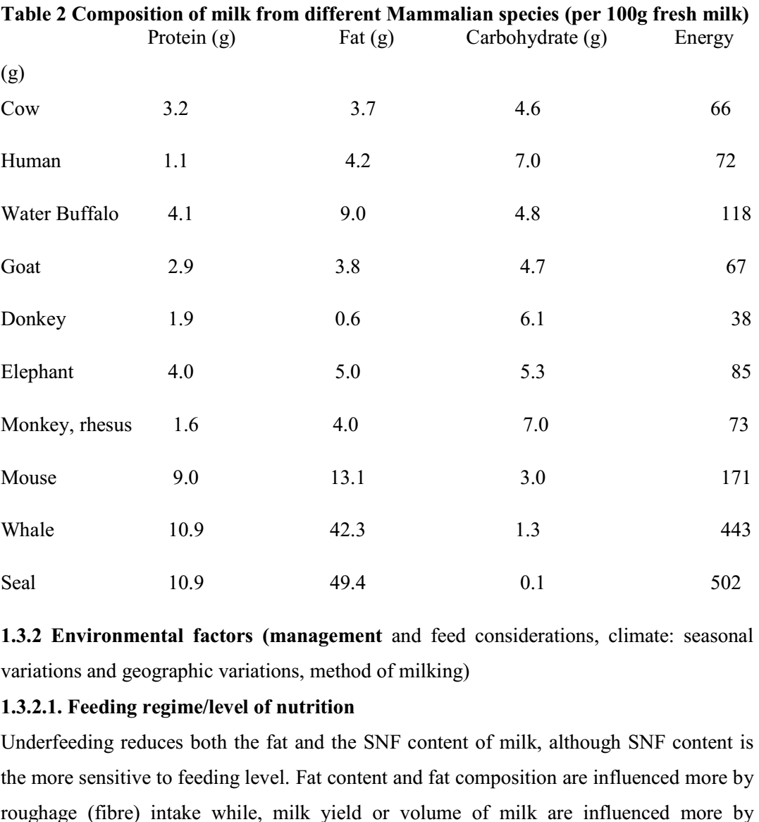

2. Environmental Factors
1. Nutrition: - Any restriction in feed or water supply will result in a drop in milk production. The most dramatic effect is brought about by shortage of water as the cow has no means of storing water. Insufficient supply of water for few hours will result in a rapid drop in milk yield.
Of all milk components, milk fat is the most influenced by dietary manipulations. Most of changes in milk composition due to dietary manipulation are related to changes in ruminal acetate: propionate ratio. Several nutritional factors can influence milk composition. These include plane of nutrition, forage: concentrate ratio, forage quality
(e.g. particle size), level and type of dietary fat.
1- Plane of nutrition: Underfeeding dairy cows reduces milk yield and protein, lactose% and increases fat %. Feeding unbalanced rations (e.g. low energy: protein ratio) may reduce milk yield, milk fat and protein percentages. Energy Shortage decrease %Fat. Mostly Occurs between 90-150 days postpartum. The Cow is usually thin. Fat test gives 2.5-3.0%. The cause may be unbalanced ration. Percent (%) protein and yield is also reduced. Underfeeding Decreases %Protein. Low protein diets also decrease% Protein. Dietary Fat Supplementation decreases %Protein. The Effect occurs due to post-ruminal digested products. By-pass Protein increase % protein.
2- Forage: concentrate ratio:- Rations that stimulate milk yield will depress fat percentage (like low roughage, high grain) and boost SNF percentage. Conversely, any ration that depress milk yield will increase fat percentage but depress SNF content. The SNF content may reduce if the cow is fed a low-energy diet, but is not greatly influenced by protein deficiency, unless the deficiency is acute. As the proportion of the concentrate in the ration increases (above 50-60% of the ration), milk fat % tends to decline. This is mainly because of the lower ruminal production of acetate and butyrate (precursors of milk fatty acid synthesis in the mammary gland) associated with feeding high concentrate diets. The extent of milk fat depression is influenced by other feeding practices such as frequency of feeding and feeding system. Feeding cows less frequently especially if the concentrates are fed separately from the forage results in a reduced ruminal acetate: propionate ratio which in turn can result in reduced milk fat %. In general, the impact of feeding high levels of concentrates on milk fat % will be less where total mix rations are fed and / or if feed is offered three or more times daily.
Diets that decrease fat without decreasing yield are: a.High grain, low roughage. b. Feeding finely ground or pelleted diets. C. Feeding certain oils or polyunsaturated fatty acids such as cod liver oil and extracted seed oils. d. Feeding flaked corn, heated starches, or expanded grains. e. grazing certain pasture plants such as; Lush spring pastures; Young oats; Pearl millet etc.

3- Forage particle size (forage processing): Feeding finely chopped forages has a negative impact on milk fat % and may cause milk fat depression syndrome (drop of milk fat % below 3%). Cows fed finely chopped forages spend less time chewing and therefore will produce less saliva. Ruminal pH will drop as less saliva is produced to buffer the acid production in the rumen. As the ruminal pH drops below 6, the activity of the cellulolytic bacteria is reduced and so is the production of acetic and butyric acids (precursors of short chain fatty acid synthesis in the mammary gland.

Milk Fat Depression Syndrome occurs at any stage of lactation. In milk fat depression syndrome case the cow is in good body condition but Fat test will give 0.9-2.0%. Off-feed condition may occur. %protein becomes higher than %fat. It is caused by Imbalance in production of VFAs.
4- Level of starch in the ration: As the level of starch ion the ration increases, the level of acetate produced in the rumen is decreased while that of propionate is increased. This may cause a reduction in milk fat %.
5- Dietary fat: Incorporation of fat or oil in dairy cow ration can substantially alter the profile of milk fatty acids. The effect of supplemented fat on milk fat % depends on the type of supplemental fat. Feeding polyunsaturated fat (susceptible to bio-hydrogenation in the rumen) such as vegetable oils may reduce milk fat %, whereas feeding protected fat tend to increase milk fat %. Milk fat differs from other sources of animal fat in that it contains significant amount of short chain fatty acids and relatively lower concentrations of long chain fatty acids. The ability of later the composition of milk fat by dietary means arises from the fact that about 50% of the fatty acids present in milk are derived directly from dietary long-chain fatty acids, adipose tissue and microbial synthesis of fatty acids. The second half of milk fatty acids is derived from de novo synthesis of short chain fatty acids, the precursors of which are acetate and butyrate. Therefore, milk fat composition is influenced by both end products of ruminal fermentation as well as the supply of dietary long chain fatty acids to the mammary gland. The extent to which dietary fat alters the fatty acid composition of milk fat is influenced by:
- Fatty acid composition of dietary fat.
- The extent of hydrolysis and bio-hydrogenation of unsaturated fatty acids by ruminal microbes.
- Effect of dietary fatty acids on de novo synthesis of short chain fatty acids by the mammary gland.
- The extent of conversion of saturated fatty acids to mono-unsaturated fatty acids (mainly C18:0 to C18:1) as a result of intestinal and mammary gland desaturase activity.
Feeding oil seeds such as canola, sunflower or flaxseed has been found to reduce the concentrations of short (C4-C10) and medium chain (C16:0) fatty acids and increase the concentrations of C18:0 and C18:1 fatty acids. The inclusion rate of oils seeds in dairy rations is limited by the negative impact of polyunsaturated fatty acids on ruminal fiber digestion. In general, the maximum inclusion level oilseeds should result in 3-4% added dietary fat. At a higher inclusion of fat or if a greater change in the concentration of unsaturated fatty acids in milk is desired, some form of protection (e.g. heat treatment) should be applied to avoid negative effects on fiber digestion in the rumen.

Diets that increase milk fat are: 1. Feeding protected lipids i. less than 5% fat inhibits rumen bacteria. ii.Unsaturated FAs saturated by rumen microbes. iii.Sodium salts of FAs can act as a detergent to kill microbes. 2. Feeding certain saturated FAs.2. Feeding high roughage diet. 3. Frequent feeding.

Feed Additives: 1. Buffers: a. Regulate rumen pH which is directly related to relate to the VFA production. b. Needed when natural system is overloaded. Saliva is the usual buffer. Examples Bicarbonate and MgO. Buffers can increase milk production if used properly. Buffers are most effective in early lactation.
2..Niacin:Vit. B3 Supplementation can improve yield and persistency. Reduces ketosis. Most effective in high producing cows in early lactation.
3. Isoacids: Branched chain FAs and n-valerate (straight chained) are substrates for amino acid synthesis by rumen bacteria and increase feed intake, weight gain, ruminal fermentation, and milk yield.
4. Supplementary dietary fat increases energy. Supplementary dietary fat is effective in high producing cows, in early lactation. Supplementary dietary fat should be of 3-4% fat diet to 7-8% fat diet. Too much fat decreases ruminal fermentation and then milk fat. Supplementary dietary fat increases milk fat % and is dependent on nutritional state. Supplementary dietary fat decreases milk protein %.Supplementary dietary fat Changes FA content of milk fat. Changes in FA content of milk fat reflect diet fat content. Supplementary dietary fat Complexes with Calcium i. Makes it less available ii. Ca should be supplemented accordingly. Supplementary dietary fat Acceptable sources include: i. Oil seeds such as whole cottonseeds, wholes soybeans, and whole sunflower seeds. Extracted seed oils have negative effect on ruminal fermentation.
ii. Tallow, Hydrolyzed animal-vegetable blends, Calcium salts of FAs.
Vitamin A and D:-Vitamin A and D are not synthesized by cow. Their amount in milk depends on diet. Sun-exposure effects Vit.
Minerals:-
1. Iodine sequestered by mammary gland. Cows can become hypothyroid 2.Iron can be increased in milk by diet.
2. Seasonal Variations:- A marked change in temperature, humidity, precipitation and consequent difference in the animal fodder in different seasons has a marked effect on the yield and composition. Increasing environmental temperature increases respiratory rate which is the primary mechanism whereby European breeds dissipate heat. When temperature increase milk production and feed consumption are reduced automatically. Depressed appetite and availability of more digestible feeds are the primary cause of reduced milk yield during heat stress. In general milk fat and SNF percentages are greatest in winter and lowest in summer. cows calving in autumn or winter produce more fat and SNF than cows freshening in spring and summer. At high temperatures (over 85ºF) milk production is often reduced more than fat production which may result in small increase in fat percentage. At high temperatures there is an increase in chlorides and a decrease in lactose and protein content of milk. As temperatures decrease below 75 ºF percent fat and SNF increase. Provision of shade, use of fans, showers, or refrigerated air alleviate thermal stress. High producers are more affected by high temperatures than low producers and the effect is especially harmful at peak lactation.The effect on milk yield and composition depends on breed. Bos indicus breeds and some temperate breeds, esp. Brown Swiss and Jersey, are more tolerant to high temperatures than other temperate breeds. Seasonal differences have become less significant because of better feeding and management of the dairy cow. Seasonal variations in milk composition are commonly observed with dairy cattle in temperate regions. In general, milk fat and solid-not-fat percentages are highest in winter and lowest in summer. Milk fat and protein percentages are lower by 0.2-0.4% in summer than winter. Cows calving in the fall or winter produce more fat and solid-not-fat than cows calving in the spring and summer. Considerable variations in milk composition can also be observed in dairy cows raised in pasture.
3. Age and size of cow:-The amount of milk produced by the cow increases with advancing lactations (age). This is due in part to an increase in body weight, which results in a larger digestive system and a larger mammary gland for the secretion of milk. Another reason for increased milk production with age is due to the effects of recurring pregnancies and lactations. Data on milk production with cows suggest that 20% of the increase in milk production is due to increased body weight and 80% to the effects of recurring pregnancy and lactations. Recurring pregnancies and lactation can result in increases of 30% in milk production from the first to the fifth lactation.
Milk yield increases at decreasing rate until about 8 years then decreases at increasing rate. Mature cow produces about 25% more milk than 2 year old heifer. This is 1/5 due to increase in body weight; 4/5 due to increased udder development. Heifers should be bred to calve at 24 months or earlier. Calving at greater than 30 months decreases lifetime production. Large cows generally produce more milk than small cows. Increases by a 0.7 power, Proportional to metabolic body size (Surface area).2X larger = 70% more milk. Between the first and fifth lactation, milk fat and SNF decrease at about 0.2% and 0.4 % respectively. There after there is little change. Lactose accounts for most of decrease in SNF. As cows grow older the fat content of their milk decreases by about 0.02 percentage units per lactation while the fall in SNF content is about 0.04 percentage units. Both fat and SNF contents can be reduced by disease, particularly mastitis.
3. Lactation number:- Milk production increases with lactation number and is maximized in the fourth or the fifth lactation. This is a result of the increasing development and size of the udder and the increasing body size over that of the first lactation animal.
4. Stage of lactation:-Colostrum differs from normal milk constituents in that it contains more minerals, salts, total protein and less lactose. SNF is high immediately after parturition and drops to become low at 2-3 months and increase slowly after 6 months and then increase rapidly to the end of lactation. The variation of this trend is more pronounced for fats.
The fat, lactose and protein contents of milk vary according to stage of lactation. Solids-not-fat content is usually highest during the first two to three weeks, after which it decreases slightly. Fat content is high immediately after calving but soon begins to fall, and continues to do so for 10 to 12 weeks, after which it tends to rise again until the end of the lactation. The high protein content of early lactation milk is due mainly to the high globulin content.

Since high lactose diets cause scours in calves, reduced lactose content of colostrum helps to prevent this diseases. Calcium, magnesium, phosphorus and chloride are high in colostrum, where as potassium is low. Iron is 10 to 17 times greater in colostrum than in normal milk .This high level of iron is needed to rapidly increase hemoglobin in red blood cells of the new born calf. Colostrum contains 10times as much vitamin a and 3 times as much vitamin D as that of normal milk.
At parturition milk production commences at a relatively high rate and the amount secreted continues to increase for about 6 weeks. Higher producing cows usually take longer than low producing cows to achieve peak production. After the peak production is attained milk production gradually declines. The rate of decline is commonly referred to as persistency. In the average non pregnant cow after peak production is attained, each month’s production is about 94 to 96% of the preceding month’s yield.
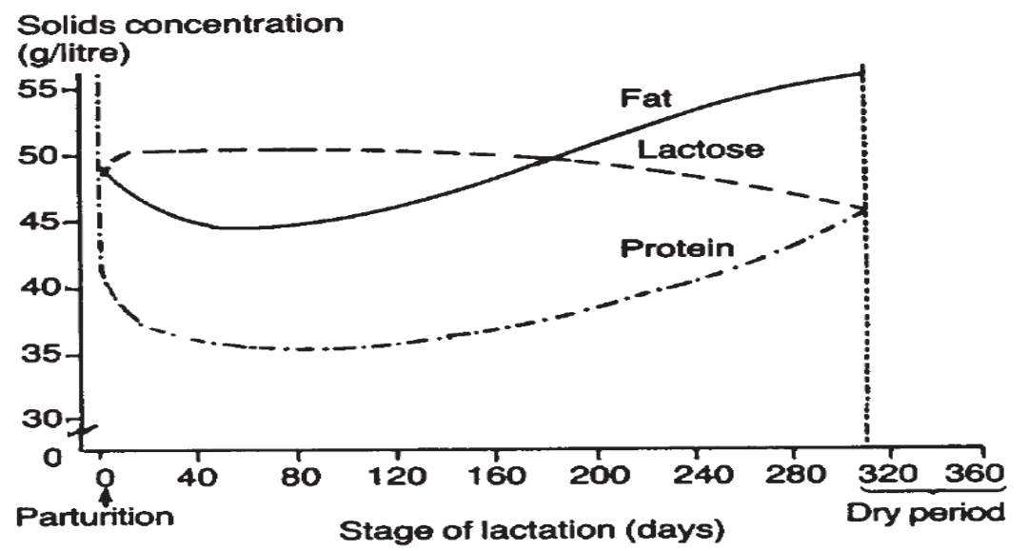
Figure 3. Changes in the concentrations of fat, protein and lactose over a lactation of a cow

4. Estrus and Pregnancy: - Estrus may depress milk yield temporarily Estrus May temporarily depress milk yield. This is primarily due to too much activity and reduction in fed intake.Milk production commences at a high level, increasing for two to six weeks. Higher producers take longer to reach their peak yield than low producers. After the peak yield, milk production gradually declines. The rate of decline is referred to as persistency, and determines the length of lactation. In non-pregnant cows, the decline in milk yield after peak lactation is very gradual. In pregnant cows, there is a marked drop in milk yield after the fifth month of gestation. During the eight month of pregnancy, there is a marked drying off. Regular calving intervals and their stimulation of milk production will greatly outweigh the negative effects of pregnancy on milk production. The major composition of milk follows a changing pattern through the lactation. Fat and SNF percentages are high in early lactation. They fall steadily until the second or third month of lactation and then gradually rise as milk yield falls with advancing lactation.
5. Disease and drugs: - Anything that causes a loss of health will automatically reduce milk yield. Many diseases, especially mastitis, ketosis, milk fever and digestive upsets adversely affect milk production and may alter composition of milk. Udder infection greatly influences the composition of milk. The principal effects are lowering of concentration of fat, SNF, lactose and Casein and increasing the serum protein and chloride contents. The ability to synthesize casein, lactose and fat is impaired. Milk from sick cow is usually high in sodium, chlorine and is discarded because of its salty test and for aesthetic reasons. Mastitis can cause a permanent reduction in milk yield due to the loss of secretory tissue.
Many drugs, including pesticides, used in treatment of cattle disease are excreted into milk. Such milk should be discarded to prevent the drugs from entering the human food supply. Presence of antibiotics and pesticides in milk is illegal and such milk is prohibited from sale.
- Milking Frequency (interval between milking):-The period following milk removal is characterized by low intra-alveolar pressure, which facilitates the transport of newly synthesized milk into the alveolar lumen. As secretion continues between milkings, pressure is exerted on the secretory process by the alveolar luminal contents. When the luminal pressure exceeds the force of secretion as the alveolar enlargement reaches its limit. In Dairy cows, average secretion rate begins to decline after 10 hours since the last milking and secretion stops after 35 hours. The pressure measured in the teat cistern increases in three phases. Milking a twice a day yields at least 40% more milk than once a day. An increasing milking frequency to 3 x day increases milk yield by up to 20% (range 5-20%).
- The fat content of milk varies considerably between the morning and evening milking because there is usually a much shorter interval between morning and evening milking than between evening and morning milking. If cows were milked at 12-hour intervals the variation in fat content between milkings would be negligible, but this is not practicable on most farms. Normally, SNF content does not vary with the length of time between milkings.
7. Milking Duration: - Milking time for most cows is 5-6 minutes per cow.5 minutes optimal.4 minutes under milked decreases yield over time.8 minutes over milked causes stress, increase chance of infection.
8. Completeness of milking (Residual milk and available milk.):-Residual milk can be defined as the amount of milk left in the udder after milking is completed. Cows should be completely milked out at each milking for maximum production. If some milk will be left in the udder this will lead to a permanent reduction in milk yield for the lactation. The first milk removed from the udder is low in fat compared with milk at the end of milking. Because fat globules are not evenly distributed in milk, incomplete milking will tend to leave high-fat milk behind.
9. Body condition: - Cows that calve in good body condition have more body energy to use for milk production in the important early lactation period. The increased peak in milk yield resulting from better body condition at calving is continued through the lactation if feeding is adequate. Calving in good body condition tends to produce milk with higher fat content than cows calving in poor condition.
10. Length of dry period: - Dairy cows are usually dried-off for two months prior to the next calving. This rest period is necessary to maximize milk production in subsequent lactation. Milk yield is usually reduced when the dry period is less than 40-60 days (25-40% less milk). 45-60 days is optimal. Dry period longer than 60 days in length does not result in a significant increase in milk production. Long dry periods decrease the average annual production of the cow by extending the calving interval beyond the normal 13-14 month interval and causing a decrease in the life time production of the dairy cow. Part of the dry period effect is related to body condition of the cow at calving. Cows in good body condition at calving produce higher milk yield during the following lactation than in cows in thin body condition at calving.
11. Calf removal:-Calf death or removal from the cow shortens lactation and reduces milk yield esp. bos indicus. 16% decrease is observed if calves were removed from the cow at milking time in a study.
12. Growth hormones (BST):-There is a positive correlation between milk production of cows and the level of growth hormone in their blood. Growth hormone causes redistribution of nutrient within the cow’s body to favor nutrient utilization towards milk production. However, growth hormone is not directly involved in milk secretion process.
13. Environmental (Ambient) temperature:-Heat and high humidity decrease yield. Optimal temperature is 50 0F for European breeds of cattle. Cold tolerated better than heat. The effect of ambient temperature on milk yield is dependent upon the breed. Holsteins and the other larger breeds are more tolerant to lower temperatures, whereas the smaller breeds particularly the Jersey are much more tolerant to high temperatures. The optimum temperature for the Holstein cow is about 10 ºC. Milk production declines when environmental temperature exceeds 27 ⁰C. The reduction in milk yield is largely due to drop in feed intake. High temperature affect high producing cows more than low producers and it is particularly harmful during the peak of lactation.
14. Exercise:-Moderate exercise is conducive to high milk yield. Cows in stanchion barns should be let out once a day for exercise and heat detection. Too much or too little exercise decreases yield.

5. Dairy building, design and construction
Cattle will produce milk and reproduce more efficiently if they are protected from extreme heat particularly from direct sunshine. Barns must protect cows from wind, moisture and extreme temperatures. Thus providing shade becomes an important factor. If cattle are kept in a confined area, it should be free from mud and manure in order to reduce hoof infection to a minimum. Concrete floors or pavements are ideal where the area per cow is limited.
Housing systems must provide:
- A comfortable, well drained lying area
- Shelter from adverse weather
- Space to allow the animal to move, lie down and rise freely without unnecessary risk of injury
- Access to adequate food and water to maintain health and vigour.

For a housing system to be successful, it must provide for the spatial and behavioural needs of the cow. To achieve this, it is important to understand how an animal behaves when performing routine activities such as drinking, feeding, lying, rising and walking. The design of the system and the level of management applied can affect the health and welfare of the cows, this can have an Influence on ailments such as lameness and mastitis.

5.1. Site selection
Good site selection is essential for a successful dairy operation. Start the site-selection process by obtaining a description of all potential sites and locations.

5.1.1. Essential Site selection Factors
1. Water: A year-round supply of potable water is essential for watering animals and sanitation. Water is also needed for fire protection and cooling cows and milk. Between 40 to 50 gallons of fresh water per cow are needed daily for lactating cow consumption and milking center cleaning. Peak water consumption usually occurs shortly after milking.
2. Drainage: Proper surface and subsurface drainage are required to divert storm water away from animal housing units and to help prevent frost heaving of foundations.
Select an elevated building site with a slope of 2 to 6 percent to provide adequate drainage while minimizing erosion.
3. Area availability for future expansion:
The site should provide an area that is several times larger than the size of the animal housing unit. Assume the operation will double in size and plan accordingly. Make room for feed areas, machine storage, vehicular traffic, and water and electricity upgrades. The site should allow for adequate manure storage. The site should also provide space for the collection and control of contaminated water from the animal housing units. Allow for adequate separation between buildings to prevent the spread of fire and to enhance natural ventilation.
4. Off-farm factors: The site must meet local building codes and pollution requirements. It should also provide adequate setback distances from neighboring residences to avoid nuisance problems such as noise and odor. A site that is isolated from the residence and sensitive environmental habitats is ideal.
5. Market access:-easy and cheap availability of raw material, and market for selling different products should be available in the nearby areas.
Other Considerations
You should consider several other site factors when evaluating potential sites. These factors are not as essential as water, drainage, required area, and off-farm factors. However, a potential site should be eliminated if it cannot provide a majority of these other factors:
1. Access: The site should provide for the construction of all-weather roads for milk trucks, service personnel, veterinarians, feed delivery, manure handling equipment, and emergency vehicles. Plan a minimum road width of 12 feet and for adequate turn-around areas. The minimum turning radius is 50 feet for a hay wagon and at least 55 feet for large milk or feed trucks.
2. Electric power: Electricity is needed for heating, lighting, pumps, and motors. The site should be located near electric lines and have access to three-phase power if it is available. A minimum 200-amp, 230-volt entrance is recommended and thorough grounding is necessary to reduce stray current problems.
3. Manure storage and usage: The seasonal high-water table must be at least one foot below the bottom elevation of the manure storage pit and the pit cannot be built within a 100-year flood plain. The site should also have sufficient land so that manure application does not exceed crop nutrient needs. Consult a certified nutrient management planner to determine if potential sites meet this criterion. The land should not be located further than one mile from the manure storage facilities to minimize hauling costs. Land for manure application should have minimal slope to minimize manure runoff and should not lie adjacent to neighboring residences or public facilities.
4. Soil type: The type of soil can have a significant impact on the cost of constructing a manure storage structure. In most cases, a lagoon must be lined with a clay-type soil, concrete, or a heavy plastic liner. If clay must be transported a long distance, the cost of constructing a clay-lined lagoon can be 25 percent more than if suitable clay is available on the farmstead. A plastic or concrete liner may be comparable in cost to a clay liner if clay must be hauled a long distance. If the proposed building site has sandy soil and extremely shallow fractured bedrock, then an aboveground storage structure may be required. Aboveground storage costs about twice as much as lined lagoons.
5. Wind and snow control: The site should have windbreaks to help deflect winter winds and control snow. Take advantage of trees, existing buildings, and hills for winter wind protection; however, windbreaks should not interfere with summertime ventilation. Consider prevailing wind directions for reducing odor complaints and for controlling snow drifting, insects, noise, and dust.
6. Security: The site should provide security against theft, vandalism, and fire. Visitor access should be limited to control disease and to reduce interference with farm work. When dairy facilities are located on the same site as the manager’s residence, the access lane should run near the home. Facilities located away from the manager’s residence pose the most problems. Install gates at remote accesses with signs warning about unauthorized entry. Also, make access roads visible from a public road or neighboring residence.
7. Safety: The site should be located away from the residence to reduce the risk of exposing children to injury or death from equipment and animals.

5.2. Type of building
There are generally two main types of dairy housing:
1. Tie Barns: - animals are tied by neck chains in rows on a platform. Closed tie up barns are easier to clean and are more hygienic, but have problem in rainy season, there is a problem of humidity/dampness and ventilation. Such types of sheds are more expensive than loose houses.
2. Loose housing:-This type of housing has yards and this is recommended for most of Ethiopian areas. Loose sheds are provided with an open paddock so that cows can lie indoors or outdoors depending on the weather conditions. Stalls may be provided for each cow in the shed. Loose houses with stalls require less space per animal than those without stalls. The cows are free to move around but in some cases tie up stalls may be used and fresh forage or hay is carried to the stalls. In case of tie up stalls, they must be fitted with a feed trough or hay rack. Cows may be milked in the stalls of a loose house. Cow stall having provision of cow dung / urine channel, slope area for easy drainage, the effluent (cow dung + urine +water) can be channeled out in such a way that it can be used to fertilize an outside plot for forage production. The loose house should have three walls with one open side to allow good ventilation and also leave provision for future extension if needed.

This system is most economical and has the following features:
- Here, the cost of construction is significantly lower than other systems.
- It facilitates easy detection of animals which are in heat.
- It allows animals to move freely and gives chance to exercise which is important for better health and production.
- Animals can be taken care of under better management.
The calves may be housed in a section of the building where cows are kept or in a separate sheds.

5.2.1. Types of dairy houses and space requirement
For protecting cattle from adverse climatic conditions and safe keeping the following types of houses are constructed:
- Cow houses or sheds
- Sheds for the young calves
- Bullock or Bull shed
- Calving box / shed
- Isolation shed / box
- Types of Housing & Housing Equipment
Calf pen:-The floor should be made of concrete with a slope of 1 in 40 to provide good drainage. A drain should be made at the rear of the calf pen to carry away the effluent. Damp and ill drained floors can cause respiratory trouble in calves. The calf pen should contain a small water trough which should be filled with clean fresh water. A bucket hanger should also be provided. Fresh straw bedding should always be provided for the calves. Most operators prefer this area in a building or section of a building where they can control the environment. It is better to classify calves as per age for resting area viz.:
- 20 to 25 square feet per calf below the age of 3 months
- 25 to 30 square feet per calf for the age of 3 to 6 months
- 30 to 40 square feet per calf for 6 to 12 months and over
- 40 to 50 square feet for every calf above one year should be provided for sheltering the calves. The height of each pen should be at least 120 cm.
The required minimum internal dimensions for an individual calf pen are 1200 by 800mm for a pen where the calf is kept to two weeks of age, 1200 by l000mm where the calf is kept to 6 to 8 weeks of age and 1500 by 1 200mm where the calf is kept from 6 to 14 weeks of age. The front of the pen should be made so that the calf can be fed milk, concentrates and water easily from buckets or a trough fixed to the outside of the pen and so that the calf can be moved out of the pen without lifting.
In Canada it is advised that Calves up to 3 months old should have individual stalls with 600 x 1500 mm (2 x 5 ft) minimum dimensions. Calves 3 to 10 months old should each have 2.2 m² (24 sq ft) of pen with bedding or 1.5 m² (16 sq ft) with slotted floors. As far as possible the young calf shed should be close to cow shed.
Milk store: - a small milk house is made to store milk and all the milking utensils. The milk house must meet strict sanitary requirements. If milk must be carried, locate the milk house to minimize the walking distance to the milking area. This room should have good ventilation. Windows are provided with fine mesh wire to keep the flies away. For easy cleaning floor should be made smooth. For cooling the milk till dispatch it is essential to have a concrete pit of three quarters the depth of the milk can so that milk filled can is possible to be immersed in cold water. Generally, a shed of 3 m by 2 m and height of 3.5 m is sufficient for a herd producing about 100 Liters per day.
Maternity pen: - For pregnant and calving cows a separate sheds (or a separate section of the milking barn) are provided as maternity pens. Most operators prefer this area in a building or section of a building where they can control the environment.
The calving pen of 3 m by 4 m with a manger, ample soft bedding and water trough is essential. This should be easily cleanable and disinfect able for avoiding any infection to the newborn calf. For each calving pen fresh straw bedding is required to be provided. Lime is used for disinfection of the shed. In Canada it is recommended to Provide one 3 x 3 m (10 x 10 ft) maternity pen, or one maternity tie-stall without gutter, for every 20 to 25 cows (in loose housing, add a treatment tie-stall for every 20 to 25 cows).
Isolation pen:-You'll also need an isolation pen for every 40 animals; it should have minimum dimensions of 3 x 3 m (10 x 10 ft), be separate from the main livestock area and have a stanchion or tie-stall in one corner.
Sheds for young stock and dry cows:-Keep this stock separate from the milking herd. Most operators use loose housing to save work. It is best to separate the large and small heifers. Heifers 10 to 24 months old should each have 3.2 m² (35 sq ft) with bedding or 2 m² (22 sq ft) with slotted floors.
Table indicates: Free stall dimension for cows
Size of cow in kg | Width in cm | Length in cm | Height of side partition in cm
454 | 107 | 208 | 102
545 | 114 | 213 | 107
636 | 122 | 221 | 114
726 | 122 | 229 | 122
Other references also give space requirements as shown below:
Water trough and manger (feed trough) space requirements:
Space per animal(front length in cm) | Width(cm) | Manger (feed trough) water trough height from floor ( cm) | Depth(cm)
Adult cattle 60 – 75 | 60 | 50 (i.e. 10 cm is concrete next to floor) | 40
Calves : 40 - 50 | 40 | 20 | 15
Gutter - Manure is collected in to a gutter (dung channel, drain) behind the cows. The gutter may be about 15 cm deep at the start, 40 cm wide with a slope of about 2.5 %.
Manger - Feed is delivered into a manger (feed trough) in front of the cows. The width of the manger is 0.5-0.6 m and separated from the stall by a curb with rounded edges about 0.15m high. The bottom of the manger should be 40-50 mm higher than the stall level.
Floors may be constructed using concrete, stone or packed earth. Floor depth should be 45 to 70 CM depending upon materials used. Floor slope should be 1 in 40 to 1 in 60 towards drains.

5.3. Arrangement and installation of equipment
Arrangement
When arranging equipment one must consider:
• hygiene and safety of operation
• the flow of raw material through to product, i.e. process sequence
• access to each item of equipment for operation, cleaning and storage
• storage and sale of product
• disposal of by-product.
Installation of equipment
Some equipment must be securely fixed. The cream separator should be mounted on a level stand fixed firmly to the floor and should be at a convenient height for working. Once the separator is mounted on the stand the level should be checked with a spirit level before final tightening of the fixing screws. Similarly, the churn stand and butter-working table should be fixed. Cheese vats of the necessary capacity are portable and can be located as desired. The fixing block for a lever-action cheese press should be fixed firmly to the wall.

If the water supply permits it, two hose points should be installed on opposite walls to facilitate cleaning. Electric wiring and installation of electrical equipment should be carried out by qualified personnel.

6. Milk as food
Milk is secreted by the mammary gland of mammals to feed their offspring. Cow’s milk is commonly used as human food, but milk from sheep, goats, buffalo, yak, horses and camels is also used. Milk contains large amounts of essential nutrients and has rightly been recognized as nature's single most complete food. Milk contains all the nutrients required by the neonate and has thus long been recognized as perhaps nature’s ultimate food; furthermore, it is also a rich source of protective agents, enzymes and growth factors.

The relative ease with which milk can be converted into a wide variety of products makes it an extremely useful base material. In some cases, milk undergoes relatively limited processing, consisting of heat treatment to increase the bacterial shelf life of the product and homogenisation to increase the physical shelf life through retarding fat separation. Other well-known processes involve the acid-induced coagulation of milk to produce yoghurt, or the enzymatic coagulation of milk to manufacture cheese. In addition, milk may be spray-dried or be used as a base from which constituents, e.g. proteins or fats, are isolated. As a result of the widespread applications and use of milk, and products derived there from, in human nutrition, it has been the subject of scientific study for over a century.
As a food, milk serves the following broad purposes: (a) growth, (b) reproduction, (c) supply of energy, (d) maintenance and repair and (e) appetite satisfaction. The requirements of these categories vary with the individual, and in some instances not all the stated functions of the food need to be served, e.g. adults no longer require food for growth whereas infants do. The functions of a food are served specifically through the various nutritionally important components, comprising proteins, carbohydrates, lipids, minerals, vitamins and water.

Nutritionally, milk has been defined as "the most nearly perfect food". It provides more essential nutrients in significant amounts than any other single food. Milk is an outstanding source of calcium and phosphorus for bones and teeth, and contains riboflavin, vitamins B6, A and B1 in significant amounts. It also contains B12, the antipernicious an anemia vitamin. Milk fat or butterfat is the second largest component of milk and is of major commercial value. It serves nutritionally as an energy source and supplies essential fatty acids. Fat content is closely followed by milk proteins at about 3.4%. Milk proteins in turn are subdivided into casein, comprising approximately 76-80% of the total milk proteins, and the whey proteins, comprising roughly 20-24%.
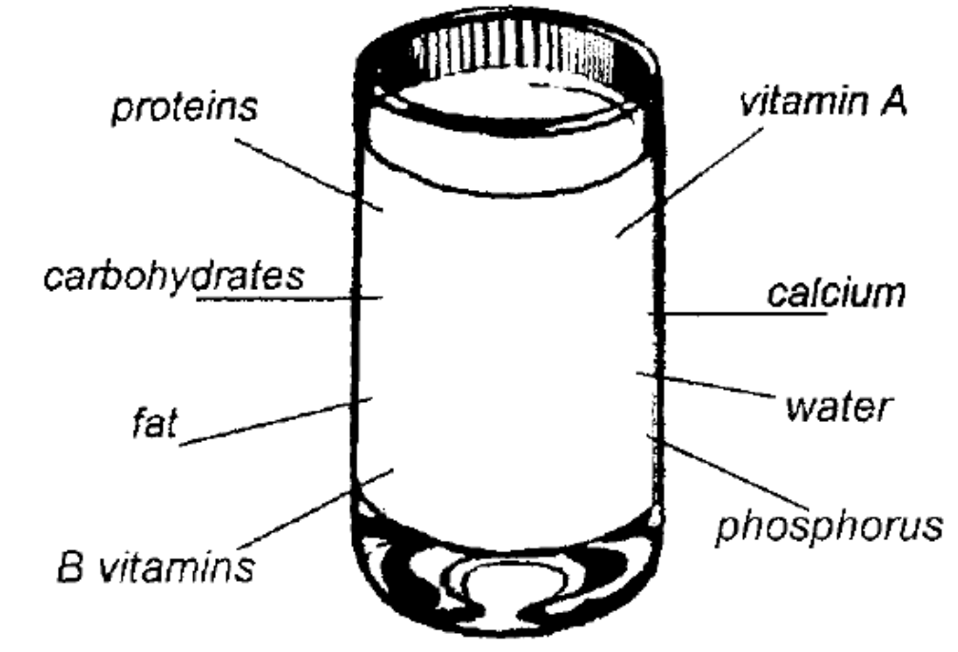
Figure 1 Main components of milk
The whey proteins are of higher nutritional value than casein. Milk proteins are outstanding sources of essential amino acids. The nutritive value of milk products is based on the high nutritive value of milk as modified by processing. Over-processing and, in particular, severe heat treatment reduce the nutritional value of milk. Butter-making concentrates the fat-soluble nutrients, while cheese making concentrates the milk fat and the major protein fractions.

In some instances milk is fortified with certain nutrients, e.g. vitamin D. It is also possible to replace butterfat with a cheaper fat, as is often done in the manufacture of calf milk replacers and in powdered milk for certain markets. Milk components are also used in other foods: sodium casein ate is used as a protein source in sausages and "filled" meats, whey proteins are used in confectionery and milk proteins are used in sauces for instant foods.
Figure 1 shows the major milk constituents and the products that can be made from each of them. Rural producers make butter and ghee from the fat fraction of milk. Ghee has excellent storage stability. Where ghee is not made, butter is occasionally spiced and heated to preserve it. Salt is rarely used as a butter preservative in the rural sector.
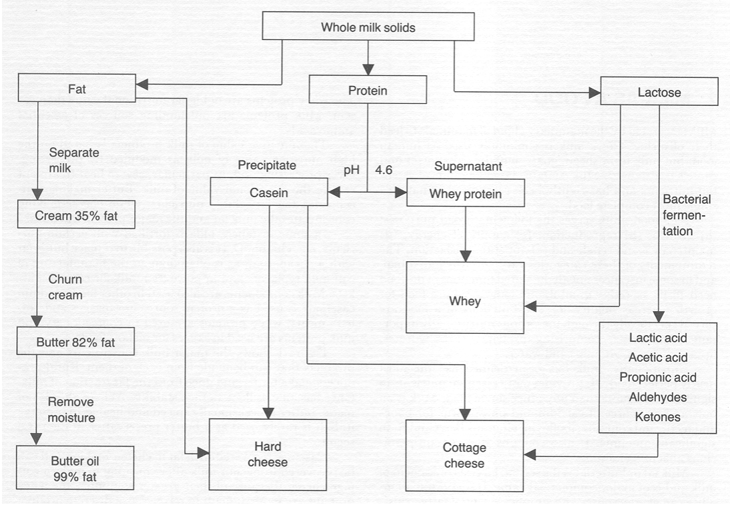
Figure .2 Flow chart illustrating the incorporation of the major milk solid fractions in milk products

Casein is recovered with fat in cheese-making and can be recovered from sour milk after churning to make a cottage cheese. Because of their greater solubility, the whey proteins are more difficult to recover as a discrete product and in the smallholder setting are best utilized by direct consumption.
Milk sugar-lactose is soluble in milk. Some people are allergic to fresh milk because of lactose intolerance but can consume sour milk because the lactose level has been solids. Lactic acid contributes to the flavor of much milk reduced by fermentation to lactic and other acids. This reduces milk pH and assists in the preservation of other milk solids. Lactic acid contributes to the flavor of many milk products. Because it is present in solution, lactose is difficult to recover as a discrete product.
6.1. Factor affecting the composition of milk
There are many factors that can affect milk composition generally genetic and environmental factors.
6.1.1. Genetic factors (species variation, breed variations and individual variations: cow to cow variations, herd to herd variation)
6.1.1.1. Breed and individuality of the cow
Both milk yield and composition vary considerably among breeds of dairy cattle. Jersey and Guernsey breeds give milk with about 5% fat while the milk of Shorthorns and Friesians contains about 3.5% fat. Zebu cows can give milk containing up to 7% fat.

Table 1. Average composition (%) of cow milk
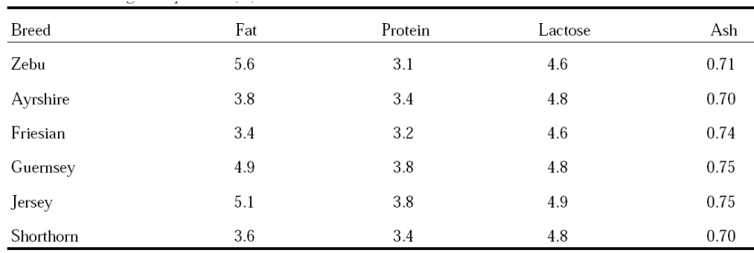
Milk of individual cows within a breed varies over a wide range both in yield and in the content of the various constituents. The potential fat content of milk from an individual cow is determined genetically, as are protein and lactose levels. Thus selection for breeding on the basis of individual performance is effective in improving milk compositional quality. Herd recording of total milk yields and fat and solids-not-fat (SNF) percentages will indicate the most productive cows, and replacement stock should be bred from these.

6.1.1.2. Species variation
Milk from different mammals (human, farm animals and water mammals vary considerably,
Table 2 Composition of milk from different Mammalian species (per 100g fresh milk)

6.2. Environmental factors (management and feed considerations, climate: seasonal variations and geographic variations, method of milking).

6.2.1. Feeding regime/level of nutrition
Underfeeding reduces both the fat and the SNF content of milk, although SNF content is the more sensitive to feeding level. Fat content and fat composition are influenced more by roughage (fibre) intake while, milk yield or volume of milk are influenced more by concentrate. The SNF content may fall if the cow is fed a low-energy diet, but is not greatly influenced by protein deficiency, unless the deficiency is acute.
6.2. 2. Interval between milking
The fat content of milk varies considerably between the morning and evening milking because there is usually a much shorter interval between morning and evening milking than between evening and morning milking. If cows were milked at 12-hour intervals the variation in fat content between milking would be negligible, but this is not practicable on most farms. Normally, SNF content does not vary with the length of time between milking.

6.2.3. Physiological Factors (stage of lactation, age of animal, estrus cycle)
6.2.3.1. Stage of lactation
The changes in milk composition during a lactation cycle of a cow are well described. Colostrum, the initial mammary secretion after parturition, contains considerably more protein, particularly serum protein. High levels of immunoglobulin are primarily responsible for this high protein level. Seasonal variation of other milk components is also observed.
The fat, lactose and protein contents of milk vary according to stage of lactation. Solids not-fat content is usually highest during the first two to three weeks, after which it decreases slightly. Fat content is high immediately after calving but soon begins to fall, and continues to do so for 10 to 12 weeks, after which it tends to rise again until the end of the lactation. The high protein content of early lactation milk is due mainly to the high globulin content. The variation in milk constituents throughout lactation is shown in Figure 3.

Figure 3. Changes in the concentrations of fat, protein and lactose over a lactation of a cow

6.2.3.2 Age
As cows grow older the fat content of their milk decreases by about 2% units per lactation while SNF content fall much greater about 4% units. Both fat and SNF contents can be reduced.
6.2.3.3. Estrus cycle
During estrus/ heat period the milk yield decrease and estrogen hormone increase.
6.2.3.4. Completeness of milking
The first milk drawn from the udder contains about 1.4% fat while the last milk (or strippings) contains about 8.7% fat. Thus, it is essential to milk the cow completely and thoroughly mix all the milk removed before taking a sample for analysis. The fat left in the udder at the end of a milking is usually picked up during subsequent milking, so there is no net loss of fat.

6.2.3.5. Pathological factors (disease and parasite: illness of the cows)
Disease
The health status of the cow also has a considerable effect on milk composition and yield. Oestrus and gestation affect milk yield primarily, but mastitis, for example, a severe inflammation of the mammary gland as a result of the entering of pathogenic bacteria, affects milk composition as well as milk yield. Mastitis is characterised by increased levels of blood components in milk. Finally, several environmental factors also influence milk yield and composition, such as extreme climates, stress, exhaustion, housing, milking technique and milking frequency.

7. Milk constituents or composition
Milk is often described as a colloidal suspension, containing emulsified globules of fat, a heterogeneous family of major and minor proteins, the carbohydrate lactose, minerals, vitamins and enzymes. While the classes of constituents are similar for milk from most species, there are considerable inter-species differences, both qualitatively (i.e. the exact nature of constituents) and quantitatively (i.e. the amount of each constituent per litre).

Table 3. Approximate composition (g 100 g-1) of milk from dairying species
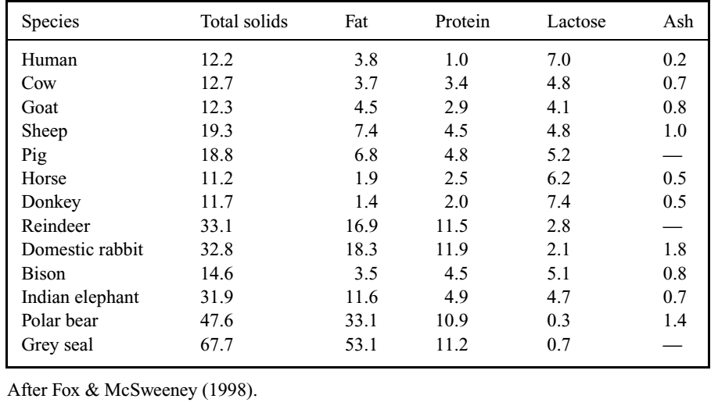
The composition and properties of fresh cow’s milk shows considerable variability. The main factors from which such variability arises are: (a) genetic factors (e.g. breed and individual), (b) stage of lactation, (c) health status of the cow and (d) environmental factors (e.g. feed, climate or method of milking).
Water is the main constituent of milk and much milk processing is designed to remove water from milk or reduce the moisture content of the product.

Milk fat
If milk is left to stand, a layer of cream forms on the surface. The cream differs considerably in appearance from the lower layer of skim milk. Milk and cream are examples of fat-in-water (oil-in-water) emulsions. The milk fat exists as small globules or droplets dispersed in the milk serum.

Under the microscope cream can be seen to consist of a large number of spheres of varying sizes floating in the milk. Each sphere is surrounded by a thin skin the fat globule membrane which acts as the emulsifying agent for the fat suspended in milk (Figure 3).The membrane protects the fat from enzymes and prevents the globules combining into butter grains. The fat is present as an oil-in-water emulsion: this emulsion can be broken by mechanical action such as shaking.
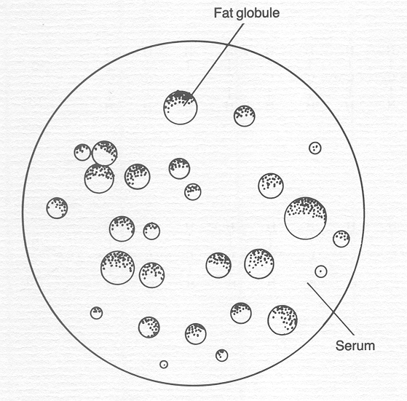
Figure 3. Fat globules in milk.
Fats are partly solid at room temperature. The term oil is reserved for fats that are completely liquid at room temperature. Fats and oils are soluble in non-polar solvents, e.g. ether.
About 98% of milk fat is a mixture of triacyl glycerides. There are also neutral lipids, fat-soluble vitamins and pigments (e.g. carotene, which gives butter its yellow colour), sterols and waxes. Fats supply the body with a concentrated source of energy: oxidation of fat in the body yields 9 calories/g. Milk fat acts as a solvent for the fat-soluble vitamins A, D, E and K and also supplies essential fatty acids (linoleic, linolenic and arachidonic).

A fatty-acid molecule comprises a hydrocarbon chain and a carboxyl group (-COOH). In saturated fatty acids the carbon atoms are linked in a chain by single bonds. In unsaturated fatty acids there is one double bond and in poly-unsaturated fatty acids there is more than one double bond. Examples of each type of fatty acid are shown in Figure 4.
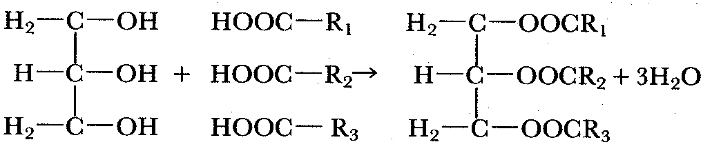
Glycerol + fatty acids → triglyceride (fat) + water
Figure 4. Structural formulae of four 18-carbon fatty acids varying in degree of saturation.

Fatty acids vary in chain length from 4 carbon atoms, as in butyric acid (found only in butterfat), to 20 carbon atoms, as in arachidonic acid. Nearly all the fatty acids in milk contain an even number of carbon atoms.
Fatty acids can also vary in degree of unsaturation, e.g. C18:0 stearic (saturated), C18:1 oleic (one double bond), C18:2 linoleic (two double bonds), C18:3 linolenic (three double bonds).
The most important fatty acids found in milk triglycerides are shown in Table 5. Fatty acids are esterified with glycerol as follows:

Table 5. Principal fatty acids found in milk triglycerides.
 | Molecular formula | Chain length | Melting point
Butyric | CH₃(CH₂)_{2COOH} | C₄ | �8�C
Caproic | CH₃(CH₂)_{4COOH} | C₆ | �2�C
Caprylic | CH₂(CH₂)_{6COOH} | C₈ | 16°C
Capric | CH₃(CH₂)_{8COOH} | C₁₀ | 31.5°C
Lauric | CH₃(CH₂)_{10COOH} | C₁₂ | 44°C
Myristic | CH₃(CH₂)_{12COOH} | C₁₄ | 58°C
Palmitic | CH₃(CH₂)_{14COOH} | C₁₆ | 64°C
Stearic | CH₃(CH₂)_{16COOH} | C₁₈ | 70°C
Arichidonic | CH₃(CH₂)_{18COOH} | C₂₀
Oleic | CH₃(CH₂)_{7CH}=CH(CH₂)_{7COOH} | C_{18: 1} | 13°C
Linoleic | CH₃(CH₂)₄(CH=CH.CH₂)₂(CH₂)_{6COOH} | C_{18: 2} | -5°C
Linolenic | CH₃.CH₂(CH=CH.CH₂)₃(CH₂)_{6COOH} | C_{18: 3}
The melting point and hardness of the fatty acid is affected by:
- the length of the carbon chain, and
- The degree of unsaturation.
As chain length increases, melting point increases. As the degree of unsaturation increases, the melting point decreases.
Fats composed of short-chain, unsaturated fatty acids have low melting points and are liquid at room temperature, i.e. oils. Fats high in long-chain saturated fatty acids have high melting points and are solid at room temperature. Butterfat is a mixture of fatty acids with different melting points, and therefore does not have a distinct melting point. Since butterfat melts gradually over the temperature range of 0-40°C, some of the fat is liquid and some solid at temperatures between 16 and 25°C. The ratio of solid to liquid fat at the time of churning influences the rate of churning and the yield and quality of butter.

Fats readily absorb flavors. For example, butter made in a smoked gourd has a Smokey flavor.
Fats in foods are subject to two types of deterioration that affect the flavor of food products.
- Hydrolytic rancidity: In hydrolytic rancidity, fatty acids are broken off from the glycerol molecule by lipase enzymes produced by milk bacteria. The resulting free fatty acids are volatile and contribute significantly to the flavor of the product.
- Oxidative rancidity: Oxidative rancidity occurs when fatty acids are oxidized. In milk products it causes tallow flavors’. Oxidative rancidity of dry butterfat causes off-flavors’ in recombined milk.
Milk proteins
Proteins are an extremely important class of naturally occurring compounds that are essential to all life processes. They perform a variety of functions in living organisms ranging from providing structure to reproduction. Milk proteins represent one of the greatest contributions of milk to human nutrition. Proteins are polymers of amino acids. Only 20 different amino acids occur, regularly in proteins. They have the general structure:
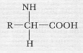
R represents the organic radical. Each amino acid has a different radical and this affects the properties of the acid. The content and sequence of amino acids in a protein therefore affect its properties. Some proteins contain substances other than amino acids, e.g. lipoproteins contain fat and protein. Such proteins are called conjugated proteins:
Phosphoproteins: Phosphate is linked chemically to these proteins. Examples include casein in milk and phosphoproteins in egg yolk.
Lipoproteins: These combinations of lipid and protein are excellent emulsifying agents. Lipoproteins are found in milk and egg yolk.
Chromoproteins: These are proteins with a coloured prosthetic group and include hemoglobin and myoglobin.

Casein
Casein was first separated from milk in 1830, by adding acid to milk, thus establishing its existence as a distinct protein. In 1895 the whey proteins were separated into globulin and albumin fractions.
It was subsequently shown that casein is made up of a number of fractions and is therefore heterogeneous. The whey proteins are also made up of a number of distinct proteins as shown in the scheme in Figure 5.
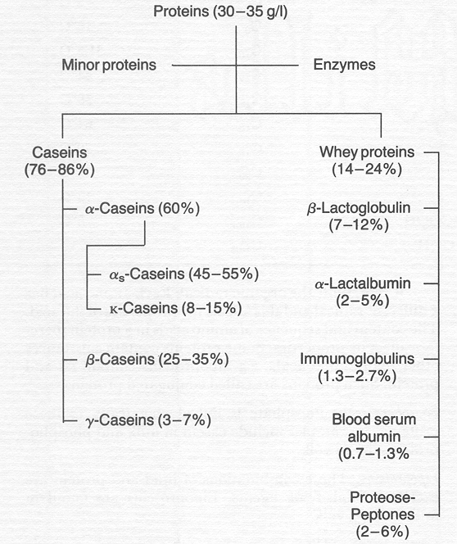
Figure 5. Milk protein fractions.
Casein is easily separated from milk, either by acid precipitation or by adding rennin. In cheese-making most of the casein is recovered with the milk fat. Casein can also be recovered from skim milk as a separate product.
Casein is dispersed in milk in the form of micelles. The micelles are stabilized by the Κ-casein. Caseins are hydrophobic but Κ-casein contains a hydrophilic portion known as the glycomacropeptide and it is this that stabilizes the micelles. The structure of the micelles is not fully understood.
When the pH of milk is changed, the acidic or basic groups of the proteins will be neutralized. At the pH at which the positive charge on a protein equals exactly the negative charge, the net total charge of the protein is zero. This pH is called the isoelectric point of the protein (pH 4.6 for casein). If an acid is added to milk, or if acid-producing bacteria are allowed to grow in milk, the pH falls. As the pH falls the charge on casein falls and it precipitates. Hence milk curdles as it sours, or the casein precipitates more completely at low pH.

Whey proteins
After the fat and casein have been removed from milk, one is left with whey, which contains the soluble milk salts, milk sugar and the remainder of the milk proteins. Like the proteins in eggs, whey proteins can be coagulated by heat. When coagulated, they can be recovered with caseins in the manufacture of acid-type cheeses. The whey proteins are made up of a number of distinct proteins, the most important of which are -lactoglobulin.
Lactoglobulin accounts for about 50% of the whey proteins, and has a high content of essential amino acids. It forms a complex with Κ-casein when milk is heated to more than 75°C, and this complex affects the functional properties of milk. Denaturation of -lactoglobulin causes the cooked flavour of heated milk.

Other milk proteins
In addition to the major protein fractions outlined, milk contains a number of enzymes. The main enzymes present are lipases, which cause rancidity, particularly in homogenised milk, and phosphatase enzymes, which catalyse the hydrolysis of organic phosphates. Measuring the inactivation of alkaline phosphatase is a method of testing the effectiveness of pasteurization of milk.
Peroxidase enzymes, which catalyse the breakdown of hydrogen peroxide to water and oxygen, are also present. Lactoperoxidase can be activated and use is made of this for milk preservation.
Milk also contains protease enzymes, which catalyse the hydrolysis of proteins, and lactalbumin, bovine serum albumin, the immune globulins and lactoferrin, which protect the young calf against infection.

Milk carbohydrates
Lactose is the major carbohydrate fraction in milk. It is made up of two sugars, glucose and galactose (Figure 6). The average lactose content of milk varies between 4.7 and 4.9%, though milk from individual cows may vary more. Mastitis reduces lactose secretion.
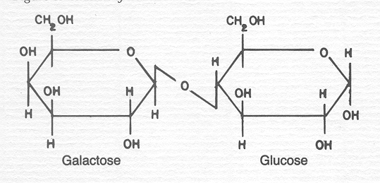
Figure 6. Structure of a lactose molecule.
Lactose is a source of energy for the young calf, and provides 4 calories/g of lactose metabolised. It is less soluble in water than sucrose and is also less sweet. It can be broken down to glucose and galactose by bacteria that have the enzyme -galactosidase. The glucose and galactose can then be fermented to lactic acid. This occurs when milk goes sour. Under controlled conditions they can also be fermented to other acids to give a desired flavour, such as propionic acid fermentation in Swiss-cheese manufacture.
Lactose is present in milk in molecular solution. In cheese-making lactose remains in the whey fraction. It has been recovered from whey for use in the pharmaceutical industry, where its low solubility in water makes it suitable for coating tablets. It is used to fortify baby-food formula. Lactose can be sprayed on silage to increase the rate of acid development in silage fermentation. It can be converted into ethanol using certain strains of yeast, and the yeast biomass recovered and used as animal feed. However, these processes are expensive and a large throughput is necessary for them to be profitable. For smallholders, whey is best used as a food without any further processing.

Heating milk to above 100ºC causes lactose to combine irreversibly with the milk proteins. This reduces the nutritional value of the milk and also turns it brown. Because lactose is not as soluble in water as sucrose, adding sucrose to milk forces lactose out of solution and it crystallises. This causes sandiness in such products as ice cream. Special processing is required to crystallise lactose when manufacturing products such as instant skim milk powders.

Some people are unable to metabolise lactose and suffer from an allergy as a result. Pre-treatment of milk with lactase enzyme breaks down the lactose and helps overcome this difficulty.
In addition to lactose, milk contains traces of glucose and galactose. Carbohydrates are also present in association with protein. Κ-casein, which stabilises the casein system, is a carbohydrate-containing protein.

Minor milk constituents
In addition to the major constituents discussed above, milk also contains a number of organic and inorganic compounds in small or trace amounts, some of which affect both the processing and nutritional properties of milk.

Milk salts
Milk salts are mainly chlorides, phosphates and citrates of sodium, calcium and magnesium. Although salts comprise less than 1% of the milk they influence its rate of coagulation and other functional properties. Some salts are present in true solution. The physical state of other salts is not fully understood. Calcium, magnesium, phosphorous and citrate are distributed between the soluble and colloidal phases (Table 3). Their equilibria are altered by heating, cooling and by a change in pH.
Table 3. Distribution of milk salts between the soluble and colloidal phases.
 | Total | Dissolved | Colloidal
 | (mg/100 ml of milk)
Calcium | 1320.1 | 51.8 | 80.3
Magnesium | 10.8 | 7.9 | 2.9
Total phosphorus | 95.8 | 36.3 | 59.6
Citrate | 156.6 | 141.6 | 15.0
In addition to the major salts, milk also contains trace elements. Some elements come to the milk from feeds, but milking utensils and equipment are important sources of such elements as copper, iron, nickel and zinc.

Milk vitamins
Milk contains the fat-soluble vitamins A, D, E and K in association with the fat fraction and water-soluble vitamins B complex and C in association with the water phase. Vitamins are unstable and processing can therefore reduce the effective vitamin content of milk.

Generally, milk is an exceedingly complex biological material, containing a multi-phase system of several groups of constituents of nutritional and technological significance, the levels of which are variable due to a range of factors. It is also a dynamic system, which is exceedingly sensitive to changes in environmental conditions, e.g. temperature and pH. Changes due to manipulation of such parameters have been exploited for centuries to produce a range of dairy products, and to ensure the safety of such products for consumers.

8. Milk chemistry
The chemical composition of milk largely determines its nutritional value; the extent to which microorganisms can grow in it; its flavor; and the chemical reactions that can occur in milk. The latter include reactions that cause off-flavours.
The principal constituents of milk are water, fat, proteins, lactose (milk sugar) and minerals (salts). Milk also contains trace amounts of other substances such as pigments, enzymes, vitamins, phospholipids and gases. The residue left when water and gases are removed is called the dry matter (DM) or total solids content of the milk. Solids-non-fat (SNF) is the total solids content less the fat content.

8.1. Basic Physico-chemical properties of milk

About 87% of milk is water and 13% dry substance, in which the other constituents are distributed in various forms. We distinguish among several kinds of distribution according to the type and size of particle present in the liquid.

Kind of solution | Particle diameter (nm)
Ionic solution | 0.01-1
Molecular solution | 0.1-1
Colloid (fine dispersion) | 1-100
Coarse dispersion  (suspension or emulsion) | 50-100

In milk we find examples of emulsions, colloids, molecular and ionic solutions.
Ionic solutions
An ionic solution is obtained when the forces that hold the ions together in a solid salt are overcome. The dissolved salt breaks up into ions which float freely in the solvent. Thus when common salt sodium chloride is dissolved in water it becomes an ionic solution of free sodium and chloride ions. Ionic solutions are largely of inorganic compounds.
Molecular solutions
In a molecular solution the molecules are only partly, if at all, dissociated into ions. The degree of dissociation represents an equilibrium which is influenced by other substances in the solution and by the pH (or hydrogen ion concentration) of the solution. Molecular solutions are usually of organic compounds
Colloids
In a colloid, one substance is dispersed in another in a finer state than an emulsion but the particle size is larger than that in a true solution. Colloidal systems are classified according to the physical state of the two phases. In a colloid, solid particles consisting of groups of molecules float freely. The particles in a colloid are much smaller than those in a suspension and a colloid is much more stable. In milk the whey protein are in colloidal solution and the casein in colloidal suspension.
Emulsions
An emulsion consists of one immiscible liquid dispersed in another in the form of droplets the disperse phase. The other phase is referred to as the continuous phase. The systems have minimal stability and require the presence of a surface-active or emulsifying agent for stability. In foods, emulsions usually contain oil and water. If water is the continuous phase and oil the disperse phase, it is an oil-in-water (o/w) emulsion, e.g. milk or cream. In the reverse case the emulsion is water-in-oil (w/o) type, e.g. butter. In summary, an emulsion consists of three elements, the continuous phase, the disperse phase and the emulsifying agent. Milk is an emulsion of fat in water; butter is an emulsion of water in fat. The finely divided liquid is known as the dispersed phase and the other as the continuous phase.
Dispersions
Dispersion is obtained when particles of a substance are dispersed in a liquid. A suspension consists of solid particles dispersed in a liquid, and the force of gravity can cause them to sink to the bottom or float to the top. For example, fine sand, dispersed in water, soon settles out.
PH and acidity
An acid is a substance which dissociates to produce hydrogen ions in solution. A base (alkaline) is a substance which produces hydroxyl ions in solution. It can equally be stated that an acid is a substance which donates a proton and a base is a substance which accepts a proton.
The symbol pH is used to denote acidity; it is inversely related to hydrogen ion concentration.
Neutrality is pH 7
Acidity is less than pH 7
Alkalinity is more than pH 7
Fresh milk has a pH of 6.7 and is therefore slightly acidic.
When an acid is mixed with a base, neutralization takes place; similarly a base will be neutralized by an acid.
Buffer solutions
Buffers are defined as materials that resist a change in pH on addition of acid or alkali. Characteristically they consist of a weak acid or a weak base and its salt. Milk contains a large number of these substances and consequently behaves as a buffer solution. Fresh cow’s milk has a pH of between 6.7 and 6.5. Values higher than 6.7 denote mastitis milk and values below pH 6.5 denote the presence of colostrums or bacterial deterioration. Because milk is a buffer solution, considerable acid development may occur before the pH changes. A pH lowers than 6.5 therefore indicate that considerable acid development has taken place. This is normally due to bacterial activity.
Litmus test papers, which indicate pH, are used to test milk activity; pH measurements are often used as acceptance tests for milk.
Measuring milk acidity is an important test used to determine milk quality. Acidity measurements are also used to monitor processes such as cheese-making and yoghurt-making. The titratable acidity of fresh milk is expressed in terms of percentage lactic acid, because lactic acid is the principal acid produced by fermentation after milk is drawn from the udder and fresh milk contains only traces of lactic acid. However, due to the buffering capacity of the proteins and milk salts, fresh milk normally exhibits an initial acidity of 0.14 to 0.16% when titrated using sodium hydroxide to a phenolphthalein end-point.

9. Microbiology of Milk
Milk must be of good hygienic quality. This is essential in terms of public health, the quality of the products made from milk, and the suitability of milk for processing. Components that are foreign to milk but enter the milk via the udder or during or after milking, as well as any changes occurring in the milk, are often detrimental to its quality. These matters are the subject of milk hygiene. Microbial, chemical, and physical hygiene may be distinguished. Thus, microorganisms may produce a health hazard (food infection or food poisoning) or spoil the milk, e.g., because they turn it sour during storage. Light-induced off-flavors, fat oxidation, and fat hydrolysis result from chemical or enzymic transformations. Furthermore, compounds that are potentially harmful to the consumer, such as antibiotics, disinfectants, pesticides, and heavy metals, may enter the milk.

9.1 General Aspects
Milk is a good source of nutrients and edible energy, not only for mammals but for numerous microorganisms, which thus can grow in milk. These microorganisms are primarily bacteria, but some molds and yeasts can also grow in milk. In this section, some general aspects of these microorganisms, their analysis, growth, and inhibition in milk will be discussed.

9.1.1 Microorganisms
Microorganisms are living creatures that are not visible with the naked eye. They must not be thought of as being sharply differentiated from the world of macroscopic life, but their small size lets them disappear beyond the limits of our unaided vision. On looking into the microscope, the extended world of algae, protozoa, yeasts, bacteria, and viruses becomes brightly clarified. Among microorganism bacteria are the principle microorganisms associated with milk and dairy products.
Micro-organism is the term applied to all microscopically small living organisms. We tend to associate micro-organisms with disease. Micro-organisms which cause disease are called pathogens. However, few micro-organisms are pathogens and micro-organisms play a crucial part in the life of our planet. For example, they provide food for fish, they occur in soil where they provide nutrients for plants and they play an important role in ruminant digestion.
In dairying some micro-organisms are harmful e.g. spoilage organisms, pathogens while others are beneficial cheese and yoghurt starters, yeasts and moulds used in controlled fermentations in milk processing.
The micro-organisms principally encountered in the dairy industry are bacteria, yeasts, moulds, and viruses.
Bacteria
Bacteria are single-celled organisms. They are present in air, water and on most solid materials. Bacterial cells are very small and can only be seen with the aid of a microscope.
When observed under a microscope the cells can be seen to differ in shape and in conformation of groups of cells. Cells are either spherical or rod-shaped (Figure 7). Spherical bacteria are called cocci; those that are rod shaped are called bacilli. This is the first basis for differentiating between bacterial cells.
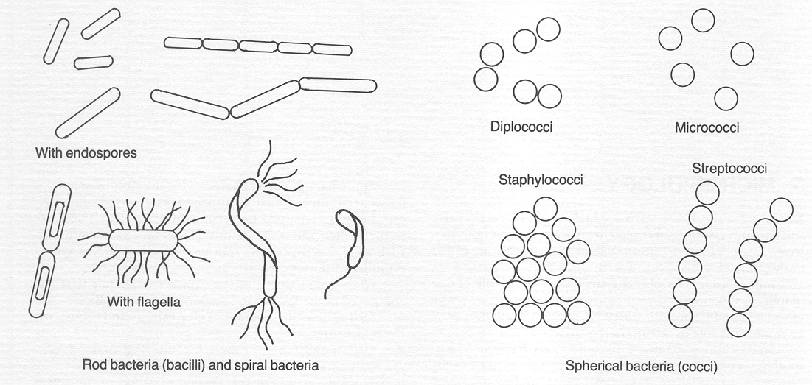
Figure 7. Rod-shaped (bacilli) and spherical (cocci) bacteria.

Bacteria are also classified according to cell cluster formation:
Diplococci - two cocci cells paired
Staphylococci - a number of cells clustered together
Streptococci - a number of cells arranged in a chain
Some bacteria are capable of locomotion by means of flagellae long, hair-like appendages growing out of the cell. Some rod-shaped bacteria contain spores. These are formed when the cells are faced with adverse conditions, such as high temperature: once suitable conditions are reestablished the spores germinate to form new cells.
Close examination of the simple cell reveals that it is composed of the following components (Figure 8):
- Cell wall-this gives the cell its shape and retains the constituents;
- Cell membrane-used for filtering in food constituents and discharging waste products;
- Nucleus-where the genetic material of the cell is stored;
- Cytoplasm-a semi liquid proteinaceous substance which contains starch, fat and enzymes.
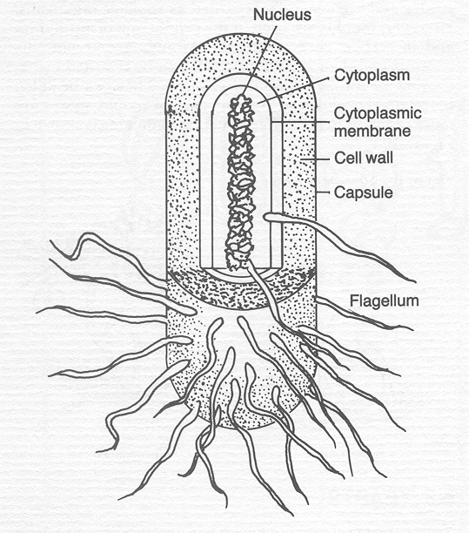
Figure 8. Schematic illustration of bacterial structure.

The cell membrane is semi permeable and allows the cell to feed by osmosis, i.e. the exchange of water between the cytoplasm of a living cell and the surrounding watery material. Only small molecules can pass in and out of the cell, e.g. with a sugar solution on one side of a semi permeable membrane and water on the other, water will diffuse in, diluting the sugar solution. The sugar molecules cannot pass out so a hydrostatic pressure, known as osmotic pressure, develops.
Bacteria can feed by selective intake of nutrients dissolved in water. They can also take in nutrients against the normal osmotic flow-active transport.
Bacterial growth
Bacterial growth refers to an increase in cell numbers rather than an increase in cell size. The process by which bacterial cells divide to reproduce themselves is known as binary transverse fission. The time taken from cell formation to cell division is called the generation time. The generation time can therefore be defined as the time taken for the cell count to double.
The curve shown in Figure 9 shows the phases of bacterial growth following inoculation of bacteria into a new growth medium. The following phases can be identified:
- Lag phase: There is usually some delay in growth following inoculation of bacteria into a new medium, during which time the bacteria adapt to the medium and synthesize the enzymes needed to break down the substances in the growth medium.
- Log phase: Once the bacteria have adapted to the new medium they start to reproduce quickly and their numbers multiply evenly for each increment of time. A plot of the log number of cells against time gives a linear relationship: this is therefore called the log phase. The cells are at their greatest activity in this phase. Transferring cultures to a fresh medium at regular intervals can maintain the cells in an active state. An active culture can rapidly dominate any new environment. The log phase can be prolonged by removing toxic waste, by adding more nutrients or both.
- Stationary phase: As the bacteria dominate the growth medium, they deplete the available nutrients or toxic waste products accumulate, slowing the rate of reproduction. At the same time, cells are dying off: A state of equilibrium is reached between the death of old cells and formation of new cells, resulting in no net change in cell numbers. This phase is called the stationary phase.
- Death phase: In the next phase the formation of new cells ceases and the existing cells gradually die off: This is called the death phase.

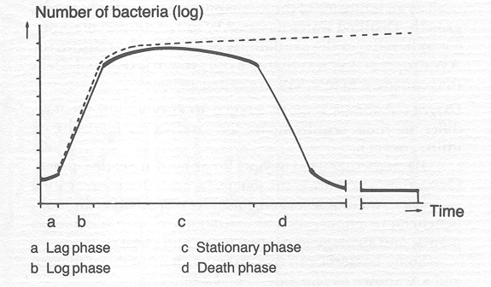
Figure 9. The four phases of bacterial growth.

Factors affecting bacterial growth
Bacterial growth is affected by (1) temperature, (2) nutrient availability, (3) water supply, (4) oxygen supply, and (5) acidity of the medium.
Temperature: Theoretically, bacteria can grow at all temperatures between the freezing point of water and the temperature at which protein or protoplasm coagulates. Somewhere between these maximum and minimum points lies the optimum temperature at which the bacteria grow best.
Temperatures below the minimum stop bacterial growth but do not kill the organism. However, if the temperature is raised above the maximum, bacteria are soon killed. Most cells die after exposure to heat treatments in the order of 70°C for 15 seconds, although spore-forming organisms require more severe heat treatment, e.g. live steam at 120°C for 30 minutes.
Bacteria can be classified according to temperature preference: Psycrophilic bacteria grow at temperatures below 16°C, mesophilic bacteria grow best at temperatures between 16 and 40°C, and thermophilic bacteria grow best at temperatures above 40°C.
Nutrients: Bacteria need nutrients for their growth and some need more nutrients than others. Lactobacilli live in milk and have lost their ability to synthesis many compounds, while Pseudomonas can synthesis nutrients from very basic ingredients. Bacteria normally feed on organic matter; as well as material for cell formation organic matter also contains the necessary energy. Such matter must be soluble in water and of low molecular weight to be able to pass through the cell membrane. Bacteria therefore need water to transport nutrients into the cell.
If the nutrient material is not sufficiently broken down, the micro-organism can produce exo-enzymes which split the nutrients into smaller, simpler components so they can enter the cell. Inside the cell the nutrients are broken down further by other enzymes, releasing energy which is used by the cell.
Water: Bacteria cannot grow without water. Many bacteria are quickly killed by dry conditions whereas others can tolerate dry conditions for months; bacterial spores can survive dry conditions for years. Water activity (AW) is used as an indicator of the availability of water for bacterial growth. Distilled water has an AW of 1. Addition of solute, e.g. salt, reduces the availability of water to the cell and the AW drops; at AW less than 0.8 cell growth is reduced. Cells that can grow at low AW are called osmophiles.
Oxygen: Animals require oxygen to survive but bacteria differ in their requirements for, and in their ability to utilise oxygen. Bacteria that need oxygen for growth are called aerobic. Oxygen is toxic to some bacteria and these are called anaerobic. Anaerobic organisms are responsible for both beneficial reactions, such as methane production in biogas plants, and spoilage in canned foods and cheeses. Some bacteria can live either with or without oxygen and are known as facultative anaerobic bacteria.
Acidity: The acidity of a nutrient substrate is most simply expressed as its pH value. Sensitivity to pH varies from one species of bacteria to another. The terms pH optimum and pH maximum are used. Most bacteria prefer a growth environment with a pH of about 7, i.e. neutrality. Bacteria that can tolerate low pH are called aciduric. Lactic acid bacteria in milk produce acid and continue to do so until the pH of the milk falls to below 4.6, at which point they gradually die off. In canning citrus fruits, mild heat treatments are sufficient because the low pH of the fruit inhibits the growth of most bacteria.
Bacteria in milk
Milk fresh from a healthy cow contains few bacteria, but contamination during handling can rapidly increase bacterial numbers. Milk is an ideal food and many bacteria grow readily in it. Some bacteria are useful in milk processing, causing milk to sour naturally, and leading to products such as irgo. However, milk can also carry pathogenic bacteria, such as Salmonella, Tuberculosis bovis and Brucella, and can thus transmit disease. Other bacteria can cause spoilage of the milk, and spoilage and poor yields of products.
Moulds
Moulds are a heterogeneous group of multicelled organisms which reproduce asexually either by spore formation or by fragmentation. They can grow on a wide variety of substrates and are generally regarded as spoilage organisms. However, moulds are used in the production of antibiotics and in certain cheese varieties. Moulds are aerobic organisms and their growth on foods can be retarded by excluding air through careful packaging. They can be killed by relatively mild heat treatments, but mould spores are more resistant to heat. The structure of moulds is shown in Figure 10.
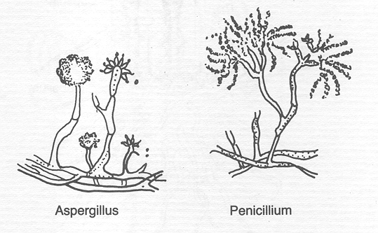
Figure 10. Structure of moulds.
Yeasts
Yeasts are unicellular organisms which reproduce asexually by budding. They are used industrially to ferment carbohydrates to such products as alcohol and citric acid. Yeasts are not usually used in milk processing and are normally regarded as spoilage organisms in dairy products. The structure of yeasts is shown in Figure 11.
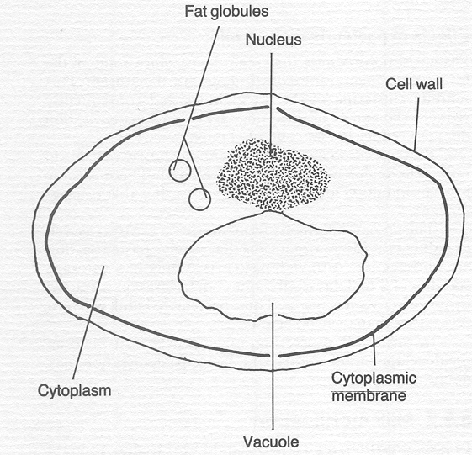
Figure 11. Structure of a yeast cell.

Viruses
Viruses are extremely small organisms comprising a spherical head containing the genetic material and a cylindrical tail. They cannot reproduce themselves, and must invade other cells in order to reproduce. Viruses that attack bacterial cells are known as bacteriophages: bacteriophages that attack acid-producing bacteria inhibit acid production in milk.

Milk Microbiology
In addition to being a nutritious food for humans, milk provides a favourable environment for the growth of microorganisms. Yeasts, moulds and a broad spectrum of bacteria can grow in milk, particularly at temperatures above 16°C.
Microbes can enter milk via the cow, air, feedstuffs, milk handling equipment and the milker. Once microorganisms get into the milk their numbers increase rapidly. It is more effective to exclude micro-organisms than to try to control microbial growth once they have entered the milk. Milking equipment should be washed thoroughly before and after using.
Table 4. Bacterial types commonly associated with milk.
Pseudomonas | Spoilage
Brucella | Pathogenic
Enterobacteriaceae | Pathogenic and spoilage
Staphylococci
Staphylococcus aureus | Pathogenic
Streptococcus
S. agalactiae | Pathogenic
S. thermophilus | Acid fermentation
S. lactis | Acid fermentation
S. lactis-diacetyllatic | Flavour production
S. cremoris | Acid fermentation
Leuconostoc lactis | Acid fermentation
Bacillus cereus | Spoilage
Lactobacillus
L. lactis | Acid production
L. bulgaricus | Acid production
L. acidophilus | Acid production
Propionibacterium | Acid production
Mycobacterium tuberculosis | Pathogenic

Microbial growth can be controlled by cooling the milk. Most micro-organisms reproduce slowly in colder environments. Cooling milk also slows chemical deterioration. The temperature of freshly drawn milk is about 38°C. Bacteria multiply very rapidly in warm milk and milk sours rapidly if held at these temperatures. If the milk is not cooled and is stored in the shade at an average air temperature of 16°C, the temperature of the milk will only have fallen to 28°C after 3 hours. Cooling the milk with running water will reduce the temperature to 16°C after 1 hour. At this temperature bacterial growth will be reduced and enzyme activity retarded. Thus, milk will keep longer if cooled.

Natural souring of milk may be advantageous: for example, in smallholder butter-making, the acid developed assists in the extraction of fat during churning. The low pH retards growth of lipolytic and proteolytic bacteria and therefore protects the fat and protein in the milk. The acidity of the milk also inhibits the growth of pathogens. It does not, however, retard the growth of moulds. Naturally soured milk is used to make many products, e.g. irgo, yoghurt, sour cream, ripened buttermilk and cheese. These products provide ways of preserving milk and are also pleasant to consume. They are produced by the action of fermentative bacteria on lactose and are more readily digested than fresh milk.
The initial microflora of raw milk reflects directly microbial contamination during production. The microflora in milk when it leaves the farm is determined by the temperature to which it has been cooled and the temperature at which it has been stored. The initial bacterial count of milk may range from less than 1000 cells/ml to 10⁶/ml. High counts (more than 10⁵/ml) are evidence of poor production hygiene. Rapid tests are available for estimating the bacterial quality of milk.

9.2. Pasteurization
Pasteurisation is the most common process used to destroy bacteria in milk. In pasteurisation, the milk is heated to a temperature sufficient to kill pathogenic bacteria, but well below its boiling point. This also kills many non-pathogenic organisms and thereby extends the storage stability of the milk. Numerous time/temperature combinations are recommended but the most usual is 72°C for 15 seconds followed by rapid (less than 2 minutes) cooling to below 10°C. This is normally referred to as High Temperature Short Time (HTST) treatment. It is carried out as a continuous process using a plate heat-exchanger to heat the milk and a holding section to ensure that the milk is completely pasteurised. Milk is normally pasteurised before sale as liquid milk. Pasteurisation is used to reduce the microbial counts in milk for cheesemaking, and cream is pasteurised before tempering for buttermaking in some factories. Batch pasteurisation is used where milk quantities are too small to justify the use of a plate heat-exchanger. In batch pasteurisation, fixed quantities of milk are heated to 63°C and held at this temperature for 30 minutes. The milk is then cooled to 5°C using iced or cold water before packing. The lower temperature used for batch pasteurisation means that a longer time is required to complete the process — 30 minutes at 63°C, compared with 15 seconds at 72°C.
Effects of pasteurization on milk
Pasteurisation reduces the cream layer, since some of the fat globule membrane constituents are denatured. This inhibits clustering of the fat globules and consequently reduces the extent of creaming. However, pasteurisation does not reduce the fat content of milk. Pasteurisation has little effect on the nutritive value of milk as the major nutrients are not altered. There is an insignificant loss of vitamin C and the B group vitamins. The process kills many fermentative organisms as well as pathogens but putrefactive micro-organisms survive pasteurisation. Although pasteurised milk has storage stability of two to three days, subsequent deterioration is caused by the putrefactive organisms. Thus, pasteurised milk will putrefy rather than develop acidity. In rural milk processing, many processes depend on the development of acidity, and hence pasteurisation may not be appropriate.
9.3. Sterilization
In pasteurisation, milk receives mild heat treatment to reduce the number of bacteria present. In sterilisation, milk is subjected to severe heat treatment that ensures almost complete destruction of the microbial population. The product is then said to be commercially sterile. Time/temperature treatments of above 100°C for 15 to 40 minutes are used. The product has a much longer shelf-life (several months) than pasteurized milk. Another method of sterilisation is ultra high temperature treatment (UHT). In this system, milk is heated under pressure to about 140°C for 4 seconds. The product is sterile, however, it retains more of the properties of fresh milk than conventionally sterilised milk.

9.4. Microbiology of butter
Butter is made as a means of preserving milk fat. It can be made directly from milk or by separation of milk and subsequent churning of the cream.
9.4.1 Sources of contamination
In addition to bacteria present in the milk other sources of micro-organisms in butter are equipment, wash water, air, packing materials and personnel.
Equipment
In smallholder buttermaking, microbial contamination can come from unclean surfaces, the butter maker and wash water. Packaging materials, cups and leaves are also sources of contaminants. Washing and smoking the churn reduces bacterial numbers. However, traditional equipment is often porous and is therefore a reservoir for many organisms. When butter is made on a larger processing scale, bacterial contamination can come from holding-tank surfaces, the churn and butter-handling equipment.
A wooden churn can be a source of serious bacterial, yeast and mould contamination since these organisms can penetrate the wood, where they can be destroyed only by extreme heat. If a wooden churn has loose bands, cream can enter the crevices between the staves, where it provides a growth medium for bacteria which contaminate subsequent batches of butter.However, if care is taken in cleaning a wooden churn this source of contamination can be controlled. Similar care is required with scotch hands (wooden spatulas) and butter-working equipment.
Wash water
Wash water can be a source of contamination with both coliform bacteria and bacteria associated with flavor defects in butter. Polluted water supplies can also be a source of pathogens.
Air
Contamination from the air can introduce spoilage organisms; mould spores, bacteria and yeasts can fall on the butter if it is left exposed to the air. Moulds grow rapidly on butter exposed to air.
Packaging
Care is required in the storage and preparation of packaging material. Careless handling of packaging material can be a source of mould contamination.
Personnel
A high standard of personal hygiene is required from people engaged in buttermaking. For example in New Zealand the 1938 dairy produce regulations stated “no person shall permit his bare hands to be brought in contact with any butter at any time immediately following manufacture or during the wrapping, packaging, storage and transport of such butter.” Personnel pass organisms on to butter via the hands, mouth, nasal passages and clothing. Suitable arrangements for cleaning and disinfecting hands should be provided, and clean working garments should not have contact with other clothes.

9.4.2. Control of micro-organisms in butter
Salting effectively controls bacterial growth in butter. The salt must be evenly dispersed and worked in well. A salt concentration of 2% adequately dispersed in butter with 16% moisture will result in a 12.5% salt solution throughout the water-in-oil emulsion.

Washing butter does little to reduce microbiological counts. It may be desirable not to wash butter, since washing reduces yield by removing curd or protein material. The acid pH of serum in butter made from ripened cream or sour milk may control the growth of acid-sensitive organisms. Microbiological analysis of butter usually includes some of the following tests: total bacterial count, yeasts and moulds, coliform estimation and estimation of lipolytic bacteria. Yeast, mould and coliform estimations are useful for evaluating sanitary practices. The presence of defect-producing types can be indicated by estimating the presence of lipolytic organisms. All butter contains some micro-organisms. However, proper control at every stage of the process can minimise their harmful effects.

10. Clean milk production
Milk is one of the most valuable foods for humans and young mammals. It also provides an excellent medium for the growth of bacteria which may spoil the milk or render it unsafe for human consumption or unfit for further processing. There is a constant challenge to those involved in milk production to prevent or minimize the entry and subsequent growth of bacteria in milk. Milk of good hygienic quality is necessary to produce milk products of good quality and adequate shelf-life and to provide a safe, wholesome food for the consumer.
10.1. Sources of contamination
10.1.1. The interior of the udder
At one time it was generally accepted that milk as it was removed from the udder contained no bacteria. It has subsequently been shown that the normal udder contains bacteria which enter the milk as soon as it is secreted. The number of bacteria in aseptically drawn milk varies from animal to animal and even from different quarters of the same animal. On average, aseptically drawn milk from healthy udders contains between 500 and 1000 bacteria/ml. Infected udders usually yield milk with very high counts. The fore milk contains many bacteria but numbers decrease during milking. This decrease is due to mechanical dislodgement of the bacteria particularly in the teat canal.
The species of bacteria found in milk as it comes from the udder are limited to a few genera. The micrococci are generally present in the greatest proportion followed by streptococci and rods. Micrococci are comparatively slow growing but if allowed to grow in milk they cause proteolysis (protein breakdown) and acid formation resulting in a very distasteful product. The streptococci in uninfected udders occur less frequently than the micrococci but they are more important owing to their action in milk. Streptococcus agalactiae is the organism commonly present even when there is no clinical evidence of mastitis. The number of S. agalactiae increases before the time the udder shows inflammation and persists after the recovery of the animal from active mastitis. This organism is not pathogenic to humans and is killed by pasteurisation (72°C for 15 seconds).
10.1.2. The cow as a source of pathogens
There are various pathogens that may be present in the milk of infected cows many of which can cause illness to humans. Fortunately, the incidence of disease transmitted by milk has been greatly reduced by better husbandry, disease prevention and eradication programmes and better sanitation methods of milk production.
Mastitis infections may result in large numbers of bacteria in milk. Mastitis is caused by Streptococcus pyogenes or Staphylococcus aureus which constitute a health hazard to consumers. Brucella abortus is found in the milk of cows suffering from the disease brucellosis. This disease is very infectious and is the cause of contagious abortion in cattle and undulant fever in humans. Tuberculosis, caused by Mycobacterium tuberculosis, is another disease that may occur in cattle and which may be transmitted to humans who drink raw milk.
The exterior of the udder can be a major source of bacterial contamination to milk. Cleaning and removal of soil, bedding material and manure from the udder and flanks of the cow before milking is necessary to prevent the entry of many types of bacteria into the milk. Special care must be given to the cloths used for cleaning the udder. The re-use of cloths for cleaning and sanitising may result in re-contamination of the udder. It is therefore recommended that separate cloths be used for cleaning and sanitising and, if possible, each cloth should be used for one cow only. Clipping and grooming the udder and flanks makes cleaning and sanitising more effective.
In addition to the exterior of the udder, the cow’s coat may also serve as a vehicle of contamination by adding bacteria directly to the milk during milking. The coat may carry bacteria from stagnant pools of water and muddy grazing areas. Coliform bacteria and members of the genus Bacillus may enter the milk from soil. and manure adhering to the coat of the cow. The presence of such organisms in milk is undesirable as they may cause off flavours and a reduction in the quality and shelf-life of milk and milk products. Periodic clipping in addition to daily washing and brushing the coat are recommended practices in the production of milk of good hygienic quality.

10.1.3. Milking utensils
Utensils used for milking and handling milk can be a most important cause of milk contamination. Increased mechanisation of milking, handling and storage has contributed significantly to the production of clean milk. However, it has been shown that where milking equipment, milk pipelines and storage tanks are improperly cleaned and maintained the hygienic quality of the milk is worse than that obtained through manual milking and handling. It is important, therefore, that milking and milk handling utensils are properly cleaned and maintained.
10.1.4. Miscellaneous sources of bacteria in milk
Micro-organisms occur in the air and in dust particles originating from manure, soil and feed. Conditions that increase the dust content in the air around the milking area will increase the microbial population and lead to increased bacterial contamination of the milk particularly where hand milking is practised. To reduce
the dust content of the air the following practices should be avoided:
- sweeping the milking area before milking
- handling hay and feeds before and during milking
- brushing the cow immediately before milking
- dusty bedding
- accumulation of dirt and dust on the walls and ceiling.
The milking barn or area must be kept clean and, to facilitate cleaning, the floors and walls should be constructed of smooth-surfaced concrete or other impervious material. Adequate lighting is needed to carry out milking and cleaning operations satisfactorily and proper ventilation is required in the milk house to avoid condensation on the walls and ceiling. Flies, insects and rodents must be kept out of the milking house since their presence on milking equipment contributes not only to the total bacteria entering milk but also to the possibility that pathogens may be introduced. The milk house should have screened doors and windows.
The health of milkers and personnel handling milk is of considerable importance. These people should be in good health and their hands free from any infections. Hands with infected wounds can add pathogenic streptococci or micrococci to milk and cause subsequent human infections. Wet-hand milking is also discouraged. Milk may serve as a carrier of human pathogens from one person to another. Typhoid and paratyphoid fever, dysentery, scarlet fever, septic sore throat, diptheria and cholera have been found to be milk-borne and to enter the milk from infected workers.
10.2. Cooling milk
To prevent or retard growth of bacteria in milk and to maintain its quality for domestic consumption or during transport to the processing plant, it is essential to cool the fresh milk as quickly as possible. The temperature to which milk can be cooled on the farm will depend on the facilities available. If mechanical refrigeration is available then the milk can be cooled to 3–4°C and the frequency of delivery to the processing plant need be no more than three times a week. However, refrigeration does not reduce bacteria numbers it only slows down their growth. Some bacteria (psychrotrophs) are capable of growing at low temperatures so the importance of limiting contamination of milk by unclean utensils, poor water supplies, unhealthy cows and general unhygienic milking practices and conditions is further emphasised.
In the absence of mechanical cooling facilities other means of cooling milk to the lowest possible temperature must be employed. In some situations water supplies may be inadequate so the milk container should be placed in a cool, shaded area. The milk can may be placed in a trough of cool water or in a stream. It may also be placed in a box or cabinet surrounded with sacking material and a layer of sand or charcoal. At high ambient temperatures the temperature of the cooling box and therefore of the milk can and its contents can be reduced to about 20°C by spraying the outside of the box with water. The evaporation of the water (evaporative cooling) reduces the temperature within the cooling box. Other methods of cooling milk which require large quantities of water include in-can coolers and surface coolers. In both cases cold water passesthrough metal tubes giving indirect contact with the milk outside the metal tubes. Whatever method of milk cooling is employed the fresh milk should be cooled quickly to the lowest possible temperature.

Summary of important points in the production of clean milk from healthy cows:
- Udder washing. Before milking, the udder should be washed with clean water. A clean cloth or, if possible, disposable towels should be used.
- Use of strip cup. A strip cup should be used to check for mastitis in each quarter before milking starts. This will prevent mixing mastitic milk with good milk.
- Milking. The body of the cow should be free of soil, dirt and manure and contamination of milk from external sources such as animal hairs, dust, flies and dirty water dripping from the cow’s body should be minimised. Avoid using dusty bedding and avoid feeding animals during milking. Milking equipment should be clean and well maintained.
- Milkers. Milkers and milk handlers should be in good health and their hands should be clean and free from cuts and sores.
- Milk house. The milking barn should have a good floor that is easy to clean and drain. There should be good ventilation and lighting and facilities for manure disposal and washing cows. A good supply of clean water is required.
- Cooling milk. Cooling milk is essential to prevent an increase in bacterial numbers and spoilage of the milk.
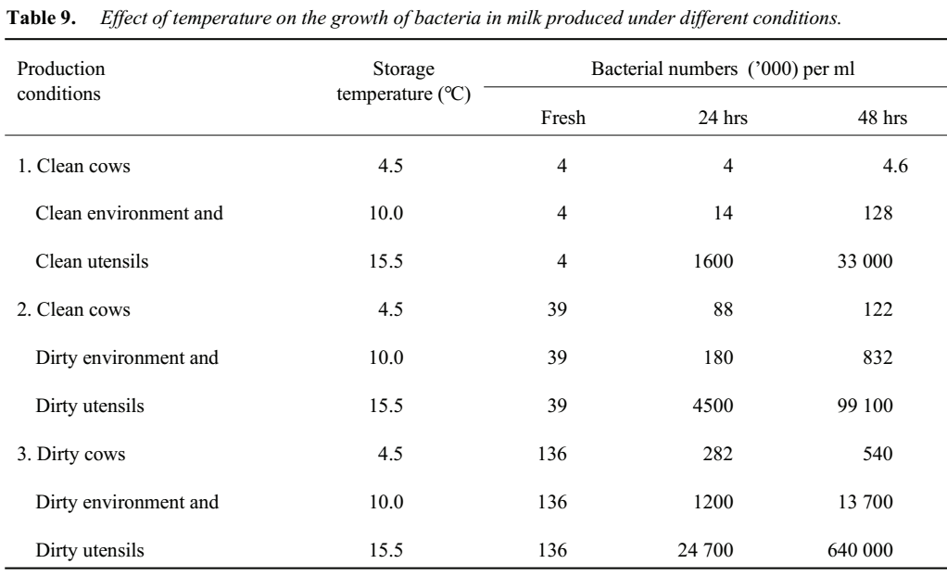

11. Milk processing and hygiene
In rural areas, milk may be processed fresh or sour. The choice depends on available equipment, product demand and on the quantities of milk available for processing. In Africa, smallholder milk-processing systems use mostly sour milk. Allowing milk to ferment before processing has a number of advantages and processing sour milk will continue to be important in this sector.Where greater volumes of milk can be assembled, processing fresh milk gives more product options, allows greater throughput of milk and, in some instances, greater recovery of milk solids in products.
Equipment not available locally, such as a milk separator, has a cost advantage and quickly gives a good financial return in terms of increased efficiency. Hand-operated milk separators are durable and have a long life when properly maintained. Importing of such equipment is, therefore, advantageous.
In many rural dairy processing plants monitoring equipment may not be available and, although yields may be maximised by adhering to the prescribed procedures, all these products can be successfully made by approximating temperature, time, pH etc. It is particularly important in cheese making to proceed when the curd is in a suitable condition. Therefore, times given are only approximate and the processor will, with experience, adopt methods suitable to his/her own environment.

11.1 Milk separation
The fat fraction separates from the skim milk when milk is allowed to stand for at least 30 to 40 minutes. This is known as ‘‘creaming’’. The creaming process can be used to remove fat from milk in a more concentrated form. A number of methods are employed to separate cream from milk. An understanding of the creaming process is necessary to maximise the efficiency of the separation process.

Gravity separation
Fat globules in milk are lighter than the plasma phase, and hence rise to form a cream layer. The rate of rise (V) of the individual fat globule can be estimated using Stokes' Law which defines the rate of settling of spherical particles in a liquid:
V = (r² (d₁ - d₂) g)/9η
Where r = radius of fat globules
d₁ = density of the liquid phase
d₂ = density of the sphere
g = acceleration due to gravity, and
η = specific viscosity of the liquid phase
Particle r²: As temperature increases, fat expands and therefore r² increases. Since the sedimentation velocity of the particle increases in proportion to the square of the particle diameter, a particle of radius 2 (r² = 4) will settle four times as fast as a particle of radius 1 (r² = 1). Thus, heating increases sedimentation velocity.
d₁- d₂: Sedimentation rate increases as the difference between d₁ and d₂ increases. Between 20 and 50°C, milk fat expands faster than the liquid phase on heating. Therefore, the difference between d_{l} and d₂ increases with increasing temperature.
g: Acceleration due to gravity is constant. This will be considered when discussing centrifugal separation.
η: Serum viscosity decreases with increasing temperature.
Calculation of the sedimentation velocity of a fat globule reveals that it rises very slowly, As shown in the equation, the velocity of rise is directly proportional to the square of the radius of the globule. Larger globules overtake smaller ones quickly. When a large globule comes into contact with a smaller globule the two join and rise together even faster, primarily because of their greater effective radius. As they rise they come in contact with other globules, forming clusters of considerable size. These clusters rise much faster than individual globules. However, they do not behave strictly in accordance with Stokes' Law because they have an irregular shape and contain some milk serum.

Factors affecting creaming: Cream layer volume is greatest in milk that has high fat content and relatively large fat globules, because such milk contains more large clusters. However, temperature and agitation affect creaming, irrespective of the fat content of the milk. Heating to above 60°C reduces creaming; milk that is heated to above 100°C retains very little creaming ability.

Excessive agitation disrupts normal cluster formation, but creaming in cold milk may be increased by mild agitation since such treatment favours larger, loosely packed clusters.

Batch separation by gravity: Cream can be separated from milk by allowing the milk to stand in a setting pan in cool place. There are two main methods.

Shallow pan: Milk, preferably fresh from the cow, is poured into a shallow pan 40 to 60 cm in diameter and about 10 cm deep. The pan should be in a cool place. After 36 hours practically all of the fat capable of rising by this method will have come to the surface, and the cream is skimmed off with a spoon or ladle (Figure 12). The skim milk usually contains about 0.5 to 0.6% butter fat.

Deep-setting: Milk, preferably fresh from the cow, is poured into a deep can of small diameter. The can is placed in cold water and kept as cool as possible. After 24 hours the separation is usually as complete as it is possible to secure by this method. The skim milk is removed through a tap at the bottom of the can (Figure 12). Under optimum conditions, the fat content of the skim milk averages about 0.2 or 0.3 %.

The pans should be rinsed with water immediately after use, scrubbed with hot water and scalded with boiling water (see section on cleaning).

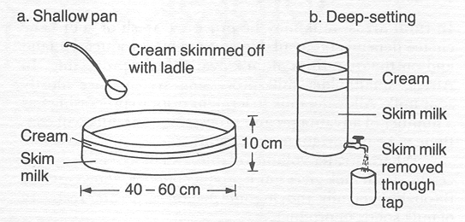
Figure 12. Batch separation of milk by gravity: (a) Shallow pan method, (b) deep-setting method

Centrifugal separation

Gravity separation is slow and inefficient. Centrifugal separation is quicker and more efficient, leaving less than 0.1% fat in the separated milk, compared with 0.5-0.6% after gravity separation. The centrifugal separator was invented in 1897. By the turn of the century it had altered the dairy industry by making centralized dairy processing possible for the first time. It also allowed removal of cream and recovery of the skim milk in a fresh state.

The separation of cream from milk in the centrifugal separator is based on the fact that when liquids of different specific gravities revolve around the same centre at the same distance with the same angular velocity, a greater centrifugal force is exerted on the heavier liquid than on the lighter one. Milk can be regarded as two liquids of different specific gravities, the serum and the fat.

Milk enters the rapidly revolving bowl at the top, the middle or the bottom of the bowl (Figure 13). When the bowl is revolving rapidly the force of gravity is overcome by the centrifugal force, which is 5000 to 10 000 times greater than gravitational force. Every particle in the rotating vessel is subjected to a force which is determined by the distance of the particle from the axis of rotation and its angular velocity.
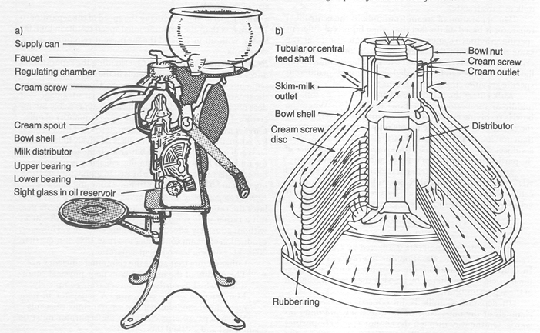
Figure 13. Cutaway diagrams of (a) hand-operated milk separator and (b) the bowl showing the paths of milk and cream fractions.
If we substitute centrifugal acceleration expressed as r₁ω² (where r₁ is the radial distance of the particle from the centre of rotation and ω² is a measurement of the angular velocity) for acceleration due to gravity (g), we obtain:
V = (r² (d₁ - d₂) r₁ω²)/9η
Thus, sedimentation rate is affected by r₁ω². In gravity separation, the acceleration due to gravity is constant. In centrifugal separation, the centrifugal force acting on the particle can be altered by altering the speed of rotation of the separator bowl.
In separation, milk is introduced into separation channels at the outer edge of the disc stack and flows inwards. On the way through the channels, solid impurities are separated from the milk and thrown back along the undersides of the discs to the periphery of the separator bowl, where they collect in the sediment space. As the milk passes along the full radial width of the discs, the time passage allows even small particles to be separated. The cream, i.e. fat globules, is less dense than the skim milk and therefore settles inwards in the channels towards the axis of rotation and passes to an axial outlet. The skim milk moves outwards to the space outside the disc stack and then through a channel between the top of the disc stack and the conical hood of the separator bowl.

Efficiency of separation is influenced by four factors: the speed of the bowl, residence time in the bowl, the density differential between the fat and liquid phase and the size of the fat globules.

Speed of the separator. Reducing the speed of the separator to 12 rpm less than the recommended speed results in high fat losses, with up to 12% of the fat present remaining in the skim milk.

Residence time in the separator: Overloading the separator reduces the time that the milk spends in the separator and consequently reduces skimming efficiency. However, operating the separator below capacity gives no special advantage it does not increase the skimming efficiency appreciably but increases the time needed to separate a given quantity of milk.

Effect of temperature: Freshly drawn, uncooled milk is ideal for exhaustive skimming. Such milk is relatively fluid and the fat is still in the form of liquid butterfat. If the temperature of the milk falls below 22°C skimming efficiency is seriously reduced. Milk must therefore be heated to liquify the fat. Heating milk to 50°C gives the optimum skimming efficiency.

Effect of the position of the cream screw: The cream screw regulates the ratio of skim milk to cream. Most separators permit a rather wide range of fat content of cream (18-50%) without adversely affecting skimming efficiency. However, production of cream containing less than 18% or more than 50% fat results in less efficient separation.
Other factors that affect the skimming efficiency are:
- The quality of the milk: Milk in poor physical condition or which is curdy will not separate completely.
- Maintenance of the separator: A separator in poor mechanical condition will not separate milk efficiently.
When separation is complete the separator must be dismantled and cleaned thoroughly.

Hand separator
In order to understand how centrifugal separation works, we shall follow the course of milk through a separator bowl. As milk flows into a rapidly revolving bowl it is acted upon by both gravity and the centrifugal force generated by rotation. The centrifugal force is 5000 to 10 000 times that of gravity, and the effect of gravity thus becomes negligible. Therefore, milk entering the bowl is thrown to the outer wall of the bowl rather than falling to the bottom.
Milk serum has a higher specific gravity than fat and is thrown to the outer part of the bowl while the cream is forced towards the centre of the bowl.
Assembling the bowl
- Fit the milk distributor to the central feed shaft.
- Fit the discs on top of each other on the central shaft.
- Fit the cream screw disc.
- Next, fit the rubber ring to the base of the bowl.
- Put on the bowl shell, ensuring that it fits to the inside of the base.
- Finally, screw the bowl nut on top.
Now the bowl is assembled and ready for use. The rest of the separator is essentially a set of gears so arranged as to permit the spindle, on which the bowl is carried, to be turned at high speed. The gears are normally enclosed in an oil-filled case. The bowl is usually supported from the bottom and has two bearings; one to support its weight and the second to hold it upright. The upper bearing is usually fitted inside a steel spring so that it can keep the bowl upright even if the frame of the machine is not exactly level.
The assembled bowl is lowered into the receptacle, making sure that the head of the spindle fits correctly into the hollow of the central feed shaft.

Operation
- When the bowl is set, fit the skim milk spout and the cream spout.
- Fit the regulating chamber on top of the bowl.
- Put the float in the regulating chamber.
- Put the supply can in position, making sure that the tap is directly above and at the centre of the float.
- Pour warm (body temperature) water into the supply can.
- Turn the crank handle, increasing speed slowly until the operating speed is reached: This will be indicated on the handle or in the manufacturer's manual of operation. The bell on the crank handle will stop ringing when the correct speed is reached.
- Open the tap and allow the warm water to flow into the bowl. This rinses and heats the bowl and allows a smooth flow of milk and increases separation efficiency.
- Next, put warm milk (37 - 40°C) into the supply can. Repeat steps 6 and 7 above and collect the skim milk and cream separately.
- When all the milk is used up and the flow of cream stops, pour about 3 liters of the separated milk into the supply can to recover residual cream trapped between the discs.
- Continue turning the crank handle and flush the separator with warm water.

Cleaning the separator: Many of the impurities in the milk collect as slime on the wall of the separator bowl. This slime contains remnants of milk, skim milk and cream, all of which will decompose and ferment unless removed promptly.
If not washed and freed from all impurities the separator bowl becomes a source of microbial contamination. Skimming efficiency is also reduced when the separator bowl and discs are dirty. Milk deposits on the separator can cause corrosion.
Washing the separator: After flushing the separator with warm skim milk, the bowl should be flushed with clean water until the discharge from the skim milk spout is clean. This removes any residual milk solids and makes subsequent cleaning of the bowl easier. The bowl should then be dismantled. Wash all. Parts of the bowl, bowl cover, discharge spouts, float supply tank and buckets with a brush, hot water and detergent. Rinse with scalding water. Allow the parts to drain in a clean place protected from dust and flies. This process should be followed after each separation.

Cream screw adjustment
The cream screw should be adjusted so that the fat content of the cream is about 33%. Producing excessively thin cream reduces the amount of separated milk available for other uses and increases the volume of cream to be handled. Low-fat cream is also more difficult to churn efficiently.
Cream containing more than 45% fat clogs the separator and causes excessive loss of fat in skim milk. Cream of abnormally high fat content also gives butter a greasy body due to lack of milk SNF. When adjusting the cream screw it is important to remember that it is very sensitive; a quarter turn of the screw is sufficient to change the percentage fat in the cream appreciably.
The fat content of whole milk influences the fat content of cream and this must be considered when adjusting the cream screw. For example, if the cream screw is set to separate milk at a ratio of 85 parts of separated milk to 15 parts of cream then, with all other conditions constant and assuming efficient separation, milk of 3% fat produces cream of 20% fat whereas milk of 4.5% fat produces cream of 30% fat.
The fat content of the cream can be calculated using the following equation:
Fc = (Wm × Fm)/Wc where,
Wm = weight of milk Fm = fat content of milk
Wc = weight of cream Fc = fat content of cream
In the first example, Fc = (100 × 3)/15 = 20
In the second example, Fc = (100 × 4.5)/15 = 30
Therefore the setting of the cream screw depends on the fat content of the milk being separated. The milk should be mixed thoroughly prior to separation to ensure even distribution of cream in the milk.
Separator maintenance
- The gears must be well lubricated. Follow the directions of the manufacturer.
- The level of the lubricant must be kept constant; observe the oil level through the sight glass.
- The bowl must be perfectly balanced.
- The bowl should be cleaned thoroughly immediately after use to ensure proper functioning of the separator and for hygiene.
Calculations
Once milk passes through a separator it is recovered in two fractions, the high-fat cream fraction and the low-fat skim milk.
Assuming negligible loss of fat in the separator, the amount of fat entering the separator with the whole milk will be collected at the other side of the separator in either the cream or the skim milk. Therefore, if we separate 200 kg of milk containing 4.5% butterfat, what weight of cream containing 30% butterfat can we expect?
Let Wm = weight of milk
Fm = fat content of the milk
Wc = weight of cream
Fc = fat content of the cream
Ws = weight of skim milk
Assuming that all of the fat present in the milk is recovered in the cream, then:
Wm × Fm = Wc × Fc
And Wm - Wc = Ws
And Wm - Ws = WC
Since Wm × Fm = Wc × Fc
(Wm × Fm)/Fc = Wc
Therefore Ws = Wm � (Wm × Fm)/Fc = Wc
In this case: Ws = 200 - (200 × 4.5)/30
= 200/30
= 170 kg
Since WC = Wm - Ws
WC = 200 - 170 = 30 kg
Percentage yield of skim milk:
=Ws × 100)/Wm = (170 × 100)/200 = 85%
Percentage cream (%WC)
= %Wm - %Ws
= 100 - 85 = 15%
If in practice we obtain only 28 kg of cream containing 30% butterfat, then (2 × 0.30) kg or 0.6 kg of butterfat has not been recovered in the cream. Since it is assumed that there are no significant losses of fat in the cream separator, the fat not recovered in the cream is lost in the skim milk.
Since 28 kg of cream was produced, and
Ws = Wm - Wc
then Ws = 200 - 28 = 172 kg
Thus there is 0.6 kg of fat in 172 kg of skim milk. The fat percentage of the skim milk is therefore:
(0.6 × 100)/172= 0.35%*
* The skim milk contains 0.35% fat, which may be incorporated in cottage cheese. If the skim milk is consumed, no nutritional loss occurs, but a financial loss is incurred since the fat is more valuable if sold as butter than as cottage cheese or if it is consumed directly.
The percentage of fat in milk and in cream influences Wc and Ws where the fat is recovered in the cream.
If Fm = 3 %
Fc = 30%
Wm = 100
Then Wc = Wm - Fm/Fc
Wc = 100 × 3/30 = 10 kg
Ws = Wm - Wc
= 100 - 10
= 90 kg
whereas if Fm = 4%
Fc = 30
Wc = 100
Then Wc =100 × 4/30 = 13.3 kg
Ws = 100 - 13.3
=86.6 kg

Standardization of milk and cream
If fine adjustment of the fat content of cream is required, or if the fat content of whole milk must be reduced to a given level, skim milk must be added. This process is known as standardization.
The usual method of making standardization calculations is the Pearson's Square technique. To make this calculation, draw a square and write the desired fat percentage in the standardized product at its centre and write the fat percentage of the materials to be mixed on the upper and lower left-hand corners. Subtract diagonally across the square the smaller from the larger figure and place the remainders on the diagonally opposite corners. The figures on the right-hand corners indicate the ratio in which the materials should be mixed to obtain the desired fat percentage.

The value on the top right-hand corner relates to the material on the top left-hand corner and the figure on the bottom right relates to the material at the bottom left corner.
Example 1
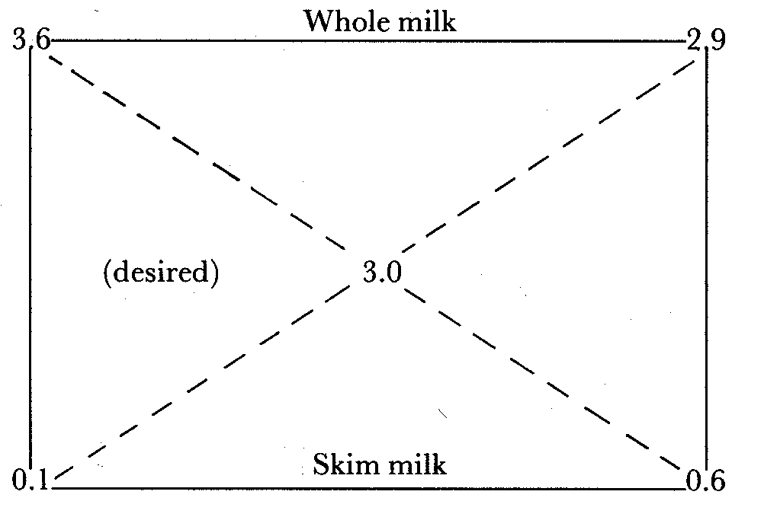

In this example, the fat content of whole milk is to be reduced to 3.0%, using skim milk produced from some of the whole milk. Using Pearson's Square, it can be seen that for every 2.9 litres of whole milk, 0.6 litres of skim milk must be added.
Example 2
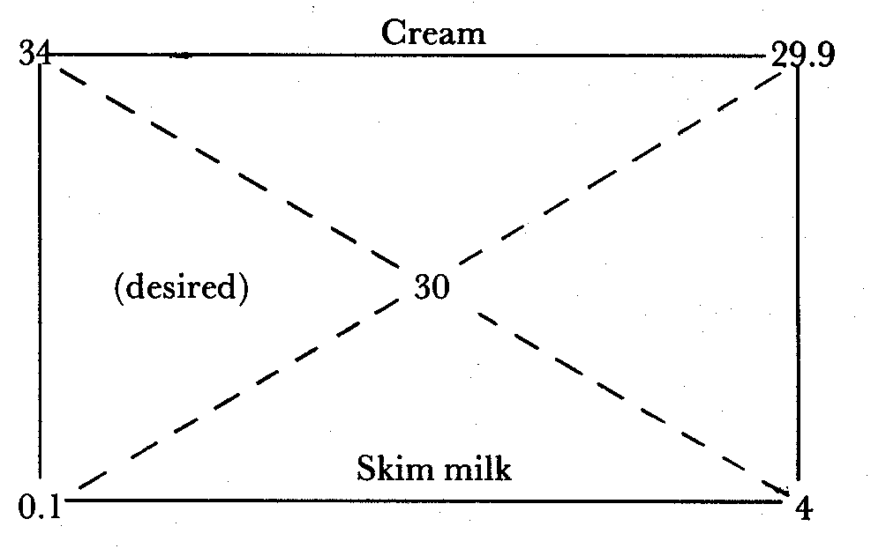
How much skim milk containing 0.1 % fat is needed to reduce the percentage fat in 200 kg of cream from 34% to 30%?
If 29.9 parts of cream require 4 parts of skim milk, 200 parts of cream require x parts of skim milk.
Weight of skim milk needed = x = (200 × 4)/29.9 = 26.75 kg
Example 3
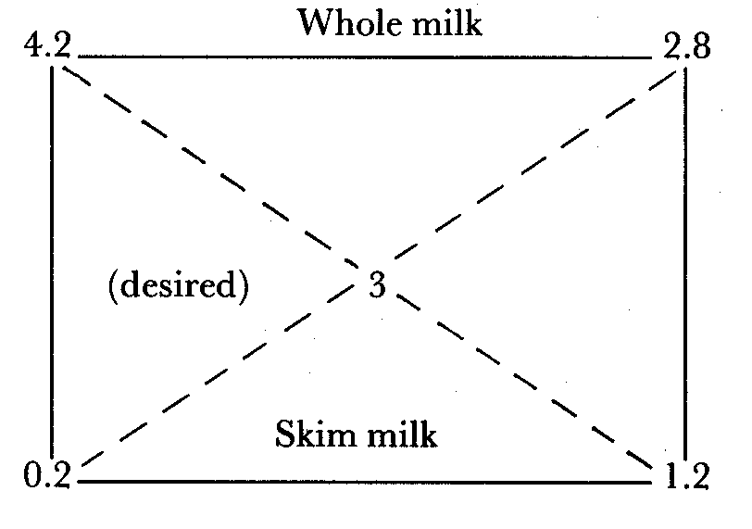
The fat content of 300 kg of whole milk must be reduced from 4.2% to 3% using skim milk containing 0.2% fat.
Every 4.0 kg of the mixture will contain 2.8 kg of whole milk and 1.2 kg of skim milk.
If 2.8 kg of whole milk requires 1.2 kg skim milk, 300 kg of whole milk requires
(1.2 × 300)/2.8 = 128.6 kg of skim milk
Thus, 128.6 kg of skim milk (0.2% fat) must be added to 300 kg of whole milk (4.2% fat) to give 428.6 kg of milk containing 3% fat.

11. 2. Butter making with fresh milk or cream
Butterfat can be recovered from milk and converted to a number of products, the most common of which is butter.
Butter is an emulsion of water in oil and has the following approximate composition:
Fat | 80%
Moisture | 16%
salt | 2%
Milk SNF | 2%

In good butter the moisture is evenly dispersed throughout the butter in tiny droplets. In most dairying countries legislation defines the composition of butter; and butter makers conform to these standards insofar as is possible. Butter can be made from either whole milk or cream. However, it is more efficient to make butter from cream than from whole milk.

Butter making theory
To make butter, milk or cream is agitated vigorously at a temperature at which the milk fat is partly solid and partly liquid. Churning efficiency is measured in terms of the time required to produce butter granules and by the loss of fat in the buttermilk. Efficiency is influenced markedly by churning temperature and by the acidity of the milk or cream.

In churning, cream is agitated in a partly filled chamber. This incorporates a large amount of air into the cream as bubbles. The resultant whipped cream occupies a larger volume than the original cream. As agitation continues the whipped cream becomes coarser. Eventually the fat forms semi-solid butter granules, which rapidly increase in size and separate sharply from the liquid buttermilk. The remainder of the butter-making process consists of removing the buttermilk, rubdown the butter granules into a coherent mass and adjusting the water and salt contents to the levels desired.

Theory of the mechanism of churning
In considering the mechanism of churning the following factors must be taken into account:
- The function of air;
- The release of stabilising material from the fat globule surface into the buttermilk;
- The differences in structure between butter and cream; and
- The temperature dependence of the process.
Air is thought to be necessary for the process, but some workers have demonstrated that milk or cream can be churned in the absence of air, although it takes longer.
About one half of the stabilising material is liberated into the buttermilk during churning. It is thought that during churning the fat globule membrane substance spreads out over the surface of the air bubbles, partly denuding the globules of their protective layer, and that a liquid portion of the fat exudes from the globule and partly or entirely covers the globule, rendering it hydrophobic. In this condition the globules tend to stick to the air bubbles. Free fat destabilises the foam, causing it to collapse. The partly destabilised globules clinging to the air bubbles thus collect in clusters cemented together by free fat. These clusters appear as butter grains.

Churning cream
Cream prepared by gravitational or mechanical separation can be used. Good butter can be made in any type of churn provided it is clean and in good repair.
Churn preparation
The churn is prepared by rinsing with cold water, scrubbing with salt and rinsing again with cold water. Alternatively, it can be scalded with water at 80°C. After the butter has been removed, the churn should be washed well with warm water, scalded with boiling water and left to air. When not in use wooden churns should be soaked occasionally with water. A new churn should first be washed with tepid water, scrubbed with salt and then washed with hot water until the water comes away clear. A hot solution of salt should then be allowed to stand in the churn for a short time. After rinsing again with hot water the churn should be left to air for at least one day before being used.

Churning temperature
The temperature of the cream during churning is of great importance. If too cool, butter formation is delayed and the grain is small and difficult to handle. If the temperature is too high, the yield of butter will be low, because a large proportion of the fat will remain in the buttermilk, and the butter will be spongy and of poor quality. Cream should be churned at 10 -12°C in the hot season and at 14 -17°C in the cold season. The temperature may be raised by standing the vessel containing the cream in hot water, or may be lowered by standing the vessel in cold spring water for a few hours before the cream is churned. The churning temperature may also be adjusted by the water used to dilute the cream. In the hot season, the coldest water available should be used, preferably water that has been stored in a refrigerator.

The amount of cream to be churned should not exceed one half the volumetric capacity of the churn. An airtight churn should be ventilated frequently during the first 10 minutes of churning to release gases driven out of solution by the agitation. If butter is slow in forming, adding a little water which is warmer than the churning temperature, but never over 25°C, usually causes it to form more quickly. When the butter appears like wet maize meal, water (1 litre per 4 litres of cream) at 2°C below the churning temperature should be added. It may be necessary to add water a second time to maintain butter grains of the required size. Churning should cease when the butter grains are as large as small wheat grains.

Washing the butter
When the desired grain size is obtained, the buttermilk is drained off and the butter washed several times in the churn. Each washing is done by adding only as much water as is needed to float the butter and then turning the churn a few times. The water is then drained off: As a general rule two washings will suffice but in very hot weather three may be necessary before the water comes away clear. In the hot season the coldest water available should be used for washing, and in the cold season water about 2 to 3°C colder than the churning temperature should be used.

Salting, working and packing the butter
Equipment for working may consist of a butter worker or a tub or keeler. Good-quality spatulas are important, and a sieve and scoop facilitate the removal of butter from the churn. This equipment must be clean (refer to method of cleansing and preparing a churn). The butter is spread on the worker, which has been soaked previously with water of the same temperature as the washing water. If salted butter is required, the butter should be salted before working at a rate of 16 g salt/kg or according to taste. The salt used should be dry and evenly ground and of the best quality available.

The butter is then either rolled out 8 to 10 times or ridged with the spatulas to remove excess moisture. If the butter is to be heavily salted, it must be worked more in proportion to the amount of salt used, as uneven distribution of the salt causes uneven colour. The butter should be worked until it seems dry and solid, but it must not be worked too much or it will become greasy and streaky.

The butter is then weighed and packed for storage. It should be packed in polythene-lined wooden or cardboard cartons and stored in a cool, dry place. The butter should be firm and of uniform colour.

Washing the churn and butter-making equipment after use
The churn and butter-making equipment should be washed as soon as possible, preferably while the wood is still damp.
Churn: Wash the inside of the churn thoroughly with hot water. Invert the churn with the lid on in order to clean the ventilator; this should be pressed a few times with the back of a scrubbing brush to allow water to pass through. (N.B. The ventilator should be dismantled occasionally for complete cleansing.)
Remove the rubber band from the lid and scrub the groove. Scald the inside of the churn with boiling water. This step is very important. Invert and leave to air. Dry the outside and treat steel parts with vaseline to prevent rusting. The rubber band should not be placed in boiling water; dipping in warm water is sufficient.

Butter worker/keeler: Place the sieve, scoop and spades on the butter worker or keeler. Pour hot water over all of them and scrub well to remove all traces of grease. Scald with boiling water and leave to air. Treat the steel part of the butter worker with vaseline to prevent rusting.
Storage of butter
Surplus good-quality butter can be stored, but should contain more salt than usual at least 30 g/kg. Low moisture content is desirable. The butter must be packed in clean containers, such as seasoned boxes or glazed crocks, and stored in a cold room or in a cold, airy place. If a box is used, it should be lined with good-quality polythene. The container should be filled to capacity from one churning. The more firmly butter is packed, the better; it may be covered with a layer of salt, but this is not essential. The container should be securely covered with a lid or a sheet of strong paper.

Overrun and produce in butter-making
Overrun
An enterprise engaged in butter-making must be able to measure the efficiency of the process, i.e. by measuring the yield of butter from the butterfat purchased.
First, the theoretical yield of butter has to be estimated. Butter contains an average of 80% butterfat. Thus, for every 80 kg of butterfat purchased 100 kg of butter should be produced, or for every 100 kg of butterfat purchased 125 kg of butter should be produced.
The difference between the number of kilograms of butterfat churned and the number of kilograms of butter made is known as the overrun. This difference is due to the fact that butter contains non-fatty constituents such as moisture, salt, curd and small amounts of lactic acid and ash in addition to butterfat.
The overrun is financially important to the dairy industry and constitutes the margin between the purchase price of butterfat and the sale price of butter. The dairy unit depends largely on overrun to cover manufacturing costs and to defray expenses incurred in the purchase of milk.
As stated above, the maximum legitimate overrun is 25%. In commercial operation, however, it is not possible to establish the degree of accuracy that is assumed in the calculation of theoretical overrun, and the actual overrun shows the difference between the amount of butter churned out and the amount of butterfat bought.
Overrun is affected by:
- Accuracy of weighing milk received.
- Accuracy of sampling and testing milk for fat.¹
Notes:
¹ The need for care when sampling milk is referred to in the section dealing with butterfat testing. For example, if careless sampling and testing results in a reading of 3.6% butterfat against an actual content of 3.2% butterfat, what will be the effect on the overrun from 100 kg of milk?
Fat paid for = 100 × 0.036 = 3.6 kg of butterfat.
Maximum theoretical yield of butter = 3.6 × 1.25 kg = 4.5 kg
Fat received = 100 × 0.032 = 3.2 kg
Maximum theoretical yield = 3.2 × 1.25 = 4 kg
Our overrun therefore is
Butter made = 4 kg
Butterfat paid for = 3.6 kg
Overrun = 4/3.6 =1.11=11%.
Thus, carelessness at the testing stage can result in serious manufacturing losses. Losses at any stage in the process should be avoided. If overrun is low, each step of the process should be checked carefully in order to trace the loss.
A more comprehensive calculation of overrun is given in Appendix 1.
- Losses during separation
- Efficiency of churning.
- The percentage of fat in the butter. ²
- The amount of salt and water in the butter. ²
- The amount of product loss throughout the process.
² The non-fatty constituents of butter are moisture, salt and curd. In most of the principal butter-producing countries the percentage of moisture in butter is limited to 16%. Salt content varies largely according to market requirements and can be as high as 3%. Curd content is fairly uniform at 0.5-0.75%.
Any practice that increases the percentage of non-fatty constituents in butter automatically lowers the percentage of fat and increases the overrun. It is because of this that most countries legislated for a minimum of 80% butterfat in butter.
Butter composition also affects overrun. If the moisture content of butter is 14% instead of 16%, 2% more of the total weight must be provided by butterfat. This reduces the theoretical overrun from 25% to 21.95%.
Produce
Another method for estimating the efficiency of a process is to measure the number of litres of milk required per kilogram of butter produced.
For example, how many litres of milk containing 4% butterfat are required to make 1 kg of butter?
In 1 kg of butter there is 0.80 kg of butterfat.
In the milk we have 4 kg fat/ 100 kg or per 100 litres/1.032.
Therefore we have:
1 kg fat in 100/(1.032 × 4) = 24.22 litres
or 0.8 kg. fat in 19.38 litres
Therefore 19.38 litres of milk containing 4% fat will be required to make 1 kg of butter. Thus the efficiency of operation can also be checked by calculating output.
The fat content of the whole milk, skim milk and buttermilk should be checked daily. The moisture content of the butter should be checked for each batch. The accuracy of weighing scales and other measuring devices should be checked regularly.

11.3 Butter making with sour whole milk

Smallholder milk processing is based on sour milk. This is due to a number of reasons including high ambient temperatures, small daily quantities of milk, consumer preference and increased keeping quality of sour milk. Products made from sour milk include fermented milks, concentrated fermented milks, butter, ghee, cottage cheese and whey. Other products are made by mixing fermented milk with boiled cereals.

The equipment required for processing sour milk is simple and available locally. Milk vessels can be made from clay, gourds and wood, and can be woven from fibre, such as the gorfu container used by the Borana pastoralists in Ethiopia. The products and by-products of butter making from sour whole milk are shown in Figure 14.

11.3.1 Butter making

This is a very important process in many parts of Africa and countries with a developing dairy industry. Smallholders produce one to four litres of milk per day for processing. Under normal storage conditions the milk becomes sour in four to five hours. Souring milk has a number of advantages. It retards the growth of undesirable micro-organisms, such as pathogens and putrefactive bacteria and makes the milk easier to churn.

Milk for churning is accumulated over several days by adding fresh milk to the milk already
accumulated. The churn may hold up to 20 litres and the amount of milk churned ranges from 4 to 10 litres. Butter is made by agitating the milk until butter grains form. The churn is then rotated slowly until the fat band together into a continuous mass. The butter thus formed is taken from the churn and squeezed in cold water.

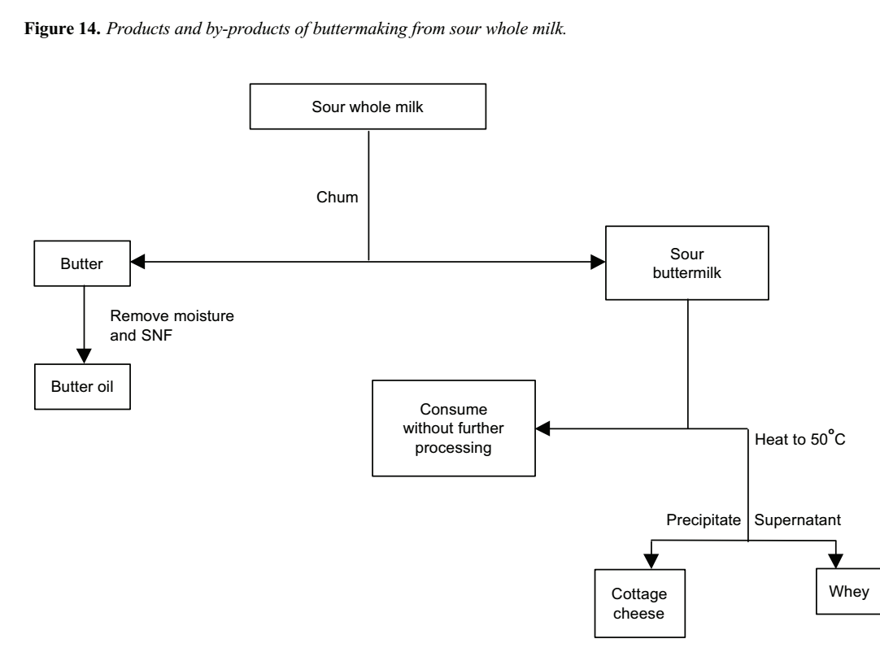
The milk is usually agitated by placing the churn on a mat on the floor and rolling it to and fro. It can also be agitated by shaking the churn on the lap or hung from a tripod. The International Livestock Centre for Africa (ILCA) has developed a wooden agitator that fits inside a clay pot which is the traditional type of churn in many parts of Africa. Using this internal agitator cuts churning time in half and increases recovery of butterfat as butter.
A number of factors influence churning time and recovery of butterfat as butter:
- Milk acidity
- Churning temperature
- Degree of agitation
- Extent of filling the churn
Effect of acidity
Fresh milk is difficult to churn ---- churning time is long and recovery of butterfat is poor ---- however, milk containing at least 0.6% lactic acid is easier to churn. Acidity higher than 0.6% does not significantly influence churning time or fat recovery.
Effect of temperature
Sour milk is normally churned at between 15 and 26°C, depending on environmental temperature. At low temperatures churning time is long; butter-grain formation can take five hours or longer. As churning temperature increases churning time decreases. ILCA trials have shown that when churning sour whole milk using the traditional method, fat recovery values of 67% and 44% were obtained with churning temperatures of 18°C and 25°C, respectively. Controlling the temperature is therefore critical. The optimum churning temperature is between 15 and 17°C.
Degree of agitation
Increasing agitation reduces churning time. Fitting an agitator to a traditional churn reduces churning time and increases butter yield. The percentage of fat recovered as butter is increased, with as little as 0.2% fat remaining in the buttermilk. The advantage of using the ILCA internal agitator was demonstrated when churning sour whole milk at 18°C. Using the traditional clay pot a fat recovery of 67% was obtained compared to a 76% fat recovery when using the clay pot fitted with the internal wooden agitator.
Extent of filling the churn
Churns should be filled to between a third and half their volumetric capacity. Filling to more than half the volumetric capacity increases churning time considerably but does not reduce fat recovery.
Thus, when churning whole milk, the following conditions should be adhered to:
- Milk acidity should be greater than 0.6%
- The temperature should be adjusted to about 18°c
- Internal agitation should be used to reduce churning time and increase fat recovery
- The churn should not be filled to more than half its volumetric capacity.
Once the fat has been recovered by churning the buttermilk contains casein, whey proteins, milk salts, lactic acid, lactose, the unrecovered fat and some fat globule membrane constituents. Buttermilk is suitable, and is often used, for direct consumption. It is also used to inoculate fresh milk to encourage acid development and for cheese making.

Butter quality
Butter quality can be discussed under two main headings:
- Compositional quality
- Organoleptic quality

The compositional quality of butter can be further divided into two subsections:
- Chemical composition
- Bacteriological composition
Compositional quality
The chemical composition of butter is determined at the processing stage when the salt, moisture, curd and fat contents of the product are regulated. Once these parameters have been set there is little one can do to change them. The microbiological quality of butter is also determined during the production and processing stages.

Chemical composition affects butter yield, while butter of poor microbiological quality will deteriorate rapidly and become unacceptable to consumers. The butter may also contain pathogens. Cleanliness at all stages of production is, therefore, essential.

Organoleptic quality
The organoleptic quality of butter can be described as the customer's reaction to its colour, texture and flavour. It has been said that the consumer tastes with his or her eyes, and it is true that a person's initial impression of a food will often determine whether or not he or she will buy it. It is important, therefore, to produce butter that has an even colour, clean flavour and close texture. It is also important that it be free from defects such as loose moisture. It should be packed attractively, both to attract customer attention and to retain its quality.
Butter produced carelessly and without the use of preservatives has a very short shelf life. Preservation of butter quality can assist the smallholder in two ways:
- The less perishable the product the longer the smallholder can retain it to obtain a good price.
- He or she can store the surplus made during the production season for consumption during the season in which he or she cannot produce butter.
The first step the producer can take to ensure a high-quality product is to make it in a clean, hygienic manner.
This results in fewer spoilage organisms being present in the butter. Another step is to take care in the handling and storage of the butter.
The use of permitted preservatives is by far the most effective means of maintaining butter quality when used in conjunction with the above precautions. Salt sodium chloride is an excellent preservative, and salting butter to 3% extends its storage life: salted butter can be stored for up to 4 months without significant deterioration. A salt concentration in excess of 3% gives little advantage and can adversely affect the flavour of the butter.
Aside from the influence of salt on the flavour and keeping quality of the butter, adding salt is of economic importance as it increases overrun.
Adding salt to butter disturbs the equilibrium of the emulsion (the butter). This, in turn, changes the character of the body and alters its colour. Unless the butter is subjected to sufficient working to regain the original equilibrium of the emulsion, it will tend to have a coarse, leaky body and uneven colour.
Salt is added to butter most commonly using the dry-salting method, in which dry salt is sprinkled evenly over the butter and worked in.
Butter must be adequately worked if it is to be stored for a long time. First, working distributes the salt uniformly in the moisture and this helps inhibit microbial growth. Secondly, it distributes the salt solution into many tiny droplets rather than fewer large ones. For a given level of microbial contamination, the microbes will be more isolated in small droplets and will have less of the butter's nutrients available to them for growth.
After salting, the butter should be stored in a clean container, and the container sealed. It should then be stored in a cool, dark place.

11.4. Ghee, butter oil and dry butterfat
These products are almost entirely butterfat and contain practically no water or milk SNF. Ghee is made in eastern tropical countries, usually from buffalo milk. An identical product called samn is made in Sudan. Much of the typical flavour comes from the burned milk SNF remaining in the product. Butter oil or anhydrous milk fat is a refined product made by centrifuging melted butter or by separating milk fat from high-fat cream.

Ghee is a more convenient product than butter in the tropics because it keeps better under warm conditions. It has low moisture and milk SNF contents, which inhibits bacterial growth.
Milk or cream is churned as described in the sections dealing with churning of whole milk or cream. When enough butter has been accumulated it is placed in an iron pan and the water evaporated at a constant rate of boiling. Overheating must be avoided as it burns the curd and impairs the flavour. Eventually a scum forms on the surface: this can be removed using a perforated ladle. When all the moisture has evaporated the casein begins to char, indicating that the process is complete. The ghee can then be poured into an earthenware jar for storage.
A considerable amount of moisture and milk SNF can be removed prior to boiling by melting the butter in hot water (80°C) and separating the fat layer. The fat can be separated either by gravity or using a hand separator. The fat phase yields a product containing 1.5% moisture and little fat is lost in the aqueous phase.

Alternatively, the mixture can be allowed to settle in a vessel similar to that used in the deep-setting method for separating whole milk. Once the fat has solidified the aqueous phase is drained. The fat is then removed and heated to evaporate residual moisture. Products made using these methods exhibited excellent keeping qualities over a 5- month test period.

11.5. Cheese-making
Cheese is a concentrate of the milk constituents, mainly fat, casein and insoluble salts, together with water in which small amounts of soluble salts, lactose and albumin are found. To retain these constituents in concentrated form, milk is coagulated by direct acidification, by lactic acid produced by bacteria, by adding rennet, or a combination of acidification and addition of rennet.

Rennet coagulation theory
Rennet, a proteolytic enzyme extracted from the abomasum of suckling calves, was traditionally used for coagulating milk. Originally, the abomasum was itself immersed in milk. The extraction of rennet that could be stored as a liquid was the first step towards refining this procedure. This was followed by purification and concentration of the enzyme. The purified enzyme was originally called rennin, and is now called chymosin.

On weaning, the chymosin of the suckling calf is replaced by bovine pepsin. With the decrease in the practice of slaughtering calves, chymosin became scarce, resulting in a search for chymosin substitutes. Rennet is a general term currently used to describe a variety of enzymes of animal, plant or microbial origin used to coagulate milk in cheese-making.

Rennet transforms liquid milk into a gel. While the process is not fully understood, rennet coagulation is thought to take place in two distinct phases, the first of which is regarded as being enzymatic, the second non-enzymatic.

The first, or primary phase, can be illustrated as:
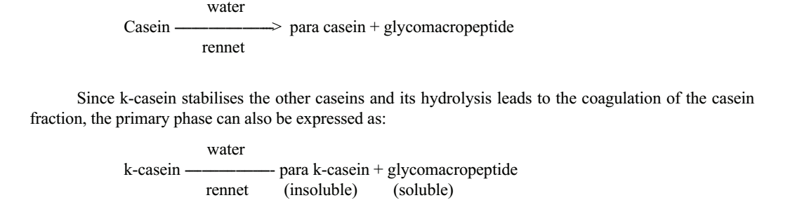
The effect of milk coagulants on the other caseins is thought to be negligible at this stage.
The second, or secondary, phase is the non-enzymatic precipitation of para casein by calcium ions. Para casein, in association with the calcium ions, is thought to produce a lattice structure throughout the milk. This traps the fat and whey is gradually exuded. The coagulum then contracts, a process known as syneresis. This is accelerated by increasing the temperature and reducing pH to as low as pH 4.6.

Rennet also has a tertiary action on milk proteins. This occurs during cheese ripening, during which rennet hydrolyses milk proteins. If the desired hydrolysis is not obtained, the cheese becomes bitter. While a wide variety of proteolytic enzymes coagulate milk, the tertiary action of many of these on milk proteins causes undesirable flavors’ in cheese, which limits the range of coagulants that can be used.

Cheese varieties
Many cheese varieties are manufactured around the world but they are all broadly classified by hardness (i.e. very hard, hard, semi-soft and soft) according to their moisture content. Cheese is usually made from cows milk, although several varieties are made from the milk of goats, sheep or horses. Flow diagrams for the manufacture of the varieties discussed are shown in Figures 14 to 17.
Queso blanco (White cheese)
Queso blanco is a Latin-American fresh, white cheese. It is usually made from milk containing 3% fat, using an organic acid, without starter or rennet.
Procedure
- Take fresh whole milk and determine its fat content. If the fat content is higher than 3%, standardise using skim milk.
- Transfer the standardised milk to a cheese vat, preferably a double-jacketed standard cheese vat, and heat to 82°C.
- While the milk is being heated measure out lemon juice of pH about 2.5 in a measuring jar. About 3 ml of lemon juice should be added per 100 ml of milk.
- Dilute the lemon juice with an equal amount of clean, fresh water.
- When the milk temperature reaches 82°C, add the diluted lemon juice carefully and uniformly while stirring. For even distribution of the juice, add in three separate amounts.
- The curd precipitates almost immediately. Continue to stir for 3 minutes after adding the juice, then allow the curd to settle for 15 minutes
- Drain the whey through a metal sieve or cheese cloth.
- While draining the whey, stir the curd to prevent excess matting.
- Distribute a total of about 3.5 to 5 kg of salt to 100 kg curd, in three applications.
- Prepare a cylindrical or square hoop by lining with cheese cloth and scoop the salted curds into it.
- Press the curd overnight at room temperature.
- Remove the pressed cheese and cut into blocks of 0.5 or 1 kg.
Queso blanco is made without starter or rennet. A variety of acidulants can be used for its manufacture. Heating the milk to 82°C pasteurises the milk and denatures the whey proteins, so that they are recovered with the curd.
This increases cheese yield. The cheese has good keeping quality and is thus suitable for manufacture in rural areas.
Expected yield: 1 kg of cheese from 8 kg of milk (12.5%).
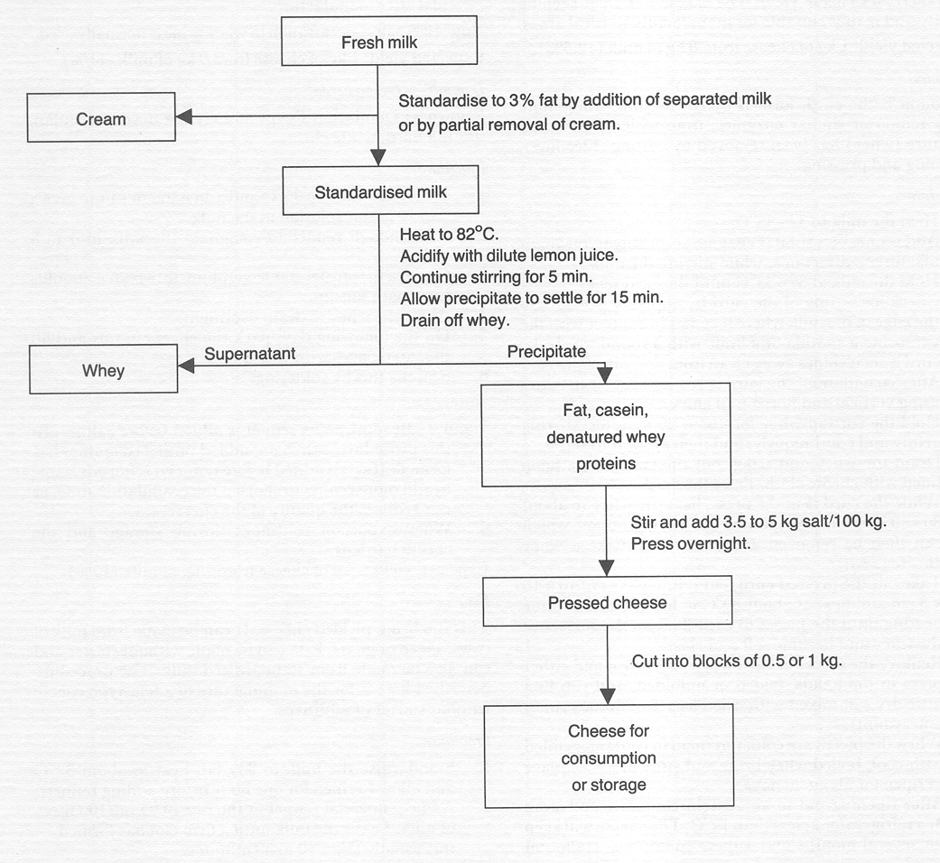
Figure 14. Manufacturing steps for Queso blanco cheese.
Halloumi
Halloumi is the curd, formed by coagulating whole milk using rennet or similar enzymes, from which part of the moisture (whey) has been removed by cutting (bleeding), warming and pressing.
Procedure
- Heat the milk to 32-35°C.
- Add rennet or a similar enzyme according to the manufacturer's directions, while stirring the milk.
- Hold the milk at 32-35°C until the curd sets.
- Check for setting of the curd by applying pressure to the edge of the milk where it comes in contact with the vat, using a spatula or a knife with a round tip. If the curd is set it comes away clean from the wall of the vat.
- After coagulation, the curd is cut into 3-5 mm cubes using vertical and horizontal knives.
- Hold the curd in whey for about 20 minutes, stirring gently and continuously, and then allow it to settle.
- Drain the whey and scoop out the curd into a hoop lined with cheese cloth. Press the curd.
- While the curd is in the press, heat the whey to about 80-90°C. This precipitates the whey proteins, which can then be removed and pressed to make a whey cheese (anari).
- Take out the pressed curd, cut it into pieces of 10 × 10 × 3 cm and heat at about 80°C in hot whey. Continue heating until the pieces of curd float on the surface of the whey and become soft and elastic.
- Remove the pieces of curd when still warm and either press in the hands, folded or unfolded, and rub in a little dry salt mixed with dried leaves of Mentha viridis (spearmint).
- When the pieces are cold, put them in containers filled with cool, boiled whey brine and store in a cool place to ripen for about 30 days.
- After ripening put in an airtight container and store in a refrigerator at less than 12°C. The cheese will keep for several months under these conditions. Halloumi cheese is best after 40 days but can also be consumed just after manufacture.
Note: 15% salt concentration in whey brine is normally used.
Expected yield: 1 kg of cheese from 9 kg of milk (11 %).

11.5.2. Cheese making with sour skim milk
The casein and some of the unrecovered fat in skim milk and buttermilk can be heat-precipitated as cottage cheese, known in Ethiopia as ayib. The defatted milk is heated to about 50°C until a distinct curd mass forms. It is then allowed to cool gradually and the curd is ladled out. Alternatively, the curd can be recovered by filtering the cooled mixture through a muslin cloth. This facilitates more complete recovery of the curd and also allows more effective moisture removal. Temperature of heating can be varied between 40 and 70°C without markedly affecting product composition and yield. Heat treatments between 70 and 90°C do not appear to affect yield but give the product a cooked flavour. The whey contains about 0.75% protein, indicating near-complete recovery of casein. Whey may be consumed by humans or fed to animals.
The approximate composition of cottage cheese made at smallholder level is 76% water, 14% protein, 7% fat and 2% ash. It has a short shelf-life because of its high moisture content. The shelf-life can be increased by adding salt, reducing the moisture content of the cheese or by storing the product in an airtight container. Skim milk can be heated in any suitably sized vessel that is able to withstand heat. Heating can be direct or indirect. A ladle or muslin cloth can be used for product recovery. The yield depends on milk composition and on the moisture content of the product, but should be at least l kg of cottage cheese from 8 litres of milk (12.5%).

11.6. Milk fermentation
Raw milk produced under normal conditions develops acidity. It has long been recognised that highly acid milk does not putrefy. Therefore, allowing milk to develop acidity naturally reserves the other milk constituents.
Bacteria in milk are responsible for acid development. They produce acid by the anaerobic breakdown of milk carbohydrate----lactose----to lactic acid and other organic acids. The conversion of carbohydrate to organic acids or alcohols is called fermentation.
Pyruvic acid formation is an intermediate step common to most carbohydrate fermentations:
C6H12O6 --------> 2 CH3.CO.COOH
However, fermentations are usually described by the end product such as lactic acid or ethyl alcohol and carbon dioxide.
A number of sugar fermentations are recognised in milk. They can be either omofermentative, with one end product, or heterofermentative, with more than one end product. The fermentations discussed are outlined in Figure 31.
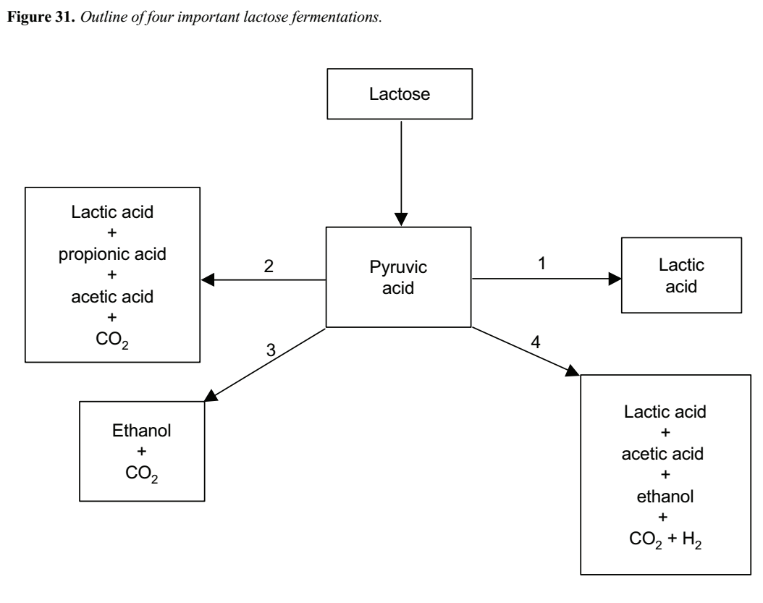
The lactic acid fermentation is the most important one in milk and is central to many processes. Propionic fermentation is a mixed-acid fermentation and is used in the manufacture of Swiss cheese varieties.

Alcohol fermentation can be used to prepare certain fermented milks and also to make ethyl alcohol from whey.
• The coliform gassy fermentation is an example of a spoilage fermentation. Large numbers of coliform bacteria in milk indicates poor hygiene. The coliform gassy fermentation disrupts lactic acid fermentation, and also causes spoilage in cheese.
The factors that affect microbial growth also affect milk fermentation. Fermentation rates generally parallel the microbial growth curve up to the stationary phase. The type of fermentation obtained depends on the numbers and types of bacteria in the milk, storage temperature and the presence or absence of inhibitory substances.
The desired fermentations can be obtained by temperature manipulation or by adding a selected culture of micro-organisms ---- starter ---- to pasteurised or sterilised milk. In smallholder milk processing, a small quantity of milk from previous batches is often used to provide ‘‘starter’’ for subsequent batches. Other sources include the container and additives such as cereal grains.
The fermentation is established once the organisms dominate the medium and continues until either the substrate is depleted or the end product accumulates. In milk, accumulation of end product usually arrests the fermentation. For example, accumulation of lactic acid reduces milk pH to below 4.5, which inhibits the growth of most micro-organisms, including lactic-acid producers. The fermentation then slows and finally stops. Fermented milks are wholesome foods and many have medicinal properties attributed to them.
11.7.1 Fermented milks
The types of fermented milk discussed here are those made by controlled fermentation. This is achieved by establishing the desired micro-organisms in the milk and by maintaining the milk at a temperature favourable to the fermentative organism.
A variety of fermented milks are made, each differing markedly from the other. However, a number of steps are common to each manufacturing process, and these are outlined in Figure 32.
Standardisation
Occasionally some fat is removed or skim milk is added to the fresh whole milk. In some instances, the removal of moisture during sterilisation increases the proportion of solids in the final product.
Heating
Milk is heated to kill pathogens and spoilage organisms and to provide a cleaner medium in which the desired micro-organisms can be established. Heating also removes air from the milk, resulting in a more favourable environment for the fermentative organisms, and denatures the whey proteins, which increases the viscosity of the product.
After heating, the milk must be cooled before it is inoculated with starter, otherwise the starter organisms will also be killed.
Inoculation with starter
Starter is the term used to describe the microbial culture that is used to produce the desired fermentation and to flavour the product. When preparing the starter, care must be taken to avoid contamination with other micro-organisms. Companies that supply starter cultures detail the precautions necessary. Care should also be taken to avoid contamination when inoculating the milk with starter.
Incubation
After inoculation the milk is incubated at the optimum temperature for the growth of the starter organism. Incubation continues until the fermentation is complete, at which time the product is cooled. Additives, e.g. fruit or herbs may be added at this stage and the product packed.
