Chapter objectives: At the end of this chapter you should be able to:

* Understand what energy is and its concepts
* The linkages between energy and development
* Global issues associated with the production and use if energy
* Understand about energy poverty and energy and poverty

1. Introduction to energy resources

Concepts and principles of energy

Energy is the ability to do work. Energy is the driving force for the universe. Energy is involved in all life cycles, and it is essential in agriculture as much as in all other productive activities. An elementary food chain already shows the need for energy: crops need energy from solar radiation to grow, harvesting needs energy from the human body in work, and cooking needs energy from biomass in a fire. The food, in its turn, provides the human body with energy.

Other sectors of rural life require energy as well. The provision of shelter, space heating, water lifting, and the construction of roads, schools and hospitals, are examples. Furthermore, social life needs energy for lighting, entertainment, communication, etc. We observe that development often implies additional energy, and also different forms of energy, like electricity.

* 1. Forms of energy

Energy is found in different forms, such as light, heat, sound, and motion. There are many forms of energy, but they can all be put into two categories: potential and kinetic energy.

* + 1. Potential Energy

Potential energy is stored energy and the energy of position, or gravitational energy. This is, for example, the energy of a water reservoir at a certain height. The water has the potential to fall, and therefore contains a certain amount of energy. More potential energy is available when there is more water and when it is at a higher height. There are several forms of potential energy.

1. Chemical energy is energy stored in the bonds of atoms and molecules. It is the energy that holds these particles together. Wood and oil contain energy in a chemical form. Furthermore, batteries contain chemical energy. Biomass, petroleum, natural gas, and propane are examples of stored chemical energy.
2. Stored mechanical energy is energy stored in objects by the application of a force. Compressed springs and stretched rubber bands are examples of stored mechanical energy.
3. Nuclear energy is energy stored in the nucleus of an atom; it is the energy that holds the nucleus together. The energy can be released when the nuclei are combined or split apart. Nuclear power plants split the nuclei of uranium atoms in a process called fission.
4. Gravitational energy is the energy of position or place. A rock resting at the top of a hill contains gravitational potential energy. Hydropower, such as water in a reservoir behind a dam, is an example of gravitational potential energy.
   * 1. Kinetic energy

Kinetic energy is motion; it is the motion of waves, electrons, atoms, molecules, substances, and objects. This is energy of movement, as in wind or in a water stream. The faster the stream flows and the more water it has the more energy it can deliver. Similarly, more wind energy is available at higher wind speeds, and more of it can be tapped by bigger windmill rotors.

1. Electrical energy: is the movement of electrons. Applying a force can make some of the electrons move. Electrons moving through a wire are called circuit electricity. Lightning is another example of electrical energy.
2. Radiant energy is electromagnetic energy that travels in transverse waves. Radiant energy includes visible light, x-rays, gamma rays, and radio waves. Solar energy is an example of radiant energy. The radiation from the sun contains energy, and also the radiation from a light or a fire.
3. Heat/thermal energy: the internal energy in a substance. Is the vibration and movement of atoms and molecules within a substance. Eg. Geothermal energy

Energy can also be classified based on various criterion:

Primaries Energy sources : - Primary energy sources are those that are either found or stored in nature. Examples include coal, oil, natural gas, and biomass (such as wood).

Secondary Energy: - Primary energy sources are mostly converted in industrial utilities into secondary energy sources; for example coal, oil or gas converted into steam and electricity.

Delivered/final energy; amount of useable energy delivered to the customer.

Useful energy: amount of energy attributed to the amount of work accomplished.

Commercial Energy: - The energy sources that are available in the market for a definite price are known as commercial energy. Important forms of commercial energy are electricity, coal and refined petroleum products. Commercial energy forms the basis of industrial, agricultural, transport and commercial development in the modern world. In the industrialized countries, commercialized fuels are predominant source not only for economic production, but also for many household tasks. Examples: Electricity, oil, natural gas.

Non-Commercial Energy: - The energy sources that are not available in the commercial market for a price are classified as non-commercial energy. This include fuels such as firewood, cattle dung and agricultural wastes, which are traditionally gathered, and not bought at a price used especially in rural households. These are also called traditional fuels. Non-commercial energy is often ignored in energy accounting. Example: Firewood, agro waste in rural areas; solar energy for water heating, electricity generation, for drying grain, and fruits; animal power for transport, , lifting water for irrigation, crushing sugarcane; wind energy for lifting water and electricity generation.

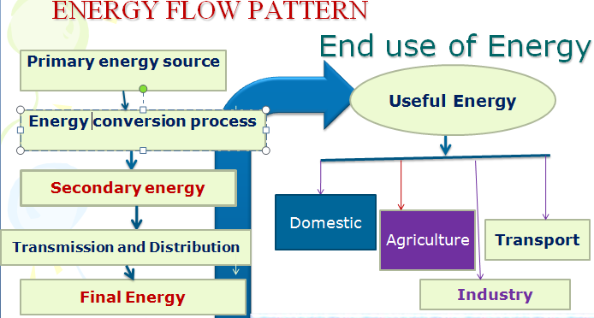

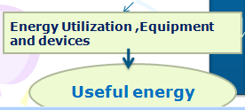

Energy Flow pattern

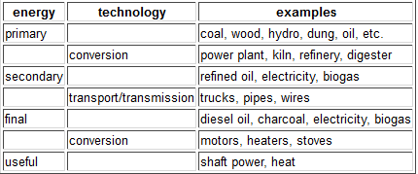

* 1. Energy and Development

Energy is the raw material needed to fuel any country’s economy growth. Advanced economies have the capacity to develop new sources of energy production or to secure imports of foreign energy to meet their needs. But many poorer countries lack this essential capacity. It is estimated that one third of the world’s population, about two billion people, are without access to “modern energy services: lights to read by, refrigeration to store medicines and food, transportation to get products to market, let alone telecommunications and information technology – all prerequisites for economic growth and poverty alleviation.” Compounding this lack of access is the population explosion that is expected to occur in the developing world.

To make matters worse, the world’s poorest inhabitants are particularly ill-equipped to adapt to high energy prices and the increasingly volatile fluctuations of global energy markets. High oil prices tend to hurt developing countries disproportionately. This is because energy-intensive manufacturing constitutes a major part of the economies of many developing countries and because these countries are highly dependent on imported oil.

In addition, purchases of foreign oil often must be paid for in U.S. dollars, a currency that is in short supply in most developing countries. These dollars could be put to better use buying a variety of foreign products that would contribute to economic growth such as modern machinery for factories.

The linkages among energy, other inputs, and economic activity clearly change significantly as an economy moves through different stages of development.

At the lowest levels of income and social development, energy tends to come from harvested or scavenged biological sources (wood, dung, sunshine for drying) and human effort (also biologically powered). More processed biofuels (charcoal), and some commercial fossil energy become more prominent in the intermediate stages. Commercial fossil fuels and ultimately electricity become predominant in the most advanced stages of industrialization and development.

Between 1850 and 2005, overall energy production and use grew more than 50-fold from a global total of approximately 0.2 billion toe to 11.4 billion toe. Most of this increase occurred in industrialized societies, which had come to rely heavily on the ready availability of energy. On a per capita basis, people in these societies now use more than 100 times the amount of energy that was used by our ancestors before humans had learned to exploit the energy potential of fire.

As societies have industrialized, they have not only used more energy but they have used energy in different forms, typically, switching: as household incomes rise, from such traditional fuels as wood, crop residues and dung to such commercial forms of energy (i.e., fuels that can be bought and sold) as oil, natural gas and electricity.

Because most commercial forms of energy are derived from fossil fuels (notably, coal, oil and natural gas), consumption of these fuels grew even faster, increasing roughly 20-fold in the 20th century alone. Non-renewable, carbon-emitting fossil fuels now supply approximately 80 percent of the world’s primary energy needs.

Overall, at least a quarter of the world’s poor are unable to take advantage of the basic amenities and opportunities made possible by modern forms of energy. Inequities in per capita electricity use are even larger than the inequities in per capita primary energy use. In 2005, the average citizen in the OECD countries used 8,365 kwh of electricity. By contrast, the average citizen in China used 1,802 kwh, the average citizen elsewhere in Asia used 646 kwh, the average citizen in Latin America used 1,695 kwh and the average citizen in Africa used 563 kwh. These estimates and projections clearly indicate unsustainable utilization of energy resources and higher energy footprint in the developed world, which generally discarded the idea of stewardship and sustainability.

The world has generally seen considerable development and progress in the past 50 years. Living standards have improved, people have become healthier and longer-lived, and science and technology have considerably enhanced human welfare. No doubt the availability of abundant and cheap sources of energy, mainly in the form of crude oil contributed to these achievements.

Although energy use and economic growth are decoupled at higher levels of development, for the world’s poorest people, small increases in energy consumption are often associated with dramatic improvements in quality of life. Energy consumption correlates closely with both welfare and economic growth.

At the local level, modern energy services help to reduce

* Drudgery of women’s labor,
* Improve health and education, and
* Stimulate micro-enterprises.

At the national level, energy services facilitate economic development by underpinning industrial growth and providing access to global markets and trade.

The importance of energy services for social development is reflected in the association between energy consumption and human development. Studies show the strong correlation between commercial energy consumption and UNDP’s Human Development Index. This index is composed of human development indicators that reflect achievements in the most basic human capabilities: leading a long life (life expectancy), being knowledgeable (educational achievement), and enjoying a decent standard of living (income, measured in purchasing power parity terms).

**Contribution of energy to achieve MDGs**

|  |  |  |
| --- | --- | --- |
| MDG | Steps Toward Goal | Modern energy contributes by |
| * Cutting Extreme Poverty and Hunger | * Reduce by half the proportion of people living on less than $1 a day * Reduce by half the proportion of people who suffer from hunger | * Reducing share of household income spent on cooking, lighting, and space heating. * Improving ability to cook staple foods. * Generating light to permit income generation beyond daylight. * Powering machinery to increase productivity |
| * Gender Equality and Women’s Empowerment | * Ensure that all boys and girls complete a full course of primary schooling | * Providing light for reading or studying beyond daylight. * Creating a more child-friendly environment (access to clean water, sanitation, lighting, and space heating/cooling), which can improve attendance in school and reduce drop-out rates. * Providing lighting in schools, this can help retain teachers. * Enabling access to media and communications that increase educational opportunities. |
| * Health | * Reduce by two-thirds the mortality rate among children under five * Reduce by three-quarters the maternal mortality ratio * Halt and begin to reverse the incidence of malaria and other major diseases | * Providing access to better medical facilities for maternal care, allowing for medicine refrigeration, equipment sterilization, and safe disposal by incineration. * Facilitating development, manufacture, and distribution of drugs. * Providing access to health education media. * Reducing exposure to indoor air pollution and improving health. * Enabling access to the latest medicines/expertise through renewable-energy based telemedicine systems. |

***Energy poverty***

Energy consumption and efficiency vary dramatically in different parts of the world. In 2005, average annual per-capita consumption of modern energy (i.e., excluding traditional biomass and waste) is 1,519 kilograms of oil equivalent (kgoe).While the average in high-income countries is 5,228 kgoe, in low-income countries it is only 250 kgoe. Traditional biomass and waste account for 10.6 percent of total global primary energy supply. In low-income countries, these sources represent on average 49.4 percent of the supply, with some countries approaching 90 percent. For the world’s poor, the only source of energy that is generally available and affordable is “traditional biomass,” including fuel wood, crop residues, and animal wastes. Often, the poorest segment of the population lacks access even to these primitive fuels.

Roughly more than two billion people worldwide do not have access to electricity in their homes, representing slightly more than one-third of the world population. This lack of electricity deprives people of basic necessities such as refrigeration, lighting, and communications. Most of the electricity-deprived live in South Asia and sub-Saharan Africa.

Energy Security: is the uninterrupted availability of energy sources at an affordable price.

Dimensions of Security: Affordability/competitive price

Reliability/uninterrupted supply

Accessible/available supply

**Global energy mateers**

**Energy and climate change**

Approximately 90% of the world’s energy demand is currently supplied by non-renewable sources. With world consumption increasing, energy shortages are inevitable unless conservation strategies are set up and reliance on alternative energy sources is focused. From an environmental perspective, all activities involving energy production, conversion and transportation have either direct or indirect adverse impacts. Obvious examples include the destruction of natural resources and habitats, the contamination of soil and water, (hazardous) waste land filling and air pollution. Burning fossil fuels for energy generates air pollutants like carbon oxides, sulphur dioxide, nitrogen oxides and respirable dusts, all of which have negative impacts.

**The impact of energy production and use on the environment**

Current trends in energy consumption are neither secure nor sustainable: economically, environmentally or socially. Energy and environmental problems undermine the potential for sustained economic development and contribute to political and economic instability. The production and consumption of energy places a wide range of pressures on the environment. According to the recent World Energy Outlook , if governments around the world continue with current policies, the world's energy needs would be 55 % higher in 2030 than in 2005, with China and India accounting for much of this rising demand. Some 84 % of the increase in primary energy demand will have to come from fossil fuels. Energy production and use, particularly of fossil fuels, have a number of environmental impactsincluding air pollution, greenhouse gas emissions and adverse impacts on ecosystems.

The world is facing twin energy-related threats. The first is that of not having adequate and secure supplies of energy at affordable prices and that of environmental harm caused by consuming too much of it.

Relatively abundant and cheap by comparison with other fossil fuels, coal is commonly used for electricity production in many countries. All aspects of its use are environmentally destructive. First, coal mining itself is a highly polluting activity that is also damaging to human health.

Combustion of coal produces higher level of CO2, nitrous oxides and sulphur oxides than all other sources. In addition to contributing to increased GHG concentrations, sulphur and nitrous oxides combine with atmospheric moisture to produce sulphuric and nitric acids in the air. This phenomenon, often referred to as “acid rain”. Its combustion also produces particulate matter.

Some of the major environmental problems that the world is facing today are discussed as follows.

1. Greenhouse gas emissions

Energy‑related greenhouse gas (GHG) emissions remain dominant, accounting for majority of the total emissions, with the largest emitting sector being electricity and heat production, followed by transport.

1.1. Carbon dioxide (CO2)

1.2. Nitrous oxide (N2O)

1.3. Methane (CH4) (Refer Climate change Adaptation and mitigation course for details)

1.4. Land degradation and deforestation

Land degradation, deforestation, and desertification are the most visible and immediate environmental concern in many developing countries. Theses have many forms and causes.

Wood is the primary fuel source in most of the developing countries, and used for 95% of energy needs. An ever increasing population led high energy demand and associated deforestation. The relationship between forests and energy is fundamental to both climate change and development. Almost the entire population in developing countries relies on charcoal or wood for household fuel, the main cause of deforestation together with expansion of agriculture. Millions of hectares of tropical forests are destroyed every year for subsistence energy demands.

1.5. Indoor Air Pollution

Household energy and indoor air pollution pose a substantial threat to the health of the world’s poor. Households reliant on biomass and coal generally use the fuel indoors, in open fires or poorly functioning stoves, and usually with inadequate venting of smoke. The smoke from biomass fuel and coal contains a large number of pollutants that are dangerous to health, including small particles, carbon monoxide, nitrogen dioxide, sulphur dioxide (this mainly from coal), formaldehyde, and carcinogens such as benzo pyrene and benzene.

The overall impacts appear to be on acute respiratory infections in children, and chronic lung disease in adults, and in developing countries the overall public health impact of indoor air pollution is substantial.

* 1. Marine pollution

Oil pollution from coastal refineries, offshore installations and maritime transport put significant pressures on the marine environment. The consistency of spilled oil can cause surface contamination and smother marine biota. In addition, its chemical components can cause acute toxic effects and long-term impacts.

* 1. Air pollution

Energy production and consumption contributes to acidifying of water bodies and soil, emissions of tropospheric ozone precursors and (primary) particles emissions. Energy‑related emissions in transport and energy production significantly contribute of all emissions, with the transport sector particularly dominant in relation to ozone precursors (due to NOX emissions).

**Chapter 2**

**Types of energy resources**

Chapter objective: At the end of this chapter you are expected to:

* Understand historical background and trends in energy use
* Understand global energy use trends
* Review national Energy use status
* Analyze future energy needs
* Familiarize types of renewable energy
* Compare and analyze renewable and non- renewable energy source

**Renewable (non-conventional or alternative energy)** is generally defined as energy that comes from [resources](http://en.wikipedia.org/wiki/Renewable_resource) which are naturally replenished on a human timescale such as [sunlight](http://en.wikipedia.org/wiki/Sunlight), [wind](http://en.wikipedia.org/wiki/Wind), [rain](http://en.wikipedia.org/wiki/Rain), [tides](http://en.wikipedia.org/wiki/Tidal_power), waves and geothermal heat.

Renewable energy refers to energy resource that occurs naturally and repeatedly in the environment and can be harnessed for human benefit. Renewable is energy from a source that can be maintained in constant supply over time. Renewable energy encompasses many different types of technology at different stages of development and commercialization.

**Non -renewable (conventional or** **finite energy**) is a resource that does not renew itself at a sufficient rate for sustainable economic extraction in meaningful human time-frames. An example is carbon-based, organically-derived fuel. The original organic material, with the aid of heat and pressure, becomes a fuel such as oil or gas. [Earth](http://en.wikipedia.org/wiki/Earth) [minerals](http://en.wikipedia.org/wiki/Mineral) and [metal](http://en.wikipedia.org/wiki/Metal) [ores](http://en.wikipedia.org/wiki/Ore), [fossil fuels](http://en.wikipedia.org/wiki/Fossil_fuel) (such as [coal](http://en.wikipedia.org/wiki/Coal), [petroleum](http://en.wikipedia.org/wiki/Petroleum), and [natural gas](http://en.wikipedia.org/wiki/Natural_gas)).

Renewable contributed 19 percent to our energy consumption and 22 percent to our electricity generation in 2012 and 2013, respectively. Both, modern renewables, such as hydro, wind, solar and biofuels, as well as traditional biomass, contributed in about equal parts to the global energy supply.

Renewable energy resources exist over wide geographical areas, in contrast to other energy sources, which are concentrated in a limited number of countries. Rapid deployment of renewable energy and [energy efficiency](http://en.wikipedia.org/wiki/Efficient_energy_use) is resulting in significant [energy security](http://en.wikipedia.org/wiki/Energy_security_and_renewable_technology), [climate change mitigation](http://en.wikipedia.org/wiki/Climate_change_mitigation), and economic benefits.

While many renewable energy projects are large-scale, renewable technologies are more suited to [rural](http://en.wikipedia.org/wiki/Rural) and remote areas and [developing countries](http://en.wikipedia.org/wiki/Renewable_energy_in_developing_countries). Renewable energy has the ability to lift the poorest nations to new levels of prosperity.

Types of renewable energy

The primary 6 types of renewable energy are solar, wind, biomass, hydro power, geothermal and biofuels.  Each of these renewable energy sources provides an alternative to traditional energy generation and can be reproduced, reducing our footprint on the environment. Conventional energy sources based on oil, coal, and natural gas have proven to be highly effective drivers of economic progress, but at the same time damaging to the environment and to human health. Furthermore, they tend to be cyclical in nature, due to the effects of oligopoly in production and distribution.

The potential of renewable energy sources is enormous as they can in principle meet many times the world’s energy demand. Renewable energy sources such as biomass, wind, solar, hydropower, and geothermal can provide sustainable energy services, based on the use of routinely available, indigenous resources.

Furthermore, many renewable technologies are suited to small off-grid applications, good for rural, remote areas, where energy is often crucial in human development. At the same time, such small energy systems can contribute to the local economy and create local jobs.

**Characteristics of RE: Basically renewable energy is**

* Indigenous (not imported form of energy)
* Labor intensive (create employment)
* Suitable for decentralized application
* Environmental friendly (pollution free)
* Help to fight global warming (global CC)
* Directly associated with sustainability
* Not marketable to on a world scale (like petrol)

Additionally, they provide a correct mix or complementarily where the absence of one is substituted by another. Eg. In the absence of hydro there is wind and vice versa.

**2.1. Biomass Energy**

Biomass is the term used for all organic material originating from plants (including algae), trees and crops and is essentially the collection and storage of the sun’s energy through photosynthesis. Biomass energy, or bioenergy, is the conversion of biomass into useful forms of energy such as heat, electricity and liquid fuels.

As an energy source, biomass can either be used directly via combustion to produce heat, or indirectly after converting it to various forms of [biofuel](http://en.wikipedia.org/wiki/Biofuel).

Biomass was the first energy source harnessed by humans and for nearly all of human history,

wood has been our dominant energy source. Only during the last century, with the development

of efficient techniques to extract and burn fossil fuels, have coal, oil, and natural gas, replaced wood as the industrialized world’s primary fuel. Today some 40 to 55 exajoules (EJ = 1018

joules) per year of biomass is used for energy, out of about 450 EJ per year of total energy use, or an estimated 10-14 percent, making it the fourth largest source of energy behind oil (33 %), coal (21 %), and natural gas (19 %). The precise amount is uncertain because the majority is used non-commercially in developing countries.

Biomass resources are potentially the largest renewable global energy source

**Source**

Biomass can be classified as plant biomass (woody, non-woody, processed waste, or processed fuel; or animal biomass. Most woody biomass is supplied by forestry plantations, natural forests,

and natural woodlands. Non-woody biomass and processed waste are products or by-products of agroindustrial activities. Animal manure can be used as cooking fuel or as feedstock for biogas generation. Municipal solid waste is also considered a biomass resource.

There are a variety of technologies for generating modern energy carriers – electricity, gas, and liquid fuels -- from biomass, which can be used at the household community, or industrial scale. The different technologies tend to be classed in terms of either the conversion process they use or the end product produced.

Table: Types and sources of plant biomass

**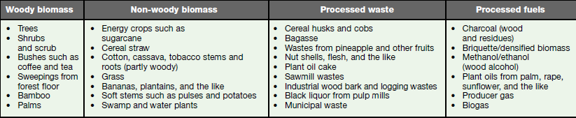**

**2.2. Biofuel**

A **biofuel** is a [fuel](http://en.wikipedia.org/wiki/Fuel) that is derived from biological materials, such as plants and animals. Biofeuls are produced in processes that convert biomass into more useful intermediate forms of energy. Also biofuel can still be seen as fuel derived from organic matter (obtained directly from plants, or indirectly from agricultural, commercial, domestic, and/or industrial wastes). Biofuels are made by [biomass](http://en.wikipedia.org/wiki/Biomass) conversion. This biomass can be converted to convenient energy containing substances in three different ways: thermal conversion, chemical conversion, and biochemical conversion. This biomass conversion can result in fuel in [solid](http://en.wikipedia.org/wiki/Solid), [liquid](http://en.wikipedia.org/wiki/Liquid), or [gas](http://en.wikipedia.org/wiki/Gas) form. This new biomass can be used for biofuels. Biofuels have increased in popularity because of rising [oil prices](http://en.wikipedia.org/wiki/Price_of_petroleum) and the need for [energy security](http://en.wikipedia.org/wiki/Energy_security).

**Bioethanol** is an [alcohol](http://en.wikipedia.org/wiki/Alcohol) made by [fermentation](http://en.wikipedia.org/wiki/Ethanol_fermentation), mostly from [carbohydrates](http://en.wikipedia.org/wiki/Carbohydrate) produced in [sugar](http://en.wikipedia.org/wiki/Sugar) or [starch](http://en.wikipedia.org/wiki/Starch) crops such as [corn](http://en.wikipedia.org/wiki/Maize), [sugarcane](http://en.wikipedia.org/wiki/Sugarcane), or [sweet sorghum](http://en.wikipedia.org/wiki/Sweet_sorghum). [Cellulosic biomass](http://en.wikipedia.org/wiki/Cellulose), derived from non-food sources, such as trees and grasses, is also being developed as a [feedstock](http://en.wikipedia.org/wiki/Feedstock) for ethanol production. Ethanol can be used as a fuel for vehicles in its pure form, but it is usually used as a [gasoline](http://en.wikipedia.org/wiki/Gasoline) [additive](http://en.wikipedia.org/wiki/Fuel_additive) to increase purity and improve vehicle emissions. Bioethanol is widely used in the [USA](http://en.wikipedia.org/wiki/Biofuel_in_the_United_States) and in [Brazil](http://en.wikipedia.org/wiki/Ethanol_fuel_in_Brazil).

Other alternative biofuels to petroleum-based fuels are alcohols produced from biomass, which can replace gasoline or kerosene. The most widely produced today is ethanol from the fermentation of biomass. In industrialized countries ethanol is most commonly produced from food crops like corn, while in the developing world it is produced from sugarcane. Its most prevalent use is as a gasoline fuel additive to boost octane levels or to reduce dependence on imported fossil fuels.

[**Biodiesel**](http://en.wikipedia.org/wiki/Biodiesel) refers to a vegetable oil - or animal fat-based diesel fuel consisting of long-chain alkyl (methyl, ethyl, or propyl) esters. **Biodiesel** is typically made by chemically reacting lipids (e.g., vegetable oil, soybean, animal fat) with an alcohol producing fatty acid esters. It can be used as a fuel for vehicles in its pure form, but it is usually used as a [diesel](http://en.wikipedia.org/wiki/Diesel_fuel) additive to reduce levels of particulates, [carbon monoxide](http://en.wikipedia.org/wiki/Carbon_monoxide), and [hydrocarbons](http://en.wikipedia.org/wiki/Hydrocarbon) from diesel-powered vehicles. Biodiesel is produced from oils or fats using [transesterification](http://en.wikipedia.org/wiki/Transesterification) and is the most common biofuel in Europe.

**Biogas**. Biogas, consisting primarily of methane, is released during anaerobic decomposition of organic matter. Facilities that deal with large quantities of or­ganic waste can employ anaerobic digesters and/or gas collection systems to capture biogas, which can be used as a source of on-site bioheat and/or biopower.

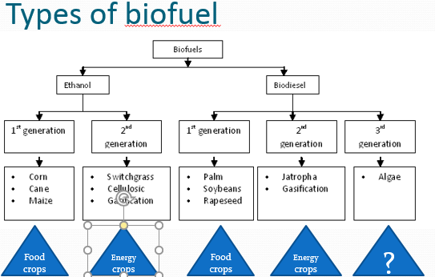

There are various social, economic, environmental and technical [issues relating to biofuels](http://en.wikipedia.org/wiki/Issues_relating_to_biofuels) production and use, which have been debated in the popular media and scientific journals. These include: the effect of moderating [oil prices](http://en.wikipedia.org/wiki/Price_of_petroleum), the "[food vs fuel](http://en.wikipedia.org/wiki/Food_vs_fuel)" debate, [poverty reduction](http://en.wikipedia.org/wiki/Poverty_reduction) potential, [carbon emissions](http://en.wikipedia.org/wiki/Carbon_emissions) levels, [sustainable biofuel](http://en.wikipedia.org/wiki/Sustainable_biofuel) production, [deforestation](http://en.wikipedia.org/wiki/Deforestation) and [soil erosion](http://en.wikipedia.org/wiki/Soil_erosion), loss of [biodiversity](http://en.wikipedia.org/wiki/Biodiversity), rural unskilled unemployment, and nitrous oxide (NO2) emissions.

**Why Use Biofuels?**

It provides a market for excess production of vegetable oils and animal fats.

It decreases the country's dependence on imported petroleum.

It is renewable and does not contribute to global warming due to its closed carbon cycle.

It provides substantial reductions in carbon monoxide, unburned hydrocarbons, and particulate  
emissions from diesel engines.

**2.3. Hydropower**

Is [power](http://en.wikipedia.org/wiki/Power_%28physics%29) derived from the [energy](http://en.wikipedia.org/wiki/Energy) of falling water and running water, which may be harness for useful purposes. Hydro-power plants convert the energy in flowing water into electricity. The most common form of hydropower uses a dam on a river to retain a large reservoir of water. Water is released through turbines to generate power.

It is a proven, predictable and typically price-competitive technology. Hydropower has among the best conversion efficiencies of all known energy sources (about 90% efficiency, water to wire). It requires relatively high initial investment, but has a long lifespan with very low operation and maintenance costs.

**Generating Power** In nature, energy cannot be created or destroyed, but its form can change. In generating electricity, no new energy is created. Actually one form of energy is converted to another form. To generate electricity, water must be in motion. This is kinetic (moving) energy. When flowing water turns blades in a turbine, the form is changed to mechanical (machine) energy. The turbine turns the generator rotor which then converts this mechanical energy into another energy form -- electricity. Since water is the initial source of energy, we call this hydroelectric power or hydropower for short. At facilities called hydroelectric powerplants, hydropower is generated. Some powerplants are located on rivers, streams, and canals, but for a reliable water supply, dams are needed. Dams store water for later release for such purposes as irrigation, domestic and industrial use, and power generation. The reservoir acts much like a battery, storing water to be released as needed to generate power.

Hydropower offers signifi cant potential for carbon emissions reductions.

Hydropower plants do not consume the water that drives the turbines. The water, after power generation, is available for agriculture, Irrigation and Water in the reservoir as potential tourism destination.

The high initial cost is a serious barrier for its growth in developing countries where most of the untapped economic potential is located.

### 2.4. Wind power

Wind energy has been one of humanity’s primary energy sources for pumping water and milling grain for several millennia. Wind power is extracted from [air flow](http://en.wikipedia.org/wiki/Wind) using [wind turbines](http://en.wikipedia.org/wiki/Wind_turbine) to produce mechanical or [electrical power](http://en.wikipedia.org/wiki/Electrical_power). Wind energy as an alternative to [fossil fuels](http://en.wikipedia.org/wiki/Fossil_fuel), is plentiful, [renewable](http://en.wikipedia.org/wiki/Renewable_energy), widely distributed, [clean](http://en.wikipedia.org/wiki/Sustainable_energy), produces no [greenhouse gas](http://en.wikipedia.org/wiki/Greenhouse_gas) emissions during operation and uses little land. The [effects on the environment](http://en.wikipedia.org/wiki/Environmental_impact_of_wind_power) are generally less problematic than those from other power sources.

Large [wind farms](http://en.wikipedia.org/wiki/Wind_farm) consist of thousands of individual wind turbines which are connected to the [electric power transmission](http://en.wikipedia.org/wiki/Electric_power_transmission) network. Onshore wind is an inexpensive source of electricity, competitive with or in many places cheaper than coal, gas or fossil fuel plants.Offshore wind is steadier and stronger than on land, and offshore farms have less visual impact, but construction and maintenance costs are considerably higher. Small onshore wind farms can feed some energy into the grid or provide electricity to isolated off-grid locations. Wind power is very consistent from year to year but has significant variation over shorter time scales. It is therefore used in conjunction with other sources to give a reliable supply.

Wind power by its nature is variable (or intermittent), therefore some form of storage or back-up is inevitably involved. This may be through:

(a) connection to an electricity grid system, which may be on a large or small  
(mini-grid) scale;

(b) incorporating other electricity producing energy systems (from conventional generating stations through diesel generators to other renewable energy systems);

(c) or the use of storage systems such as batteries or, for mechanical systems, storage via water held in a tank. So long as the system is designed to have sufficient storage capacity, whether  
for energy or product (e.g. water pumped), to cover the periods when the supply  
is unable to meet the full level of demand, then an output is always available.

Usually wind energy systems are classified in three categories: grid-connected electricity generating, stand-alone electricity generating (often subdivided into battery-based or autonomous diesel, the later having automatic start-up when the wind speed falls, although diesel generators may also be used within stand-alone battery systems) and mechanical systems.

Wind technology does not have fuel requirements as do coal, gas, and petroleum generating technologies. However, both the equipment costs and the costs of accommodating special characteristics such as intermittence, resource variability, competing demands for land use, and transmission and distribution availability can add substantially to the costs of generating electricity from wind. For wind resources to be useful for electricity generation, the site must (1) have sufficiently powerful winds, (2) be located near existing transmission networks, and (3) be economically competitive with respect to alternative energy sources. While the technical potential of wind energy to fulfill our need for energy services is substantial the economic potential of wind energy remains dependent on the cost of wind turbine systems as well as the economics of alternative options.

***Main components of a Wind Turbine***

***Rotor***The portion of the wind turbine that collects energy from the wind is called the rotor.

Gear box: Wind turbines rotate typically between 40 rpm and 400 rpm.

Generators typically rotates at 1,200 to 1,800 rpm.

Most wind turbines require a step-up gear-box for efficient generator operation (electricity production).

Generator: Converts the rotational mechanical power to electrical power.

### 2.5. Solar energy

[Solar energy](http://en.wikipedia.org/wiki/Solar_energy), radiant [light](http://en.wikipedia.org/wiki/Light) is harnessed using a range of ever-evolving technologies such as [solar heating](http://en.wikipedia.org/wiki/Solar_heating), [photovoltaics](http://en.wikipedia.org/wiki/Photovoltaics), [concentrated solar power](http://en.wikipedia.org/wiki/Concentrated_solar_power). Solar power is the [conversion of energy](https://en.wikipedia.org/wiki/Energy_transformation) from [sunlight](https://en.wikipedia.org/wiki/Sunlight) into [electricity](https://en.wikipedia.org/wiki/Electricity), either directly using [photovoltaics](https://en.wikipedia.org/wiki/Photovoltaics) (PV), or indirectly using [concentrated solar power](https://en.wikipedia.org/wiki/Concentrated_solar_power). It is used to heat buildings, water and to generate electricity.

Two ways to make electricity from solar energy are photovoltaics and solar thermal systems.

2.5.1. Photovoltaic Electricity

Photovoltaic (PV) comes from the words photo, meaning light, and volt, a measurement of electricity. PV [systems](https://en.wikipedia.org/wiki/Photovoltaic_systems) use [solar panels](https://en.wikipedia.org/wiki/Solar_panel), either on [rooftops](https://en.wikipedia.org/wiki/Rooftop_photovoltaic_power_station) or in ground-mounted [solar farms](https://en.wikipedia.org/wiki/Solar_farm), converting sunlight directly into electric power.

A [solar cell](https://en.wikipedia.org/wiki/Solar_cell), or photovoltaic cell (PV), is a device that converts light into electric current using the [photovoltaic effect](https://en.wikipedia.org/wiki/Photovoltaic_effect).

Solar-powered toys, calculators, and roadside telephone call boxes all use solar cells to convert sunlight into electricity.

2.5.2. Solar Thermal Electricity

Like solar cells, solar thermal systems, also called concentrated solar power (CSP), use solar energy to produce electricity. [Concentrated solar power](https://en.wikipedia.org/wiki/Concentrated_solar_power) (CSP, also known as "concentrated solar thermal") plants use [solar thermal energy](https://en.wikipedia.org/wiki/Solar_thermal_energy) to make steam, that is thereafter converted into electricity by a turbine.

Concentrated solar power (CSP), also called "concentrated solar thermal", uses lenses or mirrors and tracking systems to focus a large area of sunlight into a small beam. Contrary to photovoltaics – which converts light directly into electricity – CSP uses the heat of the sun's radiation to generate electricity from conventional steam-driven turbines.

Solar energy has great potential for the future. Solar energy is free, and its supplies are unlimited. It does not pollute or otherwise damage the environment. It cannot be controlled by any one nation or industry. If the technology is improved it is possible to harness the sun’s enormous power, without facing energy shortages in the future.

### 2.6. Geothermal energy

Geothermal energy is from [thermal energy](http://en.wikipedia.org/wiki/Thermal_energy) generated and stored in the Earth. Thermal energy is the energy that determines the [temperature](http://en.wikipedia.org/wiki/Temperature) of matter. Earth's geothermal energy originates mainly from [radioactive decay](http://en.wikipedia.org/wiki/Radioactive_decay) of minerals (80%). The [geothermal gradient](http://en.wikipedia.org/wiki/Geothermal_gradient), which is the difference in temperature between the core of the planet and its surface, drives a continuous conduction of thermal energy in the form of [heat](http://en.wikipedia.org/wiki/Heat) from the core to the surface.

The word geothermal comes from the Greek words geo (earth) and therme (heat). So,  
geothermal energy is heat from within the earth. We can use the steam and hot water  
produced inside the earth to heat buildings or generate electricity. Geothermal energy is a  
renewable energy source because the water is replenished by rainfall and the heat is  
continuously produced inside the earth. The heat that is used for geothermal energy can be from deep within the Earth, all the way down to Earth's core – 6,400 km down. At the core, temperatures may reach over 5,000 °C. Earth's geothermal energy originates mainly from radioactive decay of minerals (80%).

Heat conducts from the core to surrounding rock. Extremely high temperature and pressure cause some rock to melt, which is commonly known as magma. Magma convects upward since it is lighter than the solid rock. This magma then heats rock and water in the crust, sometimes up to 371 °C.

From [hot springs](http://en.wikipedia.org/wiki/Hot_springs), geothermal energy has been used for bathing since [ancient](http://en.wikipedia.org/wiki/Paleolithic) times and for space heating since ancient Roman times, but it is now better known for [electricity generation](http://en.wikipedia.org/wiki/Electricity_generation).

Most geothermal reservoirs are deep underground with no visible clues showing above  
ground.

Geothermal energy can sometimes find its way to the surface in the form of:  
volcanoes and fumaroles (holes where volcanic gases are released) hot springs and geysers. The most active geothermal resources are usually found along major plate boundaries where earthquakes and volcanoes are concentrated. Most of the geothermal activity in the world occurs in an area called the Ring of Fire where major plate boundaries where earthquakes and volcanoes are concentrated.

When magma comes close to the surface it heats ground water found trapped in porous  
rock or water running along fractured rock surfaces and faults. Such hydrothermal  
resources have two common ingredients: water (hydro) and heat (thermal). Naturally  
occurring large areas of hydrothermal resources are called geothermal reservoirs.  
Geologists use different methods to look for geothermal reservoirs.

Some applications of geothermal energy use the earth's temperatures near the surface,  
while others require drilling miles into the earth. The three main uses of geothermal energy  
are:

1) Direct Use: Geothermal heat found near the surface of the Earth can be used directly for

bathing and heating buildings

2) Electricity generation: Geothermal power plants access the underground steam or hot water from wells drilled a mile or more into the earth. The steam or hot water is piped up from the well to drive a conventional steam turbine, which powers an electric generator. Typically, the water is then returned to the ground to recharge the reservoir and complete the renewable energy cycle.

Ethiopia’s Situation

Ethiopia could possibly generate more than 5000 MW of electric power from geothermal resources alone.

Ethiopian Rift Valley and in the Afar depression, which are both part of the Great East African Rift System.

16 geothermal prospect areas are judged to have potential for high temperature steam suited to electricity generation.

Why geothermal energy is said renewable?

* + the heat emanating from the interior of the Earth is essentially limitless.
  + Hydrological cycle

**Reading assignment**

**Differentiate between oil, petroleum, natural gas, coal**

**2.2. Global energy use**

**World energy consumption** refers to the total energy used by all of human civilization. Typically measured per year, it involves all energy harnessed from every energy source applied towards humanity's endeavors across every industrial and technological sector, across every country. Being the power source metric of civilization, World Energy Consumption has deep implications for humanity's social-economic-political sphere.

According to IEA data from 1990 to 2008, the average energy use per person increased 10% while world population increased 27%. Regional energy use also grew from 1990 to 2008: the Middle East increased by 170%, China by 146%, India by 91%, Africa by 70%, Latin America by 66%, the USA by 20%, the EU-27 block by 7%, and world overall grew by 39%. In 2008, total worldwide energy consumption was 474 [exajoules](http://en.wikipedia.org/wiki/Joule) (132,000 [TWh](http://en.wikipedia.org/wiki/Watt-hour" \o "Watt-hour)). This is equivalent to an average power use of 15 [terawatts](http://en.wikipedia.org/wiki/Terawatt).

Economic growth is by far the most important driver of energy trends. The link between energy demand and economic output remains close. Projected world total primary energy demand increases by 57% between 1997 and 2020, at an average annual rate of 2%, to slightly more than 13 700 Mtoe. This compares with an annual average growth rate of 2.2% from 1971 to 1997.

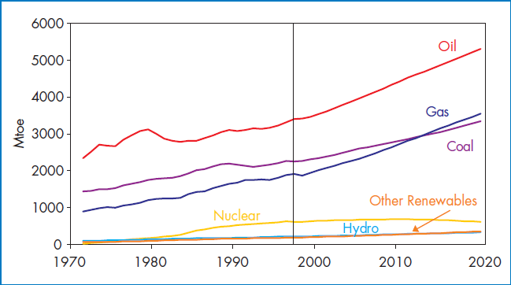

Fig. World Primary Energy Supply by Fuel, 1971-2020

The WEO projections lead to the following major conclusions:

• world energy use and related CO2 emissions will continue to increase steadily;

• fossil fuels will account for 90% of the world primary energy mix by 2020

• the shares of different regions in world-energy demand will shift significantly, with the OECD share declining in favour of developing countries;

• a sharp increase will occur in international trade in energy, especially oil and gas;

• the reliance on imported oil and gas of the main consuming regions, including the OECD and dynamic Asian economies, will increase substantially,

• power generation in developing countries will account for nearly one third of the increase in global emissions to 2020.

**National energy use status**

Despite the presence of a variety of energy resources, the bulk of the national energy consumption is met from biomass energy sources. Biomass energy (fuelwood, charcoal, wood, waste wood, crop residues and animal dung, including biogas) accounted for 89 percent of total national energy consumption in 2006. Petroleum fuels and electricity met merely 7.6% and 1.1% of the national energy consumption, respectively.

The energy sector in Ethiopia is characterized by the predominance of the household sector, accounting for 89% gross energy consumption in 2006. Domestic energy requirements are mostly met from wood, animal dung and agricultural residues. About 81% of the estimated 16 million households use firewood while 11.5% cook with leaves and dung cakes and only 2.4% kerosene for cooking.

Petroleum fuels are mainly used in the transport sector with a smaller share of the demand from the household sector (kerosene for cooking and lighting) and industrial sector (fuel oil for thermal energy). Electricity consumption among the sectors was 33% by households, 40% by industries and 26% by service sector.

The hydropower potential of Ethiopia is estimated at between 30,000 to 40,000 MW (though some estimates put the economically affordable power estimate at 40 per cent, with current exploitation at barely 3 per cent. About 92 per cent of electricity supply in the country is from hydroelectricity.

Energy resource potential of the country

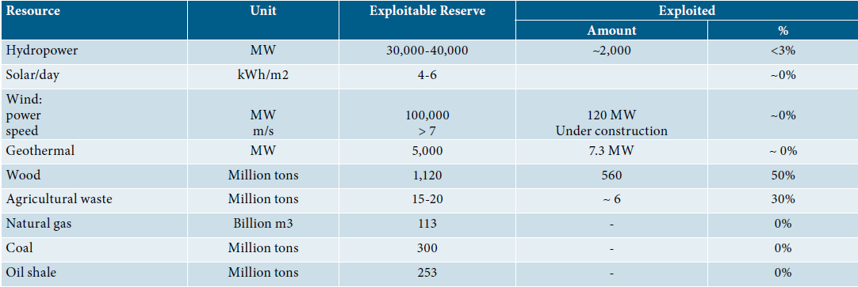

Hydroelectric projects of Ethiopia: implemented and planned

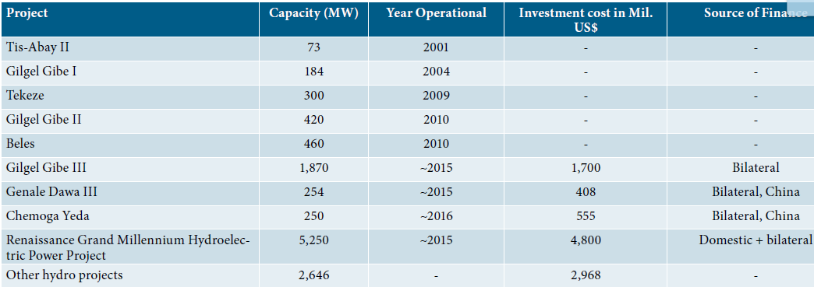

Energy consumption by fuel an d type

Approximately 96 percent of the biomass fuel was consumed by households, 3 percent by services and 1 percent by agriculture.

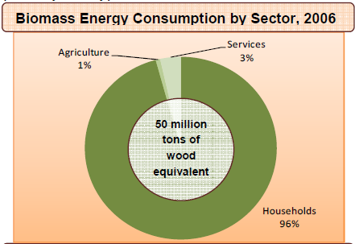

Fig. Biomass energy consumption by sector

Petroleum fuels are mainly used in the transport sector (80 percent of the total consumption of petroleum products) with a smaller share of the demand from the household sector (kerosene for cooking and lighting) and industrial sector (fuel oil for thermal energy).

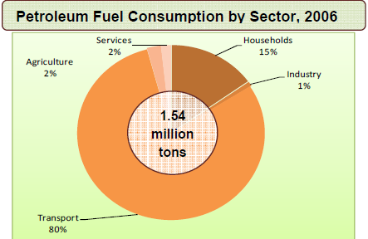

Electricity consumption was about 2,400 GWh. Electricity demand among the sectors is as follows: 33 percent by households, 40 percent by industries and 26 percent by service sector.

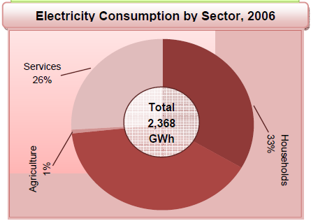

The energy sector is also characterized by the predominance of the household sector, which in 2006 accounted for 89 percent of total final energy consumption (74 percent by rural and 15 percent by urban households).

Trends in energy supply and consumption, 1996 and 2006 (G.C.)

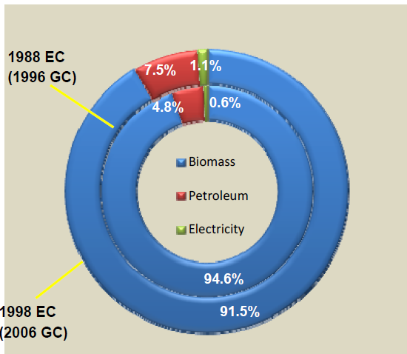

The reduction in kerosene and electricity users for cooking is accompanied by an increase in the number of households cooking with fuel-wood and charcoal. This suggests that a large proportion of kerosene and electric users may have shifted to fuelwood and charcoal or moved from using mostly kerosene and electricity for cooking to using mostly fuel-wood and charcoal. Such a shift towards a less convenient and efficient fuel suggests price may have been the main driver.

Projected overall energy demand

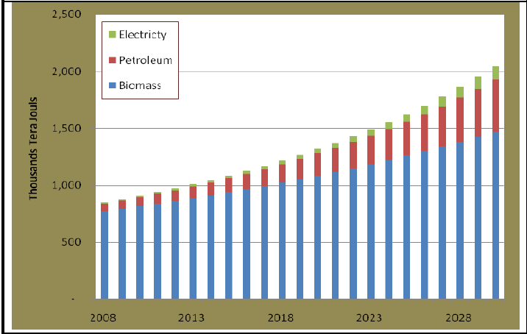

**Fig. Projected energy demand until 2028.**

**Comparison of renewable and non-renewable energy sources**

**Advantages of Renewable Sources:**

1. The sun, wind, geothermal, ocean energy are available in the abundant quantity and free to use.

2. The non-renewable sources of energy that we are using are limited and are bound to expire one day.

3. Renewable sources have low carbon emissions, therefore they are considered as green and environment friendly.

4. Renewable helps in stimulating the economy and creating job opportunities. The money that is used to build these plants can provide jobs to thousands of people.

5. No don’t have to rely on any third country for the supply of renewable sources as in case of non-renewable sources.

6. Renewable sources can cost less than consuming the local electrical supply. In the long run, the prices of electricity are expected to soar since they are based on the prices of crude oil, so renewable sources can cut electricity bills.

7. Various tax incentives in the form of tax waivers, credit deductions are available for individuals and businesses who want to go green.

**Disadvantages of Renewable Sources:**

1. It is not easy to set up a plant as the initial costs are quite steep.

2. Solar energy can be used during the day time and not during night or rainy season.

3. Geothermal energy which can be used to generate electricity has side effects too. It can bring toxic chemicals beneath the earth surface onto the top and can create environmental changes.

4. Hydroelectric provide pure form of energy but building dams across the river which is quite expensive can affect natural flow and affect wildlife.

5. To use wind energy, there is a need to rely on strong winds therefore we have to choose suitable site to operate them. Also, they can affect bird population as they are quite high.

**Advantages of Non Renewable Sources:**

1. It is possible to use small amount of nuclear energy to produce large amount of power.

2. They are considered as cheap when converting from one type of energy to another.

**Disadvantages of Non Renewable Sources:**

1. Non-renewable sources will expire some day and we have to use our endangered resources to create more non-renewable sources of energy.

2. The speed at which such resources are being utilized can have serious environmental changes.

3. Non-renewable sources release toxic gases in the air when burnt which are the major cause for global warming.

4. Since these sources are going to expire soon, prices of these sources are soaring day by day.

3. BIOENERGY RESOURCES

Chapter objectives: At the end of this chapter you should be able to:

* Familiarize yourselves with the concept of bioenergy
* Familiarize yourselves with various types of bioenergy resources
* Identify and select appropriate feedstock for bioenergy development
* Familiarize yourselves with various types and characteristics of biofuel plants
* Familiarize yourselves with bio-oil production process

**Bioenergy** is renewable energy made available from materials derived from biological sources.

Bioenergy is becoming an increasingly attractive energy choice because of high or volatile fossil fuel prices, concerns about national energy independence, the impacts of conventional energy use on the environ­ment, and global climate change. More production and use of bioenergy can improve environmental quality; provide opportunities for economic growth, often in rural areas; support state energy and environmental goals; and increase domestic energy supplies.

**3.1. What are Biomass Feedstocks?**

A feedstock is a material used as the basis for manu­facture of another product. Biomass feedstocks are sources of organic matter that are used as key inputs in production processes to create bioenergy. Eg. Cow dung is feed stock for biogas production.

Both agricul­tural/energy crops and waste/opportunity fuels can be used as biomass feedstocks.

**Cell**u**lo**s**i**c F**eed**st**o**c**k**s

Cellulosic feedstocks contain fiber, or cellulose, which is the main constituent of plant cell walls that is broken down into sugars or other intermediate products that can be converted to bioenergy.

Cellulosic feedstocks include opportunity fuels (e.g., wood waste, crop residues) and energy crops (e.g., switchgrass). In using cellulosic feedstocks, the fiber, or cellulose, is broken down into sugars or other intermediate products that can be converted to bioenergy. Using cellulosic feedstocks such as wood waste and municipal solid waste for ethanol or other biofuel production or bioproducts development could reduce the waste stream.

**3.1.1. Wood waste**. Wood waste includes mill residues from primary timber processing at sawmills, paper manu­facturing, saw dust and secondary wood products industries such as furniture makers. It also includes construction wood waste, yard waste, urban tree residue, and dis­carded consumer wood products that would otherwise be sent to landfills.

[**Biomass Pelletization Process**](http://www.bioenergyconsult.com/biomass-pelletization/)

Is a standard method for the production of high density, solid energy carriers from biomass.

Pellets: popular type of biomass fuel with a small, rounded compressed mass of biomass.

Biomass pellets are a popular type of biomass fuel, generally made from wood wastes, agricultural biomass, commercial grasses and forestry residues. In addition to savings in transportation and storage, pelletization of biomass facilitates easy and cost effective handling. Dense cubes pellets have the flowability characteristics similar to those of cereal grains. High density of pellets also permits compact storage and rational transport over long distance. Pellets are extremely dense and can be produced with a low moisture content that allows them to be burned with very high combustion efficiency.



Pellets are manufactured in several types and grades as fuels for electric power plants, homes, and other applications.

**3.2.2. Animal manure**

Anaerobic digestion technology is a powerful tool for managing organic farm waste, particularly cow, swine and chicken manure.

Methanotrophes produce CO2 and Ch4.

* Reduces waste volume,
* Reduces odor,
* Yields energy in the form of methane, or biogas
* Supplemental biofertilizer.

**3.3.3. Crop residues** Planted crops like corn, wheat, soybeans, cotton, sorghum, barley, oats, and rice leave residues like Husk, corn cobs following the harvest of many traditional agricultural crops, resi­dues such as crop stalks, leaves, cobs, and straw are left in the field. Some of these residues could be collected and used as bioenergy feedstocks.

**3.3.4. Organic waste/Opportunity Fuels**

Biomass feedstocks from waste materials are often referred to as *“*opportunity” fuels because they would otherwise go unused or be disposed of; bioenergy production is an opportunity to use these materials productively. Common opportunity fuels include:

***Wastewater treatment plants (WWTPs)***. Anaerobic digesters can be used during treatment of wastewater to break down effluent and release biogas, which can then be collected for subsequent use as a source of bioenergy.

***Landfills***. As the organic waste buried in landfills decomposes, a gas mixture of carbon dioxide (CO2) and methane (CH4) is produced. Gas recovery systems can be used to collect landfill emissions, providing usable biogas for electricity generation, direct use to offset fossil fuels, upgrade to pipe­line quality gas, or use in the production of liquid fuels.

**Food processing wastes**. Food processing wastes, kitchen refuse include nut shells, rice hulls, fruit pits (any type), cotton trash, meat processing residues, and cheese whey. Many anaero­bic digester operators are currently adding agricultural and food wastes to their digesters to provide enhanced waste management and increased biogas generation.

**Municipal solid waste**. Municipal solid waste (MSW)—trash or garbage—can be collected at land­fills, dried, and burned in high-temperature boilers to generate steam and electricity. Mass burn incineration is the typical method used to recover energy from MSW, which is introduced “as is” into the combus­tion chamber; pollution controls are used to limit emissions into the air.

**3.2. Biofuel plants/Energy crops**

These are specifically grown for the purpose of energy production.

The major crops for biodiesel feedstock are Jatropha, sugar cane and oil crops.

**3.2.1. Jatropha**

Botanical description

Jatropha is a tall bush/ shrub or small tree that can grow up to 6 meters tall, belonging to the Euphorbiaceae family. Its lifespan is in the range of 50 years. The tree is a deciduous wood type with leaves falling off under conditions of stress. It takes three to five years before jatropha produces yields, but after that harvesting is possible every six to twelve months.

**Ecology**

Seeds from fruits that are left on the ground surrounding the mother plant seldom germinate and develop. The fruit and seeds are poisonous and not eaten or collected by animals, Jatropha, therefore, is not naturally dispersed.

Jatropha is a resilient perennial plant that can adapt to many ecological conditions. Its survival mechanism enables it to withstand periods of stress (cold weather/ severe drought/ low radiation). It grows under (sub) tropical conditions and can withstand conditions of severe drought and low soil fertility. It is able to retrieve the nutrients from its leaves and store them in the plant stem and root system. The leaves then turn yellow and are subsequently shed by the plant. The stem remains green and photosynthetically active. In this dormant state the plant can survive periods of more than a year without rain. Jatropha is said to be resistant to diseases and pests.

It is a plant that produces seeds with high oil content. The seeds are toxic and in principle non edible. It is capable of growing in marginal soil, it can also help to reclaim problematic lands and restore eroded areas. As it is not a food or forage crop, it plays an important role in deterring cattle, and thereby protects other valuable food or cash crops.

Current interest by investors, farmers and NGOs in jatropha is mainly due to its potential as an energy crop. Jatropha seeds can be pressed into bio-oil that has good characteristics for direct combustion in compressed ignition engines or for the production of biodiesel. The bio-oil can also be the basis for soap making. The pressed residue of the seeds (presscake) is a good fertilizer and can also be used for biogas production.

**Jatropha and local development**

Jatropha can be integrated into traditional farming systems in developing countries. It can be planted as a living fence around agricultural fields or on marginal soils to control erosion. When the presscake is returned to the fields there is a sustainable recycling of nutrients and the soil remains productive. The production of seeds and processing into biofuel provide extra job opportunities. Jatropha biofuel can be used for transport and can give local communities energy independence. Any excess biofuel that is produced can be sold. The oil can also be used for soap production, providing a profitable rural activity. Jatropha production should only take place when there is sufficient land for local food production. Intercropping jatropha with food crops is also a good option; the extra investments in agriculture will increase food production as well.

Cultivation of the plant started only recently, as it had little relevance to human or animal consumption until the development of biofuels. Jatropha seeds have a high oil content, but they are poisonous to people and animals. Estimates of the productivity of jatropha vary greatly and are based on a limited number of actual field experiences. The jatropha seeds have to be harvested manually and can be stored for months after drying.

They can later be pressed anywhere in the world. The fact that the seeds can be stored makes it an interesting smallholder crop.

**Mechanical oil extraction**

There are different ways to extract oil from oilseeds. One way is mechanical expression using a machine to exert pressure on the oilseeds in order to remove the oil. A second method for oil removal is solvent extraction, where a solvent is added to pre- crushed seeds in which the oil dissolves. The oil can later be recovered from the solvent. In industrial oil mills, theses two processes, Mechanical expression and solvent extraction are often combined to obtain the highest yields.

 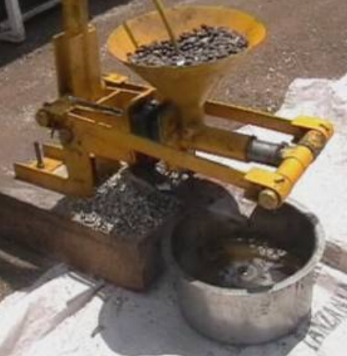

Fig. Ram press

**Applications**

Different applications of jatropha oil require different levels of quality.

Jatropha oil has a range of uses which includes uses as liquid fuel, for soap production and biocides (insecticide, fungicide and nematicide). The oil can be directly used in older diesel engines or new big motors running at constant speed (e.g. pumps, generator), blending with fossil diesel and/or other fossil fuels. The oil can also be transesterified into Jatropha biodiesel that can be used in fossil diesel engines or diesel engines with adapted parameters. About 30% of the seed weight is pure plant oil.

In most cases jatropha oil will be used for one of these three applications:

. Soap- making: The pure (untreated) oil can be used as fuel or for soap production.

. Lamps and stoves: For lamps and stoves, the conventional fuels in most rural areas are fuel wood, charcoal and petroleum. By introducing alternatives like plant oils such as jatropha oil for cooking and lighting, the use of conventional fuels could be strongly reduced.

Designs of stoves using the jatropha seed are based on three different methods.

1. UB-16 stove uses the solid jatropha seed kernels as fuel -directly fired with jatropha seeds,

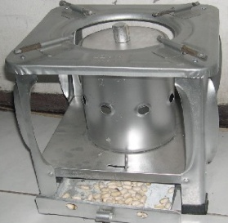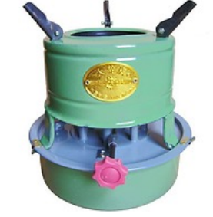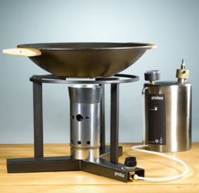

UB -16 Wheel Brand Protos plant oil stove

1. Wheel brand stove uses the jatropha oil in modified kerosene stoves with a wick.
2. Protos plant oil stove: utilizes the jatropha oil, vaporized and sprayed under pressure into a specially designed stove.

. Diesel engines: oil should comply with some standards to minimize the chance of engine damage.

3.2.2. Sugarcane

Sugarcane, a complex hybrid of *Saccharum* spp., is a tropical perennial grass most often grown for the production of sugar and molasses; however, the sugars extracted from sugarcane can be easily fermented to produce ethanol that is known as *first-generation ethanol*.  
Sugarcane byproducts (i.e., *bagasse*, which is biomass remaining after the juice is extracted from the stalks) can be used to produce cellulosic ethanol, known as *second-generation ethanol*.

Sugar cane can be grown on various types of soils. It requires fertilizers with a high level of nitrogen and potassium, but a rather low level of phosphate. To become ethanol, sugarcane needs to be processed within forty-eight hours after harvesting, otherwise, energy yields start to decrease significantly. Sugarcane is also a voluminous crop increasing transport costs. For these reasons, sugarcane should be produced in the vicinity of the ethanol plant. The optimal scale for a competitive sugarcane-ethanol plant is between one and two million tones of raw cane per year.

**Bagasse** is the fibrous matter that remains after [sugarcane](http://en.wikipedia.org/wiki/Sugarcane) or [sorghum](http://en.wikipedia.org/wiki/Sorghum) stalks are crushed to extract their juice. It is used as a [biofuel](http://en.wikipedia.org/wiki/Biofuel) and in the manufacture of [pulp](http://en.wikipedia.org/wiki/Pulp_%28paper%29) and building materials. A sugar mill that is used for crushing the raw sugarcane stalks produces considerable volumes of a pulp rest product called bagasse. This bagasse is often used in combustion furnaces in the plant to produce heat.

For each 10 tonnes of sugarcane crushed, a sugar factory produces nearly 3 tonnes of wet bagasse. Since bagasse is a by-product of the cane sugar industry, the quantity of production in each country is in line with the quantity of sugarcane produced.

Molasses is the dark, sweet, syrupy byproduct made during the extraction of sugars from [sugarcane](http://latinfood.about.com/od/glossarypronunciation/g/sugarcanedef.htm). Molasses can vary in color, sweetness, and nutritional content depending on the variety or how much sugar has been extracted.

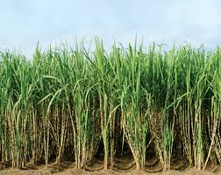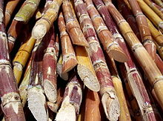

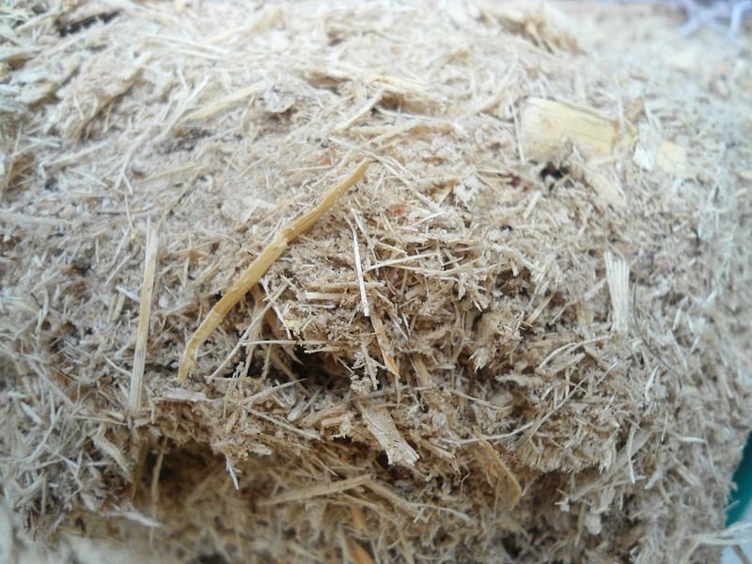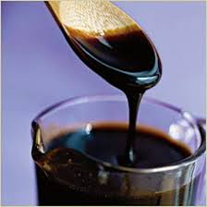

Sugarcane ethanol is an alcohol-based fuel produced by the fermentation of sugarcane juice and molasses. Because it is a clean, affordable and low-carbon biofuel, sugarcane ethanol has emerged as a leading renewable fuel for the transportation sector. Ethanol can be used two ways:

* **Blended with gasoline** at levels ranging from 5 to 25 percent to reduce petroleum use, boost octane ratings and cut tailpipe emissions
* **Pure ethanol** – a fuel made up of 85 to 100 percent ethanol depending on country specifications – can be used in specially designed engines

**Production of ethanol**

Ethanol is manufactured by production of biomass materials through fermentation. The production process consists of three main stages:

* Conversion of biomass to fermentable sugars
* Fermentation of sugars to ethanol
* Separation and purification of the ethanol

**Production process**

* The basic steps for large-scale production of ethanol are: microbial ([yeast](http://en.wikipedia.org/wiki/Yeast)) [fermentation](http://en.wikipedia.org/wiki/Fermentation_%28biochemistry%29) of sugars and [distillation](http://en.wikipedia.org/wiki/Distillation). Prior to fermentation, some crops require [saccharification](http://en.wikipedia.org/wiki/Saccharification) or [hydrolysis](http://en.wikipedia.org/wiki/Hydrolysis) of carbohydrates such as cellulose and starch into sugars.

**Fermentation**

* Ethanol is produced by [microbial fermentation](http://en.wikipedia.org/wiki/Microbial_fermentation) of the sugar. Microbial fermentation currently only works directly with [sugars](http://en.wikipedia.org/wiki/Sugar). Two major components of plants, [starch](http://en.wikipedia.org/wiki/Starch) and cellulose, are both made of sugars—and can, in principle, be converted to sugars for fermentation.

**Distillation**

* For the ethanol to be usable as a fuel, the majority of the water must be removed. Most of the water is removed by [distillation](http://en.wikipedia.org/wiki/Distillation).

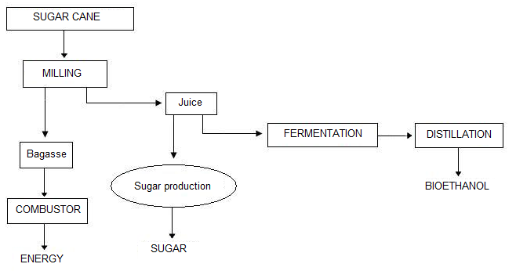

Fig. Flow diagram – ethanol production from Sugarcane

**Benefits of Ethanol**

* **Cleaner Air.**Ethanol adds oxygen to gasoline which helps reduce air pollution and harmful emissions in tailpipe exhaust.
* [**Reduced Greenhouse Gas Emissions**](http://sugarcane.org/sugarcane-benefits/greenhouse-gas-reductions/greenhouse-gas-reductions). Compared to gasoline, sugarcane ethanol cuts carbon dioxide emissions by 90 percent on average. That’s better than any other liquid biofuel produced today at commercial scale.
* **Better Performance.** Ethanol is a high-octane fuel that helps prevent engine knocking and generates more power in higher compression engines.
* **Lower Petroleum Usage.** Ethanol reduces global dependence on oil. Sugarcane ethanol is one more good option for [diversifying energy supplies](http://sugarcane.org/sugarcane-benefits/diversification-of-energy-sources).
* Bio-ethanol is usually obtained from the conversion of carbon-based [feedstock](http://en.wikipedia.org/wiki/Feedstock). Agricultural feedstocks are considered renewable because they get energy from the sun using photosynthesis, provided that all minerals required for growth (such as nitrogen and phosphorus) are returned to the land.

A typical constraint for sugar cane production is availability of water. The climatic conditions ideal for sugar cane production are plentiful precipitation that eliminates the need for irrigation. Summarizing feedstock characteristics

Table : Summarizing yields and necessary inputs of biofuel feedstock

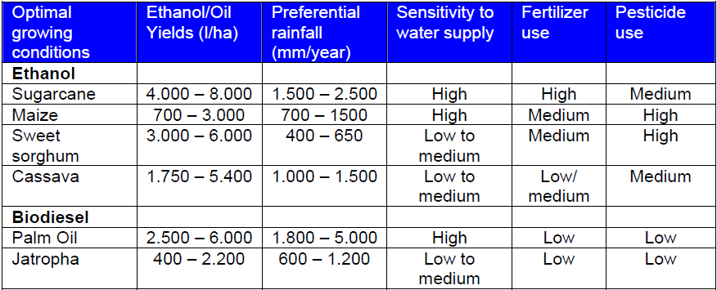

3.2.3. Oil crops

**OIL-BEARING CROPS OR OIL CROPS** include both annual (usually called oilseeds) and perennial plants whose seeds, fruits or mesocarp and nuts are valued mainly for the edible or industrial oils that are extracted from them.

**Castor Bean:** Castor bean (*Ricinus communis*) is belongs to Euphorbiaceae family, common to all the warm regions of the world. It is a fast growing fibrous nonwood plant native to eastern Africa, especially the Ethiopian area. Castor bean is grown as an annual in temperate zones and as a perennial in the tropics. This crop is cultivated for its seeds, which contain up to 45% of a fast-drying natural oil rich in ricinoleic acid used mainly in medicines industry.

Biodiesel obtained from castor oil has a lower cost compared to the ones obtained from other oils due to its solvability in alcohol transesterification occurs without heating. The biodiesel produced from castor bean also satisfies the relevant quality standards.

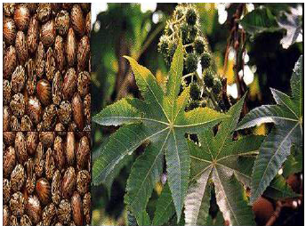

Fig. Castor been seeds

**Soybean**

It is a legume originating in East Asia. Depending on environmental conditions and genetic varieties, the plants show wide variations in height. Soy biodiesel is a clean-burning, non-toxic renewable fuel made from soybean oil. Soy biodiesel can be used in any diesel engine without modification. Biodiesel fuel made from soybeans reduces greenhouse gases and particulate emissions and helps to lessen dependence on imported petroleum. Soy biodiesel is creating new opportunities for soybean producers to market their energy crop.

Biodiesel production form soybean yields other valuable sub-products in  
addition to glycerin: soybean meal and pellets (used as food for livestock) and  
flour (which have a high content of lecithin, a protein). Grain yield varies between  
2,000 and 4,000 kg/hectare. Since the seeds are very rich in protein, oil content is  
around 18%.

**Biodiesel Production Process**

Biodiesel is produced from vegetable oils or animal fats and an alcohol, through a transesterification reaction. This chemical reaction converts an ester (vegetable oil or animal fat) into a mixture of esters of the fatty acids that makes up the oil (or fat). Biodiesel is obtained from the purification of the mixture of fatty acid methyl esters (FAME). A catalyst is used to accelerate the reaction.

The generic transesterification reaction is

****

Where, RCOORʹ indicates an ester, RʺOH an alcohol, RʹOH another alcohol (glycerol), RCOORʺ an ester mixture

**Advantages of the Use of Biodiesel**

Some of the advantages of using biodiesel as a replacement for diesel fuel are

• Renewable fuel, obtained from vegetable oils or animal fats.

• Low toxicity, in comparison with diesel fuel.

• Degrades more rapidly than diesel fuel, minimizing the environmental consequences of biofuel spills.

• Lower emissions of contaminants: carbon monoxide, particulate matter, polycyclic aromatic hydrocarbons, aldehydes.

• Lower health risk, due to reduced emissions of carcinogenic substances.

• No sulfur dioxide (SO2) emissions.

* May be blended with diesel fuel at any proportion; both fuels may be mixed during the fuel supply to vehicles.

• It is the only alternative fuel that can be used in a conventional diesel engine, without modifications.

• Used cooking oils and fat residues from meat processing may be used as raw materials.

**Disadvantages of the Use of Biodiesel**

There are certain disadvantages of using biodiesel as a replacement for diesel fuel that must be taken into consideration:

• Slightly higher fuel consumption due to the lower calorific value of biodiesel.

• Slightly higher nitrous oxide (NOx) emissions than diesel fuel.

• Higher freezing point than diesel fuel. This may be inconvenient in cold climates.

• It is less stable than diesel fuel, and therefore long-term storage (more than six months) of biodiesel is not recommended.

**4. Production and management of Biofuel plants**

Chapter objectives: At the end of this chapter you should be able to:

* Familiarize yourself with energy criteria for species selection: oil yield, oil/gas density, calorific values
* Understand the criteria for species selection and site matching
* Come up with the idea how to achieve sustainable biofuel production

**4.1. Energy criteria for species selection**

The quality of the oil is very important in order to guarantee the correct operation of the vehicles, in particular the injectors, piston rings and lubrication oil stability.

Vegetable oils have a higher density than diesel on an average of 12%, but lower energy content with a calorific value around 10% inferior.

**Cetane number** is a measure of the ignition quality of a diesel fuel, i.e. the fuel's readiness to ignite. Fuels with a high Cetane number will have short ignition delays which correspond to greater efficiency; contrarily engines started with a low Cetane number fuel may suffer from engine knock and blow white clouds of smoke during engine ignition in severely cold weather. The Cetane number for most plant oils, it is around 10–20% lower than that of fossil diesel.

**Kinematic viscosity** and **density** are important characteristics to consider because they affect the fuel spray characteristics through flow resistance inside the injection system and in the nozzle holes. High viscosity causes poor fuel atomization during the spraying process, which in turn increases the engine coke deposits, demands more energy in order to pump the fuel and wears fuel pump elements and injectors. For plant oils viscosity is higher and volatility lower than for fossil diesel.

**Flash point temperature** is the lowest temperature at which the vapour of a combustible liquid can be ignited in air. The flash point of vegetable oils is much higher than that of diesel. This makes its ignition relatively difficult, but its transportation and handling is much safer. The **Pour Point** of a liquid is the lowest temperature at which it will pour or flow under prescribed conditions. Plant oils show a higher flash point temperature and lower pour point temperature in respect to fossil diesel.

**Site selection**

Biofuel crops are highly adaptable to different ecological conditions. They are well adapted to arid and semi-arid conditions. Most crops can grow easily on marginal lands

**Propagation and plantation establishment of Jatropha**

*Jatropha* can be propagated by generative (direct seeding) and vegetative (cuttings) methods. The crop show high initial establishment success and survival. For quick establishment of living fences, erosion control and the achievement of early seed yields direct planting of cuttings can be used. In agro-forestry and intercropping systems direct seeding should be favored over pre-cultivated *Jatropha* plants, as the taproot of directly seeded plants is believed to penetrate in deeper soil layers. In the nursery, seeds have to sown in a soil with a high concentration of organic material three months before the rainy season. Pre-soaking in cow-dung slurry or cold water also enhance germination. Plantation of *Jatropha* can be monoculture, intercropping or as a live-fence. The main reason behind intercropping is to generate extra income during the first years of plantation. Intercropping is also for weed control, shading, supply of organic matter and the availability of nutrients from deeper soils. Depending on the climate various crops are used for intercropping. Spacing of seeds has major impact on yield and soil properties.

For oil production plantations the field preparation mainly consists of land clearing and preparation of the planting pits for the pre-cultivated plants. For oil production purposes it is advisable to clear the land at least partially although it is possible without any clearing. The possibilities also include ploughing the field

**Management practices** The *Jatropha* yield can be increased by several management and cultivation activities such as pruning, fertilizer application and irrigation. Pruning is used to increase the number of branches, flowers and thus fruits. Pruning in the dry or winter period after the trees have shed their leaves will result in a lower and wider tree shape, stimulate earlier seed yield and facilitate manual harvesting. The entire plant has to be cut low once every 10 years by leaving a stump of 45 cm to induce new growth and stabilize the yield.

**Seed yield**

There is considerable effort for the development of technology to optimize production. As  
*Jatropha* is still a wild plant, careful selection and improvement of suitable germplasm is necessary before mass-production can be realized. The yield is depend on site characteristics (rainfall, soil type and soil fertility) genetics and management (propagation method, spacing, pruning, fertilizing, irrigation, *etc*.) *Jatropha* exhibits great variability in productivity between individual plants and decline in productivity has been reported as plantations age.

**4.2. Achievement of sustainable biofuel production**

[Biofuels](http://en.wikipedia.org/wiki/Biofuels), in the form of [liquid fuels](http://en.wikipedia.org/wiki/Liquid_fuels) derived from plant materials, are entering the market, driven by factors such as [oil price spikes](http://en.wikipedia.org/wiki/Oil_price_increases_since_2003) and the need for increased [energy security](http://en.wikipedia.org/wiki/Energy_security). However, many of the biofuels that are currently being supplied have been criticised for their adverse impacts on the [natural environment](http://en.wikipedia.org/wiki/Natural_environment), [food security](http://en.wikipedia.org/wiki/Food_security), and [land use](http://en.wikipedia.org/wiki/Land_use).

The challenge is to support biofuel development, including the development of new [cellulosic technologies](http://en.wikipedia.org/wiki/Cellulosic_ethanol), with responsible policies and economic instruments to help ensure that biofuel commercialization is [sustainable](http://en.wikipedia.org/wiki/Sustainable). Responsible commercialization of biofuels represents an opportunity to enhance sustainable economic prospects.

Biofuels have a limited ability to replace fossil fuels and should not be regarded as a ‘silver bullet’ to deal with transport emissions. However, they offer the prospect of increased market competition and oil price moderation. A healthy supply of [alternative energy](http://en.wikipedia.org/wiki/Alternative_energy) sources will help to combat gasoline price spikes and reduce dependency on [fossil fuels](http://en.wikipedia.org/wiki/Fossil_fuel), especially in the transport sector. Using transportation fuels more efficiently is also an integral part of a [sustainable transport](http://en.wikipedia.org/wiki/Sustainable_transport) strategy.

**5. Bioenergy Technologies**

Chapter objectives: At the end of this chapter you should be able to:

* Understand various bioenergy conversion technologies
* Understand the processes in the conversion process
* Analyse the linkage between waste, energy and environment

Introduction

Today the dominant biomass conversion technology consists of the direct combustion of biomass as fuel wood, charcoal, agricultural, forest and process resides. Such combustion mechanism has poor environmental consideration and low efficiency, which is associated with negative consequences.

There are a variety of technologies for generating modern energy services such as electricity, gas, and liquid fuels from biomass. The different technologies tend to be classified in terms of either the conversion process they use or the end product produced.

* + 1. **Combustion**

Biomass power technologies convert renewable biomass fuels to heat and electricity using processes similar to those employed with fossil fuels. Combustion systems for electricity and heat production are similar to most fossil-fuel fired power plants. The biomass fuel is burned in a boiler to produce high-pressure steam. This steam is introduced into a steam turbine, where it flows over a series of turbine blades, causing the turbine to rotate. The turbine is connected to an electric generator. The steam flows over and turns the turbine where the generator finally rotates to produce electricity.

* + 1. **Gasification**

Combustible gas can be produced from biomass through a high temperature thermochemical process. Biomass gasification means incomplete combustion of biomass resulting in production of combustible gases consisting of Carbon monoxide (CO), Hydrogen (H2) and traces of Methane (CH4). This mixture is called producer gas. Producer gas can be used to run internal combustion engines, used as substitute for furnace oil in direct heat applications and can be used to produce, in an economically viable way, methanol – an extremely attractive chemical which is useful both as fuel for heat engines as well as chemical feedstock for industries (Rajvanshi and Jorapur, 1997). The gas also can either be combusted in a steam or other power cycle, or can instead be combusted in place of fossil fuels in drying or other industrial processes requiring a heat source.

* + 1. **Pyrolysis**

Pyrolysis is a thermo-chemical decomposition process in which organic material is converted and results in the production of charcoal (solid), bio-oil (liquid), and fuel gas products in the absence of oxygen (Demirbas and Arin, 2002). In pyrolysis systems, biomass is heated up to a temperature of 400-600°C to vaporize a portion of the material, leaving a char behind. Bio-oil is produced by condensing part of the gases formed by the process. Generally it is the large, carbon based molecules that will condense. Further it has been found that these molecules will tend to break down to smaller non-condensable molecules if they are maintained at high temperature (Talib and Ford, 1982).

**Biogas - Anaerobic Digestion**

Anaerobic biodegradation of organic material proceeds in the absence of oxygen and the presence of anaerobic microorganisms. AD is the consequence of a series of metabolic interactions among various groups of microorganisms. Biogas is the common name for the gas produced either in specifically designed anaerobic digesters or in landfills by capturing the naturally produced methane. Biogas is typically about 60 percent methane and 40 percent carbon dioxide.

**Overview of the anaerobic digestion process**

Combustible gas can be produced from biomass through low temperature biological processes called anaerobic (without air) digestion. There are four stages in the conversion process.

**Hydrolysis**

The hydrolysis step breaks down complex organic maters such as carbohydrates, proteins and lipids in to soluble organic molecules such as sugars, aminoacisd and fatty acids by extracellular enzymes. This stage is also known as polymer breakdown stage. For example, the cellulose consisting of polymerized glucose is broken down to dimeric, and then to monomeric sugar molecules (glucose) by cellulolytic bacteria. The hydrolyzed substrates become available for cell transport and can be degraded easily by fermentative bacteria in the following acidogenesis stage.

C6H10O4 + 2H20 → C6H12O6 +2H2

**Acidogenesis**

Acid forming bacteria convert soluble organics to carboxylic groups. In a stable anaerobic digester, the main degradation path way results in acetate, carbon dioxide and hydrogen. Intermediates like VFAs and alcohols are also produced in this step. In some cases acid may be produced in such large quantities that lower the pH to a level where all biological activity is detained. Carboxylic acids, such as propionate and butyrate are generated in this process. This initil acid phase of digestion may last about two weeks and during this period a large amount of carbon dioxide is given off.

C6H12O6 + 2 H2O → 2 CH3COOH + 2 CO2 + 4 H2

(Acetic acid)

C6H12O6→ CH3CH2CH2COOH + 2 CO2 + 2 H2

(Butyric acid)

C6H12O6 + 2H2 → 2 CH3CH2COOH + 2 H2O

(Propionic acid)

**Acetogenesis**

Acetogenesis occurs through carbohydrate fermentation, through which acetate is the main product. In this stage, products from the previous phases are transformed into hydrogen, carbon dioxide and acetic acid via acetogenic activities. Acetogens are the vital link between hydrolysis, acidogenesis and the methanogenesis in anaerobic digestion. Acetogenesis provides the two main substrates for the last step in the methanogenic conversion of organic material, hydrogen and acetate. Both the acidogenesis and acetogenesis produce the methanogenic substrates, acetate, H2 and CO2.

Both the acidogenesis and acetogenesis steps can be collectively called acid forming stages.

**Methanogenesis**

In methanogenesis step, acetate and H2/CO2 are converted to CH4 and CO2 with trace quantities of other gases (hydrogen sulphides, ammonia, nitrogen, mercaptans and amines) by methanogenic archaea). In this step, methane is produced by methanogens in two ways: either by cleavage of acetic acid molecules to carbon dioxide and methane, or by reduction of CO2 with hydrogen.

CH3COOH → CH4 + CO2

(Methane)

2 H2 + CO2 → CH4 + 2 H2O

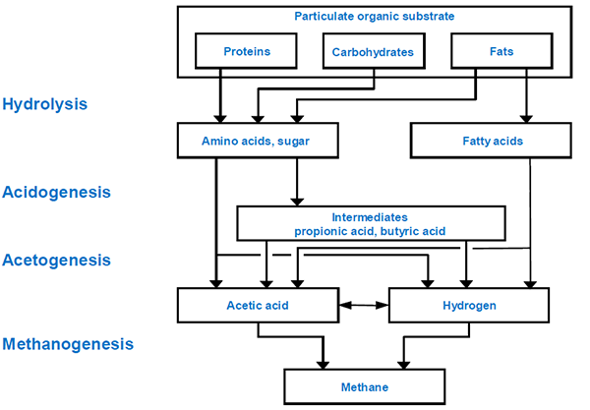

**Stages of methane fermentation process**

**Carbonization** (or **carbonisation**) is the term for the conversion of an [organic substance](http://en.wikipedia.org/wiki/Organic_substance) into [carbon](http://en.wikipedia.org/wiki/Carbon) or a carbon-containing residue through [pyrolysis](http://en.wikipedia.org/wiki/Pyrolysis) or [destructive distillation](http://en.wikipedia.org/wiki/Destructive_distillation). It is often used in [organic chemistry](http://en.wikipedia.org/wiki/Organic_chemistry) with reference to the generation of [coal gas](http://en.wikipedia.org/wiki/Coal_gas) and [coal tar](http://en.wikipedia.org/wiki/Coal_tar) from raw [coal](http://en.wikipedia.org/wiki/Coal). Fossil fuels generally are the products of the carbonization of vegetable matter. The term carbonization is also applied to the pyrolysis of coal to produce [coke](http://en.wikipedia.org/wiki/Coke_%28fuel%29). Carbonization is also a stage in the charcoal making process, and is considered the most important step of all since it has such power to influence the whole process from the growing tree to the final distribution of charcoal to various sources.

The carbonization stage may be decisive in charcoal production even though it is not the most expensive one. Unless it is carried out as efficiently as possible, it puts the whole operation of charcoal production at risk since low yields in carbonisation reflect back through the whole chain of production as increased costs and waste of resources.

Wood consists of three main components: cellulose, lignin and water. The cellulose and lignin and some other materials are tightly bound together and make up the material we call wood. The water is adsorbed or held as molecules of water on the cellulose/lignin structure. Air dry or "seasoned" wood still contains 12-18% of adsorbed water. Growing, freshly cut or "unseasoned" wood contains, in addition, liquid water to give a total water content of about 40 to 100% expressed as a percentage of the oven dry weight of the wood.

The water in the wood has all to be driven off as vapour before carbonization can take place. To evaporate water requires a lot of energy so that using the sun to pre-dry the wood as much as possible before carbonization greatly improves efficiency. The water remaining in the wood to be carbonised, must be evaporated in the kiln or pit and this energy must be provided by burning some of the wood itself which otherwise would be converted into useful charcoal.

The first step in carbonization in the kiln is drying out of the wood at 100°C or below to zero moisture content. The temperature of the oven dry wood is then raised to about 280°C. The energy for these steps comes from partial combustion of some of the wood charged to the kiln or pit and it is an energy absorbing or endothermic reaction.

When the wood is dry and heated to around 280°C, it begins to spontaneously break down to produce charcoal plus water vapour, methanol, acetic acid and more complex chemicals, chiefly in the form of tars and non-condensible gas consisting mainly of hydrogen, carbon monoxide and carbon dioxide. Air is admitted to the carbonising kiln or pit to allow some wood to be burned and the nitrogen from this air will also be present in the gas. The oxygen of the air is used up in burning part of the wood charged.

The spontaneous breakdown or carbonization of the wood above a temperature of 280°C liberates energy and hence this reaction is said to be exothermic. This process of spontaneous breakdown or carbonization continues until only the carbonised residue called charcoal remains. Unless further external heat is provided, the process stops and the temperature reaches a maximum of about 400°C. This charcoal, however, will still contain appreciable amounts of tarry residue, together with the ash of the original wood. The ash content of the charcoal is about 3-5%; the tarry residue may amount to about 30% by weight and the balance is fixed carbon about 65-70%. Further heating increases the fixed carbon content by driving off and decomposing more of the tars. A temperature of 500°C gives a typical fixed carbon content of about 85% and a volatile content of about 10%. The yield of charcoal at this temperature is about 33% of the weight of the oven dry wood carbonised - not counting the wood which was burned to carbonise the remainder. Thus the theoretical yield of charcoal varies with temperature of carbonization due to the change in its content of volatile tarry material.

**Gasification** is a process that converts [organic](http://en.wikipedia.org/wiki/Biomass) or [fossil fuel](http://en.wikipedia.org/wiki/Fossil_fuel) based [carbonaceous](http://en.wikipedia.org/wiki/Carbonaceous) materials into [carbon monoxide](http://en.wikipedia.org/wiki/Carbon_monoxide), [hydrogen](http://en.wikipedia.org/wiki/Hydrogen) and [carbon dioxide](http://en.wikipedia.org/wiki/Carbon_dioxide). This is achieved by reacting the material at high temperatures (>700 °C), without combustion, with a controlled amount of [oxygen](http://en.wikipedia.org/wiki/Oxygen) and/or [steam](http://en.wikipedia.org/wiki/Steam). The resulting gas mixture is called [syngas](http://en.wikipedia.org/wiki/Syngas) (from synthesis gas or synthetic gas) or [producer gas](http://en.wikipedia.org/wiki/Producer_gas) and is itself a fuel. The power derived from gasification and combustion of the resultant gas is considered to be a source of [renewable energy](http://en.wikipedia.org/wiki/Renewable_energy) if the gasified compounds were obtained from biomass.[[1]](http://en.wikipedia.org/wiki/Gasification#cite_note-nnfcc-1)[[2]](http://en.wikipedia.org/wiki/Gasification#cite_note-2)[[3]](http://en.wikipedia.org/wiki/Gasification#cite_note-3)[[4]](http://en.wikipedia.org/wiki/Gasification#cite_note-4)

The advantage of gasification is that using the syngas is potentially more efficient than direct combustion of the original fuel because it can be combusted at higher temperatures or even in [fuel cells](http://en.wikipedia.org/wiki/Fuel_cell), so that the thermodynamic upper limit to the efficiency defined by [Carnot's rule](http://en.wikipedia.org/wiki/Carnot%27s_rule) is higher or not applicable. Syngas may be burned directly in [gas engines](http://en.wikipedia.org/wiki/Internal_combustion_engines), used to produce [methanol](http://en.wikipedia.org/wiki/Methanol) and hydrogen, or converted via the [Fischer–Tropsch process](http://en.wikipedia.org/wiki/Fischer%E2%80%93Tropsch_process) into [synthetic fuel](http://en.wikipedia.org/wiki/Synthetic_fuel). Gasification can also begin with material which would otherwise have been disposed of such as [biodegradable waste](http://en.wikipedia.org/wiki/Organic_waste). In addition, the high-temperature process refines out corrosive ash elements such as [chloride](http://en.wikipedia.org/wiki/Chloride) and [potassium](http://en.wikipedia.org/wiki/Potassium), allowing clean gas production from otherwise problematic fuels. Gasification of fossil fuels is currently widely used on industrial scales to generate electricity

## Chemical reactions

In a gasifier, the carbonaceous material undergoes several different processes:

[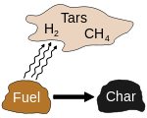](http://en.wikipedia.org/wiki/File:Pyrolysis.svg)

Pyrolysis of carbonaceous fuels

[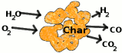](http://en.wikipedia.org/wiki/File:Gasification.gif)

Gasification of char

1. The [dehydration](http://en.wikipedia.org/wiki/Dehydration_reaction) or drying process occurs at around 100 °C. Typically the resulting steam is mixed into the gas flow and may be involved with subsequent chemical reactions, notably the water-gas reaction if the temperature is sufficiently high enough (see step #5).
2. The [*pyrolysis*](http://en.wikipedia.org/wiki/Pyrolysis) (or devolatilization) process occurs at around 200-300 °C. Volatiles are released and [char](http://en.wikipedia.org/wiki/Charring) is produced, resulting in up to 70% weight loss for coal. The process is dependent on the properties of the carbonaceous material and determines the structure and composition of the char, which will then undergo gasification reactions.
3. The [*combustion*](http://en.wikipedia.org/wiki/Combustion) process occurs as the volatile products and some of the char reacts with oxygen to primarily form carbon dioxide and small amounts of carbon monoxide, which provides heat for the subsequent gasification reactions. Letting **C** represent a carbon-containing [organic compound](http://en.wikipedia.org/wiki/Organic_compound), the basic reaction here is {\rm C} + {\rm O}_2 \rarr {\rm CO}_2
4. The *gasification* process occurs as the char reacts with steam to produce carbon monoxide and hydrogen, via the reaction {\rm C} + {\rm H}_2 {\rm O} \rarr {\rm H}_2 + {\rm CO}
5. In addition, the [reversible](http://en.wikipedia.org/wiki/Reversible_reaction) gas phase [water-gas shift reaction](http://en.wikipedia.org/wiki/Water-gas_shift_reaction) reaches [equilibrium](http://en.wikipedia.org/wiki/Chemical_equilibrium) very fast at the temperatures in a gasifier. This balances the concentrations of carbon monoxide, steam, carbon dioxide and hydrogen. {\rm CO} + {\rm H}_2 {\rm O} \lrarr {\rm CO}_2 + {\rm H}_2

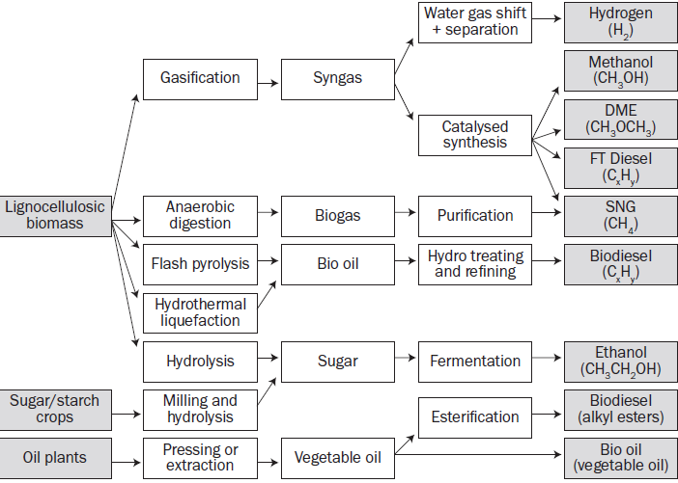

Fig. Biomass Conversion pathways

Chapter six **Renewable energy Resource and its Environmental impact**

Chapter objectives: At the end of this chapter you should be able to:

* Understand the environmental impacts of energy production and consumption
* Comprehend about energy conservation

**Environmental Impacts of Wind Power**

Harnessing power from the wind is one of the cleanest and most sustainable form to generate electricity as it produces no toxic pollution or global warming emissions.

Wind is abundant, inexhaustible, and affordable, which makes it a viable and large-scale alternative to fossil fuels.

Despite its vast potential, there are a variety of environmental impacts associated with wind power generation that should be recognized and mitigated.

**Land Use**

The land use impact of wind power facilities varies substantially depending on the site:

Wind turbines placed in **flat areas** typically use more land than those located in hilly areas. However, wind turbines do not occupy all of this land;

Wind turbines are spaced 5 to 10 rotor diameters apart (a rotor diameter is the diameter of the wind turbine blades).

Thus, the turbines themselves and the surrounding infrastructure (including roads and transmission lines) occupy a small portion of the total area of a wind facility. They use between 30 and 141 acres per megawatt of power output capacity

However, less than 1 acre per megawatt is disturbed permanently and less than 3.5 acres per megawatt are disturbed temporarily during construction.

The remainder of the land can be used for a variety of other productive purposes, including livestock grazing, agriculture, highways, and hiking trails.

Wind facilities can be sited on brownfields (abandoned or underused industrial land) or other commercial and industrial locations, which significantly reduces concerns about land use.

Offshore wind facilities require larger amounts of space because the turbines and blades are bigger than their land-based counterparts.

Depending on their location, such offshore installations may compete with a variety of other ocean activities, such as fishing, recreational activities, sand and gravel extraction, oil and gas extraction, navigation, and aquaculture.

Employing best practices in planning and siting can help minimize potential land use impacts of offshore and land-based wind projects.

### Wildlife and Habitat

A recent review of peer-reviewed research found evidence of bird deaths from collisions with wind turbines and from habitat disruption. The research concluded that these impacts are relatively low and do not pose a threat to species populations.

Offshore wind turbines can have similar impacts on marine birds, but as with onshore wind turbines, the bird deaths associated with offshore wind are minimal.

Wind farms located offshore will also impact fish and other marine wildlife.

### Public Health and Community

Sound and visual impact are the two main public health and community concerns associated with operating wind turbines.

Most of the sound generated by wind turbines is aerodynamic, caused by the movement of turbine blades through the air.

Technological advances, such as minimizing blade surface imperfections and using sound-absorbent materials can reduce wind turbine noise.

When it comes to aesthetics, wind turbines can elicit strong reactions. To some people, they are graceful sculptures; to others, they are eyesores that compromise the natural landscape.

Whether a community is willing to accept an altered skyline in return for cleaner power should be decided in an open public dialogue.

### Water Use

There is no water impact associated with the operation of wind turbines. As in all manufacturing processes, some water is used to manufacture steel and cement for wind turbines.

### Life-Cycle Global Warming Emissions

While there are no global warming emissions associated with operating wind turbines, there are emissions associated with other stages of a wind turbine’s life-cycle, including: materials production, materials transportation, on-site construction and assembly, operation and maintenance, and decommissioning and dismantlement.

Estimates of wind turbine life-cycle global warming emissions are between 0.02 and 0.04 pounds of carbon dioxide equivalent per kilowatt-hour. While natural gas generated electricity are between 0.6 and 2 pounds of CoE per kilowatt-hour, coal-generated electricity are 1.4 and 3.6 pounds of CoE per kilowatt-hour

Geothermal

The most widely developed type of geothermal power plant (known as hydrothermal plants) are located near geologic “hot spots” where hot molten rock is close to the earth’s crust and produces hot water.

Geothermal systems involve drilling into Earth’s surface to reach deeper geothermal resources, can allow broader access to geothermal energy.

Environmental impacts will differ depending on the conversion and cooling technology used.

### Water Quality and Use

Geothermal power plants can have impacts on both water quality and consumption. Hot water pumped from underground reservoirs often contains high levels of sulfur, salt, and other minerals.

Most geothermal facilities have closed-loop water systems, in which extracted water is pumped directly back into the geothermal reservoir after it has been used for heat or electricity production.

Water is also used by geothermal plants for cooling. Depending on the cooling technology used, geothermal plants can require between 1,700 and 4,000 gallons of water per megawatt-hour.

### Air Emissions

Geothermal plants emit hydrogen sulfide, carbon dioxide, ammonia, methane, and boron. Hydrogen sulfide, which has a distinctive “rotten egg” smell, is the most common emission.

Once in the atmosphere, hydrogen sulfide changes into sulfur dioxide (SO2).

* formation of small acidic particulates that can be absorbed by the bloodstream and cause heart and lung disease
* Sulfur dioxide also causes acid rain, which damages crops, forests, and soils, and acidifies lakes and streams.
* However, SO2 emissions from geothermal plants are approximately 30 times lower per megawatt-hour than from coal plants,

### Land Use

Land subsidence, a phenomenon in which the land surface sinks, is sometimes caused by the removal of water from geothermal reservoirs.

Most geothermal facilities address this risk by re-injecting wastewater back into geothermal reservoirs after the water’s heat has been captured.

Hydrothermal plants are sited on geological “hot spots," which tend to have higher levels of earthquake risk. Due to water is pumped at high pressures to fracture underground hot rock reservoirs similar to technology used in natural gas hydraulic fracturing.

Earthquake risk can be minimized by siting plants an appropriate distance away from major fault lines. When a geothermal system is sited near a heavily populated area, constant monitoring and transparent communication with local communities is also necessary.

### Life-Cycle Global Warming Emissions

In open-loop geothermal systems, approximately 10 percent of the air emissions are carbon dioxide, and a smaller amount of emissions are methane, a more potent global warming gas.

Estimates of global warming emissions for open-loop systems are approximately 0.1 pounds of CO2e/KWh.

Hydropower

### Land Use

Hydroelectric plants in flat areas tend to require much more land than those in hilly areas or canyons where deeper reservoirs can hold more volume of water in a smaller space.

Flooding land for a hydroelectric reservoir has an extreme environmental impact: it destroys forest, wildlife habitat, agricultural land, and scenic lands.

In many instances, such as the Three Gorges Dam in China, entire communities have also had to be relocated to make way for reservoirs

### Wildlife Impacts

There can also be wildlife impacts both within the dammed reservoirs and downstream from the facility.

Reservoir water is usually more stagnant than normal river water. The reservoir will have higher than normal amounts of sediments and nutrients, which can cultivate an excess of algae and other aquatic weeds.

These weeds can crowd out other river animal and plant-life, and they must be controlled through manual harvesting or by introducing fish that eat these plants.

Water is lost through evaporation in dammed reservoirs at a much higher rate than in flowing rivers. That is humid rate in air increases, air movements change and temperature, raining and wind events differ. The flora and animal living both on land and in water of the region enter into sudden changing and animal species that can adapt themselves in such an environment can survive. The hydrological effects result from flowing regime of stream and changing of physico-chemical parameters. To convert rivers to reservoirs cause vaporizing of water and increasing of quantity of salt and other minerals in water.

If too much water is stored behind the reservoir, segments of the river downstream from the reservoir can dry out.

Thus, most hydroelectric operators are required to release a minimum amount of water at certain times of year. If not released appropriately, water levels downstream will drop and animal and plant life can be harmed.

### Life-cycle Global Warming Emissions

Global warming emissions are produced during the installation and dismantling of hydroelectric power plants. Water is emitted to the atmosphere in the form of vapor.

After the area is flooded, the vegetation and soil in these areas decomposes and releases both carbon dioxide and methane commonly in tropical areas.

Small run-of-the-river plants emit between 0.01 and 0.03 pounds of carbon dioxide equivalent per kilowatt-hour.

Environmental impacts of solar power

The sun provides a tremendous resource for generating clean and sustainable electricity without toxic pollution or global warming emissions.

The potential environmental impacts associated with solar power — land use and habitat loss, water use, and the use of hazardous materials in manufacturing — can vary greatly depending on the technology, which includes two broad categories: photovoltaic (PV) solar cells or concentrating solar thermal plants (CSP).

The scale of the system — ranging from small, distributed rooftop PV arrays to large utility-scale PV and CSP projects — also plays a significant role in the level of environmental impact.

### Land Use

Depending on their location, larger utility-scale solar facilities can raise concerns about land degradation and habitat loss.

Total land area requirements varies depending on the technology, the topography of the site, and the intensity of the solar resource.

Estimates for utility-scale PV systems range from 3.5 to 10 acres per megawatt, while estimates for CSP facilities are between 4 and 16.5 acres per megawatt.

Unlike wind facilities, there is less opportunity for solar projects to share land with agricultural uses. Land impacts from utility-scale solar systems can be minimized by siting them at lower-quality locations such as brownfields, abandoned mining land, or existing transportation and transmission corridors.

Smaller scale solar PV arrays, which can be built on homes or commercial buildings, also have minimal land use impact.

### Water Use

Solar PV cells do not use water for generating electricity. However all manufacturing processes, some water is used to manufacture solar PV components.

CSP plants that use wet-recirculating technology with cooling towers withdraw between 600 and 650 gallons of water per megawatt-hour of electricity produced.

Many of the regions in that have the highest potential for solar energy also tend to be those with the driest climates, so careful consideration of these water tradeoffs is essential.

### Hazardous Materials

The PV cell manufacturing process includes a number of hazardous materials, most of which are used to clean and purify the semiconductor surface.

These chemicals, similar to those used in the general semiconductor industry, include hydrochloric acid, sulfuric acid, nitric acid, hydrogen fluoride,

The amount and type of chemicals used depends on the type of cell, the amount of cleaning that is needed, and the size of silicon wafer. Workers also face risks associated with inhaling silicon dust.

Thin-film PV cells contain a number of more toxic materials than those used in traditional silicon photovoltaic cells, including arsenide, copper. If not handled and disposed of properly, these materials could pose serious environmental or public health threats.

### Life-Cycle Global Warming Emissions

While there are no global warming emissions associated with generating electricity from solar energy, there are emissions associated with other stages of the solar life-cycle, including manufacturing, materials transportation, installation, maintenance, and decommissioning and dismantlement. Most estimates of life-cycle emissions for photovoltaic systems are between 0.07 and 0.18 pounds of carbon dioxide equivalent per kilowatt-hour.

7.2. Energy supply

The main goal of all energy transformations is to provide energy services that improve quality of life (e.g. health, life expectancy and comfort) and productivity. In bringing energy needs and energy availability into balance, there are two main elements: energy demand and energy supply. In this regard, every country aims to attain such a balance and hence develop policies and strategies. A number of factors are considered to be important in determining world energy consumption and production, including population growth, economic performance, consumer tastes, technological developments, government policies concerning the energy sector, and developments on world energy markets.

**Energy supply** is the delivery of fuels or transformed fuels to point of consumption. It potentially encompasses the [extraction](http://en.wikipedia.org/wiki/Resource_extraction), [transmission](http://en.wikipedia.org/wiki/Energy_transmission), [generation](http://en.wikipedia.org/wiki/Power_station), [distribution](http://en.wikipedia.org/wiki/Distribution_%28business%29) and [storage of fuels](http://en.wikipedia.org/wiki/Energy_storage). It is also sometimes called **energy flow**.

This supply of energy can be disrupted by several factors, including imposition of higher energy prices due to action by [OPEC](http://en.wikipedia.org/wiki/OPEC) or other [cartel](http://en.wikipedia.org/wiki/Cartel), war, political disputes, economic disputes, or physical damage to the energy infrastructure due to [terrorism](http://en.wikipedia.org/wiki/Terrorism). The [security of the energy supply](http://en.wikipedia.org/wiki/Energy_security) is a major concern of [national security](http://en.wikipedia.org/wiki/National_security) and [energy law](http://en.wikipedia.org/wiki/Energy_law).

**Energy consumption** is the consumption of [energy](http://en.wikipedia.org/wiki/Energy) or [power](http://en.wikipedia.org/wiki/Power_%28physics%29) for productive purposes.

**Energy conservation** is the practice of decreasing the quantity of energy used. It may be achieved through [efficient energy use](http://en.wikipedia.org/wiki/Efficient_energy_use), in which case energy use is decreased while achieving a similar outcome, or by reduced consumption of energy services.

Energy conservation may result in increase of [financial capital](http://en.wikipedia.org/wiki/Financial_capital), [environmental](http://en.wikipedia.org/wiki/Natural_environment) value, [national security](http://en.wikipedia.org/wiki/National_security), [personal security](http://en.wikipedia.org/wiki/Personal_security), and [human comfort](http://en.wikipedia.org/wiki/Thermal_comfort). Individuals and organizations that are direct [consumers](http://en.wikipedia.org/wiki/Consumers) of energy may want to conserve energy in order to reduce energy costs and promote economic security. Industrial and commercial users may want to increase efficiency and thus maximize profit.

It is “A three legged stool”

1) Conservation – Use less!

2) Improve Efficiency – Technology and “do more with less”

3) Renewable Energy – Invest in the future