**ASSIGNMENT ON FARM MANAGEMENT COURSE (AgEc 3112)**

**General Instructions**

1. Write Name, Id No and Section of the group members
2. Maximum load is **20 marks**
3. Neatness of the paper and legible hand writing
4. Make sure that the assignment has **4 questions**
5. Plagiarism is forbidden and cause less marks
6. ***Submission date 17/042012 E.C***

* **Write your answers briefly and precisely for the subjective questions and show the necessary steps for work out**

1. Explain the following briefly
2. Why gross revenue must cover the variable cost in short run?
3. Why farmers keep on doing farming even when they got in to losses in short run?
4. By using the following data determine the optimum input to use? input price birr 12 per unit and output price birr 3 per unit

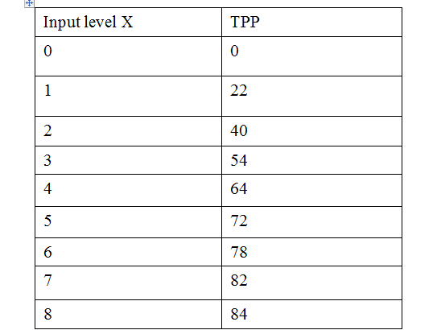

1. By using the data on the above table (on question 2) determine optimum output to produce? (input price birr 16 per unit and output price birr 2 per unit)
2. Select an optimum combination of enterprises given PY1=Birr 280 per quintal, PY2 =400 per quintal.

|  |  |
| --- | --- |
| Y1 | Y2 |
| 0 | 60 |
| 20 | 56 |
| 40 | 50 |
| 60 | 41 |
| 80 | 30 |
| 100 | 16 |
| 120 | 0 |