

**College of Agriculture and Natural Resources**

**Department of Horticulture**

**Practical/ Laboratory Manual**

**For**

**Horticultural Seed Science and Technology**

**By**

**Yibeltal wubetie (Technical Assistant)**

Nov, 2020

Debre Markos, Ethiopia

**Practical one**

**Title identification of parts of a seed**

**Objectives**

* To impart knowledge of prominent characteristics of different crop seeds.
* To identify different morphological characteristics of seeds
* To demonstrate the variation in seed size, shape, color and seed coat of different horticultural crops.

**Introduction**

Seed is a basic agricultural input and it is an embryo, embedded in the food storage tissue. It is also defined as a matured ovule which consists of an embryonic plant with storage of food and surrounded by a protective seed coat. Seed plays an important role in any technology embedding and we have to produce pure, quality, resistant, healthy seeds for production of healthy food to satisfy our needs.

In broad sense Seed is a material which is used for planting or regeneration purpose. Scientifically it is a fertilized matured ovule together covered with seed coat is called seed or it is a propagating material. Technological point of view Seed is a fertilized ripened ovule consisting of three main parts namely seed coat, endosperm and embryo, which in due course gives rise to a new plant. It also refers to Propagating materials of healthy seedlings, tuber, bulbs, rhizome, roots, cuttings, all types of grafts and vegetative propagating materials used for production purpose. A seed consists of the following parts:

* **Helium –** It is a scar that is located on the seed coat, associated with the stalk of the plant
* **Seed coat –** Forms the exterior covering of the plant, supplying with nourishment and protection to the seed inside
* **Endosperm –** It is the tissue containing nutrients for the growth of the embryo
* **Embryo –** Several divisions of the [zygote](https://byjus.com/biology/zygote/) gives rise to this structure
* **Micropyle:** It is a tiny pore in the testa that lies on the opposite of the tip of the radicle. It permits water to enter the embryo before active germination.
* **Cotyledon:** In some plants, this contains high quantities of starch and will provide a source of food for the developing embryo prior to germination, in other plants this role is performed by an [endosperm](https://www.toppr.com/guides/biology/sexual-reproduction-in-flowering-plants/endosperm-development/)
* **Epicotyls /Hypocotyls**: The basis for the plant’s stem. It is known as the epicotyls above the cotyledon and hypocotyls below the cotyledon. These grow upward in response to light.
* **Radicle:** This is the embryonic root which will develop into the primary root of the plant. It is usually the first part of the embryo to push its way out of the seed during germination.
* **Plumule:** This is the embryonic shoot. It appears as a bud which will give rise to the shoot and the remaining structures in the plant.

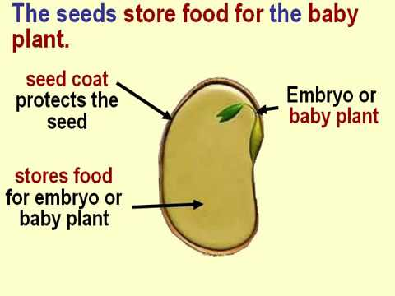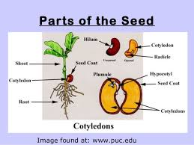

Figure 1. Parts of seed

**Materials**

* Notebook
* Pen
* Seed samples of different vegetable crops
* Petri dishes
* Hand lens etc.

**Procedures:**

* Spread the seeds of different crops on a glass petri plate and observe them with lens.
* Note the size, shape, color, surface and other identification marks particularly the location of the helium, wrinkles, spots etc. on the seed surface.
* Make sketches of all types of seeds.
* Record your observations and write the report what you observe in this practical session.

**Practical Two**

**TITLE:-Determination of seed physical purity /purity analysis/**

**Objective**:-At the end of this practical session students will able to

* Determine percentage composition by weight of the sample being tested (and by inference the composition of the seed lot).
* Identify the various species of seeds and inert particles constituting the sample.
* determine the method of seed sample taking methods
* identify the materials required for seed purity analysis
* familiarize with the procedures of seed purity analysis
* Familiarize with the information found on the seed lot
* identify the various species of the seeds and inert particles comprising the samples
* know the percentage composition by weight of the sample that has to be tested

**Introduction**

Purity analysis means the determination of the percentage by weight or the number of pure seed, weeds seeds, other seed and inert matter. The purity analysis of a seed sample in the seed testing laboratory refers to the determination of the different components of the purity viz., pure seeds, other crop seeds, weed seeds and inert matter. The criteria for purity is based on the number of weightof broken seed with more than half in size ,weed seeds ,other crop seeds and other impurities per unit weight. It is essential to follow all the general requirements established in the regulations.

**Apparatus:**

* Purity board – the main instrument.
* Hand lenses and binocular microscopes – often used for accurate identification and separation of small seed units and fragments.
* Seed blowers – mechanical devices used to separate lightweight material (e.g. chaff and empty florets) from heavier seeds. Several types of seed blower have been developed
* Sieves – used to separate components of different sizes into sized fractions. Examine each fraction and classify the particles (pure seed, other seed or inert matter). Note that the sizing of the fractions may shorten the time required to perform the purity test.
* Analytical balance, forceps and fine needles.
* Plastic trays
* Seed sampler

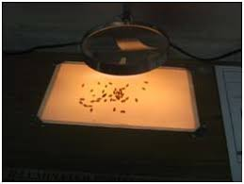 purity board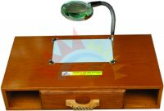

**Purity board**

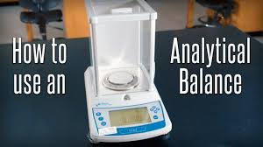 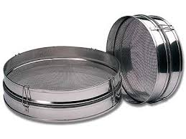

**Balance sieve**

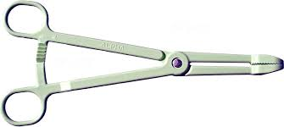 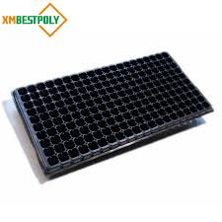

**Forceps plastic tray**

**Procedure**

* Identify the seed.
* Determine the correct weight of the working sample (≥ 2 500 seeds with a maximum weight of 1 000 g). The ISTA Rules stipulate that the analysis can be done on one working sample of this weight or on two subsamples of at least half this weight, each independently drawn.
* Weigh the working sample (or each subsample) in grams to the minimum number of decimal places necessary to calculate the percentage of its component parts to one decimal place, as indicated in the table below:

|  |  |  |
| --- | --- | --- |
| Weight of working sample or subsample (g) | Minimum number of decimal places | Example |
| < 1.000 | 4 | 0.7056 |
| 1.000–9.999 | 3 | 7.056 |
| 10.00–99.99 | 2 | 70.56 |
| 100.0–999.9 | 1 | 705.6 |
| ≥ 1 000 | 0 | 7 056 |

* Divide the working sample on the working board into three components (pure seed, other seed and inert matter).
* Weigh the individual fractions independently using an analytical balance. For example: - Pure seed = X (g) - Other seeds = Y (g) - Inert matter = Z (g**)**

Results are expressed as a percentage with two decimals. The third decimal place is round down if 4 or less (98.384 will read 98.38), and up if 5 or more (98.386 will read 98.39

|  |  |  |  |  |  |
| --- | --- | --- | --- | --- | --- |
| Component | Weight (g) | Percentage | Example (rice) | | |
| Weight (g) | % | |
| Pure seed | Pure seed | (X × 100) ÷ W | X = 68.88 | | 98.4 |
| Other seeds | Other seeds | (Y × 100) ÷ W | Y = 0.14 | | 0.2 |
| Inert matter | Inert matter | (Z × 100) ÷ W | Z = 0.98 | | 1.4 |
| Total | Total | 100 | W = 70 | | 100.0 |

* Pure seed = 98.4%
* Other seeds = 0.2%
* Inert matter = 1.4%

Laboratory reports of purity analysis should include the following information:

• Name and address of issuing laboratory

• Name of responsible individual

• Laboratory test or sample number

• Date of issue of analysis report

• Applicant information (e.g. seed type, cultivar, lot number, lot size, certification number, treatment)

• Pure seed type by common name

• Weight of working sample

• Percentage by weight of pure seed, other crop seed, inert matter and weed seed (to two decimal places)

• Scientific name or common name – or both – of all other crop or weed seed (including noxious weeds) found, if any (if none, specify

**Seed sampling**

The purpose of seed sampling is to obtain a representative sample of a seed lot. This sample size must be such that laboratory tests can determine the probability of occurrence of different constituents in the seed lot. Seed sampling requires in-depth knowledge of the rules and methods. A properly trained seed sampler must take a good sample that represents as accurately as possible the quality of the seed lot.

**Seed lot sampling procedures**

Seed testing is based on lots, i.e. precise quantities of seed. Seed lots should be uniform and harvested from a specific seed field so that analysis results can be related to particular fields. The size of the seed lot depends on the size of the seed. In general, the bigger the seed, the bigger the seed lot. The ISTA Rules specify that maximum lot sizes must comply with the following general pattern:

The seed lot is represented by a very small quantity of seed (the sample). No matter how accurately the laboratory tests are carried out, the results only show the quality of the sample submitted for analysis.

1. **Primary samples**

A primary sample is a portion taken from the seed lot in the warehouse in a single sampling action. In order to meet statistical requirements, ISTA defines the minimum number of primary samples for three different container types

**These samples taken by hand should be taken from**

* the middle of the container if one sample is taken,
* the top & bottom if 2 samples are taken,
* the top/middle/bottom if 3 samples are taken, etc. to ensure a representative composite sample

1. **Composite samples**

To obtain a composite sample, it is necessary to combine and mix all the primary samples taken from the seed lot. During sampling, primary samples are compared to check for homogeneity. If the primary samples appear uniform, they are combined to form the composite sample. Otherwise, the sampling procedure is interrupted. Primary samples are sometimes collected directly in one container. The content of this container may be regarded as the composite sample only if uniform. Otherwise, do not use as a submitted sample.

1. **Submitted samples**

A submitted sample is a sample sent to the testing laboratory. It may comprise the entire composite sample or a subsample obtained using one or more ISTA reduction methods as for the working sample

1. **Working samples**

A working sample is obtained in the laboratory from the submitted sample using an appropriate reduction method. It is the working sample that actually undergoes seed testing.

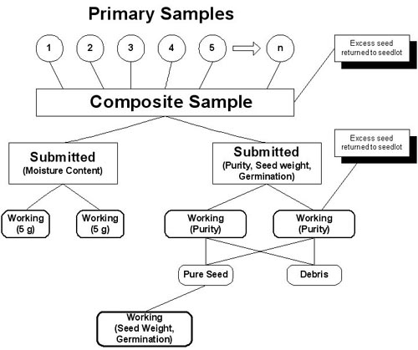

The following sampling intensities shall be used:

1-4 containers 3 primary samples from each container

5-8 containers 2 primary samples from each container

9-15 containers 1 primary sample from each container

16-30 containers 15 primary samples from the lot taken from randomly selected containers with no more than one sample per container

31-59 containers 20 primary samples from the lot taken from randomly selected containers with no more than one sample per container

**Methods for obtaining working sample**

The working sample must be representative of the submitted sample. Mix thoroughly the submitted sample before dividing it mechanically or manually. Each method has advantages and disadvantages; select the most appropriate according to the seed and the means available. The working sample is divided into three components:

* Pure seed
* Other seeds
* Inert matter

Identify all species of seed and each kind of inert matter present, and then determine the percentage of each part by weight.

* Pure seed – the species stated by the applicant, or that found to predominate in the test, and including all botanical varieties and cultivars of that species. The pure seed fraction comprises also
* mature undamaged seeds of the species; and
* Pieces of broken seeds that are more than half the original size.
* Other seeds – seed units of any plant species other than that of pure seed.
* Inert matter – seed units and all other matter and structures not defined by ISTA as pure seed or other seed, for example:
* Broken pieces of pure seed and crop seed species that are half or less their original size;
* Soil particles, sand, stones, chaff, stems, leaves, flowers; and
* Smut balls, ergots and nematode galls.

Purity percentage=weight of pure seed/total seed sample multiplied by 100

Purity test separates pure seed, inert matter, other crop seed and weed seed

**Procedures**

1. Takea 100gm seed sample at random from the seed lot

2. Mix the sample well and divide in to four sub sample

3. Combine the two subsamples/usually found in opposite side/ together

4. Subdivide the combine sample again

5. Separate one of the sub divide samples in to pure seed, other crop seed , and inert matter

6. Measure the weight of each category

**Calculate the percentage of**

A. Pure seed

B. other seed

C. inert matter

D. weeds seed

At the end of this practical the following information must be put under the specific crop as a tag

* Zone/woreda /kebele
* The company name/farmers name
* Crop type/variety
* Origin
* Net weight
* Germination percentage
* Purity percentage
* Lot number
* Germination percentage
* Purity percentage

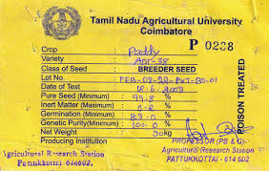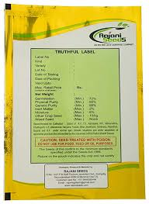

**Practical two**

**Title: Determination of germination seed**

**Objective:** **At the end of this session students will be able to**

* Determine the germination potential of a seed lot, which is vital to compare the quality of different lots and estimate the field planting value.
* Test the germination percentage of different crop seeds
* To understand the procedures of seed germination test
* Identify the materials required for seed germination
* Determine the germination percentage
* To obtain information about the planting value of the seed sample
* Know the viability or the seed quality and to predict its performance in the field

**Introduction**

Germination is the emergence and development of the seedling to a stage at which the appearance of its essential structures indicates whether it can develop further into a satisfactory plant under favorable conditions in the field.

Germination test is checking the emergency and development of a seedling and knowing the germination rate

In laboratory testing, on the other hand, external conditions are controlled in order to obtain the most regular, rapid and complete germination for the majority of samples of a particular species. Moreover, conditions are standardized so that test results can be reproduced within limits as close as possible to the limits of random sample variation.

Germination tests are performed on seed taken either from the pure seed fraction extracted in a purity test or from a representative fraction of the submitted sample.

The prescribed number of seeds for germination tests is 400, which can be divided into four replicates of 100 seeds. They are tested under favorable moisture conditions and in accordance with the methods prescribed.

The seeds are spread apart on the substratum to prevent seedlings from coming into contact with one another before they are counted and removed. At the end of the specified germination period, the replicates are examined; two counts are usually made of the seedlings and seeds in each category undergoing testing.

The germination percentage reported on the certificate issued indicates the proportion by number of seeds that have produced “normal” seedlings under the conditions and within the period specified by the Rules.

**Essential seedling structures**

A seedling, depending on the species tested, consists of a specific combination of some of the following structures essential for its development into a satisfactory plant:

• Root system (primary root; in certain cases seminal roots)

• Shoot axis (hypocotyls; epicotyls; in certain Poaceae mesocotyl; terminal bud)

• Cotyledons (one or more)

• Coleoptiles (in all Poaceae)

**Apparatus:**

* Bell jar or Jacobsen apparatus (Copenhagen tank) – a germination plate on which are placed filter paper substrates with seeds. The substrate is kept continuously moist by means of a wick, which passes through slits or holes in the germination plate into the underlying water bath.
* Germination incubator and room germinator – used for germinating seeds in darkness or light, or for providing seeds with pre-treatments to break dormancy (e.g. pre-chilling). They are well insulated and are equipped with both heating and cooling systems to ensure the maintenance of required temperatures.
* Petri dishes
* Forceps
* covering net
* water
* Blotting paper
* Sand.



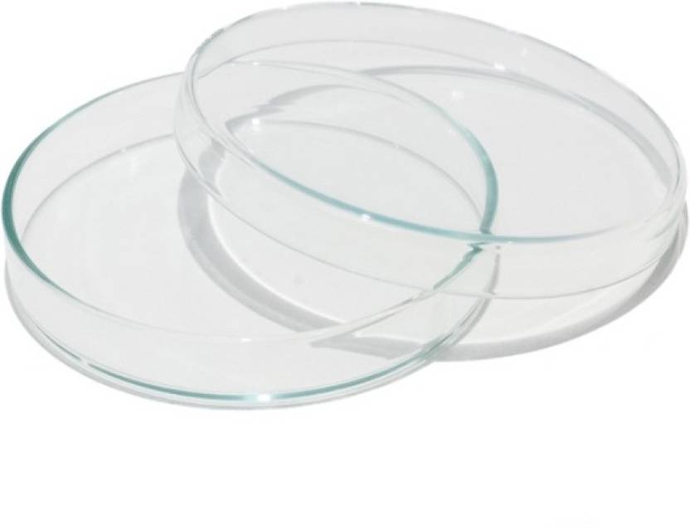

**Procedure**

* Take a sample of 400 seeds at random from well-mixed pure seed. It is important to not select seeds, as this would give biased results.
* Use four replicates of 100 seeds to ensure adequate spacing. Split replicates of 50 seeds (or even 25, particularly where there are seed-borne pathogens or saprophytes present) to minimize the effect of adjacent seeds on seedling development.
* Place seeds uniformly and sufficiently apart on the moist substrate on the Petri dish. If seeds grown on paper substrates are heavily infected, at an intermediate count, transfer remaining seeds and seedlings to fresh media.
* Place Petri dishes in the germination apparatus; record the number of seeds set and the date.
* Make two counts of seedlings. Schedule the first and final counting according to the ISTA Rules.
* Keep the seed moist throughout the test period.

The germination percentage is expressed as follows:

Germination (%) = Number of normal seedlings ×100

Number of seeds set for germination

**Seedlings are evaluated and categorized as follows**

* **Normal seedlings** with potential to develop into satisfactory plants when grown in good quality soil and under favorable conditions of moisture, temperature and light.
* **Abnormal seedlings** no potential to develop into a normal plant when grown in good quality soil and under favorable conditions of moisture, temperature and light. The following seedlings are classified as abnormal:
* Damaged – seedlings with any of the essential structures either missing or so badly and irreparably damaged that balanced development cannot be expected.
* Deformed or unbalanced – seedlings with weak development or physiological disturbances, or with essential structures deformed or out of proportion.
* Decayed – seedlings with any of the essential structures so diseased or decayed as a result of primary infection that normal development is prevented.
* **Un germinated seeds** – not germinated by the end of the test period.

**Classification is as follows:**

* Hard – seeds that remain hard at the end of the test period, because they have not absorbed water. Hardness in seeds is a form of dormancy. It is common in many Fabaceae species, but can also occur in other families.
* Fresh – seeds (other than hard seeds) that have failed to germinate under the conditions of the germination test because of dormancy, but which remain clean and firm and have the potential to develop into a normal seedling. They are able to imbibe water under the conditions set out in the ISTA Rules, but the germination process is blocked.
* Dead – seeds that are neither hard nor fresh and have produced no part of a seedling at the end of the test period. Dead seeds absorb water, are usually soft or discolored and frequently mouldy. They show no sign of seedling development.
* Other – in some circumstances, empty and un germinated seeds may be further categorized according to the ISTA Rules.

The result of the germination test is expressed as a percentage by number of normal and abnormal seedlings and hard, fresh and dead seeds. The percentages are rounded to the nearest whole number.

For example, 75.00 and 75.25 are rounded to 75%; 75.50 and 75.75 are rounded to 76%. The sum of the percentages of normal, abnormal seedlings and un germinated seeds must be 100.

**Information that will be considered while we are doing a germination test**

* Kind of Seed
* Temperature
* First count days
* Final count days
* Additional Germination Procedures
* Percentage of Normal Seedlings
* Percentage of Abnormal Seedlings
* Percentage of Dead Seeds:
* Percentage Dormant Seeds:
* Other Seeds

**Practical three**

**Title: Tetrazolium test for viability**

**Objectives**

* Make a rapid assessment of seed viability and seed vigor in the following circumstances:
* Seeds need to be sown shortly after harvest.
* Seeds have deep dormancy or show slow germination.
* A very quick estimate of germination potential is required (e.g. when a seed lot is received at a processing plant).
* A solution is required to problems encountered in a germination test (e.g. reasons for abnormal are not clear or treatment with pesticides is suspected).

**Introduction**

Viability is the capability of the seed to germinate and produce a normal seedling. It indicates that a seed contains the structures and substances required to germinate under favorable conditions in the absence of dormancy. External physical appearance alone cannot determine whether a seed is alive or dead. Seed viability testing is therefore carried out to determine the percentage of viable seed in a given lot. The test is valid for all species for which a method is described in the ISTA Rules.

Tetrazolium solution is an indicator and produces a substance called formazan in living cells. Formazan is red, stable and non-diffusible and turns living tissues red; they can thus be distinguished from colorless dead tissues.

A viable seed shows staining in all those tissues whose viability is necessary for normal seedling development. Seeds can then be classified into viable and non-viable seed classes.

**Apparatus**:

* Petri dishes
* filter paper
* magnifying glass
* dropper and bottle
* solution of tetrazolium
* dissecting needle
* Forceps

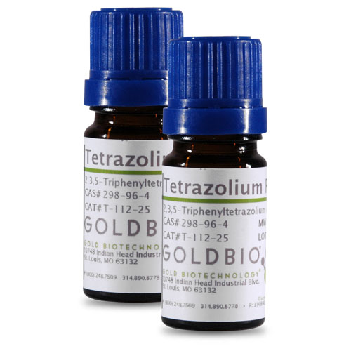 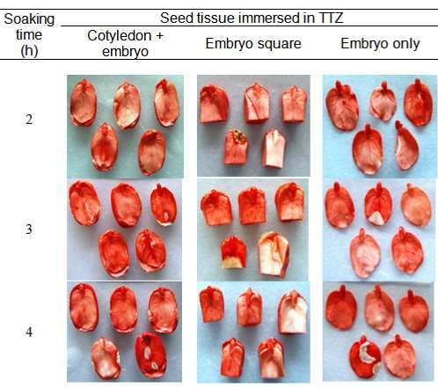

**Procedure:**

* Draw four replicates of 100 pure seeds at random, either from the pure seed fraction of a purity test carried out or from a representative fraction of the submitted sample.
* Mix the pure seed fraction thoroughly taking care to not select seeds causing biased results.
* Soak seeds in water overnight to soften the embryo and endosperm and activate the enzyme system.
* Make a cut or completely remove the seed-coat (depending on the species) – to expose the embryo and facilitate contact with the tetrazolium solution.
* Immerse the prepared seeds or embryos in tetrazolium salt solution. Avoid exposure to direct light, as it would cause a reduction of the tetrazolium salt. Refer to the ISTA Rules for optimum temperatures and staining times.
* Wash seeds repeatedly with distilled water.
* Examine seeds under a magnifying glass.

**Example**: For maize, the seeds are soaked for 18 hours in water at 20 °C, then cut longitudinally through the embryo and ¾ of the endosperm before staining in 1% tetrazolium solution for 2 hours at 30 °C. The seeds are then halved and the cut surfaces observed.

Seeds are classified as follows:

• Living – red or purple embryo.

• Dead – no color in the embryo. Even when the embryo is not stained but red colour develops on other parts, the seed is still classified as dead.

Viable seed (%) = Number of living seeds ×100

Number of seeds set for viability test

**Practical 4**

**Title Vigor test**

**Objectives:**

* Assess the extent of seed lot deterioration and/or physical damage that has occurred during handling and storage.
* Distinguish important differences in physiological potential among seed lots of commercial value (in particular those of similar germination percentage).

**Introduction**

The germination test does not detect quality differences among seed lots with similar germination percentages. A vigor test is more sensitive and able to detect such differences.

There are several definitions of seed vigor, including:

Seed properties that determine the potential for rapid uniform emergence and development of normal seedlings under a wide range of field conditions (AOSA, 1983)

Sum total of properties of seeds that determine the activity and performance of seed lots of acceptable germination in a wide range of environments (ISTA, 1995)

Seed vigor is not a single measurable property. It is a concept describing several seed characteristics associated with aspects of performance in the field, including:

• Rate and uniformity of seed germination and seedling growth;

• Ability of seeds to emerge under unfavorable environmental conditions; and

• Performance after storage, particularly retention of the ability to germinate.

It is possible to identify lots more likely to perform well under non-optimal environmental conditions. Indeed, germination tests take place under optimal germination conditions and the results express the germination potential. This figure may be quite different from actual performance under stressed field conditions.

For example, two seed lots may have similar germination potential (> 90%), but significant differences in seed vigor (Table 3.2). An efficient vigor test must pinpoint differences in physiological potential not detected by viability tests and rank lots according to performance potential.

Table 3.2 Example of germination and emergence in two seed lots

|  |  |  |  |
| --- | --- | --- | --- |
| Seed lot | Germination (%) | Seedling emergence (%) | |
|  |  | Field 1 (near ideal conditions) | Field 2 (unfavorable conditions) |
| A (high vigor | 90 | 88 | 75 |
| B (low vigor) | 90 | 87 | 50 |

• Field 1 – the stands of both high (A) and low (B) vigor seed lots are similar to their germination.

• Field 2 – the low vigor seed lot (B) has poor seedling emergence compared with the high vigor seed lot (A). In addition, despite seed lot A’s superior vigor, emergence in Field 2 is lower than the germination percentage; therefore, stand may be unacceptable if conditions are stressful

**Materials**

* Seeds sample
* Petri dish
* filter paper to fit the Petri dishes
* Tape and wax
* pencil and markers to label your experiment
* light sources
* data recording tool
* distilled water

**Practical four**

**Determination of moisture content**

**Objectives:**

* Determine the appropriate drying conditions for optimum preservation during storage.
* Verify whether seed complies with the maximum moisture content specified in the seed regulations.
* Familiarize with the materials required for seed moisture testing
* Know the moisture content of the different seeds

**Introduction**

Moisture content is crucial for preserving quality of stored seed and maintaining viability. Seeds with the correct moisture content can be stored longer and are relatively resistant to damage by insects.

The moisture content of a sample is derived from the loss in weight when the seed is dried in accordance with ISTA methods. It is expressed as a percentage of the weight of the original sample.

**Moisture meter method**

An indirect method, any type of moisture meter can be used, as long it meets the calibration and determination requirements. The moisture content measured is calibrated against the moisture content obtained using the oven method.

Meters are very practical and particularly useful when a rapid result is required, for example, when seed arrives at the processing plant after harvest and it is necessary to decide whether further drying is required

**Apparatus**:

* containers
* thermohygrometer
* analytical balance
* Sieves
* seed sampler
* sample seed
* moisture tester
* Light source

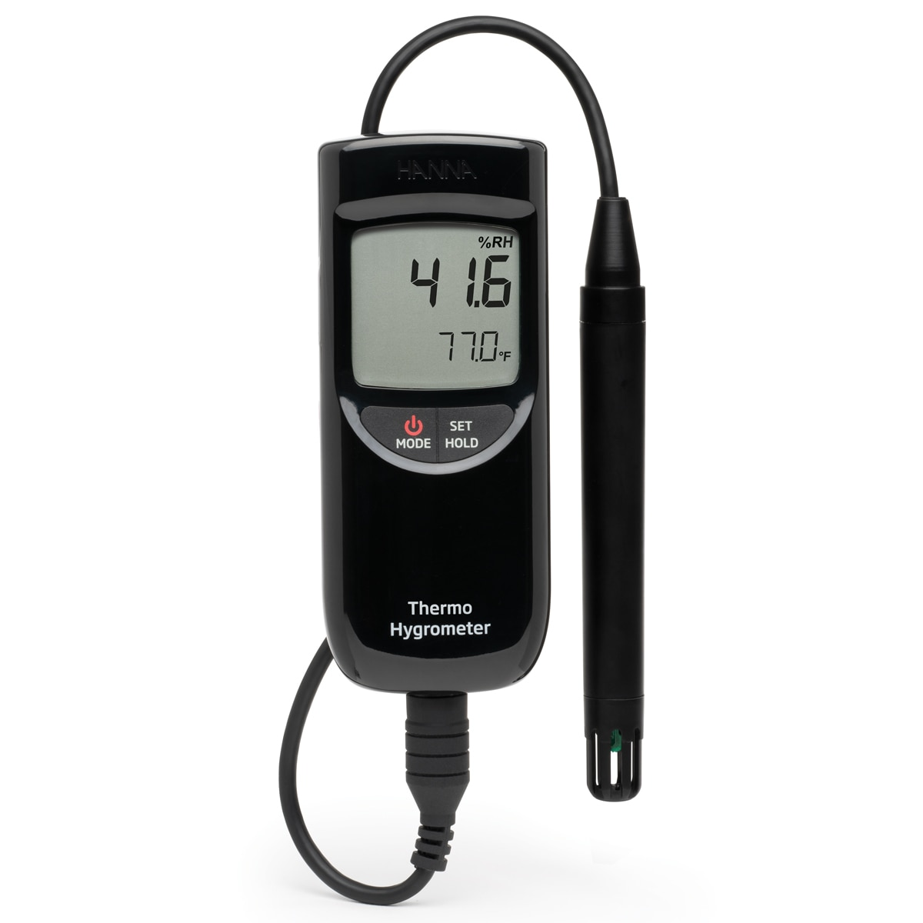

Portable thermo hygrometer

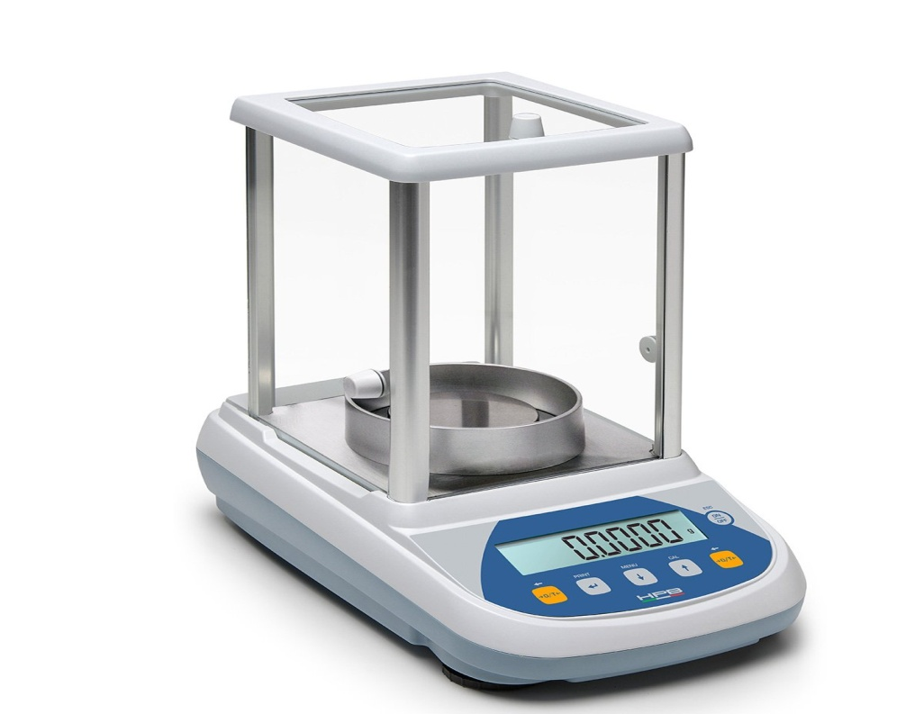

analytical balance

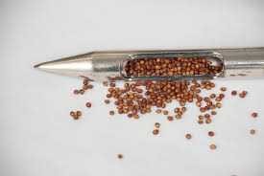

Seed sampler

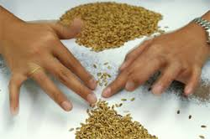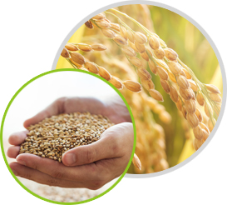

Sample seed

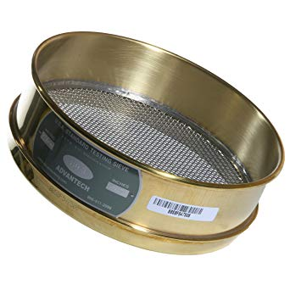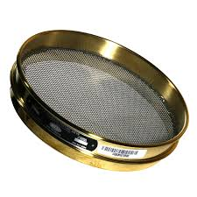

sieve

**Procedure:**

* Take the sample seed from the lot
* Mix all the sample seed together.
* Divide equally in to four sub samples
* Combine the two subsamples/usually found in opposite side/ together
* Subdivide the combine sample again in to pure seed, other crop seed, and inert matter
* Then after measure the weight of each category
* Measure the weight of the container
* Measure the weight of the container with the sample seed before drying
* Measure the weight of the container with the sample seed after drying
* Then we can calculate the moisture content of the sample seed

The moisture content as a percentage by weight is calculated to three decimal places for each replicate using the following formula:

MC (%) = Loss of weight x 100 or M2 – M3 x 100

Initial weight M2 – M1

Where:

* M1 = weight (g) of container and cover
* M2 = weight (g) of container, cover and contents before drying
* M3 = weight (g) of container, cover and contents after drying
* m2-m3 = moisture loss or loss of weight
* m2-m1 =fresh weight of the sample or initial weight

Example if the moisture loss of the seed is 2 and the fresh weight of the sample seed is 8. then

1. Calculate the weight of the seed with its container before drying?
2. Calculate the weight of the seed with its container after drying?
3. Calculate the mc percentage?

Let the weight of the container is 2